Exploring Sentimental Analysis
Tanisha Roy¹, Raj AryanSingh², Pradyut Singh³, Abhipsha Roy⁴
Sikkim Manipal Institute of Technology^{1,2,3,4}, Majhitar, East Sikkim 737136

- Introduction

With the passing years, the sentimental complexity of human beings has evolved as well as time spent on buying products. It has evolved a lot due to the involvement of different technological advancements introduced in the process. Human beings now want the least amount of physical labor in life and depend more upon virtual tools for daily needs. As a result, the idea of sentiment analysis for product rating does hold utmost importance in the domain of Ecommerce. AI based tool uses NLP, text analysis, computational linguistics to study the reviews given by other users to give opinions to the buyers. The idea dates to the 1950s when it was circulated as a written document.
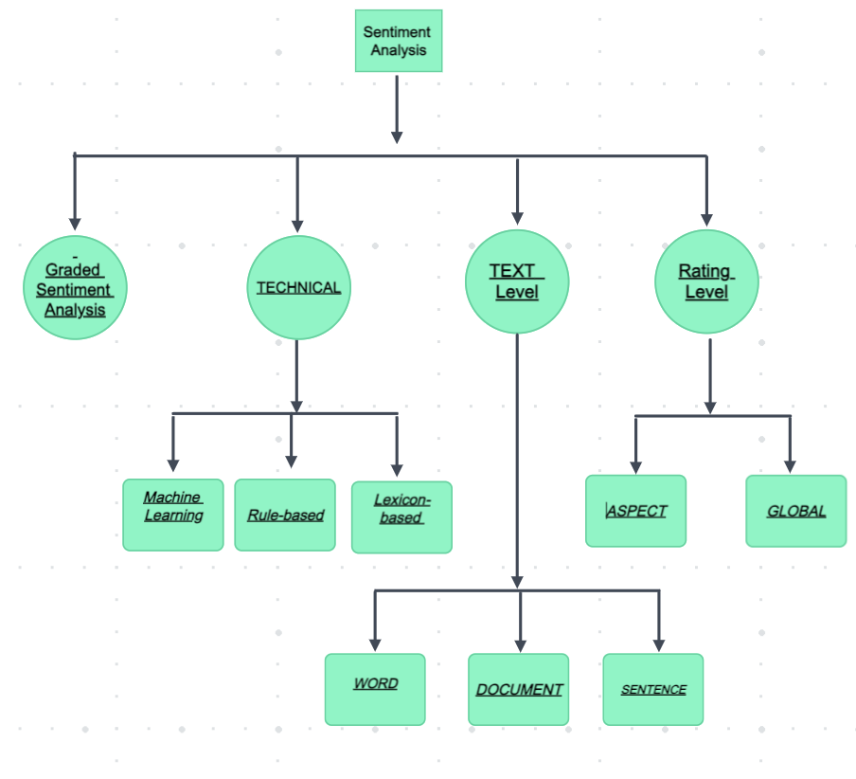
Sentiment is not just a word, it depicts the emotions, attitude, or nature of an individual. It represents the opinion and originality of an idea. Sentiment is a continuous tug-of-war between subjective emotions and objective facts. Sentiment analysis is a process which determines the polarity of the review given by users and it understands the actual emotion what the user is trying to convey through online review of the product. Sentimental analysis is based on the interpretation of the comment given by the user. It can be broadly divided into four categories as given in Figure 1.
Figure 1: Sentimental Analysis Categories
1.1 Sentimental Analysis Methodologies[1]
Sentiment analysis methodologies can broadly be categorized into the following classes.
- Machine Learning: In this method machines are trained to detect the polarities of the statement or review.
- Rule Based: In this method the review is extracted from the data set and then the polarity of the is reviewed. It uses different sets of rules of idioms, dictionary polarity, emoticon etc.
- Lexicon Based: It decides the subjective opinion over the objective facts.

For text level sentiment analysis can be further classified as word level, document level or sentence level.
- Document Level: Document level is one of the most crucial level in sentiment analysis where the information is taken as a whole and then is fed into the system whether it is a positive or a negative comment.
- Sentence Level: Here the document is sliced into sentences and then fed into the system for determining whether the input is positive or negative.
- Word Level: Here each word is considered and fed into the system to check for the review posted by the user.

Rating of a product can be done at both aspect and global level. This is basically used to support the product review with some kind of graphical or image-based representation. The emotional aspect goes beyond the basic polarity of the statement. It checks the mental state of the user whether he was happy, sad, or angry while giving the review.
Sentiment analysis for product rating plays a very crucial role in creating a relation between the rating and the comment given by the user. This helps in increasing the reach of a product and helps the buyer to choose the product. When we talk about sentimental analysis at its core algorithms to classify statements as positive negative or neutral. It analyses different types of comments and determines the sentiment behind them.

- Sentimental Analysis: Natural Language Processing & Machine Learning[4]

Sentimental Analysis is extensively used in today's world and is based mostly on two algorithms NLP(Natural Language Processing) or byML( Machine Learning).They help in understanding the key emotions behind the online reviews.

2.1 NLP (Natural Language Processing)[8]
NLP is a natural learning process suitable for artificial intelligence as it helps to train AI to help and make the process of learning languages by machines more efficient.

Prominent Natural Language Processing (NLP) Tasks:
- Text and Speech Processing: Encompassing speech recognition, handling text and speech data, encoding (conversion of text or speech to machine-readable format), etc.
- Text Classification: This involves tasks like Sentiment Analysis, wherein machines discern qualities, emotions, and sarcasm in text, categorizing it accordingly.
- Language Generation: Tasks like machine translation, summarization writing, and essay generation fall under this category. The aim is to create coherent and fluent text output.
- Language Interaction: Encompasses areas like dialogue systems, voice assistants, and chatbots. These tasks facilitate natural communication between humans and computers.

NLP techniques find application in numerous domains such as search engines, machine translation, sentiment analysis, text summarization, question answering, and more. Continuous research in NLP, coupled with advancements in deep learning, has yielded substantial improvements in performance. Nevertheless, NLP remains a demanding field, necessitating a grasp of both computational and linguistic principles.

2.1.1 Working of Natural Language Processing (NLP)
Engaging in natural language processing (NLP) typically involves utilizing computational methods to analyze and comprehend human language. This encompasses tasks like language understanding, generation, and interaction.

NLP consists of three distinct components:
1. Speech Recognition: This entails translating spoken language into text. It serves as the initial stage of natural language understanding (NLU). Modern voice recognition systems often rely on Hidden Markov Models (HMMs), which are statistical models employing mathematical calculations to convert speech into text. HMMs break down spoken content into small units, analyze phonemes (the smallest speech units), and use statistical analysis to deduce the most likely words and sentences spoken.

2. Natural Language Understanding (NLU): The subsequent and more complex phase involves comprehending the content. NLU is where the computer endeavors to grasp the meaning of individual words, determining their grammatical roles (noun, verb, tense) through Part-of-Speech tagging (POS). NLP systems also integrate a lexicon and grammatical rules. Understanding is the most intricate aspect of NLP, entailing challenges such as polysemy (words having multiple meanings) and synonymy (different words with similar meanings). Developers encode rules and train NLU systems to learn and apply these rules effectively.

3. Natural Language Generation (NLG): NLG pertains to the computer's ability to generate coherent natural language. This might include constructing sentences, paragraphs, or even longer text passages. NLG becomes relevant when the machine is required to communicate its findings or responses in a human-like manner.
Professionals in the field of NLP often possess backgrounds in computer science, linguistics, or related domains. They may be proficient in programming languages such as Python and C++, and familiar with NLP libraries and frameworks like NLTK, spaCy, and OpenNLP.
By understanding these components and their underlying methodologies, practitioners in NLP can design and develop systems that enable machines to comprehend, interact with, and generate human language, contributing to advancements in areas such as voice recognition, virtual assistants, and more.

2.1.2 Roles in Natural Language Processing (NLP) encompass a range of responsibilities:
In the realm of Natural Language Processing (NLP), various roles contribute to advancing the field:
1. NLP Engineer: Responsible for designing and implementing NLP systems and models. NLP engineers create algorithms and technologies that enable computers to understand, generate, and interact with human language effectively.
2. NLP Researcher: Conducts in-depth research into NLP techniques and algorithms. NLP researchers explore the theoretical aspects of language processing and work on developing innovative approaches to enhance NLP capabilities.
3. Machine Learning (ML) Engineer: Designs and deploys a wide range of machine learning models, including those tailored for NLP tasks. ML engineers focus on developing algorithms that power language-related functionalities.
4. NLP Data Scientist: Analyzes and interprets data generated by NLP systems. NLP data scientists identify patterns and insights within linguistic data, contributing to the improvement of models and systems.
5. NLP Consultant: Offers specialized expertise in NLP to organizations and businesses. NLP consultants provide guidance on implementing language-related solutions and ensure the effective utilization of NLP techniques to address specific challenges.
Engaging in NLP is both demanding and rewarding, requiring a solid grasp of computational and linguistic principles. The dynamic nature of NLP mandates practitioners to stay updated with the latest advancements in order to remain effective and innovative.
Professionals in NLP are at the forefront of technology, contributing to groundbreaking developments in artificial intelligence, voice recognition, chatbots, sentiment analysis, and other applications that demand human-like language understanding and generation.

2.1.3 Applications of Natural Language Processing (NLP):
1. Spam Filters: NLP is at the core of modern email systems like Gmail, using linguistic analysis to differentiate between genuine emails and spam. By analyzing email content, NLP-powered filters can identify suspicious patterns and effectively categorize emails.
2. Algorithmic Trading: NLP is a game-changer in the realm of algorithmic trading. It processes and comprehends news headlines related to companies and stocks, aiding traders in making informed decisions about their investments based on the sentiment and context of the news.
3. Question Answering: NLP drives tools like Google Search and voice assistants like Siri. These systems utilize NLP techniques to understand user queries and generate relevant responses, making it possible for users to find information quickly and accurately.
4. Text Summarization: With the overwhelming amount of information available online, NLP enables the creation of concise and coherent summaries. By extracting key points from lengthy texts, NLP facilitates efficient information consumption, saving time and effort.
These real-world applications highlight how NLP is integrated into various sectors to improve efficiency, decision-making, and user experiences by effectively processing and comprehending human language.

2.2 Machine Learning
Machine learning [2][6] comprises a set of techniques designed to automatically generate models from data. The driving force behind machine learning is its algorithms, which transform a given dataset into a functional model. The choice of the most suitable algorithm type (such as supervised, unsupervised, classification, regression, etc.) hinges on factors like the specific problem at hand, the computational capacity at your disposal, and the inherent characteristics of the data being dealt with.
Several methods and intricate algorithms are employed to instruct and train machines for conducting sentiment analysis. Each method carries its own advantages and drawbacks. However, when employed collectively, they have the potential to yield exceptional outcomes.

2.2.1 Popular algorithms:

Naive Bayes:
Naive Bayes stands as a relatively uncomplicated set of probabilistic algorithms. In the context of sentiment analysis classification, this approach assigns a probability to a given word or phrase, indicating whether it should be classified as positive or negative. Fundamentally, Bayes' theorem operates on the principle that the probability of event A, given that event B has occurred, equals the probability of event B given that event A has occurred, multiplied by the probability of event A occurring, and divided by the probability of event B occurring.

Mathematical representation of Bayes' theorem: As in Figure 2, it is computed as the probability of A, given that B is true, is equal to the probability of B, given that A is true, multiplied by the probability of A being true, divided by the probability of B being true.

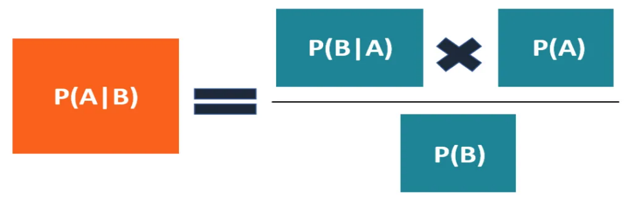

Figure 2: Bayesian Approach[ 7]

Though involving intricate mathematical concepts, the essence of Naive Bayes involves comparing words. By leveraging machine learning models trained to understand word sentiment, we can calculate the likelihood that a word, phrase, or text carries a positive or negative connotation.
Incorporating techniques such as lemmatization, stopword removal, and TF-IDF (Term Frequency-Inverse Document Frequency) enhancement further refines the predictive accuracy of Naive Bayes.

Linear Regression:
Linear regression stands as a statistical technique employed for predicting a Y value based on X features. In the realm of machine learning, datasets are analyzed to unveil relationships, which are then depicted on the X/Y axis. A linear regression line is plotted through these relationships, facilitating predictions of forthcoming relationships.
The essence of linear regression lies in assessing how the input X (comprising words and phrases) correlates with the output Y (representing polarity). Through this analysis, linear regression identifies the position of words and phrases on a polarity scale, ranging from profoundly positive to deeply negative and encompassing all gradations in between.

Support Vector Machines (SVM):
Support Vector Machines (SVM) are a type of supervised machine learning model that bears similarity to linear regression but holds a more sophisticated nature. SVM employs algorithms to both train and classify text within the context of our sentiment polarity model. This takes the process beyond mere X/Y prediction, advancing into the domain of refined text classification within the sentiment analysis framework.

Deep Learning:
Deep learning is a specific subset of machine learning that aims to mimic human brain functions using artificial neural networks. At its core, deep learning functions hierarchically. It's structured as a multi-layered framework that connects various algorithms, advancing through stages to tackle complex challenges. This approach imitates the step-by-step problem-solving process seen in human thinking. By utilizing artificial neural networks, deep learning can perform tasks and overcome complex problems, showcasing its effectiveness in addressing intricate data-driven challenges.

- Sentiment Analysis Tools

Few of the popular tools are listed as follows:

- MonkeyLearn:
MonkeyLearn offers a suite of text analysis tools, including a highly accurate sentiment analysis tool.
MonkeyLearn's products seamlessly integrate with platforms like Zendesk and Google Sheets. For those familiar with coding, the MonkeyLearn API enables connection of sentiment analysis tools to your stack.
Custom sentiment analysis models can be created without coding, resulting in improved accuracy. By training the model with your business data and criteria, it learns industry-specific language and defines sentiment levels according to your business needs.

- Lexalytics:
Lexalytics offers the Semantria API for cloud-based sentiment analysis setup. For an on-premises solution geared towards data scientists and architects who require full technology access or on-premise deployment for security, Lexalytics Salience is recommended. Both of the options provide access to a potent NLP sentiment analysis system, customizable to your needs. However, comprehending the workings of the Lexalytics API demands a background in data science. Once you've assessed customer sentiments, results can be visualized and stored within Semantria's robust business intelligence tool.
It's important to note that while Lexalytics covers text analysis and data visualization, technical proficiency is necessary for its effective use.

- Brandwatch:
Brandwatch emerged as a leader in the 2020 Forrester Wave for social listening platforms, lauded for its superior sentiment analysis precision compared to peers. Brandwatch aids businesses in monitoring online mentions, comprehending customer sentiment, identifying sentiment fluctuations, and gauging real-time brand visibility. Touted as a "consumer intelligence" platform, it offers machine learning custom classifiers and automatic entity disambiguation, uncovering topics within sentiment-analyzed data. An intriguing feature is Brandwatch's "image insights," which extends beyond text data, enabling tracking of logo dissemination across numerous online sources and their placements.

- Social Searcher:
Social Searcher tracks keywords, hashtags, and usernames on various social media platforms. It offers comprehensive social analytics, including audience insights, trending hashtags, and influential users.
The free version incorporates a sentiment analysis tool that gauges overall sentiment from social media data on each platform. It also breaks down popular posts into positive and negative categories.

- MeaningCloud:
Utilize MeaningCloud's Sentiment Analysis API for multilingual sentiment analysis. This tool conducts aspect-based sentiment analysis, discerning whether topics are discussed positively, negatively, or neutrally. Furthermore, you can customize a vocabulary specific to your industry using a dictionary. MeaningCloud's standout features include gauging overall sentiment, distinguishing opinion from fact, and identifying sentiment within individual sentences of a text.

- Talkwalker's Quick Search:
Talkwalker's Quick Search is a social media search engine. It automates the analysis of brand mentions on social media, providing insights for campaign assessment, content inspiration, and trend discovery.
Quick Search boasts sentiment analysis for social mentions across 25 languages. With real-time social listening, it ensures you're up-to-date on ongoing matters and helps gauge customer sentiments toward your brand or product.

- Rosette
Utilizing Rosette's sentiment analysis tool is effortless. The API facilitates sentiment analysis on social media content and enables detailed analyses, such as sentiment associated with particular products, companies, or individuals. Rosette achieves part-of-speech identification through morphological analysis and lemmatization, grouping inflected word forms. For multinational businesses, Rosette's sentiment analysis tool can be trained to recognize up to 30 languages.

- Repustate:
Repustate's sentiment analysis software excels in detecting sentiment from slang and emojis, deciphering whether a message carries a positive or negative sentiment. The tool is available for trial to evaluate its suitability. The API can be personalized to identify any of 23 languages. Additionally, sentiment analysis models can be trained to recognize diverse word meanings, enhancing sentiment accuracy further.

- Clarabridge
Clarabridge furnishes tools for assessing customer sentiments across various data sources like social media, emails, chats, and surveys. Notably, it excels in Speech Analytics, enabling sentiment analysis on audio data. This proves highly advantageous for teams managing extensive call volumes, such as sales and support teams.

- Aylien
Aylien's News API offers real-time insight into the gravity and repercussions of news events. It gauges sentiment across news stories and delves into subjects with aspect-based sentiment analysis.
This text analysis platform even empowers you to effortlessly construct your own models, requiring minimal machine learning or NLP expertise to initiate.

- Social Mention
Social Mention offers an uncomplicated, free sentiment analysis tool. It allows users to input any keyword and obtain a comprehensive performance analysis. This analysis encompasses an overview of the keyword's overall sentiment, individual mention sentiments, and the quantity of positive, negative, or neutral comments associated with the keyword.

- Critical Mention
Critical Mention facilitates sentiment analysis of your social media mentions. Through real-time tracking of mentions, you can effectively manage your brand, leverage positive references, and identify issues. This tool tracks mentions and branded terms across platforms like Facebook, YouTube, and Twitter. It also enables keyword searches for specific topics. Marketers can utilize sentiment analysis to assess brand well-being and conduct competitive analysis. Seamless integration with other tools is possible via the API, enhancing the sentiment analysis process.

- Awario
Awario is a real-time social listening tool employing sentiment analysis for assessing tweets, posts, and Reddit threads. By instantly gauging sentiment in brand mentions, you acquire up-to-the-minute business insights. Moreover, you can track sentiment surrounding specific keywords of interest. These keywords could pertain to your brand, product, competitors, industry, or any topic you wish to monitor.
Awario's comprehensive dashboard dissects sentiment data per keyword, brand, topic, and more. It also provides a competitive analysis, revealing who garners more negative feedback or mentions, for instance.

- Hootsuite Insights
Hootsuite Insights, a social listening tool, enhances brand strategies by seamlessly integrating with all social networks. This grants immediate access to real-time online conversations, offering insights that are invaluable for refining your approach. With on-the-go sentiment analysis, you can monitor customer discussions about your brand. Alerts can be set up to notify you of unusual spikes in negative sentiment or emerging industry-related topics that resonate with customers. Effortlessly allocate conversations or concerns to the relevant team members for action or response. Utilize filters like date, demographics, and geography to eliminate noise and access precise data whenever and wherever you require it.

- HubsSpot's Service Hub
HubSpot's Service Hub stands as customer service software that offers comprehensive customer data management. It encompasses a sentiment analysis function capable of categorizing open-ended survey feedback by intent. Integrating with your CRM, it identifies customers expressing negative sentiments towards your company, enabling timely intervention to mitigate churn.

- PYTORC
PyTorch is a comprehensive framework for constructing deep learning models, frequently utilized in tasks such as image recognition and language processing. Written in Python, it's accessible for most machine learning developers. Notably, PyTorch stands out due to its strong GPU support and utilization of reverse-mode auto-differentiation, facilitating dynamic modification of computation graphs. This feature makes it popular for rapid experimentation and prototyping.

Sentiment Analysis Use Cases & Applications
Application of sentimental analysis is endless at today’s world it not only helps in manufacturing industries but also helps in hospitality, finance, education, security and technology-based industries. Following are the few of the top applications:

- Social media Analysis:
With the help of sentiment analysis in social media companies or brands gain insight knowledge about customer experiences with different products. Moreover, with the help of social media itself companies gain knowledge about lower-level issues which could never reach the main handling committee or mainstream media.
For example: On one of the flights of United, the staff forcibly removed an Asian passenger who was also a doctor due to overbooking, and much to the horror of his fellow passengers he(the Asian passenger) was dragged outside the flight which led to serious injuries. This event was recorded by one of the passengers and posted on social media, which was shared more than 87000 times and had a view count of 6.8 million times by 6pm of he same day.
This resulted in a tweet by United’s CEO Oscar Munoz who apologized for the incident and said, “I continue to be disturbed by what happened on this flight and I deeply apologize to the customer forcibly removed and to all the customers aboard. I want you to know that we take full responsibility and we will work to make it right.”[5]

- Education:
In the field of education sentimental analysis plays a pivotal role, it helps in detecting the climate of the classroom like how each student behaves in a particular situation and can even predict reaction of students based on this study. It can also provide insight to the teachers that whether the entire class have understood the topic taught or not and if it comes negative (i.e. most of the class shows frustration and confusion regarding the topic) the teacher can revisit the topic or change the teaching method.

- Politics:
Public opinions and polls about their representators changes throughout the duration of election, which can lead to unpleasant surprises like changes in vote ratio at the day of election etc. Moreover, it helps the party representators to learn more about their voter with the help of applications like Determ which can track and analyze it without any efforts.

- Market Research and Analysis:
When going through all different kinds of review it becomes very easy to generate the market studies because it gives reasons why customers are not responding to something, whether the product, user experience, or customer support. Moreover, it has a huge data collection so it can give a easy market survey and competitive analysis of any product out there in the market.Eg when I as a product developer for product xyz will use this AI for gaining knowledge about other competition of xyz it will not only give me information about competition products but also give information about limitation of this competition product which will help me (a product developer) to introduce a much better and advanced product in the market..It helps in creating community servies around a particular location based on requirments and needs of that area picked up from social media discussions of that locality.

- Challanges _{[2][3]}
Just as a coin has two sides, every project in the market also comes with its own set of limitations. In the case of this project, some of its limitations include: -

- Tone: -
Sentiment analysis studies the opinion of users and their emotions which they try to express in the reviews of products, but when people express their emotions the data comments which is in text form, it does not clearly give an idea of what the user is feeling while giving the review and hence the AI which tries to analyze the review may misinterpret and send a data which was not intended by the user.

- Lexicon: -
Lexicon based sentimental analysis method usually does not identify sarcasm, grammatical mistakes, missed spellings, or irony which the user tries to display through their review. It becomes difficult to segregate these kinds of comments that is based on the negative or positive things.

- Emoji: -
There are two types of emojis according to Guibon et al, that is, western emoji and eastern emoji. Western emojis are generally short and encoded (example :0) whereas the eastern emojis are longer and a combination of multiple vertical characters (example (\ (ツ) / ¯)). Emojis plays a very vital role in deciding the sentiment of the text specially while using social networking platforms such as twitter. Because of which word and sentence level analysis had come into play. But it consumes a large amount of time as compared to document level analyzing.

- Human Annotator Accuracy: -
Sentiment analysis is a very difficult task for even human beings. For example, a person A and B are reviewing a same product and there is more than 70-80% chances that their views are different on the product. Since, sentimental analysis is done with the help of machine learning from labeled data it might not be precise and even experts from different platforms expect the rate of correct prediction to be 70-80% [3].

- Comparative sentences: -
It becomes very difficult for the machine to identify the polarity of statements which are of the given type, for example: - the display of phone A is better than that of phone B, in this kind of statements it becomes difficult for AI to comment the polarity of the review.

Conclusion
Sentiment analysis for product rating is an AI based system which helps in determining the quality of a product by gathering reviews of various users. It can be used in various fields for example, shopping, rating drivers in uber or zomato etc, food quality in a restaurant and so on. This system has a huge influence in our current society, for example, we check review for everything when we perform any task whether it is shopping, going to movies or doing something else. This is because we human beings tend to ask questions before doing something new or unique to get a surety that we might not regret our decision later and that there is no monitorial loss. We henceforth rely on the reviews of other people. This is the key reason behind the development of Sentiment analysis.

References

1. AUTHOR: Suparna Dhar
BOOK NAME: 'Decision Support Systems, Volume 162, November 2022, 113769 '
PUBLISHER: Science Direct.
LINK: https://www.sciencedirect.com/science/article/abs/pii/S0167923622000409

2.AUTHOR: Rachel Wolff

BOOK NAME: Sentiment Analysis & Machine Learning , April 20th, 2020

PUBLISHER: Monkey Learn BLOG.
LINK: https://www.sciencedirect.com/science/article/abs/pii/S0167923622000409
3.AUTHOR: Nick Barney
BOOK NAME: A guide to artificial intelligence in the enterprise
PUBLISHER: Tech Accelerator
LINK:https://www.techtarget.com/searchbusinessanalytics/definition/opinion-mining-sentiment mining#:~:text=Sentiment%20analysis%2C%20also%20referred%20to,a%20product%2C%20service%20or%20idea
4. AUTHOR:Xing Fang & Justin Zhan
BOOK NAME:Sentiment analysis using product review data
PUBLISHER:bigdata.speingeropen.com
LINK:https://journalofbigdata.springeropen.com/articles/10.1186/s40537-015-0015-2
5. AUTHOR:Anjali Bisaria
BOOK NAME:11 Times When Airline Staff Misbehaved With Passengers
PUBLISHER:indiatimes.com
LINK:https://www.indiatimes.com/news/india/8-times-when-airline-staff-misbehaved-with-passengers-333323.html

6. AUTHOR:Martin Heller
BOOK NAME:The engines of AI: Machine learning algorithms explained
PUBLISHER:infoworld.com
LINK:https://www.infoworld.com/article/3702651/the-engines-of-ai-machine-learning-algorithms-explained.html

7. AUTHOR:Sebastian Taylor
BOOK NAME:Bayes' Theorem
PUBLISHER: corporate finance institute.com
LINK:https://corporatefinanceinstitute.com/resources/data-science/bayes-theorem/

8. AUTHOR: Avinash Ray, Laxmi Shinde, Pawan kumar
BOOK NAME:Over view of Natural Language Processing.
PUBLISHER: greeksforgreeks.org
LINK: https://www.geeksforgeeks.org/natural-language-processing-overview/

