Analyzing the Shifting Age Structure of India and its Impact on Economic Growth: A Mixed Methods Research Approach

Dr. Jyoti Badge
Assistant Professor.
VIT Bhopal University
badge.jyoti@gmail.com

Dr. Priya Dwivedi
Associate Professor
IPER, Bhopal
Priyadwivedi4@gmail.com

Abstract- This paper analyzes the effects of India's changing age structure, particularly the working-age population, on its economic growth. Employing a mixed methods research design, both quantitative and qualitative data are collected, analyzed, and interpreted. Quantitative analyses such as correlation and regression are conducted to investigate the relationship between age structure and economic growth. Additionally, a minor qualitative analysis, supported by a questionnaire, is employed to validate and confirm the quantitative findings. The chosen sequential mixed method design provides comprehensive insights into the subject matter and facilitates a thorough examination of the phenomenon.

Key words: Working Age Population, Gross Domestic Product, Quantitative analysis, Qualitative analysis, Mixed Method Research.

Introduction

The debate surrounding population and its growth has long been a pivotal discussion in macroeconomics, given its profound implications for a country's development and growth. Understanding this contribution necessitates the division of the population into two key categories: the dependent population and the working-age population. According to the World Bank, individuals aged 15-64 fall into the working-age cohort, and India has earned the distinction of being one of the world's youngest nations due to the increasing size of this segment. Among various macroeconomic factors, the working-age population stands out as a significant contributor to a country's growth performance.

This research paper aims to analyze the consequences of India's shifting age structure, particularly the working-age population, on its economic growth, using a mixed methods research approach. Mixed methods research involves the collection, analysis, and interpretation of both quantitative and qualitative data within a single study or a series of studies investigating the same underlying phenomenon. This approach is driven by the understanding that combining quantitative and qualitative methodologies yields a more comprehensive comprehension of research problems than either approach alone.

In this study, we will utilize mixed methods to examine economic phenomena, specifically exploring the linkages between population dynamics and a country's economic growth. By integrating quantitative analyses, such as correlation and regression with qualitative investigations, we aim to provide a comprehensive and nuanced understanding of the relationship between India's age structure and its economic performance. This research seeks to shed light on the critical role played by the working-age population in India's economic growth trajectory and contribute valuable insights to the broader field of economic development studies.

Literature Review
The literature review encompasses a range of studies exploring the interplay between population dynamics, economic growth, and development. Basu et al. (2007) presented a comprehensive analysis of India's economic growth post-independence and its comparison with other nations, while Agarwal (2014) emphasized the need to control population growth for sustained economic development. Koduru (2016) investigated the impact of rapid population growth on India's economic development through regression analysis. Peterson (2017) drew on historical data to examine the links between population growth and overall economic growth globally. Kamarudin et al. (2018) explored the effects of population growth on economic development in both developed and developing countries, highlighting the importance of human capital policies for addressing poverty. Additionally, Johnson (2007) provided insights into the use and descriptions of mixed research methods, while Isabel Leal (2016) and Julie Lucero (2016) showcased the benefits of employing mixed methods in exploring clinical outcomes and community-based participatory research practices, respectively. These studies contribute valuable insights to the complex relationship between population, economic growth, and development, aiding policymakers and researchers in understanding this intricate nexus.

Objective of the Research

The primary objective of this paper is to assess the variations and relationships between two key variables: Population ages 15-64 (% of total population) and GDP growth (annual %). The study aims to inform stakeholders and relevant constituencies about the dynamics of these variables and their potential impact on the economy.

Research Question

- How does demographic transition influence the age structure of India and its impact on economic growth?
- What are the key demographic factors affecting the age structure of India, and how do they correlate with the country's economic growth?

Research Design
The chosen research design for this study is the Sequential Mixed Methods Design, which involves conducting a major quantitative study using correlation and regression methods along with a questionnaire. This quantitative phase focuses on collecting structured data to examine relationships between variables and identify predictive factors. Subsequently, the study proceeds to the qualitative phase, where qualitative data is gathered through interviews or focus groups to provide context and deeper insights into the quantitative findings. Integrating both types of data, the Sequential Mixed Methods Design aims to offer a comprehensive and well-rounded perspective on the research topic, enhancing the overall quality and depth of the research by triangulating and enriching the results from both quantitative and qualitative data sources.

QUANT qual
qual follow-up
Figure 1

Theoretical Framework
Thomas Robert Malthus outlined his perspective on population growth in his renowned book, "An Essay on the Principle of Population as it affects the Future Improvement of Society," published in 1798. His theory suggested that population growth would outpace the growth in food supply, leading to dire consequences if not addressed. In today's context, the food supply could be considered synonymous with all the country's resources necessary for sustaining life. According to Malthus's theory, the rate of population growth and resource availability should be harmonious. However, he argued that while the population grows geometrically, food supply (or resources) increase arithmetically. This disparity potentially results in a growing gap between population size and available resources, underscoring the significance of population control.

Empirical Results

Table 1 shows Population Ages 15-64 (% of Total Population) and GDP Growth (Annual %)

Table 1: Population Ages % and GDP %
Year | Population ages 15-64 (% of total population) | GDP growth (annual %) | Year | Population ages 15-64 (% of total population) | GDP growth (annual %) | Year | Population ages 15-64 (% of total population) | GDP growth (annual %)
1961 | 56.18 | 3.72 | 1980 | 57.14 | 6.74 | 1999 | 60.54 | 8.85
1962 | 55.81 | 2.93 | 1981 | 57.18 | 6.01 | 2000 | 60.91 | 3.84
1963 | 55.46 | 5.99 | 1982 | 57.23 | 3.48 | 2001 | 61.19 | 4.82
1964 | 55.25 | 7.45 | 1983 | 57.29 | 7.29 | 2002 | 61.5 | 3.8
1965 | 55.21 | -2.64 | 1984 | 57.39 | 3.82 | 2003 | 61.83 | 7.86
1966 | 55.09 | -0.06 | 1985 | 57.54 | 5.25 | 2004 | 62.17 | 7.92
1967 | 55.16 | 7.83 | 1986 | 57.55 | 4.78 | 2005 | 62.52 | 7.92
1968 | 55.35 | 3.39 | 1987 | 57.65 | 3.97 | 2006 | 62.81 | 8.06
1969 | 55.57 | 6.54 | 1988 | 57.82 | 9.63 | 2007 | 63.1 | 7.66
1970 | 55.78 | 5.16 | 1989 | 58.02 | 5.95 | 2008 | 63.41 | 3.09
1971 | 55.86 | 1.64 | 1990 | 58.23 | 5.53 | 2009 | 63.74 | 7.86
1972 | 55.95 | -0.55 | 1991 | 58.37 | 1.06 | 2010 | 64.11 | 8.5
1973 | 56.07 | 3.3 | 1992 | 58.55 | 5.48 | 2011 | 64.43 | 5.24
1974 | 56.23 | 1.19 | 1993 | 58.76 | 4.75 | 2012 | 64.81 | 5.46
1975 | 56.44 | 9.15 | 1994 | 59.01 | 6.66 | 2013 | 65.21 | 6.39
1976 | 56.5 | 1.66 | 1995 | 59.32 | 7.57 | 2014 | 65.6 | 7.41
1977 | 56.62 | 7.25 | 1996 | 59.57 | 7.55 | 2015 | 65.94 | 8
1978 | 56.79 | 5.71 | 1997 | 59.86 | 4.05 | 2016 | 66.27 | 8.17
1979 | 56.97 | -5.24 | 1998 | 60.19 | 6.18 | 2017 | 66.54 | 7.17
 |  |  |  |  |  | 2018 | 66.77 | 6.81

Table 2: Correlation between Population Ages 15-64 (% of Total Population) and GDP Growth (Annual %)
Correlation | Population ages 15-64 (% of total population) | GDP growth (annual %)
Population ages 15-64 (% of total population) | 1 | 0.431**
GDP growth (annual %) | 0.431** | 1
**. Correlation is significant at the 0.01 level (2-tailed)
Table-2 shows correlation between working age population and GDP growth. Its shows that there is weak positive correlation between working age population and GDP growth

Table 3
Model | R | R square | Adjusted R Square | Std. Error of the Estimate
1 | 0.431 | 0.186 | 0.171 | 2.67887

The table 3, model summary shows the results of a simple linear regression analysis with "Population ages 15-64 (% of total population)" as the predictor and "GDP Growth (Annual %)" as the outcome variable. The correlation coefficient (R) of 0.431 indicates a positive but moderate relationship between these variables. The coefficient of determination (R Square) is 0.186, indicating that about 18.6% of the variance in GDP growth can be explained by variations in the working-age population. The adjusted R Square is slightly lower at 0.171 due to the inclusion of only one predictor. The standard error of the estimate (2.67887) represents the accuracy of the regression model in predicting GDP growth based on the working-age population. While this analysis suggests a moderate association between the two variables, additional factors may also influence GDP growth. Further research is necessary for a comprehensive understanding of this relationship.

Table 4: Analysis of Variance (ANOVA)
 | Sum of Squares | df | Mean Square | F | Sig.
Regression | 91.529 | 1 | 91.529 | 12.754 | 0.001
Residual | 401.876 | 56 | 7.176
Total | 493.405 | 57

The ANOVA table-4 presents the results of the regression analysis between "Population ages 15-64 (% of total population)" and "GDP Growth (Annual %)." The regression model significantly explains a portion of the variability in GDP growth, as indicated by the significant F-statistic (F = 12.754, p = 0.001). The predictor variable, "Population ages 15-64 (% of total population)," contributes to the explained variability with a sum of squares of 91.529. The residual sum of squares, representing the unexplained variability, is 401.876. Overall, the regression model provides valuable insights into the relationship between the working-age population and GDP growth, suggesting that variations in the working-age population are statistically linked to fluctuations in economic growth.

Table 5: Regression Coefficients
 | Unstandardized  Coefficients |  | Standardized Coefficients | t | Sig.
Model | B | Std. Error | Beta
(Constant) | -15.926 | 5.943 |  | -2.680 | .010
Population ages 15-64 (% of total population) | 0.357 | 0.100 | 0.431 | 3.571 | 0.001

The "Coefficients" table-5 presents the results of the regression analysis between "Population ages 15-64 (% of total population)" and "GDP Growth (Annual %)." The analysis shows that the working-age population percentage has a statistically significant and positive impact on GDP growth. For every one-unit increase in the working-age population percentage, GDP growth is expected to increase by 0.357 units. The findings highlight the importance of the working-age population as a significant driver of economic growth, offering valuable insights into the relationship between population dynamics and economic performance.

GDP Growth = -15.926+0.357(Working age population)

Validation of Theory
Throughout the preceding discussion, there are indications of exploring the relevance of the Malthusian theory of Population growth and its potential impact on the current context of India. This theory posits that a rapidly growing population eventually becomes a burden in its later stages due to its growth rate outpacing the availability of resources needed for sustenance.

In the context of India, the Malthusian theory suggests that the country's population growth could present challenges in the future as the demand for resources like food, water, energy, and healthcare may surpass the rate at which these resources can be provided. The increasing population could strain existing infrastructure, social services, and the environment, leading to potential socio-economic and environmental issues. As a result, it becomes imperative for policymakers to consider effective strategies and policies to manage the population growth and ensure sustainable development for the well-being of the nation.

Discussion on Methodological Framework

In our current study working age population’s contribution in India’s economic growth is analyzed with the help of statistical tools and the results showed insignificant relationship. Here in the present case if only quantitative analysis would have to be used, thought the quant is justifying its efforts and analysis but it is leaving many important questions unanswered. Therefore, using the mixed methods Research technique and applying Sequential Design ‘qual’ is used in order to get full justification about the research problem.
The gap, that is arising between the two variables under study ie. Working age population and economic growth may because of Employment factor. In the absence of suitable / perfect employment opportunities the gap will become even wider. In order to gain better insight about the situation Qualitative analysis is done on employability and its sustainability. Data collection is done with the help of simple questionnaire filled from 77 respondents. This Sequential Design is helping in tracing the right and complete answer of the research question.

The Details of qualitative analysis is given as under:
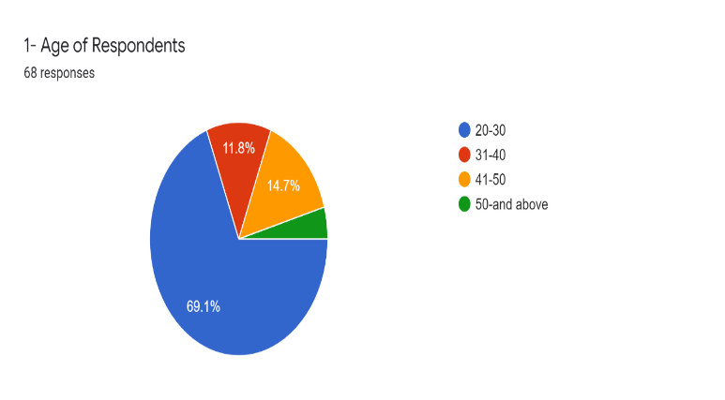
Figure 2

The above figure shows the age of respondents. The highest percentage is 69.1 which belongs to the age group of 20-30 years
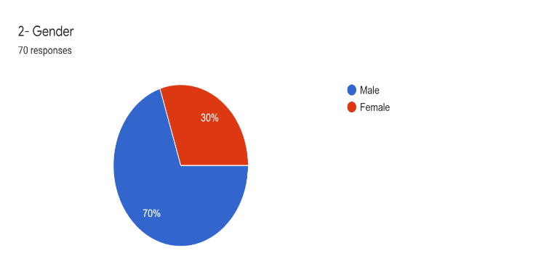
Figure 3
The above figure shows there are 70% male and 30% female respondents
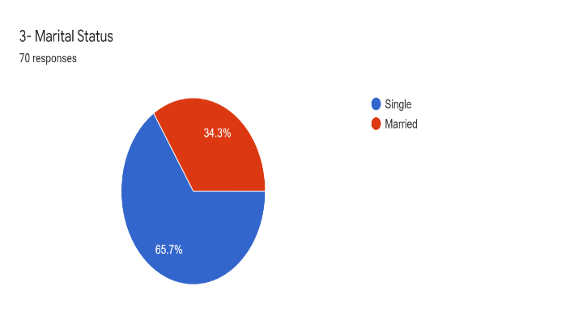
Figure 4
The above figure shows 65.7% are single and 34.3% are married respondents
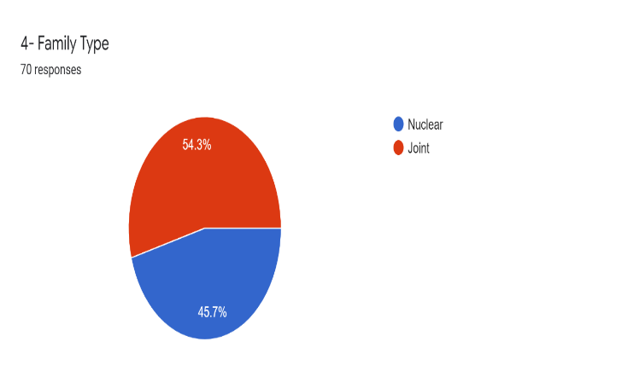
Figure 5
The above figure shows 54.3% are joint and 45.7% are nuclear family

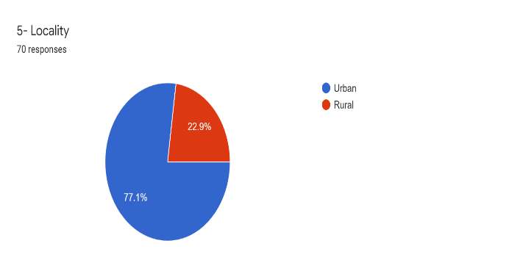
Figure 6
The above figure shows 77.1% are urban and 22.9% are rural
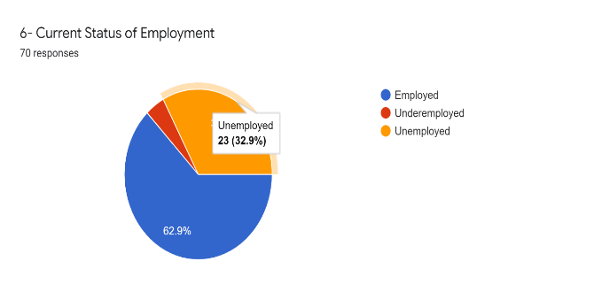
Figure 7
The above figure current status of employment. Under the survey unemployed were 32% and those employed were mainly related with non-technical field
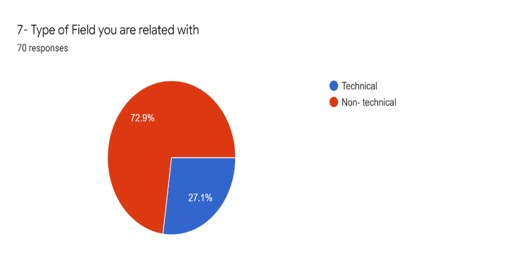
Figure 8
The above figure shows type of field. There are 72.9% are non-technical and 27.1% are related to technical field. .

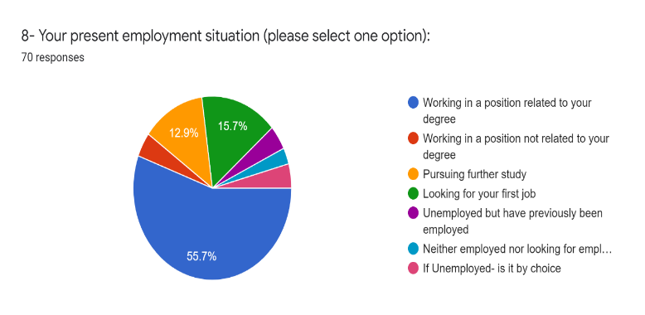
Figure 9
The above figure shows present employment situation. From the survey it is found that the respondents had the clear choice of job field as they have chosen the right course and they got their job there. But greater portion are also of unemployed persons.
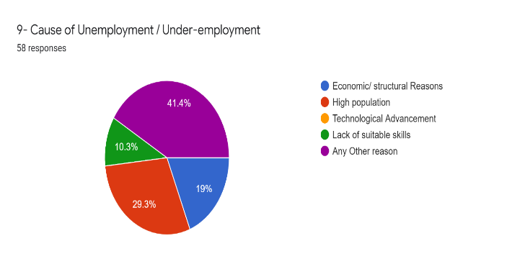
Figure 10
The above figure show cause of unemployment. With respect to unemployment major proportion don’t know the reasons for unemployment but many of them says because of many chasers and few employment availabilities there is unemployment and few says it is lack of suitable skills

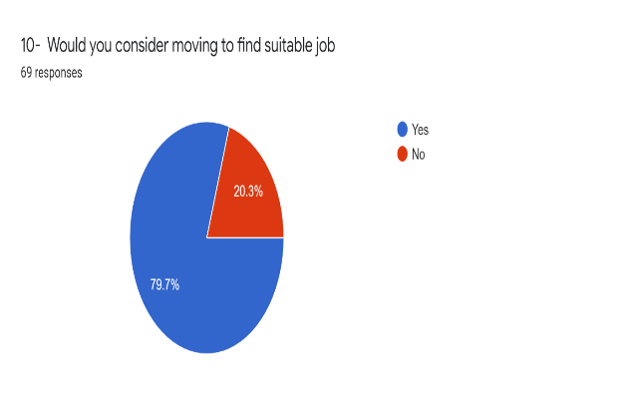
Figure 11
The above figure shows responses of moving to find suitable job. It is interesting to know under survey that majority of respondents want to change their job may be because of dissatisfaction that means they are not getting sustainably. Majority found that it is communication skill that is utmost important for job sustainability and second most Important factor is technological upgradation
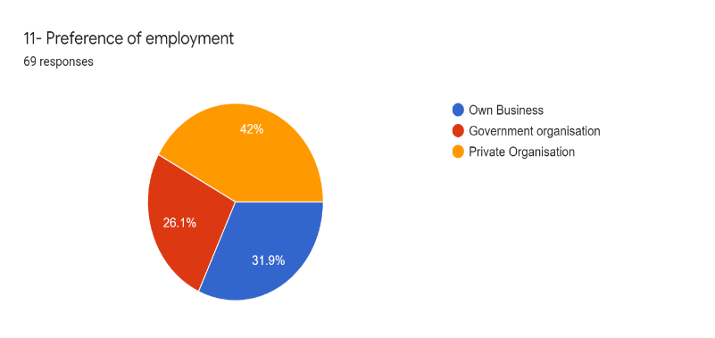
Figure 12
The above figure shows preference of employment. It was found that 42% are in private organization. 31.9% are in their own business and 26.1% are in Government organization.

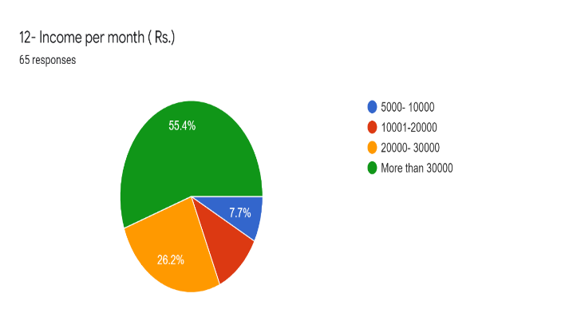
Figure 13
The above figure shows income per month in rupees. 55.4% having more than 30,000 income per month.
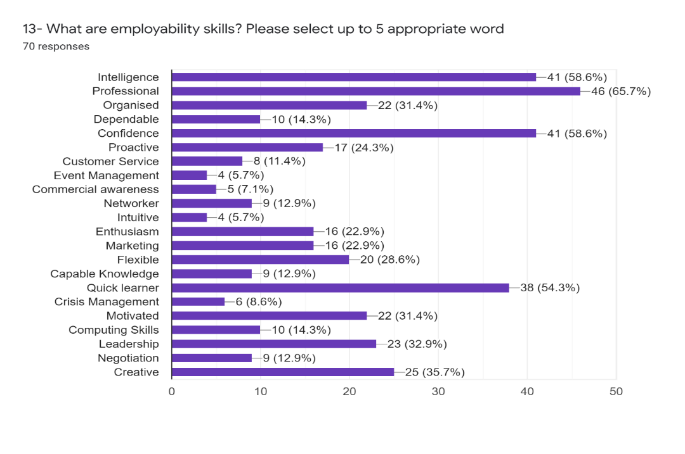
Figure 14

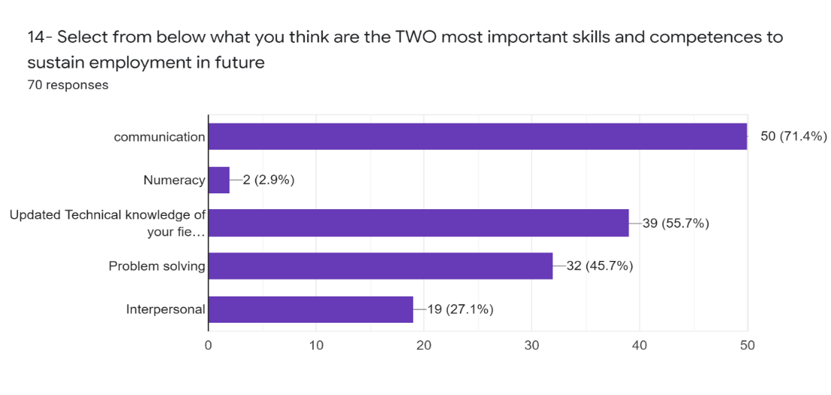
Figure 15

Conclusion
In conclusion, the research employed a Sequential Mixed Methods Research Design to gain a comprehensive understanding of the characteristics of respondents and their employment status, as well as the sustainability factors in their respective fields. The findings revealed that updated technological knowledge and communication skills are crucial skill traits for job sustainability. This approach allowed us to not only answer the "WHAT" (Quantitative) aspect of the research but also address the "HOW" (Qualitative) aspect effectively. The Sequential Mixed Methods Research Design proved valuable in providing a better insight into the scenario, offering a more holistic view of the research topic. By combining quantitative and qualitative data, this study successfully explored the intricacies of employment dynamics and sustainability factors, contributing valuable insights for policymakers and researchers alike.

References:

- Malthus T R(1970) An essay on the principle of population (1798) and A Summary view of the principle of population (1830). Flew A, e. (. (n.d.).
- AGARWAL, S. (Volume : 3 , Issue : 5 ,May 2014). Impact of India’s Population Growth on Economic Development. Indian Journal of Research.
- Bhanu Phani Krishna Koduru, A. T. (n.d.). Effect of Population Growth Rate on Economic Development in India .
- https://data.worldbank.org/indicator/SP.POP.1564.TO.ZS. (n.d.).
- Kamarudin, M. K. (Vol- 7 (2018), 123-127 ). Population Growth and Economic Development in Developing and Developed Countries . International Journal of Engineering & Technology .
- Maertens, K. B. (2007). The pattern and causes of economic growth in India. Oxford Review of Economic Policy, Volume 23, Number 2, , pp.143–167.
- Peterson, E. W. ( 2017: 1 –15 ). The Role of Population in Economic Growth. SAGE Open .

