Reinforcing the Role of English Communication Skills in Cross-Cultural Communication among Tertiary Level Students

Shalini Roy. S¹
¹Research Scholar, Department of English,
School of Social Sciences and Languages,
Vellore Institute of Technology, Vellore, India. shaliniroy.s@vit.ac.in
Dr. Gandhimathi S.N.S^{2*}
^{2*}Assistant Professor, Department of English, School of Social Sciences and Languages,
Vellore Institute of Technology, Vellore, India. gandhimathisns@vit.ac.in

ABSTRACT

Cross-cultural communication is the study and practice of verbal and non-verbal communication among students from various cultures. It enhances the understanding, conversation, and harmony. Understanding and respecting cultural differences in a globalized society is essential where students interact across borders and cultures. It also facilitates the elimination of misconceptions between two distinct cultural groups and promotes the development of students with the confidence to overcome cultural barriers and cultivate interpersonal interactions. The English language has been seen as fostering intercultural communication among students with varying language and cultural origins. Integrating language learning with creative teaching has become prevalent in English as a Second Language (ESL) classes. Including cultural awareness in a English curriculum is essential for the comprehensive development of intercultural communication proficiency. The insufficiency in English communication skills among tertiary-level students has reflected in cross-cultural communication in which they struggle to engage themselves. Therefore, it is essential to strengthen English communication skills to avoid discrepancies in cross-cultural communication. An act of accelerating communication skills in cross-cultural communication the resolution of language obstacles globally. A survey has been conducted among undergraduate students in Vellore Institute of Technology (VIT) to get insights on cross-cultural communication. A total of 111 students' responses have been obtained from the survey. The findings indicate that misconceptions about intercultural communication within social contexts occur. The current study suggests to incorporate the intercultural components like language, culture, cognition, identity, and ideology in the curriculum. Language teachers are responsible for inspiring and supporting their students to facilitate their understanding of cross-cultural communication concepts that must be addressed in language lessons.

Keywords: Cross-cultural communication, English as a second language, Language barriers, Communication Skill

I. INTRODUCTION

Culture can be discerned as the spread of social heredity from one generation to the next, incorporating the accumulation of individual experiences. It encompasses a range of behaviours that distinguish students of one society from those of another. Ali et al. (2015) clearly points out that the culture plays a significant role in shaping students' beliefs, facilitating the transmission of ideas, and fostering the dissemination of knowledge about customs and values which have been conveyed through language. Therefore, cross-cultural communication means the communication among students with many differences related to employment, age, status, ethnicity, race, gender, sexual orientation, etc. It also applies to student community and other that communicate, discuss, and mediate cultural differences through language and gestures. Cultural disputes arise because students see their own culture as superior to another. Several academic fields have shaped the field of cross-cultural communication. It is essential to proactively prevent misinterpretations that may lead to interpersonal or intergroup disputes. The practice of cross-cultural communication fosters the development of trust and facilitates cooperative efforts. Cultural critic Edward Hall (1959) has referred to intercultural communication as a new discipline in the human sciences that became a component of Communication Studies in the mid-1970s. Across international borders, people must interact and communicate with those of diverse cultures. Cross-cultural cognizance and proficiency are essential for effective communication in this context. Intercultural Communicative Competence involves the knowledge, motivation, and skills required to interact effectively and appropriately with students of different cultures (Habiňáková, 2016).
The English language, a medium of international communication, is currently mediating the cultural and cross-cultural aspects for the benefit of every student. Language teaching has integrated into artistic instruction in English as a Second Language (ESL) classroom. Specific conversation and dialogue models like greeting forms, addressing forms in reading texts demonstrate that students acquire cultural knowledge through language. The communication between the students of their own and people with diverse culture fosters the behavioural cultural influences. It has been reflected in students' own culture in their thoughts and forms of expression as well as it also gives a hand to achieve standardized and effective target language teaching and learning with the help of behavioural cultural influences (Viju, 2012). In order to minimize or reduce occurrences of cross-cultural misunderstanding, ESL students need to understand the disparities in communicative norms, a kind of knowledge that may not naturally arise (DeCapua & Dunham, 2007). Besides, acquiring knowledge of the English language, it is equally essential for ESL students to cultivate pragmatic competence. It refers to their capacity to effectively use language in a specific social context (Bardovi-Harlig, 2001).
The significance of cross-cultural communication skills has progressively seen as a fundamental characteristic of students who possess solid social aptitude rather than being perceived as a mere deviation from matters of greater importance. The predominant focus on language proficiency in cultural education has led to a recognition of the need to include a broader spectrum of cultural variances in communication in addition to language concerns. Language is a cultural phenomenon through which students share ideas, views, and experiences. The interdependence among cultural context, social behaviour, and language use is prominent for effective communication. The prime objectives are to analyze the efficacy of cross-cultural communication at an individual level within a tertiary level students' community and to investigate the misconceptions regarding intercultural communication in the educational domain. This research examines and explains the fundamental issues and misconceptions about various kinds of communication that students have encountered among tertiary-level students. Additionally, it seeks to highlight the role of English as a second language in facilitating cross-cultural communication within the social context.

II. REVIEW OF LITERATURE

Language should not be viewed solely as a means of transmitting information but as a social behaviour within specific cultural contexts (Ali et al., 2015). If students do not pay attention to the cultural context, it may have a negative impact like misunderstanding and misinterpreting. It is essential that second-language students know both the language and the culture (Emitt & Komesaroff, 2003). DeCapua (2018) has examined that ESL instructors should assist students in acquiring cross-cultural awareness and pragmatic competence, which are the capacity to use language effectively in varied social circumstances. It also includes pedagogical implications and examples of experiential learning activities that might integrate culture and cross-cultural interaction into language instruction.
The regularity of communication and social interactions is empirical support for the connection between language and culture. The geographical setting and nearby ethnic populations influence the development of language. Language is a complex and intricate system of symbolic representations that students use to effectively convey and articulate their ideas and thoughts to fellow human beings (Croucher, S. M. 2020). Language plays a vital role in discovering and comprehending the complexity of our social existence. It is used within the communication framework, it becomes linked with the social context in which it is positioned (Rabiah, 2018). It exists a widely held belief that a natural connection between the language used by an individual from a certain social group and their corresponding social identity. The prevalence of accomplishment recognition within a broader societal context has increased whereas numerous hazards and obstacles exist in the field of social communications.
Marquardt (1966) argues that effective communication with various groups is attained through understanding their values, interests, and expectations. Based on the assertion, this specific methodology catalyzes student motivation, augmenting their writing proficiencies and practises while cultivating a heightened awareness of cultural plurality. Irving's (1984) examines the significance of cross-cultural awareness and communication skills in the context of ESL teachers and students within a multicultural setting. The proposition argues that cultural disbelief has the potential to serve as a constructive educational encounter, fostering self-awareness and facilitating individual development. The study highlights the distinction between oral expression and effective interpersonal exchange in a second language and the need to instruct communicative competencies within the relevant cultural framework.
C., L., & Thakkar, B. (2012) suggest adopting an alternative perspective on the behavioural capabilities of the concept of language contexts to guarantee the effectiveness of social interactions. Hu (2014) examines cross-cultural communication and the development of students with the language skills to engage with persons from diverse cultural backgrounds. The inclusion of second language teaching has to be seen as an essential element within the broader objective of global education that aims to bridge cultural divides. The review of English as a second language has the potential to sustain misconceptions within the realm of cultural exchange.
III. METHODOLOGY

The current study has used a qualitative approach. The researcher has administered the questionnaire to the target audience using Google forms and it contains 10 questions. The questions are related to misconstructions and cross -cultural communication in universities. The researcher has shared the link of the questionnaire through WhatsApp and several social media streams to the students from Vellore Institute of technology (VIT). As a result of the survey 111 responses have been received from the respondents. The researcher has also used a statistical approach that integrates a linear scale to analyze the data received.

IV. DISCUSSION

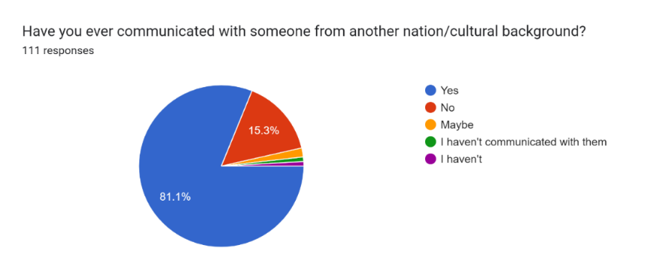
The results are highlighted in the graphs and charts provided in this section. The respective analysis follows each set of data. The researcher has undertaken a survey through questionnaire among the tertiary level students in VIT to grasp the misconceptions involved in cross-cultural communication. It includes a series of multiple-choice questions combined with close-ended questions. Finally, sufficient responses are obtained for the research.
Figure 1: Communication level among cultural backgrounds

The pie chart shows a positive response from the majority of the participants to the questions. A considerable proportion of respondents, precisely 81.1%, indicated their involvement in intercultural communication with students from diverse cultural backgrounds. The remaining 15.3% of students lack familiarity with this particular mode of communication. Culture is recognized as one of the contemporary business activities with complex and demanding aspects. students with a comprehensive understanding and genuine appreciation for diverse cultures are more inclined to participate in proficient social communication.
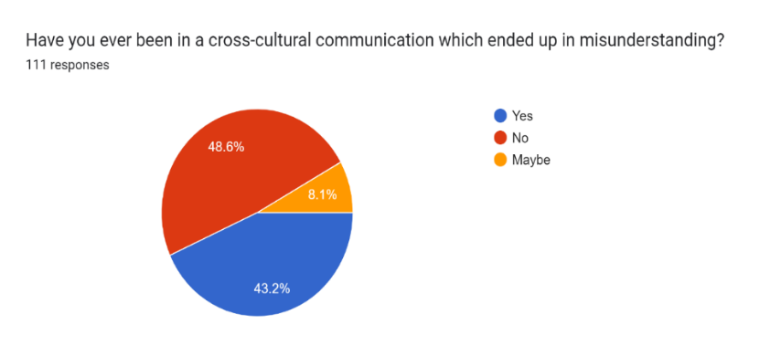

Figure 2: Misunderstanding through cross-cultural communication.

The received responses to this question are identical with others. Among them, 48.6% of the respondents have selected ‘No’ to the posed question, while 43.2% of the respondents have expressed an optimistic view. Apart from that, 8.1% of students have found themselves in a state of confusion. In the context of verbal communication, it is essential to acknowledge that the tone of voice plays a vital role in evaluating the messages. The statement made by the supervisor, "I noticed that you took an unusually extended break this morning," would have potentially been interpreted as criticism if it has delivered in a negative tone. The interpretation of the message will be influenced by several factors such as the tone, situational and relationship factors.
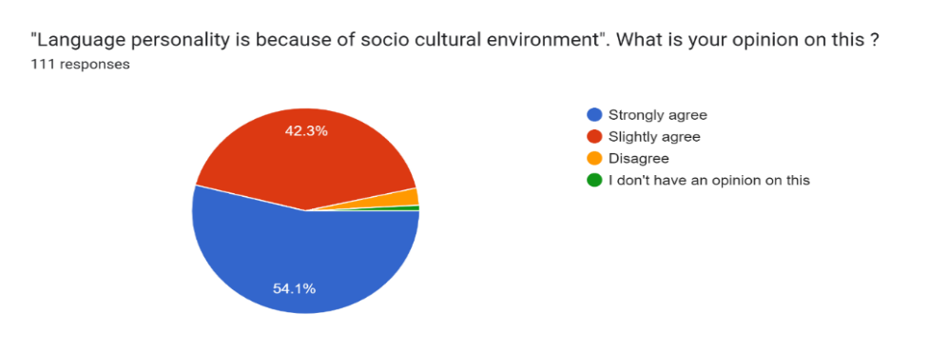

Figure 3: Impact of language Personality

The pie chart illustrates that 42.3% of students strongly agree that sociocultural factors influence language personality. Language can serve as a medium to transmit the culture. It encompasses the entirety of cultural knowledge expressed orally and in writing. Nevertheless, culture exerts influence over and moulds language. The subsequent analysis is situated within the sociocultural discourse analysis framework to emphasize language's role as a cultural and psychological instrument for achieving goals. It has been demonstrated that the speakers construct the foundational aspects of their language. Based on the research results, adopting a new perspective on the heuristic possibilities of language personality can ensure the efficacy of cross-cultural communications.
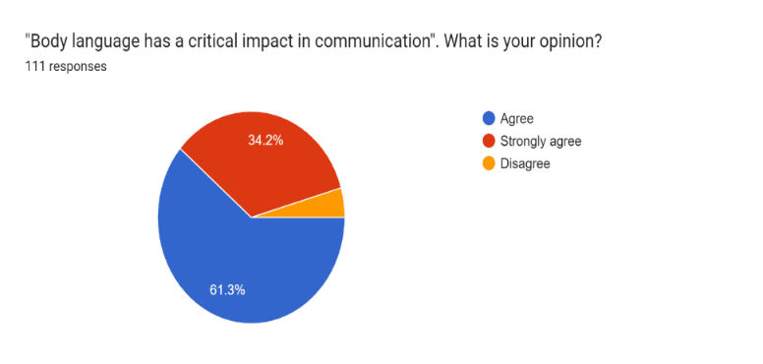

Figure 4: Body language in communication

The figure (4) indicates that 61.3% of respondents agree with "Body language has a significant impact on communication," while 34.2% disagree with that. It also highlights that there is a non-verbal means of communication in which it has the ability to use essential words to describe oneself. Generally, communication is discerned as a human-to-human phenomenon which is contrary to a language phenomenon. The movement or posture is either conscious or unconscious. students are capable of expressing their thoughts by their body movements.
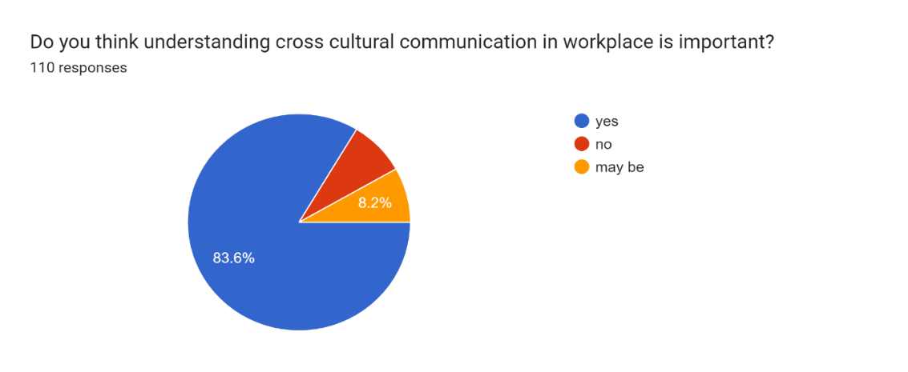
Figure 5: Importance of cross-cultural communication in the workplace

The pie chart given above indicates that 83.6% of responses have explicably highlighted that Cross - cultural communication plays a key role in the workplace. Cultural diversity holds considerable importance within the context of remote work. Effective social communication is a focal point in various business interactions which has no regard whether it is offline or online. Employees who can communicate across diverse cultures tend to experience greater ease in collaborating with colleagues in different countries or with distinct cultural backgrounds, linguistic expressions, and communication preferences. Consequently, insufficient communication can get contrasting outcomes. It is noted that lack of clarity in intercultural communication may give rise to heightened conflicts and misunderstandings.

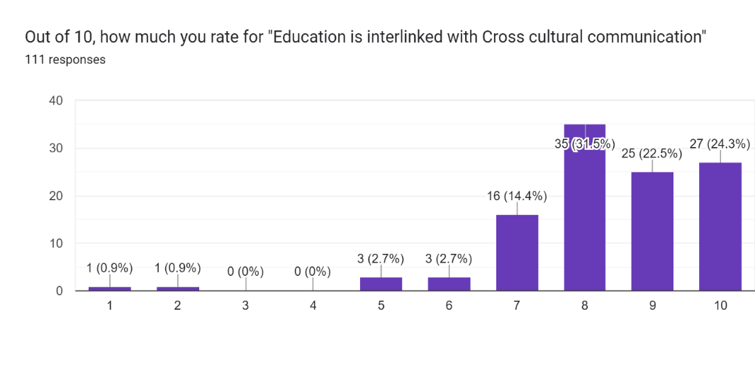

Figure 6: Rating scale of cross-cultural communication in education

The researcher has used linear scale ranging from 1 to 10. The bar graph shows that a total number of 35 respondents provided a rating of 8 out of 10. Moreover, it is significant that 27 respondents selected the full-scale rating of 10 out of 10. The cross-cultural learning process can develop students' comprehension of their own culture and other cultures. This kind of learning enables students to learn about the norms, values, and behaviours that are prevalent in various cultural contexts. Moreover, it allows the students to comprehend and effectively convey cultural distinctions with dedication and assurance. Subsequently due to the influence of societal education, academic publications are sometimes more adapted to their evolving cultural environment.
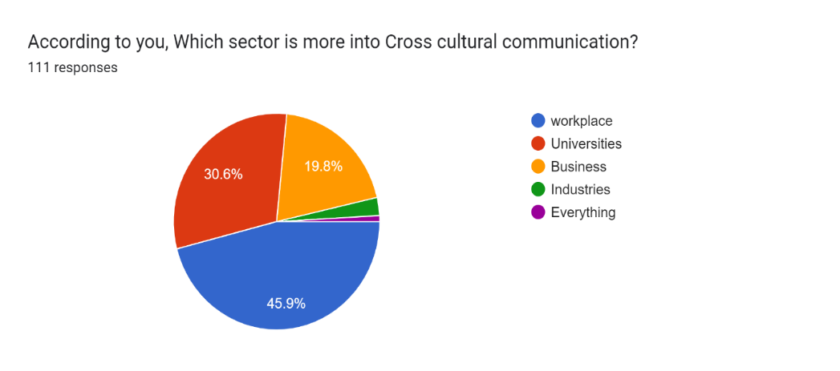
Figure 7: Sectors in cross-cultural communication

It is explicit from the chart that the respondent’s opine that the workplace exhibits a greater inclination towards engaging in intercultural communication. According to the poll results, universities rank second with a percentage of 19.8%, while businesses and industries have positioned after the workplace and universities. Cross-cultural communication in the workplace pertains to the comprehension and appreciation of diverse corporate practices, beliefs, and communication strategies. It occurs when persons from various cultural origins interact with one another. Given the advent of the era of economic advancement, it is only logical that companies are not exclusively limited to recruiting persons within their immediate vicinity. It has been observed that there is a notable rise in the prospects of working for multinational organizations with the increasing number of employees engaged in remote work. When engaging in this practice, it is essential to consider that there exist some cultural barriers that might impact effective communication within a team. It precisely shows that there is a need for a greater understanding of societal communication since it is in these instances that its fundamental concepts come into effect.

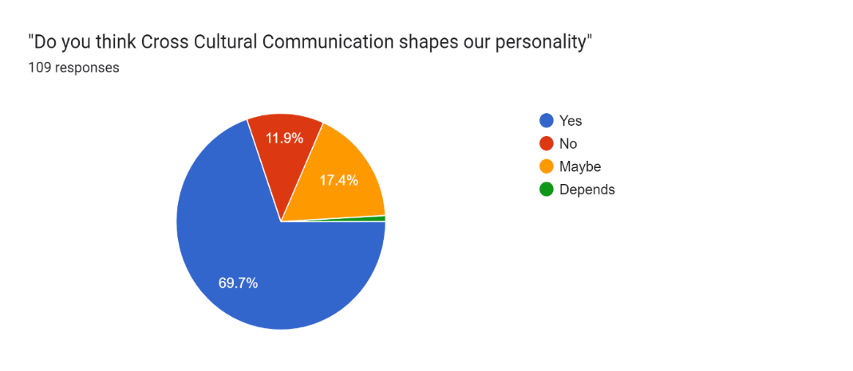
Figure 8: Impact of cross-cultural communication in personality

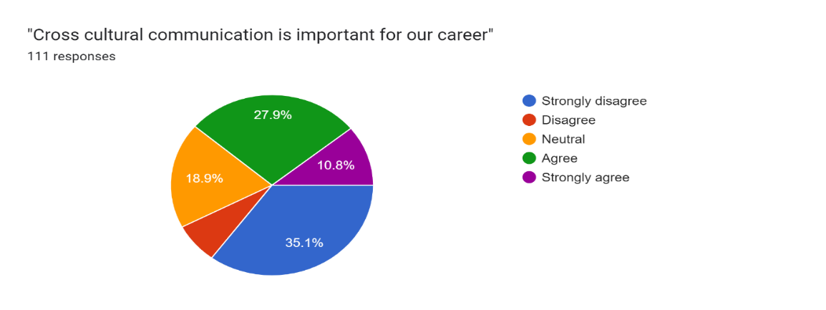
The respective figure highlights that 69.7% of the respondents have given positive responses to the questions. A discernible difference exists in average personality traits among the students residing in various countries. It indicates that the average disparities in personality traits among countries should not be conflated with students' preconceptions. While there is a consensus on the prevailing personality type in many countries, the empirical study reveals that the existed beliefs on personality traits in cross cultural communication often deviate from reality.

Figure 9: Cross-cultural communication in career

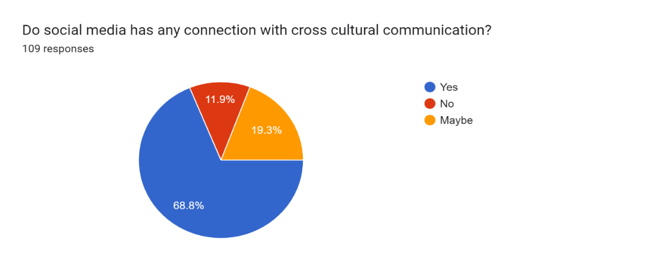
A considerable proportion of students have expressed dissenting opinions about the issue at hand, while 35% of respondents strongly disagree and 10.8% strongly agree. The remaining respondents are classified into the following groups as disagree, agree, neutral. As students’ progress in their professional trajectory, it becomes essential to cultivate and refine their interpersonal communication abilities within social contexts. This is often because several students may encounter one another and possess divergent perspectives and cultural expectations. The ability to communicate effectively across cultures will directly influence career advancement.
Figure 10: Influence of social media in cross-cultural communication

The article expresses that there has been a gradual increase in the worldwide recognition of diverse social media platforms, resulting in an escalating importance of "virtual social network platforms" within social interaction. It also declares that the researchers in psychological science and neuroscience and scholars involved in multidisciplinary investigations have been undertaken to study the motivation, underlying factors, and outcomes of communication on social media platforms across many cultural settings (Di et al., 2022). Introducing new media, particularly social media, presents both a gap and a problem in achieving effective communication. Social media platforms have been shown to increase students' communication competence, particularly in the context of international connections. Through social media, participants can effectively communicate with their friends from abroad, improve adaptability and develop strong interpersonal relationships. Social media platforms have also been viewed to strengthen students' English language skills.
Language and culture are intricately interconnected as it encompasses both lexical and linguistic factors. Language is crucial in preserving historical records, facilitating cultural knowledge exchange, and fostering cultural preservation. English is the globally recognized primary language, facilitating communication among students from many ethnicities and linguistic backgrounds. It is the reference language for all modern scientific, literary, and philosophical terms. Misunderstandings in intercultural communication decrease when students involve in communication using the English language. The learning settings within the English as a Second Language curriculum support the development of students' comprehension of languages. English language is the key in fostering effective and valuable tools for cross-cultural communication. In many social circumstances, students have the potential to enhance their personal and professional lives by overcoming communication barriers.
The interrelationship among language, business, and sociopolitical concerns is essential and enhances each other. The correlation between cross-cultural communication and professional success is significant in which it enhances one's professional responsibilities and it becomes imperative to engage actively in cross- cultural communication deliberately. students are participating in the acquisition of knowledge and skills. It enhances students' comprehension of their own and diverse cultures, enabling them to engage with students from different cultural backgrounds confidently. Culture plays a significant role in influencing and shaping language. Language plays a pivotal role in the manifestation of artistic expression.

V. CONCLUSION

Cross-cultural communication entails multiple risks and difficulties. The need to establish successful cross-cultural communication has become more significant in the context of globalization and the increasing importance of social connections. It necessitates implementing a comprehensive and diverse strategy that considers the unique characteristics of various modes of cross-cultural communication. The result proposes many suggestions for enhancing students' cross-cultural communication awareness. These ideas include integrating intercultural elements into the curriculum, using resources sourced from the target culture, and analyzing and comparing texts from diverse cultural backgrounds. The curriculum for English as a Second Language courses should include both language and cross-cultural elements to foster intercultural dynamics inside the classroom and address the potential obstacles that students may encounter. The use of intercultural communication may facilitate the integration of pupils. The presence of various cultural backgrounds might lead to misconceptions or a lack of comprehension among the students. If teachers identify and highlight the critical errors that students make, it will lead to the enhancement of the students.

REFERENCES

Ali, S., Kazemian, B., & Mahar, I. H. (2015). The importance of culture in second and foreign language learning. Dinamika Ilmu, 1–10. https://doi.org/10.21093/di.v15i1.99
Avison, D., & Banks, P. B. (2008). Cross-Cultural (mis)Communication in IS Offshoring: Understanding through Conversation Analysis. Journal of Information Technology, 23(4), 249–268. https://doi.org/10.1057/jit.2008.16
Bardovi-Harlig, K. (2001). Evaluating the empirical evidence: Grounds for instruction in pragmatics? In K. Rose & G. Kasper (Eds.), Pragmatics in language teaching (pp. 13–32). Cambridge, England: Cambridge University Press.
Barnett, G. A., Ke, J., & Chen, L. (2017). 5. Issues in intercultural communication: A semantic network analysis. In De Gruyter eBooks (pp. 99–118). https://doi.org/10.1515/9781501500060-005
Davidovitch, N., & Khyzhniak, K. (2018). Language Personality in the conditions of Cross-Cultural Communication: Case-Study experience. International Education Studies, 11(2), 13. https://doi.org/10.5539/ies.v11n2p13
DeCapua, A., & Dunham, J. F. (2007). The pragmatics of advice giving: Cross-cultural perspectives. Intercultural Pragmatics, 4, 319–42.
DeCapua, A. (2018). Cross-Cultural Communication in the English as a Second Language (ESL) classroom. The TESOL Encyclopedia of English Language Teaching, 1–7. https://doi.org/10.1002/9781118784235.eelt0287
Discuss the role of language in culture - Academia.edu, https://www.academia.edu/94226638/Discuss_the_role_of_language_in_culture.
Di, Y., Liu, X., Li, J., & Han, L. (2022). Cross-Cultural Communication on social media: Review from the perspective of Cultural Psychology and Neuroscience. Frontiers in Psychology, 13. https://doi.org/10.3389/fpsyg.2022.858900
Emmett, M., Pollock, J., & Komesaroff, L. (2003). Doing Things with Language. In Language and Learning: An Introduction for Teaching (pp. 21-47). Melbourne: Oxford University Press.
Fillmore, L. W. (1989). Language Learning in Social Context. The View from Research in Second Language Learning. In North-Holland linguistic series (pp. 277–302). https://doi.org/10.1016/b978-0-444-87144-2.50014-8
Habiňáková, E. (2016). Foreign Language Teaching with Integration of Cultural Content. Mediterranean Journal of Social Sciences. https://doi.org/10.5901/mjss.2016.v7n1s1p299
Hu, S. (2014). Cross-cultural communication and foreign language teaching. Advances in Social Science, Education and Humanities Research. https://doi.org/10.2991/icetss-14.2014.54
Irving, K. J. (1984). Cross‐cultural awareness and the English‐as‐a‐second‐language classroom. Theory Into Practice, 23(2), 138–143. https://doi.org/10.1080/00405848409543104
Jiang, Y., & Wang, J. (2018). A Study of Cultural Empathy in Foreign Language Teaching from the Perspective of Cross-cultural Communication. Theory and Practice in Language Studies, 8(12), 1664. https://doi.org/10.17507/tpls.0812.12
Marquardt, W. F. (1966). Composition in English as a second language: cross cultural communication. College Composition and Communication, 17(1), 29. https://doi.org/10.2307/354056
Rabiah, S. (2018). Language as a Tool for Communication and Cultural Reality Discloser. Lamdj, Enllukdejtdnk Jkm Euctura. https://doi.org/10.31227/osf.io/nw94m
Viju, M. K. (2012). The Study on Cross-Cultural Communication of English as Foreign Language. Paripex Indian Journal of Research, 3(7), 215–216. https://doi.org/10.15373/22501991/july2014/81

