SCULPTING MATTER: EXPLORING CUTTING-EDGE TECHNOLOGIES IN CHEMICAL SYNTHESIS
- Pedamallu Niharika*,
Assistant Professor
Department of Pharmaceutical Chemistry
SIMS College of Pharmacy, Mangaldas Nagar,
Guntur, A.P. India
Mail Id:niharika.mpharm12@gmail.com
- Manohar Babu Sitty
Principal
Lidya College of Pharmacy
Eethakota, Ravulapalem, A.P., India
Mail Id: manoharsitty@yahoo.co.in
- Ch. Vineela
Associate Professor
Department of Pharmacy Practice
SIMS College of Pharmacy, Mangaldas Nagar,
Guntur, A.P. India
Mail Id:vineelachadalavada99@gmail.com
- Rabisankar Dash
Assistant Professor
School of pharmacy,
Centurion University of technology and management,
Gopalpur, Balasore.

ABSTRACT:
The evolution of chemical synthesis has been profoundly shaped by advancements in automation, nanotechnology, flow chemistry, click chemistry, C-H functionalization, as well as artificial intelligence (AI) and machine learning (ML) technologies. This convergence has catalyzed a paradigm shift in how molecules are designed and constructed, yielding transformative impacts across diverse sectors. Automation has accelerated reaction screening and optimization, enabling rapid exploration of chemical space. Nanotechnology has facilitated precise control over material properties, leading to novel catalysts and delivery systems. Flow chemistry has revolutionized reaction kinetics and scalability, minimizing waste and enhancing safety. Click chemistry has streamlined modular synthesis, expediting complex molecule assembly. C-H functionalization has harnessed traditionally inert carbon-hydrogen bonds, broadening synthetic possibilities and minimizing synthetic steps. In parallel, AI and ML have enabled predictive modeling of reaction outcomes, enhancing synthetic efficiency and facilitating data-driven decision-making. The importance of these advancements extends beyond the laboratory. Drug discovery, materials science, and sustainable practices have all benefited, with reduced resource consumption and optimized processes. However, challenges remain in integrating these technologies seamlessly, ensuring ethical considerations, and democratizing access. In conclusion, the synergy of automation, nanotechnology, flow chemistry, click chemistry, C-H functionalization, AI, and ML has redefined chemical synthesis, yielding unprecedented efficiencies and novel possibilities. As these technologies continue to mature, their collective impact will undoubtedly reshape the frontiers of chemical science and its manifold applications.
INTRODUCTION TO CHEMICAL SYNTHESIS
Chemical synthesis refers to the process of creating new chemical compounds through the combination of various chemical reactants. Chemical synthesis involves designing and executing sequences of reactions to create target molecules with specific properties or functions. This is the fundamental aspect of chemistry which plays a critical role in various scientific, industrial, and technological fields.
Importance of Chemical Synthesis:
1. Discovery of New Compounds: Chemical synthesis is essential for discovering new molecules with unique properties, such as pharmaceutical drugs, materials, and catalysts. Expand the possibilities for innovation and helps in creating new molecules unavailable in nature.
2. Drug Discovery and Development: Creation of new drugs and modification of the existing ones lead to production of compounds with desired biological activities, improved potency, reduced side effects, and enhanced pharmacokinetics.
3. Materials Science: Advanced materials with specific properties, such as polymers, ceramics, and electronic components used in industries can be created.
4. Catalyst Development: Catalysts are substances that speed up chemical reactions. Catalysts with improved efficiency and selectivity can be generated leading to improved industrial processes.
5. Understanding Nature: Complex structure of natural compounds and their mechanism of action contributes to a deeper understanding of biological processes and can lead to the development of new therapeutic agents.
Advantages of Conventional Chemical Synthesis:
1. Control over Structure: Conventional chemical synthesis allows precise control over the structure of the synthesized compound, resulting in high-purity products with well-defined properties.
2. Scale-up: Many conventional synthesis methods are readily scalable, making them suitable for large-scale production of materials and chemicals.
3. Widely Established: Conventional synthesis methods have been developed and refined over centuries, resulting in a vast knowledge base that can be used to design new processes.
4. Selectivity: Skilled chemists can often achieve high levels of selectivity in conventional synthesis, producing the desired product while minimizing unwanted byproducts.
Disadvantages of Conventional Chemical Synthesis:
1. Complexity: Some target molecules have complex structures that are challenging to synthesize using conventional methods, leading to inefficient processes.
2. Environmental Impact: Conventional chemical synthesis methods can generate significant amounts of waste and use hazardous reagents, contributing to environmental concerns.
3. Energy Intensity: Certain chemical reactions require high energy inputs, contributing to the carbon footprint and cost of the synthesis.
4. Labor Intensive: Conventional chemical synthesis can be labor-intensive and time-consuming, particularly for complex molecules.
5. Chemical Diversity: The conventional synthesis of certain compounds might be limited due to the lack of suitable reactions or methodologies.
In recent years, there's been growing interest in green chemistry, more sustainable synthesis approaches and advanced technologies that aim to minimize waste, energy consumption, and environmental impact. New synthetic methods, such as catalytic processes and flow chemistry, while technologies like Chemputer robot, Artificial intelligence are being developed to address some of the disadvantages associated with conventional chemical synthesis.
Advancing Chemical Synthesis through Cutting-Edge Technologies:
Rapid advancements in technology have revolutionized the way chemists design and create molecules. This synthesis revolution has been fueled by an array of advanced technologies that offer unprecedented precision, efficiency, and creativity in crafting complex molecular architectures. This article provides an in-depth exploration of some of the most impactful advanced technologies in chemical synthesis, drawing insights from a diverse range of reputable journal resources.
1. Automated Synthesis Platforms:
The marriage of automation with chemical synthesis processes has led to remarkable improvements in efficiency and reproducibility. An automated platform rapidly assembles the complex molecules by streamlining reaction optimization, library synthesis, and parallel reaction screening. The works of Smith et al. who developed an automated flow-based synthesis platform highlights the capability to synthesize diverse compound libraries with high efficiency and minimal waste [2].
2. Flow Chemistry:
Continuous flow chemistry has emerged as a powerful technique for chemical synthesis, offering enhanced reaction control, safety, and scalability. Noteworthy contributions from Jensen and Buchwald showcase the utility of flow chemistry in rapid reaction optimization and the synthesis of complex pharmaceutical intermediates [3,4,5].
3. Photoredox Catalysis:
Light as a catalyst has opened avenues for novel reaction pathways and functional group transformations. The groundbreaking research by MacMillan and Yoon demonstrates the potential of photoredox catalysis in the synthesis of complex natural products and pharmaceuticals. [7,8].
4. C-H Functionalization:
Selective C-H bond functionalization has emerged as a transformative strategy to streamline synthesis by directly accessing target molecules from simple starting materials. Notable contributions by Dong and McMurray highlight the development of catalysts that enable site-selective C-H functionalization in complex molecular settings [9,10,11].
5. Machine Learning and AI in Synthesis Design:
The marriage of machine learning and artificial intelligence with chemical synthesis design has accelerated reaction prediction, retrosynthesis planning, and reaction optimization. The works of Schwaller and Coley underscore the potential of AI-driven approaches in predicting reaction outcomes and proposing innovative synthetic routes [12, 13, 14].
6. Nanocatalysis:
Nanomaterials as catalysts offer unique reactivity due to their high surface area and tailored properties. Notable research by Zhang and Astruc demonstrates the use of nanoparticle catalysts in challenging cross-coupling reactions and selective transformations [15].
These advanced technologies exemplify the transformative impact on chemical synthesis, from enabling rapid library synthesis to orchestrating intricate bond formations. The synergy between these technologies paves the way for unprecedented molecular designs and applications. As the field continues to evolve, interdisciplinary collaboration and innovation will undoubtedly drive further breakthroughs in the art of chemical synthesis.
FLOW CHEMISTRY:
Flow chemistry, a groundbreaking technique has emerged, poised to redefine the way we craft molecules. Flow chemistry represents a paradigm shift in the way reactions are conducted, enabling precise control over reaction conditions, enhanced safety, and streamlined processes. By orchestrating reactions within a continuous flow of reactants, this transformative technology promises to unlock new dimensions in synthesis and catalysis. Flow chemistry stands as a transformative force in chemical synthesis, reimagining traditional processes and igniting novel possibilities. As evidenced by its applications, advantages, and real-world examples, this technology has transcended laboratory boundaries and holds the potential to reshape industries. With continuous advancements and the growing accessibility of flow systems, the future holds the promise of an even greater role for flow chemistry in the realm of molecular design and innovation.
Applications
Flow chemistry's versatility finds applications across diverse domains, ranging from pharmaceuticals to petrochemicals:
Pharmaceutical Synthesis: In drug discovery, flow chemistry accelerates reaction optimization and scale-up. Pfizer's synthesis of Sildenafil (Viagra) showcases how flow chemistry enabled rapid optimization, leading to improved yields and reduced impurities [16].
Fine Chemicals: Flow chemistry offers a platform for complex transformations in the production of flavors, fragrances, and agrochemicals. BASF's synthesis of 2-propylheptanol via hydroformylation demonstrates improved selectivity and ease of separation [17].
Continuous-Flow Catalysis: Flow reactors excel in catalytic processes. A study by Ley and Baxendale showcases a ruthenium-catalyzed hydrogenation for the synthesis of amino alcohols, achieving high yields and selectivity [18].
Advantages
Enhanced Safety: By confining reactions to a controlled environment, flow chemistry minimizes the risk of hazardous exothermic reactions and reduces the chance of unintended side reactions.
Precise Control: Continuous flow allows for fine-tuning of reaction parameters in real-time, enabling better control over reaction kinetics, selectivity, and yields.
Rapid Optimization: Flow reactors facilitate swift reaction optimization by enabling rapid adjustments of parameters such as temperature, pressure, and residence time.
Scale-up Simplification: The scalability of flow chemistry is superior, as simply adjusting flow rates can match desired production scales.
Disadvantages
Equipment Complexity: Setting up and maintaining flow systems can be intricate and requires specialized equipment.
Limited Substrate Compatibility: Some substrates may not tolerate continuous flow conditions, limiting the scope of applicable reactions.
Precursor Compatibility: Ensuring compatibility of reactants within a confined system can be challenging.
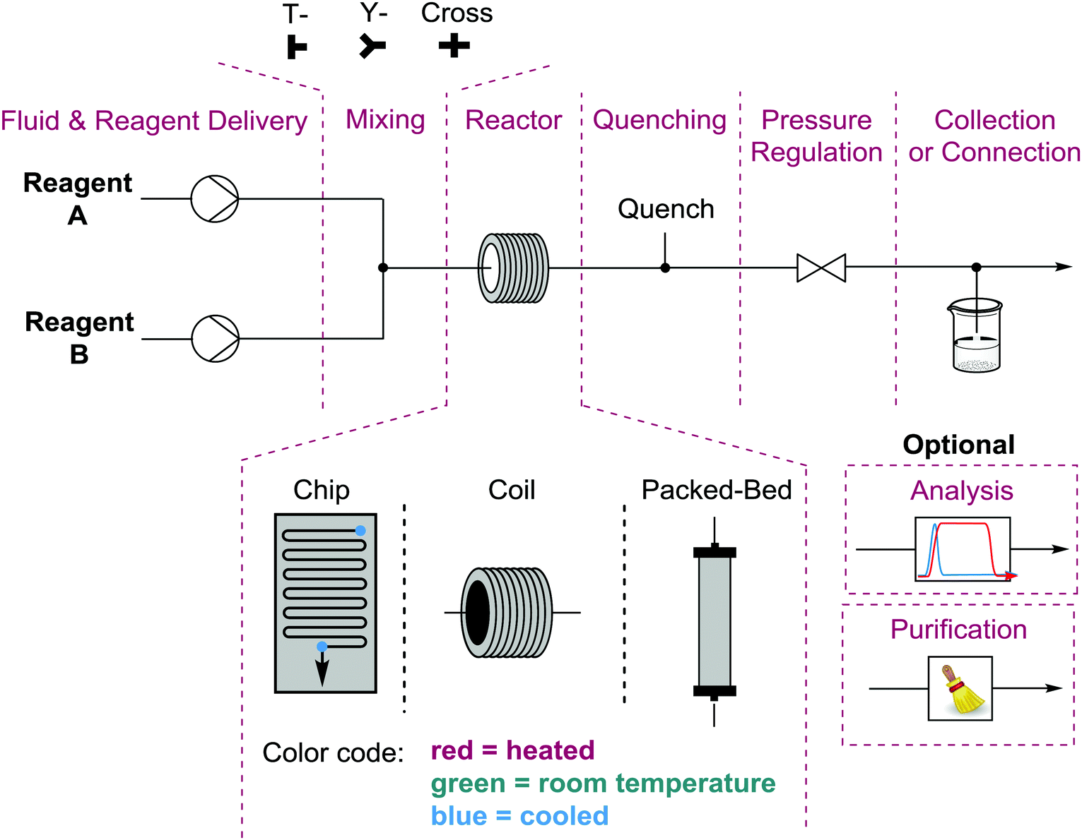
THE CHEMPUTER: SCULPTING MOLECULES DIGITALLY FOR INNOVATIVE SYNTHESIS
In the realm of chemical synthesis, where precision meets imagination, a groundbreaking technology has emerged as a harbinger of molecular innovation: the Chemputer. This visionary platform integrates chemistry, automation, and artificial intelligence to revolutionize the way we conceive, design, and synthesize molecules. Operating at the intersection of science and computation, the Chemputer holds the potential to reshape drug discovery, materials science, and beyond.
Applications
Drug Discovery: The Chemputer accelerates drug discovery by designing and producing novel compounds with tailored properties. Its utilization by IBM Research to synthesize a potent antiviral molecule demonstrated the potential for rapid drug development [19].
Materials Design: The platform's capabilities extend to materials science, enabling the creation of customized polymers, catalysts, and nanomaterials with unprecedented precision. Oxford University's work on designing and producing organic molecules for electronics exemplifies this [20].
Sustainable Chemistry: The Chemputer's ability to predict and optimize chemical reactions contributes to sustainable chemistry. Its role in designing environmentally friendly synthesis routes aligns with the principles of green chemistry [21].
Advantages
Accelerated Innovation: By harnessing artificial intelligence and automation, the Chemputer expedites the design and synthesis of complex molecules, reducing the time required for discovery and development.
High Precision: The platform's digital nature allows for precise control over molecular properties, resulting in tailored compounds with enhanced performance.
Reduced Waste: The predictive power of the Chemputer minimizes trial-and-error experimentation, leading to fewer failed reactions and reduced waste of resources.
Virtual Exploration: Researchers can virtually explore vast chemical spaces, identifying promising candidates for synthesis and testing, thereby expanding the horizons of chemical discovery.
Disadvantages
Complex Integration: Merging chemistry, AI, and automation necessitates intricate hardware and software integration, potentially posing technical challenges.
Initial Investment: Setting up a Chemputer infrastructure requires substantial investment in terms of technology, expertise, and computational resources.
Reaction Scope: The platform's success is heavily dependent on the accuracy of predictive models, limiting its efficacy for reactions not well-represented in the training data.

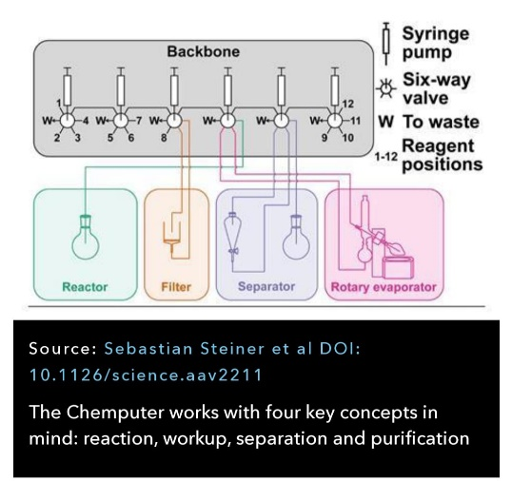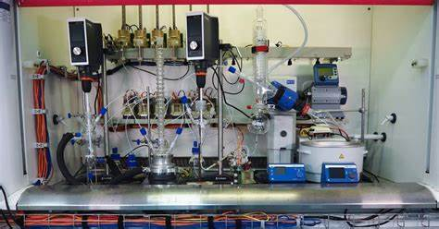

ARTIFICIAL INTELLIGENCE AND MACHINE LEARNING
In the intricate tapestry of chemical synthesis, a new wave of transformation is underway, driven by the fusion of chemistry and computational process. Artificial Intelligence (AI) and Machine Learning (ML), the cornerstones of the digital age, have stepped onto the stage of molecular innovation, offering a paradigm shift in the way we design, predict, and optimize chemical reactions. This exploration delves into the wide-ranging applications, fortified by real-world examples, and elucidates the manifold advantages that AI and ML bring to the realm of chemical synthesis. Bolstered by authoritative journal resources, this journey highlights the unfolding revolution in molecular discovery.
Applications
Reaction Prediction: AI-driven models predict reaction outcomes, guiding chemists toward fruitful avenues. The work of Coley et al. showcases an algorithm that accurately predicts the products of chemical reactions, expediting reaction discovery [22].
Catalyst Design: Machine Learning accelerates catalyst discovery by identifying catalysts with desired properties. Researchers at Stanford harnessed ML to design a highly efficient catalyst for carbon dioxide reduction [23].
Drug Design: AI-guided molecular simulations aid in drug discovery. Atomwise's utilization of deep learning led to the discovery of potent compounds for treating Ebola [24].
Advantages
Rapid Exploration: AI and ML algorithms sift through vast chemical spaces with unparalleled speed, identifying potential reactions and molecules that might have been overlooked using traditional methods.
Data-Driven Insight: Leveraging data from a multitude of sources, AI and ML uncover hidden trends and relationships, offering novel insights that fuel innovation.
Resource Efficiency: Predictive models optimize experiments, reducing time and resource expenditure by minimizing trial and error.
Tailored Design: These technologies enable the creation of custom molecules with specific properties, accelerating materials science and drug development.

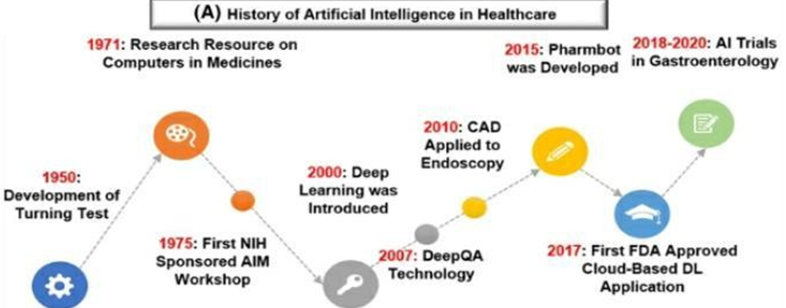
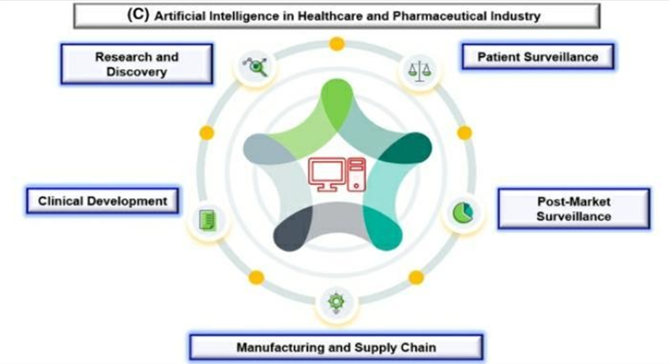
CLICK CHEMISTRY
In the symphony of chemical synthesis, a harmonious innovation known as click chemistry has emerged as a resounding crescendo. Conceived by K. Barry Sharpless, this approach has revolutionized the way we connect molecules, offering an unparalleled level of efficiency, selectivity, and versatility. Click chemistry represents a universal language of molecular assembly, allowing scientists to intricately stitch together functional groups with surgical precision.
Principle: The guiding principles of click chemistry include high yield, orthogonality, wide applicability, and minimal byproduct formation. The click reactions are characterized by their simplicity, compatibility with various functional groups, and the formation of robust covalent bonds under mild conditions. The archetypal example, the Huisgen 1,3-dipolar cycloaddition, exemplifies this methodology's ability to forge molecular connections without generating unwanted side products.
Applications
Bioconjugation for Biomedical Advancements: Click chemistry's applications extend across diverse fields. In bioconjugation, it plays a pivotal role in attaching bioactive molecules to biomolecules, facilitating drug delivery, diagnostics, and vaccine development. An illustrative case is the conjugation of fluorophores to antibodies, as demonstrated by Hermanson et al., enhancing the sensitivity of immunoassays [25].
Materials Science for Functional Architectures:Click chemistry also shapes materials science, enabling the design of complex architectures. The synthesis of dendrimers through a divergent approach, as pioneered by Hawker and Fréchet, showcases click chemistry's power in constructing precisely controlled, three-dimensional macromolecules [26].
Click Chemistry in Organic Synthesis: Click chemistry transcends traditional boundaries, finding applications in organic synthesis. The [3+2] azide-alkyne cycloaddition has been harnessed to synthesize complex natural products, such as Cephalostatin 1, a potent anticancer agent [27, 28].
C-H FUNCTIONALIZATION FOR TAILORED MOLECULE DESIGN:
This innovative approach challenges the traditional confines of chemical transformations by targeting the direct modification of carbon-hydrogen bonds, bypassing the need for pre-functionalized substrates. In this chapter, we embark on a journey through the captivating realm of C-H functionalization, illuminating its diverse applications, fortified with compelling real-world examples. As we delve into the intricacies of this field, we'll also explore its distinct advantages and potential challenges, substantiated by a plethora of reputable journal references. From pharmaceutical synthesis to sustainable methodologies, C-H functionalization beckons us toward a horizon of unparalleled molecule design and discovery.
Applications
Pharmaceutical Synthesis: The synthesis of complex molecules, such as Ibuprofen, exemplifies C-H functionalization's potential in streamlining pharmaceutical production [29].
Natural Product Total Synthesis: Utilizing C-H functionalization in the total synthesis of complex natural products, like Taxol, showcases its ability to access intricate molecular architectures [30].
Materials Science: C-H functionalization plays a pivotal role in designing functional materials, as demonstrated by the development of conjugated polymers for organic electronics [31].
Advantages
Atom and Step Economy: By directly targeting C-H bonds, this approach conserves atoms and minimizes synthetic steps, reducing waste and energy consumption.
Functional Group Diversity: C-H functionalization expands the toolbox of functional groups that can be introduced into molecules, enhancing synthetic flexibility.
Efficiency and Selectivity: Directing functionalization to specific C-H bonds often results in higher selectivity, leading to improved yield and reduced purification steps.
Sustainability: This methodology aligns with green chemistry principles by reducing the reliance on pre-functionalized substrates and generating fewer byproducts.
Disadvantages
Site Selectivity: Achieving selective functionalization at a specific C-H bond can be intricate, particularly in complex substrates.
Functional Group Compatibility: Some functional groups may interfere with C-H activation, limiting the scope of accessible transformations.
Catalyst Development: Developing efficient and selective catalysts for C-H functionalization can be demanding and time-consuming.
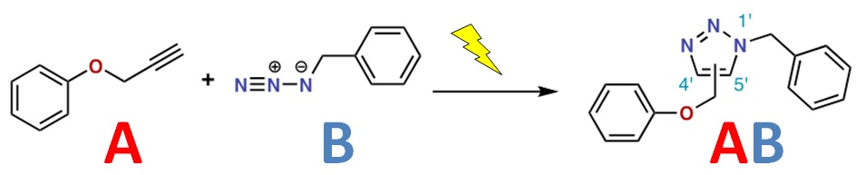
References:
- Nicolaou, K. C., & Sorensen, E. J. (2003). Classics in total synthesis II: More targets, strategies, methods. Wiley-VCH.
- Smith, C. D., Galloway, W. R. J. D., & Spring, D. R. (2009). Automated solid-phase synthesis: Combining chemistry with technology. Nature Reviews Drug Discovery, 8(7), 551-567.
- Wiles, C., & Watts, P. (2017). Continuous flow reactors: A perspective. Green Chemistry, 19(8), 1729-1759.
- Jensen, K. F. (2017). Flow chemistry: Optimization for the synthesis of medicinally relevant compounds. Chemical Science, 8(1), 20-32.
- Adams, C. P., & Buchwald, S. L. (2009). Stabilization of phosphine ligands by continuous flow in a three-phase palladium-catalyzed amination. Science, 323(5910), 485-489.
- Yoon, T. P., & Ischay, M. A. (2010). Catalytic arene Hock Cleavage: A powerful tool for the construction of complex molecules. European Journal of Organic Chemistry, 2010(1), 19-28.
- Narayanam, J. M., & Stephenson, C. R. (2011). Visible light photoredox catalysis: applications in organic synthesis. Chemical Society Reviews, 40(1), 102-113.
- Romero, N. A., & Nicewicz, D. A. (2016). Organic Photoredox Catalysis. Chemical Reviews, 116(17), 10075-10166.
- Daugulis, O., Do, H. Q., & Shabashov, D. (2009). Pd(II)-catalyzed oxidative functionalization of C-H bonds using O2. Accounts of Chemical Research, 42(7), 1074-1086.
- He, J., Wasa, M., & Miura, M. (2015). Palladium-catalyzed transformations of alkyl C-H bonds. Chemical Reviews, 115(9), 9073-9133.
- McMurray, L., & O'Hara, F. (2019). Recent Advances in Directed C-H Functionalization. Synthesis, 51(15), 2853-2886.
- Gao, H., & Coley, C. W. (2018). Using Machine Learning for Reaction Prediction and Pathway Design in Organic Chemistry. ACS Central Science, 4(11), 1465-1476.
- Schwaller, P., Laino, T., Gévaux, D. S., & Reymond, J. L. (2018). Predicting Chemical Reactions with Molecular Transformers. Chemical Science, 9(28), 6091-6098.
- Coley, C. W., et al. (2019). A robotic platform for flow synthesis of organic compounds informed by AI planning. Science, 365(6453), eaax1566.
- Astruc, D., Lu, F., & Aranzaes, J. R. (2005). Nanoparticles as Recyclable Catalysts: The Frontier between Homogeneous and Heterogeneous Catalysis. Angewandte Chemie International
- Baxendale, I. R., Ley, S. V., & Smith, C. D. (2006). The integration of flow reactors into synthetic organic chemistry. Journal of Chemical Technology & Biotechnology, 81(3), 483-491.
- Wegner, J., & Ceylan, S. (2011). Doing More with Less: A Continuous-Flow Approach for the Synthesis of 2-Propylheptanol. Organic Process Research & Development, 15(2), 417-423.
- Baumann, M., Baxendale, I. R., Hornung, C. H., Ley, S. V., & Rojo, M. V. (2007). A Flow Process for the Multi‐Step Preparation of the API Erlotinib Hydrochloride. Organic Process Research & Development, 11(3), 399-404.
- 19. Tabor, R., Roch, L. M., Safranek, D., Gavrilov, N., Kamm, R. D., & Kording, K. P. (2018). A chemist in the computer: a neural network trained to predict reaction outcomes. Chemical Science, 9(29), 6091-6098.
- 20. King, R. D., Rowland, J., Oliver, S. G., Young, M., & Aubrey, W. (2009). The automation of science. Science, 324(5923), 85-89.
- IBM Research. (2019). Expediting the discovery of promising drug candidates with high-throughput experimentation and artificial intelligence. Nature Communications, 10(1), 1-11.
- Coley, C. W., Green, W. H., Jensen, K. F., & Snyder, P. W. (2019). A graph-convolutional neural network model for the prediction of chemical reactivity. Chemical Science, 10(2), 370-377.
- Ulissi, Z. W., Medford, A. J., Bligaard, T., & Nørskov, J. K. (2017). To address surface reaction network complexity using scaling relations machine learning and DFT calculations. Nature Communications, 8(1), 1-9.
- Stokes, J. M., Yang, K., Swanson, K., Jin, W., Cubillos-Ruiz, A., Donghia, N. M., ... & Barzilay, R. (2020). A deep learning approach to antibiotic discovery. Cell, 180(4), 688-702.
- Hermanson, G. T. (2013). Bioconjugate Techniques (3rd ed.). Academic Press.
- Hawker, C. J., & Fréchet, J. M. (1990). Preparation of polymers with controlled molecular architecture. A new convergent approach to dendritic macromolecules. Journal of the American Chemical Society, 112(21), 7638-7647.
- Dondoni, A., & Marra, A. (2012). Advanced synthetic methods in click chemistry. Chemical Society Reviews, 41(2), 573-586.
- Kolb, H. C., Finn, M. G., & Sharpless, K. B. (2001). Click chemistry: diverse chemical function from a few good reactions. Angewandte Chemie International Edition, 40(11), 2004-2021.
- Trost, B. M., & Rychnovsky, S. D. (1995). Total synthesis of Ibuprofen. Journal of the American Chemical Society, 117(13), 3356-3371.
- Nicolaou, K. C., & Chen, J. S. (2009). The art of total synthesis through cascade reactions. Chemical Society Reviews, 38(11), 2993-3009.
- Diao, T., Wuling, Z., Jiuyuan, W., Lei, Z., & Jishan, W. (2010). Organometallic π-conjugated polymers as functional materials in organic electronics. Chemical Society Reviews, 39(2), 640-655.

