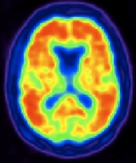
NUCLEAR MEDICINE

- Introduction
- Nuclear Medicine Definition
- Radioactive Tracer
- Principle Of Nuclear Medicine
- Single Photon Emission Tomography
- Positron Emission Tomography
- Radiopharmaceuticals Used In Nuclear Medicines
- Advantages Of Nuclear Medicine
- Disadvantages Of Nuclear Medicine
- Application Of Nuclear Medicine

TABLE OF CONTENT

INTRODUCTION
Nuclear medicine, often known as nucleology, is a medical speciality that uses radioactive chemicals to diagnose and treat disease. Nuclear medicine uses radioactive material inside the body to either diagnose how organs or tissue are working or to target and eliminate damaged or diseased organs or tissue (for treatment).
Nuclear medicine (NM) is distinct in its complicated and critical reliance on the use of radiopharmaceuticals (RPh) for every procedure. RPh is made up of a radioisotope (radioisotopes [RI], which are created in a research reactor [RR] or particle accelerator like a medical cyclotron [MC]) that delivers radiation for detection based imaging or targeted therapy, and a carrier molecule that provides bio specificity for the organ, lesion, or dysfunction being addressed.
Over decades, the NM has undergone both evolutionary and revolutionary changes, owing primarily to dynamic and responsive trends in the global development and deployment of RPhs, as well as the introduction of superior technology imaging systems (single photon emission computed tomography [SPECT]/CT, PET/magnetic resonance) with quantification capability.
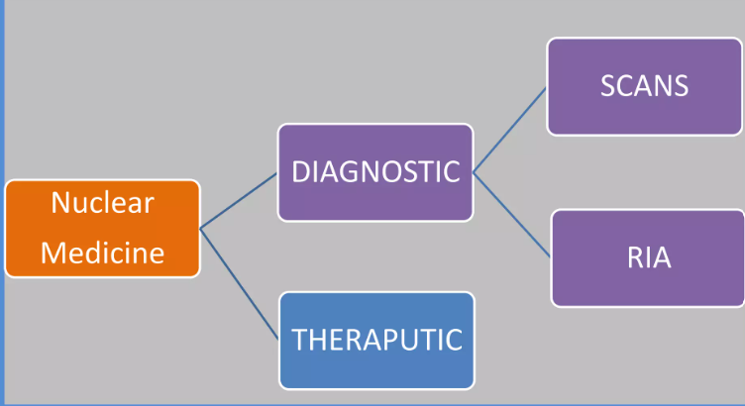
FIG 1. NUCLEAR MEDICINE USE
DEFINITION-
Nuclear medicine is a medical speciality that assesses body functioning and diagnoses and treats disease using radioactive tracers (radiopharmaceuticals). Doctors can track the passage of these radioactive tracers using specially developed cameras. Emission of a Single Photon The two most prevalent imaging modalities in nuclear medicine are computed tomography (SPECT) and positron emission tomography (PET).
RADIOACTIVE TRACERS
Radioactive tracers are made up of carrier molecules that are bonded tightly to a radioactive atom. These carrier molecules vary greatly depending on the purpose of the scan. Some tracers employ molecules that interact with a specific protein or sugar in the body and can even employ the patient’s own cells. For example, in cases where doctors need to know the exact source of intestinal bleeding, they may radiolabel (add radioactive atoms) to a sample of red blood cells taken from the patient. They then reinject the blood and use a SPECT scan to follow the path of the blood in the patient.
In most nuclear medicine diagnostic investigations, the radioactive tracer is supplied to the patient through intravenous injection. A radioactive tracer, on the other hand, can be delivered through inhalation, oral ingestion, or direct injection into an organ. The mode of tracer injection will be determined by the disease process being researched.
Tracers that have been licensed are referred to as radiopharmaceuticals since they must meet the FDA's strict standards for safety and suitable performance for the approved clinical usage. The nuclear medicine doctor will choose the tracer that will provide the most specific and dependable information for a patient's individual ailment. The tracer used decides whether a SPECT or PET scan is performed on the patient.
PRINCIPLE OF NUCLEAR MEDICINE
In diagnostic nuclear medicine, a wide variety of radionucleotides are utilized to meet the requirements for successful and efficient imaging. All radionucleotides are synthesized artificially by one of four methods.
- CYCLOTRON BOMBARDMENT: gallium-67, indium-11, thallium-201, cobalt-57, carbon-11, oxygen-15, nitrogen-13 and fluorine-18
- REACTOR IRRADIATION: chromium-51, selenium-75, iodine-125 and iodine-131.
- FISSION PRODUCTS: iodine-131, xenon-133 and strontium-90
- GENERATORS THAT PROVIDE SECONDARY DECAY PRODUCTS FROM LONGER LIVED PARENT RADIONUCLIDES: Column generators incorporating molybdenum-99 for the provision of technetium-99m.

SINGLE PHOTON EMISSION TOMOGRAPHY
Single-photon emission computed tomography (SPECT) is a nuclear medicine tomographic imaging technique that uses gamma rays.The approach requires the injection of a gamma-emitting radioisotope (a radionuclide) into the patient's bloodstream. On rare occasions, the radioisotope is a simple soluble dissolved ion, such as a gallium (III) isotope. However, most of the time, a marker radioisotope is coupled to a specific ligand to generate a radioligand, the qualities of which bind it to specific types of tissues. This union permits the ligand and radiopharmaceutical to be transported and bonded to a site of interest in the body, where the ligand concentration may be measured using a gamma camera.
Principle -A gamma camera is used to gather several 2-D images (also known as projections) from various angles for SPECT imaging. The various projections are then processed by a computer using a tomographic reconstruction method, providing a 3-D data set. This data set can then be processed to reveal thin slices of the body along any desired axis, similar to those acquired by other tomographic techniques including magnetic resonance imaging (MRI), X-ray computed tomography (X-ray CT), and positron emission tomography (PET).
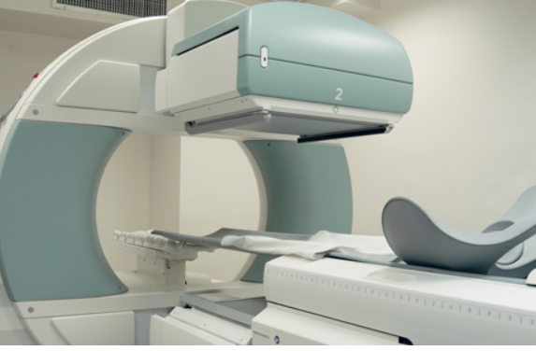
FIG NO 2. SINGLE PHOTON EMISSION TOMOGRAPHY

POSITRON EMISSION TOMOGRAPHY

Positron emission tomography (PET) is a functional imaging technique that visualises and measures changes in metabolic processes and other physiological activities such as blood flow, regional chemical composition, and absorption using radioactive compounds known as radiotracers. PET is utilised in pre-clinical and clinical settings as a medical and research tool. It is widely utilised in the imaging of tumours and the search for metastases in the field of clinical oncology, as well as in the clinical diagnosis of some diffuse brain illnesses that cause various types of dementias. PET is a vital research technique for learning and improving our understanding of the normal human brain, heart function, and drug development. PET is also employed in animal-based pre-clinical research. It enables repeated studies on the same participants over time, where subjects can function as their own controls, and it significantly reduces the number of animals required for a given study. This method permits research projects to lower the required sample size while boosting the statistical quality of their conclusions.

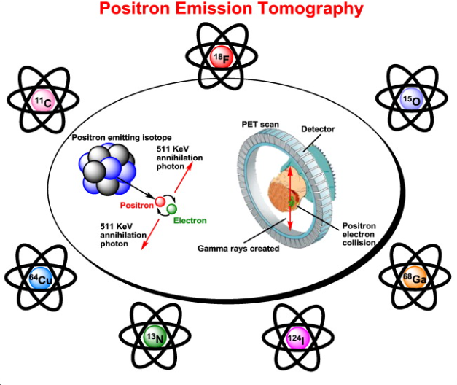

In clinical oncology, PET scanning with the tracer 18F-FDG is commonly employed. FDG is a glucose analogue that is absorbed by glucose-consuming cells and phosphorylated by hexokinase (the mitochondrial form of which is greatly increased in quickly growing malignant tumours). The PET scan is enabled by the metabolic trapping of the radioactive glucose molecule. The imaging FDG tracer concentrations reflect tissue metabolic activity because they correspond to regional glucose uptake.

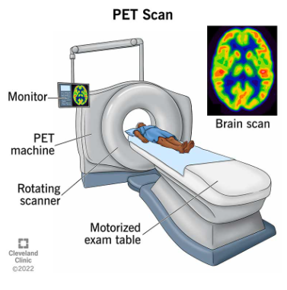

FIG NO 3. POSITRON EMISSION TOMOGRAPHY

PET imaging is best accomplished using a dedicated PET scanner. PET images can also be obtained using a standard dual-head gamma camera equipped with a coincidence detector. The gamma-camera PET imaging quality is worse, and the scans take longer to acquire. However, for institutions with modest PET scanning demand, this approach provides a low-cost on-site solution. An alternative would be to refer these patients to another center or to rely on a mobile scanner visit.
RADIOPHARMACEUTICALS USED IN NUCLEAR MEDICINES
Carbon-11
- Chemical Symbol: ¹⁴C
- Chemical Form: Carbon-11 Choline
- Half-life: 20.334 minutes.
- Diagnostic use:
Indicated for PET imaging of patients with suspected prostate cancer recurrence based upon elevated blood prostate specific antigen (PSA).

Carbon-14
- Chemical Symbol: ¹⁴C
- Chemical Form: Carbon-14 urea
- Half-life: 5,730 years
- Trade name(s): PYtest
- Diagnostic use: Detection of gastric urease as an aid in the diagnosis of Pylori infection in the stomach

Fluorine-18
- Chemical Symbol: ¹⁸F
- Chemical Form: Fluorine-18 sodium fluoride
- Half-life: 109.771 minutes
- Manufacturer: Various
- Diagnostic use: PET bone imaging agent to
delineate areas of altered osteogenesis

Fluorine-18
- Chemical Symbol: F
- Chemical Form: Fluorine-18 fludeoxyglucose
- Half-life: 109.771 minutes
- Diagnostic use:
- As a PET imaging agent to:
- Assess abnormal glucose metabolism in oncology
- Assess myocardial hibernation
- Identify regions of abnormal glucose metabolism associated with foci of epileptic seizures

Gallium-67
- Chemical Symbol: ⁶⁷Ga
- Chemical Form: Gallium-67 Gallium Citrate
- Half-life: 3.26 days
- Trade name(s): Neoscan (GE), DuPont Ga-67, Mallinckrodt Ga-67
- Diagnostic use:
- Useful to demonstrate the presence/extent of:
- Hodgkin's disease
- Lymphoma
- Bronchogenic carcinoma
- Aid in detecting some acute inflammatory lesions

Indium-111
- Chemical Symbol: ¹¹¹In
- Chemical Form: Indium-11 Capromab Pendetide
- Half-life: 3.20 days
- Trade name(s): ProstaScint
- Diagnostic use:
- A diagnostic imaging agent in newly-diagnosed patients with biopsy-proven prostate cancer, who are at high-risk for pelvic lymph node metastases.
- A diagnostic imaging agent in post-prostatectomy patients with a rising PSA.

Iodine - 131
- Chemical Symbol^{: 131} I
- Chemical Form: Iodine - 131 human serum albumin
- Half-life: 8.0197 days
- Trade name(s): Megatope
- Diagnostic use: Indicated for use in determinations of:
- Total blood and plasma volumes
- Cardiac output
- Cardiac and pulmonary blood volumes and circulation times
- Protein turnover studies
- Heart and great vessel delineation
- Localization of the placenta
- Localization of cerebral neoplasm

Advantages of Nuclear medicine
- Functional
- Sensitive, quantitative.
- Very safe.
- Low radiation.
- Screening & Follow up
- Whole body evaluation without increased radiation dose to the patient.
- Very high specificity (no natural radioactivity from the body).

Disadvantages of Nuclear medicine
- Not widely available.
- Poor SNR.
- Require NM instruments & radiopharmaceuticals.
- Relatively higher cost than X-ray or US.
- Radiation exposure to the patient.
- Low spatial resolution (5-10mm)

Application of nuclear medicines-
- Scintigraphy is a technique that uses radiopharmaceuticals to create pictures of organs or tissues of interest. A gamma camera is a sort of medical instrument that can detect the gamma rays released by the radioisotope.
- Certain ailments are diagnosed and treated using nuclear medicine treatments. Radiopharmaceuticals, which are radioactive materials, are used in these operations. Diseases treated using nuclear medicine methods include
- Hyperthyroidism
Radioactive iodine (RAI) is used to treat hyperthyroidism and certain kinds of thyroid cancer. The phrase "radioactive" may sound alarming, but it is a safe, generally well-tolerated, and dependable medication that targets thyroid cells while exposing very few other cells in your body.

- Thyroid cancer
I-131 radiation is a treatment for thyroid cancer that is usually used after the thyroid has been removed. After surgery, the therapy is intended to remove any residual malignant or healthy thyroid tissue. The radioactive substance used in I-131 radiotherapy is radioactive iodine I-131.
- Lymphomas
Positron emission tomography (PET) scanning and PET in conjunction with computer-aided tomography (CT) scanning (PET-CT) are the most often utilized molecular imaging techniques for diagnosing and treating lymphoma. Patients with non-Hodgkin's lymphoma who do not react to chemotherapy may benefit from radioimmunotherapy (RIT).
- Radiotherapy
Radiotherapy is one of the most often utilized cancer treatments. Nuclear radiation, often known as ionizing radiation, is used in radiotherapy to injure and eliminate malignant tumor cells.
- Nuclear medicine therapy is a cancer treatment that employs radioactive medicines that bind to and destroy cancer cells. Some persons with neuroendocrine tumors, prostate cancer, meningiomas, thyroid cancer, and lymphoma may benefit from this treatment.
- Nuclear medicine therapy employs the use of a little amount of radioactive material in conjunction with a carrier molecule. This is known as a radiopharmaceutical. Nuclear medicine therapies are used to treat cancer and other diseases. Radiopharmaceuticals bind to select cells before delivering a high dosage of radiation that kills them.

