IN VITRO ANTI-INFLAMMATORY AND ANTIDIABETIC ACTIVITY OF HIBISCUS ROSA SINENSIS
Ganga Raju M, N V L Suvarchala Reddy V, Konaparthi Sree Bhavya, Korra Anasuya, Polagoni Shrivani, Polisetty Amrutha
Department of Pharmacology
Gokaraju Rangaraju college of Pharmacy
Hyderabad, India.

ABSTRACT
Due to the rising illness load, natural plant products are becoming popular nowadays. The Malvaceae family includes the plant Hibiscus rosa sinensis Linn, which may be found throughout the world. In India's traditional medicine, its leaves, bark, roots, and flowers have been used to cure a variety of illnesses. Hibiscus rosa sinensis, commonly known as the Chinese hibiscus, is a plant with a long history of traditional medicinal use. This study aimed to investigate the potential in vitro anti-inflammatory and anti-diabetic activities of Hibiscus rosa sinensis extract (Red tea). The anti-inflammatory activity was evaluated through an in vitro assay, measuring the inhibition of protein denaturation and anti-proteinase activity. The anti-diabetic activity was assessed through in vitro inhibition of α-amylase and α-glucosidase enzymes. The red tea of Hibiscus rosa sinensis with a dose of 10, 20, 30, 40, and 50 μg/ml, was taken for the activity and compared with the acarbose. Anti-proteinase and Protein denaturation model was taken for activity and compared with diclofenac sodium 10-50μg/ml. The results demonstrated that Hibiscus rosa sinensis extracts exhibited significant anti-inflammatory and anti-diabetic activity in a dose-dependent manner. The red tea showed significant results in both anti-inflammatory as well as antidiabetic models. However, these effects need to be confirmed using in vivo models for their effective utilization as therapeutic agents.
Keywords: Hibiscus rosa-sinensis, Antidiabetic activity, Anti-inflammatory activity, Red Tea.
- INTRODUCTION
The prevalence of diabetes, a fatal and incurable condition, is rising globally. Diabetes incidence is steady [1]. The critical factor controlling blood sugar is insulin. Diabetes mellitus is a condition in which the body cannot utilize or create enough insulin on its own. Blood sugar is a result of this. Diabetes can cause major health issues like amputations, heart disease, blindness, and kidney failure. In the US, it ranks as the seventh most prevalent cause of death. In individuals 18 and older, diabetes was expected to affect 9% of people worldwide in 2014. Over 80% of fatalities from diabetes take place in low- and middle-income nations [2]. In 2030 diabetes will overtake smoking as the seventh biggest cause of death, according to the WHO [3]. From 171 million cases in 2000 to 366 million cases in 2030, the prevalence of diabetes is predicted to more than quadruple, with India experiencing the biggest rise [4]. By 2030, it is predicted that up to 79.4 million Indians will have diabetes. Due to the negative side effects of using insulin and oral hypoglycaemic medications, there is an increasing demand from the market for alternative diabetes treatment options such as herbal remedies [5]. More than 200 plants are thought to possess anti-diabetic qualities. The 21,000 plant species used as medicines worldwide are recorded by the World Health Organization (WHO) [7]. The capacity to reduce glucose levels has been found in more than 400 medicinal plants [8].
Herbal plants have been used for several years by different cultures in the region of the world for the cure of diabetes [9]. Inflammation is part of the complex biological response of body tissues to harmful stimuli, such as pathogens, damaged cells, irritants, injury, infection, or destruction characterized by heat, redness, pain, swelling, and disturbed physiological functions [10]. Chemical mediators released by damaged tissue and migratory cells serve as its trigger. The commonly used drugs for the management of inflammatory conditions are non-steroidal anti-inflammatory drugs (NSAIDs). These drugs block COX-1 and COX-2 enzyme activity preventing prostaglandin production. NSAIDs have several adverse effects especially gastric irritation leading to formation of gastric ulcers. Long-term uses of these drugs cause adverse side effects and damage human biological systems such as the liver, gastrointestinal tract, etc. So there is a need for the new safe, potent, nontoxic, or less toxic anti-inflammatory drug. In many impoverished nations, plant medicines are quite significant in primary healthcare. The anti-inflammatory drugs act as the lysosomal membrane stabilizing agents. In the present investigation, the in vitro anti-diabetic and anti-inflammatory properties of Hibiscus rosa-sinensis flowers were evaluated. The red tea obtained from the flowers was tested for α-glucosidase inhibition activity α-amylase inhibition activity, anti-proteinase, and protein denaturation ability.
- MATERIALS AND METHODS
Collection of Hibiscus Flowers
Hibiscus rosa-sinensis flowers were obtained in the month of February in Hyderabad, Telangana, and were verified by botanist Harikrishna from Osmania University.
Preparation of Red Tea:
Pick fresh hibiscus flowers separate all the petals from the flowers and add the petals into a sufficient quantity of water to allow it to boil for some time (purplish pink color). Allow it to cool; filter it to get red tea extract [11] represented in Figure 1
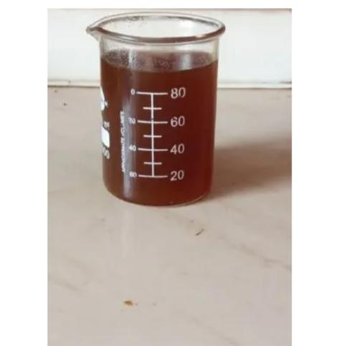
Figure 1: Red tea extract obtained from Hibiscus rosa-sinensis flowers
Determination of Extraction Yield
The following equation estimated the extraction yield (%)

$Extraction yield =\frac{weight of the extract after evaporating solvent and freeze drying}{dry weight of the sample }$ × 100

Phytochemical Screening

Screening for phytochemicals was done for the red tea [12].

Proteinase inhibitory assay

The Oyedepo and Femurewa-modified technique for the proteinase inhibitory test was used. The reaction mixture (2 ml) included 0.06 mg of trypsin, 1 ml of Tris-HCl buffer (20 mM, pH 7.4), and various quantities of the test plant extract sample. After 5 minutes of incubation at 37 °C, 1 ml of 0.8% (w/v) casein was added to the reaction mixture. A further 20 minutes were spent incubating the mixture. To halt the process, 2 ml of 70% perchloric acid was added. After centrifuging the hazy solution, the supernatant's absorbance at 210 nm was measured using a Tris-HCl buffer as a reference. The experiment was carried out three times [13].

Inhibition of protein denaturation method

Inhibition of protein denaturation was determined according to the method with some modifications. The reaction mixture contained the test extract at different concentrations and 1% BSA (aqueous solution). The pH of the reaction mixture was adjusted using 1 N HCl. The samples were heated at 37 °C for 20 min and then 57 °C for 20 min, and allowed to cool [14]. The turbidity of the samples was measured at 660 nm. The experiment was performed in triplicate. Percent inhibition of protein denaturation was calculated as follows:
Percentage inhibition = (A_{C} of control–A_{C} of test sample) × 100/A_{C}), where A_{C} and A_{S} are the absorbance (at 600 nm) of the control and sample, respectively.
In vitro α-amylase inhibitory activity
α-amylase inhibitory activity of red tea was carried out according to the standard method with minor modification. The reaction mixture containing 50 μl phosphate buffer (100 mM, pH = 6.8), 10 μl α–amylase (2 U/ml), and 20 μl of varying concentrations of red tea (10, 20, 30, 40and 50 µg/ml) was preincubated at 37°C for 20 min. Then, the 20 μl of 1% soluble starch (100 mM phosphate buffer pH 6.8) was added as a substrate and incubated further at 37°C for 30 min; 100 μl of the DNS color reagent was then added and boiled for 10 min. The absorbance of the resulting mixture was measured at 540 nm using a UV Spectrophotometer. Acarbose at various concentrations (10, 20, 30, 40 and 50 µg/ml) was used as a standard. Without test (red tea) substance was set up in parallel as control and each experiment was performed in triplicates. The results were expressed as percentage inhibition, which was calculated using the formula [15].
Inhibitory activity (%) = (1 − As/Ac) ×100, Where, As is the absorbance in the presence of test substance and Ac is the absorbance of control.

In vitro α-glucosidase inhibitory activity
α-glucosidase inhibitory activity of red tea was carried out according to the standard method with minor modification. The reaction mixture containing 50 μl phosphate buffer (100 mM, pH = 6. 8), 10 μl alpha-glucosidase (1 U/ml), and 20 μl of varying concentrations of extract and fractions (0.1, 0.2, 0.3, 0.4, and 0.5 mg/ml) was pre-incubated at 37°C for 15 min. The substrate was then added to 20 µl of P-NPG (5 mM), and the reaction was continued for 20 more minutes at 37°C. The reaction was halted by adding 50 µl of 0.1 M Na2 CO3. The absorbance of the released p-nitrophenol was measured at 405 nm using a UV Spectrophotometer. Acarbose at various concentrations (10, 20, 30, 40, and 50 µg/ml) was included as a standard. Each experiment was carried out in three separate runs, using a control setup parallel to the test setup. The results were expressed as percentage inhibition, which was calculated using the formula [16].
Inhibitory activity (%) = (1 − As/Ac) ×100, Where, As is the absorbance in the presence of test substance and Ac is the absorbance of control.

RESULTS

According to phytochemical analysis, the main bioactive compounds responsible for the chemical composition are flavonoids, tannins, terpenoids, saponins and alkaloids given in table 1.
Table 1: Preliminary phytochemical screening
Phytochemical constituents | Results
Flavonoids | ++
Tannins | +
Terpenoids | +++
Saponins | ++
Alkaloids | +
Note: + indicates presence
Assessment of in-vitro anti-inflammatory activity
The inhibitory actions of different extracts of Hibiscus rosa sinensis on protein denaturation, proteinase activity were determined and in vitro anti-inflammatory potential was estimated.
Antiproteinase action
In this method the red tea extract from Hibiscus rosa sinensis showed graded inhibition which was found to be increasing with increasing concentrations i.e., at 10 µg/ml it showed 15% inhibition and at 50 µg/ml it exhibited 71% when compared to the standard Diclofenac Sodium at 10 µg/ml it showed 10% inhibition and at 50 µg/ml it exhibited 57%. The IC₅₀ value of red tea was found to be 38.46 µg/ml when compared to diclofenac sodium which showed 34.09 µg/ml given in Table 2.
Table 2: Antiproteinase activity of Hibiscus rosa sinensis red tea and standard drug
Name of the compound | Concentration (µg/ml) | % inhibition | IC ₅₀
Hibiscus rosa sinensis  red tea | 10 | 15 | 38.46
 | 20 | 23
 | 30 | 39
 | 40 | 57
 | 50 | 71
Diclofenac Sodium | 10 | 10 | 34.09
 | 20 | 15
 | 30 | 44
 | 40 | 52
 | 50 | 57
Inhibition of protein denaturation method
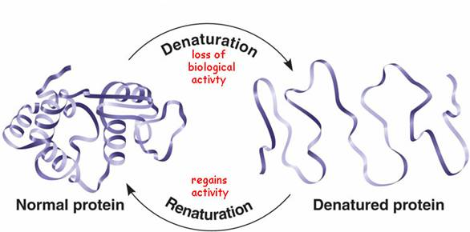
Figure 2: Mechanism of protein denaturation
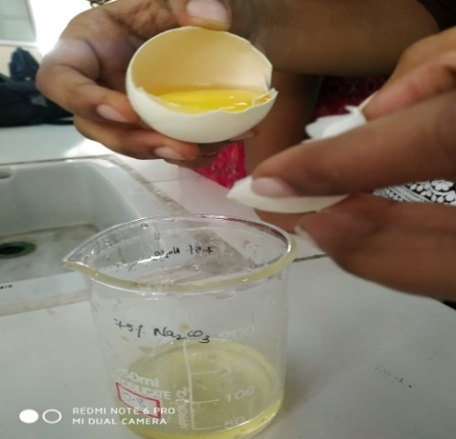
Figure 3: Extraction of egg albumin

Protein denaturation inhibition
In this method, the red tea extract from Hibiscus rosa sinensis showed graded inhibition, which was found to be increasing with increasing concentrations, i.e., at 10 µg/ml it showed 29% inhibition, and at 50 µg/ml it exhibited 69% when compared to the standard Diclofenac Sodium at 10 µg/ml it showed 24% inhibition and at 50 µg/ml it exhibited 90%. The IC₅₀ value of red tea was found to be 31.323 µg/ml when compared to diclofenac sodium, which showed 3.479 µg/ml, as given in Table 3. The mechanism of denaturation is represented in Figure 2 and the extraction of albumin from eggs is given in Figure 3.
Table 3: Protein denaturation of Hibiscus rosa sinensis red tea and standard drug
Name of the compound | Concentration (µg/ml) | % inhibition | IC ₅₀
Diclofenac sodium | 10 | 29 | 31.323
 | 20 | 38
 | 30 | 47
 | 40 | 53
 | 50 | 69
Hibiscus rosa sinensis red tea | 10 | 24 | 39.47
 | 20 | 25
 | 30 | 38
 | 40 | 68
 | 50 | 90
Assessment of in vitro Anti diabetic Activity
α-Amylase inhibition assay
In this method, the red tea extract from Hibiscus rosa sinensis showed graded inhibition, which was found to be increasing with increasing concentrations, i.e., at 10 µg/ml it showed 31% inhibition, and at 50 µg/ml it exhibited 85% of the standard acarbose, and at 50 µg/ml it exhibited 80% inhibition. The IC50 value of red tea was found to be 38.46 µg/ml when compared to acarbose, which showed 21.6 µg/ml, as given in Table 4, and the mechanism by which it works is given in Figure 4.
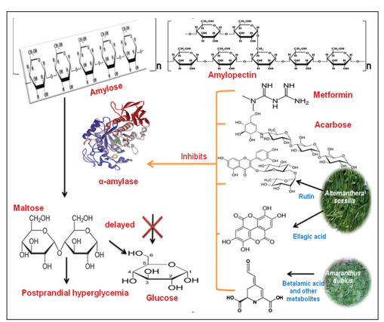
Figure 4: Mechanism of α-amylase enzyme in inhibition assay

Table 4: α-amylase activity of Hibiscus rosa sinensis red tea and standard drug
Name of the compound | Concentration (µg/ml) | % inhibition | IC₅₀
Acarbose | 10 | 31 | 21.6
 | 20 | 46
 | 30 | 55
 | 40 | 83
 | 50 | 85
Hibiscus rosa sinensis (red tea) | 10 | 14 | 38.6
 | 20 | 26
 | 30 | 39
 | 40 | 53
 | 50 | 80
Percentage inhibition = (Abs control –Abs sample) X 100/ Abs control
α-Glucosidase inhibition assay
In this method, the red tea extract from Hibiscus rosa sinensis showed graded inhibition, which was found to be increasing with increasing concentrations, i.e., at 10 µg/ml it showed 31% inhibition, and at 50 µg/ml it exhibited 89% of the standard acarbose, and at 50 µg/ml it exhibited 78%. The IC50 value of red tea was found to be 44.11 µg/ml when compared to acarbose, which showed 27.7 µg/ml, as given in Table 5.
Table 5: α-Glucosidase inhibition assay of Hibiscus rosa sinensis red tea and standard drug
Name of the compound | Concentration  (µg/ml) | % inhibition | IC₅₀
Acarbose | 10 | 31 | 27.7
 | 20 | 36
 | 30 | 57
 | 40 | 78
 | 50 | 89
Hibiscus rosa sinensis (red tea) | 10 | 10 | 44.11
 | 20 | 21
 | 30 | 34
 | 40 | 63
 | 50 | 78

Percentage inhibition = (Abs control –Abs sample) X 100/ Abs control
- DISCUSSION
The protein denaturation technique and anti-proteinase were used to assess the anti-inflammatory activity of the red tea extract of Hibiscus rosa sinensis. The presence of polyphenolic compounds in the plant extract, such as alkaloids, tannins, flavonoids, steroids, and phenols, suggests that the extract has strong anti-inflammatory capabilities. The well-understood cause of inflammation is the denaturation of proteins. In the present context, the capacity of plant extract to prevent protein denaturation was investigated. When compared to the standard medication diclofenac sodium, the extract was efficient at preventing protein denaturation [17]. Leukocyte proteinase has been implicated in the development of tissue damage during inflammatory responses, and proteinase inhibitors have been shown to offer a considerable degree of protection. Comparing the red tea extract to the standard drug [18].
The Pancreatic α-amylase and intestinal α-glucosidase are the enzymes that are in charge of carbohydrate metabolism, which raises blood sugar levels. When these enzymes are inhibited, the metabolism of carbohydrates slows down, which reduces the amount of glucose absorbed from the gut. The main phytoconstituents such as phenols, flavonoids, tannins and other bioactive substances possess α-amylase and α-glucosidase inhibitory activity resulting in regulation of postprandial hyperglycaemia. This study looked at the red tea extract of the Hibiscus rosa sinensis' ability to inhibit alpha-amylase and alpha-glucosidase. Therefore, the results of the current investigation suggest that Hibiscus rosa sinensis may be helpful in the treatment of postprandial hyperglycaemia [19].
- CONCLUSION
Flowers contain a lot of flavonoids and other bioactive substances, which may explain why they have a hypoglycaemic impact. Additional research is required to clarify the mechanism of action and establish its anti-diabetic potential in people. The presence of polyphenolic substances such as alkaloids, flavonoids, tannins, steroids, and phenols, which have high anti-inflammatory properties, Heat-induced albumin denaturation, and proteinase activity, was prevented by the red tea extract. This study suggests that a constituent of the Hibiscus rosa sinensis plant may provide the basis for the creation of potent anti-inflammatory and anti-diabetic drugs that may potentially be utilized to treat other ailments.
REFERENCES
- Subramonium, A., Babu, V., Standardised phytomedicines for Diabetes. In: Role of Biotechnology in Medicinal and Aromatic plants, 2003, pp. 3-46.
- World Health Organization. Global Health Estimates: Deaths by Cause, Age, Sex and Country, 2014, Geneva.
- Mathers, C. D., Loncar, D., Projections of global mortality and burden of disease from 2002 to 2030. PLoS Med. 2006;3(11):442.
- Wild S, Roglic G, Green A, Sicree R, King H. Global prevalence of diabetes-estimates for the year 2000 and projections for 2030. Diabetes Care. 2004;27(3):1047–1053.
- Ali H, Houghton PJ, Soumyanath A. α-amylase inhibitory activity of some Malaysian plants used to treat diabetes with particular reference to Phyllanthus amarus. Journal of Ethnopharmacology. 2006;107:449-455.
- Karthic K, Kirthiram KS, Sadasivam S, Thayumanavan B. Identification of α-amylase inhibitors from Syzygium cumini Linn seeds. Indian Journal of Experimental Biology. 2008;46:677-680.
- Modak M, Dixit P, Londhe J, Ghaskadbi S, Devasagayam TPA. Indian herbs and herbal drugs used for the treatment of diabetes. Journal of Clinical Biochemistry and Nutrition. 2007;40:163-173.
- Luo Q, Cai Y, Yan J, Sun M, Corke H. Hypoglycemic and hypolipidemic effects and antioxidant activity of fruit extracts from Lycium barbarum. Life Sciences. 2004;76:137-149.
- Bhandari MR, Anurakkum NJ, Hong G, Kawabata J. α-Glucosidase and α-amylase inhibitory activities of Nepalese medicinal herb pakhanbhed (Bergenia ciliate Haw.). Food Chemistry. 2008; 106:247-252.
- Ferrero-Miliani L, Nielsen OH, Andersen PS, Girardin SE, Anderse N, Girardin. Chronic inflammation: importance of NOD2 and NALP3 in interleukin-1beta generation. Clin. Exp. Immunol. 2007;147 (2):227–235.
- Sanadheera S, Subasinghe D, Solangaarachchi MN, Suraweera M, Suraweera NY, Tharangika N. Hibiscus rosa-sinensis L. (red Hibiscus) Tea, Can It Be Used as A Home-Remedy to Control Diabetes and Hypercholesterolemia? Biology, Medicine, & Natural Product Chemistry 2021;10 (1): 59-65.
- Suvarchala Reddy NVL, Anarthe SJ, Raghavendra NM. In vitro Antioxidant and antidiabetic activity of Asystasia gangetica (Chinese violet) Linn. (Acanthaceae). International Journal of Research in Pharmaceutical and Biomedical Sciences. 2010; 1(2): 72-75.
- Leelaprakash G, Dass SM. In vitro anti-inflammatory activity of methanol extract of Enicostemma axillare. International Journal of Drug Development and Research. 2011 Jul;3(3):189-96.
- Chirumamilla P, Taduri S. Assessment of in vitro anti-inflammatory, antioxidant and antidiabetic activities of Solanum khasianum Clarke. Vegetos. 2023;36:575–582.
- Suvarchala Reddy NVL, Mary JL, Raghavendra NM and Subrahmanyam CVS. Antidiabetic and Antioxidant activity of Rhynchosia beddomei Baker. American Journal of Phytomedicine and Clinical Therapeutics. 2014; 2(11):1323-1332.
- Suvarchala Reddy NVL, Akhila M, Subrahmanyam CVS, Trimurtulu G and Raghavendra NM. Isolation, in vitro antidiabetic, antioxidant activity and molecular docking studies of pentacyclic triterpenoids from Syzygium alternifolium (wt.) Walp. Journal of Pharmacy and Biological Sciences. 2015; 10(6): 22-27.
- Begum Z, Younus I, Khan H. Analgesic and anti-inflammatory activities of the ethanol extract of Hibiscus rosa sinensis Linn (roots). Pak J Pharm Sci. 2018;31(5):1927-1933.
- Viado AEE, Purnamasari L, and dela Cruz JF. Anti-Diabetic Effects of Hibiscus spp. Extract in Rat and Mice Models: A Review. Jurnal Gizi Indonesia (The Indonesian Journal of Nutrition). 2022;11(1):39-48.
- Anieska Eunice E. Viado, Listya Purnamasari, Joseph F. Dela Cruz, Anti-Diabetic Effects of Hibiscus spp. Extracts in Rat and Mice Models &amp; Jurnal Gizi Indonesia, 2022 Dec; vol. 11: 38-48

