Advancing Functionalization of Polymer Nanocomposite

Anamika Das,^{1, 3} Madhumita Mukhopadhyay, *² Satarupa Biswas³ and Moumita Mukherjee³
¹Department of Physics, Acharya Prafulla Chandra College, New Barrackpore, Kolkata, West Bengal 700131, India
²Department of Materials Science & Technology, School of Applied Science & Technology, Maulana Abul Kalam Azad University of Technology (MAKAUT), West Bengal, Haringhata, 741249, India
³Department of Physics, Adamas University, Kolkata - Barrackpore-Barasat Road, Kolkata, West Bengal 700126
Corresponding author: madhubanerji@gmail.com (Madhumita Mukhopadhyay)

Keywords
Polymer; nanocomposite, functionalization, solid state devices.

Table of Contents

1 | Introduction:  Functionalization of polymer nano composite  - Global scenario of polymer as functional material  - An insight on processing of polymer nano composite  - Processing of multifunctional polymer nano composite  - Resin matrix-based polymer nano composite  - A view on property augmentation of multifunctional polymer nano composite
2 | Functionalization of carbon nanotube with polymer  - Chemical functionalization CNC-polymer matrix  - An insight on CNC-polymer interface and interaction improvement methods  - Property augmentation upon improved interfacial interaction in CNC-polymer
3 | Challenges and prospects of green polymer nanocomposite  - Green aspect of polymer nano composite  - Polymer-polymer blend based composite  - Application and challenges of green polymer nano composite
4 | Mechanistic understanding on role of nanoscale fillers on interfacial chemistry of polymer nano composite
5 | Conclusion & challenges with possible research direction

- Introduction
Functionalization of polymer nano composite
In recent years functionalized polymeric materials have been developed for their dimension, stability, flexibility, diversity, processability, high sensitivity, tailoring properties in solid state physics, fuel cell, sensor, drug delivery system, water treatment, food safety and many other applications. Polymer can be classified mainly in two types viz. natural polymer and synthetic (manmade) polymer. It is a chain of macromolecule consisting basic unit monomer. Now a days it takes great importance to develop hybrid functional composite material. Properties of polymer matrix composite can be tailored based on requirement and specific field of applications. It is also called smart polymer for its wide applications in different practical fields. Few polymers are functional and active in nature and the surface of other synthetic and natural polymers need to be modified for activation with reactive functional groups [1]. The multivariant field of application of functional polymer is shown in Figure 1.
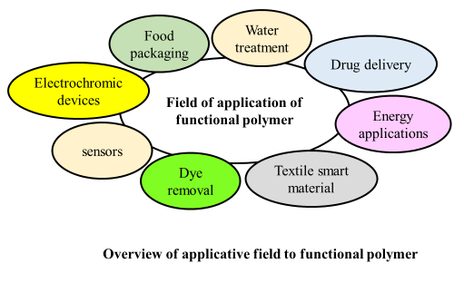
Figure 1. Application of functional polymer in different fields.
Polymeric nanocomposite materials are processed by several nano additives using organic polymeric material. Nano additives, ceramic, metals, clay etc are used with host polymer matrix using various processing methods with the control of chemical structure, geometrical parameters, chemical reactions etc. It also requires functionalization to enhance compatibility of the polymer with substrate or guest species (polymer being the host entity). Functional polymeric materials are widely applicable for its unique properties with reactive chemical groups. As a host matrix material polymer are mainly selected due to its flexibilities, chemical stability, compatibility, mechanical strength and processability etc. Conducting Polymer nanocomposite based functional material have sought features in energy storage device like solar cell, fuel cell, super capacitors. Organic conducting polymers have unique feature to conduct electricity and also behaves like semiconductor with magnetic, electronic, mechanical, optical properties. Few applications of conducting polymer are shown in Figure 2.
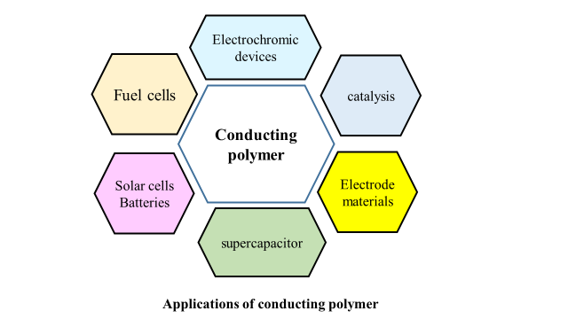
Figure 2. Applications of conducting polymer
New functional polymeric materials are developer in medical diagnostic purposes. In drag control system, imaging technology, biosensor, in vivo and in vitro biocompatible devices have been developed in functionalized polymer matrix system. Transparent polymer nanocomposites are used in optical devices in medical treatment and other industrial propose also. In medical science purpose biodegradability, antimicrobial activity, biocompatibility properties of polymer as well as polymer nanocomposites are important to study and to tailor their functionality and architecture to develop new biomaterials. Polyamide, polyester, polyurethane is the most explored polymer as biocompatible material. Few polymer nanocomposites show smart behaviours like stimuli responsive behaviour with self-cleaning and self-healing abilities. The subsequent sections describe the global context and practical implication of polymer nanocomposites.
  - Global scenario of polymer as functional material

Polymer nanocomposites are the material in nanoscale regime, combination of polymer and nanomaterial within 100 nm in dimension. Now a days polymer matrix in nanomaterial improves material properties (chemical, physical) and it plays important role due to uniqueness in property. Polymer nanocomposites are the material of dispersed inorganic nano sized material within polymer matrix. It is the combination of inorganic material with different physical, chemical properties incorporated within organic polymer matrix system. It is much more advanced, tailored material than other polymeric materials [2-5].
It is classified in three categories on the basis of their dimensions like i) zero dimensional nanomaterials (length, width, and thickness of material in order of nano meter (within 100 nm), i.e. Metals and their hydroxides, oxides, carbonates etc. and carbon quantum nanodots (CD), polyhedral oligomeric silses quioxanes (POSS), inorganic semiconductor quantum dots etc.), ii) one dimensional nanomaterials ( width and thickness of the materials are in the nm range, but length is in μm or more, e. g. nanorods, nanotubes, nanofibers and nanowires etc.), two dimensional nanocomposites (with thickness is in the nm, width and length are in the μm in dimension like nano clays, graphene, reduced graphene oxide (RGO), graphene oxide (GO) etc. ) [6].
In generally polymer nanomaterials are the composite materials of polymer and one-dimensional nanomaterials. In polymer nanocomposites, one dimensional nanomaterial i.e., cellulose nanofibers, carbon nanofibers, Carbon nanotubes etc. are commonly used. Carbon nanotubes (CNTs) are made up of rolled graphene sheet of sp² hybridized carbon atom which is also in covalent bond with neighbour three atoms. Single walled carbon nanotubes (SWCNT), multi-walled carbon nanotubes (MWCNTs) are commonly used CNTs with unique thermal, optical, mechanical and electrical properties. Mostly it is very difficult to incorporate it into polymeric system without functionalization due to its π-π bond and strong van der Waals force. So, functionalization of CNTs or surface modification is very necessary to make a strong interaction with polymer matrix system to develop new materials. Though, there is a movement for plastic free world, however, biocompatible polymer macromolecules offer good compatibility with metals, metal oxides, fillers etc to form composites termed as functional materials applicable for multivariant purposes. This is described in details in the subsequent sections.
1.2. An insight on processing of polymer nano composite
I. Processing of multifunctional polymer nano composite

Composite material having 1-100 nm size is called nanocomposites. To improve or alter matrix dominated properties like shear strength, stiffness, fiber reinforce etc. small in size and low weighted nanomaterials are used in composite materials. Al ₂ O ₃, SiO ₂, TiO ₂ etc nanoparticles are used in nanocomposites. Commonly as a nanoparticle carbon nano tube (CNTs), carbon nanofiber (CNF), single-walled carbon nanotube (SWCNT), multi-walled carbon nanotubes (MWCNT), graphite nanoplatelet (GNP), etc. are used widely in the nanocomposite materials. GNP, CNF, CNT are additive in nature and these are used to enhance electrical conductivity property of nanocomposite materials. In polymer matrix, nanoparticles are incorporated to develop polymer nanocomposites. Processing techniques also influence on the functionalization, alignment and dispersion properties of polymer nanocomposite materials.so proper processing technique is necessary to achieve required properties of nanocomposites. Most commonly used processing techniques to prepare polymer nanocomposites are discussed below in very brief including solution mixing, melt mixing, in-situ particle process, etc is shown in Figure 3. The processing as mentioned are also highlighted in brief in the subsequent sections.
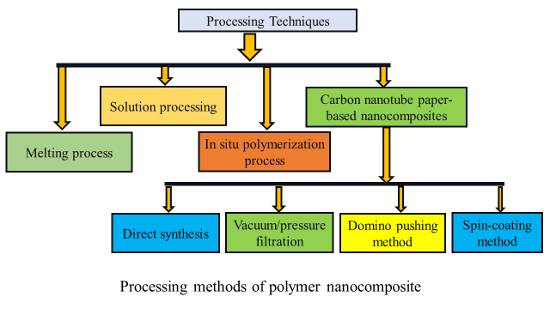
Figure 3. Few common processing techniques of polymer nanocomposites.
1.2.Polymer Melting process
Melt mixing process is widely used to mix or incorporate high volume of nanoparticles into insoluble thermoplastic polymer matrix such as polystyrene, polycarbonate, polypropylene, polyamide-6 etc. In this technique thermoplastic polymers are heated to form soft without altering any properties even after cooling. Amorphous polymers are heated above glass transition temperature and semi-crystalline polymers are processed above melting temperature [7]. Polymer pellets are processed after melting to make it viscous liquid. By a high shear mixer, compression molding Nanoparticles are injected into the liquid polymer to form bulk nanocomposites. With incorporation of nanoparticles Viscosity of melted polymer can be changed which is the main cause of polymer degradation [7]. Carbon nanotubes are dispersed into polymer network in melting process with and high temperature high shear. Schematic diagram of melting process of polymer-based nanocomposites is shown in Figure 4. To prepare nylon-6/MWNTs nanocomposites 1 wt% MWNTs was used through Brabender twin-screw mixer [8]. It was confirmed through SEM image MWNTs was homogenously dispersed in polymer matrix with high mechanical strength. Through Brabender Plasticorder internal mixer, MWNTs/ LLDPE (linear low-density polyethylene) nanocomposites was fabricated by melt mixing process [9]. By twin screw melt compounding PE/MWNT nanocomposite was developed. It was confirmed through microscopic observations and X-ray diffraction, MWNTs were dispersed in PE network uniformly in the experiment of T McNally et al [10]. Melt mixing process is applicable with very easy technique to develop well dispersed polymer nanocomposites, polymer –CNTs. polycarbonate/CNT [11,12], PMMA/CNT [13,14], polypropylene/CNT [15,16], polyimide/CNT [17], PE/CNT [18], etc. are the examples of developed polymer matrix composites with CNTs.
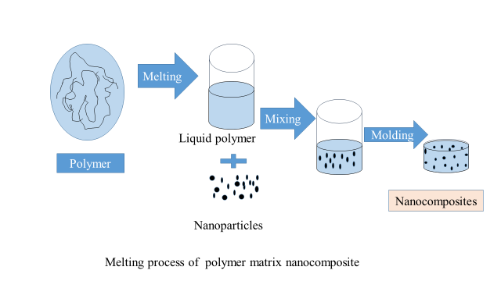

Figure 4. Melting method of the polymer nanocomposites preparation.
1.2. B. Solution processing technique
One of the simple and useful technique is solution mixing process to prepare polymer nanocomposites in thin film or sheet structure. In this process nanoparticles are dispersed in a suitable solvent or polymer solution. Dispersed nanoparticle and polymer solution are uniformly mixed by magnetic stirring or sonication. It is difficult to prepare well and uniform dispersed polymer nanoparticle mixer solution due to high aspect ratio of nanoparticles. Most of time surfactants are used to improve dispersion quality of nanoparticles. Solvent selection is dependent on the solubility property of particular polymer. Uniformly dispersed polymer nanoparticle solution or mixer is taken into a mold to evaporate to make sheet or film. The solution process is shown in Figure 5.
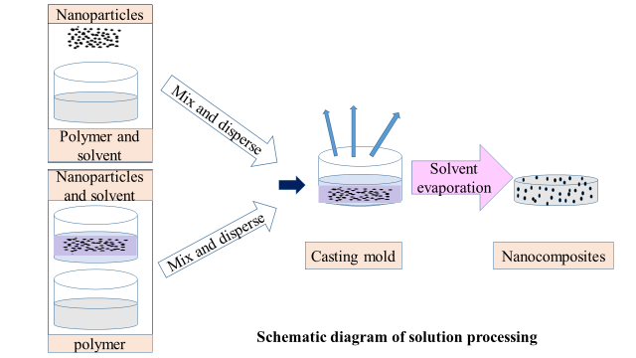
Figure 5. The solution method of the polymer nanocomposites preparation.

Jin et al. used chloroform as a solvent to prepare dispersed MWCNTs by sonication and to dissolve PHAE (polyhydroxy amino ether). Suspension of homogeneously dispersed PHAE/MWCNTs/chloroform solution was taken into Teflon mould to dry in a fume hood to get polymer composite with 50 wt% of MWCNTs [19]. In this process solution of CNTs of suitable solvent is added with polymer solution to form polymer CNT composite by evaporation of solvent or by precipitation. To prepare homogeneous well dispersed CNT solution ultrasonication process is more useful rather than simple stirring. In their experiment Li et al. showed that CNTs were homogeneously dispersed in poly carbonate solution by sonication for 10 min at 20 KHz frequency due to magnetically stirring with ultrasonic wave [20]. Homogeneous solution of CNTs in Polystyrene (thermocole) (PS) was prepared by Safadi et al. by ultra-sonication for 30 min at 300W [21]. It is very essential to select proper surfactant to get uniform dispersion of high loading CNTs. Several polymer/CNTs composites are fabricated using this process such as PS/CNT [22, 23], P(MMA-co-EMA)/CNT [24], PU/CNT [25], epoxy/CNT [26,27], polyacrylonitrile/CNT [28], Poly (vinyl alcohol)/CNT [29], and polyethylene (PE)/CNT [30] have been fabricated by this method.

1.2. C In situ polymerization process

Nanoparticles are dispersed in liquid monomer in situ polymerization method. Most of nanoparticles can be dispersed easily to interact strongly with polymer system. Polymerization process can be initiated by diffusion of an initiator, by radiation or heating, by surfactant etc. At the end of this polymerization process molecules of polymer matrix are surrounded or covalently attached to the nanoparticles, depending on the surface interaction nature of nanoparticles and polymer matrix [31]. This process is applicable to prepare polymer nanocomposite materials with thermally unstable and insoluble polymer that cannot be developed by melt mixing and solution process method. Radical, ring-opening, anionic etc. polymerization process is performed with proper molecular weight of the polymer. The schematic diagram is shown in Figure 6. Through this process polymer molecules are grafted onto the surface area of nanoparticles. In 1990 by this polymerization technique Toyota Motor Corp developed (clay/polyamide-6) nanocomposites as commercially [32]. Poly (methyl methacrylate) (PMMA) and polystyrene/clay polymer nanocomposites was developed by Zeng and Lee using this technique [33].
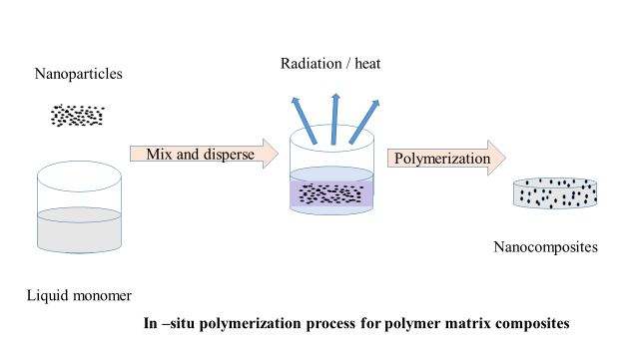
Figure 6. Schematic representation of in – situ polymerization process.

In in –situ polymerization process, strong surface interaction can be formed between conducting polymer matrix and carbon nanotubes to improve optical, electrical, magnetically etc. properties of CNTs [34-36]. MWNT/polypyrrole (PPy) was developed by Cho et al, using oxidant (ferric chloride) in polymerization of PPy on carbon nanotubes [37]. The layer thickness of polypyrrole (PPy) was controlled by altering the ratio of pyrrole/MWNT in fabricated MWNT/polypyrrole (PPy) nanotubes. On other hand Long et al. studied that conductivity of functionalized polymer nanotube (CNT/PPy) complex system could be increased with increasing the weight percentage of CNTs [38]. In in-situ polymerization process polyurethane/CNT composites were prepared by two way. In first method proper amount of carboxylate MWNT was mixed to a prepolyurethane mixture with 1, 4-butanediol (BD) in proper chain reaction. In other method, required amount of MWNTs were dispersed in poly (ϵ -caprolactone)diol (PCL). Then 4,4′ -methylene bis(phenylisocyanate) (MDI) was mixed with the dispersed solution. To synthesis PU-MWNTs complex nanocomposites 1, 4-butanediol (BD) was added to prepolymer finally [39]. This is very useful technique to synthesis or develop organic-inorganic nanocomposites with strong surface interaction with polymer network.

1.2. D. Carbon nanotube paper-based nanocomposites
There is various technique to prepare paper structured carbon nanotube. One-step and two-step methods are very useful technique to manufacture carbon nanotube paper. It is directly grown in one step method. From synthesized CNTs, carbon nanotube paper is manufactured in two-step method. Vacuum/pressure filtration, domino pushing and spin-coating are the process in two step method to prepare paper structured carbon nanotubes. The paper structured carbon nanotube film is known as bucky paper. It has attractive potential applications in biomedical (artificial muscles), in solid state devices (actuators, sensor), in charge storage devices (hydrogen storage materials, supercapacitors,), filtration and in so many other fields.
i) Direct synthesis
In this process, as a precursor, trichlorobenzene (TCB) is used to synthesis carbon nanotube paper in in situ. CVD method is also applicable to prepare carbon nanotube paper in direct synthesis technique. Carbon nanotube paper was synthesized with ferromagnetic metal nanowire in in-situ without surfactant but using trichlorobenzene (TCB) as precursor [40]. Synthesized carbon nanotube paper contains impurities.
ii) Vacuum/pressure filtration
In this method filter paper is used to separate the suspension of CNTs in four steps. At first CNTs are purified then proper solvent is used to disperse it uniformly to get a homogeneous suspension. In third step suspension of CNTs is filtrated under pressure or vaccume and lastly vacuum oven is used to dry filtrated suspension of carbon nanotube paper. This is easy, low-cost manufacturing process [41].

iii) Domino pushing method

To improve the thickness and alignment of carbon nanotube paper this method is develop to manipulate carbon nanotube arrays. The Domino pushing is a macroscopic manipulation technique of the alignment of CNTs array in a particular direction under magnetic field. This is used to align bucky papers with wide surface with in-situ and dry method. Figure 7, Explains the domino pushing method.
First, a membrane with micro-pores is used to cover the nanotubes. A constant pressure is applied in one direction by pushing a cylinder to force down the nanotube array. Due to van der Waals force array of nanotubes are attached to form an aligned nanotube paper like film. In next step, along with the membrane buck paper is peeled off from the silicon substrate. Ethanol is used to spread on the membrane surface to permeate through with enabling proper alignment of buckypaper to easily peel off from the micro porous membrane. The straight morphology of carbon nanotubes can be developed in this method without aggregation and waviness comparing with conventional CNTs. It is useful technique to improve the electrical, thermal properties of buckypaper for multifunctional applications of paper structured CNT composite films [7, 42, 43].

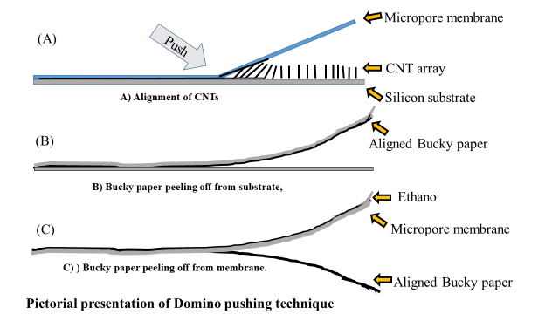

Figure 7. Schematic for Domino pushing method

iv) Spin-coating method

With uniformity CNTs paper like film can be developed from the solution of purified CNTs by spin coation method and using chemical oxidation it can be stabilized. In this technique dispersed carbon nanotube solution is poured in glass panel of the spinning. Thickness of it is dependent on spinning speed, solution concentration of CNTs etc. Uniform surface CNTs paper like film of very small thickness can be developed and controlled in this technique. It is widely used in the solar cell [44]. Schematic diagram of spin coating method is shown in Figure 8.
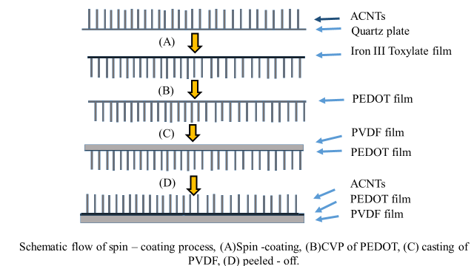
Figure 8. Schematic representation of spin coating method.

For unique chemical, mechanical and tailoring properties of nanocomposite materials have been taken the main attention of recent researchers in wide field of applications. Nanocomposite material with carbon nanotubes have been used to develop reinforced materials and in field of hydrogen storage device, nanoelectronics devices, emission devices and in other field of applications [45-48]. CNTs based polymer composite materials are developed for different applications with advanced properties which is related to fabrication process [49, 50]. Properties of CNTs-polymer composites are dependent on polymer matrix and processing method. So polymer selection should be proper as a polymer specific matrix material in CNTs-polymer composites. In processing method microstructural characteristics of CNTs (aspect ratio, diameter in size, purity) also plays important role for dispersion into polymer matrix, optimization properties and reinforcing effect of new nanocomposites. Alignment of CNTs effects on mechanical (strength, stiffness), optical, electrical, magnetic etc. properties of nanocomposite materials [51]. Liquid crystal matrix may be used to orient MWCNTs in an electric field [52]. In carbon nanotube polymer composites functionalization of CNTs are necessary to active surface area, to unbundle tubes, to active or add functional groups on the defect sides of end caps or the sidewalls, to make strong interfacial bonding between host polymer matrix and CNTs. Several functionalization techniques to active surface area of nanotubes are discussed below.

- Resin matrix-based polymer nano composite

In chemistry, resin is solid or semisolid or high viscous, reinforced natural or synthetic organic substance. To protect themselves from any injury or any attack from insects, plants usually secrete natural resin [53]. Artificial or synthetic resin is combination of hydrogen, oxygen, carbon, sulfur, nitrogen etc. atoms as a macromolecule or polymer. It is a combination of carbon-based polymers, monomers with some additives. It is commonly used in composites as a reinforce fiber to transfer load and to provide protection from damage. Most commonly thermosetting polymer is epoxy resin that is used widely in advance composite materials due to mechanical properties, chemical resistance, easy processability, low cost, adhesive property in many fields of applications such as electronics, semiconductor encapsulation, aerospace etc. Thermoset resin (epoxy resin, unsaturated polymer) are commonly used in fiber reinforced polymer to form strong cross-linking between polymeric chains and to form a non-reformable (or stable) matrix. The thermoplastic resin (polyamide, polypropylene) is used in fiber reinforced polymer with reformable week covalent bonds in polymer matrix. Nanocomposite resins are used in polymer composites as a filler to achieve interesting electrical, mechanical, optical properties etc. Metal oxide nanocomposites and carbon nanocomposites are mostly used in polymer matrix as a nanocomposite resin.

- Carbon nanocomposite resin
In recent technology it is extensively studied to develop new resin matrix with excellent properties using widely applicable carbon nano fillers in polymer composite system. carbon structure and easy uniform dispersion of carbon nanofillers in polymer matrix and strong interaction with strong interfacial bond with matrix such properties of carbon-based nanofiller resin are extensively used to improve or develop performance of polymer-based nanocomposites. For strong van der Waal force, large surface area etc. carbon nanocomposite resins show the tendency to stack and not to aggregate with polymer matrix. To overcome this limitation of carbon nanocomposite resin functionalization, chemical treatment, surfactants, ultrasonication etc. are applied. To enhance mechanical properties with electrical and thermal properties, usually a very little amount of carbon nanofiller is used develop polymer-based conducting nanocomposites. It was reported by Rahman et al, that 0.5-1.0 wt.% nanotube was used to make transition from an insulating state to conduction state of epoxy resin [54]. Carbon nanomaterials in polymer system is used to the properties of hardness, toughness, impact resistance and strength etc. to modify or develop the properties of carbon nanocomposite-based epoxy resin blending , processing , orientation , interaction with functional groups are most responsible parameter.
- Metal oxide nanocomposite resin
Surface interaction properties of nanomaterials are quite different and attractive due to large surface are compared to bulk materials. Metal oxide nanoparticles have tendency to combine and interact strongly with polymer matrix. Electrical conductivity property of polymer-based nanocomposite resin is much better or higher than pristine polymer (polyester) due to effect of ZnS nanoparticle [55]. Bouzidi et al. have been shown in their experiment that optical band gap energy also decreases with incorporation of little amount of nanoparticle of TiO₂ in polymer system. Metal oxide nanoparticle may help to expand valance band on the forbidden gap of pristine polymeric system [56].
  - A view on property augmentation of multifunctional polymer nano composite
Polymer nanocomposites are the hybrid materials of organic and inorganic materials. Nano scale size filler materials (i.e. nanotubes, nanoparticles etc.) are incorporated or dispersed in host polymeric system. Multifunctional polymer nanocomposite materials (MFPCMs) perform two or more than two constructive functions with increasing autonomy, lifespan, efficiency, light weight, low cost and so on without altering basic properties. Multifunctional polymer nanocomposites have attracted researcher’s attention in industrial and academia field of applications due to outstanding chemical, physical properties. Multifunctional polymer nanocomposites are applicable in field of aerospace (such as body flap, telescope tube, panel etc.), radar stealth (such as electronic parts, anechoic chamber etc.), nuclear protection (such as nuclear cladding materials etc.), heat engine (such as combustor liner, exhaust nozzle, turbine blade etc.), brake system and so on. MFPCMs are applicable in wide field of industrial application for their structural properties and non-structural properties. MFPCMs are one of the wide field of research to develop light weight composite material with property to resist deformation. Mecklenburg et al. have already developed a composite material of light weight with load resisting properties through chemical vapor deposition (CVD) process adjusting zinc oxide molcules with polymer matrix (polyvinyl butyra) [57]. New mechanical properties can be achieved by addition suitable nanoparticles with proper ratio in polymer based composite system. Mechanical properties such as fracture toughness, stiffness, load bearing etc. can be enhanced by little amount addition of carbon nanotube, SWCNT, MWCNT in polymer matrix composite. MFPCMs are also used in the application field of supercapacitors to improve electrical properties with structural properties. Carbon based fiber composites have strong influence on the electric charge storage properties [58]. Multifunctional polymer composites are used as thermal storage, thermal conductor, and also thermal insulator with mechanical strength. Thermally conducting polymer composite materials are used in charge storage device, electrical batteries with efficiency of good heat dissipation at the charging and discharging period [59]. J. Che et al. have been established the improvement of thermal conductivity of high density polyethylene (HDPE), carbon nanotubes (CNT) and boron nitride (BN) composites in presence of filler [60]. Non-structural functional properties such as energy storage capacity, biodegradability, self -healing, adsorption etc and structural properties such as stiffness, strength, toughness etc. can be modified in polymer nanocomposite materials with application of filler through proper functionalization process.
- Functionalization of carbon nanotube with polymer

Carbon based nanotubes with diameter of nanometres, takes attention in young researcher, due to its functionalization property. Comparably CNT is chemically more inert within other forms of carbon. Functionalization of CNT is improving its dispersion state or changing or modifying the functional groups of surfaces which has important role to decrease long range Vander Waal force and improve interactions in polymer nanocomposite materials and stabilize CNTs within polymer matrix to get homogeneous dispersion and to improve solubility in deferent media and to attach with polymer chain. Chemical modification on the surface area of CNTs improve its dispersion state, to modify its characteristics, strength of interface, to change the properties of polymer nanocomposite materials and stabilize it within polymer matrix [3]. Polymer nanocomposites are multiphase system with two or more Nano polymeric and polymeric components.
Chemical modification of surface of CNTs have great role in various applications due to surface interaction of CNTs and polymer chain etc. So, method of functionalization is also important to modify the dispersion property as well as mechanical properties.
  - Chemical functionalization CNC-polymer matrix
Due to unique properties of carbon nanotubes, it is used in different filed of research applications. So, functionalization is necessary to exploit CNT’s all possible properties in various field of application. Through functionalization surface properties of CNTs can be modified to attaching with different functional groups, polymer matrix and to soluble in different media. Various Functionalization techniques have been developed to modify dispersion state of CNTs of surface functional group to make strong interaction at interfacial section. In chemical interaction usually into polymer composite system CNTs show nonreactive nature and week interaction at surface area that causes uneven load distribution or transfer and phase separation. So, surface modification or functionalization is necessary to improve physical, mechanical properties of CNTs to improve strength of interaction.
  - An insight on CNC-polymer interface and interaction improvement methods
There are so many functionalization techniques are developed to modify surface interaction property of carbon nanotube in to polymer composite system. Mainly it is classified in Exohedral approach and Endohedral approach depending on modification of outer surface of CNTs or inner surface of CNTs. Functionalization method of carbon nanocomposite polymer is shown in Figure 9.
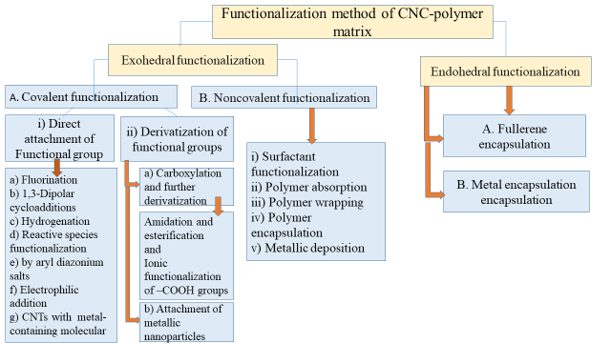
Figure 9. Functionalization method of polymer carbon nanocomposites.
2.2.1. Exohedral functionalization:
In this functionalization technique, physical and chemical property of outer wall of CNTs is modified by covalent, non-covalent bonding of functional groups of any size between it to polymer system. There is limitations related to size of functional groups such as endohedral functionalization technique. Exohedral functionalization technique mainly classified into two classes;
- Covalent functionalization
- Noncovalent functionalization
2.2.1. A. Covalent Exohedral functionalization:
Most common technique to modify functional groups onto the side surface or ends of CNTs is modifying covalent bond between CNTs and polymer matrix , by hybridization of carbon atom from sp2 to sp3 [61]. In simple words it can say that through this functionalization carbon atoms can changes to sp³ from sp². Intrinsic properties of carbon nanotubes may alter through covalent modifications to improve compatibilities and solubilities etc. It is the functionalization of covalent chemistry or linking of carbon atom with polymer system. Covalent exohedral functionalization is irreversible linking with the carbon atoms located at the boarder or outer wall of tube (especially side wall (through side wall functionalization), defect area or points (through defect functionalization)) with polymer chain by grafting to or grafting from mechanism [62]. The pictorial representation of “Grafting to” and “ Grafting from” approaches are shown in figure 10.

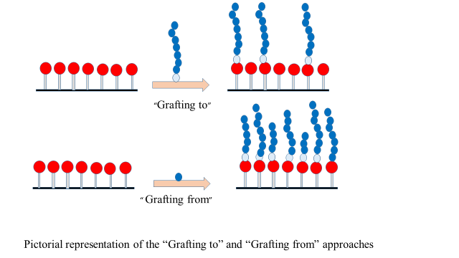
Figure 10. Schematic of Grafting to and grafting from approaches.
Covalent Hexahedral functionalization is classified into two categories depending on modification of functional groups,
- Direct attachment of Functional group
- Derivatization of (Carboxylic or hydroxyl) functional groups

2.2.1. A. i) Direct attachment of Functional group
- Fluorination
Fluorination is a functionalization process where fluorine is covalently attached to the side wall of single wall carbon nanotube (SWNT) at different temperature [63]. Degree of fluorination is depended on temperature of reaction. Generally this process is allowed at temperature 150C to 600C. This process helps to improve solubility of SWNT in organic solvent. With IR spectroscopy, Raman spectroscopy new covalent carbon bond formation was confirmed by Mickelson et al.[64]. Electronic property can be modified through fluorination with different temperature. On the other hand defluorination (removing fluorine from single wall carbon nanotube) is possible using anhydrous hydrazine and it is confirmed through SEM and Raman studies.
- 1,3-Dipolar cycloadditions
This functionalization technique is applicable to SWCNTs and MWCNTs to modify solubility in organic solvent like acetone, methanol, chloroform etc and water. Azomethine ylides (condensed an aldehyde and α- amino acids) attack the sidewall and the tips of p-system of the CNT. Many pyrrolidine rings of different chemical functionalities, can attached to with C-C bonds of CNT through this reaction, to construct novel materials with wide application [65].
- Hydrogenation
It is a useful technique to develop C-H bond of CNTs. Pekker et al. had shown in their research in liquid ammonia the hydrogenation is possible to SWNTs and MWNTs via dissolved metal reduction method [66]. Chemically hydrogenated structure of CNTs can be studied through transmission Electron Microscopy (TEM). To modify chemical and physical properties of SWNTs, gas phase technique is very useful to CNTs with hydrogen atom at low temperature and through FTIR atomic hydrogen bonds with SWNTs can be studied [63].
- Reactive species functionalization
In this side walled nanotubes functionalization technique, unsaturated pi electron of nanotube directly reacting with three reactive species like nucleophilic nitrenes, carbenes and radicals is discussed [67]. To improve solubility property in solvent sidewall functionalization technique of CNTs is used to develop new polymer composites with new electronic and chemical structure.
To functionalize carbon nanotubes direct addition of nitrenes is one of the way. In an ultrasound bath over few hours 1,1,2,2-trtrachloroethane (TCE) is used to redisperse SWNTs in nitrogen atmosphere under heating condition. Similarly, to generate dipyridyl imidazolidene, dipyridyl imidazolium was used in carbon addition with SWNTs [68]. Ying et al. [69] it was shown that that, a new free radical is formed by decomposition of benzoyl peroxide with alkyl iodides, to functionalized SWNTs by alkyl groups.
- Functionalization by reduction of aryl diazonium salts
Aryl diazonium salts is used to enhance reactivity of SWCNTs with small diameter to nanotubes with large diameter. Electro chemically or at room temperature Nanotubes can be functionalized with aryl moieties using a variety of aryl diazonium salts. In argon atmosphere this functionalization can be remove with sufficient heating [68].
- Electrophilic addition.
It was reported by Tagmatarchis and co-workers that carbon nanotubes have been functionalized as organic macromolecule by derivatization process of an Electrophilic addition in the presence of aluminium trichloride (AlCl₃), with addition of CHCl₃ [70]. There are free functional groups present on the skeleton of CNTs after this functionalization technique. Reaction scheme for the functionalization of SWNTs is shown in figure 11.
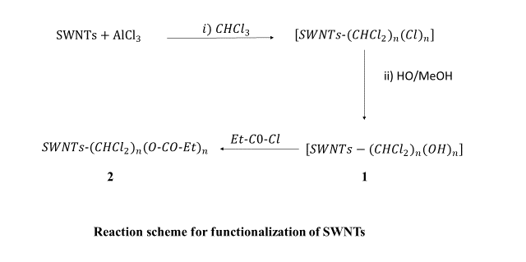
Figure 11. The reactive scheme for functionalization of SWNT’s

- Functionalization of CNTs with a metal-containing molecular complex
Raw, purified and oxidized CNTs have been functionalized with Vaska’s complex. A metal complex is formed by the reaction with unsaturated Vaska’s compound trans-chlorocarbonylbis (triphenylphosphine) iridium to CNTs by coordination of oxygen atom. This type of oxidized carbon nanotubes is soluble and stable in organic solutions [71]. Figure 12 shows the synthesis scheme for the said compound. It is reported that, the compound complexes to raw nanotubes by η2 coordination across the graphene double bonds, as denoted in Figure 3a. For the oxidized carbon nanotubes, coordination through the oxygen atoms seems a more likely possibility, in other words through an oxidative addition to form a hexacoordinate structure, as illustrated in Figure 3b.
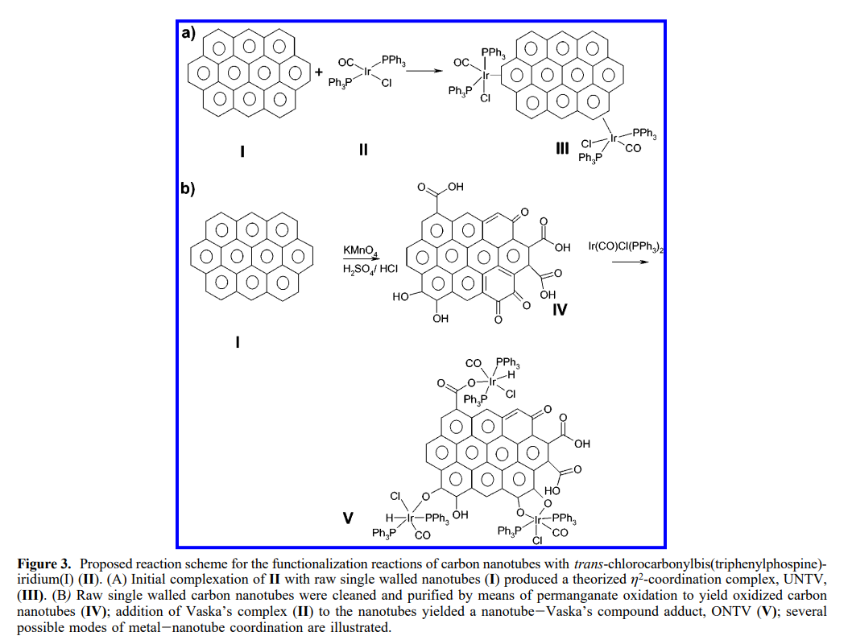

Figure 12. Synthesis scheme for Vaska’s compound trans-chlorocarbonylbis (triphenylphosphine) iridium to CNTs [with copyright permission obtained from ACS [71]]
2.2.1.A.ii) Covalent functionalization by derivatization of (Carboxylic or hydroxyl) functional groups
- Carboxylation and further derivatization.
Purification of carbon nanotubes is the process to remove the impurities like metal particles, amorphous carbon, multishell carbon nano capsules by oxidation, ultra-sonication, bromination, acid treatment and heat treatment in hot water [72]. Here the purification of CNTs by oxidation method in acidic media is focused. In this purification method, end caps of CNTs become acidic (-COOH) and opened and other (-OH) groups are functionalized for further derivatization. At high temperature CNTs can be purified by oxidation in air and also at low temperature oxidation in the liquid of potassium permanganate [73].

- Amidation and esterification of –COOH groups via covalent linkages

Carbon nanotubes can be divided in two parts, like a) the side wall and b) the end caps. Niyogi et al. studied on the use of acid groups to attach alkali chain to the SWCNTs via formation of amide or ester bond [74]. In their work, open ends of NTS were functionalized through functionalization of associated carbons and defects after removing the end caps. To functionalize the carbon nanotubes by oxidized method, amidification and esterification takes play great role. In Fig.13 carboxylic acid derivatization protocol is shown.
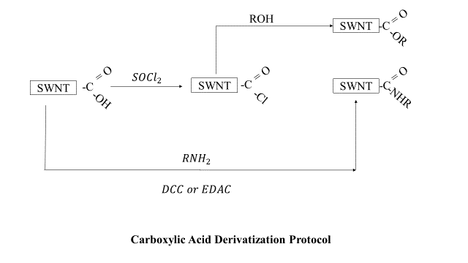
Figure 13. Protocol for carboxylic acid protocol

- Ionic functionalization of –COOH groups
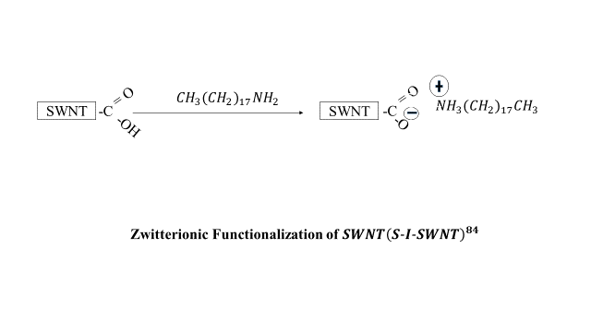
As a nanoscale conductor, composite material, SWCNTs are used widely. Ionic functionalization has been carried out by the reaction of SWNTs –COOH (non covalent functional group) with octadecylamine (s-l-SWNT), to form SWCNT-carboxylate zwitterions [74]. By any other inorganic and organic cations, (+NH3 (CH2)17CH3) can be exchanged in the ionic bond of SWNT-COO- +NH3 (CH2)17CH3 (shown in above figure). Such ionic feature can help to develop biocompatible SWCNTs by electrostatic interaction between biological molecule and SWCNTs. Reaction scheme for Zwitterionic functionalization of SWNT (S-I-SWNT)⁸⁴ is shown in Figure 14.

Figure 14. Reaction scheme for Zwitterionic functionalization of SWNT

- Attachment of metallic nanoparticles.
To functionalize carbon nanotubes inorganic materials used through chemical or electro chemical reaction. Metals (like Ag, Pt, Au, Pd), metal carbides (i.e. TiC etc), metal oxide (i.e. Fe₂O₃, ZnO etc), metal nitrides (i.e. Fe2N, TiN etc) and metal chalcogenides (i.e. CdSe, CdS etc.) have been used to modify the functionalities of CNTs [75]. Nanoparticles Pt, Ru, alloy PtRu have been used for deposition [76].
2.2.1.B. Exohedral noncovalent functionalization:
This is a more acceptable functionalization process than other, because it does not alter any physical property of CNTs to improve processabilities, solubilities, surfactants and wrapping with polymers etc. In exohedral noncovalent functionalization process, hydrophobic components of absorbed molecules interact with the outer surface of CNTs with π- π, van der Waals and other interactions. It is much more useful technique to prepare organic and aqueous solution polymer and CNTs with surfactants [63,77]
- Surfactant functionalization
Surfactant based modification is very common technique in non covalent exohedral modification. CNTs can be dispersed via physical adsorption in Ionic and non ionic surfectants, with hydrophobic tails and hydrophilic heads (like sodium dodecyl benzene sulfonate (SDBS), sodium dodecyl sulphate (SDS), Tween, cetyltrimethyl ammonium bromide (CTAB), Triton X, Brij etc. Hydrophobic SWNTs can be stabilized by micelles (greater than critical micellar concentration of surfactant) inner core for. Here, concentration and nature and structure of surfactant is very important to solubilize and disperse CNTs [71].

- Polymer absorption
Pyrene is very effective system with carbon nano tubes due to its large aromatic structure. To anchored biomolecules, protines the functionalized pyrenes is used. Due to hydrophilic groups like carboxylates, ammonium ions and copolymer group of pyrenes, it helps CNTs to soluble in aqueous medium. Another polyaromatic molecules, anthracenes forms π-π interactions with CNTs. With stronger interaction, anthracenes can be replaced by pyrenes. Phthalocyanines and porphyrins, due to the heterocyclic polyaromatic molecules also show strong interactions with tubes. Nakashima and co-workers show that in dispersive medium porphyrin helps to disperse CNTs [78].

- Polymer wrapping
To enhance solubility of carbon nanotubes amphiphilic polymers are commonly used over other surfactants of small molecules. Small molecules are less interactive than some conjugated polymers. Polymer having hydrophilic pendent groups and hydrophobic back bone, like PVP, interact with the surface of nanotubes. It is also possible to unwrap CNTs in other solvent[79]. In polymer wrapping technique water soluble PEXO (poly(2-ethyl-2-oxazoline)) can be used to functionalize MWCNTs. In water and other organic solvents (i.e. N,Ndimethylformamide (DMF), ethanol ) functionalized MWCNTs show stable dispersion [80]. In polymer wrapping technique with nanotubes polynucleotides form helical wrapping due to its hydrophilic back bone and hydrophobic base. To increase solubility biological molecules like protein, peptides, are used to interact with outer surface of CNTs.
- Polymer encapsulation
In surface modifications polymer encapsulation is a useful non-covalent technique. Here polymer is used to encapsulate into the nanotube with strong interaction without altering basic electronic properties and to improve compatibilities between CNTs and polymer. To form electrode an active polymer is encapsulated into the tube. oppositely little amount of CNTs encapsulation in polymer helps to enhance the strength of the polymer [81,82].

- Metallic deposition
Metal like Au, Pt, Pd etc. (nanoparticles) can be deposited successfully on carbon nano tubes by different technique like electrochemical deposition etc. to functionalize CNTs. Carbon nanotubes is also deposited into metal or metallic material to modify metallic properties of Metal/CNT composites. Sidewall of nanotubes is less active than tube end. In metallic deposition technique both side wall and tube end are uniformly plated by deposition technique under potential control. Particle Size, deposited area of CNTs can be controlled by the deposition time, nature of solvent etc. [83].
2.1.2 Endohedral functionalization

Endohedral functionalization technique is used to functionalize or modify the inner part (strong binding energy) of carbon nanotubes to trap polymer macromolecules. In this case nanotubes are considered in nanometre in size with nano space inside the tube for new reaction which may not take place at the outer surface of the tube. This technique is limited by inner diameter of tubes over so many advantages [84]. Inner cavity space of the tube may help to interact strongly with polymer macromolecules and protect other guest molecules.

2.2.2. A. Fullerene encapsulation
In the chemistry of endohedral functionalization, fullerene encapsulation is the process to modify the properties of the inner environment of the defect area in the sidewalls or ends of the nanotubes by the incorporation of metallofullerenes (Sm@C82) or fullerenes (C60 and C70) to develop new comprised hybrid structure of SWCNTs. Incorporation of molecular species into the nano space or inner area of CNTs can be modify the electronic properties [85,86].
2.1.2. B. Metal encapsulation
Few metallic materials or metal particles are used to encapsulate inner part of nanotubes. Metal encapsulation can be processed by in situ and wet chemical methods. Incorporation of nanoparticle into CNTs tubes, helps to decrease the diameter of the tube [87]. The wet chemistry encapsulation process is applicable to the nanotube with diameter not more than 2nm [88,89]. The precious and non-precious metallic nano particles (like Au, Pts, Ag, etc. and Ni, Fe, Cu etc.) can be incorporate into CNTs nanotubes in wet chemistry [ 90-95]. The main limitation of this process is poor filling efficiency in the narrow tubes.

  - Property augmentation upon improved interfacial interaction in CNC-polymer
For unique mechanical and physical properties of carbon nanotube, it plays an important role in new reinforced polymer matrix-based nanocomposite materials for structural and functional applications. Incorporation of little amount of carbon nanotube helps to improvement of mechanical and physical properties of nanocomposites. Properties of the carbon nanotube polymer-based nanocomposite materials are attached to many factors related to CNTs such as orientation of CNTs with polymer, aspect ratio of CNTs, defects or impurities in CNTs, purification method of CNTs, dispersion rate of CNTs in host polymer matrix etc. Synthesis method of used to develop carbon nanotubes as well as CNT-polymer nanocomposites also takes attention of researchers. Tailoring the doping level of nitrogen in CNTs, the electrical conductivity of CNT-polymer composite materials can be altered. Conducting polymer such as polyaniline interact strongly with CNTs. Conducting Polyaniline is used to increase absorption capacity of CNTs on the interface of the host polymer to improve the properties of polymer – carbon nanocomposite product material [96]. Similarly little amount of CNTs is used to develop polymer blend composite material to change morphological structure of end nanocomposite material [97]. The migration property of CNTs between different phases helps to change morphological structure of polymer matrix-based blend nanocomposite materials [98].
Electrical properties of polymer composites materials can be enhanced by the use of small amount of CNTs as a conducting filler [99,100]. Researchers are like to use CNTs as a conducting filler in polymer-based nanocomposites in various field of applications such as electromagnetic interference shielding [101,102]. Polymer based CNTs nanocomposite materials with low density and high processability are used for shielding [103]. The pristine CNTs are used to improve electrical conductivity in polymer-based nanocomposite materials.
Mechanical properties of polymer-based carbon nanocomposite materials can be improved by the use of carbon nanotube as a reinforce material. As a nano filler CNTs are widely used for its unique mechanical properties, high aspect ratio, fibre structure, low density etc. to reinforce thermoplastic and thermoset polymer [104-108]. As a filler CNTs are also used to improve mechanical properties like modulus and tensile strength of polymer-based nanocomposite materials.
Thermal conductivity of Single-walled carbon nanotubes is very high due to large length of phonon mean free path. Single walled carbon nanotubes widely used to improve thermal properties or thermal conductivity of nanocomposite materials to use composites in different field of applications such as in batteries, in heat sinks, connectors, packaging, electronic control devices, light emitting diode and other thermal control units [109,110]. Thermally conducting polymer-based carbon nanocomposite materials can be applicable as a shielding in electromagnetic interface as a thermal insulator [111]. Due to high thermal resistance in the interface between polymer network and CNTs can resist heat flow in polymer nanocomposite material [112,113]. Oppositely thermal properties can be improved by quick heat transfer across the interface. The chemical functionalization of CNTs can increase thermal conductivity across the interface with decreasing thermal conductivity of the filler in polymer nanocomposite materials [114]. Still now it is a major challenge to develop a composite material to get maximum benefits from the basic thermal properties of CNTS in polymer-based nanocomposites.

- Challenges and prospects of green polymer nanocomposite

Polymer nanocomposites are used in many fields of applications for its unique chemical, physical and other properties. In recent technology green polymer composites are promising alternative to other conventional composites in packaging and automotive industries, medical applications (like pharmacology, surgery), agriculture and so other field of applications due to its unique properties. It has both properties of organic polymer and natural fiber. Green polymers are renewable, environment friendly, bio degradable, sustainable, bio reinforced with relatively low cost, high stiffness and strength nanocomposties with low CO₂ emission during processing time [115]. Eco friendly polymers are used to save or protect environment from toxic materials, generating plastic waste etc [116]. In green polymer, host polymer matrix of the composite material should be renewable, biodegradable as well as environment friendly. Biodegradable polymer should be degrade in nature with changing structural property, chemical property and mechanical strength without any toxic effect to the environment. The green polymers are mostly natural polymer. Microorganisms and enzymes are used to degrade such polymers composites to other nature friendly compound [117].
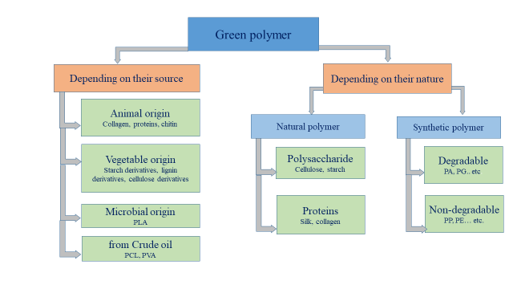
Figure 15. Classifications of green polymer is shown in above figure
Biodegradable polymers should be synthesized in natural environment. Chitin, cellulose, starch, collagen, polylactide, polyhydroxyalkanoates, polycaprolactone and other polypeptides etc. are the example of biodegradable polymers [118, 119].
  - Green aspect of polymer nano composite
Green polymers are source renewable, biodegradable, compos able, environment friendly, producing less CO₂ at the processing time. It may be categorized in biodegradable polymer or biopolymers, source renewable polymer and recyclable polymer. The source renewable polymers are mainly based on animal body or plant fiber and source of synthetic polymers are derived from petroleum crude oil. From renewable sources sustainable polymer can be develop through their chemical modifications of starch, cellulose, chitin like natural polymer. Bio polymers also can be prepared from biomass like plant oils, lignin etc. through two step processing technique [120, 121]. Now a days researchers are interested to develop or use green polymers in modern eco friend environment due to its unique and superior properties like high flexibility, anticorrosive, light weight, energy saving, reusable or recyclable, easy processable etc. [122, 123].

  - Polymer-polymer blend based composite

Researchers are interested to achieve biodegradable new polymer composite by blending with two or more than two polymers. Poly (lactic acid) (PLA) is a very popular, widely used polymer to produce bio compatible, biodegradable, bio based polyester. To overcome its very low toughness with high brittleness property another polymer is used to blend with PLA. Very common biodegradable polymer such as poly (butylene succinate-co-butylene adipate) (PBSA) and poly (butylene adipate-co-butylene terephthalate) (PBAT) are used to blend with PLA to produce green polymer without causing any hazards on human life or environment [124]. Thermoplastic starch with polyesteramide blends, starch with modified polyester blends, polycarprolactone with poly vinyl alcohol blends etc. are some polymers blended composite [125-127].
  - Application and challenges of green polymer nano composite
The green polymer-based nanocomposites have been used in many fields of applications in our daily life such as door panel, door handles, instrument panel, trunk liner, engine covers, vacuum cleaners, covers for portable electronic devices, bags etc shown in Figure 16 [128-130]. Depending on barrier properties, surface properties and also chemical resistance, nanocomposites have been used in food packaging industries like drink bottles, fruit juice paperboard. In tissue implantation engineering PLA based nanocomposites have been used as a non-toxic, eco-friendly composite material [131] as a light weight material in aerospace it may have future application. It is a great challenge to new researchers to design or achieve new eco-friendly, renewable or source renewable polymer matrix nanocomposite with safety and causing less waste products.
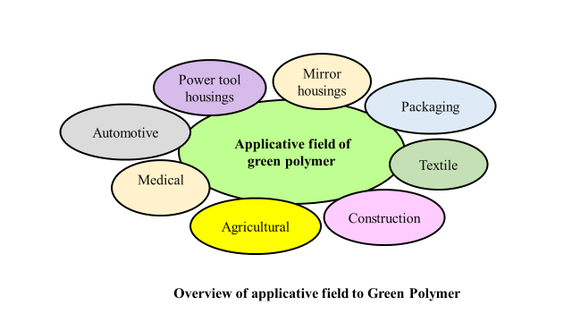
Figure 16. Applicative fields of green polymer

- Mechanistic understanding on role of nanoscale fillers on interfacial chemistry of polymer nano composite
Polymer nanocomposites are the combination of polymer with other materials. To overcome some limitations and make it wide applicable in different fields, nano particles or nanoscale fillers are used to improve or modify physical, chemical properties of polymer over conventional composite materials. Nano fillers are used to adjust or modify properties (such as electrical, optical, thermal properties and mechanical etc.) of polymer composite in proper ratio with organic matrix. Nano fillers are mainly classified as organic (cellulosic and carbon black etc.) and inorganic (calcium carbonate (CaCO3), silica (SiO2) and titanium dioxide (TiO2) etc.) fillers. Depending on the size or dimension of the filler polymer nanocomposites mainly classified in three categories. Nanofillers can be commonly classified in three main categories on basis of their size or dimension such as i) zero-dimensional (0D) spherical ones (silica nanoparticles [132], quantum dots [133] etc.), ii) one-dimensional (1D) fibrous (carbon nanotube and nanofiber [134] etc.) and iii) two-dimensional (2D) layered (graphene [135], silicate [136], nano clay [137] etc.).
Nanofillers are used to add in polymer matrix in 1 to 10% of weight (of the host polymer) [138]. Classification of nanoparticles depending on their size is summarized in Table1. Polymer nanocomposites are composite materials of host polymer matrix with dispersed nanoscale filler combination. Properties of polymer-based nanocomposite materials show unique interesting new properties rather than individual properties of individual composites depending on the following parameters i) shape and dimension of filler, ii) properties, orientation of filler materials iii) fabrication technique, iv) adhesive properties of filler and host polymer interface, v) volume ratio of filler, vi) phases of filler and host matrix and vii) morphology of the composites, etc. [139-141].

Table 1 Classification of Nanofillers

One– dimension nanofiller | Two–dimension nanofiller | Three–dimension nanofiller
Nanographene platelets  Montmorillonite Clay  ZnO nanoplatelets  Carbon nanoballs | Cellulose nano whiskers  Carbon nanotubes  Sisal fiber  Graphene oxide | Silica  Carbon black  Nano alumina  Quantum Dots
Nanoplate  Thickness <100nm | Nanofiber  Diameter <100nm | Nanoparticles  All dimensions <100nm

Properties of polymer nanocomposites can be enhanced by the nature of surface properties and interaction between host polymer matrix with incorporated dispersed nano fillers. Well and homogeneous dispersion and distribution of the nanofiller is very essential to get uniform modified properties of nano composites [142].

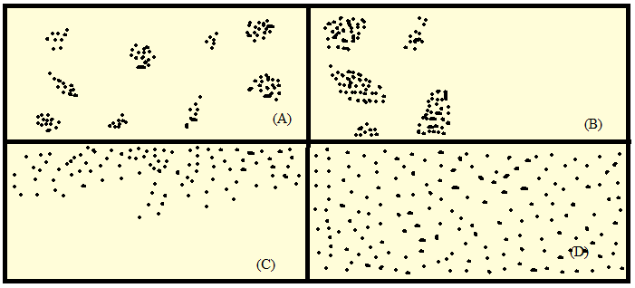
Figure 17. Figure shows nanoparticles (NP) in polymer matrix, (A) poor dispersion but good distribution of NP, (B) poor dispersion and poor distribution of NP, (C) good dispersion but poor distribution of NP and (D) good distribution and good dispersion of NP.

In polymer nanocomposites nanofiller selection is very important for the specific applications or objectives, characteristics, interfacial area and interaction between nanofiller and polymer matrix. Interfacial area and interfacial interaction can be improved or modified the properties of polymer nanocomposites by the proper selection of nanofiller. The properties of polymer nanocomposites can be tailored with surface modifications to use it various field of applications [143]. Incorporation of very little amount nanoscale filler into polymer matrix can be used to enhance physical and mechanical properties. Properties of polymer nanocomposites also depends on filler size, filler types, filler surface interaction with polymer network, dispersion properties, processing method etc.

- Conclusions

In a nutshell, the present context highlights the significance of polymer in present scenario exhibiting the mechanistic approach as well. Nano functionalization is described to showcase its significance in property augmentation and ensuring biocompatible nature. Surface exposure of polymer composite imbibes unbalance or uncompromised forces or interactions which are primarily responsible for lower activation barrier for reaction and nano functionalization of the film/composite. A detailed description is presented on the novelty, processing, function and outcome of the targeted polymer systems. This interaction termed as host guest interactions are effective in ensuring the cavitation and core-shell matrix generation.

Acknowledgement
MM intend to acknowledge MAKAUT WB, Kolkata for providing infrastructural support for carrying out a part of experimental work. AD, SB, and Dr. Moumita Mukherjee acknowledges Adamas University, Kolkata for their extended support.

References
- Recent Advances in Functional Polymer Materials for Energy, Water, and Biomedical Applications: A Review Yassine EL-Ghoul 1,2,* , Fahad M. Alminderej 1,*, Fehaid M. Alsubaie 3,*, Radwan Alrasheed 4 and Norah H. Almousa 3
- Fundamentals of Nanomaterials and Polymer Nanocomposites Niranjan Karak,
- A review of the interfacial characteristics of polymer nanocomposites containing carbon nanotubes Junjie Chen, * Baofang Liu, Xuhui Gao and Deguang Xu,
- A brief review on polymer nanocomposites and its applications M. Muhammed Shameem a , S.M. Sasikanth a , Raja Annamalai b , R. Ganapathi Raman,
- Polymer Nanocomposites in Sensor Applications: A Review on Present Trends and Future Scope Prashant Shuklaa* and Pooja Saxena
- Gusev, A.I., Rempel, A.A., 2004. Nanocrystalline Materials. Cambridge International Science Publishing, , Cambridge. http://refhub.elsevier.com/B978-0-12-814615-6.00001-1/rf0105
- Processing of polymer nanocomposites J. GOU, J. ZHUGE and F. LIANG, University of Central Florida, USA
- Zhang WD, Shen L, Phang IY, Liu T. Carbon nanotubes reinforced nylon-6 composite prepared by simple melt-compounding. Macromolecules 2004; 37:256–9
- Bocchini S, Frache A, Camino G, Claes M. Polyethylene thermal oxidative stabilisation in carbon nanotubes-based nanocomposites. Eur Polym J 2007; 43:3222–35
- McNally T, Potschkeb P, Halley P, Murphy M, Martin D, Bell SEJ, et al. Polyethylene multiwalled carbon nanotube composites. Polymer 2005; 46:8222–32.
- Potschke P, Fornes TD, Paul DR. Rheological behavior of multiwalled carbon nanotube/polycarbonate composites. Polymer 2002; 43:3247–55
- Pötschke P, Bhattacharyya AR, Janke A. Melt mixing of polycarbonate with multiwalled carbon nanotubes: microscopic studies on the state of dispersion. Eur Polym J 2004;40:137–48.
- Zeng J, Saltysiak B, Johnson WS, Schiraldi DA, Kumar S. Processing and properties of poly(methyl methacrylate)/carbon nano fiber composites. Compos Part B 2004; 35:173–8.
- Gorga RE, Cohen RE. Toughness enhancements in poly(methyl methacrylate) by addition of oriented multiwall carbon nanotubes. J Polym Sci Part B Polym Phys 2004;42:2690–702.
- McNally T, Potschkeb P, Halley P, Murphy M, Martin D, Bell SEJ, et al. Polyethylene multiwalled carbon nanotube composites. Polymer 2005;46:8222–32
- Valentini L, Biagiotti J, Kenny JM, Santucci S. Morphological characterization of single-wall carbon nanotube/polypropylene composites. Compos Sci Technol 2003;63:1149–53.
- Siochi EJ, Working DC, Park C, Lillehei PT, Rouse JH, Topping CC, et al. Melt processing of SWNT-polyimide nanocomposite fibres. Compos Part B 2004;35:439–46.
- Tang W, Santare MH, Advani SG. Melt processing and mechanical property characterization of multi-walled carbon nanotube/high density polyethylene (MWNT/HDPE) composite films. Carbon 2003;41:2779–85
- Jin, L., Bower, C. and Zhou, O., ‘Alignment of carbon nanotubes in a polymer matrix by mechanical stretching’, Applied Physics Letters , 1998, 73 , 1197–1199.
- Li C, Pang XJ, Qu MZ, Zhang QT, Wang B, Zhang BL, et al. Fabrication and characterization of polycarbonate/carbon nanotubes composites. Compos Part A 2005;37:1485–9
- Safadi B, Andrews R, Grulke EA. Multiwalled carbon nanotubes polymer composites: synthesis and characterization of thin films. J Appl Polym Sci 2002;84:2660–9.
- Kota AK, Cipriano BH, Duesterberg MK, Gershon AL, Powell D, Raghavan SR, et al. Electrical and reheological percolation in polystyre/MWCNT nanocomposites. Macromolecules 2007;40:7400–6
- Qian D, Dickey EC, Andrews R, Rantell T. Load transfer and deformation mechanisms in carbon nanotube-polystyrene composites. Appl Phys Lett 2000;76:2868–70.
- Yang J, Hu J, Wang C, Qin Y, Guo Z. Fabrication and characterization of soluble multi-walled carbon nanotubes reinforced P(MMA-co-EMA) composites. Macromol Mat Eng 2004;289:828–32.
- Chen W, Tao X. Self-organizing alignment of carbon nanotubes in thermoplastic polyurethane. Macromol Rapid Commun 2005;26:1763–7.
- Wong M, Paramsothy M, Xu XJ, Ren Y, Li S, Liao K. Physical interaction at carbon nanotube-polymer interface. Polymer 2003;44:7757–64.
- Song YS, Youn JR. Influence of dispersion states of carbon nanotubes on physical properties of epoxy nanocomposites. Carbon 2005;43:1378–85
- Chae HG, Sreekumar TV, Uchida T, Kumar S. A comparison of reinforcement efficiency of various types of carbon nanotubes in polyacrylonitrile fiber. Polymer 2005;46: 10925–35
- Shaffer MSP, Windle AH. Fabrication and characterization of carbon nanotube/poly(vinyl alcohol) composites. Adv Mater 1999;11:937–41
- Bin Y, Kitanaka M, Zhu D, Matsuo M. Development of highly oriented polyethylene filled with aligned carbon nanotubes by gelation/crystallization from solutions. Macromolecules 2003;36:6213–9
- Ray, S. S. and Okamoto, M., ‘Polymer/layered silicate nanocomposites: A review from preparation to processing’, Progress in Polymer Science , 2003, 28 , 1539–1641
- Yano, K., Usuki, A. and Okada, A., ‘Synthesis and properties of polyimide– clay hybrid’, Journal of Polymer Science Part A: Polymer Chemistry , 1997, 35, 2289–2294.
- Zeng, C. and Lee, L. J., ‘Poly(methyl methacrylate) and polystyrene/clay nanocomposites prepared by in situ polymerization’, Macromolecules , 2001, 34, 4098–4103.
- Karim MR, Lee CJ, Park YT, Lee MS. SWNTs coated by conducting polyaniline: synthesis and modified properties. Synt Met 2005;151:131–5
- Fan J, Wan M, Zhu D, Chang B, Pan Z, Xie S. Synthesis, characterizations, and physical properties of carbon nanotubes coated by conducting polypyrrole. J Appl Polym Sci 1999;74:2605–10
- An KH, Jeong SY, Hwang HR, Lee YH. Enhanced sensivity of a gar sensor incorporating single-walled carbon nanotube-polypyrrole nanocomposites. Adv Mater 2004;16:1005–9
- Sahoo NG, Jung YC, So HH, Cho JW. Polypyrrole coated carbon nanotubes: synthesis, characterization, and enhanced electrical properties. Synth Met 2007;157. p. 179–374
- Long Y, Chen Z, Zhang X, Zhang J, Liu Z. Electrical properties ofmultiwalled carbon nanotube/polypyrrole nanocables: percolationdominated conductivity. J Phys D Appl Phys 2004;37:1965
- Yoo HJ, Jung YC, Sahoo NG, Cho JW. Electroactive shape memory polyurethane nanocomposites from in-situ polymerization with carbon nanotubes. J Macromol Sci Part B Phys 2006;45:441–51.
- Lv, R. T., Tsuge, S., Gui, X. C., et al ., ‘In situ synthesis and magnetic anisotropy of ferromagnetic buckypaper’, Carbon , 2009, 47 (4), 1141–1145.
- Liu, J., Rinzler, A. G., Dai, H. J., et al ., ‘Fullerene pipes’, Science , 1998, 280 (5367), 1253–1256.
- D. Wang, P.C. Song, C.H. Liu, W. Wu and S.S. Fan, Nanotechnology, 19, 075609 (2008).
- Li, Y. H., Zhao, Y. M., Roe, M., et al ., ‘In-plane large single walled carbon nanotube fi lms: In situ synthesis and fi eld emission properties’, Small , 2006, 2 (89), 1026–1030
- Ago, H., Petritsch, K., Shaffer, M. S. P., et al ., ‘Composites of carbon nanotubes and conjugated polymers for photovoltaic devices’, Advanced Materials , 1999, 11 (15), 1281–1285.
- Chen P, Wu X, Lin J, Tan KL. High H2 uptake by alkali-doped carbon nanotubes under ambient pressure and moderate temperatures. Science. 1999;285:91–3
- Cao Q. Carbon nanotube transistor technology for More-Moore scaling. Nano Res. 2021;14:3051–69
- Dwivedi N, Dhand C, Carey JD, Anderson EC, Kumar R, Srivastava AK, et al. The rise of carbon materials for feld emission. J Mater Chem C. 2021;9:2620–59.
- Shoukat R, Khan MI. Carbon nanotubes: a review on properties, synthesis methods and applications in micro and nanotechnology. Microsyst Technol. 2021;27:4183–92
- B. P. Grady, Carbon Nanotube-Polymer Composites: Manufacture, Properties, and Applications, John Wiley & Sons, Inc., Hoboken, New Jersey, 2011.
- D. Tasis, Carbon Nanotube-Polymer Composites, Royal Society of Chemistry, London, 2013
- Xie, X. L., Mai, Y. W. and Zhou, X. P., ‘Dispersion and alignment of carbon nanotubes in polymer matrix: A review’, Materials Science and Engineering R , 2005, 49 , 89–112
- Lynch, M. D. and Patrick, D. L., ‘Organizing carbon nanotubes with liquid crystals’, Nano Letters , 2002, 2 , 1197–1201.
- Sustainable resin systems for polymer composites, Faisal I. Chowdhury
- Rahman, M.T., Asadul Hoque, M., Rahman, G.T., Gafur, M.A., Khan, R.A., Hossain, M.K., 2019. Study on the mechanical, electrical and optical properties of metal-oxide nanoparticles dispersed unsaturated polyester resin nanocomposites. Results Phys. 13 (1), 102264.
- Zhao, Y., Wang, F., Fu, Q., Shi, W., 2007. Synthesis and characterization of ZnS/hyper-branched polyester nanocomposite and its optical properties. Polymer 48 (10), 2853-2859.
- Bouzidi, A., Omri, K., Jilani, W., Guermazi, H., Yahia, I.S., 2018. Influence of TiO2 incorporation on the microstructure, optical, and dielectric properties of TiO2/epoxy composites. J. Inorg. Organomet. Polym. Mater. 28 (1), 1114-1126.
- M. Mecklenburg, A. Schuchardt, Y. K. Mishra, S. Kaps, R. Adelung, A. Lotnyk and K. Schulte, Adv. Mater., 2012, 24, 3486–3490.
- A. Bismarck, P. T. Curtis, E. S. Greenhalgh, K. K. C. Ho, A. Javaid, A. Kucernak and J. H. G. Steinke, 18th International Conference on Composites Materials, 2010, pp. 1–8
- Z. Su, H. Wang, X. Ye, K. Tian, W. Huang, C. Xiao and X. Tian, Composites, Part A, 2017, 99, 166–175.
- J. Che, K. Wu, Y. Lin, K. Wang and Q. Fu, Composites, Part B, 2017, 99, 32–40.
- H. Li, F. Cheng, A. M. Duft, and A. Adronov, “Functionalization of single-walled carbon nanotubes with well-defined polystyrene by “click” coupling,” Journal of the American Chemical Society, vol. 127, no. 41, pp. 14518–14524, 2005.
- Chemical Functionalization of Carbon Nanotubes with Polymers: A Brief OverviewAna Maria Díez-Pascual , Universidad de Alcalá, Facultad de Ciencias, Departamento de Química Analítica, Química Física e Ingeniería Química, Ctra. Madrid-Barcelona Km. 33.6, 28805 Alcalá de Henares, Madrid, España (Spain); am.diez@uah.es; Tel.: +34-918-856-430
- Functionalized carbon nanotubes: synthesis, properties and applications in water purification, drug delivery, and material and biomedical sciences, Rama Dubey, Dhiraj Dutta, Arpan Sarkar and Pronobesh Chattopadhyay.
- E. T. Mickelson, C. B. Huffman, A. G. Rinzler, R. E. Smalley, R. H. Hauge and J. L. Margrave, Chem. Phys. Lett., 1998, 296, 188–194
- N. Tagmatarchis and M. Prato, J. Mater. Chem., 2004, 14, 437
- S. Pekker, J. P. Salvetat, E. Jakab, J. M. Bonard and L. Forr´o, J. Phys. Chem. B, 2001, 105, 7938–7943
- F. J. M. Holzinger, O. Vostrowsky, A. Hirsch, M. Kappes and R. Weiss, Angew. Chem., Int. Ed., 2001, 40, 4002–4005
- J. L. Bahr, J. Yang, D. V. Kosynkin, M. J. Bronikowski, R. E. Smalley and J. M. Tour, J. Am. Chem. Soc., 2001, 123, 6536–6542
- Y. Ying, R. K. Saini, F. Liang, A. K. Sadana and W. E. Billups, Org. Lett., 2003, 5, 1471–1473
- N. Tagmatarchis, V. Georgakilas, M. Prato and H. Shinohara, Chem. Commun., 2002, 2, 2010–2011.
- S. Banerjee and S. S. Wong, Nano Lett., 2002, 2, 49–53.
- P. X. Hou, S. Bai, Q. H. Yang, C. Liu and H. M. Cheng, Carbon, 2002, 40, 81–85.
- K. C. Hwang, J. Chem. Soc., Chem. Commun., 1995, 173–174
- S. Niyogi, M. A. Hamon, H. Hu, B. Zhao, P. Bhowmik, R. Sen, M. E. Itkis and R. C. Haddon, Acc. Chem. Res., 2002, 35, 1105–1113.
- Functionalization of Carbon Nanotubes, Gerard Tobias, Ernest Mendoza & Belén Ballesteros
- W. Zhang, J. Chen, G. F. Swiegers, Z.-F. Ma and G. G. Wallace, Nanoscale, 2010, 2, 282–286
- Polymer nanocomposites based on functionalized carbon nanotubes Nanda Gopal Sahooa, Sravendra Rana b, Jae Whan Cho b,∗, Lin Li a,∗∗, Siew Hwa Chana
- H. Murakami, T. Nomura and N. Nakashima, Chem. Phys. Lett., 2003, 378, 481–485.
- A. H. Labulo, B. S. Martincigh, B. Omondi and V. O. Nyamori, J. Mater. Sci., 2017, 52, 9225–9248
- Z. Guo, P. J. Sadler and S. C. Tsang, Adv. Mater., 1998, 10, 701–703
- Encapsulation of organic active materials in carbon nanotubes for application to highelectrochemical-performance sodium batteries† Jae-Kwang Kim,‡*a Yongil Kim,‡b Seungyoung Park,b Hyunhyub Kob and Youngsik Kim*
- Encapsulation of polystyrene within carbon nanotubes with the aid of supercritical CO2
- L. Qu and L. Dai, J. Am. Chem. Soc., 2005, 127, 10806–10807
- Advanced Carbon Nanotubes Functionalization, A Setaro, Department of Physics, Freie Universität Berlin, Arnimallee 14, 14195 Berlin
- B. W. Smith, M. Monthioux and D. E. Luzzi, Chem. Phys. Lett., 1999, 315, 31–36
- T. Okazaki, K. Suenaga, K. Hirahara, S. Bandow, S. Iijima and H. Shinohara, Phys. B Condens. Matter, 2002, 323, 97– 99.
- T. Cui, X. Pan, J. Dong, S. Miao, D. Miao and X. Bao, Nano Res., 2018, 11, 3132–3144
- La Torre, A.; Rance, G. A.; El Harfi, J.; Li, J. N.; Irvine, D. J.; Brown, P. D.; Khlobystov, A. N. Transport and encapsulation of gold nanoparticles in carbon nanotubes. Nanoscale 2010, 2, 1006–1010.
- Liao, G. M.; Pan, Y. Y.; Wu, Q.; Li, S. Y.; Weng, Y. Y.; Zhang, X. H.; Yang, Z. H.; Guo, J.; Chen, M. Z.; Tang, M. H. et al. A novel method to encapsulate a Au nanorod array in 15 nm radius multiwalled carbon nanotubes. Nanoscale 2014, 6, 14872–14876
- Govindaraj, A.; Satishkumar, B. C.; Nath, M.; Rao, C. N. R. Metal nanowires and intercalated metal layers in single-walled carbon nanotube bundles. Chem. Mater. 2000, 12, 202–205
- Sloan, J.; Wright, D. M.; Bailey, S.; Brown, G.; York, A. P. E.; Coleman, K. S.; Green, M. L. H.; Sloan, J.; Wright, D. M.; Hutchison, J. L. et al. Capillarity and silver nanowire formation observed in single walled carbon nanotubes. Chem. Commun. 1999, 699–700
- Hao, J.; Lian, Y. F.; Guan, L. H.; Yue, D. M.; Guo, X. H.; Zhao, S. X.; Zhao, Y. L.; Ibrahim, K.; Wang, J. O.; Qian, H. J. et al. Supercritical synthesis and characterization of swntbased one dimensional nanomaterials. Nanoscale 2011, 3, 3103–3108.
- Borowiak-Palen, E.; Bachmatiuk, A.; Rüemmeli, M. H.; Gemming, T.; Pichler, T.; Kalenczuk, R. J. Iron filled singlewalled carbon nanotubes—Synthesis and characteristic properties. Phys. Status Solidi B 2006, 243, 3277–3280.
- Zoberbier, T.; Chamberlain, T. W.; Biskupek, J.; Suyetin, M.; Majouga, A. G.; Besley, E.; Kaiser, U.; Khlobystov, A. N. Investigation of the interactions and bonding between carbon and group viii metals at the atomic scale. Small 2016, 12, 1649–1657.
- Kharlamova, M. V.; Niu, J. J. New method of the directional modification of the electronic structure of single-walled carbon nanotubes by filling channels with metallic copper from a liquid phase. JETP Lett. 2012, 95, 314–319.
- A. Ameli, M. Arjmand, P. P¨otschke, B. Krause and U. Sundararaj, Effects of synthesis catalyst and temperature on broadband dielectric properties of nitrogen-doped carbon nanotube/polyvinylidene uoride nanocomposites, Carbon, 2016, 106, 260–278
- M. S. de Luna and G. Filippone, Effects of nanoparticles on the morphology of immiscible polymer blends – challenges and opportunities, Eur. Polym. J., 2016, 79, 198–218.
- I. O. Navas, M. Arjmand and U. Sundararaj, Effect of carbon nanotubes on morphology evolution of polypropylene/ polystyrene blends: understanding molecular interactions and carbon nanotube migration mechanisms, RSC Adv., 2017, 7(85), 54222–54234.
- Z. Spitalsky, D. Tasis, K. Papagelis and C. Galiotis, Carbon nanotube-polymer composites: chemistry, processing, mechanical and electrical properties, Prog. Polym. Sci., 2010, 35(3), 357–401.
- N. G. Sahoo, S. Rana, J. W. Cho, L. Li and S. H. Chan, Polymer nanocomposites based on functionalized carbon nanotubes, Prog. Polym. Sci., 2010, 35(7), 837–867.
- S. Gong, Z. H. Zhu, M. Arjmand, U. Sundararaj, J. T. W. Yeow and W. Zheng, Effect of carbon nanotubes on electromagnetic interference shielding of carbon ber reinforced polymer composites, Polym. Compos., 2018, 39(S2), E655–E663.
- M. Mahmoodi, M. Arjmand, U. Sundararaj and S. Park, The electrical conductivity and electromagnetic interference shielding of injection molded multi-walled carbon nanotube/polystyrene composites, Carbon, 2012, 50(4), 1455–1464.
- D. D. L. Chung, Electromagnetic interference shielding effectiveness of carbon materials, Carbon, 2001, 39(2), 279–285.
- Y. Li, S. Wang, Q. Wang and M. Xing, A comparison study on mechanical properties of polymer composites reinforced by carbon nanotubes and graphene sheet, Composites, Part B, 2018, 133, 35–41.
- A. K. Gupta and S. P. Harsha, Analysis of mechanical properties of carbon nanotube reinforced polymer composites using multi-scale nite element modeling approach, Composites, Part B, 2016, 95, 172–178.
- L. Guadagno, B. De Vivo, A. Di Bartolomeo, P. Lamberti, A. Sorrentino, V. Tucci, L. Vertuccio and V. Vittoria, Effect of functionalization on the thermo-mechanical and electrical behavior of multi-wall carbon nanotube/epoxy composites, Carbon, 2011, 49(6), 1919–1930.
- E. Moaseri, M. Karimi, M. Baniadam and M. Maghrebi, Improvements in mechanical properties of multi-walled carbon nanotube-reinforced epoxy composites through novel magnetic-assisted method for alignment of carbon nanotubes, Composites, Part A, 2014, 64, 228–233.
- H. Yazdani, B. E. Smith and K. Hatami, Multi-walled carbon nanotube-lled polyvinyl chloride composites: Inuence of processing method on dispersion quality, electrical conductivity and mechanical properties, Composites, Part A, 2016, 82, 65–77.
- Z. Han and A. Fina, Thermal conductivity of carbon nanotubes and their polymer nanocomposites: a review, Prog. Polym. Sci., 2011, 36(7), 914–944.
- N. Burger, A. Laachachi, M. Ferriol, M. Lutz, V. Toniazzo and D. Ruch, Review of thermal conductivity in composites: mechanisms, parameters and theory, Prog. Polym. Sci., 2016, 61, 1–28.
- P. Gong, G. Wang, M.-P. Tran, P. Buahom, S. Zhai, G. Li and C. B. Park, Advanced bimodal polystyrene/multi-walled carbon nanotube nanocomposite foams for thermal insulation, Carbon, 2017, 120, 1–10.
- X. Wei, T. Zhang and T. Luo, Thermal energy transport across hard-so interfaces, ACS Energy Letters, 2017, 2(10), 2283–2292.
- N. Mehra, L. Mu, T. Ji, X. Yang, J. Kong, J. Gu and J. Zhu, Thermal transport in polymeric materials and across composite interfaces, Appl. Mater. Today, 2018, 12, 92–130.
- R. Gulotty, M. Castellino, P. Jagdale, A. Tagliaferro and A. A. Balandin, Effects of functionalization on thermal properties of single-wall and multi-wall carbon nanotubepolymer nanocomposites, ACS Nano, 2013, 7(6), 5114–51
- Review of Green Polymer Nanocomposites , Adeosun Sunday. O. , Lawal G. I. , Balogun Sambo. A. and Akpan Emmanuel I.
- Sustainability and Green Polymer Chemistry—An Overview H. N. Cheng and Richard A.Gross
- Review on Green Polymer Nanocomposite and Their Applications , Vivek Kumar Modi 1 , Yagyanarayan Shrives 2 , Chandan Sharma 3 , Prakash Kumar Sen 4 , Shailendra Kumar Bohidar
- Green polymer nanocomposites and their environmental applications S.A. Bhawani*, A.H. Bhat† , F.B. Ahmad*, M.N.M. Ibrahim‡ *Universiti Malaysia Sarawak, Sarawak, Malaysia, † University Technology PETRONAS, Bandar Seri Iskandar, Malaysia, ‡ Universiti Sains Malaysia, Penang, Malaysia
- Green Polymers and Their Uses in Petroleum Industry, Current State and Future Perspectives Manar Elsayed Abdel-Raouf, Mohamed Keshawy and Abdulraheim M.A. Hasan
- B.M. Upton and A.M. Kasko, Strategies for the conversion of lignin to high-value polymeric materials: Review and perspective, Chem. Rev., 116 (4) (2015) 2275.
- Gandini, T. Lacerda, A. J. Carvalho and E. Trovatti, Progress of polymers from renewable resources: Furans, vegetable oils, and polysaccharides, Chem. Rev. 116 (3) (2015) 1637
- Y. Xu, M.A. Hanna, and L. Isom, Green" chemicals from renewable agricultural biomass—A mini review, open Agric. J., 2 (2008) 54.
- B.E. Dale, ‘Greening’ the chemical industry: Research and development priorities for biobased industrial products, J. Chem. Technol. Biotechnol., 78 (10) (2003) 1093.
- Binary Green Blends of Poly(lactic acid) with Poly(butylene adipate-co-butylene terephthalate) and Poly(butylene succinate-co-butylene adipate) and Their Nanocomposites Serena Coiai 1 , Maria Laura Di Lorenzo 2 , Patrizia Cinelli 3 , Maria Cristina Righetti 4,* and Elisa Passaglia 1,
- Averous, L.; Fauconnier, N.; Moro, L. Fringant Blends of thermoplastic starch and polyesteramide: Processing and properties. J. Appl. Polym. Sci. 2000, 76, 1117-1128.
- Willett, J.L.; Shogren, R.L. Processing and properties of extruded starch/polymer foams. Polymer 2002, 43, 5935-5947
- Kesel, C.D.; Wauven, C.V.; David, C. Biodegradation of polycaprolactone and its blends with poly(vinylalcohol) by micro-organisms from a compost of household refuse. Polym. Degrad. Stab. 1997, 55, 107-113.
- Njuguna, J.; Pielichowski, K.; Desai, S. Nanofiller-reinforced polymer nanocomposites. Polym. Adv. Technol. 2008, 19, 947-959
- TPA Plast global Engineering Nanocomposite polymer http://www.tpacomponents.com/uploads/pdf/en/0305_EN.pdf (accessed on 20 August 2010)
- Leja, K.; Lewandowicz, G. Polymer biodegradation and biodegradable polymers—a review. Polish J. Environ. Stud. 2010, 19, 255-266.
- http://refhub.elsevier.com/B978-0-08-102262-7.00023-4/rf0370
- J.E. Mark, Ceramic-reinforced polymers and polymer-modified ceramics, Polym. Eng. Sci. 36 (1996) 2905–2920.
- P. Huang, H.Q. Shi, S.Y. Fu, H.M. Xiao, N. Hu, Y.Q. Li, Greatly decreased redshift and largely enhanced refractive index of mono-dispersed ZnO-QD/silicone nanocomposites, J. Mater. Chem. 4 (2016) 8663–8669
- P. Calvert, Nanotube composites - a recipe for strength, Nature 399 (1999) 210–211.
- J.H. Du, H.M. Cheng, The fabrication, properties, and uses of graphene/polymer composites, Macromol. Chem. Phys. 213 (2012) 1060–1077.
- M.T. Albdiry, B.F. Yousif, H. Ku, K.T. Lau, A critical review on the manufacturing processes in relation to the properties of nanoclay/polymer composites, J. Compos. Mater. 47 (2013) 1093–1115
- G. Choudalakis, A.D. Gotsis, Permeability of polymer/clay nanocomposites: a review, Eur. Polym. J. 45 (2009) 967–984.
- Properties of Nanofillers in Polymer Damien M. Marquis, Éric Guillaume* and Carine Chivas-Joly Laboratoire national de métrologie et d’essais (LNE) France
- In-Yup Jeon, Jong-Beom Baek, ͞NaŶoĐoŵposites Deƌiǀed fƌoŵ PolǇŵeƌs aŶd IŶoƌgaŶiĐ NaŶopaƌtiĐles,͟ Materials, vol. 3, 2010, pp. 3654-3674.
- Jeffrey Jordon, Karl I. Jacob, Rina Tannenbaum, Mohammad A. Sharaf, Iwona Jasiuk, ͞EǆpeƌiŵeŶtal tƌeŶds iŶ polǇŵeƌ ŶaŶoĐoŵposites- a ƌeǀieǁ,͟ Material Science and Engineering A, vol. 393, 2005, pp. 1-11.
- Polymer nanocomposites – synthesis techniques, classification and properties Waseem. S. Khan1 , Nawaf. N. Hamadneh2 , Waqar A. Khan*
- P. M. Ajayan, L. S. Schadler, P. V. Braun, Nanocomposite Science and technology, WILEY-VCH 2003, ISBN 3-527-30359-6.
- S.S. Ray, M. Okamoto, Polymer/layered silicate nanocomposites: a review from preparation to processing, Prog. Polym. Sci. 28 (2003) 1539–1641.

******************************

