EFFECT OF BISMUTH FERRITE (BiFeO₃) NANOPARTICLES ON RHEOLOGICAL AND MECHANICAL PROPERTIES OF CLASS G OIL WELL CEMENT

Authors
Md. JABIR CHOWDHURY
DEPARTMENT OF PETROLEUM AND MINING ENGINEERING
SHAHJALAL UNIVERSITY OF SCIENCE AND TECHNOLOGY
SYLHET-3114 BANGLADESH
Email- jabirchowdhury1998@gmail.com
&
PARTHA SAHA
DEPARTMENT OF PETROLEUM AND MINING ENGINEERING
SHAHJALAL UNIVERSITY OF SCIENCE AND TECHNOLOGY
SYLHET-3114 BANGLADESH
Email- parthasaha5020@gmail.com
&
Dr. Md. Saiful Alam
Professor
DEPARTMENT OF PETROLEUM AND MINING ENGINEERING
SHAHJALAL UNIVERSITY OF SCIENCE AND TECHNOLOGY
SYLHET-3114 BANGLADESH
Email- Saifulraju@yahoo.com

ABSTRACT
Oil well cement plays an important role in drilling operations. Oil well cement restricts fluid movement between the formation and supports the casing. To understand the behavior of cement slurry, we must analyze the rheological and mechanical properties of that slurry. Now a day, adding nanoparticles (NPs) to cement slurry seems to be successful in enhancing its properties. This study investigates the effect of bismuth ferrite (BiFeO₃) nanoparticles in API Class G oil well cement (OWC). In this experiment, nanoparticles of bismuth ferrite (BiFeO₃) are made in the laboratory using the solution evaporation method (SEM). NPs are dosed at different concentrations of 0.05, 0.1, 0.2, 0.3 and 0.4% by weight of cement (BWOC) in the laboratory-prepared cement slurries. For all cement slurries, the water-cement (w/c) ratio was maintained at 0.44. The experimental work encompassed the synthesis and characterization of bismuth ferrite NPs, evaluating slurry density, specific gravity, apparent viscosity, plastic viscosity, and yield point. The result of this study reveals that 0.1 and 0.4% BWOC concentrations of nanoparticles increased the plastic viscosity of cement slurries by 39.9% and 9.42% respectively compared to base cement slurry. On the other hand, 0.05, 0.2, and 0.3% BWOC concentrations of nanoparticles decreased the plastic viscosity by a maximum of 42%. Apparent viscosity of cement slurries was increased for all concentrations of nanoparticles except 0.3% BWOC and a maximum increment of 30.91% for the 0.4% BWOC. This experiment also provides an increment for the yield point of cement slurries. The yield point was increased by 6.1%, 18.5%, 23.47% and 47.18%, compared with the base cement slurry at 0.05, 0.2, 0.3 and 0.4% BWOC concentrations of nanoparticles respectively. In this study, the density and specific gravity of cement slurry dropped slightly by 4.9% and 2.08% respectively. In the compressive strength test, this NPs showed a great result and there was an increment in compressive strength for all concentrations of nanoparticles. A maximum increment of 145% was obtained at 0.4% BWOC concentration of NPs. This indicates that BiFeO₃ nanoparticles can be used as a potential additive in Class G oil well cement (OWC) to enhance its rheological and mechanical properties. However, further tests should be conducted to ascertain its stability under High pressure, High Temperature (HPHT) conditions.

ACKNOWLEDGEMENT

Thanks to the Almighty for His boundless blessings, guidance, and grace throughout this research journey. His divine wisdom and unwavering support have been the foundation upon which this thesis was built.
First and foremost, we are indebted to our supervisor, Dr. Md. Saiful Alam, for his invaluable guidance, unwavering support, and insightful feedback throughout the entire research process. His expertise and mentorship have been instrumental in shaping the direction of this work and enhancing its quality. It is also a pleasure for us to express again, our sincere appreciation and profound regards to Dr. Md. Saiful Alam for providing the guidelines to efficiently conduct all the laboratory experiments, constructive suggestions, and technical writing throughout the research work.
I would like to extend my deepest appreciation and gratitude to Sylhet Gas Field Company Limited (SGFCL) for their generous provision of Class G oil well cement for this research study. Their support and cooperation have been invaluable in ensuring the availability of the necessary materials to carry out the experiments and analysis.
We wish to express appreciation to all faculty and staff members of the Petroleum and Mining Engineering Department for extending their hands of cooperation in different phases of this work.
And last but not least, we would like to express our gratitude to our beloved parents for their support and blessings that have made this achievement possible.

TABLE OF CONTENTS
ABSTRACT....................................................................................................................................................i
ACKNOWLEDGMENT................................................................................................................................ii
TABLE OF CONTENTS..............................................................................................................................iii
LIST OF FIGURES.......................................................................................................................................v
LIST OF NOMENCLATURE......................................................................................................................vi
LIST OF ACRONYMS...............................................................................................................................vii
CHAPTER-1: INTRODUCTION..................................................................................................................1
1.1 Significance of This Research.............................................................................................................1
1.2 Previous Research...............................................................................................................................2
1.3 Research Objectives............................................................................................................................3
CHAPTER-2: LITERATURE REVIEW........................................................................................................4
2.1 Oil Well Cement..................................................................................................................................5
2.2 Classification of Oil Well Cement.......................................................................................................5
2.3 Functions of Oil Well Cement.............................................................................................................6
2.3.1 Zonal Isolation..............................................................................................................................7
2.3.2 Wellbore Integrity and Casing Support........................................................................................7
2.3.3 Hydraulic Isolation.......................................................................................................................7
2.3.4 Casing Centralization...................................................................................................................7
2.3.5 Pressure and Temperature Control...............................................................................................7
2.3.6 Well Abandonment and Plug Setting............................................................................................8
2.4 Properties of Oil Well Cement.............................................................................................................8
2.4.1 Plastic Viscosity............................................................................................................................8
2.4.2 Apparent Viscosity........................................................................................................................9
2.4.3 Yield Point....................................................................................................................................9
2.4.4 Gel Strength..................................................................................................................................9
2.4.5 Density........................................................................................................................................10
2.4.6 Compressive Strength.................................................................................................................10
2.4.7 Thickening Time.........................................................................................................................11
2.4.8 Water-to-Cement Ratio...............................................................................................................12
2.4.9 Sulfate Resistance.......................................................................................................................12
2.5 Nanotechnology.................................................................................................................................13
2.5.1 Nanoparticles..............................................................................................................................13
2.5.2 Nanoparticles-Based Oil Well Cement.......................................................................................13
CHAPTER-3: EXPERIMENTAL METHOD..............................................................................................15
3.1 Materials........................................................................................................................................16
3.2 Synthesis of BiFeO3 Nanoparticles...............................................................................................17
3.3 Design of Cement Slurry................................................................................................................17
3.4 Rheology Tests...............................................................................................................................18
3.5 Measurement of Slurry Density and Specific Gravity...................................................................20
3.6 Compressive Strength Test.............................................................................................................20
CHAPTER-4: RESULTS AND DISCUSSION...........................................................................................22
4.1 Characterization of BiFeO3 Nanoparticles.....................................................................................22
4.2 Effect of BiFeO3 Nanoparticles on Plastic Viscosity (PV) of cement slurries...............................23
4.3 Effect of BiFeO3 Nanoparticles on Apparent Viscosity (AV) of cement slurries...........................24
4.4 Effect of BiFeO3 Nanoparticles on Yield Point (YP) of cement slurry..........................................25
4.5 Effect of BiFeO3 Nanoparticles on cement slurry Density and Specific Gravity...........................26
4.6 Effect of BiFeO3 Nanoparticles on Compressive Strength of cement slurry..................................28
CHAPTER-5: CONCLUSIONS..................................................................................................................29
5.1 Summary............................................................................................................................................29
5.2 Outcomes...........................................................................................................................................29
5.3 Limitations.........................................................................................................................................30
5.4 Future Work........................................................................................................................................30
BIBLIOGRAPHY........................................................................................................................................31
APPENDIX..................................................................................................................................................33

LIST OF FIGURES

Figure 2.1 Cementing Operation during drilling...........................................................................................4
Figure 3.1 Flowchart of experimental analysis conducted..........................................................................16
Figure 3.2 Magnetic Stirrer with hot plate...................................................................................................17
Figure 3.3 Muffle Furnace...........................................................................................................................17
Figure 3.4 Hamilton Beach Mixer.................................................................................................................18
Figure 3.5 Fann Model 35SA viscometer......................................................................................................19
Figure 3.6 Fann Model 140 mud balance......................................................................................................20
Figure 3.7 Cylindrical specimens of Class G oil well cement.......................................................................21
Figure 3.8 STYE-2000 Analogue type compression testing machine...........................................................21
Figure 4.1 XRD pattern of synthesized BiFeO₃ nanoparticles......................................................................23
Figure 4.2 Effect of concentration of BiFeO₃ NPs on plastic viscosity of Class G oil well cement slurries...24
Figure 4.3 Effect of concentration of BiFeO₃ NPs on the apparent viscosity of Class G oil well cement slurries..........................................................................................................................................................25
Figure 4.4 Effect of concentration of BiFeO₃ NPs on the yield stress of Class G cement slurries..................26
Figure 4.5(a) Effect of concentration of BiFeO₃ NPs on the density of Class G oil well cement slurries..27
Figure 4.5(b) Effect of concentration of BiFeO₃ NPs on the specific gravity of Class-G oil well cement slurries..........................................................................................................................................................27
Figure 4.6 Effect of concentration of BiFeO₃ NPs on Compressive Strength of Class G cement slurries......28
LIST OF NOMENCLATURE

Symbol Description
μ_{a} Apparent viscosity
F Compressive strength
Ɵ Diffraction angle
Ɵ₆₀₀ Dial readings at 600 RPM
Ɵ₃₀₀ Dial readings at 300 RPM
π Mathematical constant
P Maximum load to the material
μ_{p} Plastic viscosity
r Radius of cylindrical specimens
τ_{o} Yield point

LIST OF ACRONYMS

API American Petroleum Institute
AV Apparent Viscosity
BWOC By Weight of Cement
cP Centipoise
HTHP High Temperature and High Pressure
MPa Megapascals
nm Nanometer
NPs Nanoparticles
OWC Oil Well Cement
psi Pounds Per-Square Inch
Pa Pascals
PV Plastic Viscosity
RPM Revolutions Per Minute
SEM Solution Evaporation Method
w/c Water to Cement Ratio
XRD X-Ray Powder Diffraction
YP Yield Point

CHAPTER-1: INTRODUCTION

  - Significance of This Research
The exploration and production of hydrocarbon resources in the oil and gas industry are highly dependent on cementing operations. Cement plays a crucial role in providing well integrity, zonal isolation, and long-term stability for oil and gas wells. However, harsh downhole conditions, such as high pressures, temperatures, and corrosive fluids, pose significant challenges to the performance and durability of cement sheaths (Kiran et al., 2017).
To address these challenges, researchers and engineers have been actively seeking innovative approaches to improve the properties and functionality of oil well cement. One promising avenue is the incorporation of nanomaterials into cement matrices, enabling the development of nano-enhanced cement with superior mechanical, thermal, and chemical properties. Among the various nanomaterials, BiFeO₃ nanoparticles (NPs) have emerged as a particularly compelling candidate due to their unique physical and chemical characteristics.
BiFeO₃, a multiferroic compound, possesses remarkable ferroelectric, ferromagnetic, and piezoelectric properties (Park et al., 2007). These properties make it an intriguing candidate for applications in energy, electronics, and catalysis.
API Class G oil well cement, commonly used in oil and gas industry operations, faces numerous challenges related to its mechanical strength, resistance to high temperatures, and chemical stability in corrosive environments. These challenges have motivated the exploration of alternative materials and approaches to improve the properties of Class G oil well cement. BiFeO₃ NPs, with their unique properties, offer a novel pathway to address these issues.
The solution evaporation method is a widely employed technique in the synthesis of various materials, including nanoparticles, thin films, and crystals. In this method, a solution containing the desired precursor compounds is prepared, and controlled evaporation of the solvent is carried out to obtain the desired product. The process begins by dissolving the precursor compounds in a suitable solvent, forming a homogeneous solution. Once the solution is prepared, it is subjected to
controlled evaporation. This can be achieved through various methods such as heating, stirring, or exposure to a controlled environment. The evaporation process removes the solvent gradually, leaving behind a concentrated solution of the desired materials. After the complete evaporation of the solvent, the obtained product is typically in the form of a solid or powder. Its applicability in producing nanoparticles, thin films, and crystals makes it a valuable tool for researchers in fields such as materials science, chemistry, and nanotechnology.
1.2 Previous research
- A study was conducted on the effect of SiO₂ nanoparticles on the rheological properties of oil well cement (Pik\lowska et al., 2021). The results showed that the addition of silica nanoparticles improved the plastic viscosity, apparent viscosity, and yield point of the cement and obtained the optimal parameters (high structural strength with the smallest filtration and relatively low amount of settling, consistency, and yield point) indicated a concentration of 1% (BWOC) as the best-chosen concentration to using in drilling wells. The researchers attributed the improvement to the high aspect ratio and high surface area of the nanoplatelets which led to better bonding between the cement particles.
- In another study (Choolaei et al., 2012), the effect of nano-SiO₂ on the physical properties of oil well cement was investigated. The experimental results illustrate that the SiO₂ nanostructure, which was mixed with the cement mortars was highly beneficial in improving the rheological properties of drilling cement slurry, concurrently producing an increase in the compressive and flexural strengths of the cement mortar. The strength of the mortars was found to increase as the nano-SiO2 content increased.
- The application of TiO₂ nanoparticles for the design of oil well cement slurry based on compressive strength, setting time, and rheology was also studied (Khan et al., 2023). The experimental investigation reveals that the mixing of the diminutive amount of TiO₂ nanoparticles (0.5, 0.1, 1.5, and 2.0% BWOC) can simultaneously enhance the compressive strength and reduce the setting time of the cement slurry. The compressive strength of the cement mixture was seen to be increasing with the increment of TiO₂ nanoparticle concentration in the slurry, while the setting time was found to be reduced. The cement slurry's viscosity was also found to be increased with the addition of nanoparticles.
It's important to note that the development and application of nanoparticle-based oil well cement are still areas of active research and development. The selection and incorporation of nanoparticles must be carefully evaluated to ensure compatibility, performance, and long-term stability. Proper testing and validation are necessary to assess the effectiveness and safety of nanoparticle-based oil well cement in real-world well conditions.
1.3 Research Objectives
This study aims to investigate the effects of BiFeO₃ NPs on the properties of Class G oil well cement. Through a comprehensive experimental study, we will examine the influence of varying nanoparticle concentrations on the cement's rheological and mechanical properties.
The specific objectives of this thesis are to:
- Synthesize BiFeO₃ nanoparticles using the solution evaporation method (SEM) method.
- Study the effect of BiFeO₃ nanoparticles on the rheological properties and mechanical properties of Class G oil well cement including apparent viscosity, plastic viscosity, yield point, density, specific gravity, and compressive strength.
The results of this study will contribute to the understanding of the potential of BiFeO₃ nanoparticles as an additive for improving the properties of Class G oil well cement. The findings will also provide insight into the mechanism of improvement in properties, which can aid in the development of more efficient and effective cementing materials for the oil and gas industry.

CHAPTER-2: LITERATURE REVIEW
Cementing, in the petroleum industry, refers to the process of placing cement into the wellbore to create a cement sheath or barrier between the casing and the wellbore walls as shown in Figure 2.1. It is a critical operation that ensures zonal isolation, provides structural support to the well, and maintains well integrity.
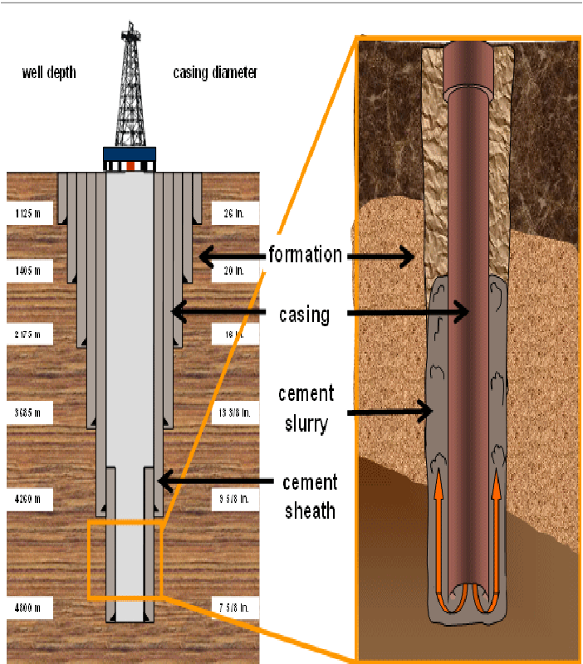
Figure 2.1 Cementing Operation during drilling

2.1 Oil Well Cement
Oil well cement, also known as well cement or oilfield cement, is a specialized type of cement used in the oil and gas industry for various applications, including well construction, wellbore isolation, and zonal isolation. It is primarily used to secure the steel casing in place, provide structural support, and prevent fluid migration between different zones in the wellbore.
Oil well cement typically consists of a mixture of Portland cement, various additives, and water. The specific composition and properties of the cement are carefully designed and formulated to meet the specific requirements of each well, taking into consideration factors such as well depth, temperature, pressure, and formation characteristics.
2.2 Classification of Oil Well Cement
The American Petroleum Institute (API) has established a classification system for oil well cement to ensure standardization and quality control in the oil and gas industry. This institute classifies eight categories of cement depending on the well condition and use of well cementing purposes (Bensted, 2008). The API classifies oil well cement into the following categories:
- Class A: This class represents the general or ordinary use of cement. It is used for typical wellbore conditions where no specific temperature or pressure challenges are expected. Class A cement has moderate sulfate resistance and is suitable for most common well construction applications.
- Class B: Class B cement is similar to Class A cement but has higher early strength development properties. It is designed to provide higher compressive strength at early stages after placement, allowing for faster drilling or well-completion operations. Class B cement is commonly used when time-sensitive operations are required.
- Class C: Class C cement is a type of oil well cement with a relatively low heat of hydration. It is used in situations where the risk of thermal cracking due to excessive heat generation during hydration is a concern. Class C cement is commonly used in wells with temperature-sensitive formations or when preventing excessive temperature rise is crucial.
- Class D: Class D cement is formulated to have high sulfate resistance. It is used in wells where exposure to high sulfate concentrations in the formation or wellbore is expected. Class D cement helps prevent cement degradation and maintains long-term integrity in sulfate-rich environments.
- Class E: Class E cement is similar to Class D cement but has additional expansive properties. It is used in wells with formations prone to shrinkage or compaction. The expansive properties of Class E cement help minimize the risk of annular gas migration and improve zonal isolation.
- Class F: Class F cement is a high-early-strength cement designed to provide rapid strength development. It is used in situations where early setting and strength gain are critical. Class F cement is commonly used in wellbore conditions with narrow operational time windows or when immediate wellbore support is required.
- Class G: Class G cement is a general-purpose oil well cement widely used in a variety of wellbore conditions and temperatures. It provides good performance in most typical well applications and has moderate sulfate resistance. Class G cement is one of the most commonly used cement classes in the industry.
- Class H: Class H cement is a high-temperature cement designed to withstand elevated temperatures encountered in deep drilling operations or geothermal wells. It exhibits excellent compressive strength at high temperatures and maintains zonal isolation and well integrity in extremely heated environments.
These API cement classes define the minimum performance requirements and specifications for different types of oil well cement. The selection of the appropriate API class depends on factors such as wellbore conditions, temperature, pressure, well depth, and regulatory requirements. Adhering to the API classification ensures the use of suitable cement for specific well conditions and helps maintain the integrity and longevity of oil and gas wells.

2.3 Functions of Oil Well Cement
The functions of oil well cement is specific to its application in the oil and gas industry. Oil well cement is formulated to meet the unique challenges and requirements of well construction and completion in oil and gas wells. Here are the primary functions of oil well cement (Benstead, 1989):
2.3.1 Zonal Isolation
One of the key functions of oil well cement is to provide zonal isolation by creating a barrier between different geological formations or zones within the wellbore. The cement is placed in the annular space between the casing and the wellbore walls, preventing the migration of fluids between formations. Proper zonal isolation is crucial for preventing cross-contamination of hydrocarbons, protecting freshwater zones, and maximizing production efficiency.
2.3.2 Wellbore Integrity and Casing Support
Oil well cement plays a critical role in ensuring the integrity of the wellbore and providing support to the casing. It helps to prevent collapse or deformation of the well structure and provides mechanical support to the casing strings. By anchoring the casing in place, oil well cement helps maintain the stability and structural integrity of the well.
2.3.3 Hydraulic Isolation
Oil well cement acts as a hydraulic barrier, preventing the flow or migration of fluids within the wellbore. It ensures that production fluids, such as oil, gas, or water, are contained within their intended zones and do not mix or interfere with other formations. Proper hydraulic isolation is essential for efficient production, reservoir management, and environmental protection.
2.3.4 Casing Centralization
Oil well cement assists in achieving proper casing centralization, which refers to the uniform positioning of the casing within the wellbore. Centralization helps ensure consistent cement coverage around the casing, optimizing zonal isolation and the mechanical strength of the cement sheath. Proper casing centralization also facilitates effective wellbore cleaning and cement placement.
2.3.5 Pressure and Temperature Control
Oil well cement provides pressure and temperature control within the wellbore. It helps prevent the influx of formation fluids, controlling formation pressures and minimizing the risk of blowouts. Additionally, oil well cement is designed to withstand high-temperature environments encountered in deep wells or thermal recovery operations, maintaining its structural integrity and performance under elevated temperatures.
2.3.6 Well Abandonment and Plug Setting
In the eventual abandonment of oil and gas wells, oil well cement is used to permanently seal and isolate specific zones. Cement plugs are set at predetermined depths to secure the well and prevent fluid movement or contamination. Proper plug placement and cement bonding are crucial for long-term well integrity and environmental protection.
Oil well cement is specifically engineered to meet the demanding conditions and requirements of the oil and gas industry. It ensures the successful construction, completion, and long-term operation of oil and gas wells, providing zonal isolation, wellbore integrity, hydraulic control, and casing support.
2.4 Properties of Oil Well Cement
Oil well cement is a specialized type of cement used in the petroleum industry for well construction and cementing operations. It possesses specific properties that make it suitable for the harsh downhole conditions encountered in oil and gas wells. Some important properties of oil well cement include:
2.4.1 Plastic Viscosity
Plastic viscosity specifically refers to the resistance to flow exhibited by a fluid when subjected to shear stress within the laminar flow regime. It is an important parameter in characterizing the flow behavior and pumpability of certain fluids, including drilling fluids and cement slurries. In the context of oil well cement slurries, plastic viscosity measures the thickness or stickiness of the slurry and quantifies its resistance to flow. It is typically determined using a viscometer, such as a rotational viscometer, by measuring the shear stress and shear rate relationship within the laminar flow region. A higher plastic viscosity value indicates a more viscous slurry that resists flow, while a lower plastic viscosity value indicates a less viscous slurry that flows more easily. The plastic viscosity of a cement slurry is influenced by factors such as cement composition, water-to-cement ratio, additives, temperature, and shear rate.
2.4.2 Apparent Viscosity
The apparent viscosity of oil well cement refers to the resistance of the cement slurry to flow under applied shear stress. It is an important parameter in the oil and gas industry, as it affects the pumping and placement of cement during well cementing operations. It combines the plastic viscosity and the yield point of the fluid. It provides a measure of the overall resistance to the flow of cement slurry. The apparent viscosity of oil well cement is typically measured using a rotational viscometer, such as a Marsh funnel viscometer or a rotational rheometer. The measurement is usually performed at different shear rates to assess the flow behavior of the cement slurry under varying conditions. The units of apparent viscosity depend on the specific system of measurement used. In the oil and gas industry, the most commonly used unit for apparent viscosity is the centipoise (cP). It’s important to note that the apparent viscosity of oil well cement can vary depending on several factors, including the cement composition, water-to-cement ratio, additives, temperature, and shear rate.
2.4.3 Yield Point
The yield point of oil well cement refers to the stress or shear force at which the cement slurry starts to flow or deform permanently. It is an important parameter in cementing operations as it indicates the minimum stress required to initiate fluid movement or displacement. A higher yield point indicates a thicker and less flowable cement slurry. The yield point of oil well cement is typically determined using a rheometer or a rotational viscometer. The measurement involves applying increasing shear stress or shear rate to the cement slurry and observing the point at which the material transitions from elastic behavior (no flow) to plastic behavior (flow). The yield point is commonly reported in units of pressure, such as pounds per square inch (psi) or pascals (Pa) since it represents the stress required to initiate flow. The specific value of the yield point can vary depending on factors such as cement composition, water-to-cement ratio, additives, temperature, and testing conditions.

2.4.4 Gel Strength
Gel strength refers to the ability of the cement slurry to resist flow or deformation after it has begun to set. It is a measure of the strength and stability of cement during the transition from a liquid to a solid state. Proper gel strength is important to maintain wellbore stability and prevent fluid migration. The gel strength of oil well cement is typically determined using a rotational viscometer or a specialized gel strength testing instrument. The measurement involves subjecting the cement slurry to a controlled shear rate for a specific period and then measuring the resulting shear stress. Gel strength is reported in units of pressure, such as pounds per square inch (psi) or pascals (Pa) since it represents the stress required to overcome the internal structure and initiate flow in the cement slurry. It is often measured at various time intervals to assess the development and stability of the gel structure over time. The gel strength of oil well cement is influenced by factors such as cement composition, water-to-cement ratio, additives, temperature, and curing time. It is crucial for maintaining proper zonal isolation and preventing fluid migration in the wellbore during and after cementing operations.
2.4.5 Density
The density of oil well cement refers to the mass per unit volume of the cement slurry. It is an important property that determines the hydrostatic pressure exerted by the cement column in the wellbore and helps ensure well integrity and zonal isolation. The cement density is typically higher than that of water and can be adjusted by adding various additives or weighting materials to achieve the desired density. The density of oil well cement is typically measured using a mud balance or a density meter specifically designed for cement slurries. The measurement involves weighing a known volume of the cement slurry and calculating the density by dividing the mass by the volume. The density of oil well cement is commonly expressed in units of pounds per gallon (lb/gal) or kilograms per cubic meter (kg/m³). In some cases, it may be reported in other units such as pounds per cubic foot (lb/ft³) or specific gravity (relative to water). The density of oil well cement is influenced by factors such as cement composition, water-to-cement ratio, additives, temperature, air entrainment, and contamination. These factors can affect the mass and volume of the cement slurry, resulting in variations in density. It is important to control these factors to achieve the desired density and ensure well integrity.

2.4.6 Compressive Strength
Compressive strength is a critical property of oil well cement, indicating its ability to withstand applied loads and maintain structural integrity. The cement must develop sufficient compressive strength over time to support the weight of the casing, withstand wellbore pressures, and prevent fluid migration. The compressive strength of oil well cement is typically measured by subjecting cylindrical cement specimens to compressive loads until failure occurs. The testing is conducted in a controlled laboratory environment, following specific procedures outlined by industry standards. The compressive strength is reported in units of pressure, such as pounds per square inch (psi) or megapascals (MPa). It represents the maximum stress or load that the cement can withstand before it fails or fractures. The specific compressive strength requirements for oil well cement can vary depending on the well conditions, regulatory guidelines, and design considerations. The desired compressive strength is typically designed to exceed the anticipated downhole stresses to ensure reliable zonal isolation and prevent failure. The compressive strength of oil well cement can be influenced by several factors, including cement composition, water-to-cement ratio, curing conditions (time and temperature), additives, and the presence of contaminants. Proper mixing, curing, and testing procedures are crucial to obtaining accurate and representative compressive strength measurements.
2.4.7 Thickening Time
The thickening time of oil well cement refers to the time it takes for the cement slurry to transition from a pumpable fluid state to a thickened consistency. It is a critical parameter in oil well cementing operations as it determines the time window available for pumping, placement, and proper bonding within the wellbore. The thickening time of oil well cement is influenced by factors such as cement composition, water-to-cement ratio, temperature, and the inclusion of additives. These factors can affect the cement slurry's hydration process, which leads to the development of a thickened, gel-like state. The thickening time is typically determined through laboratory testing or field tests. Common methods involve monitoring the cement slurry's consistency, viscosity, or certain rheological properties at specific time intervals until it reaches the desired thickened state. These tests help assess the cement's setting and thickening characteristics under specific temperature and pressure conditions. Thickening time can be influenced by accelerators or retarders, which are additives used to control the setting time and thickening behavior of the cement slurry. These additives can be tailored to specific well conditions and requirements. Proper control and monitoring of the thickening time are essential for successful cement placement, ensuring zonal isolation, and preventing issues such as fluid migration or cement contamination.
2.4.8 Water-to-Cement Ratio
The water-to-cement ratio refers to the ratio of water volume to cement volume in the slurry. It is an important parameter that affects the cement's properties, including its density, strength, setting time, and rheology. The optimal water-to-cement ratio must be determined to achieve the desired strength, durability, and workability of the set cement. The water-to-cement ratio is typically expressed as a decimal or a fraction. For example, a water-to-cement ratio of 0.40 means that 0.40 parts of water are used for every part of cement. The water-to-cement ratio has a significant impact on the workability and consistency of the cement slurry. Higher water-to-cement ratios generally result in a more fluid and pumpable slurry, but they can negatively affect the cement's strength and durability. On the other hand, lower water-to-cement ratios can enhance strength but may lead to challenges in pumping and placement. Balancing the water-to-cement ratio is crucial to achieve the desired cement performance and meet the specific well requirements. It is important to consider factors such as cement type, well depth, temperature, desired density, and the use of additives when determining the appropriate water-to-cement ratio for oil well cementing operations.
2.4.9 Sulfate Resistance
Sulfate resistance in oil well cement is an important consideration due to the presence of sulfates in formation fluids and potential exposure to sulfate-rich environments. Sulfate ions can react with certain compounds present in cement, leading to the formation of expansive compounds, such as ettringite, that can cause cement deterioration and reduced long-term strength. Proper curing practices are crucial for developing good sulfate resistance. Adequate hydration and curing conditions, including sufficient time, appropriate temperature, and humidity control during the early stages of cement setting, promote the formation of a dense and durable cement structure with enhanced sulfate resistance. Lower water-to-cement ratios generally result in a denser cement matrix with reduced permeability, making it more resistant to sulfate ingress. It is important to maintain a proper balance between workability and a low water-to-cement ratio to achieve the desired sulfate resistance. Incorporating chemical additives can also improve sulfate resistance. Admixtures such as sulfates inhibitors or pozzolanic materials like metakaolin or silica fume can react with sulfates and reduce their detrimental effects on cement.
2.5 Nanotechnology
Nanotechnology is a field of science and technology that deals with the manipulation and control of matter at the nanoscale. It involves the understanding, creation, and utilization of materials, devices, and systems with unique properties and functions at the nanoscale. Nanotechnology encompasses a wide range of disciplines, including physics, chemistry, biology, materials science, and engineering. It offers the ability to manipulate and engineer materials and structures at the atomic and molecular levels, resulting in enhanced properties and functionalities.
2.5.1 Nanoparticles
Nanoparticles are particles with dimensions in the nanoscale range, typically between 1 and 100 nm (Hulla et al., 2015). These particles exhibit unique properties and behaviors that are distinct from their bulk counterparts due to their small size and high surface-to-volume ratio. Nanoparticles can be engineered and synthesized from various materials, including metals, metal oxides, semiconductors, polymers, and carbon-based materials like graphene. They can be produced through different methods such as chemical synthesis, physical vapor deposition, or bottom-up self-assembly processes.
2.5.2 Nanoparticles-Based Oil Well Cement
Nanoparticle-based oil well cement refers to the use of nanoparticles in the formulation of cement specifically designed for oil and gas well applications. These nanoparticles are incorporated into the cement matrix to enhance its properties and address specific challenges encountered in the oil and gas industry (Santra et al., 2012). Here are some ways nanoparticles can be used to improve the properties of oil well cement:
- Strength and Durability Enhancement
Nanoparticles can be added to oil well cement to improve its compressive strength, tensile strength, and overall durability. The presence of nanoparticles enhances the cement matrix by providing reinforcement at the nanoscale, resulting in a stronger and more resilient cement sheath.
- Fluid-Loss Control
Nanoparticles with suitable surface characteristics can be used as fluid-loss control agents in oil well cement. These nanoparticles reduce the permeability of the cement sheath, preventing fluid migration and maintaining zonal isolation. They help to mitigate issues related to lost circulation and improve the overall wellbore integrity.

- Set Time Control
Nanoparticles can influence the setting time of oil well cement. By incorporating specific nanoparticles, the setting time of the cement can be manipulated to ensure optimal placement and bonding. This control over the setting time allows for better management of the cementing process in various well conditions.
- Gas Migration Control
Nanoparticles can help mitigate gas migration issues in oil well cement. They enhance the integrity of the cement sheath by reducing permeability and minimizing the pathways for gas to escape. This helps prevent gas migration and its associated complications, such as wellbore instability and production challenges.
- High-Temperature Performance
Nanoparticles with high thermal stability, such as certain metal oxides or nanoceramics, can improve the high-temperature performance of oil well cement. They enhance the cement's resistance to degradation and maintain its strength and stability in challenging downhole conditions, including high-temperature environments.
- Environmental Considerations
Nanoparticle-based oil well cement formulations can also offer environmental benefits. By optimizing the cement's properties, such as fluid-loss control and strength development, the overall cementing process can be more efficient, reducing the amount of cement required. This can lead to reduced environmental impact in terms of resource usage and waste generation.

CHAPTER-3: EXPERIMENTAL METHOD

This chapter presents the research methodology employed to address the research objectives outlined in section 1.3. It encompasses a detailed description of the sample preparation procedures, materials used, and the laboratory tests conducted. The proposed methodology consists of two main components: nanoparticle synthesis and characterization, as well as Class G oil well cement slurry preparation and evaluation of its rheological and mechanical properties.
In the first stage, the nanoparticles are synthesized using a specific method, and their characterization is carried out using X-ray powder diffraction (XRD). The XRD analysis provides valuable insights into the structural and compositional characteristics of the nanoparticles, offering essential information to identify the desired features required for the nanoparticles.
In the second stage, Class G cement slurries are prepared and subjected to various tests. The density and specific gravity of the cement slurries are determined using the Fann mud balance, which ensures accurate measurements. The rheological properties of the slurries are assessed using a Fann viscometer, enabling the evaluation of their flow behavior and consistency.
To provide a visual representation of the experimental process, a flow chart as shown in Figure 3.1 is included, illustrating the sequential steps and the logical progression of the methodology.
This chapter serves as a comprehensive guide, detailing the research methodology followed in the study, and provides a foundation for the subsequent analysis and interpretation of the obtained results.
CCollection of Materials
Preparation of Mother solution and Stirred

Preparation of NPs
Characterization of NPs
CDesign of Cement Slurry
CMeasurements of Rheological Properties
CMeasurement of Compressive strength
Figure 3.1 Flowchart of experimental analysis conducted

3.1 Materials
- Class G Oil well cement (Collected from SGFCL)
- Iron (III) nitrate nonahydrate (Fe(NO₃)₃·9H₂O)
- Tartaric acid (C₄H₆O₆₎
- Nitric acid (HNO₃)
- Distilled water
- Bismuth (III) nitrate pentahydrate (Bi(NO₃)₃·5H₂O)
3.2 Synthesis of BiFeO₃ NPs
In this research study, the synthesis of bismuth ferrite (BiFeO₃) nanoparticles was carried out using the solution evaporation method (SEM) as described by (Manzoor et al., 2016). The methodology involved the precise preparation of a transparent solution by combining equimolar concentrations (0.1M) of iron nitrate nonahydrate (Fe(NO₃)₃.9H₂O), 2.43 grams of bismuth nitrate pentahydrate (Bi(NO₃)₃.5H₂O), and 0.3M tartaric acid (C₄H₆O₆₎ with (65%) diluted 2N nitric acid (HNO₃). The resulting mixture was subjected to controlled heating on a magnetic hot plate stirrer (Figure 3.2) at a temperature of 105°C while maintaining constant stirring at a speed between 1000 RPM and 1200 RPM for 2 hours. This heating and stirring process facilitated the evaporation of the entire liquid from the beaker, resulting in the formation of a light green powder. To obtain a fine powder, the synthesized powder was further processed by subjecting it to a temperature of 550°C for 2 hours in a muffle furnace (Figure 3.3). This thermal treatment transformed the powder into a fine, well-defined form, suitable for subsequent characterization and analysis. By employing this systematic and controlled synthesis methodology, the study successfully obtained bismuth ferrite nanoparticles and characterized their crystal structure and size using XRD analysis.
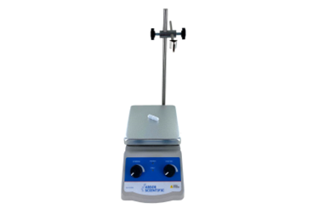 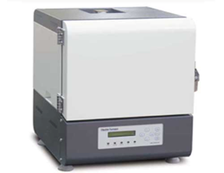
Figure 3.2 Magnetic Stirrer with hot plate Figure 3.3 Muffle Furnace

3.3 Design of Cement Slurry
In this study, the preparation of the base cement slurry and the introduction of BiFeO₃ nanoparticles were conducted according to (API, 2013). Table 1 presents the composition of the Class G oil well cement (Ridha et al., 2013).

Table 1 Composition of the Class G oil well cement
Raw oxide Wt. % Bogue phasesª Wt. %
CaO 64.3 C₃S (tricalcium silicate) 62.5
SiO₂ 21.2 C₂S (dicalcium silicate) 9.3
Al₂O₃ 3.8 C₃A (tricalcium aluminate) 2.0
Fe₂O₃ 4.76 C₃AF (tetracalcium aluminoferrite) 14.5
SO₃ 2.61
MgO 2.30
K₂O 0.32
Na₂O 0.46
ª Cement chemistry notation: C CaO, S SiO₂, A Al₂O₃, F Fe₂O₃
For the base cement slurry, 500 grams of Class G oil well cement was mixed with 220 milliliters of distilled water, resulting in a water-to-cement ratio of 0.44. The mixing process was carried out using a Hamilton Beach mixer (Figure 3.4) at 13,000 revolutions per minute (rpm) for 10 minutes. To create cement slurries with incorporated nanoparticles, varying weights of BiFeO₃ nanoparticles (0.05%, 0.1%, 0.2%, 0.3% and 0.4% BWOC) were added to the mixture after 5 minutes of initial mixing. The nanoparticle addition was followed by an additional 5 minutes of mixing. This step allowed for the dispersion and homogenization of the nanoparticles within the cement slurry. These prepared cement slurries, both the base slurry and the nanoparticle-modified slurries, were then subjected to rheological and mechanical property measurements. These measurements aimed to evaluate and compare the rheological behavior and mechanical strength of the different cement slurries. The methodology employed in this study provides a standardized and controlled process for the preparation of the cement slurries, ensuring consistency and facilitating accurate analysis of their properties.
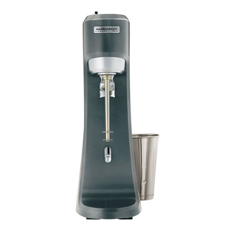
Figure 3.4 Hamilton Beach Mixer
3.4 Rheology Tests
Rheological properties of the cement slurry were measured using a 6-speed rotational viscometer or as known as rheometer (Figure 3.5). The slurry was poured into the rheometer cup and the cup was placed on the rheometer stage. The following measurements were performed:
- Plastic viscosity
To determine the plastic viscosity of the cement slurry, the API recommended Practice 10B-2 (API, 2013) was followed at room temperature. A rheometer (Figure 3.5) was utilized, and the spindle was programmed to rotate at different speeds, ranging from 3 rpm to 600 rpm. By conducting this rotational test, the difference between the dial readings obtained at 600 rpm and 300 rpm was precisely calculated using equation (E-1) below and recorded as the plastic viscosity value.
Plastic viscosity (PV), μ_{p} = Ɵ₆₀₀-Ɵ₃₀₀ (E-1)
Where
μ_{p} = Plastic viscosity, (cP)
Ɵ₆₀₀ = Dial readings at 600 RPM
Ɵ₃₀₀ = Dial readings at 300 RPM
- Apparent Viscosity
The apparent viscosity of the cement slurry was measured at room temperature following the API recommended Practice 10B-2 (API, 2013). The rheometer (Figure 3.5) was programmed to rotate the spindle at different speeds, spanning from 3 rpm to 600 rpm. The apparent viscosities for all rotor speeds were determined using equation below (E-2) where N is the rotor speed (rpm) and Ɵ is the rheometer dial reading (°).

Apparent viscosity (AV), μ_{a} = 300($\frac{θ}{N})$ (E-2)

- Yield point
The determination of the yield point of the cement slurry was carried out at ambient temperature following the recommended procedure (API, 2013), which serves as a recognized industry standard. A rheometer (Figure 3.5) was employed, programmed to set the spindle in motion at a range of speeds spanning from 3 rpm to 600 rpm. The yield point value was computed by using equation below (E-3).
Yield point (YP), τ_{o} = Ɵ₃₀₀ – μ_{p} (E-3)
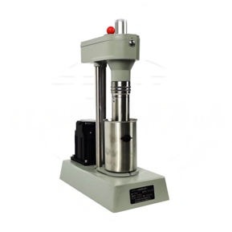
Figure 3.5 Fann Model 35SA viscometer

3.5 Measurement of Slurry Density & Specific Gravity
To determine the density and specific gravity of the cement slurry, the mud balance apparatus (Figure 3.6) was suspended from a balance hook, ensuring its stability and accuracy (API, 2013). A representative sample of the cement slurry was then carefully poured into the cup of the mud balance until it reached the brim. Any excess slurry was meticulously removed using a straight edge to achieve a level surface. The weight of the cement slurry in the air was accurately recorded using the mud balance.
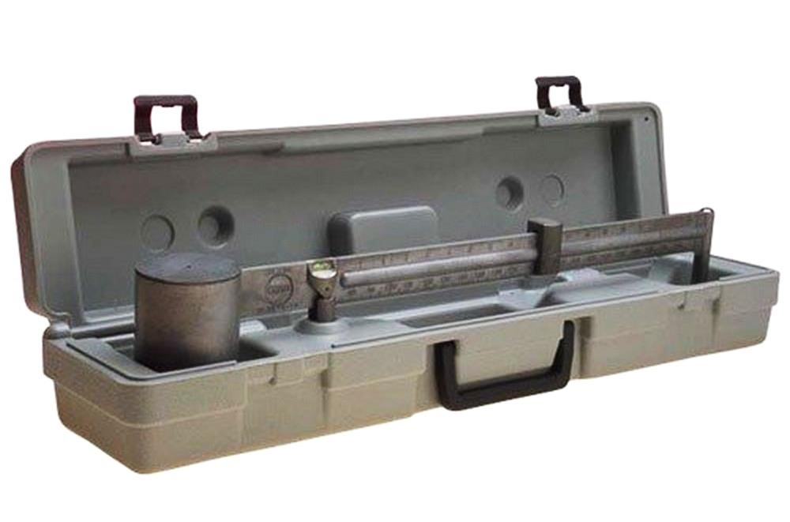
Figure 3.6 Fann Model 140 mud balance

3.6 Compressive Strength Test
The compressive strength of Class G cement was measured using standardized destructive testing procedures (De la Roij et al., 2012). Cylindrical specimens (Figure 3.7), with a diameter of 1.5 inches and a height of 1.5 inches, were prepared from cement slurry. The specimens were carefully cast and compacted to ensure uniformity and minimize voids. Then the specimens were subjected to a compressive force using a mechanical or hydraulic testing machine (Figure 3.8). The compressive strength test involved gradually increasing the applied load until failure occurred. The maximum load at failure was recorded, and the compressive strength was calculated by using equation below (E-4).
Compressive strength, $P=\frac{F}{A}=\frac{F}{πr^{2}}$ (E-4)
Where
P = compressive strength, MPa
F = Maximum load (or load until failure) to the material, N
r = Radius of cylindrical specimens, m
Multiple specimens were tested to ensure statistical validity, and the average compressive strength value was reported as the representative value for the cement.
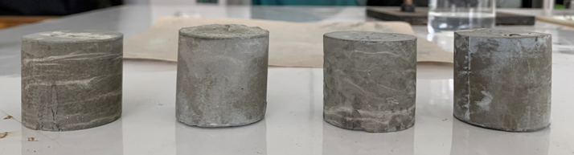
Figure 3.7 Cylindrical specimens of Class G oil well cement
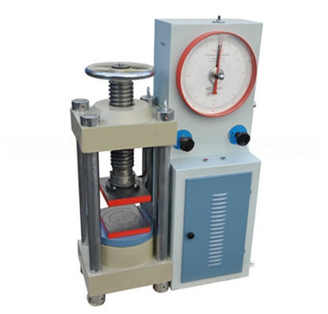
Figure 3.8 STYE-2000 Analogue type compression testing machine

CHAPTER-4: RESULTS AND DISCUSSION

This chapter contains the outcomes of the experiments carried out as part of this thesis. Experiments are conducted in accordance with the techniques outlined in Chapter 3 to acquire reliable findings. Initially, the experimental analysis is performed to characterize the synthesized bismuth ferrite (BiFeO₃) NPs. In the next step, investigative analysis is performed to evaluate the performance of class G oil well cement slurry. Then the evaluation of NPs-based cement slurries is conducted. In all cases, the NPs-based cement slurries are compared with the base cement slurry. The detailed results of this study are presented in Appendix.

4.1 Characterization of BiFeO₃ Nanoparticles
The crystal structure and size of the synthesized Bismuth Ferrite (α-BiFeO₃) nanoparticles were investigated through X-ray diffraction (XRD) analysis. The XRD pattern displayed in Figure 4.1 represents the distinct diffraction peaks corresponding to the synthesized BiFeO₃ nanoparticles. The characteristic peaks observed at specific 2θ values, approximately 22.22°, 31.58°, 39.09°, 45.35°, 50.83°, 51.30°, 55.94°, 56.59°, 56.61°, 66.5°, 70.71°, and 75.40°, correspond to the crystallographic planes 82.6, 100, 29.5, 40, 29, 14.8, 14, 19.1, 33.2, 11, 7.8, and 9.8, respectively. The sharp and narrow peaks observed in the XRD pattern indicate the highly crystalline nature of the synthesized BiFeO₃ nanoparticles. This suggests the achievement of high purity in the synthesized nanoparticles using the employed synthesis method. The presence of well-defined diffraction peaks at the expected positions confirms the formation of the desired α-BiFeO3 crystal structure.
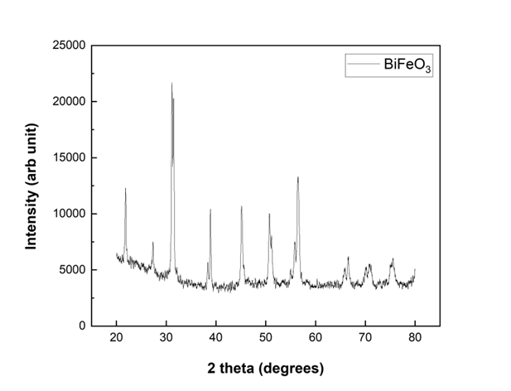
Figure 4.1 XRD pattern of synthesized BiFeO₃ nanoparticles
4.2 Effect of BiFeO₃ Nanoparticles on Plastic Viscosity (PV) of cement slurries
The plastic viscosity of an oil well cement slurry is a measure of its resistance to flow under shear stress. It is an important parameter in oil well cementing operations as it directly affects the slurry's ability to achieve good displacement and fill the wellbore effectively. The plastic viscosity of base cement slurry and NPs-based cement slurries was measured by using formulas described in the previous chapter. The graphical representation of plastic viscosity (cP) vs. BiFeO₃ NPs concentration (%BWOC) is shown in Figure 4.2. For base cement slurry we got 23 cp as plastic viscosity. Here the increment of plastic viscosity is found at 0.1, 0.4 % BWOC of BiFeO₃ NPs concentration by 39.9%, 9.42% respectively compared with the base slurry. This increment in PV occurred because nanoparticles have a high surface area-to-volume ratio, which can increase the overall solids concentration in the slurry. The presence of a higher concentration of solid particles leads to an increase in the plastic viscosity of the slurry. On the other hand, plastic viscosity was reduced by 6.55%, 11.6%, and 42% at 0.05, 0.2, and 0.3 %BWOC of BiFeO3 NPs concentration respectively and this is probably due to the low concentration of NPs.
It is crucial to carefully evaluate and optimize the concentration and characteristics of nanoparticles added to oil well cement slurries to achieve the desired increment on plastic viscosity.
Figure 4.2 Effect of concentration of BiFeO₃ NPs on plastic viscosity of Class G oil well cement slurries
4.3 Effect of BiFeO₃ Nanoparticles on Apparent Viscosity (AV) of cement slurries
Apparent viscosity is one of the main rheological properties of oil well cement. Monitoring apparent viscosity during cementing operation is very important to measure slurry’s pumpability and displacement efficiency. In this study, AV was measured with different BiFeO3 NPs concentrations. The graphical representation of plastic viscosity (cP) vs. BiFeO3 NPs concentration (%) BWOC is shown in Figure 4.3. The apparent viscosity of base cement slurry was about 59.139 cp. The apparent viscosity of cement slurries increased with the addition of bismuth ferrite NPs except for 0.3% BWOC concentration. Here, the maximum 30.91% rise of apparent viscosity is found at 0.4 % BWOC of BiFeO3 NPs concentration compared with the base cement slurry.
Figure 4.3 Effect of concentration of BiFeO₃ NPs on the apparent viscosity of Class G oil well cement slurries.

4.4 Effect of BiFeO₃ Nanoparticles on Yield Point (YP) of cement slurry
The yield point is a measure of the minimum shear stress required to initiate flow. It represents the point at which the slurry transitions from a static, solid-like state to a flowing, liquid-like state. The yield point of an oil well cement slurry is significant as it influences pumpability, displacement efficiency, suspension of solid particles, stability, and thixotropic behavior. Figure 4.4 shows that increasing NPs concentration can enhance the yield point of oil well cement. It happened because nanoparticles are surface-modified or functionalized to improve their compatibility with the cement matrix. The surface modification process typically involves the addition of organic molecules or polymers. These surface modifiers can introduce additional polymer chains into the slurry, leading to increased interparticle interactions and the formation of a more rigid network, thereby increasing the yield point. The maximum increment of yield point is 47.18% at 0.4% BWOC of BiFeO3 NPs concentration compared with the base cement slurry. But at the concentration of 0.1% BWOC yield point was reduced by 23%. As most of the concentrations provide the increment of yield point, so we can consider this NPs as a potential additive to enhance the yield point of oil well cement slurry.
Figure 4.4 Effect of concentration of BiFeO₃ NPs on the yield point of Class G cement slurries
4.5 Effect of BiFeO3 Nanoparticles on cement slurry Density and Specific Gravity
The density of an oil well cement slurry, also known as slurry density or cement slurry density, is an important parameter in oil well cementing operations. It is significant as it affects well control, zonal isolation, buoyancy control, cement placement, curing and setting properties, and overall cement slurry design. We should carefully consider and control the slurry density to ensure safe, efficient, and reliable cementing operations in oil and gas wells. The specific gravity of an oil well cement slurry is a measure of its density relative to the density of water. It is observed that density and specific gravity decreased after adding nanoparticles in this study. The base cement slurry had a density of 16.3 lb/gal and specific gravity was 1.92 gm/cm³. The value of specific gravity fluctuated between 1.88 gm/cm³ to 1.89 gm/cm³ after adding nanoparticles into the cement slurry and the density value oscillated between 15.8 lb/gal to 15.85lb/gal. This may occur due to the dilution effect on the cement slurry. Additionally, nanoparticles affect the packing arrangement of cement particles within the slurry as we know if the nanoparticles promote better particle dispersion or interfere with the formation of denser packing structures, it can result in a lower overall density of the cement slurry. But as the reduction of both properties is very slight, it will not affect the overall cementing process. (API spec 10A, 2019)
Figure 4.5(a) Effect of concentration of BiFeO₃ NPs on the density of Class G oil well cement slurries

Figure 4.5(b) Effect of concentration of BiFeO₃ NPs on the specific gravity of Class-G oil well cement slurries
4.6 Effect of BiFeO₃ Nanoparticles on Compressive Strength of cement slurry
The compressive strength of Class G oil well cement is significant in the oil and gas industry. Compressive strength refers to the ability of the cement to resist axial loads or pressure without undergoing significant deformation or failure. According to field and laboratory investigations, a high compressive strength should not be of much concern, especially for shallow and weak formations where compressive strength higher than the formation can be deleterious. A minimum compressive strength of 50 psi is sufficient to support the casing. About 250–1000 psi is adequate to meet the requirement of many operations. (Stephen et al. 2020)
In our study, it is observed that an increment in compressive strength after adding NPs in different concentrations to the cement slurry. Figure 4.6 shows the graphical representation of the increased percentage of compressive strength (%) vs. percentage of NPs (%). We got a maximum 145% increment in compressive strength compared with base slurry after adding 0.4% BWOC concentration of NPs. The numerical value of highest compressive strength was 14.326 MPa or 2077.81 psi which meets the demand. For other concentrations increment in compressive strength was 25%, 40%, 75%, 80%, after adding 0.05, 0.1, 0.2, 0.3, % BWOC concentration of NPs respectively. So, we can conclude that this bismuth ferrite (BiFeO₃) NPs have the potential to use as an additive to increase the compressive strength of oil well cement.
Figure 4.6 Effect of concentration of BiFeO₃ NPs on Compressive Strength of Class G cement slurries.

CHAPTER-5: CONCLUSIONS

5.1 Summary of Results
1. In general, the addition of nanoparticles increases the apparent viscosity of cement slurry. For NPs concentrations of 0.05% BWOC, 0.1% BWOC, 0.2% BWOC, 0.4% BWOC apparent viscosity increased by 0.048%, 0.61%, 5.54% and 30.9% respectively compared to base cement slurry.
2. For some concentrations, Nanoparticles have increased the plastic viscosity of cement slurry. For NPs concentrations of 0.1% BWOC and 0.4 %BWOC plastic viscosity increased by 39.9% and 9.42% respectively compared to base cement slurry. On the other hand, for NPs concentrations of 0.05% BWOC, 0.2% BWOC, and 0.3% BWOC plastic viscosity decreased by 6.55%, 11.6%, and 42% respectively compared to base cement slurry.
3. Yield stress of cement slurry got increment after the addition of NPs except for the concentration of 0.1% BWOC, where yield stress decreased by 23% compared to base cement slurry. We got the highest increment of yield stress for NPs concentration of 0.4% BWOC and it was 47.18% from the base slurry.
4. In case of density and specific gravity, it has decreased after the addition of nanoparticles for all concentrations compared to base cement slurry.
5. This nanoparticles are great for increasing the compressive strength of class G cement slurry. Compressive strength increased maximum of 145% at 0.4 % BWOC concentration of NPs. Besides that, we got 25%, 40%, 75% and 80%increments for the 0.05, 0.1, 0.2 and 0.3% BWOC concentrations of nanoparticles respectively.
5.2 Outcomes
The experimental results confirmed that the bismuth ferrite nanoparticles can also be used as a potential additive in Class G oil well cement to reduce viscosity and increase yield stress, and compressive strength which in turn increases the productivity index and save drilling time and cost, but the concentration of NPs must be monitored properly to get the best output.
5.3 Limitations
The utilization of bismuth ferrite (BiFeO₃) nanoparticles in Class G oil well cement presents certain limitations. Achieving homogeneous dispersion and compatibility of the nanoparticles within the cement matrix can be challenging, as they may tend to agglomerate or settle, leading to uneven distribution and compromised effectiveness. Moreover, the stability of BiFeO₃ nanoparticles in extreme downhole conditions, characterized by high temperatures, pressures, and corrosive environments, remains a concern. Interaction between the nanoparticles and the various additives commonly used in oil well cement formulations can further complicate their performance. Additionally, the cost and availability of BiFeO₃ nanoparticles at the required scale for industrial applications may pose practical constraints. Furthermore, the long-term performance and durability of BiFeO₃ nanoparticles in oil well cement systems warrant further investigation. Consideration of these limitations is crucial in assessing the feasibility and suitability of BiFeO₃ nanoparticles as additives in Class G oil well cement.
5.4 Future Work
The following recommendations are proposed for the future studies:
- The impact of NPs on compressive strength on broader scale should be evaluated to be sure about the security of the long-term integrity of the wellbore.
- The effectiveness of NPs should be examined after changing the cement mixing procedure and w/c ratio.
- Bismuth ferrite NPs should be used in the HPHT environment.

BIBLIOGRAPHY

- Adjei, S., & Elkatatny, S. (2021). Overview of the lightweight oil-well cement mechanical properties for shallow wells. Journal of Petroleum Science and Engineering, 198, 108201.
- API, A. (2013). API RP 10B-2, Recommended Practice for Testing Well Cements.
- Benstead, J. (1989). Oilwell cements. World Cement;(UK), 20(10).
- Bensted, J. (2008). Development with oilwell cements. Structure and Performance of Cements, 237–252.
- Choolaei, M., Rashidi, A. M., Ardjmand, M., Yadegari, A., & Soltanian, H. (2012). The effect of nanosilica on the physical properties of oil well cement. Materials Science and Engineering: A, 538, 288–294.
- De la Roij, R., Egyed, C., & Lips, J.-P. (2012). Nano-engineered oil well cement improves flexibility and increases compressive strength: A laboratory study. SPE International Oilfield Nanotechnology Conference and Exhibition.
- Hulla, J. E., Sahu, S. C., & Hayes, A. W. (2015). Nanotechnology: History and future. Human & Experimental Toxicology, 34(12), 1318–1321.
- Khan, F., Kesarwani, H., Kataria, G., Mittal, G., & Sharma, S. (2023). Application of titanium dioxide nanoparticles for the design of oil well cement slurry–a study based on compressive strength, setting time and rheology. Journal of Adhesion Science and Technology, 37(10), 1666–1682.
- Kiran, R., Teodoriu, C., Dadmohammadi, Y., Nygaard, R., Wood, D., Mokhtari, M., & Salehi, S. (2017). Identification and evaluation of well integrity and causes of failure of well integrity barriers (A review). Journal of Natural Gas Science and Engineering, 45, 511–526.
- Manzoor, A., Afzal, A. M., Amin, N., Arshad, M. I., Usman, M., Rasool, M. N., & Khan, M. F. (2016). Investigation of dielectric and optical properties of structurally modified bismuth ferrite nanomaterials. Ceramics International, 42(9), 11447–11452.
- Park, T.-J., Papaefthymiou, G. C., Viescas, A. J., Moodenbaugh, A. R., & Wong, S. S. (2007). Size-Dependent Magnetic Properties of Single-Crystalline Multiferroic BiFeO ₃ Nanoparticles. Nano Letters, 7(3), 766–772. https://doi.org/10.1021/nl063039w
- Pik\lowska, A., Ziaja, J., & Kremieniewski, M. (2021). Influence of the addition of silica nanoparticles on the compressive strength of cement slurries under elevated temperature condition. Energies, 14(17), 5493.
- Ridha, S., Irawan, S., & Ariwahjoedi, B. (2013). Strength prediction of Class G oilwell cement during early ages by electrical conductivity. Journal of Petroleum Exploration and Production Technology, 3. https://doi.org/10.1007/s13202-013-0075-9
- Santra, A., Boul, P. J., & Pang, X. (2012). Influence of nanomaterials in oilwell cement hydration and mechanical properties. SPE International Oilfield Nanotechnology Conference and Exhibition.

APPENDIX
Table A1 Summarized Data of Class G Oil Well Cement Slurry Properties
Percentage of Nanoparticle (%) | Plastic Viscosity (cp) | Apparent Viscosity (cp) | Yield Point (lb/100ft²⁾ | Density (lb/gal) | Specific Gravity (gm/cm³)
0.00% | 23 | 59.139 | 71 | 16.3 | 1.92
0.05% | 21.5 | 59.16667 | 75.33 | 15.8 | 1.89
0.10% | 32.17 | 59.5 | 54.67 | 15.8 | 1.88
0.20% | 20.33 | 62.41667 | 84.167 | 15.8 | 1.89
0.30% | 13.33 | 57.16667 | 87.67 | 15.85 | 1.88
0.40% | 25.167 | 77.41667 | 104.5 | 15.85 | 1.89
Table A2 Summarized Data of Compressive Strength of Class G Oil Well Cement
Percentage of Nanoparticle (%) | Force (KN) |  |  |  | Radius of Samples (m) | Area of Samples (m²) | Compressive Strength of Sample (Pa) | Compressive Strength of Sample (MPa) | Increased percentage (%)
 | Sample 1 | Sample 2 | Sample 3 | Average
0.00% | 7 | 6 | 7 | 6.67 | 0.01905 | 0.00114 | 5847468.52 | 5.8475 | -
0.05% | 8 | 8 | 9 | 8.33 | 0.01905 | 0.00114 | 7309335.65 | 7.3093 | 25
0.10% | 10 | 9 | 9 | 9.33 | 0.01905 | 0.00114 | 8186455.93 | 8.1865 | 40
0.20% | 13 | 10 | 12 | 11.67 | 0.01905 | 0.00114 | 10233069.91 | 10.2331 | 75
0.30% | 12 | 11 | 13 | 12 | 0.01905 | 0.00114 | 10525443.34 | 10.5254 | 80
0.40% | 18 | 15 | 16 | 16.33 | 0.01905 | 0.00114 | 14326297.88 | 14.3263 | 145

