Theranostic Property of Pigments Producing Actinobacteria
M. Rajeswari, V. Priya Barathi, P. Dhanalakshmi, P. Priya Dharsini and A. Winny Fred Crossia
Shrimati Indira Gandhi College, PG and Research Department of Microbiology, Trichy -02.
Address for Correspondence: Dr. P. Priya Dharsini, Assistant Professor, PG and Research Department of Microbiology, Shrimati Indira Gandhi College, Trichy -02.
E - Mail - priyadharsinip@sigc.edu, Mobile - 9944617963
ABSTRACT
Since ancient times, pigments have been utilized in the food, cosmetic, pharmaceutical, and other sectors. Plants and insects are two of the main sources of natural pigments, but microbes are also important because of their bioactivities and advantages in pigment manufacturing. Streptomyces is a genus of actinobacteria that produces specialized metabolites with a variety of bioactivities, including antioxidant, anticancer, antibiofilm, antifouling, and antibiotic activities, as well as pigments, among others. This makes actinobacteria significant in the field of biotechnology. The data supporting the possibility that some strains of Streptomyces could serve as biological sources of bioactive pigments is identified, summarized, and evaluated in this review.
Key words
Actinobacteria, Actinobacterial Pigments, Application, Carotenoids, Prodigiosin, Melanin, Violacein, Pyocyanin, Lip Balm Production

INTRODUCTION
Actinobacteria are a distinct class of filamentous bacteria that resemble fungi and are prokaryotic. They are facultative anaerobes and generate early microcolonies in their surroundings that are made up of thread-like filaments and asexual spores that can be found singly or in chains [1]. They are widely dispersed as both terrestrial and aquatic bacteria in a variety of settings [2]. The majority of actinobacteria have been discovered and isolated from soil and are used extensively in industrial agriculture and medicine [3]. Actinobacteria create a wide variety of "Pigments" that come in a variety of colors, including yellow, green, red, brown, and black [4]. The Streptomyces group produces the most active secondary metabolites, accounting for over 80% of all naturally occurring bioactive compounds with medicinal uses [5]. To isolate pigment-producing Actinobacteria and test for anti-microbial efficacy, researchers have conducted numerous investigations. Therefore, the focus of the current study was on actinobacterial pigments that have a variety of uses against human and marine infections from different geographical regions.
Ⅰ. ACTINOBACTERIAL PIGMENTS
Actinobacteria are a good alternative source for the creation of synthetic pigments because of their short life cycles and simplicity of genetic modification. Actinobacterial pigment is still in the research and development stages to produce pigments like melanin, carotenoids, pyocyanin, bacteriochlorophylls, violacein, prodigiosin, and monascins. Additionally, actinobacterial pigment has better biodegradability and higher compatibility with the environment compared to fungal pigments and bacterial pigments [6].
The species Streptomyces sp., Nocardia sp., Micromonospora sp., Thermomonospora sp., Actinoplanes sp., Rhodococcus sp., and Kitasatospora sp. all create pigment. For instance, Streptomyces coelicolor and Streptomyces griseoviridis [7].
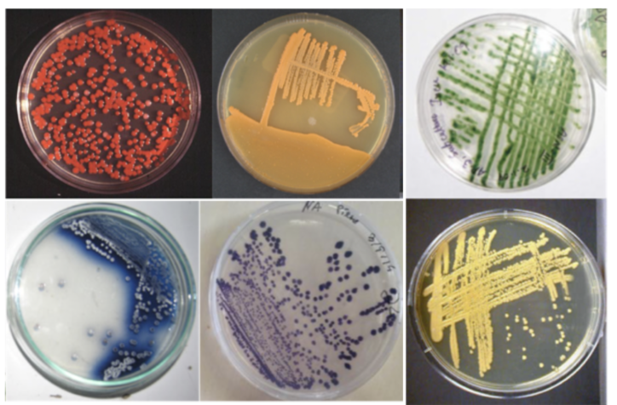

Fig 1: Representative images of actinobacteria producing natural pigments.

II. TYPES OF ACTINOBACTERIAL PIGMENT

IⅡ.APPLICATION OF ACTINOBACTERIAL PIGMENTS

- ACTINOBACTERIAL PIGMENTS AS ANTIMICROBIAL AGENTS
Infectious infections were the leading cause of death worldwide earlier than in 1900. Infectious diseases are now, behind non-communicable diseases, the second leading cause of death worldwide and in developed nations. The enormous demand for novel antibiotics nowadays is a direct result of the growing number of resistant microorganisms [8]. According to reports, actinobacterial pigments exhibit antibacterial properties that are effective against both gram-positive and gram-negative bacteria [9].
- ACTINOBACTERIAL PIGMENTS AS ANTICANCER AGENTS
Cancer is one of the main causes of illness and mortality in humans and is a non-communicable disease. Drugs to treat cancer have been created and are currently undergoing clinical trials. Due to restrictions, adverse effects, and resistance to medications and treatments, treating cancer is extremely difficult [10].
- ACTINOBACTERIAL PIGMENTS AS ANTIOXIDANT
A condition known as oxidative stress is brought on by an excess of free radicals in the body, which raises the risk of developing chronic illnesses including diabetes and autoimmune diseases. Antioxidants are obtained from either natural or artificial sources in the pharmaceutical business [11]. The most popular antioxidant is synthetic, although it has recently lost popularity as more evidence of potential harm to human health has been documented [12] [13].
4. ACTINOBACTERIAL PIGMENTS AS ANTIMALARIAL AGENTS
Malaria is a contagious illness that is prevalent in tropical nations and is still one of the biggest health concerns. Originally based on natural ingredients, antimalarial medications have mostly been superseded by a variety of synthetic medications since the 1930s. The discovery of this novel treatment aims to fight malaria [14].
5. ACTINOBACTERIAL PIGMENTS AS ANTIVIRAL AGENTS
Innumerable virus infections had threatened people all over the world and resulted in innumerable pandemic deaths in humans. Despite advances in drug discovery, there are still many viruses for which there are no vaccines or effective antiviral medications [15].
IV.ACTINOBACTERIAL PIGMENTS
ⅰ) CAROTENOIDS
The phylum of bacteria with the largest genome in the bacteria domain, Actinobacteria, contains a variety of colourful species. Their examination of their pigments indicated that their colouring is caused by structurally different carotenoids.
Carotenoids with the C50 chain length are one type. Second one is Aromatic end group-containing carotenoids and third one is Monocyclic keto-carotene derivatives or keto carotenoids like canthaxanthin (alpha, beta-carotene-4,4-dione). The only known Actinobacteria having a simultaneous route to aromatic and keto carotenoids are species from the genus Rhodococcus sp, and they may be antibacterial [16].
Antimicrobial Property
The Micrococcus sp. producing carotenoids had been reported to demonstrate antimicrobial activities against antibiotic resistant Klebsiella sp, Saureus, Pseudomonas aeroginosa, ophthalmic Escheriachia coli, S.aureus and Strepcoccus pyogens. Carotenoids produced by actinobacteria isolated from dried seafood which was Kocuria roseus [17].
Anticancer Property
Using carotenoids as colors, actinobacterial cell multiplication is inhibited, and apoptosis is induced. Actinobacteria place a strong emphasis on lutein and zeaxanthin and have a lot of cancer cells [18].
Antioxidant Property
Carotenoids from Rhodococcus sp. B7740 were tested for antioxidant activity. By using the tests for -carotene bleaching, lipid peroxidation inhibition, protein oxidation inhibition, and oxidative DNA breakage inhibition, the in vitro antioxidant activity was assessed [19].
ⅱ) PRODIGIOSIN
One of the more noticeable pigments that is now present in the microbial world is prodigiosin, a brilliant red pigment generated by Serratia-related species. Prodigiosin's chemical makeup has been thoroughly investigated, and Wrede and Rothhaas classified it as a tri-pyrrlymethene in 1934.A modest number of orange-red coloured Streptomyces sp. were found while we were isolating enormous amounts of actinobacteria from soils gathered all over the world [20].
Antimicrobial Property
Prodigiosin is utilized as a bacteriostatic agent in Actinobacterium for E. coli. It is employed in a variety of biological processes by antimicrobial agents. Additionally, it has been noted that the Streptomyces sp.-produced deep red pigment undexyl prodogiosin exhibits effective antibacterial properties against Bacillus sp, Micrococcus sp., and Candida albicans [21].
Anticancer Property
It is used to create actinobacterial medicines that target numerous cell types, including cancer cell lines that are drug resistant to multiple drugs but not normal cells [22].
Antimalarial Property
In E. coli cells, prodigiosin functions as an actinobacterial antimalarial drug to diluted cells restarted growth usage. It is used to distinguish the actinobacterial antimalarial agent [23].
Antiviral Property
It has not yet been reported that it has been tested against actinobacterial pathogenic viruses. The focus of biological activities to shield vaccines from antiviral agents is revealed by the Streptomyces sp [24].
ⅲ) MELANIN
Microbes are mostly used to extract natural pigments. Actinobacteria produce large amounts of the pigments known as melanoid or dark-brown melanin. These gram-positive, aerobic bacteria generate spores and have DNA that has a high G+C concentration (>55%) [25].

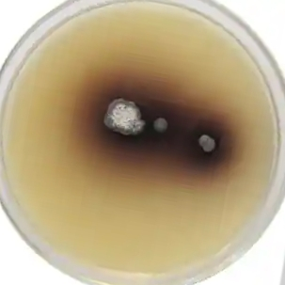

Fig 2: Melanin production by Streptomyces glaucescens

Characterization of Melanin
Despite their obvious abundance in the biosphere. Due to the complex polymerization, amorphous, and insoluble character of some melanin types, existing biochemical and biophysical methods are unable to provide definitive chemical constructions. As a result, some unknown features of the whole chemical structure of some melanin types have to be revealed.
Because of this, a number of physical practices are unable to provide an identification test for melanin. These practices include surface morphology studies (scanning electron microscopy and transmission electron microscopy), structural elucidation, and tests for physicochemical properties (resistance to solvents, bleaching, and solubilization in aqueous alkali).
EPR is an example of a paramagnetic resonance, Electron spin resonance (ESR), X-ray photoelectron spectroscopy (XPS) , UV Mass spectrometry and visible spectroscopy
For the purpose of identifying melanin, numerous investigations and procedures have recently been carried out. Raman Spectroscopy has been used in the past to examine melanin that possesses particular characteristics.
Raman scattering properties
The atomic force microscope, often known as an AFM, is a high-resolution imaging device that uses 3D topographical data to detect intermolecular forces at the atomic level. Due to the fact that it offers measurements at the nanometre scale, AFM has significant benefits over other microscopic techniques [26].

For chemical analysis, use electron spectroscopy (ESCA).
It is an elemental analysis method and is also referred to as XPS. The chemical makeup of the atoms of nitrogen and sulphur is helpful in this. It is employed to ascertain the chemistry and quantitative atomic composition of melanin [27].
Fast atom bombardment, Laser Desorption Ionization (LDI), and Matrix Assisted Laser Desorption and Ionization are all used in MALDI analysis, also known as matrix assisted laser desorption and ionization (MALDI) [28].
Types of Melanin
a. Eumelanin
b. Pheomelanin
c. Allomelanin
a) Eumelanin
Human hair, skin, and some actinobacteria may all produce eumelanin, which is primarily a black to dark brown pigment. Tyrosine or phenylalanine undergo oxidative polymerization to form -3,4-Dihydroxyphenylalanine, which is then converted into dopachrome, and then melanin, a dark brown pigment, is produced [29].

b) Pheomelanin
Pheomelanin is a naturally occurring red or yellow pigment that is primarily present in human hair. Although it resembles eumelanin, -DOPA undergoes cysteine integration into the polymer (cysteinylation) and includes sulphur. It gives the lips and hair pink and red colour [30].
c) Allomelanin
Allomelanin, a heterogenous pigment found in numerous fungi and plants, belongs to the heterogenous group of polymers that are nitrogen-free. They come from a variety of sources, such as carechols, homogentistic acid, and dihydrofolate. This type contains water-soluble Pyomelanin produced when homogentistics acid, a byproduct of the tyrosine breakdown pathway, accumulates and ultimately polymerizes [31], as well as melanin, which is derived from 1, 8 dihydroxy naphthalene (DHN) molecules.
Antimicrobial Property
Melanin demonstrated that actinobacteria had antibacterial action against the phytopathogenic strains Erwina chrysantheni and Erwina carotovora, as well as against S. aureus, E. coli, and C. albican. Streptomyces sp strain of soil-extracted melanin exhibited antibacterial activity against E. coli at a concentration of 1 l [32].
Anticancer Property
Streptomyces sp. NEAE-H's black extracellular melanin pigment exhibited strong cytotoxic action against the HFB4 skin cancer cell line. Streptomyces sp.'s dihydroxyphenylalanine (DOPA) melanin. The cytotoxicity of DOPA melanin against cervical cancer cells demonstrated a dose-response action, and MVCS6 was discovered and described [33].
Antioxidant Property
Melanin isolated from Streptomyces sp. was tested for its antioxidant properties using a slightly modified DPPH assay, lipid peroxidation assay, and total antioxidant activity (TAA) assay. The proportion used to express the scavenging capacity of melanin constituents is [34].
Theranostic application of Melanin:
1. Anti-Oxidative therapy
2. Synergistic therapy
3. Chemotherapy
4. Photodyamine therapy
5. Photo thermal therapy & Immuno therapy
ⅳ) VIOLACEIN
Target bacteria's development and secondary metabolism are impacted by the secondary metabolites that actinobacteria create in large quantities. Actinobacterial interactions are modulated by many kinds of secreted secondary metabolites, including siderophores, biosurfactants, and antibiotics. Antibiotics affect intraspecies social behaviour, such as the creation of biopics, and they contribute to prejudice against unrelated people. Antibiotics can change virulence and the secreted metabolome in interspecies interactions [35].
Anticancer Property: According to Actinobacteria, violacein is a powerful anticancer drug that has lethal effects against a number of tumor cell lines by enhancing the hyperpolarization of the mitochondrial membrane [36].
Violacein, another advantageous bacterial pigment isolated from Streptomyces sp against C.violaceum, similarly demonstrated protection against oxidative damage in gastric ulceration by triggering the mucosal defence mechanism [37].
Violacein shown antimalarial activity of actinobacteria, which demonstrates lethal effects against a number of tumor cell lines by enhancing the biological activities of antimalarial against [38].
ⅴ) PYOCYANIN
The PhzMS proteins contribute to the production of pyocyanin, a pigmented virulence factor that is blue-green in colour. The host's cell will interact with pyocyanin during the infection process. To generate intercellular ROS, it also interacts with Streptomyces sp. (Mavrodi et al., 2001).
Antimicrobials
Actinobacterial pyrocyanin compounds are known to have broad-spectrum antibacterial action against actinobacterial species. Actinobacteria shown antiparasitic properties in agricultural settings, as well as applications as biocontrol agents and pharmaceuticals. Istamycin is produced by Streptomyces tenjimariensis (Slattery et al., 2001). Because of this, actinobacterium is employed to fight a range of germs [39].
Pyocyanin, a key virulence factor generated by actinobacteria, inhibits the growth of human hepatoma cells and the actions of biological agents that are known to be anticancer. The media added with shikimic acid led to the overproduction of pyocyanin. Pyocyanin was found to be hazardous to glioma cells (U87MG) in a cytotoxicity assay, depending on the quantity used [4

Ⅴ. ACTINOBACTERIAL PIGMENTS AS BIOPHARMACEUTICALS
LIPBALM PRODUCTION FROM PIGMENTS PRODUCING ACTINOBACTERIA
Many bioactive substances with a variety of clinical effects and significant implications in human health may come from actinobacteria. Actinobacteria are thought to be the source of about one-third of the thousands of naturally occurring antibiotics. The World Health Organization asserts that excessive antibiotic prescription and misuse have contributed to the development of antibiotic resistance in many bacterial infections. The deadly pathogens Streptomyces sp., E. coli, Staphylococcus aureus, and Bacillus strains cause a variety of illnesses and have become resistant to most drug classes. Therefore, finding new medications that are effective against these pathogens with drug resistance is necessary. The majority of antibiotics used today are derived from actinobacterial natural compounds.
In order to reduce the use of chemicals in the cosmetic sectors, a second goal was to create bio-cosmetics and dye textile using the extracted bio-pigments. Additionally, this is an inexpensive source of colorant that is simple to create in big quantities quickly (Oskey M., et al., 2004).
One of the most delicate parts of the human face is said to be the lips. Lip skin is delicate, irritable, and prone to problems since it is so thin and sensitive. Therefore, it is crucial to take good care of your lips. If certain precautions are not taken, a number of issues may affect the lips. Lip symptoms include dryness, cracking, soreness, numbness, swelling, and ulcers. If we experience discomfort in our lips can hurt, and the discomfort might be described as sharp, dull, or stabbing. throbbing and burning.
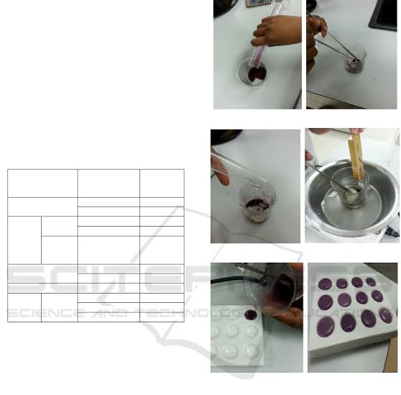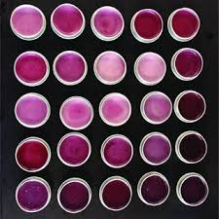
Fig 3: Production of Lip Balm in Natural pigments

- COLOURING AGENT OF LIPBALM
It has long been known that actinobacteria may create colours, particularly melanin pigments, which can be red, orange, green, pink, and brownish. Colour has been used in cosmetics since the beginning of time. Colorants are colouring compounds that are primarily employed to give cosmetic products a distinctive appearance. Researchers may find novel natural colouring compounds thanks to the current need for natural pigment. Violacein (violet) and prodigiosin (red) are the bioactive components of the colouring ingredient. Carotenoids (yellow-orange), flexirubin (yellowish, orange), and pyocyanin (blue, green) [45]. The lips receive the colour in two different ways.
1. By discolouring the skin with a dye solution that can pierce the skin of the lips.
2. By concealing any skin roughness on the lips with a coloured coating.
Actinobacteria have long been known to produce pigments which may be red, orange, green, pink and brownish especially melanin pigments. Colorants are colouring agents are mainly used to impart a distinctive appearance to the cosmetic products colour has been used in cosmetics since early times. The present requirement of natural pigment can foster researchers in discovering novel natural colouring agents. The bioactive compounds of colouring agent are violacein (violet), prodigiosin (red). Pyocyanin (blue, green), flexirubin (yellowish, orange) and carotenoids (yellow-orange) [45]. The colour is imparted to the lips in two ways.
1. By staining the skin with a solution of dyestuff which can penetrate the outer of the lip skin.
2. By covering the lips with a coloured layer that helps to mask skin imperfections and provide the appearance of smoothness [46].

Fig 5: Natural LipBalm produced from extracred green and orange pigment.

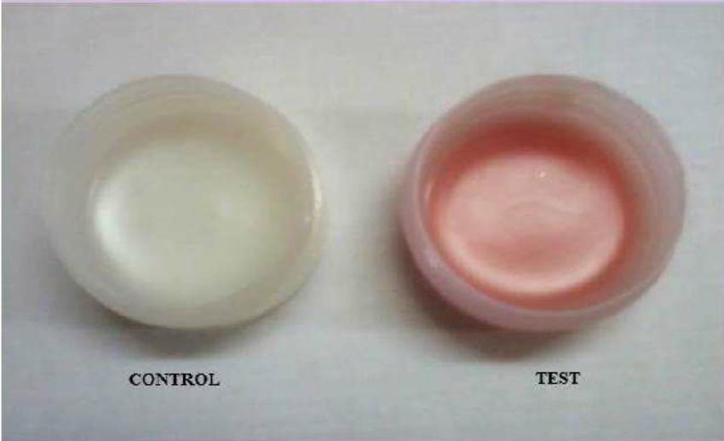
Fig 4: Control and Test of the lip balm production by using actinobacterial pigments.
FLAVOURING ENHANCER
The generation of the flavouring component in lip balm is greatly aided by actinobacteria. Melanin pigment served as a source of flavouring for the actinobacteria. Typically, flavours or flavouring chemicals are needed to cover over the four basic taste sensations. The term "flavour" refers to a variety of tastes, including salt, bitter, sweet, and acid. Which demonstrates the interaction of physiological and physiochemical processes, which affect how chemicals are perceived with the development of technology in the flavour industry. Many artificial or limited flavours require more art than science to create. Flavourants are chosen based on the flavour of the medicine or the necessity to introduce additional substances [47].
VI. CONCLUSION
Actinobacteria are common in a variety of organisms and exhibit biological characteristics in the environment in addition to playing a significant part in the creation of pigments. Future research may employ the existing application of pigments, sources, and actinobacterial characterisation to concentrate on the pharmacological activity. It is specifically used in aquaculture for the bioremediation of organic and inorganic waste in the culture system, disease prevention, and treatment. It is helpful in the creation of organic biopharmaceutical qualities and has the potential to improve human wellbeing by generating bioactivity agents and other commercial goods like antibiotics and cosmetics.

REFERENCES
1. Bhatti AA, Haqs, Bhat RA (2017) Actinomycetes benefaction role in soil and plant health. Micro Pathog iii: 458-467.
2. Ghorbani-Nasrabadi R, Greiner R, Alikhani HA, Hamedi J, Yakhchali B (2013) Distribution of actinomycetes in different soil ecosystems and effects of media composition on extracellular phosphate activity. Soil sci plant Nutr 13(1); 223-236.
3. Bawazir AMA, Shantaram M, (2018) Ecology and distribution of actinomycetes in nature-a review. Int J curr Res 10(7); 71664-71668.
4. Narai A, Abhay S, Sen S, Mondal S, Manigandan N, Yogesh BJ (2014) study and classification of red pigmented actinomycetes from the Bannerghatta National park soil Int Multidiscip Res J2(2): 2320-5083.
5. Manandhar S, Sharma S (2017) practical approach to microbiology, 3rd edn. National Book Centre, Kathmandu, Nepal.
6. Venil CK, Zakaria Ahmad WA (2013) Bacterial pigments and their applications. Process Biochemistry, 48, 1065-1079.
7. Franks A, Haywood P, Holmstrom C, Egan S, Kjelleberg S, Kumar N (2005) Isolation and structure elucidation of a novel yellow pigment from marine bacterium Pseudoalteromonas tunicate. Molecules, 10, 1286-1291.
8. Yoneyama H, Katsumata R. (2006) Antibiotic resistance in bacteria and its future for novel antibiotic development Bioscience, Biotechnology and Biochemistry, 70, 1060-1075.
9. World Health Organization (WHO). (2018) the top 10 causes of death Available from http://www.who.int/news-room/fact-sheets/detail/the-top-10-causes-of-death. [Accessed 1 June 2018].
10. Foo J, Michor F. (2014) Evolution of acquired resistance to anti-cancer therapy. Journal of Theoretical Biology, 355, 10-20.9
11. Phaniendra A, Jrstadi DB, Penyasamy L (2015) Free radicals; properties, sources, targets, and their implication in various diseases. Indian Journal of Clinical Biochemistry, 30, 11-26
12. Anbudhasan P, Surendraraj A, Karkuzhali S, Sathishkumaran P (2012) Natural antioxidant and its benefits, International Journal of food Sciences and Nutrition, 3,225-232.
13. Ahmed N, Singh J, Mudasir, Malik A, Kour H, Gupta P, Chauhan h. (2013) Naturaaly occurring preservatives in food and their role in food preservation International Journal of Pharma and Bio Sciences, 4, 22-30.
14. Mojab F. (2012) Antimalarial natural products; a review Avicenna Journal of Phytomedicine, 2, 52-62.
15. Suba KP, Stalin A, Girija AS, Raguraman R. (2013) Homology modelling and docking analysis of prodigiosin from Serratia marcescens Biotechnology, 55, 12897-12902.
16. Arpin N, Liaan-Jensen S, Trouilloud M (1972) Bacterial carotenoids. XXXVIII C50- carotenoids
17. Ravikumar S, Uma G, Gokulakrishnan R. (2016) Antibacterial property of Halobacterial carotenoids against human bacterial pathogens Journal of Scientific & Industrial (India), 75, 253-257.
18. Martinez Andrade KA, Lauritano C, Romano G, Ianora A. (2018) Anticancer application of carotenoids 16(5) 165.
19. Frei R, Craucher C, Poulton SW, Canfield DE. Melanin in their potentials (2009) 461, 250-253.
20. Williams RP. Prodigiosin a microbial of Actinobacteria App in (1973).
21. Dharshan N, Manomani H.K. Prodigiosin and its potential application Food Sci Technol (2015), 52, 5393-5407.
22. Ziegler Rg. (1989) A review of anticancer agents in Prodigiosin.
23. Gerber NN. Prodigiosin like the pigments, (1975) CRC Crit Rev microbial Prodigiosin; 3:469-485.
24. Castro AJ, Corwin A.H, Waxham FJ, Beiby ALF. (2019) Org chem.,24,455.
25. Mencher JR, Heim AH (1962) Melanin biosynthesis by Streptomyces Lavendulae. J Gen Microbial 28. https://doi.org/10.1099/00221287-28-4-665.
26. Pralea, I.E.; Moldovan, R.C.;Petrache, A.M.;IIies, M.;Heghes, S.C.;ielciu, I.;Nicoara, R.;Moldovan, M.;Ene, M.;Radu, M.; et al from extraction to advanced analyticalmethods:The challenges of melanin analysis. Int.J.Mol.Sci.2019,20,3943.
27. Yacout, S.M.;Mcllwain, K.L.;Mirza, S.P.; Gaillard, E.R. Characterization of retinal pigment epithelial melanin and degradation synthetic melanin using mass spectrometry and in vitro biochemical diagnostics. Photochem, Photobiol. 2019,05,183-191.[PubMed]
28. Pralea, I.E.; Moldovan, R.C.;Petrache, A.M.;IIies, M.;Heghes, S.C.;ielciu, I.;Nicoara, R.;Moldovan, M.;Ene, M.;Radu, M.; et al from extraction to advanced analyticalmethods:The challenges of melanin analysis. Int.J.Mol.Sci.2019,20,3943.
29. Tarangiri, K.; Mishra, S. Production of melanin by soil microbial isolate on fruit waste extract: two step optimization of key parameters. Biotechnol. Rep. 2014, 139-146.
30. Singh, S.; Nimse, S.B.; Mathew, D.E.; Dhimmar, A.; Sahastrabudhe, H.;Gajjar, A.; Ghadge, V.A.; Kumar, P.; Shinde, P.B. Microbial melanin: Recent advances in biosynthesis, extraction, characterization, and applications. Biotechnol. Adv. 2021, 53,107773. [CrossRef].
31. Vasanthakumar, A.; DeAraujo, A.; Mazurek, J.; Schilling, M.; Mitchell, R. Pyomelanin production in Penicillium chrysogenum is stimulated by L-tyrosine. Microbiology 2015, 161, 1211-1218. [CrossRef]
32. Vasanthabharathi V, Lakshminarayanan R, Jayalakshmi S. (2011) Melanin production from marine Streptomyces. African journal of Biotechnology, 10, 11224-11234.
33. Sivaperumal P, Kamala K, Rajaram R. (2015) Bioactive DOPA melanin isolated and characterized from a marine actinobacterium Streptomyces sp. MVCS^ from Versova coast Natural Product Research, 29, 2117-2121.
34. Kamala K, Sivaperumal P, Gobalakrishnan R, Swarnakumar NS, Rajaram R, Isolation and characterization of biologically active alkaloids from marine actinobacteria Nocardiopsis sp. NCSI. Biocatal Agric Biotechnol. 2015;4:633-9
35. Dodou HV, de Morais Batista AH, Sales GWP, de Medeiros SC, Rodrigue ML, Nogueira PCN, Silveira ER, Noguiera NAP. (2017) Violacein antimicrobial activity on Staphylococcus epidermis and synergistic effect on commercially available antibiotics. Journal of Applied Microbiology, 123, 853-860.
36. Bhandari R. (2015) Crocus Sativus fro anticancer chemoprevention. 5(2); 81-87.
37. Yusuf M, Shabbir M and Mohammad F. (2017) processing of violacein in antioxidant agent.
38. Lister J.L Horswill A.R. (2014) Actinobacteria development in violacein 4; 178.
39. Glick BR. (1995) prohibit the complex and given the application of pyocyanin of antimicrobial agent 41(2); 109-117.
40. Castro AJ, Gale GR means G.E and Tertzakian GJ. (1967) Med chem.10, 29.
41. M.G. Denavarre, The chemistry and manufacture of cosmetics, second ed., Contenental Press; Orlando, USA, 1975,3,pp,699.
42. A.R. Fernandas, M.F. Dario, C.A.S.O. Pinto, T.M. Kaneko, A.R. Baby, M.V.R. Velasco, Stabilitry evaluation of organic Lip Balm, Braz. J. Pharm. Sci.2 (2013) 49.
43. R.G. Harry, J.B. Wilkinson, Harry’s Cosmeticology, six ed. Leonard Hill books and Intertext publisher, London, 1973.
44. B.M.Mittal, R.N.Saha, A Handbook of cosmetics, first ed., Vallabh Prakashan: New Delhi, India, 2000.
45. Venil C.K and Lakshmanaperumalsamy P, “An insightful overview on microbial pigment, prodigiosin,” (2009) Electronic Journal of Biology, vol.5, 3, pp. 49-61.
46. V.P. Kapoor, herbal colouring agent of lip balm from natural products (2005).
47. B.J. Kukreja, V.Dodwad, Natural products of herbal extracts from flavouring agent (2012).

