A Novel Approach To Drug Delivery Systems: Microsponges

Madhavi M.N ¹, Pankaj M Pimpalshende², Satish B.Kosalge³

1 Associate Professor, Department of Pharmaceutics  Hi-Tech College of Pharmacy, Chandrapur.  Maharashtra, India  Mail: madhumartha@gmail.com | 2. Professor, Department of Pharmaceutics, Hi-Tech College of Pharmacy, Chandrapur. | 3 Principal,  Hi-Tech College of Pharmacy, Chandrapur.

ABSTRACT
To maximize therapeutic efficacy and cost-effectiveness, innovative drug delivery technology has become intensely competitive and is evolving quickly. Microsponges are one of these cutting-edge developing techniques for precise, controlled, and target-specific medication administration. Microsponges are microscopic polymeric particles with porous surfaces resembling sponges, and pore ranges in size from 5 to 300 microns. The microsponge system can be made into gel, ointment, creams, liquids, or powders with good efficiency. More recently, it has been made into tablets and capsules for oral delivery. Microsponges can be made using lyophilization, ultrasonic assisted production, liquid-liquid suspension, quasi-emulsion solvent diffusion, particle size determination, morphology and surface topography of microsponges, loading efficiency and practical yield determination, accurate density determination, pore structure, compatibility studies, dissolution studies, and release kinetics. The present review is about the multifunctional microsponge technology including its advantages, preparation methods and Applications.

Keywords: Microsponge, Porous surface, Control release, drug delivery system

I. INTRODUCTION

The healthcare system is significantly impacted by novel drug delivery systems (DDS) that can regulate drug release rates or target drugs to a particular body site. By attaching the drug to a carrier particle, such as microsponges, microspheres, nanoparticles, liposomes, etc., which controls the release and absorption characteristics of the medicines, carrier technology offers an innovative method for drug delivery. Because of their small size and effective carrier qualities, microsponges are a crucial component of DDS.[1]

The microsponge technology was developed by Won in 1987 and the original patents were assigned to Advanced Polymer Systems, Inc. The Microsponge Delivery System is a patented, polymeric system made up of porous microspheres that is extensively cross-linked. They are tiny, spherical particles with a spongy-like texture comprising an enormous number of empty spaces connected by an impermeable framework. The pace at which active ingredients are released is controlled by this porous surface. A typical 25-μm sphere can have up to 250000 pores, while microsponge sizes range from 5 to 300 m in diameter (Figure 1). This Microsponge technology has numerous advantages, making it a versatile drug delivery vehicle. These properties improve stability, lessen adverse effects, and favorably alter drug release.[1,2]

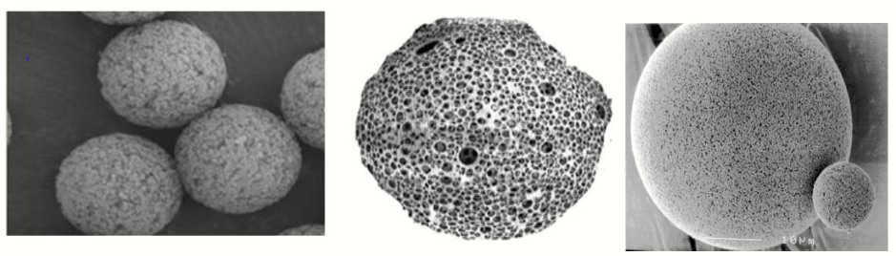
Figure 1: Highly Porous Nature Of A Microsponge.

Earlier, By overcoming the shortcomings of conventional dermatological formulations like uncontrolled evaporation of active ingredients, unpleasant odour, short-term overmedication followed by long-term under medication, rashes, or more severe side effects when active ingredients penetrate the skin, this system was used to improve the performance of topically applied drugs.[3]
Due to its low cost of therapy and convenience of administration, which may result in higher patient compliance, the oral route is the preferred method for administering therapeutic drugsSome medications that have a short half-life and are easily absorbed in the gastrointestinal tract are quickly removed through blood circulation. Orally controlled release formulations, which release medication gradually into the digestive system and aid in maintaining steady medication concentration in the serum for extended periods, have been created to address these issues. The use of microsponge technology is unique because it allows for the regulated release of medications while also speeding up the rate at which drugs that are poorly soluble in water dissolve.[4]

A. Characterstics of microsponges [5]
- Microsponge formulations are stable over range of pH 1 to 11;
- Microsponge formulations are stable at the temperature up to 130ºC;
- Microsponge formulations are compatible with most vehicles and ingredients;
- Microsponge formulations are self-sterilizing as their average pore size is 0.25μm where bacteria cannot penetrate;
- Microsponge formulations have higher payload (50 to 60%), still free flowing and can be cost effective.
B. Advantages [5,6]
- Advance oil control, absorb up to 6 times its weight without drying.
- Improved product elegancy.
- MDS allows the incorporation of immiscible products.
- Improves stability, thermal, physical and chemical stability.
- Enhanced drug stability
- Improves material processing e.g. liquid can be converted to powder.
- Extended release & Controlled drug release continuous action up to 12 hours.
- Site specific action produce on target organ.
- Reduced irritation, better tolerance means broader consumer acceptance
- Flexibility to develop novel product forms.

II. MEHODS OF PREPARATION [4,5,6]

- Liquid-Liquid Suspension Polymerization Method
In liquid-liquid systems, suspension polymerization is a one-step method used to create microsponges. First, the monomers are dissolved in a suitable solvent solution containing the active components (non-polar drug), which are then disseminated in the phase of water with agitation. In order to aid in the development of suspension, aqueous phases frequently contain additives like surfactants and suspending agents, among others. Once separate droplets of the desired size have been produced in the suspension, polymerization is started by adding a catalyst, raising the temperature, or using radiation. The polymerization process creates a reservoir-type system that opens at the surface through pores. In other instances, the pore network is created during the polymerization process using an inert solvent that is entirely miscible with the monomer but immiscible with water. Following the completion of the polymerization process, the liquid is removed, leaving the microsponges. These prefabricated microsponges are then permeated with a variety of active ingredients, including as antifungals, rubefacients, antiacne agents, and anti-inflammatory agents, and they serve as topical carriers. Solvents may occasionally be utilised to incorporate useful compounds more quickly and effectively. If the medication is susceptible to the condition of polymerization, a two-step procedure is used. Under moderate conditions, the polymerization is carried out using an alternative porogen, and the drug is replaced by a functional component. The steps of liquid-liquid suspension polymerization processes are summarised in Figure 2.

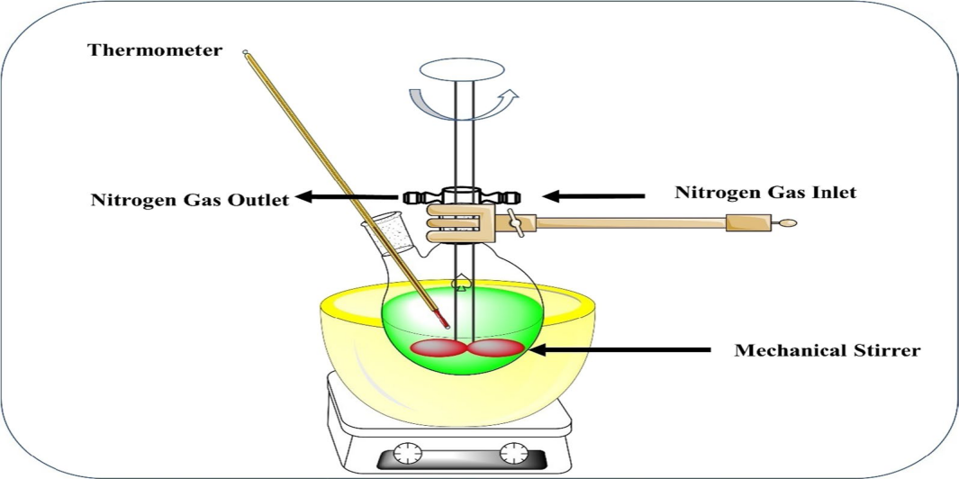
Figure 2 : Liquid-Liquid Suspension Polymerization Method

- Quasi-Emulsion Solvent Diffusion Method
The method is commonly used to prepare topical and oral microsponges. The method involves the preparation of two phases, one is the inner organic phase, which contains the drug, and the other is the external aqueous phase. With the aid of a mechanical stirrer, the internal phase is added to the exterior phase drop by drop over the course of 60 minutes. Continuous stirring produces quasi-emulsion droplets, while organic solvent evaporation produces solid cages of microsponges. The microsponges were then separated by filtration and dried for 12 hours in the oven. Figure 3 highlights the procedures for producing microsponges using the quasi-emulsion solvent difusion method

.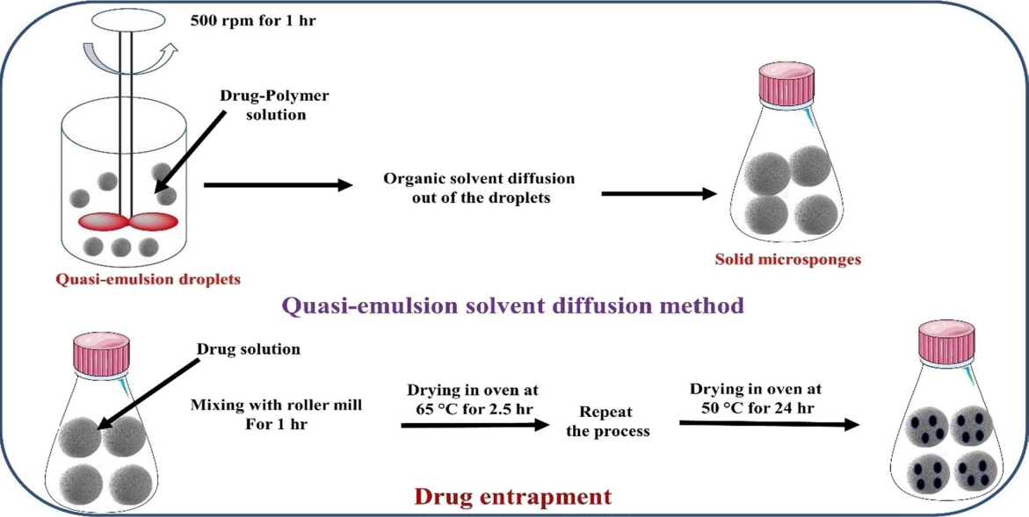
Figure 3: Quasi-Emulsion Solvent Diffusion Method

- Multiple emulsion solvent diffusion method
The method was designed to produce biodegradable, permeable microspheres. The span was dispersed in solution using an aqueous inner phase with the addition of stearyl amine. To create a (w/o/w) double emulsion, this w/o emulsion is subsequently dispersed once more in an aqueous phase with polyvinyl alcohol. The benefit of capturing both soluble and insoluble actives is made clear by this procedure. Using this technique, proteins and other thermolabile substances can be loaded.

- Addition of Porogen
In this method, the many emulsions were swapped out for porogen's like sodium bicarbonate or hydrogen peroxide. To achieve this, a single-phase system made by dissolving the porogen in a polymeric solution and dispersing it in a water phase containing polyvinyl alcohol was created. Then an initiator was applied to produce many emulsions, the organic solvent was removed, leaving the particles behind to make MDS, and finally, the particles were dried.

- Lyophilization
This method was used to create porous microspheres from the gelation procedure's generated microspheres. After being treated in chitosan hydrochloride solution, the microspheres were then stored for lyophilization. The fast solvent removal in this method results in microsphere holes. The lyophilization method for manufacturing MDS has the drawback of resulting in shrunken or otherwise fractured micro particles due to the fast elimination of solvent.
- Ultra sound assisted production
This method was developed by altering the procedure for MDS production known as liquid-liquid suspension polymerization. This method produces MDS by cross-linking diphenyl carbonate with beta-cyclodextrin monomer. The reaction mixture is heated and sonicated to control the size of the microparticles. As shown in Fig. 4, the mixture was cooled and pulverized before being cleaned with ethanol and then distilled water. This production method has limitations, such as entrapping harmful cross-linking agent residue.

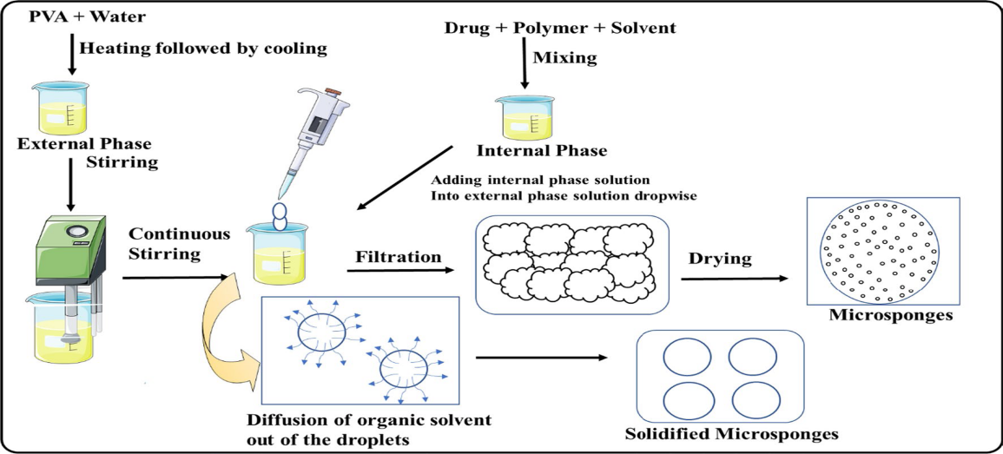
Figure 4: Ultrasound-assisted microsponge production method

III.EVALUATION OF MICROSPONGES [6,7]
Evaluation of microsponges by various methods which are given in table no. 1.

Table 1: Evaluation of Microsponges

S.NO | Parameters | Methods
1 | Particle size (Microscopy), size  distribution and polydispersity | Diffractometry
2 | Morphology & surface  topography | Electron microscopy
3 | Density | Displacement method
4 | Pore structure | Mercury intrusion porosimetry
5 | Drug polymer interaction | FTIR
6 | Crystallinity | XRD studies
7 | Production Yield
8 | Loading efficiency | 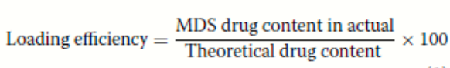

IV. MECHANISM OF DRUG RELEASE FROM MICROSPONGES [5]

In reaction to one or more of the following environmental triggers, such as pressure, temperature change, and solubility, which are described as follows, microsponges may gradually release a fixed amount of active components.
- Temperature change: Few encapsulated active ingredients might be too viscous at room temperature to flow quickly from microsponges onto the skin. Increased skin warmth also causes the flow rate to rise, which enhances release.
- Pressure: By rubbing or exerting pressure, the active ingredient in microsponges can be released onto the skin.
- Solubility: When water is present, microsponges carrying water-soluble substances, such as antiseptics and deodorants, release their contents. The release can also be triggered by diffusion.

pH Triggered Systems: The pH-based release of the active can be initiated by changing the coating on the microsponge. There are several ways to use this for drug delivery.

V. PHARMACEUTICAL UTILIZATION OF MICROSPONGES

Different applications can be made use of micro sponges. It is usually used topically, though oral use has increased recently. The safety, efficacy, and aesthetic value of topical prescription, over-the-counter, and personal care products are improved via microsponge delivery methods. Due to its high loading capacity and capacity for prolonged release as an excipient, several patents have been reported.

To prevent local and systemic cutaneous side effects, microsponge drug delivery system (MDS) ensures drug localization in the epidermis and the skin's surface. By using a MDS, reducing the amount of drug that enters the percutaneous blood circulation is feasible. Table 2 displays microsponge-based formulations for dermatological uses. Since significantly fewer severe regulatory restrictions exist, cosmetic items are developed, marketed, and supplied far more rapidly than dermatological products. Table 3 lists some examples of current cosmetics designed with microsponge technology.

Table 2: Drug candidates explored using MDS for dermatological applications

S.N | Drug | Polymer | Dosage form | Method of preparation | Application
1 | Diclofenac diethylamine [8] | Eudragit RS-100 | Gel | Quasi-emulsion solvent diffusion | Prolonged release for proficient arthritis therapy
2 | Benzophenone‑3 [9] | Starch | Sunscreen cream | Emulsion gela-  tion method | Safe, effective, cosmetically elegant product with enhanced user compliance, reduced systemic absorption and undesirable side effects.
3 | Clobetasol propionate [10] | Eudragit RS 100 and | Carbopol gel | Quasi-emulsion solvent diffusion | Maximum  therapeutic activity with minimum toxic effects due to Extended release.
4 | Diltiazem hydrochloride [11] | Eudragit RS 100 | Gel | Quasi emulsion solvent diffusion method | Sustained delivery system to overcome side effects
5 | Benzoyl peroxide (BPO) [12] | Ethyl cellulose, | Cream | Emulsion solvent  diffusion method | Reduced side effects by reducing percutaneous absorption
13 | Naringenin [13] | Ethyl cellulose | TOPICAL GEL FOR | quasi-emulsion-solvent diffusion | 3-fold greater drug deposition in skin than plain gel.
7 | Silver sulfadiazine [14] | Ethyl cellulose, xanthan gum, | Gel | w/o/w emulsion solvent evaporation | Prolonged effect without skin irritation and low cytotoxicity with enhanced wound contraction.
8 | Oxybenzone[15] | Ethyl cellulose | Gel | Quasi emulsion solvent diffusion method | Enhanced sun protection factor with reduced toxicity due to controlled release of drug onto the skin over a prolonged period of time
9 | Dithranol [16] | Ethyl cellulose, | Gel | Quasi-emulsion solvent diffusion method | Extended release, reduced irritation and  improved patient compliance
10 | Babchi essential oil [17] | Ethyl cellulose, |  | Quasi emulsion solvent evaporation | Enhanced photostability and stability, handling benefits, skin irritation problems overcome by Controlled release of drug.
11 | Betamethasone [18] | Eudragit RS100 | Microsponge based gel | Quasi emulsion solvent | Released of drug in a controlled manner
12 | Oxiconazole nitrate [19] | Eudragit S-100 and Eudragit L-100. | Microsponge based gel | Quasi-emulsion solvent diffusion | Remain on the skin for a longer time, gradually releasing their contents over the time.
13 | Aceclofenac [20] | Ethyl cellulose and Eudragit ES100 | Topical Gel | Quasi-emulsion solvent diffusion | Sustain the drug release over a period of 8 hour
15 | Sertaconazole [21] | Eudragit RS 100 | Corbopol gel FOR TOPICAL | quasi emulsion solvent diffusion | CONTROL RELEASE
16 | Diclofenac Sodium [22] | xanthan gum-facilitated ethyl cellulose | Carbopol gel | Double emulsification technique | Prolonged effect for effective treatment

Table 3: Examples of MDS currently marketed as cosmetic products [6, 23]

S.NO | Product name | Active moiety | Indication | Manufacturer
1 | Retin A Micro | Tretinoin | Acne-vulgaris | Ortho-McNeil  Pharmaceutical, Inc. USA
2 | Carac cream | Fluorouracil | Actinic keratoses | Dermik Laboratories, Inc. USA
3 | Line eliminator dual retinol facial  treatment | retinol | Anti-wrinkle | Avon Products, Inc. UK
4 | Retinol night cream | Retinol | Anti-wrinkle | Biomedical IMPORIUM, South Africa
5 | Lactrex™ 12% moisturising  cream | Lactic acid | Moisturiser | SDR Pharmaceuticals Pvt. Ltd.,  India
6 | EpiQuin micro | Hydroquinone and retino | Hyperpigmentation | SkinMedica, Inc. USA
7 | Oil-free matte block SPF20 | Zinc gluconate | Sunscreen | Dermalogica, LLC, US
8 | Ultra guard | Dimethicone | Protective for babies | Scott Paper Company, USA
9 | Micro-peel plus/acne peel | Salicylic acid | Acne vulgaris | Biomedical IMPORIUM, South Africa
10 | Retinol cream | Retinol | Skin supplement | Biomedical IMPORIUM, South Africa
11 | Glycolic acid moisturiser w/  SPF 15 | Glycolic acid | Anti-wrinkle and soothing agent | AMCOL Health and Beauty Solu  tions, Inc. USA
12 | Aramis fragrances |  | High- performance antiperspirant | Aramis inc
13 | NeoBenz®Micro | Benzoyl peroxide, methyl methacrylate/glycol | Antibacterial properties | Intendis Inc  Morristown  NJ07962 USA
14 | Salicylic Peel 20 | Salicylic acid 20% | Excellent exfoliation | Biophora
15 | Salicylic peel 30 | Salicylic acid 30% | Freeing the skin of all dead cells | Biomedic
16 | Dermalogica Oil Control | Niacinamide, zinc gluconate, yeast extract, caffeine,  biotin, salicylic acid, enantia chlorantha bark extract | Skin protectant | John and Ginger  Dermalogica Skin  Care Products
17 | Retinol 15 Night cream | Retinol, Vitamin A | Anti-wrinkle | Sothys

By trapping poorly water-soluble pharmaceuticals in the pores of the microsponge system, it has been demonstrated that the microsponge system increases the solubilization rate of such drugs in oral applications. As a result of the drug being effectively reduced to microscopic particles due to the tiny size of these pores, the solubilization rate is significantly accelerated by the significant increase in surface area. Controlled oral delivery of drugs and colon delivery drugs is achieved with microsponges technology using an acrylic polymer, Eudragit RS polymers. Table 4 lists research projects on microsponge drug delivery systems of different medications for various reasons other than topical treatment.

Table: 4 List of research work that was conducted on MDS for various purposes.
s.n | Drug | Polymer | Dosage form | Method of preparation | Application
1 | Albendazole [24] | Eudragit RS100 | Oral for colon delivery | Oil in Oil emulsion solvent diffusion | Sustained release
2 | Domperidone [25] | Eudragit RS-100 | Microsponges loaded in capsules | Quasi-emulsion solvent diffusion method | Sustained delivery, reduced frequency and side effects
3 | Meloxicam [26] | Eudragit RS100 | Matrix tablet loaded with Microsponges | Modified Quassi-emulsion solvent diffusion | Colon-targeted
4 | Cyclosporine [27] | Polyvinyl pyrrolidone, hydroxpropyl cellulose | Microsponges | Sequential wet-  milling and drop freeze-drying (DFD) process | Solubility Improved
5 | Dicyclomine [28] | Eudragit S-100, | Pectin: hydroxypropyl methyl cellulose coated tablets | Quasi-emulsion solvent diffusion | colonspecific  drug delivery.
6 | Flurbiprofen [29] | Eudragit RS100, | Coating of microsponges with pectin:HPMC mixture followed by tabletting. | Quasi-emulsion solvent diffusion method. | Colon specific drug delivery,
7 | Curcumin [30] | Ethyl cellulose and Eudragit S 100 | Floating gastro retentive drug delivery system | Modified quasi emulsion solvent diffusion method | Increased the rate of solubilization and Gastro retentive drug delivery system
8 | Ketoprofen[31] | Eudragit RS 100 | Direct compressed tablets | Quasi-emulsion solvent diffusion method | Tablets with much improved compressibility
9 | Ranitidine HCl [32] | Eudragit S 100, Xanthan gum, | Sustained release  gastric buoyant microsponges | water/oil/water emulsion - solvent evaporation method | Improved the anti-ulcer effect of Ranitidine
10 | Parecoxib [33] | Eudragit RS 100 and Ethyl cellulose, | Microsponge hydrogel sustained release tablets | Quasi emulsion solvent diffusion | For sustained release
11 | Ketoprofen [34] | Ethyl cellulose. HPMC, | Microsponges | Quasi emulsion solvent diffusion | For controlled release
12 | Miconazole [35] | Eudragit RS100 | vaginal gel | quasi emulsion solvent diffusion | Improved vaginal retension with enhanced antifungal activity
13 | Sulpiride [36] | Eudragit RS100 | Microsponges | Quasi-emulsion solvent diffusion | Microsponges retained in the stomach up to 8.0 h post administration to enhance the sulpiride absorption and bioavailability.
14 | Meloxicam [37] | Eudragit E100, Eudragit L100 | Transdermal gel | Quasi-emulsion solvent diffusion method | Enhanced dissolution rate.
15 | Candesartan Cilexetil [38] | Eudragit RS100, RL100, and S100 | Powder | Quasi-emulsion solvent diffusion | Enhanced solubility and dissolution rate
16 | Curcumin [39] | Ethyl cellulose | Capsule and topical carbopol gel | Quasi-emulsion solvent diffusion | Prolonged release of drug
17 | Indomethacin [40] | Eudragit RS 100 | Microsponges | Quasi emulsion solvent diffusion | Controlled release
18 | Diclofenac [41] | Eudragit L100, Eudragit RS 100 and Eudragit EPO 100 | Microsponges | Quasi emulsion solvent diffusion | Colon targeted Controlled release by predetermined rate.
19 | Diclofenac Sodium [42] | Eudragit RS100 | Capsule | Quasi emulsion solvent diffusion | Prolonged release
20 | Diclofenac Sodium [43] | Ethyl cellulose | Microsponges | Quasi emulsion solvent diffusion | Controlled release of drug
21 | Acetazolamide [44] | Ethyl cellulose polymer | Ophthalmic pluronic F-127 in situ gel | Quasi emulsion solvent diffusion | Improved therapeutic efficacy and reduction in the systemic side effects

VI. CONCLUSION:

The market for unique and highly effective medicinal and cosmetic products makes microsponge technology and its adaptability promising.The highly controlled release of an active chemical loaded in MDS via MDS is a promising approach that reduces pharmacological adverse effects while retaining therapeutic efficacy. It also showed significant increases in formulation stability and more elegant and adaptable formulations. They are also reported to be non-toxic, non-allergic, and non-mutagenic based on several research. Today, prescription drugs, cosmetics, sunscreens, and over-the-counter (OTC) skincare products use this drug delivery system. It is an up-and-coming technology that will be thoroughly studied in the years ahead through several research projects because of its wide range of drug-administering options.

VII. REFERENCES:
- Joshi G, Kaur R, Kaur H. Microsponges: a novel drug delivery system. International Research Journal of Pharmaceutical and Biosciences. 2016 Jan;3(1), pp. 01-11.
- Ahmed A, Makram M, Sayed M, Louis D. An overview of microsponge as a novel tool in drug delivery. MADD. 2018 Dec;2(3). pp 1-7.
- Shelke PK, Gadhave MV, Gaikwad DD., Rajpure PB., Microsponge Drug Delivery system. International Journal of Universal Pharmacy and Life Sciences. ; 2013; 3(August), pp 1–17.
- Kar AK, Kar B, Parya H, Kundu S, Hirawat R. A novel approach on microsponge: multifunctional modern dosage form. Int J Pharm Sci Rev Res. 2018;51(2). pp 64-72.
- Tile MK, Pawar AY. Microsponges: a novel strategy for drug delivery. International Journal of Pure and Applied Bioscience. 2015;3(1). pp. 224-35.
- Tiwari A, Tiwari V, Palaria B, Kumar M, Kaushik D. Microsponges: a breakthrough tool in pharmaceutical research. Future Journal of Pharmaceutical Sciences. 2022 Jun 11;8(1):31.
- Verma NK, Alam G, Mishra JN. A review of dendrimer-based approach to novel drug delivery systems. Int J Pharm Sci Nanotechnol. 2015 Aug 30;8. Pp. 2906-18.
- Osmani RA, Aloorkar NH, Ingale DJ, Kulkarni PK, Hani U, Bhosale RR, Dev DJ. Microsponges based novel drug delivery system for augmented arthritis therapy. Saudi pharmaceutical journal. 2015 Oct 1;23(5). Pp. 562-72.
- Bhuptani RS, Patravale VB. Starch microsponges for enhanced retention and efficacy of topical sunscreen. Materials Science and Engineering: C. 2019 Nov 1;104:109882.
- Devi N, Kumar S, Prasad M, Rao R. Eudragit RS100 based microsponges for dermal delivery of clobetasol propionate in psoriasis management. Journal of drug delivery science and technology. 2020 Feb 1;55:101347.
- Ivanova NA, Trapani A, Di Franco C, Mandracchia D, Trapani G, Franchini C, Corbo F, Tripodo G, Kolev IN, Stoyanov GS, Bratoeva KZ. In vitro and ex vivo studies on diltiazem hydrochloride-loaded microsponges in rectal gels for chronic anal fissures treatment. International Journal of Pharmaceutics. 2019 Feb 25;557. pp.53-65.
- Jelvehgari M, Siahi-Shadbad MR, Azarmi S, Martin GP, Nokhodchi A. The microsponge delivery system of benzoyl peroxide: Preparation, characterization and release studies. International journal of pharmaceutics. 2006 Feb 3;308(1-2). pp.124-32.
- Nagula RL, Wairkar S. Cellulose microsponges based gel of naringenin for atopic dermatitis: design, optimization, in vitro and in vivo investigation. International Journal of Biological Macromolecules. 2020 Dec 1;164. pp. 717-25.
- Kumar PM, Ghosh A. Development and evaluation of silver sulfadiazine loaded microsponge based gel for partial thickness (second degree) burn wounds. European journal of pharmaceutical sciences. 2017 Jan 1;96. Pp.243-54.
- Pawar AP, Gholap AP, Kuchekar AB, Bothiraja C, Mali AJ. Formulation and evaluation of optimized oxybenzone microsponge gel for topical delivery. Journal of drug delivery. 2015;2015.
- Tripathi PK, Gorain B, Choudhury H, Srivastava A, Kesharwani P. Dendrimer entrapped microsponge gel of dithranol for effective topical treatment. Heliyon. 2019 Mar 1;5(3).
- Wadhwa G, Kumar S, Mittal V, Rao R. Encapsulation of babchi essential oil into microsponges: Physicochemical properties, cytotoxic evaluation and anti-microbial activity. Journal of Food and Drug analysis. 2019 Jan 1;27(1). pp.60-70.
- Mohanty D, Bakshi V, Rashaid MA, Reddy TV, Dholakia NA, Babu AM. Design and in-vitro characterization of betamethasone microsponge loaded topical gel. International journal of Pharma research and health sciences. 2016;4(2). pp.1124-9.
- Yadav V, Jadhav P, Dombe S, Bodhe A, Salunkhe P. Formulation and evaluation of microsponge gel for topical delivery of antifungal drug. International Journal of Applied Pharmaceutics. 2017 Jul 13. pp.30-7.
- Patel U, Code QR. Formulation and development of Aceclofenac loaded microsponges for topical delivery using quality by design approach. Int J Adv Pharm. 2018;7. pp.17-32.
- Pande VV, Kadnor NA, Kadam RN, Upadhye SA. Fabrication and characterization of sertaconazole nitrate microsponge as a topical drug delivery system. Indian journal of pharmaceutical sciences. 2015 Nov;77(6). pp.675-680.
- Maiti S, Kaity S, Ray S, Sa B. Development and evaluation of xanthan gum-facilitated ethyl cellulose microsponges for controlled percutaneous delivery of diclofenac sodium. Acta Pharmaceutica. 2011 Sep 1;61(3). pp.257-70..
- Nidhi K, Verma S, Kumar S. Microsponge: An advanced drug delivery system. Journal of Clinical and Scientific Research. 2021 Apr 1;10(2). pp.108-11.
- Abdellatif AA, Zayed GM, Kamel HH, Mohamed AG, Arafa WM, Khatib AM, Sayed OM. A novel controlled release microsponges containing Albendazole against Haemonchus contortus in experimentally infected goats. Journal of Drug Delivery Science and Technology. 2018 Feb 1;43. pp.469-76.
- Osmani RA, Aloorkar NH, Thaware BU, Kulkarni PK, Moin A, Hani U, Srivastava A, Bhosale RR. Microsponge based drug delivery system for augmented gastroparesis therapy: Formulation development and evaluation. Asian journal of pharmaceutical sciences. 2015 Oct 1;10(5). pp.442-51.
- Srivastava R, Kumar D, Pathak K. Colonic luminal surface retention of meloxicam microsponges delivered by erosion based colon-targeted matrix tablet. International journal of pharmaceutics. 2012 May 10;427(2). pp.153-62.
- Kobayashi M, Kondo K, Nakashima C, Kida Y, Niwa T. Design of self-dispersible microsponge containing cyclosporine through wet milling and drop freeze-drying processes to improve dissolution behavior. Journal of Drug Delivery Science and Technology. 2020 Jun 1;57:101577.
- Jain V, Jain D, Singh R. Factors effecting the morphology of eudragit S-100 based microsponges bearing dicyclomine for colonic delivery. Journal of pharmaceutical sciences. 2011 Apr 1;100(4): pp.1545-52.
- Orlu M, Cevher E, Araman A. Design and evaluation of colon specific drug delivery system containing flurbiprofen microsponges. International journal of pharmaceutics. 2006 Aug 2;318(1-2). pp.103-17.
- Arya P, Pathak K. Assessing the viability of microsponges as gastro retentive drug delivery system of curcumin: optimization and pharmacokinetics. International journal of pharmaceutics. 2014 Jan 2;460(1-2). pp.1-2.
- Çomoglu T, Gönül N, Baykara T. The effects of pressure and direct compression on tabletting of microsponges. International journal of pharmaceutics. 2002 Aug 21;242(1-2). pp.191-5
- Jafar M, Mohsin AA, Khalid MS, Alshahrani AM, Alkhateeb FS, Alqarni AS. Ranitidine hydrochloride stomach specific bouyant microsponge: preparation, in-vitro characterization, and in-vivo anti-ulcer activity. Journal of Drug Delivery Science and Technology. 2020 Feb 1;55:101453.
- Maruthi. N, Lakshmi Radhika G., Preparation And Evaluation Of Parecoxib Microsponge Hydrogel Sustained Released Tablet. Journal of Biomedical and Pharmaceutical Research. 2019, May 8;3. pp.79-89.
- Shahzad Y, Saeed S, Ghori MU, Mahmood T, Yousaf AM, Jamshaid M, Sheikh R, Rizvi SA. Influence of polymer ratio and surfactants on controlled drug release from cellulosic microsponges. International journal of biological macromolecules. 2018 Apr 1;109. pp.963-70.
- Salah S, Awad GE, Makhlouf AI. Improved vaginal retention and enhanced antifungal activity of miconazole microsponges gel: Formulation development and in vivo therapeutic efficacy in rats. European Journal of Pharmaceutical Sciences. 2018 Mar 1;114. pp.255-66.
- Younis MA, El-Zahry MR, Tallat MA, Tawfeek HM. Sulpiride gastro-retentive floating microsponges; analytical study, in vitro optimization and in vivo characterization. Journal of drug targeting. 2020 Apr 20;28(4). pp.386-97.
- Nief RA, Hussein AA. Preparation and evaluation of meloxicam microsponges as transdermal delivery system. Iraqi Journal of Pharmaceutical Sciences (P-ISSN 1683-3597 E-ISSN 2521-3512). 2014;23(2). pp.62-74.
- Alhammid SN. Enhancement of the solubility and the dissolution rate of candesartan cilexetil using microsponge technology. Asian J. Pharm. Clin. Res. 2018;11. pp.385-90.
- Bhatia M, Saini M. Formulation and evaluation of curcumin microsponges for oral and topical drug delivery. Progress in biomaterials. 2018 Sep;7. pp.239-48.
- Mahajan AG, Jagtap LS, Chaudhari AL, Swami SP, Mali PR. Formulation and evaluation of microsponge drug delivery system using indomethacin. International research journal of pharmacy. 2011 Oct;2(10). pp.64-9.
- Janakidevi S, Ramanamurthy K. Design of a novel colon targeted microsponges loaded with diclofenac sodium using three different polymers. Int Res J Pharm. 2018;9(4). pp.9-10.
- Londhe K A, Sheetal B G , Ravindranath B S.,Preparation and characterization of Diclofenacfenac sodium loaded microsponges for capsules, American Journal of . PharmaTech Research. 2014; 4(6); pp.408-417.
- Gadhve Manoj V, Bankar Priyanka P, Jadhav SL, Gaikwad DD. Formulation and evaluation of Microsponges of Diclofenac Sodium, World Journal of Pharmaceutical Research, 2017;6(11). pp.417-429.
- Obiedallah MM, Abdel-Mageed AM, Elfaham TH. Ocular administration of acetazolamide microsponges in situ gel formulations. Saudi Pharmaceutical Journal. 2018 Nov 1;26(7). pp.909-20.

