Organic Light Emitting Diode of Materials & its Application
Sunil Kumar Yadav¹, Dr. Hari Om Sharan², Dr.C. S. Raghuvanshi ³
Abstract/ Summary
OLED materials possess a big impact on how efficiently they operate. The categorization of OLED materials and common OLED materials are treated in this chapter.
From the point of view of how they are made, there are essentially two types of OLED materials: those made by vacuum evaporation and those made by solutions. Most of the time, small molecular materials are used in vacuum evaporation, while polymers, dendrimers, and small molecular materials are used in solution-type materials. There are also fluorescent materials, phosphorescent materials, and thermally triggered delayed fluorescent (TADF) materials. In terms of how emissions are made. From the point of view of how they work, OLED materials can be categorised as hole injection material, hole transport material, emission material, host material in the emissive layer, electron transport material, electron injection material, charge blocking material, etc.
The chemicals on the anode and cathode are also important, so this part also talks about them. This part also talks about the chemical orientations of biological materials because this also affects how OLEDs work.
Key words Material, vacuum evaporation, solution, small molecule, polymer, dendrimer, electrode, Molecular orientation
2.1 Types of Organic light Emitting Diode Materials
OLEDs, which can be formed from different kinds of materials. Figure 2.1 shows how OLED materials can be classified into groups. From a process point of view, there are two types of OLED materials: vacuum evaporation type (dry process) and solution type (wet process). Figure 2.2 shows drawings of the three kinds of OLED devices, which are grouped by the type of process they use. Hybrid OLEDs have both organic layers made by a solution method and organic layers made by evaporation in a vacuum. Fukagawa and Tokito et al. of Japan's NHK Science and Technical Research Laboratories made white OLEDs with glowing layers that were processed with a solution and placed in a vacuum [1]. From the point of view of the construction of the molecules, OLEDs are made of small molecular materials, polymer materials, and dendrimer materials. Most materials that are made by vacuum evaporation are small molecules, but some studies have talked about the deposition of polymer intermediates that turn into polymers when they cure on the medium [2]. Polymers, dendrimers, and small-molecule materials are all types of materials that can be found in solutions. In real OLED systems, each material is used for what it does best. From this point of view, OLED materials can be broken down into hole injection materials, hole transport materials, generating materials, host materials in the emission layer, electron transport materials, electron injection materials, and charge blocking materials, as shown in Fig. 2.1. From the point of view of how they give off light, materials can also be split into fluorescent, phosphorescent, and TADF groups. Electrode materials, which include anode and cathode materials, are also important for how well an OLED works. Using the above materials, OLED displays can be made in many different ways.

Vacuum evaporation type (dry process)
Process
Solution type (wet process)

 | Small molecule
Molecular structure | Dendrimer
 | Polymer

Hole injection
Hole transport
Emission
Function
Host in emission layer
Electron transport
Electron injection
Charge blocking

 |  | Fluorescent
Emission mechanism |  | Phosphorescent
 |  | Thermally activated delayed fluorescent (TADF)

Figure 1.1 Types of OLED materials
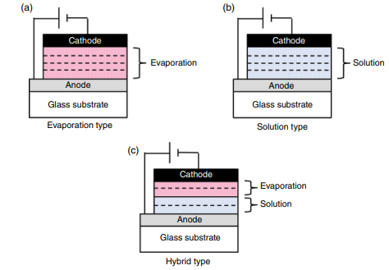
Figure 1.2 Three Types of OLED devices classified by process
2.2 Anode Materials
The anode's most important function is to make holes in the organic layer that is next to it. For these reasons, it is very important that the anode can do its job. Since the work function of the organic layer next to it, such as a hole injection layer (HIL) or a hole transport layer (HTL), is usually around 5.5 eV, the work function of the anode needs to be high. Normal bottom-emitting OLEDs also need the anode to be see-through. ITO (indium tin oxide) has been the most used anode material because of the aforementioned factors.
The vast majority of the time, however, apply deposition is used to make the ITO layer. ITO has a work function of about 4.5–5.2 eV, based on the method it was made, the qualities of the film, the state of the surface, etc. Before putting down the next organic layer next to it, the surface of the ITO is often cleaned with O₂ plasma [3, 4] or UV-O₃ [4, 5] to get rid of any organic materials on the surface. These surface processes also tend to make the work function go up, which makes the hole filling trait better.
Milliron and his colleagues at Princeton University found that treating ITO with oxygen plasma raises its work function by about 0.5 eV [3]. Wu et al. at Princeton University looked into the effect of O₂ plasma and compared it to other ways to treat the disease. They also found that the shape of the surface didn't change much, which shows that shape is not the most important factor in improving gadget performance and stability. It was proven that treatments with UV ozone and oxygen plasma change the turn-on voltage and the performance. In particular, they said that treatments with oxygen plasma have amazing results. On the other hand, therapy with Ar and H₂ plasma did not help. They thought that a change in the chemical makeup of the surface might have something to do with how well holes can be injected at the ITO/organic junction.
There have also been studies and reports on other ways to treat the surface. In the first, Hung et al. of the Eastman Kodak Company wrote about how CHF3 could change the anode through low-frequency plasma polymerization [6]. Polymerized film can be anywhere from 2.5 nm to 10 nm thick. They said that they got better hole filling and better operating steadiness. For example, in the first 150 hours of continuous operation at 40mA/cm2, the drop in brightness was 1% in the OLED device with a 6nm thick polymerized buffer layer and 15% in the OLED device without a buffer.
Ganzorig et al. from Fujihara's group at the Tokyo Institute of Technology (Japan) looked into the way of treating surfaces with benzoyl chlorides and wrote about it [7]. They used H⁻, Cl⁻, and CF₃-terminated benzoyl chlorides to change the surface of ITO, which they then used to make OLED devices. Due to the huge rise in ITO work function, they noticed that the drive power dropped by a lot. Also, they found that the order of decreasing drive voltage matches the order of increasing permanent dipole moments (CF₃ > Cl > H).
Self-assembled monolayers (SAMs) have also been used in some ways. Campbell et al. of Los Alamos National Laboratory and The University of Texas at Dallas (USA) found that putting SAM on a metal electrode improves charge injection by changing the Schottky energy barrier between a metal electrode and an organic material [8].
ITO has problems like being cold, having problems with rare metals, and being expensive. Recently, research and development on non-ITO clear electrodes has begun, with the goal of using them in OLEDs, touch screens, etc. Such clear wires that don't use ITO will be talked about.
On the other hand, OLEDs that release light from the top need an anode that reflects light. For OLEDs that radiate light from the top, the anode is often made of Ag, Ag/ITO, or ITO/Ag/ITO. Ag is a good choice because it reflects a lot of visible light and doesn't conduct electricity well. But since Ag's work function is about 4.3eV, there is still a big barrier to hole filling. So, Ag alone is not good enough for hole filling.
The Ag/ITO piling seems to be the best way. Hsu et al. from Taiwan's National Chiao Tung University and National Tsing Hua University said that Ag/ITO stacking could be used to make OLED devices that release light from the top [9].
Chen et al. of National Taiwan University (Taiwan, Republic of China) found that putting a thin Ag₂O layer (around 10 nm) on Ag gave good hole injection, which led to good OLED features [10]. With a Fermi level of 4.8–5.1 eV, Ag₂O is known to be a p-type semiconductor. By treating Ag with UV and ozone, the group made thin Ag₂O that still had a high reflectivity of 82–91%, which is only a little lower than the reflection of a film made of just Ag.
Chong et al. of Taiwan's National Cheng Kung University wrote about how an organic fluid (tetrahydrofuran) changed an anode made of silver [11]. After a silver film was deposited on ITO-coated glass, the Ag anode was handled right away by putting it in THF for 30 minutes. After the reaction, a nitrogen steam was used to dry the THF-modified Ag anode, which was then put into a glove box filled with nitrogen. The study of the X-ray photoelectron spectroscope shows that the THF molecules chemically bonded to the surface of the Ag, causing oxygen-rich species to form through substrate-catalyzed breakdown. The THF-modified Ag has a work function of 4.79 eV, while the base Ag had a work function of 4.54 eV. On this material, an OLED with the structure ITO/THF-modified Ag/HY-PPV/Ca(12nm)/Ag(17nm) that emits light from the top was made. The HY-PPV is a poly(para-phenylene-vinylene) copolymer with phenyl groups added to it. OLED Materials 29 The device showed 2.93cd/A, while the standard device with unmodified Ag only showed 0.51cd/A. This shows that the THF treatment caused the work function to go up, which is why the efficiency of the current went up.
2.3 Vaporize Organic materials (Small Molecular materials)
Majority OLED technologies, including industrial goods, use materials that are made by evaporating them in a vacuum. In general, the materials are small molecules, and their functions split them into groups like hole injection materials, hole transport materials, releasing materials, host materials in the emission layer, electron transport materials, electron injection materials, charge blocking materials, etc. In the next part, we'll talk about these things.
2.3.1 Hole Injected of OLED Materials
In OLEDs, there exists a barrier of energy between the anode and the bodily functions layer next to it. So, this barrier needs to be lowered so that holes can flow smoothly from the anode to the organic layer next to it. In order to do this, hole injection materials are often used in real-world OLED devices. This is because they can help lower the drive voltage, improve efficiency, increase lifetime, etc.
Figure 1.3 shows materials that are often used for hole topping. Materials can be either biological or artificial, and some materials can also be some combination of both of them.

Organic materials |  | Inorganic materials
Copper phthalocyanine (CuPc)  Starburst amines  Hat-CN |  | Metal oxides: MoOx, RuOx  VOx, WO3, etc.

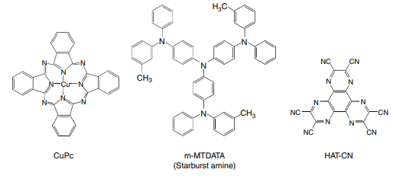
Figure 2.3 Typical hole injection materials
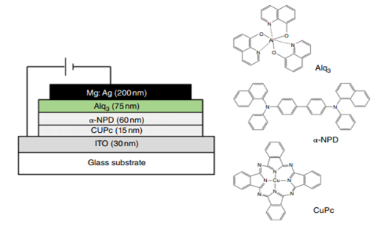
Figure 2.4 Device structure and molecular structures of utilized materials

Copper phthalocyanine (CuPc) has become a well-known material used to generate holes. VanSlyke et al. of Eastman Kodak described the addition of a CuPc layer between an ITO anode and a hole transport layer of N,N′-diphenyl-N,N′-bis(1-naphthyl)-1,10-biphenyl-4,4′-diamine (NPD) [12]. Figure 2.4 illustrates the structure of the device that was reported and the structures of the materials that were used. CuPc's ionisation potential is 4.7 eV, which is less than that of NPD, which is 5.1 eV. ITO has an ionisation potential of about 4.7 eV, so the barrier between ITO and CuPc is smaller than the barrier between ITO and NPD. They said that lowering the distance between the surfaces can affect how well holes are injected and can help improve the lifetime.As hole injection materials, starburst amines with bulky chemical structures are also often used. Shirota et al. of Osaka University were the first to talk about them [13, 14]. The common material is shown in Fig. 2.3 as 4,4′,4′′trisN,(3methylphenyl)Nphenylaminotriphenylamine) (mMTDATA).Shirota et al. found that adding mMTDATA makes the efficiency and lifetime of an OLED better. They did this by looking at how mMTDATA affects the performance of an OLED. The OLED device with the structure ITO/mMTDATA(60nm)/TPD(10nm)/Alq3 (50nm)/MgAg is said to have about 30% higher quantum efficiency and a longer lifetime than the standard device with the structure ITO/TPD(10nm)/Alq₃ (50 nm)/MgAg [14].
1,4,5,8,9,11-hexaazatriphenylene-hexacarbonitrile (HAT CN) is another type of HIL material. Figure 2.3 shows how the molecules are put together. HAT-CN is often used in real-world OLED devices because it has useful qualities like high movement and good hole injection into the layer next to it. Rhee et al. of Sunmoon University and the Korea Institute of Materials Science in South Korea studied the effect of HATCN by comparing it to other HIL materials [15].
It has been said that some artificial oxides can be used as a hole input layer to make OLEDs work better. Molybdenum trioxide (MoO₃) is used a lot in OLED products that are used in the real world.
Tokito et al. of Toyota Central Research and Development Laboratories in Japan have written about using thin metal oxides like vanadium oxide (VOx), molybdenum oxide (MoOx), and ruthenium oxide (RuOx) as a hole injection layer [16]. When these metal oxides are used for hole injection, the working voltage is lower than when the more common ITO electrode is used. This result is because the energy barrier for putting holes into the hole transport layer is getting lower.
Other metal oxides, like SiO₂ [17], CuOx [18], NiO [19, 20], and WO₃ [21], have also been suggested and studied as hole-injecting materials.
Matsushima and Murata et al. of the Japan Advanced Institute of Science and Technology studied how the thickness of MoO₃ affected the hole injection properties. They found that an OLED device with a 0.75nm MoO₃ layer forms ohmic hole injection at the ITO/MoO₃/ NPD interfaces, and the I–V characteristics of this device are controlled by a space-charge-limited current [22].
A p-doped hole injection layer is another way to do it. Technische Universitat Dresden in Germany, where Zhou and Leo et al. work, wrote about a hole injection layer made of TDATA filled with F4TCNQ [23]. Figure 2.5 shows how the device and molecules of TDATA are put together. They said that the working voltage for 100 cd/m² of brightness is 3.4V in an OLED device with 2% F4 TCNQ and 9V in an OLED device without F4 TCNQ.
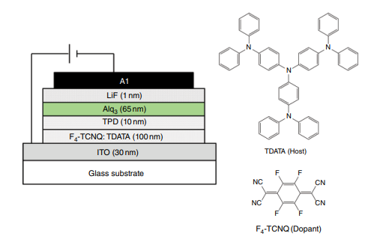
Figure 2.5 Device structure of OLED with a hole injection layer consisting of TDATA doped with F4 ‐TCNQ
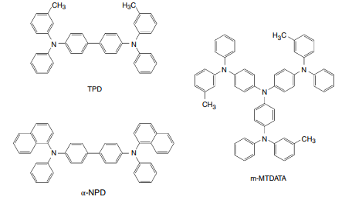
Figure 2.6 Typical hole transport materials for OLEDs
2.3.2 Hole Transport of OLED Materials
The responsibility of materials that move holes is to move them to the discharge layers. As shown in Fig. 2.6, Aromatic amino chemicals are often used to move holes in OLEDs.N,N′-diphenyl-NN′-bis(3-methylphenyl)-[1,1′-biphenyl]-4,4′-diamine (TPD), a standard hole transport material, was used in the OLED device reported by Tang et al. in 1987 [24]. TPD has a high hole mobility, and vacuum deposition makes it easy to make an amorphous film on a substrate. Due to the low glass transition temperature (Tg, about 60°C), the film will crystallise if it is kept at room temperature for a long time. Because the structure of the film changes, it is known that this crystallisation lowers the effective contact area with the anode, which leads to a big drop in efficiency [25].
As hole transport materials with a higher glassy temperature, 4,4′-bis[N-(1-naphthyl)-N-phenyl-amino]biphenyl (NPD) and starburst amines are two that stand out.
The temperature at which NPD turns to glass (Tg) is about 95°C [26]. The natural NPD molecule can be oxidised and the NPD+ cation can be reduced, but both changes can be made back. Also, the double-charged cation NPD++ can go back and forth between oxidation and reduction.
Starburst amines [13, 14, 27, and 29], which are also used to fill holes, can also be used to move holes. Figure 4.7 shows some typical starburst amines. These materials have thick molecular structures that prevent them from taking on a flat form. This keeps the molecules from reorienting themselves and, as a result, from crystallising. Because of this effect, starburst amines tend to give a steady amorphous glassy state, which is needed in OLED devices. Starburst amines are also used as hole injection materials in combination with other hole transport materials like NPD [14].
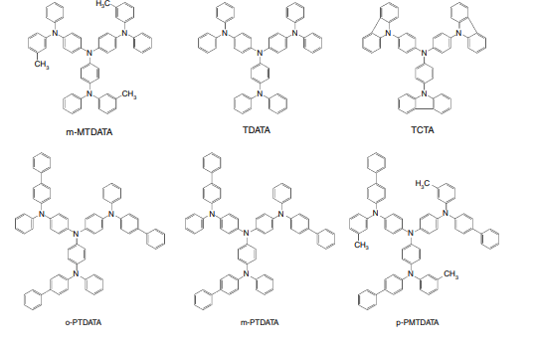
Figure 2.7 Typical starburst amines for OLEDs
2.3.3 Emitting Materials and Host Materials in Fluorescent Emission Layer
The most significant function that materials in the emission layer of OLEDs do is give the right colour and high-efficiency emission. In fact, releasing materials have a lot to do with how well they shine, what colour they shine, how long they last, etc.
Materials in releasing layers are often made up of a host and a dopant, which is also called a guest–host system. In Fig. 2.8, you can see some examples of materials that release light and materials that house those layers.Perylene (blue) and distyrylamine (blue) [30], coumarin (green) [31], Alq₃ (green), rubrene (yellow) [32], and dicyano methylene piran derivatives (red), such as DCM, DCM1, DCM2, DCJTB [31–33], are examples of common releasing dopants. Alq₃, distyrylarylene (DSA), etc. are well-known host materials. Alq₃ is a material that gives off green light on its own and is often used as a host material.
In these guest-host systems, the energy gap of the guest dopant should be smaller than that of the host material. Most of the time, it's between 0.5 and 5%. A better focus is not good because it makes it harder to concentrate. At the moment, most commercial OLED products still use blue-emitting fluorescent OLED materials because there aren't any deep blue phosphorescent materials on the market. However, most green and red materials have already been changed to phosphorescent OLED materials.
Hosokawa et al. of Demits Kosan in Japan made blue OLEDs out of a DSA host and an amino-substituted DSA dopant [30]. Here are some DSA host and
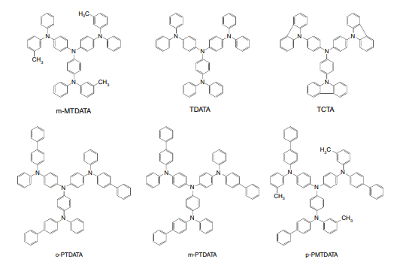
Figure 2.8 Examples of emitting and host materials for fluorescent emitting layer

Figure 2.9 demonstrates DSA dopants with amino groups added to them. In 1997, they said that by using a DSA emission layer with a small amount of an amino-substituted DSA dopant, they could get 6lm/W and a half-life of 20,000 hours at a starting brightness of 100cd/m² [34]. The first industrial OLED goods that gave off blue light were made from these materials. Triplet-triplet fusion (TTF) is an interesting thing that can happen in bright OLED materials. Kawamura et al. of Idemitsu Kosan in Japan said that when triplet excitons (3A*) hit each other, they create singlet excitons (1A*) using the following formula [35]:
$3_{A}*+3_{A}*→4/9.^{1}A$+$4/9.^{1}A*+\left({13}/9\right).^{3}A*$
They call this triplet-triplet fusion (TTF) which describes what it is. Kawamura et al. [36] said that they had made a deep blue luminous OLED using the TTF effect. It had a CIEy of 0.11 and a high EQE of over 10%. They also made a bottom emission OLED with a CIE1931 coordinate of (0.14, 0.08) and a current efficiency of 6.5 cd/A [35].

2.3.4 Emitting Materials and Host Materials in Phosphorescent Emission Layer
Subsequently Baldo et al. of Thompson and Forrest's group at Princeton University (USA) reported the initial phosphorescent OLED devices that worked well at room temperature [37, 38], phosphorescent OLEDs were worked on in a big way.
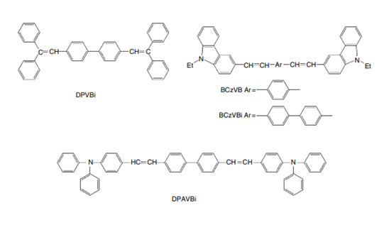
Figure 1.9 Molecular structures of distyrylarylene (DSA) derivatives in blue OLED devices
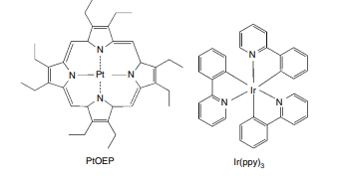
Figure 2.10 Molecular the of structures of PEOEP and Ir(ppy)₃
In their first research, they used a phosphorescent emitter called 2,3,7,8,12,13,17,18-octaethyl-21H,23H-porphine platinum(II) (PtOEP). Fig. 2.10 shows how the molecules of PtOEP get assembled together. Even though they saw phosphorescence, the highest EQE they got was only 4% [37]. In their next report, they used iridium phenylpyridine complex Ir(ppy)₃ (Fig. 2.10) and reported high efficiencies, such as an EQE of 8%, a current efficiency of 28cd/A, and a power efficiency of 31 lm/W [38].
The energy diagram for the OLED device with Ir(ppy)₃ [38] is shown in Figure 2.11. A small amount of Ir(ppy)₃ was added to the CBP host material in the emission layer. In their tests, the best results were found when the amount of doping was 6%. Between the emission layer and the electron carrying layer (Alq₃), a thin barrier layer of BCP was added to keep excitons in the luminescent zone and keep the efficiency high.
Investigations have also shown that the internal quantum efficiency is almost 100% [39–41].
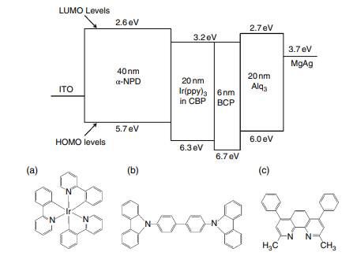
Figure 2.11 Energy level structure of the the OLED device with Ir(ppy)₃ .Note that the HOMO and LUMO levels for Ir(ppy)₃ are unknown. The inset shows the chemical structural formulas of (a) Ir(ppy)3 , (b) CBP, and (c) BCP
2.3.4.1 Phosphorescent Emitting Dopants of OLED
As mentioned aforementioned, phosphorescent OLED devices typically contain phosphorescent dopant and host material in their emission layers. For phosphorescent OLEDs, the emitters are metal clusters with a heavy metal like iridium, platinum, ruthenium, osmium, or rhenium.
As mentioned aforementioned, phosphorescent OLED devices typically contain phosphorescent dopant and host material in their emission layers. For phosphorescent OLEDs, the emitters are metal clusters with a heavy metal like iridium, platinum, ruthenium, osmium, or rhenium.
As shown in Fig. 2.14, there are two distinct kinds of geometrical isomers: face isomers and meridional isomers. Tamayo et al. of the University of Southern California (USA) looked into the face and meridional isomers from multiple Ir-complexes [44] and reported the following:
- The surface isomer is more stable from a thermodynamic point of approach than the meridional isomer. The thermodynamic product is the face isomer, and the kinetic result is the meridional isomer. At high temperatures, it's easy to switch from the meridional isomer to the face isomer.
- When controlling the chemical conditions, each isomer can be made in manner that renders it selective.
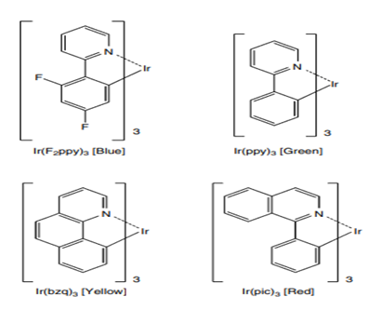
Figure 2.12 Tris‐liganded type of phosphorescent Ir complexes

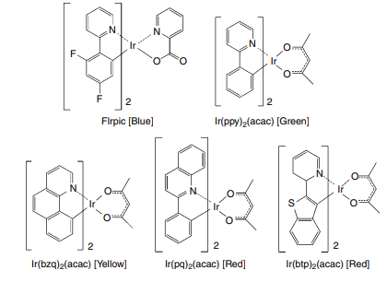
Figure 2.13 Di‐liganded type of phosphorescent Ir complexes
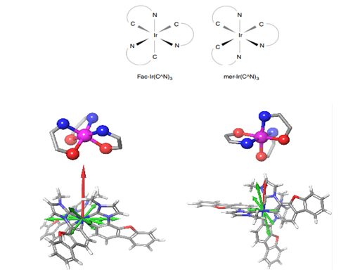
Figure 2.14 Facial and meridional isomers of Ir(ppy)3
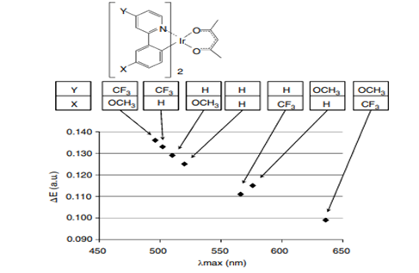
Figure 2.15 The substituent effect of phosphorescent Ir‐complexes on the emission wavelength [45]. ΔE is the calculated energy difference between the HOMO and LUMO levels. λmax is the photoluminescent peak wavelength of the solution containing each phosphorescent Ir complex
- Comparing to the facial isomer, the meridional isomer has a wide emission that is moved toward the color red.
- The face isomer has a higher photoluminescent quantum efficiency than the meridional isomer.
Yoshihara et al. of Gunma University in Japan wrote about the impacts of substituents on the wavelength of light given off by phosphorescent Ir-complexes [45]. Figure 2.15 shows how things turned out. In a toluene the solution. This is the spectra of PL phosphorescent emissions were measured. They worked through the difference in energy between the HOMO and LUMO levels, which they called ΔE. It has been found that the emission peak wavelength is almost the same as ΔE. In the Y-position, the CF₃ group, which takes an electron away, makes the emission wavelength shorter, while the OCH₃ group, which gives an electron away, makes the emission wavelength longer.
On the other hand, at the X-position, the connection is the opposite. That is, in the X-position, the CF₃ group, which takes an electron away, makes the emission wavelength longer, while the OCH₃ group, which gives an electron away, makes the emission wavelength shorter. At the moment, red and green phosphorescent materials have been used in commercial goods, but blue phosphorescent materials still have problems, especially with color purity and durability. For blue phosphorescent materials, FIrpic (iridium(III)bis(4,6‐di‐fluorophenyl)‐pyridinato‐ N,C‐2′)picolinate) and FIr6 (iridium(III)bis(4′,6′‐difluorophenylpyridinato)tetrakis(1‐pyr azolyl)borate) are famous emitters, showing an emission peak at 470 and 458 nm, respectively. But both emission bands have a long tail in the green part of the spectrum that moves into the bluish green part. So, people are still working on making blue phosphorescent devices. Fig. 2.16 shows some blue phosphorescent emitters that have been made recently. A group of cyclometallated carbene-iridium complexes showed promise as high PL blue emitters [46]. The most common material is mertris(Ndibenzofuranyl N′methyl imidazole)iridium(III) (Ir(dbfmi), which gives off a blue light with a peak wavelength of 445 nm). The highest power economy of the blue OLED with Ir(dbfmi) was 35.9 lm/W. With these techniques, a white OLED device with a maximum power efficiency of 59.9lm/W and no light-out coupling improvement was made.
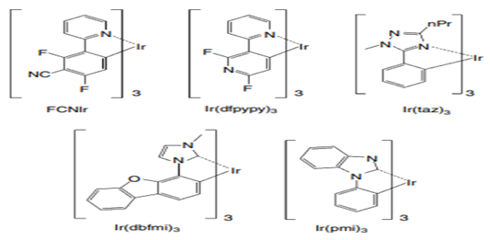
Figure 2.16 several blue phosphorescent emitters
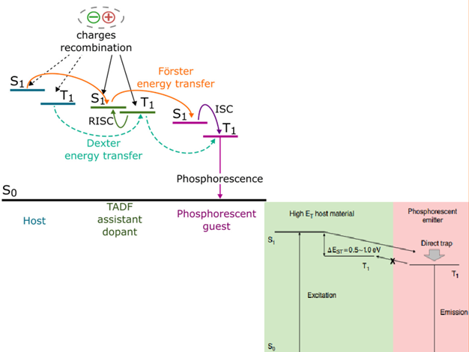
Figure 2.17 Energy transfer model of phosphorescent OLED with host material and phosphorescent emitter

2.3.4.2 Host Materials for Blue Phosphorescent OLEDs
Blue phosphorescent OLED technologies still have issues but red and green phosphorescent OLED content have been used extensively in industrial goods. One reason is that there isn't a good material for the phosphorescent blue discharge layer to stick to. Blue phosphorescent OLEDs need wide energy gap organic materials or high triplet excited energy level (ET) materials.
As shown in Fig. 2.17, wide energy gap organic host materials and charge carrying materials need to be made. Also, both a small EST (the difference in energy between the S₁ and T₁ states) and a high ET are needed. In order for blue phosphorescent OLEDs to work, the host materials must have high triplet energy (ET) of more than 2.75 eV. Adachi et al. of Forrest and Thompson's group at Princeton University (USA) reported that an OLED device with FIrpic doped to 4,4′‐N,N‐′‐dicarbazole‐biphenyl (CBP) showed blue phosphorescent emission with the peak wavelength of 470 nm, a very high maximum organic light‐emitting device external quantum efficiency of (5.7±0.3)% and a luminous power efficiency of (6.3±0.3)lm/W [42]. But CBP and FIrpic have triplet energies of 2.6 eV and 2.7 eV, respectively [47, 48].
The energy confinement is not enough because the triplet energy of CBP is lower than that of FIrpic.Tokito et al. of Japan's NHK Science and Technical Research Laboratories used CDBP (4,4′-bis(9-carbazolyl)-2,2′-dimethyl-biphenyl), which is a CBP derivative with a dimethyl added [47,48]. Figure 2.18 shows how the molecules of CDBP, CBP, and FIrpic are made and how much energy they have. CDBP has a higher triplet energy of 3.0 eV than both CBP and FIrpic. The kink in the biphenyl molecule, which is caused by adding two methyl groups to the ortho position of the biphenyl, seems to be the reason why the triplet energy of CDBP goes up. Since the triplet energy of CDBP is higher than that of FIrpic, there seems to be a good transfer of energy from the triplet state of CDBP to the triplet state of FIrpic. This makes the process very efficient.
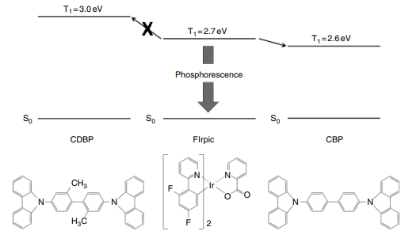
Figure 2.18 Molecular structures and energy levels of CDBP, CBP, and FIrpic
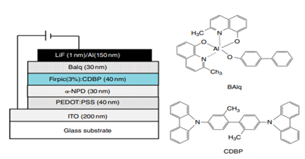
Figure 2.19 A blue phosphorescent device
Actually, Tokito et al. used FIrpic and CDBP to make a phosphorescent OLED technology that worked exceptionally well [47]. Figure 2.19 shows the construction of the device and some of the materials that are used. They said that the best external quantum efficiency they could get was 10.4%, which is the same as a current efficiency of 20.4cd/A.
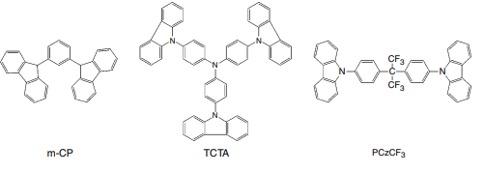
Figure 2.20 Example of recently developed host materials for blue phosphorescent OLEDs

So far, numerous types of host materials for blue phosphorescent OLEDs have been researched and made. Figure 2.20 shows some cases. Sasabe et al. at Yamagata University in Japan made a blue phosphorescent OLED with high-efficiency multi-photon emission. They got 90cd/A and 41 lm/W [49].
2.3.5 Emitting Materials and Host Materials in TADF Emission Layers
Thermally activated delayed fluorescent (TADF) materials are good candidates for the next wave of materials because TADF can make fluorescent materials work well even if they don't contain any rare metals. Fig. 2.6 shows that TADF materials need a small energy difference (EST) between the excited singlet state (S₁) and the excited triplet state (T₁). Most bright materials are thought to have an EST of 0.5–1.0 eV. Adachi's group at Kyushu University in Japan, led by Uoyama et al., said that the critical point of the molecular design in highly luminescent TADF materials is a compatibility of a smaller ΔEST than 0.1 eV and a longer radiative decay rate than 106 /s to overcome competitive non-radiative pathways [50]. Since these two needs are at odds with each other, the overlap of the highest filled molecular orbital (HOMO) and the lowest empty molecular orbital (LUMO) must be carefully managed. Also, they said that the way the molecular orientation changes between the S0 and S₁ states should be limited to stop non-radiative decay.
Uoyama et al. wrote about how they used carbazolyl dicyanobenzene (CDCB) to make a set of very efficient TADF emitters [50]. Fig. 2.21 shows some examples of TADF transmitters with the CDCB structure. The carbazole unit gives up an electron, while the dicya nobenzene unit takes in an electron. The CDCB materials emit light in a wide range of colors, from sky blue with a peak emission wavelength of 473 nm to orange with a peak emission wavelength of 577 nm. The length of the light depends on how well the carbazolyl group on the outside and the dicyanobenzene unit in the middle can give and take electrons. As shown in Fig. 2.22, they used the TADF materials to make OLED devices. The green OLED device is said to have a very high EQE of 19.31.5%, which is the same as an internal EQE of 64.3–96.5% if the light outcoupling efficiency is 20–30%.
More active work is being done to get things that can be used in real life [51–53]. Fig. 2.23 shows some cases.
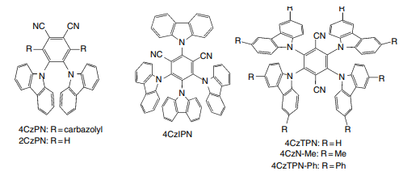
Figure 2.21 Examples of TADF emitters with CBCB structure
2.3.6 Electron Transport Materials
The primary function during electron transport materials is to transfer the electrons that are introduced through the layers that emit light. Figure 2.24 shows some examples of materials that have been used for a long time to move electrons. Tris(8-hydroxyquinoline)aluminum (Alq₃) is a well-known element that moves electrons and also gives off green light. Since Alq₃ was used in OLED devices, as reported by Tang and VanSlyke [54], it has been used a lot as both a material that emits light and a material that moves electrons.
But OLEDs made with Alq₃ tend to have a high drive voltage and low performance because it is hard for electrons to move and get into the device. Based on this information, different electron transport materials have been made with the goal of making OLEDs work better. In these developments, electron-poor aromatic molecules like oxadiazoles, triazoles, imidazoles, pyridines, and pyrimidines have often been used as building blocks for electron transport materials that easily take electrons from the cathode.
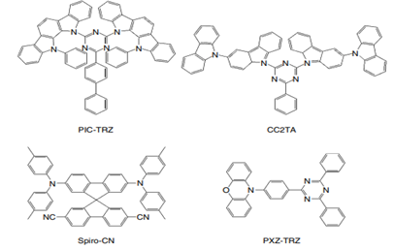
Figure 2.23 Examples of TADF emitters
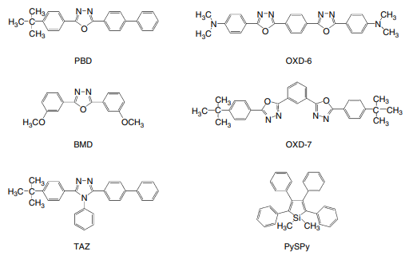
Figure 2.24 classical electron transport materials
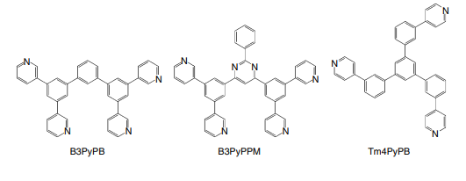
Figure 2.25 Currently developed electron transporting materials
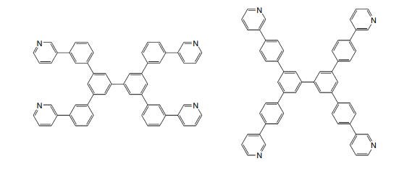
Figure 2.26 Recently developed electron transporting materials
Li et al. of OITDA (Optoelectronics Industry and Technology Development Association) and Yamagata University (Japan) have recently developed new phenanthroline derivatives (Phens) as electron transport materials [55]. Their companies said that the Phens lower the turn-on voltage, making the Alq3 more efficient.
For phosphorescent OLEDs, electron transport materials need to have several properties, such as high electron motion, good hole blocking, and enough triplet energy (ET) for exciton blocking. Based on these needs, new electron-transporting materials [56, 57] have been made. Figures 2.25 and 2.26 show the cases.
2.3.7 Electron Injection Materials and Cathodes
The cathode's foremost responsibility is to transmit electrons into an organ that is close to it. For this reason, the cathode's work function should be low. However, most cathode metals like Al, Ag, and ITO do not have a high work function. So, to properly insert electrons into the organic layer next to it, an extra layer called an electron injection layer (EIL) is needed. In fact, EILs are very important in OLED devices because they reduce the injection barrier between a cathode metal and an organic layer next to it, which is usually an electron transport layer. This lowers the operating voltage by a lot.
In OLED devices, there is often a layer that is both the electron input layer and the cathode. This layer is often just called the cathode.
Scientists and technologists have looked into and made different kinds of electron injection materials for EIL. An artificial electron injection layer is an example of a common type of electron injection material. For small molecule OLEDs, examples include Mg:Ag [58], LiF [59–61], AlLi [62], and CsF [60], and for polymer OLEDs, examples include Ca, Ba, etc. [63–67]. Wakimoto et al. of Pioneer in Japan looked into how different alkaline metal combinations affected the performance of OLEDs [62].
They found that OLED devices made with alkaline metal compounds needed less driving power and worked better. Jabbour et al. of the Optical Sciences Center in the United States wrote about how different cathode materials affect the properties of OLEDs [60]. In their study, they said that an Al cathode had a high driving voltage and a very low efficiency. However, Mg, LiF/Al, AlLiF composite, and AlCsF composite all had lower driving voltages and much higher efficiencies. Hung et al. [59] said that an ultrathin LiF/Al bilayer was used in organic surface-emitting diodes. Chen et al. reported that stacked LiF(0.5 nm)/Al(1 nm)/Ag(20 nm) cathode layers had low sheet resistance (1/sq), low optical absorption, and good electron injection [68]. Okamoto et al. at Sharp were able to make high-efficiency top-emitting OLEDs by using the micro-cavity effect caused by LiF(0.5nm)/Al(1nm)/Ag(20nm) at the cathode [69].
Around the point of interaction between the biological cathode and the metal, an ultrathin metal like Mg or Li can be used to inject electrons. Kido et al. put a Mg (50nm) or Li (1nm) layer between an Ag cathode and an Alq₃ layer that was producing light, which greatly increased the light's brightness [70].
Metal-doped organic layers are the third type [71, 72]. In 1998, Kido et al. from Yamagata University in Japan wrote about a metal-doped Alq₃ layer that was put between an Al cathode and an Alq₃ layer that wasn't metal-doped [71]. Metals like Li, Sr, and Sm, which are very volatile, are used as dopants. A device with a Li-doped Alq₃ layer showed a high brightness of over 30,000 cd/m², while a device without the metal-doped Alq₃ layer only showed 3400 cd/m². They thought that adding Li to the Alq₃ layer makes radical anions of Alq₃ that act as natural electron carriers. This makes the barrier height low for electron injection and the Li-doped Alq₃ layer very good at conducting electrons. The fourth kind is made of metal complexes like 8quino linolato lithium (Liq, Fig. 2.27), which are used to add electrons [57,73–76]. These metal complexes can be evaporated at temperatures between 200 and 300 °C and are easy to work with at room temperature. Endo et al. [73] wrote about two different ways to put metal clusters on OLED screens. The first one is just adding a metal complex layer between a metal cathode and an organic layer. The other is putting in a layer made of a biological material that has a metal complex mixed into it. Kido et al. from Yamagata University recently wrote about lithium phenolate derivatives like LiBPP, LiPP, and LiQP (see Fig. 2.27 [57, 76]).
2.3.8 Charge‐Carrier and Exciton Blocking Materials
Charge-carrying as well as exciton-blocking materials often play a big role in making things work better, last longer, etc. In particular, it is well known that materials that block charge carriers and excitons work well in phosphorescent OLEDs.
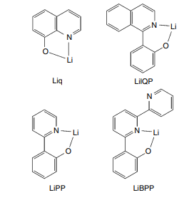
Figure 2.27 Examples of metal complex materials for EIL
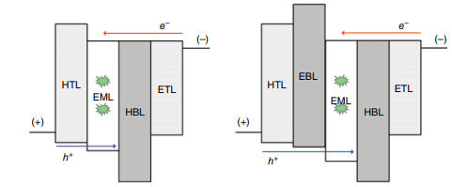
Figure 2.28 The role of charge‐carrier and exciton blocking materials. Excitons are indicated as
starburst patterns
Figure 2.28 shows the graphic energy graphs illustrating the manner in which charge-carrier and exciton-blocking materials work. Figure 2.28(a) shows how a hole and exciton blocking layer (HBL) is put between the electron transport layer (ETL) and the emission layer (EML). The HBL stops holes and excitons from leaking into the ETL. This makes OLED devices much more efficient.
The previously HBL should have a lower HOMO level than the EML. Figure 2.28(b) shows how an electron and exciton blocking layer (EBL) is put between the hole transport layer (HTL) and the emission layer (EML). With adjusting carrier input into the EML, the EBL stops electrons and excitons from leaking into the HTL. This makes OLED devices much more efficient. The EBL should have a higher LUMO level than the EML. In phosphorescent OLED devices, it is also important for the EBL to have a higher energy triplet level so that excitons don't leak into the neighboring HTL, which doesn't emit light. By using these materials that block charge carriers and excitons, carrier recombination and exciton trapping within the emission layer can be done in a very effective way. Figure 2.29 shows some typical HBL materials, such as the well-known material BAlq, which is aluminum(III)bis(2-methyl-8-quinolinato)4-phenylphenolate [77–79]. Kwong et al. said that using a BAlq layer as a hole and exciton blocking layer made the lives of phosphorescent OLEDs last a lot longer. The other well-known one is 2, 9-dimethyl-4,7-diphenyl-1,10-phenanthroline, or bathocuproine BCP [79–82].
It is shown in Figure 1.29. The HOMO and LUMO of BCP are, respectively, 6.5 eV and 3.2 eV [79]. With such a deep HOMO, hole movement can be stopped. Electron blocking materials aren't used as often as hole blocking materials because the mobility of holes is higher in many OLED devices than the mobility of electrons. But in some cases, materials that stop electrons are helpful, and they often need to have a high triplet energy level to keep excitons from escaping into an HTL that doesn't give off light. Irppz and ppz² Ir(dpm), which are shown in Fig. 2.30, are two materials that are often used in EBL.
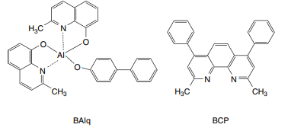
Figure 2.29 Typical materials for HBL
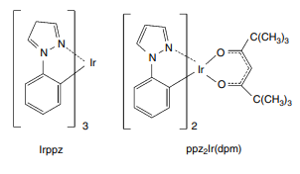
Figure 2.30 Typical materials for EBL
2.3.9 N‐Dope and P‐Dope Materials
It has been said that pin OLED light sources work well to get high efficiency and low working power [23, 83–86]. In the structure of these p-i-n OLEDs, an emission layer is sandwiched between p-type and n-type doped wide-band gap carrier transport layers and the right charge blocking layers. Conventional LEDs made of artificial semiconductors use highly n- and p-doped electron and hole transport layers. This makes tunneling injection work well and keeps the band flat while the LED is running. The same ideas can be used to make living LEDs. Figure 2.31 shows an example of an OLED gadget.
The device has a hole injection and transport layer (HTL) that is p-doped and an electron transport layer (ETL) that is n-doped. By filling organic semiconductor layers with electron sources for electron transport materials or electron acceptors for hole transport materials, the conductivity can be made better and the voltage drop between these layers can be cut down by a lot. Such pin-type device designs ensure that carriers are injected from both poles into the doped transport layers efficiently and that the highly conductive layers have low ohmic losses. Technische Universität Dresden in Germany, led by Zhou et al., reported a p-doped hole injection layer doped with F4-TCNQ [23]. Fujihira and Ganzorig at the Tokyo Institute of Technology in Japan found that adding oxidizing chemicals like iodine, FeCl₃, and SbCl₅ to a p-doped hole transport TPD layer lowers the turn-on voltage and lowers the hole injection barrier [84].
When these oxidizing chemicals were added to an ITO/TPD/Alq₃/Al device, the turn-on voltage was said to be less than 10V, while the turn-on voltage of a non-doped device was said to be more than 15V. Ikeda et al. of the Semiconductor Energy Laboratory wrote about molybdenum oxide (MoOx)-doped hole injection layers [85]. Su et al. from Taiwan's I-Shou University also wrote about doped molybdenum oxide (MoOx) hole injection layers [86]. They added MoOx to 4,4′,4,tris[2-naphthyl(phenyl)amino] triphenylamine (2-TNATA) to make a p-doped hole injection layer (HIL) its OLEDs.
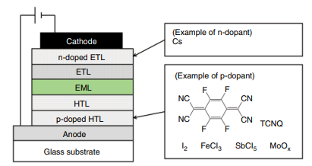
Figure 2.31 An example p‐i‐n OLED device
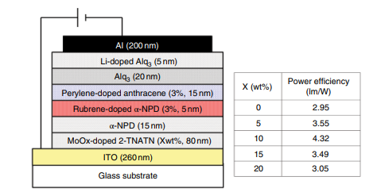
Figure 2.32 OLED device structures utilizing the p‐doped HIL and their typical performances.
The p-doping HIL was used in device designs, and Fig. 2.32 shows how they usually work. The results show that adding MoOx makes the power usage better and lowers the drive voltage. They also said that the quality of life was greatly better. On the other hand, co-evaporation of BPhen with pure Cs [84] has been reported for n-doped layers.
2.4 Solution Materials
Alternative methods for making OLED devices have gotten a great deal of attention due to they might prove a success for technologies that make the process simpler to make low-cost OLEDs. Solution methods need OLED materials that can disintegrate in water. These materials can be divided into three groups: polymers, dendrimers, and small molecules that can dissolve in water.
Polymer Materials
Solution of Materials
Small Molecules
Dendrimers
2.4.1 Polymer Materials
Burroughes et al. of the Cambridge group were the initial ones to provide information about polymer OLEDs [87, 88]. As shown in Fig. 2.33, they used PPV, or poly(p-phenylene vinylene). PPV is a linked organic semiconductor in which the chemical orbitals are spread out along the polymer filament. Burroughes et al. wrote that injecting an electron and a hole into a conjugated chain can lead to a self-localized excited state that can then decay by radiating, which suggests that these materials could be used in electroluminescent devices. As shown in Fig. 2.33, they made a solution-processable precursor polymer (II) to make PPV. The precursor polymer II was spin-coated on surfaces with indium oxide. This was followed by thermal conversion (usually >250°C in vacuum for 10 hours) to a homogeneous, dense, and uniform film of PPV (I) with a normal thickness of 100nm. Al was put on the polymer to act as a cathode. Fig. 2.33 also shows how the device is put together.
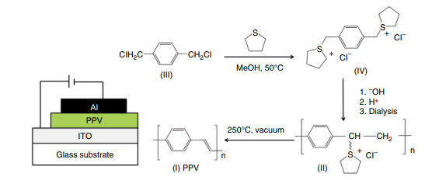
Figure 2.33 PPV synthesized by a device structure with a PPV.
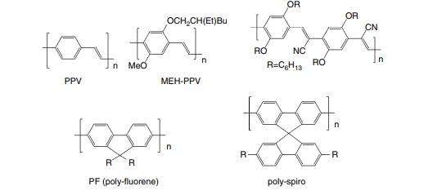
Figure 2.34 Examples of conjugated polymers utilized in polymer OLED devices
Subsequently Burroughes et al.'s report, the development and research process got back on track. Even though the device by Burroughes et al. only has one layer of biological material, designs with multiple layers and different materials have been made.
2.4.1.1 Fluorescent Emitting Polymers
In Fig. 2.34, some examples of linked polymers used in polymer OLED devices are shown. Poly(p-phenylene vinylene), or PPV, was used in the first report of electroluminescence from linked polymers [87, 88]. The energy gap between the π and π* forms of PPV is about 2.5eV, which makes yellow/green light. Several of the PPV variants shown in Fig. 2.34 have been synthesised and used in polymer OLED devices. One of the most well-known PPV products is MEH-PPV, or poly(2methoxy,5(2′-ethyl-hexoxy)1,4phenylene-vinylene. MEH-PPV makes an orange-red colour and has been used in many studies because it dissolves in organic solvents [89]. MEHPPV has a π‐π* electrical energy gap of about 2.2eV, which is smaller than that of PPV. Copolymers have been widely created and used in polymer OLED devices because they let you change the colour and have better brightness [90]. Poly(dialkylfluorene)s [91–93] gives off blue light and has a high luminescence. Various copolymers with poly(dialkylfluorene) have been made and used in OLED displays. Some copolymers of polyfluorene made green and red colours. The examples are shown in Fig. 2.35.
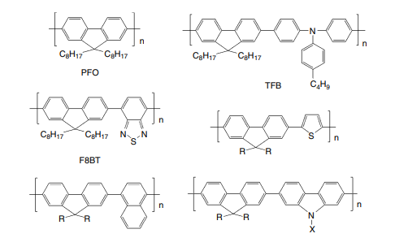
Figure 2.35 Examples of copolymers with polyfluorene.
2.4.1.2 Hole Injection Materials
Illustration 2.34 shows some instances of linked polymers that have applications in polymer OLED systems. The first report of electroluminescence from corresponding polymers [87, 88] used poly(p-phenylene vinylene), or PPV. The energy gap between the π and π * forms of PPV is about 2.5eV, which makes it glow yellow or green. Several of the PPV variants in Fig. 2.34 have been made and used in polymer OLEDs. MEH-PPV, or poly(2-methoxy-5-(2-ethylhexoxy)-1,4-phenylene-vinylene, is a well-known PPV product that gives off an orange-red colour and has been used in many studies because it dissolves in organic solvents [89]. MEHPPV has a smaller electrical energy gap than PPV, which is about 2.2eV. Copolymers have been made and used a lot in polymer OLEDs because they let you change the colour and have better brightness [90]. Poly(dialkylfluorene)s [91–93] gives off blue light and glows brightly. Poly(dialkylfluorene) has been used to make different copolymers that have been used in OLED devices. Some polyfluorene copolymers turned out to be green and red. Figure 2.35 shows some examples
The hole filling feature is important in polymer OLED devices as well as small molecule OLED devices. Most of the time, hole injection materials (usually ITO) are placed on the anode to lower the barrier to hole injection. Yang and Heeger et al. of Uniax Corporation (USA) said that putting in a hole-injecting layer made of mixes of polyaniline (PANI) in low molecular weight polyester resin [94] makes it easier for charge carriers to get into an ITO anode. Cao et al. of Heeger's group used polyethylene dioxythiophene–polystyrene sulfonate (PEDOT:PSS) thin films on polymer light-emitting diodes made of poly(2methoxy,5(2′-ethyl hexyloxy)1,4phenylene vinylene) (MEHPPV) [95]. It was said that the OLEDs with an ITO/PEDOT:PSS/MEHPPV/Ca structure worked better and lasted longer. Figure 2.36 shows how PEDOT: PSS is made up at the molecular level. PEDOT:PSS has been used a lot, not just for polymer-type OLEDs but also with evaporated organic layers [96–101].
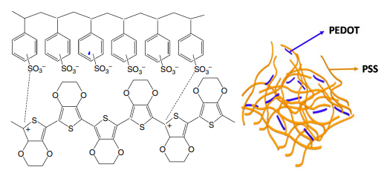
Figure 2.36 Molecular structure of PEDOT:PSS
2.4.1.3 Degradation of PEDOT: PSS and Interlayer
Whilst PEDOT:PSS is a helpful solution substance with the capability to make in and move holes, one of its major problems is that it shortens the life of OLEDs when they are being driven. As a way to stop people from using PEDOT: PSS, it has been suggested to put a space between the PEDOT:PSS and the layer that emits light. Figure 2.37 shows how polymer OLEDs with PEDOT: PSS are usually made up of two devices. Figure 2.37(a) shows the structure with two layers and no middle layer. Figure 2.37(b) shows the structure with three layers and a middle layer. People have said that the interlayer stops excitons from dying out [102] and/or electrons from blocking [103–107]. Fig. 2.38 shows illustration graphic energetic graphs of these two device designs, with or without first an intermediate, based on the electron blocking model. When there is no layer in between, as shown in Fig. 2.38(a), it is easy for electrons to move to PEDOT: PSS. If, on the other hand, the intermediate stops electrons from getting to PEDOT: PSS, they don't tend to go there.
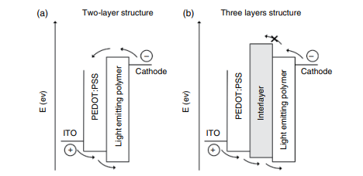
Figure 2.38 Typical schematic energy diagrams of two device structures of polymer OLED devices with or without an interlayer. (a) Two‐layer structure without an interlayer (b) Three‐layer structure with an interlayer
Be transferred to PEDOT:PSS, as shown in Fig. 2.38(b). The way PEDOT:bPSS breaks down is closely linked to the idea of the electron-blocking intermediate. Sakamoto et al. in Furukawa's group at Waseda University used fluctuations in the Raman spectrum to study the breakdown of PEDOT:PSS in polymer-based OLED devices [108] in order to figure out how it breaks down. Glass/ITO(100 nm)/PEDOT:PSS(30 nm)/F8BTPF8(90 nm)/LiAl is the structure of their device. They said that while driving, the PEDOT band got bigger. Their companies afterwards came to the conclusion that this happened because the PEDOT chains got smaller (de-doped). They also said that some of the electrons introduced into the F8BTPF8 blende layer could get past the recombination process and reach the PEDOT:PSS layer. If this happens, the PEDOT chains could be shortened (dedoped). They said that this is probably one of the things that causes polymer OLED devices with PEDOT:PSS to break down over time. In fact, there are several stories about how adding a barrier between PEDOT:PSS and a light-emitting polymer can make the device work better or last longer. Morgado et al. wrote about the layer in polymer OLEDs that blocks electrons [103]. They put a thin layer of poly(p-phenylene vinylene), or PPV, between a layer of PEDOT:PSS with holes and a layer of polyfluorenes that gives off light. Figure 2.39 shows the schematic energy map of their device with ITO/PEDOT:PSS/PPV/EML/Ca, where EML is PFO with 5% green-emitting F8BT. They said that adding a PPV layer raised the performance from 2.1 cd/A to 4.1 cd/A. Due to a big difference between the LUMO levels of F8BT and PPV, there is a barrier of about 0.4eV where electrons can't get into PPV. They thought that this gain was mostly caused by the PPV layer's ability to stop electrons, which led to a better balance of charge carriers in the emissive layer. Conway et al. of Cambridge Display Technology (CDT) looked into the part of the inter layer by using an electron-only current device with an interlayer with different electron motion [104]. They saw that the EQE and lifetime went up as the electron current of the interlayer went down. This led them to conclude that the transport properties of the interlayer and the light-emitting polymer are the most important, while the properties of the interlayer that block excitons are not as important.
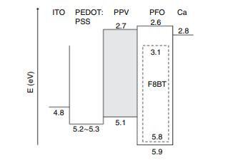
Figure 2.39 The schematic energy diagram of the device with ITO/PEDOT: PSS/PPV/EML/Ca, where EML is PFO with 5\wt% of green emitting F8BT.
Table 2.1 Effects of an insertion of interlayer
 |  | Efficiency (cd/A) |  | Half lifetime (h)
 |  | Luminance |  | Initial luminance
Red devices | Two‐layer (without IL) | 2.3 | 450cd/m2 | 98h | 3000cd/m2
 | Three‐layer (with IL) | 3.0 |  | 569h
Green devices | Two‐layer (without IL) | 13.0 | 900 cd/m2 | 130h | 6000cd/m2
 | Three‐layer (with IL) | 14.1 |  | 378h
Blue devices | Two‐layer (without IL) | 5.7 | 150 cd/m2 | 15h | 1000cd/m
 | Three‐layer (with IL) | 11.2 |  | 464h

Shirasaki et al. of Casio (Japan) further stated that they used an insulator to stop electrons within their polymer AM-OLED display [105]. a combination of the interlayer, Fujita et al. at Sharp (Japan) made red, green, and blue polymer OLED devices work better and last longer [106]. Even though the efficiency of red and green polymer OLEDs isn't getting much better, the efficiency of blue OLEDs is getting better by a huge amount, which is twice as much. Also, as shown in Table 1.1, the lives of red, green, and blue OLEDs have been greatly improved. Fig. 2.40 shows one example of how life curves get better over time. Hatanaka et al. at Sharp in Japan used single carrier devices and bipolar devices to study the role of the interlayer [107]. Figures 2.41 and 2.42 show the layout of their single carrier devices. In red, green, and blue polymer OLED devices, the same interlayer material with the same thickness of 20nm is used. Figure 1.41 shows the V–I graphs of electron-only devices (EODs). By adding the interlayer, the V–I graphs of EODs show that the currents are much lower. Figure 2.41 shows that the intermediate does a good job of keeping electrons out. But the difference can't explain why this is happening.
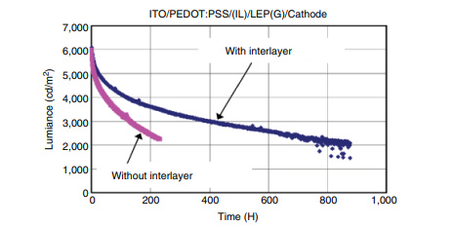
Figure 2.40 an example of lifetime improvement by an insertion of an interlayer
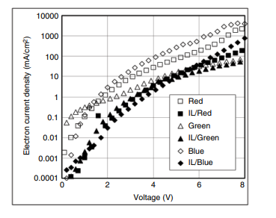
Figure 2.41 Device structure and I–V cures of electron‐only devices (EODs) for investigating role of Inter-layers
Within LUMO levels. The energy diagram is shown in Figure 2.43. If the electron blocking is caused by the difference in LUMO values between the interlayer and the producing polymer, then the red OLED should have the most electron blocking and the blue OLED should have the least. But Fig. 2.41 shows that the most electrons are blocked in the blue OLED. So, we can say that the effect of the intermediate stopping electrons is not because of the distinction that exists.
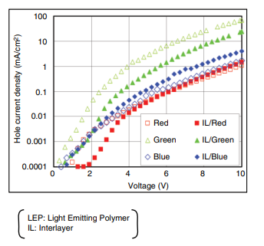
Figure 2.42 Device structure and I–V cures of hole‐only devices (HODs) for investigating role of inter-layers
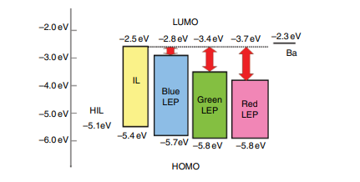
Figure 2.43 the energy diagram of several polymer materials
On LUMO scales. The energy curve is shown in Figure 2.43. If the electron obstructing is caused by the difference in LUMO values between the interlayer and the producing polymer, then the red OLED should have the greatest degree of electron blocking and the blue OLED should have the least. But Fig. 2.41 shows that the most electrons are blocked in the blue OLED. So, we can say that the effect of the intermediate stopping electrons is not because of the distinction that exists.
2.4.1.4 Phosphorescent Polymer Materials
Solution-type phosphorescent polymeric substances have additionally been investigated. The first generation of these materials was made by mixing a host polymer with a small molecule phosphorescent dopant. Guo et al. at the University of California at Los Angeles and the University of Southern California (USA) added small molecules of platinum (II)2,8,12,17-tetraethyl3,7,13,18-tetramethylporphyrin (PtOX) to a host polymer [109]. The structure of the device is made up of two layers: one that moves holes and one that moves electrons. The layer that moves holes is made of poly(vinylcarbazole). The electron moving layer is made of poly(9,9 bis(octyl)fluorene-2,7-diyl) (BOcPF) that has been treated with PtOX, which is a dopant that gives off phosphorescent light. When treated with PtOX, the OLED device's performance from the outside was said to go up from 1% to 2.3%. Lee et al. at the Kwangju Institute of Science and Technology in Korea reported phosphorescent OLEDs with tris(2-phenylpyridine) iridium [Ir(ppy)3] as a triplet emissive dopant in a poly(vinylcarbazole) (PVK) host [110]. Figure 2.44 shows how their device is put together. With 8% [Ir(ppy)3] doping in PVK, the device had an EQE of 1.9% and a peak brightness of 2500cd/m². Lamansky and his colleagues at the University of Southern California in the United States also found phosphorescent OLEDs made of a single layer of poly(N-vinylcarbazole) (PVK) filled with small molecule phosphorescent dyes [111]. Lane et al. looked into polymer OLEDs with a glowing polymer host, poly(9,9-dioctyl fluorene) (PFO), dyed with a red phosphorescent dye, 2,3,7,8,12,13,17,18-octaethyl 21H,23Hporphyrin platinum(II) (PtOEP) [112]. At a cheating level of 4% PtOEP, they got the highest EQE, which was 3.5%.

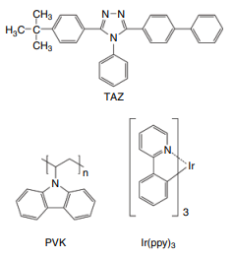
Figure 2.44 Device structures of OLEDs with a host polymer and a phosphorescent dopant.
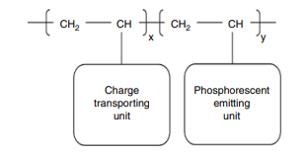
Figure 2.45 Schematic illustrations of second generation phosphorescent polymers
Vaeth and Tang of Eastman Kodak in the US developed phosphorescent OLEDs by adding factris (2phenylpyridine) iridium (Irppy) to a poly(vinyl carbazole) host [113]. With a second dopant made of 2(4-biphenylyl)5(4-tert-butylphenyl)1,3,4-oxadiazole, they got a brightness efficiency of 30cd/A and an EQE of 8.5% in the most favorable scenario. Hino et al. at Osaka University in Japan wrote about phosphorescent OLED devices made with Ir(ppy)3 put into a low-molecular material that can be processed with a solution [114].As the host material, they used 1,3,5-tris[4-(diphenylamino)phenyl]benzene (TDAPB) that had been replaced with methoxy and dissolved in 1,2-dichloroethane. They got an EQE of 8.2% at its peak and an efficiency of 29cd/A at the moment. Solution-type phosphorescent materials of the second generation are emissive polymers with a small number of phosphorescent units in the side group. Figure 2.45 shows a diagram of these kinds of products. Lee and his colleagues at the Kwangju Institute of Science and Technology in Korea made a new material with carbazole units and iridium complexes so that phosphorescent OLED devices could be made [115].
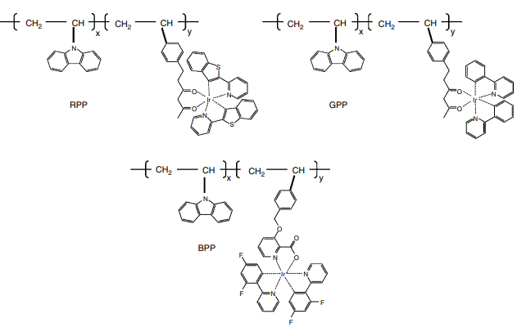
Figure 2.46 Molecular structures of phosphorescent polymer involving a carbazole unit and an iridium‐complex unit developed
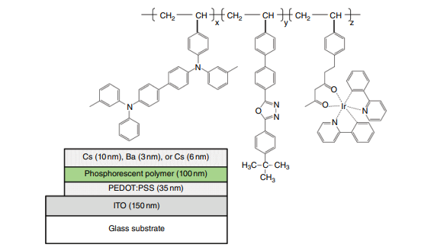
Figure 2.47 Device structures of OLEDs with a phosphorescent polymer
In terms of the carbazole unit in the polymer, the amount of Ir complex is 7.8wt%. Their device is made of ITO / PEDOT (40nm) / Ir-complex copolymer (30nm) / TAZ (30nm) / Alq₃ (20nm)/ LiF(1nm) / Al(180nm). They said that the device had a maximum EQE of 4.4% at 36 cd/m², a maximum power efficiency of 5.0 lm/W at 6.4V, and a peak brightness of 12,900cd/m² at 24.2V (360mA/cm²). Tokito et al. also made phosphorescent polymers with a carbazole unit and an iridium-complex unit as part of a study done by NHK Science and Technical Research Laboratories and Showa Denko in Japan [116]. Figure 2.46 shows how the molecules are put together. They made OLED devices with the structure glass/ITO/PEDOT:PSS(30 nm) /EML (85nm) / Ca(10nm)/Al (150nm), where the emission layer (EML) is a phosphorescent polymer doped with an electron transport material. In red, green, and blue OLEDs, high external quantum efficiencies of 5.5%, 9%, and 3.5% were each found. Tokito et al. of NHK Science and Technical Research Laboratories improved the performance of phosphorescent OLED devices with a phosphorescent polymer by adding aluminum (III) bis-(2methyl8quinolinato)4phenylphenolato (BAlq) as a hole blocking layer between an emissive polymer layer and a cathode [117]. In red, green, and blue OLEDs, they got external quantum efficiencies of 6.6%, 11%, and 6.9%, respectively. They also made plastics that were better. Suzuki and his colleagues made new phosphorescent copolymers [118]. The copolymers have bis (2‐phenylpyridine) iridium (acetylacetonate) [Ir(ppy)(2)(acac)], N,N′‐diphenyl‐NN′‐bis(3‐methylphenyl)‐[1,1′‐biphenyl]‐4,4′‐diamine (TPD) and 2‐(4‐biphenyl)‐5‐(4‐tert‐butylphenyl)‐1,3,4‐oxadiazole (PBD) as a side group. Figure 2.47 shows the structure of the molecules in the polymer that was made and the structure of the OLED device that used the polymer.
They looked at how the concentration ratio of three types of substituents and three low work function metals, Ca, Ba, and Cs, affected the electron injection layer. In the best case, the ratio of TPD: PBD: Ir(ppy) 2 (acac)=18:79:3 and Cs gives an EQE of 11.8% and a power efficiency of 38.6lm/W for the mix of the materials.
2.4.2 Dendrimers
Dendrimers are also materials that behave like solutions. Fig.2.48 shows how this works. Dendrimers have a core, dendrons that are joined together, and external groups. The core in the middle of a dendrimer molecule has Optoelectronic qualities, which are mostly linked to how well an OLED works. The dendrons can control the movement of charges, etc. On the other hand, the stability and ability to be broken down depend on the surface groups on the outside of the molecule. Dendrimers have a clear structure and can be cleaned up with standard cleaning methods, but structural flaws in polymers can't be easily fixed, which could make the device less stable. Fluorescent dendrimers were the first way that dendrimers were used in OLEDs. Figure 2.49 shows conjugated dendrimers that Halim et al. of the University of Durham and Dyson Perrins Laboratory in the UK found [119]. Simple OLED devices with the structure of glass/ITO/dendrimer/cathode were made with these materials. The dendrimer is spin-coated and the metal cathode is melted. They said that the chemical structure of dendrimers could be changed to make green, red, and blue OLEDs.
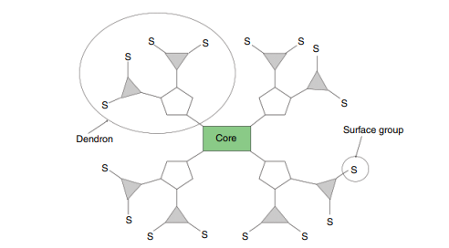

Figure 2.48 the dendrimer concept showing the core, conjugated dendrons, and surface group
Lupton et al. of the University of St. Andrews and other places in the UK found charge-carrying dendrimers [120], which are shown in Fig. 2.50. Phosphorescent dendrimers are the second way to use dendrimers.
Most of the time, phosphorescent dendrimers have an emission core made of a heavy metal and surrounded by dendrons. In a neat film, these dendrons move charge carriers and stop iridium cores from interacting with each other, which would cause the photoluminescence to go out. Also, dendrimer metal complexes are usually easier to dissolve than other types of metal complexes. One of the things a dendron must have is a higher triplet excited energy level than the core complex, so that it doesn't stop the core complex from giving off triplets. In 2001, Lupton et al. reported a phosphorescent dendrimer with a heavy metal called Platinum (Pt) at its centre [121]. Markham et al. at the University St. Andrews (UK) found phosphorescent dendrimers with iridium (Ir) as the heavy metal in the middle [122]. Fig. 2.51 shows how the molecules are put together. They used the dendrimer to make OLEDs, as shown in Fig. 2.52. The TCTA and the dendrimer G1 are what make up the emission layer. A layer of TPBI that moves electrons is put on top of the dendrimer layer. At 4.5V and 400 cd/m², they got the best efficiency, which was 40 lm/W (55 cd/A). Sumitomo Chemical (Japan) and Cambridge Display Technology (CDT) (UK) have also reported solution-type emitting materials with a phosphorescent dendrimer and a linked host polymer [123]. Figure 2.52 shows a diagram of how the molecules are put together. The dendrimers have a core with an Ir complex that emits phosphorescence and a dendron with aromatic moieties that have groups that are compatible with groups in solution. These dendrimers have good emission properties, good charge transport properties, and are easy to dissolve. The host polymers are poly-fluorene polymers that are very good at moving charge carriers and being processed in a solution. They added a red dendrimer to a host material that gives off blue light when it glows. How OLED gadgets are put together.
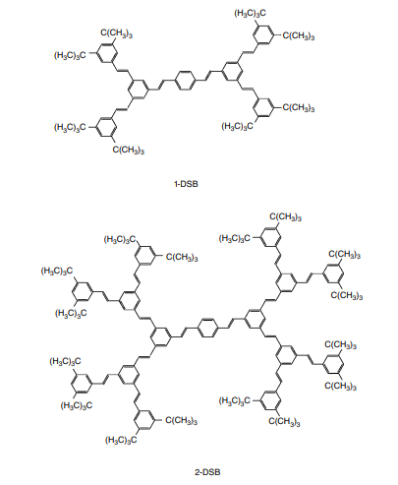
Figure 2.49 Fluorescent dendrimers reported
Fig. 2.54 illustrates what occurs with the dendrimers. From a starting brightness of 400cd/m², they got a current efficiency of 4.6 cd/A, a CIE colour coordinate of (0.66, 0.32), and a half life (T50) of 5700 hours. Tsuzuki and others in Tokito's group at NHK Japan Broadcasting in Japan made phosphorescent dendrimers with a phosphorescent core and dendrons made of charge-carrying building blocks [124]. They made first-generation and the subsequent generations dendrimers with a factris(2phenylpyridine)iridium [Ir(ppy)3] core and hole-transporting.
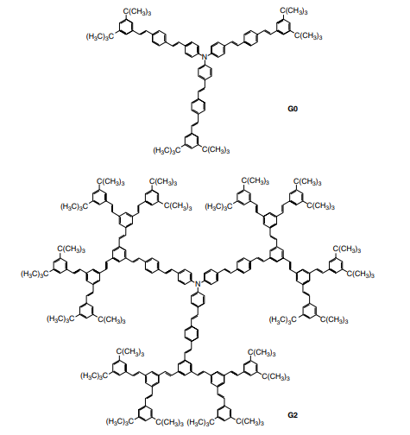

Figure 2.50 Charge transporting dendrimers reported
Dendrons generated from phenylcarbazole. With a highest EQE of 7.6%, the OLEDs that used the film with a mixture of the dendrimer and an electron-transporting material were estimated to emit a bright green or yellowish green light. Iguchi and his colleagues at Yamagata University in Japan made iridium complexes with heavy carbazole dendrons that can be processed in a liquid [125]. Fig. 2.54 shows the products that have been made. The 4-pyridinesubstituted dendron on the ligand makes it easier for electrons to move from the cathode to the anode.
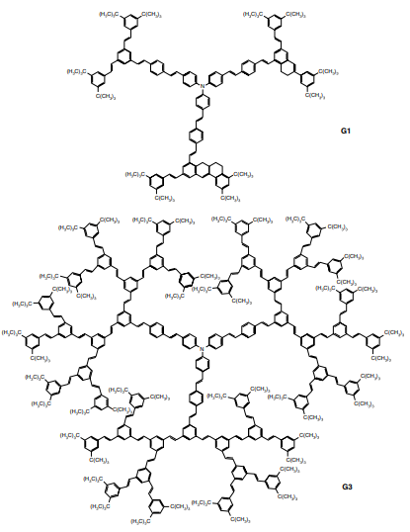
Metal. Investigators have found that heavy dendrons with higher triplet energy than Ir(ppy)₃ can stop concentration cooling and keep excitons close together. In their weakened solutions, the photoluminescence quantum efficiencies (PLQEs) of (mCP)₃ Ir and (mCP)₂ (bpp)Ir were 91% and 84%, respectively. (mCP)₃ Ir and (mCP)₂ (bpp) both had high PLQEs of 49% and 29%, respectively.
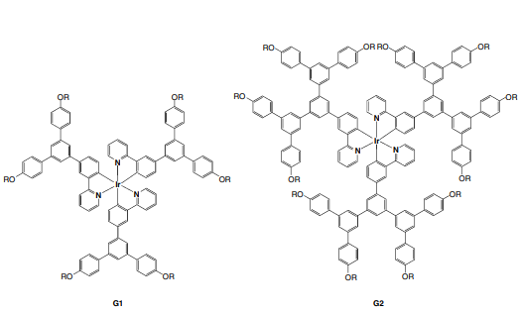
Figure 2.51 Molecular structure of phosphorescent dendrimers reported
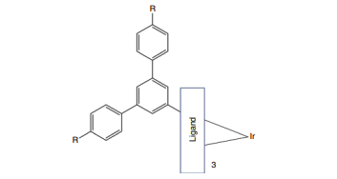
Figure 2.52 Molecular structures of dendrimers and host polymers reported
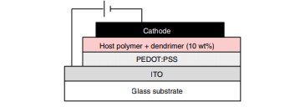
Figure 2.53 The OLED device with a dendrimer reported

Or even in an interesting drama. The triplet exciton energy levels of the dendronized ligand (2.8eV) and the dendron (2.9eV) are both higher than that of the core complex Ir(ppy)3 (2.6eV). When an electron-transporting and hole-blocking material was used, the EQEs of double-layer devices went from 8.3% for (mCP)3 Ir and 5.4% for (mCP)2 (bpp)Ir at 100cd/m2 to 8.3% for (mCP)3 Ir and 5.4% for (mCP)2 (bpp)Ir.
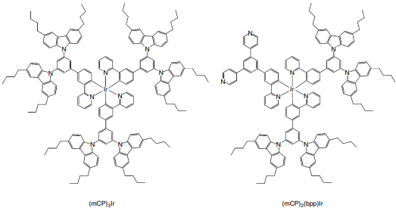
Figure 2.54 Solution‐processable iridium complexes having bulky carbazole dendrons
2.4.3 Small Molecules
A third approach to make OLED materials that can be handled in solution is to use liquid small molecule OLED materials. Herron and Gao of DuPont Displays in the United States gave a report on their small OLED materials that are based on solutions [127]. Table 2.2 shows how well the OLED devices worked that were made by spin-coating their small OLED materials that were made from a solution. So that manufacturing can be done in a cost-effective way, the data collected are based on the "common layers architecture" shown in Fig. 1.56. Because of this, the width of HIL, HTL, and ETL are all the same. It is known that all three colours in Table 4.2 show that a device works well.
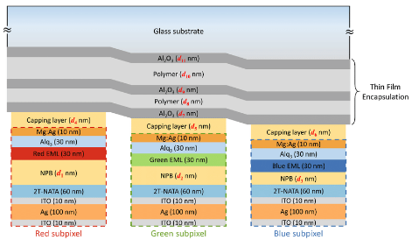
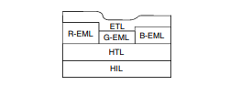
Figure 2.56 Illustration of the common layers architecture used in full‐color displays
2.5 Molecular Orientation of Organic Materials
To identify an extended period, it was thought that organic thin films for OLED devices should be amorphous because the presence of randomly rough surfaces, like in a polycrystalline structure, causes an unwanted current barrier, leak current between the anode and cathode, and unwanted light scattering. Also, it has been thought that films made by vacuum deposition have an irregular molecular structure if no special methods are used. But it was recently said that molecular direction of vacuum-deposited or wet-coated films has been achieved in some cases. Organic thin film molecular orientations are not only interesting from a scientific point of view, but also from a functional point of view, because they can improve carrier movement, carrier injection, and light extraction efficiency. Yokoyama et al. at Kyushu University in Japan found that organic materials in evaporated organic layers can have anisotropic molecular orientation. They used variable angle spectroscopic ellipsometry (VASR) to study the molecular orientation of organic films [128]. Using the effect of releasing materials' molecular direction, Frischeisen et al. at Kyushu University (Japan) found that the effectiveness of light out-coupling was greatly improved [129]. They used two materials, PEBA and BDASBi, that are very similar except for the way they are oriented. Figure 2.57 shows the structure of the molecules and the structure of the device that these materials are used in. They looked at and measured the dipole orientation in guest–host systems. They found that when PEBA is added to CBP, there is no preferred molecular orientation and the dipole orientation is completely random (on average, 2/3 of the dipoles are oriented horizontally and 1/3 are oriented vertically), but when BDASBi is added, there is a clear tendency towards horizontal orientation (with 0.27 for random dipole orientations and 0.73 for horizontal dipole orientations, respectively). In fact, the device with BDASBi has an EQE of 2.7%, which is much better than the device with PEBA, which has an EQE of 1.6%. They came to the conclusion that the OLED with BDASBi has 45% more out-coupling efficiency because the dipoles are strongly aligned horizontally.
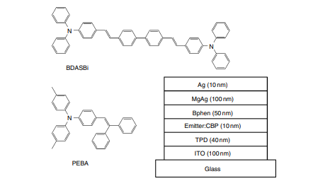
Figure 2.57 Molecular structures and device structure of the materials
References
[1] H. Fukagawa, K. Watanabe, S. Tokito, Organic Electronics, 10, 798–802 (2009).
[2] A. Kawakami, E. Otsuki, M. Fujieda, H. Kita, H. Taka, H. Sato, H. Usui, Jpn. J. Appl. Phys., 47(2), 1279–1283
(2008); E. Otsuki, H. Sato, A. Kawakami, H. Taka, H. Kita, H. Usui, Thin Solid Films, 518, 703 (2009).
[3] D. J. Milliron, I. G. Hill, C. Shen, A. Kahn, J. Schwartz, J. Appl. Phys., 87(1), 572–576 (2000).
[4] C. C. Wu, C. I. Wu, J. C. Sturm, A. Kahn, Appl. Phys. Lett., 70(11), 1348–1350 (1997).
[5] C. W. Tang, S. A. VanSlyke, C. H. Chan, J. Appl. Phys., 65(9), 3610–3616 (1989).
[6] L. S. Hung, L. Z. Zheng, M. G. Mason, Appl. Phys. Lett., 78(5), 673–675 (2001).
[7] C. Ganzorig, K.‐J. Kwak, K. Yagi, M. Fujihira, Appl. Phys. Lett., 79(2), 272–274 (2001).
[8] I. H. Campbell, J. D. Kress, R. L. Martin, D. L. Smith, N. N. Barashkov, J. P. Ferraris, Appl. PLys. Lett., 71(24), 3528–3530 (1997).
[9] S. F. Hsu, C.‐C. Lee, A. T. Hu, C. H. Chen, Current Applied Physics, 4, 663–666 (2004); S.‐F. Hsu, C.‐C. Lee, S.‐W. Hwang, H.‐H. Chen, C. H. Chen, A. T. Hu, Thin Solid Films, 478, 271–274 (2005).
[10] C. W. Chen, P. Y. Hsieh, H. H. Chiang, C. L. Lin, H. M. Wu, C. C. Wu, Appl. Phys. Lett., 83(25), 5127–5129 (2003).
[11] L.‐W. Chong, T.‐C. Wen, Y.‐L. Lee, T.‐F. Guo, Organic Electronics, 9, 515–521 (2008).
[12] S. A. VanSlyke, C. H. Chen, C. W. Tang, Appl. Phys. Lett., 69(15), 2160–2162 (1996).
[13] Y. Shirota, T. Kobata, N. Noma, Chem. Lett., 1145 (1989).
[14] Y. Shirota, Y. Kuwabara, H. Inada, T. Wakimoto, H. Nakada, Y. Yonemoto, S. Kawami and K. Imai, Appl. Phys. Lett., 65(7), 807–809 (1994).
[15] S. H. Rhee, K. B. Nam, C. S. Kim, S. Y. Ryu, ECS Solid State Lett., 3(3), R7‐R10 (2014).
[16] S. Tokito, N. Noda and Y. Taga, J. Phys. D‐Appl. Phys., 29, 2750–2753 (1996).
[17] Z. B. Deng, X. M. Ding, S. T. Lee, W. A. Gambling, Appl. Phys. Lett., 74(15), 2227–2229 (1999).
[18] W. Hu, M. Matsumura, K. Furukawa, K. Torimitsu, J. Phys. Chem. B, 108, 13116–13118 (2004).
[19] I‐M. Chan, F. C. Hong, Thin Solid Films, 450, 304–311 (2004).
[20] H. C. Im, D. C. Choo, T. W. Kim, J. H. Kim, J. H. Seo, Y. K. Kim, Thin Solid Films, 515 , 5099–5102 (2007).
[21] J. Li, M. Yahiro, K. Ishida, H. Yamada, K. Matsushige, Synthetic Metals, 151, 141–146 (2005).
[22] T. Matsushima, Y. Kinoshita, H. Murata, Appl. Phys. Lett., 91(25), 253504 (2007); T. Matsushima, H. Murata, J. Appl. Phys., 104, 034507 (2008).
[23] X. Zhou, M. Pfeiffer, J. Blochwitz, A. Werner, A. Nollau, T. Fritz, K. Leo, Appl. Phys. Lett., 78(4), 410–412 (2001).
[24] C. W. Tang and S. A. VanSlyke, Appl. Phys. Lett., 51, 913 (1987).
[25] E. Han, L. Do, Y. Niidome and M. Fujihira, Chem. Lett., 969 (1994).
[26] S. A. VanSlyke, C. H. Chen and C. W. Tang, Appl. Phys. Lett., 69, 2160 (1996).
[27] T. Noda, Y. Shirota, Journal of Luminescence, 87–89, 1168–1170 (2000).
[28] Y. Shirota, K. Okumoto, H. Inada, Synthetic Metals, 111–112, 387–391 (2000).
[29] K. Okumoto, K. Wayaku, T. Noda, H. Kageyama, Y. Shirota, Synthetic Metals, 111–112, 473–476 (2000).72 OLED Displays and Lighting
[30] C. Hosokawa, H. Higashi, H. Nakamura, T. Kusumoto, Appl. Phys. Let., 67(26), 3853–3855 (1995);
C. Hosokawa, H. Yokailin, H. Higashi, T. Kusumoto, J. Appl. Phys., 78(9), 5831–5833 (1995).
[31] J. Kido, K. Hongawa, K. Okuyama and K. Nagai, Appl. Phys. Lett., 64(7), 815–817 (1994).
[32] Y. Hamada, H. Kanno, T. Tsujioka, H. Takahashi, T. Usuki, Appl. Phys. Lett., 75(12) 1682–1684 (1999).
[33] C. W. Tang, S. A. VanSlyke, C. H. Chen, J. Appl. Phys., 65, 3610 (1989).
[34] C. Hosokawa, M. Eida, M. Matsuura, K. Fukuoka, H. Nakamura, T. Kusumoto, Synth. Met., 91, 3–7 (1997).
[35] Y. Kawamura, H. Kuma, M. Funahashi, M. Kawamura, Y. Mizuki, H. Saito, R. Naraoka, K. Nishimura, Y. Jinde, T. Iwakuma, C. Hosokawa, SID 11 Digest, 56.4 (p. 829) (2011).
[36] M. Kawamura, Y. Kawamura, Y. Mizuki, M. Funahashi, H. Kuma, C. Hosokawa, SID 10 Digest, 39.4 (p. 560) (2010).
[37] M. A. Baldo, D. F. O’Brien, Y. You, A. Shoustikov, S. Sibley, M. E. Thompson, and S. R. Forrest, Nature, 395, 151 (1998).
[38] M. A. Baldo, S. Lamansky, P. E. Burrows, M. E. Thompson, S. R. Forrest, Appl. Phys. Lett., 75, 4–6 (1999).
[39] C. Adachi, M. A. Baldo, S. R. Forrest, Appl. Phys. Lett, 77, 904–906 (2000).
[40] M. Ikai, S. Tokito, Y. Sakamoto, T. Suzuki, Y. Taga, Appl. Phys. Lett., 79, 156–158 (2001).
[41] C. Adachi, M. A. Baldo, M. E. Thompson, S. R. Forrest, J. Appl. Phys., 90(10), 5048–5051 (2001).
[42] C. Adachi, R. C. Kwong, P. Djurovich, V. Adamovich, M. A. Baldo, M. E. Thompson, S. R. Forrest, Appl. Phys. Lett., 79(13), 2082–2084 (2001).
[43] C. Adachi, M. A. Baldo, S. R. Forrest, S. Lamansky, M. E. Thompson, R. C. Kwong, Appl. Phys. Lett., 78(11), 1622–1624 (2001).
[44] A. B. Tamayo, B. D. Alleyne, P. I. Djurovich, S. Lamansky, I. Tsyba, N. N. Ho, R. Bau, M. E. Thompson, J. Am. Chem. Soc., 125, 7377–7387 (2003).
[45] T. Yoshihara, Y. Sugiyama, S. Tobita, Proc. of 6th Japanese OLED Forum, S7–2 (p. 37) (2008).
[46] H. Sasabe, J. Takamatsu, T. Motoyama, S. Watanabe, G. Wagenblast, N. Langer, O. Molt, E. Fuchs, C. Lennartz, J. Kido, Adv. Mater., 22, 5003–5007 (2010).
[47] S. Tokito, T. Iijima, Y. Suzuri, H. Kia, T. Tsuzuki, F. Sato, Appl. Phys. Lett., 83(3), 569–571 (2003);; S. Tokito, T. Tsuzuki, F. Sato, T. Iijima, Current Appl. Phys., 5, 331–336 (2005).
[48] I. Tanaka, Y. Tabata, S. Tokito, Chem. Phys. Lett., 400, 86–89 (2004).
[49] H. Sasabe, K. Minamoto, Y.‐J. Pu, M. Hirasawa, J. Kido, Organic Electronics, 13, 2615–2619 (2012).
[50] H. Uoyama, K. Goushi, K. Shizu, H. Nomura, C. Adachi, Nature, 492, 234 (2012).
[51] A. Endo, K. Sato, K. Yoshimura, T. Kai, A. Kawada, H. Miyazaki, and C. Adachi, Appl. Phys. Lett., 98,
083302 (2011).
[52] Q. Zhang, J. Li, K. Shizu, S. Huang, S. Hirata, H. Miyazaki, C. Adachi, J. Am. Chem. Soc., 134, 14706–14709 (2012); bH. Tanaka, K. Shizu, H. Miyazaki, C. Adachi, Chem. Commun., 48, 11392–11394 (2012).
[53] C. Adachi, Jpn. J. Appl. Phys., 53, 060101 (2014).
[54] C. W. Tang and S. A. VanSlyke, Appl. Phys. Lett., 51, 913 (1987).
[55] Y.‐J. Li, H. Sasabe, S.‐J. Su, D. Takana, T. Takeda, Y.‐J. Pu, J. Kido, Chem. Lett., 38(7), 712–713 (2009).
[56] H. Sasabe, J. Kido, Chem. Mater., 23, 621–630 (2011).
[57] H. Sasabe, J. Kido, Eur. J. Org. Chem., 7653–7663 (2013).
[58] C. W. Tang and S. A. VanSlyke, Appl. Phys. Lett., 51, 913–915 (1987).
[59] L. S. Hung, C. W. Tang, M. G. Mason, Appl. Phys. Lett., 70(2), 152–154 (1997).; L. S. Hung, C. W. Tang, M. G. Mason, P. Raychaudhuri, J. Madathil, Appl. Phys. Lett., 78(4), 544–546 (2001);M. G. Mason, C. W. Tang, L.‐S. Hung, P. Raychaudhuri, J. Madathil, L. Yan, Q. T. Le, Y. Gao, S.‐T. Lee, L. S. Liao, L. F. Cheng, W. R. Salaneck, D. A. dos Santos, J. L. Bredas, J. Appl. Phys., 89(5), 2756–2765 (2001).
[60] G. E. Jabbour, B. Kippelen, N. R. Armstrong, N. Peyghambarian, Appl. Phys. Lett., 73(9), 1185–1187 (1998).
[61] S. E. Shaheen, G. E. Jabbour, M. M. Morrell, Y. Kawabe, B. Kippelen, N. Peyghambarian, M.‐F. Nabor, R. Schalaf, E. A. Mash, N. R. Armstrong, J. Appl. Phys., 84(4), 2324–2327 (1998).
[62] T. Wakimoto, Y. Fukuda, K. Nagayama, A. Yokoi, H. Nakada, M. Tsuchida, IEEE Transitions on Electron Devices, 44(8), 1245–1248 (1997).
[63] A. R. Brown, D. D. C. Bradley, J. H. Burroughes, R. H. Friend, N. C. Greenham, P. L. Burn, A. B. Holmes, A. Kraft, Appl. Phys. Lett., 62(23), 2793–2795 (1992).
[64] I. D. Parker, J. Appl. Phys., 75(3), 1656–1666 (1994).
[65] R. H. Friend, R. W. Gymer, A. B. Holmes, J. H. Burroughes, R. N. Marks, C. Taliani, D. D. C. Bradley,
D. A. Dos Santos, J. L. Bredas, M. Lögdlung, W. R. Salaneck, Nature, 397, 121–128 (1999).
[66] Y. Cao, G. Yu, I. D. Parker, A. Heeger, J. Appl. Phys., 88(6), 3618–3623 (2000).
[67] T. M. Brown, R. H. Friend, I. S. Millard, D. L. Lacey, T. Butler, J. H. Burroughes, F. Cacialli, J. Appl. Phys., 93(10), 6159–6172 (2003).OLED Materials 73
[68] C. W. Chen, P. Y. Hsieh, H. H. Chiang, C. L. Lin, H. M. Wu, C. C. Wu, Appl. Phys. Lett., 83(25), 5127–5129 (2003).
[69] K. Okamoto, Y. Fujita, Y. Ohnishi, S. Kawato, M. Koden, Proc. of 7th Japanese OLED Forum, S9‐2 (2008).
[70] J. Kido, K. Nagai, Y. Okamoto, IEEE Transactions on Electron Devices, 40(7), 1342–1344 (1993).
[71] J. Kido, T. Matsumoto, Appl. Phys. Lett., 73, 2866–2868 (1998).
[72] K. Walzer, B. Maennig, M. Pfeiffer, K. Leo, Chem. Rev., 107, 1233–1271 (2007).
[73] J. Endo, J. Kido, T. Matsumoto, Ext. Abst. (59th Autumn Meet. 1998); Jpn. Soc. Appl. Phys., 16a‐YH‐10 (p. 1086) (1998).
[74] J. Endo, T. Matsumoto, J. Kido, Jpn. J. Appl. Phys, 41, L800–L803 (2002).
[75] C. Schmitz, H.‐W. Schmidt, M. Thelakkat, Chem. Mater., 12, 3012–3019 (2000).
[76] Y.‐J. Pu, M. Miyamoto, K. Nakayama, T. Oyama, M. Yokoyama, J. Kido, Org. Electron, 10, 228 (2009).
[77] C. Adachi, R. C. Kwong, P. Djurovich, V. Adamovich, M. A. Baldo, M. E. Thompson, S. R. Forrest, Appl. Phys. Lett., 79(13), 2082–2084 (2001).
[78] R. C. Kwong, M. R. Nugent, L. M. Michalski, T. Ngo, K. Rajan, Y.‐J. Tung, M. S. Weaver, T. X. Xhou,
M. Hack, M. E. Thompson, S. R. Forrest, J. J. Brown, Appl. Phys. Lett., 81(1), 162–164 (2002).
[79] V. I. Adamovich, S. R. Cordero, P. I. Djurovich, A. Tamayo, M. E. Thompson, B. W. D’Andrade, S. R. Forrest, Organic Electronics, 4, 77–87 (2003).
[80] M. B. Khalifa, D. Vaufrey, J. Tardy, Organic Electronics, 5, 187–198 (2004).
[81] M. A. Baldo, S. Lamansky, P. E. Burrows, M. E. Thompson, S. R. Forrest, SR, Appl. Phys. Lett., 75(1), 4–6 (1999).
[82] C. Adachi, M. A. Baldo, S. R. Forrest, S. Lamansky, M. E. Thompson, R. C. Kwong, Appl. Phys. Lett., 78(11), 1622–1624 (2001).
[83] M. Fujihira, C. Ganzorig, Materials Science and Engineering, B85, 203–208 (2001).
[84] D. Gebeyehu, K. Walzer, G. He, M. Pfeiffer, K. Leo, J. Brandt, A. Gerhard, P. Stößel, H. Vestweber, Synthetic Metals, 148, 205–211 (2005).
[85] H. Ikeda, J. Sakata, M. Hayakawa, T. Aoyama, T. Kawakami, K. Kamata, Y. Iwaki, S. Seo, Y. Noda, R. Nomura, S. Yamazaki, SID 06 Digest, P‐185 (p. 923) (2006).
[86] S.‐H. Su, C.‐C. Hou, J.‐S. Tsai, M. Yokoyama, Thin Solid Films, 517, 5293–5297 (2009).
[87] J. H. Burroughes, D. D. Bradley, A. R. Brown, R. N. Markes, K. Mackay, R. H. Friend, P. L. Burns and
A. B. Holmes, Nature, 347, 539–541 (1990).
[88] R. H. Friend, R. W. Gymer, A. B. Holmes, J. H. Burroughes, R. N. Marks, C. Taliani, D. D. C. Bradley,
D. A. Dos Santos, J. L. Bredas, M. Logdlund, W. R. Salaneck, Nature, 397, 121–128 (1999).
[89] D. Braun, A. Heeger, Appl. Phys. Lett., 58, 1982 (1991).
[90] P. L. Burn, A. B. Holmes, A. Kraft, D. D. C. Bradley, A. R. Brown, R. H. Friend, R. W. Gymer, Nature, 356, 47–49 (1992).
[91] M. Fukuda, K. Sawada, S. Morita, K. Yoshino, Synth. Met., 41, 855 (1991).
[92] Y. Ohmori, M. Uchida, K. Muro, K. Yoshino, Jpn. J. Appl. Phys., 30, L1941 (1991).
[93] M. T. Bernius, M. Inbasekaran, J. O’Brien, W. Wu, Adv. Mater., 12(23), 1737–1750 (2000).
[94] Y. Yang, E. Westerweele, C. Zhang, P. Smith, A. J. Heeger, J. Appl. Phys., 77(2), 694–698 (1995).
[95] Y. Cao, G. Yu, C. Zhang, R. Menon, A. J. Heeger, Synth. Met., 87(2), 171–174 (1997).
[96] S. A. VanSlyke, C. H. Chen, C. W. Tang, Appl. Phys. Lett., 69, 2160 (1996).
[97] G. Greczynski, T. Kugler, W. R. Salaneck, Thin Solid Films, 354, 129–135 (1999).
[98] A. Elschner, F. Bruder, H. W. Heuer, F. Jonas, A. Karbach, S. Kirchmeyer, S. Thurm, Synth. Met., 111,
139–143 (2000).
[99] A. Elschner, F. Jonas, S. Kirchmeyer, K. Wussow, Proc. AD/IDW’01, OEL3‐3 (2001).
[100] R. H. Friend, Proc. AM‐LEC’01, OLED‐1 (2001).
[101] X. Gong, D. Moses, A. J. Heeger, S.Liu, A. K. –Y. Jen, Appl. Phys. Lett., 83(1), 183–185 (2003).
[102] M. Leadbeater, N. Patel, B. Tierney, S. O’Connor, I. Grizzi, C. Town, SID 04 Digest, 11.5L (p. 162)(2004).
[103] J. Morgado, R. H. Friend, F. Cacialli, Appl. Phys. Lett., 80(14), 2436–2438 (2002).
[104] N. Conway, C. Foden, M. Roberts, I. Grizzi, Proc. Euro Display, 18.4 (p. 492) (2005).
[105] T. Shirasaki, T. Ozaki, K. Sato, M. Kumagai, M. Takei, T. Toyama, S. Shinoda, T. Tano, R. Hattori,
SID 04 Digest, 57.4L (p. 1516) (2004).
[106] Y. Fujita, M. Koden, SID/MAC OLED Research and Technology Conference (Park Ridge, USA, 2004); Y. Fujita, A. Tagawa, M. Koden, OLEDs Asia 2005 (2005).
[107] Y. Hatanaka, Y. Fujita, M. Koden, Proc.of 2nd Japanese OLED Forum, S7–2 (p. 53) (2006).
[108] S. Sakamoto, M. Okumura, Z. Zhao, Y. Furukawa, Chem. Phys. Lett., 412, 395–398 (2005).
[109] T.‐F. Guo, S.‐C. Chang, Y. Yang, R. C. Kwong, M. E. Thompson, Organic Electronics, 1, 15–20 (2000).74 OLED Displays and Lighting
[110] C. L. Lee, K. B. Lee, J. J. Kim, Appl. Phys. Lett., 77(15), 2280–2282 (2000); C. L. Lee, K. B. Lee, J. J. Kim, Mater. Sci. Eng., B85, 228–231 (2001).
[111] S. Lamansky, R. C. Kwong, M. Nugent, P. I. Djurovich, M. E. Thompson, Organic Electronics, 2(1), 53–62 (2001).
[112] P. A. Lane, L. C. Palilis, D. F. O’Brien, C. Giebeler, A. J. Cadby, D. G. Lidzey, A. J. Campbell, W. Blau, D. D. C. Bradley, Phys. Rev. B., 63(23), 235206 (2001): D. F. O’Brien, C. Giebeler, R. B. Fletcher, A. J.Cadby, L. C. Palilis, D. G. Lidzey, P. A. Lane, D. D. C. Bradley, W. Blau, Synthetic Metals, 116, 379–383 (2001).
[113] K. M. Vaeth, and C. W. Tang, J. Appl. Phys., 92(7), 3447–3453 (2002).
[114] Y. Hino, H. Kajii, Y. Ohmori, Organic Electronics, 5, 265–270 (2004).
[115] C. L. Lee, N. G. Kang, Y. S. Cho, J. S. Lee, J. J. Kim, Optical Materials, 21, 119–123 (2002).
[116] S. Tokito, M. Suzuki, F. Sato, M. Kamachi, K. Shirane, Organic Electronics, 4, 105–111 (2003).
[117] M. Tokito, M. Suzuki, F. Sato, Thin Solid Films, 445, 353–357 (2003).
[118] M. Suzuki, M. Tokito, F. Sato, T. Igarashi, K. Kondo, T. Koyama, T. Yamaguchi, Appl. Phys. Lett., 86(10), 103507 (2005).
[119] M. Halim, J. N. G. Pillow, I. D. W. Samuel, P. L. Burn, Adv. Mater., 11(5), 371–374 (1999); M. Halim, I. D. W. Samuel, J. N. G. Pillow, P. L. Burn, Synthetic Metals, 102, 1113–1114 (1999).
[120] J. M. Lupton, I. D. W. Samuel, R. Beavington, P. L. Burn, H. Bässler, Adv. Mater., 13(4), 258–261 (2001).
[121] J. M. Lupton, I. D. W. Samuel, M. J. Frampton, R. Beavington, P. L. Burn, Adv. Funct. Mater., 11(4), 287–294 (2001).
[122] J. P. J. Markham, T. Anthopoulos, S. W. Magennis, I. D. W. Samuel, N. H. Male, O. Salata, S.‐C. Lo, P. L. Burn, SID 02 Digest, L‐8 (p. 1032) (2002).
[123] J. Pillow, Z. Liu, C. Sekine, S. Mikami, M. Mayumi, SID 2005 Digest, 22.4 (p. 1071) (2005); C. Sekine, S. Mikami, M. Mayumi, Y. Akino, H. Onishi, J. Pillow, Z. Liu, Proc of 1st Japanese OLED Forum, S3–1 (2005).
[124] T. Tsuzuki, N. Shirasawa, T. Suzuki, S. Tokito, Jpn. J. Appl. Phys., 44(6A), 4151–4154 (2005).
[125] N. Iguchi, Y.‐J. Pu, K. Nakayama, M. Yokoyama, J. Kido, Organic Electronics, 10, 465–472 (2009).
[126] J. W. Levell, J. P. Gunning, P. L. Burn, J. Robertson, I. D. W. Samuel, Organic Electronics, 11, 1561–1568 (2010).
[127] N. Herron, W. Gao, SID 10 Digest, 32.3 (p. 469) (2010).
[128] D. Yokoyama, A. Sakaguchi, M. Suzuki, C. Adachi, Organic Electronics, 10, 127–137 (2010).
[129] J. Frischeisen, D. Yokoyama, A. Endo, C. Adachi, W. Brütting, Organic Electronics, 12, 809–817 (2011).

