IOT BASED PLANT LEAF DISEASE IDENIFICATION
Ms. B.Parkavi, Assistant Professor,
School of Computer Science and Engineering & Information Science
Presidency University, Bangalore
Ms. Josephine.R, Assistant Professor,
School of Computer Science and Engineering & Information Science
Presidency University, Bangalore
Ms. Leelambika K V, Assistant Professor,
School of Computer Science and Engineering & Information Science
Presidency University, Bangalore

ABSTRACT
There are numerous ways for identifying and classifiying plants based on leaf authentication is essentially a visual comparison of photos captured by a camera with a reference of visual image. The goal of this paper is to use artificial intelligence, namely the random forest regression to evaluate the performance in parkinson’s disease progress. This algorithm, which falls within the group model category, typically enhances the outcomes produced by regression trees, making it more appropriate for disease prevention. For the purpose of rating the quality of mango and machine vision have been utilized to extract exterior attributes including color,size,shape.
1.INTRODUCTION:
The backbone of our country is Agriculture. Because of the world's rapid population growth and water shortage, agricultural land will be lost day by day everywhere. Analyzing healthy and unhealthy vegetable plants is an important process for agriculture development. Identification of infected part of plant is an vital role to protect the infected plant from uninfected plants. Despite the fact that farmers around the world are still discovering the scientific techniques for growing vegetables. Modern technology is fully utilised for the detection of vegetable illnesses in fields in order to produce vegetables of high quality. This study uses the random forest classifier and the k-means clustering models to identify and classify vegetable crops diseases using deep learning with machine learning

2. RELATED WORK:
Mohit Agarwal[1] worked on Effective CNN model for identifying tomato crop diseases. To diagnose the vegetable disease from leaf photos, techniques such Naive Bayes Classifier, K-means clustering, Artificial Neural Network, Decision trees, and Random forest were used. There is no sophisticated network of pretrained models used in the CNN model will provide quick response time while maintaining accuracy. Excellent results when evaluating different datasets.
Naimur Rashid Methun1 [2] described a utilising deep learning to identify carrot disease for sustainable agriculture, uses CNN Archictecture to identify the carrot diseases. It provides structural architecture for recognize and identify the diseases from database. It does not work on identify the serverity of diseases.
Nageswararao Naik[4] developed for a squeeze-and-excitation-based CNN model. They identified five main diseases such as down curl of a leaf,gemini virus,cercospora leaf set,yellow leaf diseases and upcurl diseases were discovered using SECNN Model. Class wise and network wise performance metrics done. Disease identified and performance metrics done only for 5 main leaf diseases. This model used very few parameters for trained data set.
Meenaxi Raikar [5] presented Size, weight, screen, electronic colour, and reflectance grading are some of the numerous methods used for grading. The softness of the pod is not taken into account for classification in the paper. ResNet 50, GoogleNet, and AlexNet are three deep learning models. They have taken grade based on length of the pod with rich green color.Challegnes in this study are freshness,scared, affected area (color,shape,decay,cuts,worms not taken). Initially, it was not possible to capture the ladies finger veggie dataset and convert it to the same size. the best deep learning model for categorization should then be chosen.
Umme Saraa [6] adopted an technique called feature ranking based model generation process used. Techniques for enhancing data include flipping, rotating, cropping, moving, scaling, translating, noise, and colour.. It does not allow validate performance metrics. It does not allow validate performance metrics. By black rot, downy mildew, and bacterial spot, they separated healthy and disease-affected cauliflower head and leaves in the dataset. In experimental procedure, following steps were executed. It contains image processing,feature extraction, Use the feature ranking approach, the best-ranked feature set selection, data balance, and prototype construction with performance evaluation.
Akshada C.Jadhav [7] analysed approaches for segmentation,recognition and identification. They discovered that nearly every models are in their infancy. Segmentation uses K-means clustering algorithm and image processing. Uncertain disease in leaves is detected. Validation done with few diseases. Due to their ignorance of the infections and diseases that can affect their crops, modern farmers are unable to detect diseases in their early stages.
Rabia Saleem[8] determined the characteristics to identify illnesses on mango leaves. Novel Segmentation Approach study about Mold, powdery mildew.Only Two features(color and texture)are extracted. Reduced the dataset's image count. increase the time it takes to identify a feature Optimisation techniques were used. Mango is cheap and highly demand. Mango is to gain high returns. Automated recognition is increase challenge. Due to the diversity of symptoms and lack of mango experts, manual illness identification is not practical. The division of diseases into different segments, according to Rabia Saleem and Jamal Hussain, is a significant problem.In this paper, novel segmentation method is suggested to segment the sick area while taking into account the leaf vein pattern. Following feature extraction and fusion using CCA (Canonical Coorelation Analysis),. Finally the result is validated using cubic SVM. In this proposed method 95.5% accuracy was achieved.
3. CHALLENGES:
The challenges currently being faced in this area is the compatiability of the operating system and the languages used to develop the project. There is no proper support available as of now for many issues. However, the presented solution has nearly overcome this issue and is built with the compatible development tools.

4. OBJECTIVES:
The quality mango can be identified, the process of grading mango according to attributes like size, color and texture. Automate the traders labour so they can quickly grade the mango based on quality such as rotten,ripen and decay. Reduce the amount of human involvement.
Steps followed:
Mango are either collected when they are young or when they are fully ripe. The processed mong has has been taken into account here.
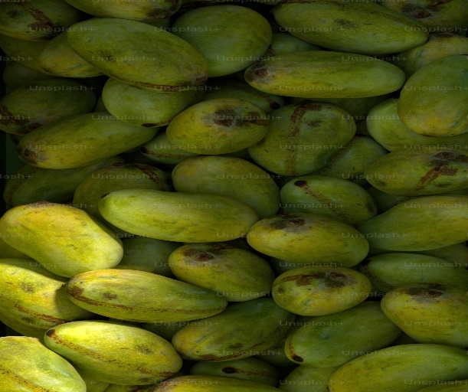
Fig 1: Unprocessed Raw Mango
I. Fig 1 represents an unprocessed, raw mango. Raw mango are either ripe or decay or rotten must be processed.

II. Collection of images:
Many mango samples were acquired to prepare the basic dataset. Several areca classification including Grade 1 and Grade 2 which are also used for grading, are included.
III. Data augmentation for dataset:
Data augmentation techniques create several copies of a dataset in order to fictitiously increase its size. Computer vision and natural language processing models employ data augmentation as a strategy to address data scarcity and lack of diversity.
IV. Image processing:
The act of performing various procedures on an image is known as image processing. In image processing, we start with an input image, make the necessary adjustments and then finished image.
- Image: Open() and Show()
- Reading the image:imread() syntax: imag=cv2.imread(f1)
- Saving the image: imwrite()
- Splitting the channels: Using split() functions
- Resize image: img=cv2.resize(img,(xdim,ydim))
- Converting the image using cvt()
V. Training the model and model saving:
We can preserve your model's progress both during and after training. This allows a model to pick up where it left off and reduces the need for lengthy training sessions. Finally, we have published the data utilised as test sets.
The disease can also be identified by using Basal DBH and height of the tree. The decision tree regression is depicted in the graph below, which predicts a number as an output for a given input. The average of the predictions serves as the output of the random forest regression.
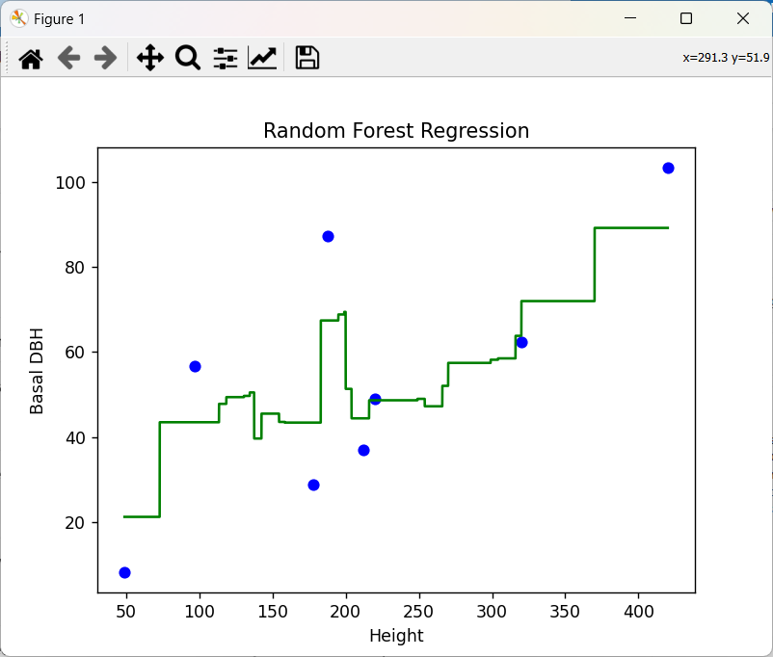
Fig.2 Performance Metrics using Random Forest Regression
5. CONCLUSION AND FUTURE ENHANCEMENT:
To determine the best algorithm for categorization, a thorough assessment of the literature has been done in this study, the mango leaf images were used to train the chosen algorithms. Each algorithm is trained using a data set containing thousands of images of mango leaf and based on their height of the tree to assess the accuracy of machine learning models based on data set also. These trained algorithms and graphical pictorical representation shows accuracy performance metrics.

REFERENCES:
1]. Development of Efficient CNN model for Tomato crop disease identification, Mohit Agarwal ∗, Suneet Kr. Gupta, K.K. Biswas Deptt. of Computer Science Engineering, Bennett University, Greater Noida 201310, India, 2020 Elsevier.
[2]. Carrot Disease Recognition using Deep Learning Approach for Sustainable Agriculture Naimur Rashid Methun1 , Rumana Yasmin2 Nasima Begum3 , Aditya Rajbongshi4 , Md. Ezharul Islam(IJACSA) International Journal of Advanced Computer Science and Applications, Vol. 12, No. 9, 2021.
[3]. Automated recognition of optical image based potato leaf blight diseases using deep learning,Kulendu Kashyap Chakraborty a , Rashmi Mukherjee b , Chandan Chakroborty c , Kangkana Borad, a Dept. of Computer Science and Engineering, Girijananda Chowdhury Institute of Management and Technology, Guwahati, 781017, Assam, India, 0885-5765/© 2021 Elsevier.
[4]. Detection and classification of chilli leaf disease using a squeeze-and-excitation-based CNN model B. Nageswararao Naik , R. Malmathanraj, P. Palanisamy , Department of ECE, National Institute of Technology, Tiruchirapalli 620015, India, 1574-9541/© 2022 Elsevier B.V.
[5]. Classification and Grading of Ladies finger using Deep learning,Meenaxi Raikar,MeenaSM Chaitra Kuchanur, Shantala Girraddi,pratiksha Benagi,Elsevier-2020
[6]. Vegnet:A organized dataset of cauliflower disease for a sustainable agro based automation system,mme Saraa , Aditya Rajbongshi a, Rashiduzzaman Shakil b , Bonna Akter b , Mohammad Shorif Uddin,Elsevier,2022

