Interesting Selenium-Oxygen/Phosphorus Containing Mixed Donor Macrocycles; Synthetic and Structural Perspectives
Partha Pratim Das
P. G. Dept. of Chemistry, Magadh University, Bodh-Gaya
Abstract:
Oxygen, Sulfer-based macrocycles were known and investigated widely. Emergence of the equivalent macrocyclic polyselena ethers was anticipated, since the introduction of sulphur coronands and their extensive and fascinating coordination chemistry. The synthetic along with coordination chemistry investigations of selena-macrocycles have attracted a lot of interest following accidental finding of selena-crown ethers. A lot of work has been put into designing and synthesizing new homo as well as mixed donor selenoether macrocyclic molecules over past few decades in order to examine their ligation characteristics towards transition along with post-transition metal ions. To be able for interaction with both "hard" as well as "soft" guest ions and/or molecules, macrocycles containing soft Se atoms along with other hard donor atoms as binding sites, close to one another within same ring framework, were produced. In this chapter, chemistry of mixed donor (O/P) selena macrocycles has been discussed from their synthetic and structural perspectives, briefly.
Introduction:
Since Pedersen¹, Cram², and Lehn's³ pioneering discovery, the science related to "supramolecular chemistry"/"host-guest chemistry" has expanded significantly. The chemistry of associates having an extensively defined framework or chemistry that goes beyond our traditional covalent bonds is both examples of supramolecular chemistry. A number of comparatively weak forces, including H-bonding, π−π stacking, ion-dipole, dipole-dipole forces, van der Waals interactions, etc., control the architecture of the associated. Chemical sensing, the specific extraction of toxic or radioactive metal ions from streams of waste, membrane transport, the immobilization of radioisotopes, phase-transfer catalysis, and other uses are only a few of the numerous uses involving selective association with metal ions. Prototype platforms for (metallo)enzymes, activation of small molecules, the specific interaction of anions, as well as the nucleophilic parts of neutral compounds are additional fields of importance. Owing of their extremely specific ability for chelating metal ions, mixed donor macrocycles received a great deal of attention. Bigger Se atom's inclusion ought to alter ring's cavity's dimensions, allowing for certain intriguing coordinating behavior. Additionally, Se-containing macrocycles prove good ligands for binding transition metals and this subject have been thoroughly investigated because of the low electronegativity of Se. Therefore, macrocycles with soft Se atoms and hard donor atoms like Phosphorus, Nitrogen, or Oxygen in the ring structure may function as possible hetero dinuclear macrocyclic ligands. Such macrocyclic ligands are going to possess both 'hard' as well as 'soft' binding sites adjacent to one another, which gives them the ability to communicate with both 'hard' and 'soft' guest ions and/or molecules. The term "hard" describes Group I (alkali metal) as well as Group II (alkaline earth metal) cations that possess poor polarizability. Since these are extremely easy to polarize, transition metal ions are referred to as "soft" cations. The redox characteristics exhibited by the transition-metal ions are going to differ when a hard cation and a transition-metal cation form compounds together within a single macrocycle. These compounds can be utilized for supramolecular network development, activation, along with bimetallic catalysis⁴. In this chapter selena-macrocyclic systems which additionally have donor centers (Oxygen/Phosphorus) are discussed briefly; from their synthetic, metal complexation and structural viewpoints.
Selenium-Oxygen donor atom containing macrocycles:
Se-Se bond-containing organoselenium molecules tend to be interesting as they make good substrates during selected synthetic organic chemistry. These also act as intermediates in crucial biological reactions which involve glutathione peroxidase, which is enzyme that contain Se. when suitable metal cations exist within the cavity, incorporating this bond into crown ether kind hosts offer an outstanding chance for a novel molecular device that can experience specific membrane transport of particular metal cations upon exposure to light or function as a catalyst during a photochemically induced redox process. The inter- as well as intra-molecular cyclization associated with substrates having Se has been utilised to describe the synthesis of the initial macrocycles with Se-Se linkage (L¹, L²), shown in Scheme 1. The noteworthy closeness of Se and O atoms within the structural arrangements of L¹ and L² is an especially intriguing aspect of the structures. The atoms in question have significant attractive interactions with one another, given such seemingly low interatomic spacing. O(12')-Se(1)-Se(2)-O(51) in L¹ and Se(6)-Se(5)-O(16) in L² are in a nearly straight arrangement, which [Figure 1] convincingly demonstrate that those interactions are caused by the hypervalent feature of the Se atoms. The benzene ring and carbonyl group's π-electron conjugation as well as the integrated impact of hypervalent interactions all help to maintain the macrocyclic system's structural integrity⁵.
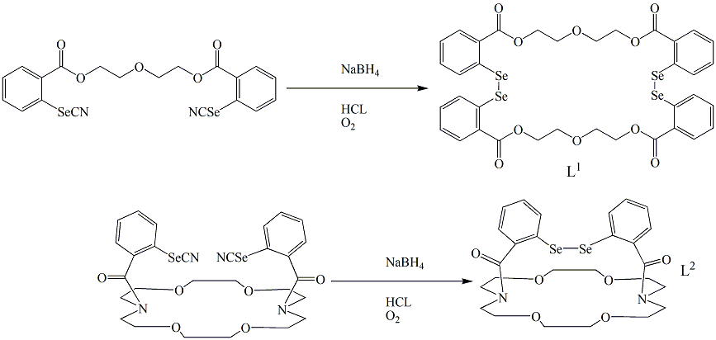
Scheme 1
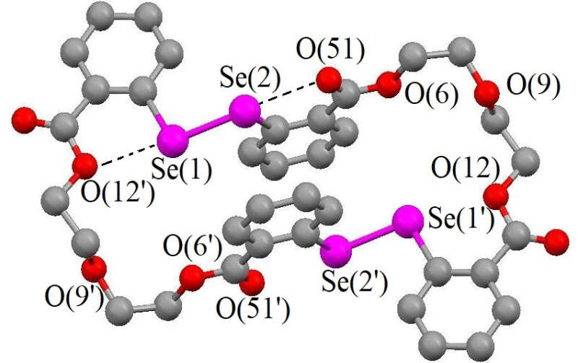  L¹ | 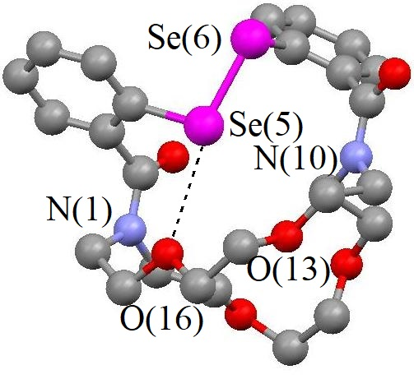  L²
Figure 1

Three distinct Se₄ crown ethers (L³, L⁴ and L⁵; n= 1, 2 and 3, respectively) were synthesized using dipotassium benzene-1,2-diselenolate [o-C₆H₄(SeK₂)] with dihalogeno selenoethers o-C₆H₄[SeCH₂(CH₂OCH₂)_{n}CH₂X]₂ (X = Cl, n = 1, 2, 3 or X= Br, n = 3, 4). The yield might be raised by utilizing the "Cs effect" [Scheme 2]^{6,7}. X-Ray diffraction was used to evaluate the crystal framework and solid-state configuration of L⁴ (Figure 2). The formation of unsymmetrical crown ether modified on just a single benzene ring was additionally done using the "cesium effect."
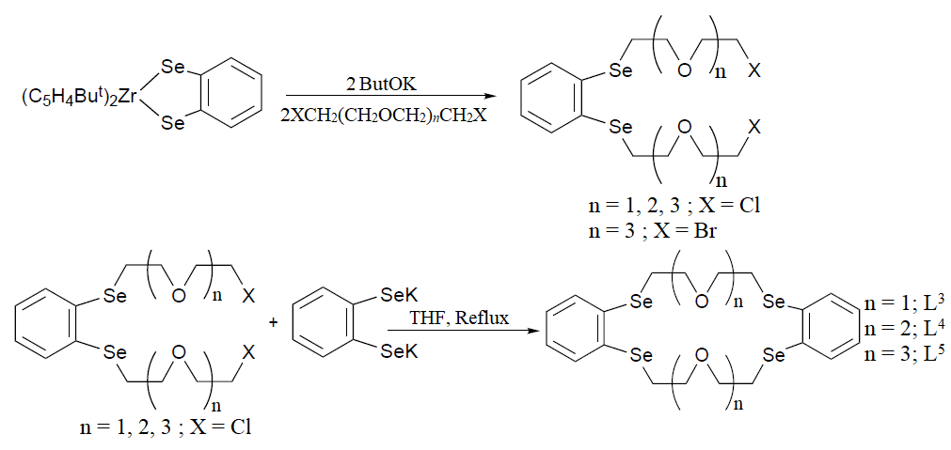
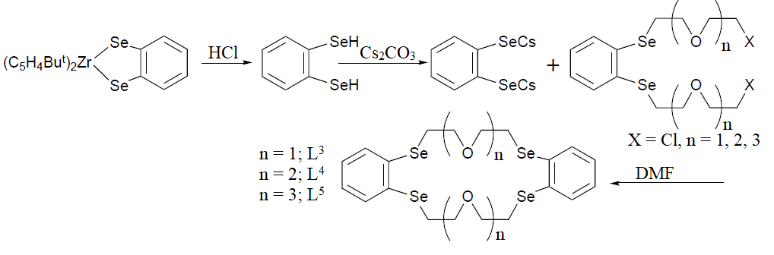
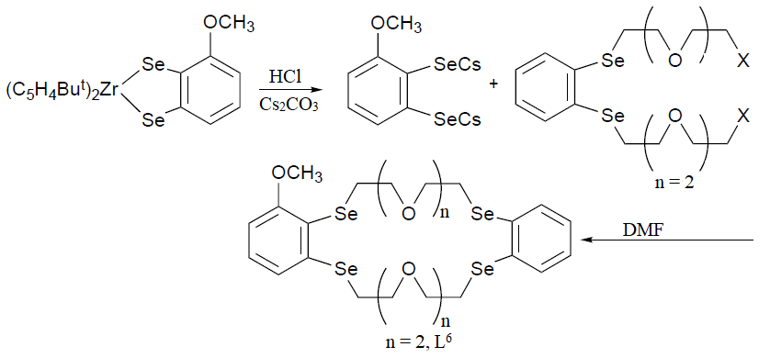
Scheme 2
Two mole equivalents of Mercuric Iodide are bound with these Se-crown ethers to generate dinuclear compounds⁶ with basic composition as [(HgI₂)₂(L^{n})]; n = 3, 4 and 5. Just those Se donors within the macrocycle connect around the roughly tetrahedral Hg^{II} centres, according to the arrangement of [(HgI₂)₂(L^{n})] [Figure 2], while I⁻ donors filling the other two positions for coordination for both Hg^{II} center. The synthesis is displayed in Scheme 3, below.
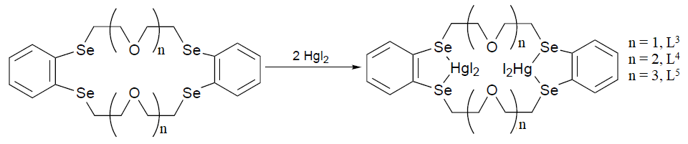
Scheme 3
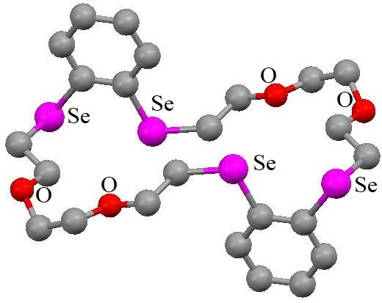 | 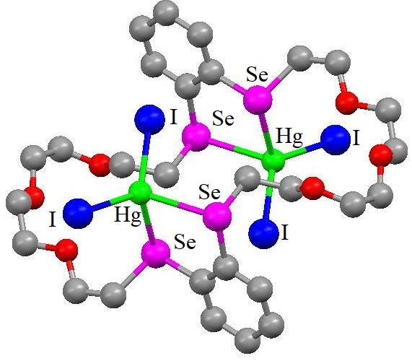
L⁴ | [(HgI₂)₂(L⁵)]
Figure 2
The photophysics along with electrochemistry properties of the compound [Cu(PPh₃)₂(L⁷)](BF₄) [Figure 3] were described. The ligand L⁷ was synthesised as shown in Scheme 4. Electronic absorption as well as emission spectroscopy is used to examine how soft metal ions are encapsulated by the complex's ring. In contrast to the analogous all-oxygen counterpart crown ether complex, that favours binding Gr I and Gr II cations including Na⁺, K⁺, and Ba²⁺, [Cu(PPh₃)₂(L⁷)](BF₄) favors to interact with transition metal cations including Zn²⁺ and Cd²⁺. The inclusion of the softer Se donor element in L⁷, provides greater affinity towards softer metal cations, is responsible for the changes that have been noted in ion interaction properties⁸.
Researchers produced L⁸ using a method⁹ identical to that used for generating L³⁻⁵. The interaction between L⁸ and Li₂[PdCl₄] produced the neutral molecule [PdCl₂(L⁸)], where Pd^{II} is most likely linked to a Se₂Cl₂ combination (Scheme 5). Four Se donors comprising from two Se-macrocyclic molecules are arranged in a square planar pattern surrounding the cation in the framework of the unique Se-cationic Pd^{II} compound [Pd(L⁸)₂]X₂, [X=NO₃, PF₆]¹⁰. Figure 3, displays the crystal structure of the cation of [Pd(L⁸)₂](PF₆)₂.
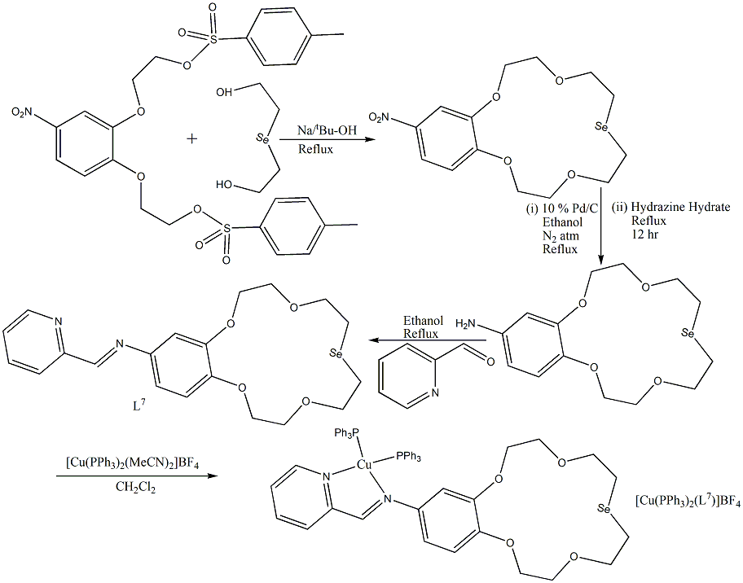
Scheme 4
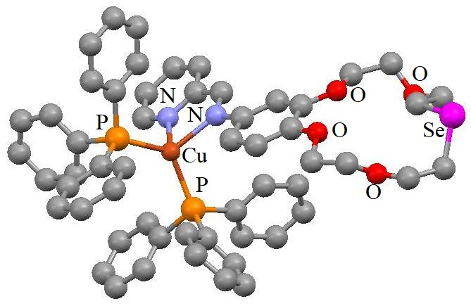  Cation of [Cu(PPh₃)₂(L⁷)](BF₄) | 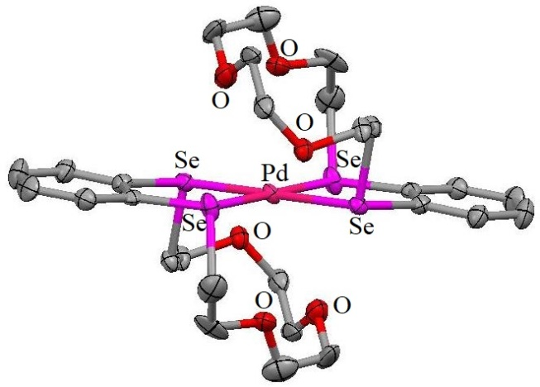  Cation of [Pd(L⁸)₂](PF₆)₂
Figure 3
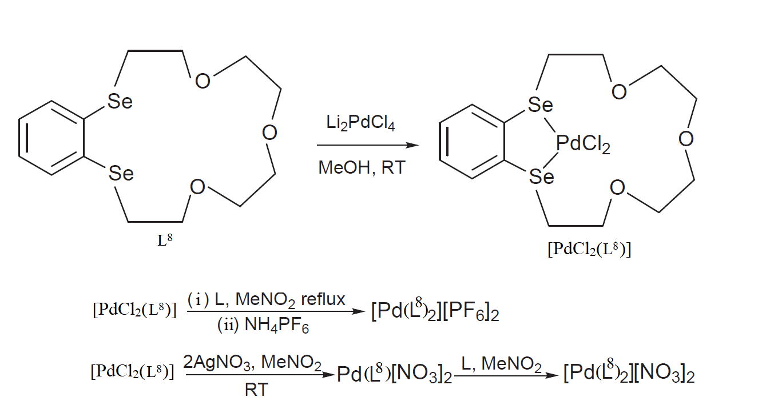
Scheme 5
The cation binding properties of a number of Se₄-crown ether analogues using aqueous Group I (Li⁺, Na⁺, K⁺) as well as certain heavy (Ag⁺, Tl⁺) metal cations are assessed^{11,12,13}. The ligands involved are displayed in Figure 4. Synthesis method of L¹⁰ is shown in Scheme 6.
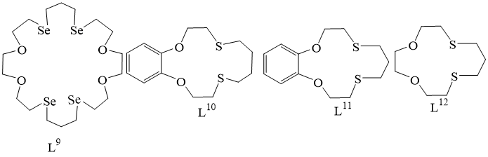
Figure 4
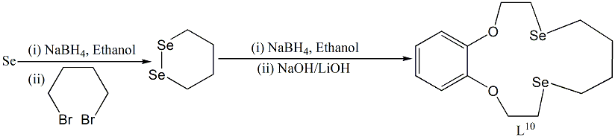
Scheme 6
By carrying out the study in C₂H₅OH rather than liquid NH₃¹⁴, it is possible to improve the production of the novel macrocycle L¹³ [Scheme 7]. The reaction involving 1,2-bis(2-bromoethoxy)ethane, 1,2-diselenocyanatoethane, and sodium borohydride yields the nine-membered ring molecule L¹⁴ as a side effect, that was additionally noted as an unanticipated ring contracting result¹⁵ [Scheme 7]. As shown in Figure 5, the compound [PtCl₂(L¹³)] exhibits a square planar architecture (Se₂Cl₂) therefore the Pt^{II} core is not interacting with any ether oxygen donors.
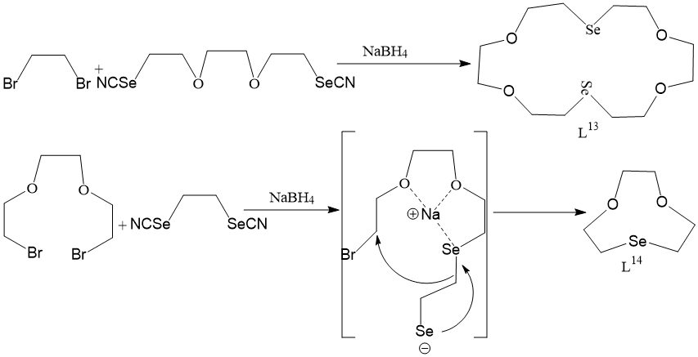
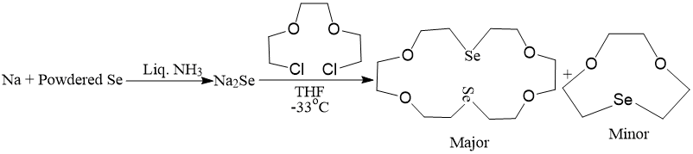
Scheme 7
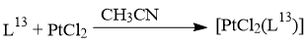 | 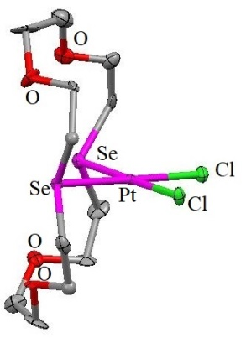
Figure 5
According to Scheme 8, two calix[4]crowns with Se functionality, L¹⁵ and L¹⁶, were produced. In the process of producing L¹⁶, a byproduct known as double bridged biscalix[4](tetraseleno)crownether (L¹⁷) is produced in 4% production; nevertheless, this amount of product is capable of being boosted by gradually adding the disodium salt of 1,3-propanediselenol into the solution of the corresponding precursor. Figure 6 shows the cone structure that Calix[4]crown ether (L¹⁵) exhibits¹⁶.
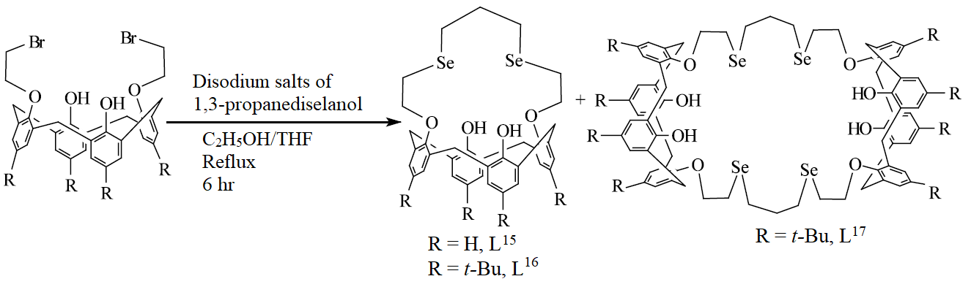
Scheme 8
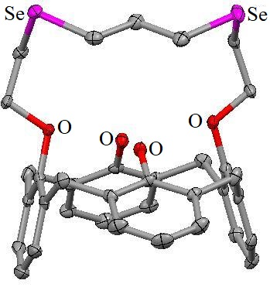 | 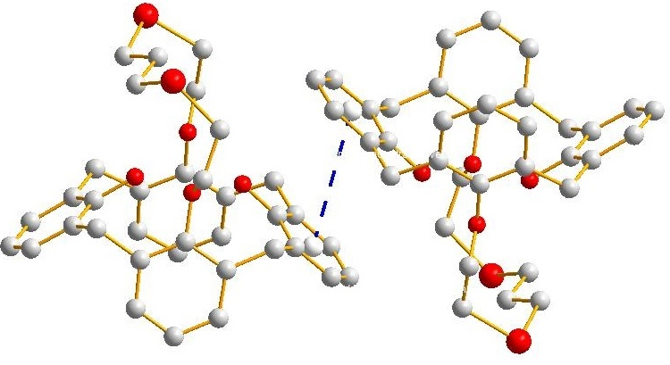
L¹⁵ | Self-assembly of L¹⁵ via parallel-displaced π–π stacking
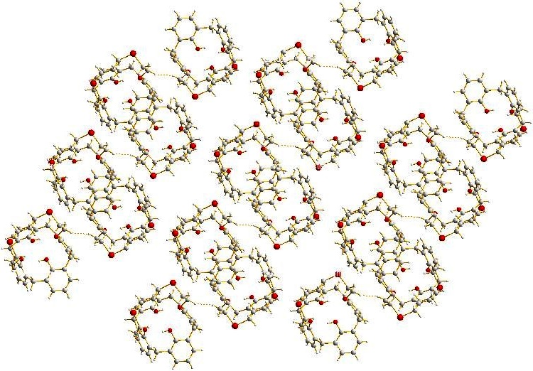
Infinite sheet aggregate of calix[4]crown ether L¹⁵
Figure 6
Through the self-inclusion of the two cavities, it generates a dimer-like architecture. Surprisingly, in the solid phase, inter-molecular Se-Se interactions allowed this dimeric arrangement to gradually organise forming a 2-D aggregation¹⁶ [Figure 6]. These ionophores work effectively for Ag^{I}-selective electrodes. Exceptional potentiometric selectivity coefficients for Ag^{I} can be obtained by polymer membranes comprising the ionophores L¹⁵ and L¹⁶. This happens as a result of their strong linkage to Se donor atoms through soft-soft interactions with high hydration energies as opposed to transition metal cations having +2 charges for their fragile interactions with Se donors of the ionophore.
Step-by-step synthesis was used to generate two novel Se-crown ethers, L¹⁸ and L¹⁹ [Scheme 9]. UV-Vis spectroscopy was used for calculating the complex stability constants as well as thermodynamic variables related to the interaction of C₆₀ with various crown ethers, resulting L¹⁹ having the highest K_{s} value. The association of C₆₀ to L¹⁸ and L¹⁹ [Scheme 10] is completely enthalpy-driven thermodynamically, whereas the stability of the combination is controlled by the entropy component¹⁷.
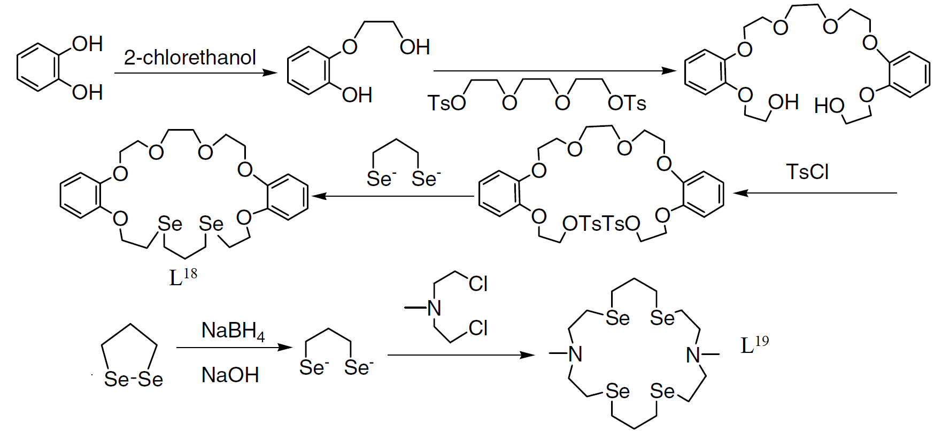
Scheme 9
Scheme 10

Selenium-Phosphorus donor atom containing macrocycles:
The one-pot procedure depicted in Scheme 11 was used to generate the 10 to 17-member macrocycles L^{21–32}, each of which contained one P and two Se donors. A byproduct L²⁰, is additionally separated in each instance¹⁸. Furthermore, as shown in Scheme 12, two similar macrocycles L³³ and L³⁴ that each contained two ether-O donors within the cycle were published. The phosphoryl P=O bond for all three of the structurally characterised macrocycles (L²³, L²⁶, and L³⁴) points upward towards the interior of the macrocycles¹⁸. Four sets of two separate molecules, each of which can't be converted into other through a translational as well as symmetrical operation, comprise L²³'s unit cell. Apart from the dihedral angles among the benzene ring's planes, there are no appreciable variations in the bonding properties between the two molecules. Aside L³³, that generates a 2:1 compound, all macrocyles interact with PdCl₂ to form 1:1 compounds¹⁸, as depicted in Scheme 12. The crystal structures of L²³, L²⁶, and L³⁴ are shown in Figure 7. The reported synthesis of metal complexes with these ligands is shown in Scheme 13. Selenium-containing phosphocane L³⁵, forms 2:1 Pd^{II} Complex [Pd(L³⁵)₂Cl₂] with PdCl₂. The synthetic method is shown in Scheme 13 and the crystal structure is shown in Figure 7.
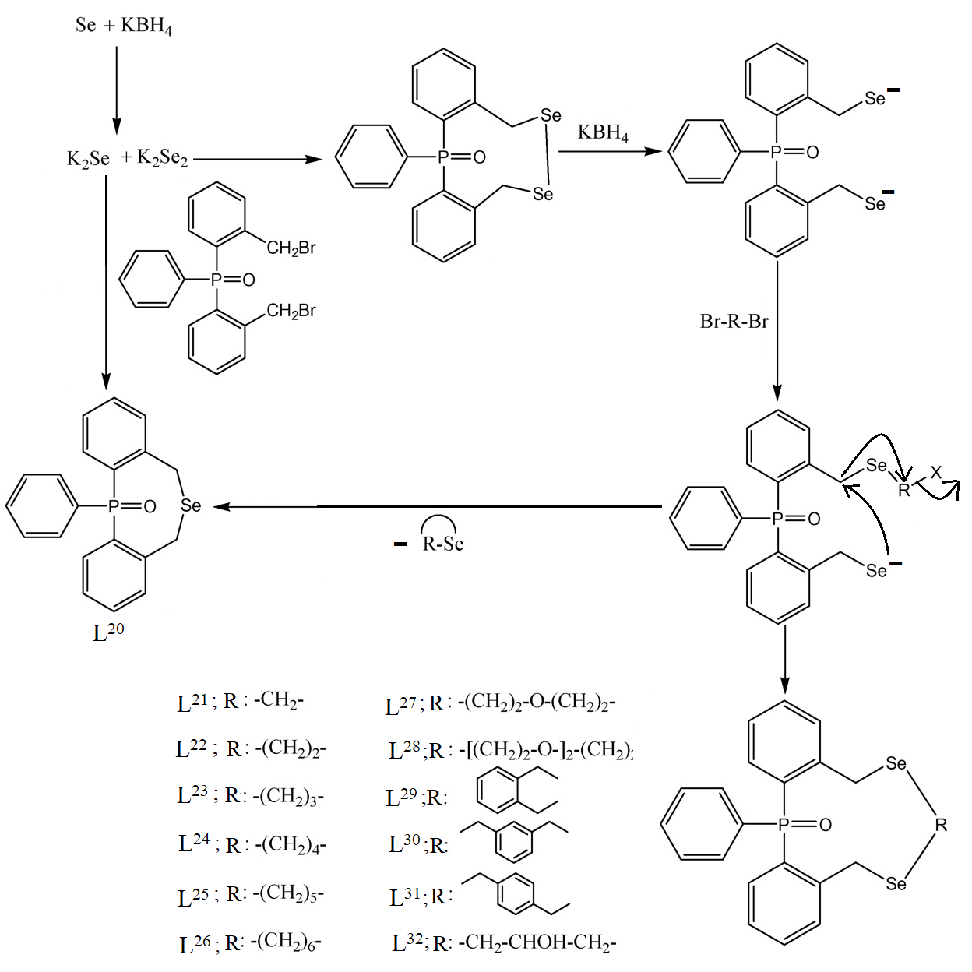
Scheme 11
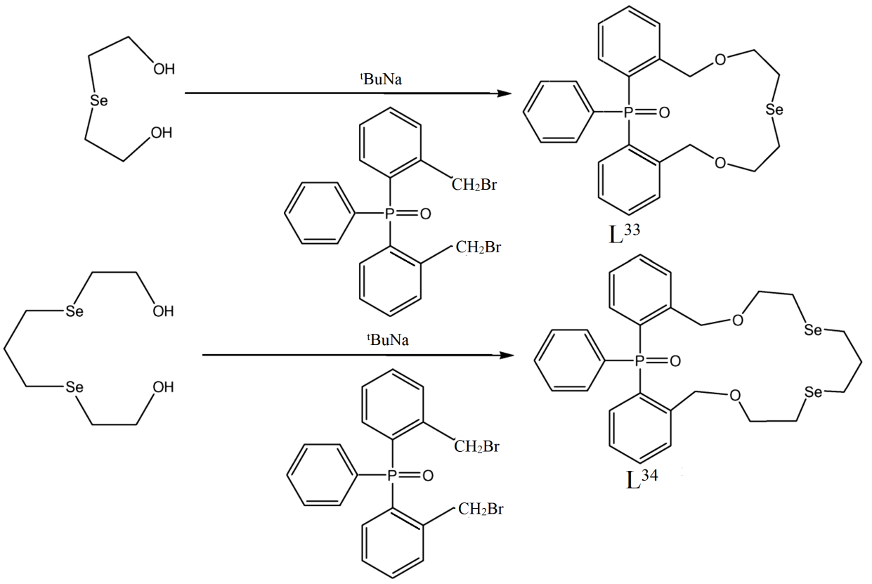
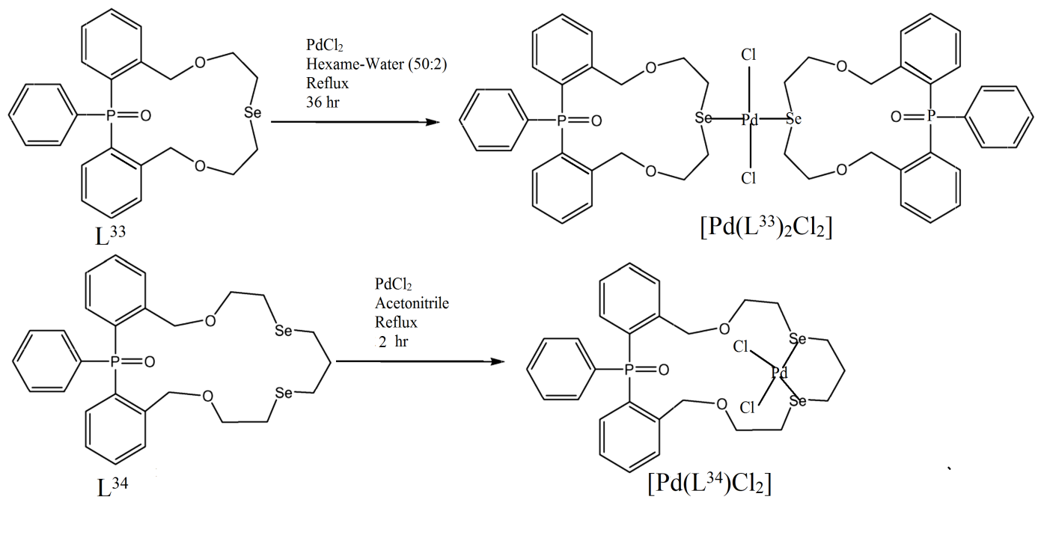
Scheme 12
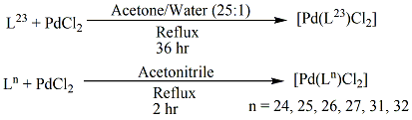
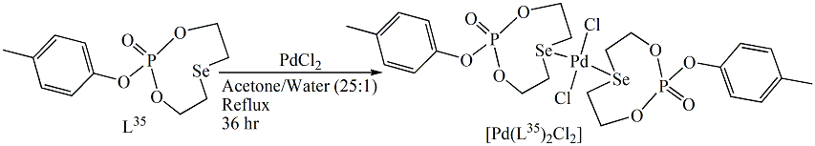
Scheme 13
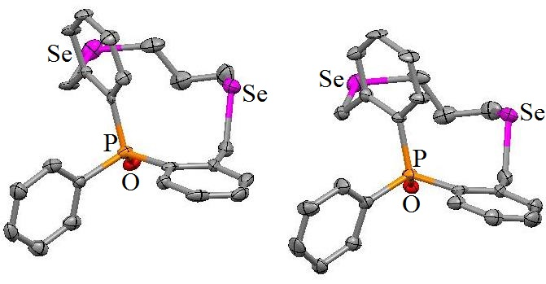  L²³ |  | 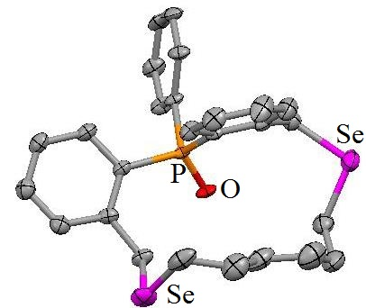  L²⁶
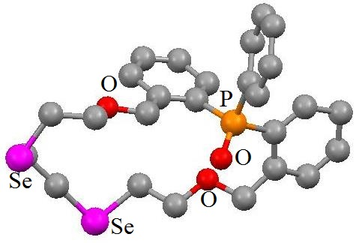 | 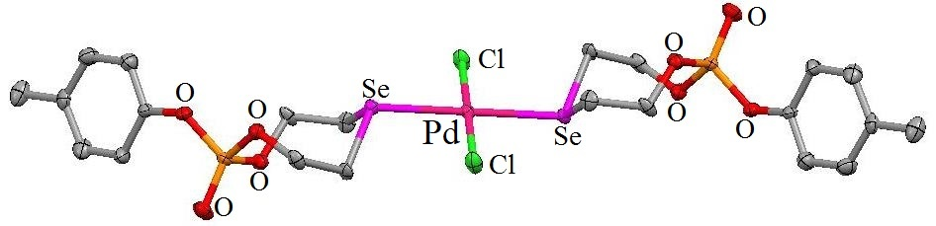
L³⁴ | [Pd(L³⁵)₂Cl₂]
Figure 7
For [Pd(L³⁵)₂Cl₂]¹⁸, the protons' signals α− to the Se atom for L³⁵ (δ = 2.86 and 3.12 ppm) are moved by 0.5-0.6 ppm to the lower field (δ = 3.50 and 3.60 ppm). The drop in electron density over the Se atom following complex formation was the cause for this down-field movement. It must be emphasised that only minor downfield movements (0-0.2 ppm) were seen for the protons of [Pd(L³⁵)₂Cl₂] α− to the O donors, demonstrating Pd^{II} binding does not take place on O donors.
The head-to-tail cyclization of the intermediate anion derived from the reaction between the dimer [(Cl)(Se=)P(μ-N^{t}Bu)]₂ and Na metal, resulting in Se-bridged hexamer [(Se=)P(μ-N^{t}Bu)₂P(μ-Se)]₆ macrocycle¹⁹. In Scheme 14, the interaction is depicted. The intermediary anion's ambidentate character is what causes the P-Se-P link to develop. The structural analysis of [(Cl)(Se=)P(μ-N^{t}Bu)]₂ and the ³¹P NMR spectrum studies indicate the existence of cis- and trans- isomers in a 7:1 ratio. A macrocyclic product is influenced by the amount of the cis- isomer of [(Cl)(Se=)P(μ-N^{t}Bu)]₂ present. Six [(Se=)P(μ-N^{t}Bu)₂P(μ-Se)] components connected via bridging Se atom, collectively generates a macrocyclic configuration of [(Se=)P(μ-N^{t}Bu)2P(μ-Se)]₆. Just a minor distortion from overall planarity exists in the molecule. The P₂N₂ ring components give the molecules a toroidal form because they are nearly perpendicular towards the median plane of the macrocycle. A brand-new class of Se-macrocycle; [(Se=)P(μ-N^{t}Bu)2P(μ-Se)]₆, stands out due to its rigid, crown-like structure and enormous cavity diameter. In [(Se=)P(μ-N^{t}Bu)₂P(μ-Se)]₆, the μ-Se donors have a cisoid shape in relation to the P₂N₂ rings, which makes Se donors accessible for possible metal linkage¹⁹. Additionally, exo- Se donors have the potential to coordinate to metal ions. Such Se-macrocycle's rigidity as well as sizable molecular cavity render the host-guest interaction especially intriguing. The crystal structure of [(Se=)P(μ-N^{t}Bu)2P(μ-Se)]₆ is shown in Figure 8.
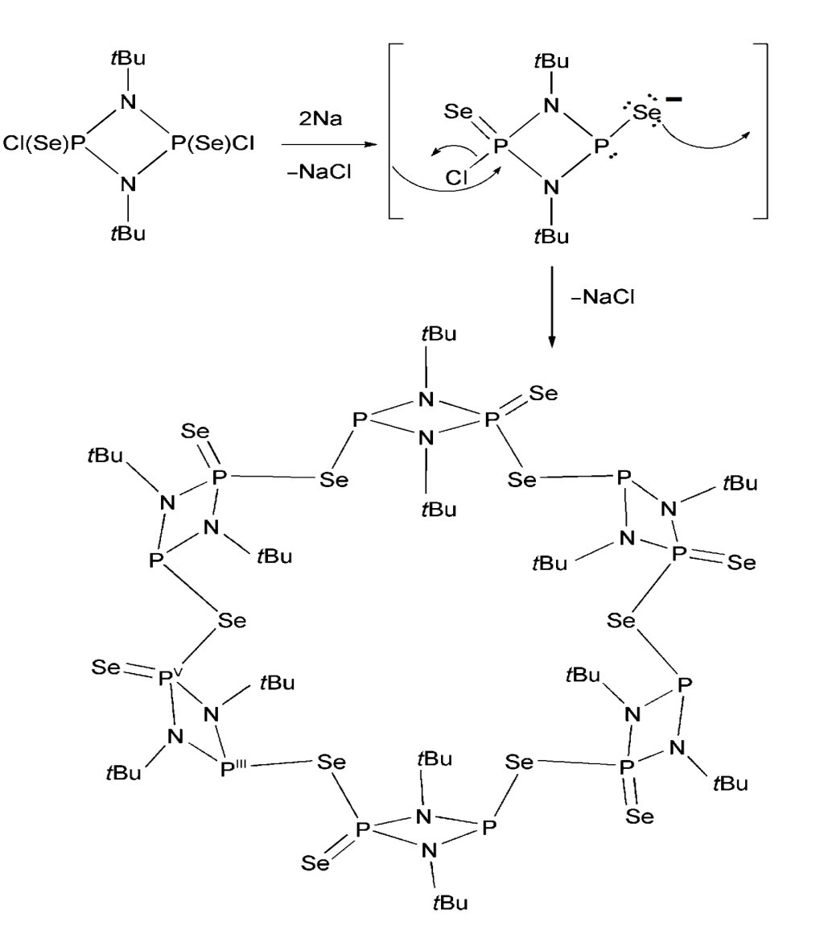
Scheme 14
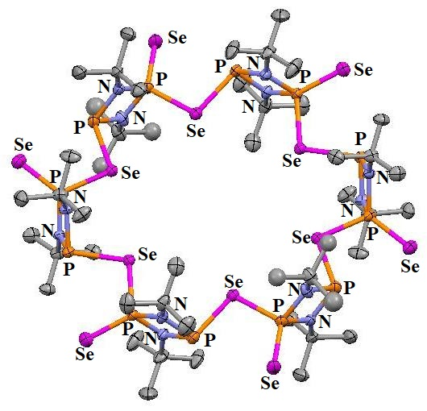
Figure 8
Massive ring diselenides with the P-Se-Se-P connectivity were reportedly synthesised, as shown in Scheme 15. The eight, nine, and ten-member rings are present, according to the frameworks of L³⁶⁻³⁸. Each of the molecules contain both R, R as well as S, S enantiomers; no R, S/S, R diastereomers were found. Two phenyl rings are located on the reverse side of the heterocycle, and the macrocyclic structure is strongly puckered. Tetrahedral geometry around both P atoms is deformed²⁰. In Figure 9, their crystal structures are displayed. L³⁹ and L⁴⁰, two further P-Se heterocyclic diselenides, was additionally documented²⁰. Despite the P-Se-Se angles for L³⁹ as well as L⁴⁰ are greater compared to that observed in L³⁶⁻³⁸, the architecture of L³⁹ and L⁴⁰ resemble the structures of L³⁶⁻³⁸. In Figure 9, their structures are depicted. Synthesis of L³⁶⁻³⁸ are also displayed in Scheme 15.
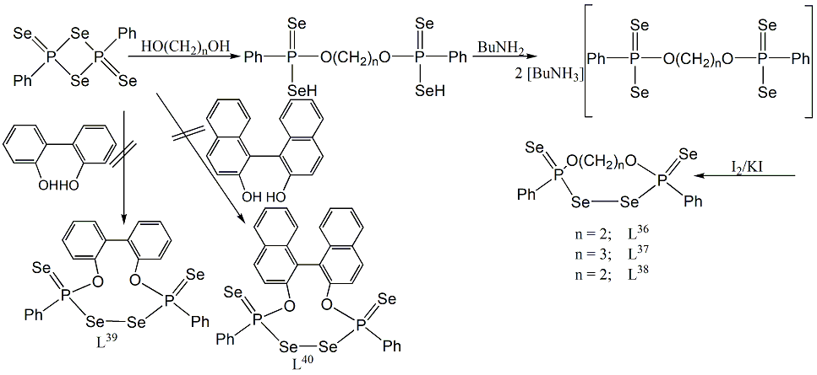
Scheme 15
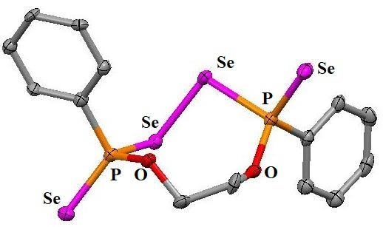 | 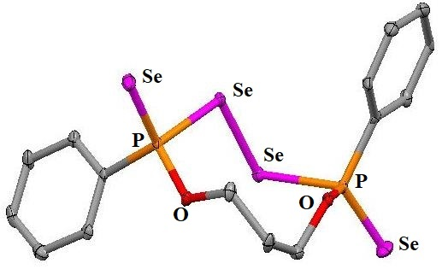
L³⁶ | L³⁷
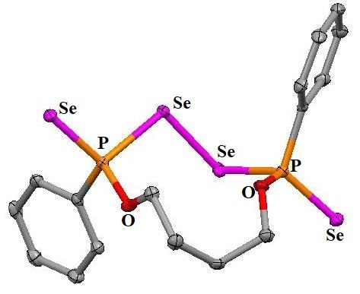 | 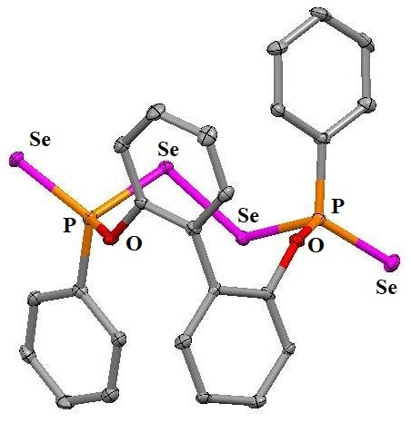
L³⁸ | L³⁹
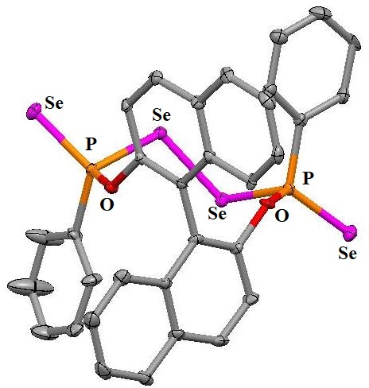
L⁴⁰
Figure 9
Conclusion:
In summary, this chapter addresses chemistry of some important Selenium-Oxygen/ Phosphorus containing macrocycles. Organoselenium compounds with Se-Se (Diselenium) bonds are usually noteworthy because they function diversely as substrates in some synthetic organic chemistry. In important biological processes involving glutathione peroxidase, a selenium-containing enzyme, diselenium components function as intermediates. Keeping that mind, macrocycles with diselenium bonds⁵ were discussed. Macrocycles with multiple Se, O donors with different ring sizes and their metal complex synthesis have been thoroughly discussed. Two calix[4]crowns with Se functionality and double bridged biscalix[4](tetraseleno)crownether were mentioned. Regarding Ag^{I}-selective electrodes, such ionophores function satisfactorily. This occurs as a consequence of their robust association with Se donors via soft-soft connections¹⁶. Interaction of C₆₀ with Se-O-crown ethers is intriguing¹⁷. Phosphorus containing Se-macrocycles are not common. P/Se and P/O/Se-containing macromolecule’s synthesis, metal complexation were focused¹⁸. Diselenides with the P-Se-Se-P connectivity²⁰ and a very unique and rare P/N/Se containing macrocyclic molecule¹⁹ [(Se=)P(μ-N^{t}Bu)₂P(μ-Se)]₆ are known and their synthesis procedures and structural details are depicted.
References:
- C.J. Pedersen, “Cyclic polyethers and their complexes with metal salts”, J. Am. Chem. Soc., Vol. 89, pp. 7017–7036, 1967.
- D.J. Cram, “The Design of Molecular Hosts, Guests, and Their Complexes (Nobel Lecture)”, Angew. Chem. Int. Ed. Engl., Vol. 27, pp. 1009-1020, 1988.
- (a) J.M. Lehn, “Design of organic complexing agents Strategies towards properties”, Struct. Bond. (Berl.) Vol. 16, pp. 1-69, 1973. (b) J.M. Lehn, “Supramolecular Chemistry—Scope and Perspectives Molecules, Supermolecules, and Molecular Devices (Nobel Lecture)”, Angew. Chem. Int. Ed. Engl., Vol. 27, pp. 89-112, 1988.
- F. C. J. M. Van Veggel, W. Verboom and D. N. Reinhoudt, “Metallomacrocycles: Supramolecular Chemistry with Hard and Soft Metal Cations in Action”, Chem. Rev., Vol. 94, pp. 279-299, 1994.
- S. Tomoda and M. lwaoka, “Synthesis and Structures of Host Molecules containing a Se-Se Bond. Intramolecular Hypervalent Nature of Selenium Atoms in the Crystal State”, J. Chem. Soc., Chem. Commun., Issue 3, pp. 231-233, 1990.
- A. Mazouz, P. Meunier, M. M. Kubicki, B. Hanquet, R. Amardeil, C. Bornet and A. Zahidi, “Tetraselena crown ethers: synthesis and complexation with mercury salts. Crystal structure of a macrocycle and a mercury(II) complex”, J. Chem. Soc., Dalton Trans., Issue 6, pp.1043–1048, 1997.
- W. P. Li, J. Wu, X. F. Liu and H. S. Xu, “Studies on Heterocrown Ether(Ⅺ)-The Syntheses or o-Benzene Diselenium Type of Selenacrown Compounds”, Chem. J. Chin. Univ., Vol. 16, pp. 1559-1562, 1995.
- V. W. –W. Yam, Y. –L. Pui, W. –P. Li, K. K. –W. Lo and K. –K. Cheung, “Synthesis, photophysics and electrochemistry of copper(I) diimine complexes containing thia-, selena- and tellura-crowns. A spectrochemical and luminescence ion probe for soft metal ions”, J. Chem. Soc., Dalton Trans., Issue 21, pp. 3615–3621, 1998.
- A. Mazouz, J. Bodiguel, P. Meunier and B. Gautheron, “Synthesis of selenium-containing crown ethers and related compounds”, Phosphorus, Sulfur Silicon Relat. Elem., Vol. 61, pp. 247-249, 1991.
- C. Bornet, R. Amardeil, P. Meunier and J.C. Daran, “Structural and complexation properties of diselenacrown ethers. Synthesis and crystal structure of a novel cationic palladium tetraselena complex”, J. Chem. Soc. Dalton Trans., Issue 7, pp. 1039-1140, 1999.
- Y. Liu, S.-P. Dong, Y. Inoue, T. Wada, “Complexation Thermodynamics of Selenacrown Ether: Origin of High Silver(l) Selectivity of 1, 5, 14, 18-Tetraselena-8, 11, 21, 24-tetraoxacyclohexacosane”, J. Chem. Res.(S), Issue 4, pp. 284-285, 1999.
- Y. Liu, H.-Y. Zhang, “Molecular design of crown ethers. 18. Cationextractability and selectivities of selena-13- to 14-crown-4”, Chin. J. Chem., Vol. 18 pp. 66-68, 2000.
- Y. Liu, H. -Y. Zhang, L. -X. Chen, X. -W. He, “The Ag+ selective electrode properties of benzodiselena selena-13-to 14-crown-4”, J. Chem. Res.(S), pp. 216-217, 2000.
- M. J. Hesford, W. Levason, M. L. Matthews and G. Reid, “Synthesis and complexation of the mixed tellurium–oxygen macrocycles 1-tellura-4,7-dioxacyclononane, [9]aneO₂Te, and 1,10-ditellura-4,7,13,16-tetraoxacyclooctadecane, [18]aneO₄Te₂ and their selenium analogues”, Dalton Trans., Issue 14, pp. 2852-2858, 2003.
- H. Higuchi, K. Tani, T. Otsubo, Y. Sakata and S. Misumi, “New Synthetic Method of [2,2]cyclophanes via diselena [3,3] cyclophanes”, Bull. Chem. Soc. Jpn., Vol. 60, pp. 4027-4036, 1987.
- X. Zeng, X. Han, L. Chen, Q. Li, F. Xu, X. He, Z. -Z. Zhang, “The first synthesis of a calix[4](diseleno)crown ether as a sensor for ion-selective electrodes”, Tetrahedron Lett., Vol. 43, pp. 131-134, 2002.
- Y. Liu, J. -R. Han, Y. -L. Zhao, H. -Y. Zhang, Z. -Y. Duan, “Synthesis of Some Selenacrown Ethers and the Thermodynamic Origin of Their Complexation with C60”, J. Incl. Phenom. Mac. Chem., Vol. 51, pp. 191-198, 2005.
- J. L. Li, J. B. Meng, Y. M. Wang, J. T. Wang and T. Matsuura, “Synthesis of phosphorus- and selenium-containing macrocycles and their complexation with Pd(II)Cl₂”, J. Chem. Soc. Perkin Trans., Vol. 1, pp. 1140-1146, 2001.
- S. González-Calera, D. J. Eisler, J. V. Morey, M. McPartlin, S. Singh and D. S. Wright, “The Selenium-Based Hexameric Macrocycle [(Se=)P(μ-NtBu)2P(μ-Se)]6”, Angew. Chem. Int. Ed., Vol. 47, pp. 1127-1130, 2008.
- G. Hua, Y. Li, A. M. Z. Slawin and J. D.Woollins, “Synthesis and Structure of Eight-, Nine-, and Ten-Membered Rings with P-Se-Se-P Linkages”, Angew. Chem. Int. Ed., Vol. 47, pp. 2857-2859, 2008.

