Pearl Millet
Introduction
As we know, grains are important, just like millet and sorghum. Pearl millet (Pennisetum glaucum (L.) R. Br.) is the most popular crop grown in the semi-arid tropics of the world.In Gujarat, the western state of India, known locally as Bajra, the total production area of ​​Gujarat Pearl Millet is 7033 hectares [2008-2009]. Gujarat ranks third in pearl millet yield compared to all other states in India. In Gujarat, the highest production is recorded in the northern Banaskantha plain (2,558 t). Banaskantha is one of the 25 administrative districts in northeastern Gujarat. product 26According to the Gujarati government's 2007-2008 Seasonal Harvest Report, pearl millet accounts for 61%, followed by wheat (11.7%).
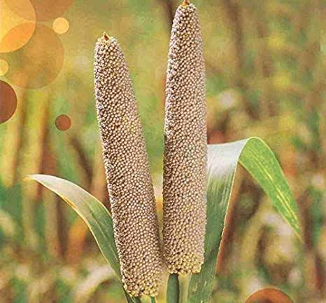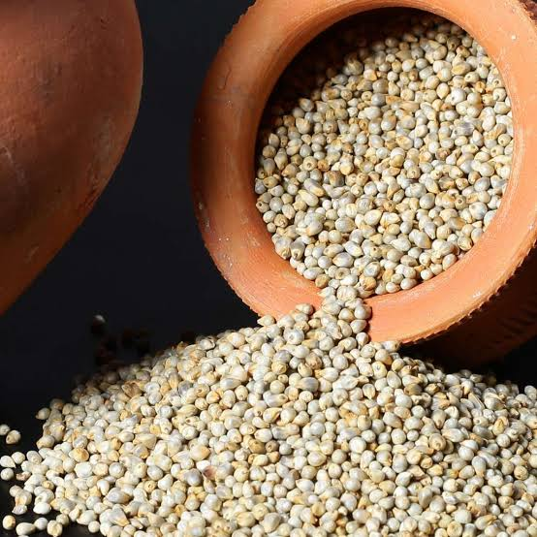

Climate change Improved heat tolerance and drought resistance help pearl millet fight climate change

The reference genome and analysis of 1,000 lines of the pearl millet genome have provided clues as to how this dry grain live temperatures in excess of 42 °C. Nutrients quality of pearl millet may and their productivity be affected at higher as higher worldwide temperatures, it is time to develop crops that are resistant to the adverse effects of climate change. The Bajra looks to be the solution of the future as temperatures rise. The clarification of the pearl millet grain by a team of 65 scientists from 30 research institutes showed its adaptability and expanding drought tolerance.

A study coordinated by the ICRI for the Semi-Arid Tropics in India, BGI-Shenzhen in China and France's National Research Institute for Sustainable Development used the latest innovations in DNA sequencing and examine to recognise new genetic tools such as recognise markers associated with drought and heat tolerance, as well as other important traits such as an improved nutrient profile and pest resistance.

This will help increase farmer productivity as pearl millet is the livelihood for millions of people living in arid and semi-arid areas of Africa and Asia. As specialist suppose, there will be increased drought and high temperatures on both continents in the coming years due to climate change. Pearl millet is currently grown on about 27 million hectares globally and is the daily food of over 90 million people. It is also an principal food source for millions of families. However, crop yields have been low for six decades in because crops are grown on poor soil.
Varieties of pearl millet
The latest list of hybrids and varieties of pearl millet is given below.
Region/ State |  | Recommended Hybrid | Recommended Variety
Rajasthan | Kharif | KBH 108, GHB 905, 86M89, MPMH 17, Kaveri Super Boss, Bio 448, MP 7872, MP 7792, 86M86, 86M66, RHB-173, HHB 67 | MBC 2, PC 443, JBV 3, PC 383, ICMV 221, Raj 171
 | Summer | Nandi 70, Nandi 72, 86M64
 | Kharif – arid parts | HHB 234, Bio 70, HHB-226, RHB-177 | CZP 9802
Gujarat | Kharif | KBH 108, GHB 905, 86M89, MPMH 17, Kaveri Super Boss, Bio 448, MP 7872, MP 7792, 86M86, 86M66, RHB-173, HHB 67 | MBC 2, PC 443, JBV 3, PC 383, ICMV 221, Raj 171
 | Summer | Nandi 70, Nandi 72, 86M64
 | Kharif – arid parts | HHB 234, Bio 70, HHB-226, RHB-177 | CZP 9802
Haryana | Kharif | KBH 108, GHB 905, 86M89, MPMH 17, Kaveri Super Boss, Bio 448, MP 7872, MP 7792, 86M86, 86M66, RHB-173, HHB 67 | MBC 2, PC 443, HC 20, JBV 3, PC 383, HC 10, ICMV 221, Raj 171
 | Kharif – arid parts | HHB 234, Bio 70, HHB-226, RHB-177 | CZP 9802
Punjab | Kharif | KBH 108, GHB 905, 86M89, MPMH 17, Kaveri Super Boss, Bio 448, MP 7872, MP 7792, 86M86, 86M66, RHB-173 | PCB 164, ICMV 221, Raj 171
Delhi | Kharif | KBH 108, GHB 905, 86M89, MPMH 17, Kaveri Super Boss, Bio 448, MP 7872, MP 7792, 86M86, 86M66, RHB-173 | JBV 3, PC 383, ICMV 221, Raj 171
Uttar Pradesh | Kharif | KBH 108, GHB 905, 86M89, MPMH 17, Kaveri Super Boss, Bio 448, MP 7872, MP 7792, 86M86, 86M66, RHB-173 | JBV 3, PC 383, ICMV 221, Raj 171
Madhya Pradesh | Kharif | KBH 108, GHB 905, 86M89, MPMH 17, Kaveri Super Boss, Bio 448, MP 7872, MP 7792, 86M86, 86M66, RHB-173 | JBV 4, JBV 3, PC 383, ICMV 221, Raj 171
Maharashtra | Kharif | Kaveri Super Boss, Pratap, PKV Raj, Shine, MP 7792, 86M86, PAC 909, 86M64, 86M53 | ABPC-4-3, PC 612, Parbhani Sampada, Samrudhi, ICMV 221, Raj 171, ICMV 155
 | Summer | Nandi 70, Nandi 72, 86M64
Tamil nadu | Kharif | Kaveri Super Boss, Pratap, Co 9, Shine, MP 7792, 86M86, PAC 909, 86M64, 86M53 | PC 612, CoCu 9, Samrudhi, ICMV 221, Raj 171, ICMV 155
 | Summer | Nandi 70, Nandi 72, 86M64
Andhra Pradesh | Kharif | Kaveri Super Boss, Pratap, Shine, MP 7792, 86M86, PAC 909, 86M64, 86M53 | PC 612, Samrudhi, ICMV 221, Raj 171, ICMV 155, Ananta
Karnataka | Kharif | Kaveri Super Boss, Pratap, Shine, MP 7792, 86M86, PAC 909, 86M64, 86M53 | PC 612, Samrudhi, ICMV 221, Raj 171, ICMV 155

Pearl millet production and cultivation
Geographically, pearl millet is mainly cultivated in Africa and Asia on more than 32 million hectares. India has the largest area (8.8 million hectares) for growing pearl millet in the world (FAO 2016). Global production of pearl millet is estimated at 30 million tons in 2016. In the late 1980s, pearl millet production in India remained relatively stable and steadily increased with the introduction of high-yielding hybrids.Annual millet production in India increased in 2000, but per capita consumption in the country fell by 50-75%. In 2016, 10.28 million tons of pearl millet grains were produced on nearly 8.8 million hectares of land in Rajasthan, Uttar Pradesh, Haryana, Maharashtra, Gujarat, Madhya Pradesh and Karnataka. Pearl millet consumption was also higher in these states. Although consumed by the populace, it has gained great importance in recent times due to its nutritional value and hence it is used in snack foods such as noodles, pappad and vermicelli; Ladoo are special pearl millet specialties. Acceptance of chapati increased when processed (blanched, acid-treated, or heat-treated) beans were used. Pearl Millet is also used in the preparation of traditional dishes: Ogi (a Nigerian grain dish), Fura (a traditional Nigerian product)
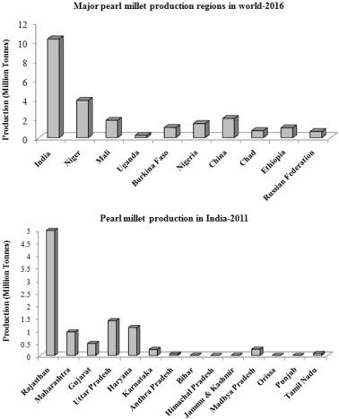
Major pearl millet production regions in the world and india
Nutrients in pearl millet
As compared to other crops Pearl millet (Pennisetum glaucum) is a rich source of nutrients. However, the main factors that limit its use are the presence of anti-nutritional factors (phytates, tannins and polyphenols) that reduce the availability of minerals and average keeping quality due to increased lipase activity.
Nutrient composition of pearl millet
Pearl millet's nutritional value surpasses other grains in terms of protein content, with an magnificent balance of amino acids and relatively high levels of vitamin A. It is also examined a "high energy" grain because it contains more oil than corn. The nutritional content of pearl millet is shown in the table below. The protein content of pearl millet is between 9 and 11.8%. 32% of total nitrogen. Millet is 40% richer in the amino acids methionine and lysine. Pearl millet also has a higher fat content (4g/100g) than rice, corn, wheat and sorghum. Approximately 70% of dry grains are mainly carbohydrates, contain of 56-65% starch, of which 20-22% is amylase.
Nutrients | Per 100 g
Protein (g) | 11.8
Carbohydrate (g) | 67.0
Fat (g) | 4.8
Minerals (g) | 2.3
Fibre (g) | 3.3
Calcium (mg) | 42
Phosphorous (mg) | 238
Iron (mg) | 8
Energy (kcal) | 36.5
Thiamine (mg) | 0.37
Niacin (mg) | 2.5
Source: Nutritive value of Indian foods, national institute of nutrition, hyderabad (2021)
Health benefits of pearl millet
1.Benefit for Diabetic Diet - Millet contains carbohydrates that are absorb slowly and keep glucose levels fixed over a long duration and for diabetics it is nutritious option.
2. Heart Health Benefits – High in fiber and cholesterol-lowering properties, these cereals are good for heart patients.
3. Ideal for celiac disease and gluten intolerance – Gluten intolerance can opt a miilet as in the diet as it is gluten free and can tolerate by anyone. It is good for Patients with celiac disease.
4. Heals for Suffering From Frequent Acidity And Ulcers in stomach - Millet is one of the few foods that reduces stomach acid, thereby reducing the formation of ulcers and the discomfort caused by frequent hyperacidity.
5. Prevents Constipation – Pearl millet benefits include promoting good gut health.Simply put, consuming pearl millet prevents constipation.
6. Provides Protein for Vegetarians – Meat and fish product is good source of protein Vegetarians cannot get as they need. This is where pearl millet comes into play. Pearl millet health benefits also include its ability to provide vegetarians with the protein they need.
7. Lowers Blood Pressure – Bajra is known to be rich in potassium, which people with high blood pressure need. Eating more potassium-rich foods helps remove sodium from your body, which lowers your blood pressure.
8. Strengthens Bones – Alcohol's high phosphorus content helps strengthen bones.
9. Helps Relieve Constipation – The high fiber content helps build mass and relieves constipation.
10. Lowers Cholesterol – Millet contains the right amount of good fats, which is a desirable dietary quality for sufferers of high cholesterol.
11.Nutrient-Rich Baby Food - Millet is easily digested and well tolerated by babies, making it an indispensable part of baby meals during and after weaning.
12. Rich in Antioxidants - Reduces free radical damage in the body and prevents premature aging, Alzheimer's disease, Parkinson's disease and cardiovascular disease and supports wound healing.
13. Ideal for weight control and obesity.
14. Reduces the risk of colon cancer – It makes the pH of the stomach alkaline, thus reducing the risk of colon cancer.
Pearl Millet or Bajra comes in several forms for regular consumption. You can use it as a flour dosas, as a granola for oatmeal, as a processed grain like poha or upma for breakfast, and as a RTE snack like millet or multigrain biscuit. The great health benefits of pearl millet make it an ideal nutrient rich food that is optimal for regular eaten by everyone. You can pair your favorite millet food with high-protein recepies like lentils, soybean chunks, fresh fruit and a veggie smoothie or salsa to create the perfect recommended meal for a balanced diet. .
Advantages and disadvantages of pearl millet
Whole grains are increasingly recognized as one of the best holistic food sources available to mankind. Bajra is a nutrient-dense whole grain that is in high demand for its many health benefits.
1. Pearl millet supports digestion
2. Pearl millet helps in losing weight
3.Pearl millet may improve diabetes control
4. Pearl millet improves muscle mass
5. Pearl millet prevents hypersensitivity to gluten
Pearl millet, like all millet groats, is high in fiber. Dietary fiber is one of the most valuable nutrients for gut health, as it helps maintain the balance of the various intestinal flora, protects the gastric and intestinal mucosa, and also improves intestinal function.
Pearl millet helps to lose weight
One of the main reasons for the popularity of pearl millet is that it can promote weight loss, especially as a substitute for unhealthy carbohydrates in weight loss diets. Pearl millet is low in calories but high in fiber. The fiber in the bagel can also aid in digestion and speed up your metabolism.
Pearl millet may improve diabetes control
Pearl millet has a low glycemic index of 54 and a glycemic load of 6.06. Both numbers suggest that Pearli millet is unlikely to cause a postprandial spike in blood sugar. This in turn indicates that pearl millet is safe to consume by people with diabetes and pre-diabetes.
Pearl millet improves muscle mass
The protein in the bagel is a high quality plant protein rich in nearly all essential amino acids. This means that regular consumption of pearl millet can help you build and maintain muscle mass, especially if you are an athlete. It can also help those at risk of suffering from or already suffering from malnutrition, protein deficiency and muscle wasting.
Pearl millet prevents hypersensitivity to gluten
Pearl millet is a gluten-free grain, meaning it will not cause gluten intolerance, gluten allergy, or wheat allergy. The manufacturing process of Pearl millet and Pearl millet products does not require or involve the addition of any other grains or flours. This ensures that Pearl millet products are gluten-free and safe for moderate consumption by people with celiac disease or other gluten-related issues.
Disadvantages
Pearl millet is a healthy and nutritious food that is safe for most people to consume. However, in some cases, excessive consumption of bajra can also lead to side effects. Below are all the health problems that can be caused or aggravated by the consumption of bajra.
1. Pearl millet can cause malabsorption syndrome
2. Pearl millet can cause kidney stones
3. Pearl millet can increase indigestion
4. Pearl millet may aggravate thyroid dysfunction
5. Pearl millet can cause malabsorption syndrome

Pearl millet can cause malabsorption syndrome
Pearl millet carry numerous nutrients or phytochemicals and the specific class of nutrients in this grain are also known as antinutrients. Antinutrients like phytic acid are plant compounds that interfere with the body's ability to absorb essential nutrients and are generally not a problem in a balanced diet free of antinutrients - heavy grains and legumes.
Pearl millet can cause kidney stones
Pearl millet contains large amounts of calcium and oxalates. Both compounds tend to build up in the body and form kidney stones in the long run, especially if the bajra is not washed and cooked properly.
Pearl millet can increase indigestion
Pearl millet is high in fiber, which is great for most people but a nightmare if you already have digestive issues. If you have irritable bowel syndrome, an inflammatory bowel disease, consuming even small amounts of bajra can cause your intestines and stomach lining to catch fire.
Pearl millet may aggravate thyroid dysfunction
Millet, like pearl millet, can contain high levels of goiter-forming compounds such as glucosylvitexin, glycosylvitexin, and vitexin.eating excessive quantity of Bajra can harm impair thyroid function, and also weaken iodine absorption. Eating large amount of pearl millet can cause hypothyroidism, deficiency of iodine, and even goiter.
References
- https://vikaspedia.in/agriculture/crop-production/package-of-practices/cereals-and-millets/bajra-1
- FAO (2016). http://www.fao.org/faostat/en/#data/QC. Accessed 18 Dec 2017

- Savita Rani, Rakhi Singh, Rachna Sehrawat, Barjinder Pal Kaur, Ashutosh Upadhyay.(2018).Nutrition & Food Science.ISSN: 0034-6659 Pearl millet processing: a review
- Ref. FAO (2016). http://www.fao.org/faostat/en/#data/QC. Accessed 18 Dec 2017
- Ref. https://pharmeasy.in/blog/12-nutritional-benefits-of-bajra-pearl-millets/
- Nutritive value of Indian foods, national institute of nutrition, hydrabad (2021)
- www.downtoearth.org.climate change of pearl millet.

