STUDY OF FUEL AND PAPER USE REDUCTION IN A UNIVERSITY CAMPUS
M. Muthukannan ª, V.Ganeshmoorthy^{b}, Shankar Kannan.P^{c}
ªAssociate Professor, Department of Mechanical Engineering, SSM Institute of Engineering and Technology, Tamilnadu.
^{b}AssistantProfessor, Department of Agricultural Engineering, Sethu Institute of Technology, Virudunagar District,Tamilnadu.
^{c}Assistant Professor, Department of Mechanical Engineering, SSM Institute of Engineering and Technology, Tamilnadu
ABSTRACT
This paper discusses the implementation of waste minimization and conversion techniques with reference to food and paper waste generated in an Indian university. The university under discussion is one of the well-known rural technical college located in Virudunagar district of South India well known as Sethu Institute of Technology. The SIT is having a strength of 10000 students with 11 academic blocks, 4 men hostels and 3 ladies hostels accommodating 4000 students in total. The daily food waste generated from these hostels is around 285 kg. Total LPG consumption of hostels is 190 kg / day and CO₂ emitted by burning of LPG Consumption is38 tonnes/ year. Regarding paper waste a study was conducted on the usage of answer script and it was observed that each student leaves at least 2 pages in 20 pages as answer script and 4 pages in 44 pages as answer script which are used for sessional and end semester examination respectively. In this study we have suggested generating biogas, manure and gardening water from waste. An anaerobic digestion plant is proposed which will be built over the ground instead of building underground to avoid maintenance problem. A demo was conducted to convert the food waste into manure by using a food waste converting machine of 50 kg capacity. It is observed that the machine produced 13.65 kg of manure with 11% moisture and 27 liter of gardening water. In case of paper waste suggestion is made to reduce the number of pages in answer script and introduce separate additional sheets to minimize wastage. By implementing these two efforts the college could be able to reduce the carbon foot print by 114.332 tonnes of CO₂ emission per year
Keyword: Food Waste, Biogas, Manure, Paper Waste, Carbon Foot Print
Highlights:
- This study describes food and paper waste minimization in an indian university
- A total of 38 tonnes of energy and 0.59 tonnes of paper reduced with a cumulative carbon emission reduced 114.332 tonnes of CO₂
NOMENCLATURE:
FW_{t} - Total food waste generated(kg/ day)
FW_{h} - Waste generated in each hostel(kg/ day)
F₁ - Food waste in Bharathi hostel (kg/day)
F₂ - Food waste in Nelson Mandela hostel (kg/day)
F₃ - Food waste in Bhagat Singh hostel (kg/day)
F₄ - Food waste in Dr. S. Radhakrishnan hostel (kg/day)
F₅ - Food waste in Indhira Gandi hostel (kg/day)
ν - Volume of gas production/ kg of waste
ρ - Density of biogas (kg/m³)
E_{si} - Total sessional examination answer script papers used
E_{s1} - Sessional 1 examination answer script papers used
E_{s2} - Sessional 2 examination answer script papers used
E_{S3} - Sessional 3 examination answer script papers used
W_{TP1} - Total weight of sessional paper answer script (in tonnes)
W_{P1} - Weight of each sessional examination answer scriptpapers (in gram)
W_{TP2} - Total weight of end semester answer scriptpapers (in tonnes)
E_{E} - Total no of end semester answer scriptpapers used
W_{P2} - Weight of end semester examination answer script papers (in gram)
T_{CO2} - Total CO₂ emission saved (in tonnes)
CE₁ - CO₂ emission reduction in biogas usage
CE₂ - CO₂ emission reduction in paper reduction
e - Equivalent LPG conversion factor
c - Compost generated from slurry (kg)
C - Cost of compost generated from slurry
E - Energy& compost generated from the plant
G_{c} - gas produced in terms of cost
N_{W} - Number of working days of mess
TC - Total cost obtained from the plant
TEC - Total Earning Cost per annum
OC - Operating Cost
CE - Current Earning cost
P_{usage} - Paper usage in tonnes
T_{paper} - Trees are equivalent to tonnes of paper usage
TTS - Total Tree Savings
N_{cp} - Number of tree cutting for current paper usage
N_{pp} - Number of tree cutting for proposed paper usage
T_{LPG} - Total LPG consumption/ year

1.0 INTRODUCTION
According to FAO (Food and Agricultural Organization), estimated food waste generated is 1.3 billion tonnes/annumin the world and India stands at 67 million tonnes. In the World nearly one third of food is wasted or lost for unknown reasons.Food wastage, which includes both food loss and food waste, is not only morally irresponsible, but also contributes to huge economic losses and makes severe damage to the environment around us.
The increase in food waste generates nearly 3.3 billion tonnes of greenhouse gas emission. (3) Although the Government all over the world made many efforts to control the food waste, thesefoodwastes are directly dumped in the open placewithout considering their effect onatmosphere. Food waste ended up in a landfill which produces a large amount of methane – a more influential greenhouse gas than even CO₂. As for the uninitiated, excess amounts of greenhouse gases such as methane, CO₂ and Chloro Fluro Carbons (CFC), they absorb infrared radiation and heat up the earth’s atmosphere, causing global warming and climate change.
In this article food waste quantification and suggestion to convert into useful product is presented. The University under discussion is having 5 hostel messes.. Thesehostels generate food waste of5.7 tonnes/annum (285 Kg * 200 daysi.e.effective working days are considered as 200 days). Now these food wastes are sold to outside contractor fora fixed annual cost of Rs.1, 10,000.
According to U. S Environmental Protection Agency, each year, the world produces more than 300 million tons of paper; one of the biggest components of solid waste in landfills is 26 million tons 16% of landfill in 2009. India produces 2.6% of the world production and the per capita consumption hovers between 9and 11 kg.
Due to usage of paper, the main problem faced is deforestation.Treesare indiscriminately cut for producing paper, and these trees absorb carbon dioxide and smoke, which we breathe out. Without the trees, the carbon dioxide accumulates in the atmosphere which results in pollution. Therefore a better environment can be envisaged by preserving a more number of trees.

2.0 LITERATURE REVIEW
Literature review was done to study the food waste and paper waste utilization.
K.A. Wani et al (2013)studiedvermicomposting of garden waste, kitchen waste and cow dung. He concluded that they not only produce a value added product (vermicomposting) but also reduce the quantity of waste.Hamed M. El-Mashad et al (2010) found a hydraulic retention time (HRT) of 20 days could be recommended for a continuous digester. The average methane content was 62% and 59% for the first and second mixtures
Tarek A. Hamad et al (2014) provided an overview of Waste to Energy Conversion technology, including both its conversion options and its useful products (e.g., electricity, heat, greenhouse gas emissions) and also discussed the benefits of WTE (Waste to Energy) and the major challenges in expanding WTE (Waste to Energy) incineration in Libya.Leonidas Matsakas et al (2017) reviewed biological (e.g., anaerobic digestion) and thermochemical processes (e.g., pyrolysis) to convert waste into valuable chemicals (ethanol, methane, hydrogen, bacterium Clostridium beijerinckii P260)
Cunsheng Zhang, et al(2014)reviewed the food waste performance of Anaerobic Digestion, Physical, Thermo chemical, biological or combined pretreatment (2014). Xignang chen et al investigated the five types of food waste derived fromsoup processing plant, cafeteria, commercial kitchen and fish form in an anaerobic digester.
Sun - Zen - Han et al(2012) studied to evaluate the performance of an innovative two stage process, Biocell, H₂ and methane from food waste, on the basis of phase separation, reactor rotation mode and sequential batch technique. The biocell process consisted of four leaching bed reactor for H₂ and the Upflow Anaerobic Sludge Blanket (UASB) reactor for CH₄ recovery. He observed that biogasproduction rate was 3.63m³ /m³day, while CH₄ production rate was 1.75 m³/m³ day.
Jobien laurijssen et al(2010) in his study suggested that due to carbon emission, energy use get reduced and the availability of biomass increases while recycling paper.He has also quantified reduction in energy use at 22 GJ/t and carbonemissions −1100 kgCO2/t while recycling paper.
Danielle P.et al (2010)studied waste management for sustainability for university campus andobserved that recycling and composting improves the sustainability. Hehas also suggested more than 70% of the waste can be diverted through activities like compositing recycling and reduction in the university campus of Prince George campus (UK) in the academic year 2008.
Liseappels et al (2008)analyzed the microbial anaerobic digestion system for community development. He designed the potential opportunities and challenges of biomass utilization.M.S.Raoet al(2000)conducted a study on the effects of organic solids concentration and digestion in a batch digestion system. He noted that the efficiency of the digestion is 84.51%. The methane content of the biogas generated from the reactor was (62 -67%).
Hatem Abushammala et al (2023) summarized various solutions to provide recycling the papers and reusgae of papers
It is observed from the above literature survey that many significant studies were conducted to reduce foodand paper waste. In this article we have studied to minimize paper usage itself in addition to reduction of paper waste.
3.0 METHODOLOGY
The methodology used in the present study is represented in fig (1).The food waste from hostel and paper waste from academic activity was studied in depth. Food waste from each hostel mess is converted into useful product such as biogas, fertilizer and water with the help of anaerobic digestion reactor system and manure conversion machine. Anaerobic digestion (AD) of food waste producesbiogas comprising mainly CH₄ and CO₂, and traces amounts ofother gases. Under mesophilic conditions at a hydraulic retention time (HRT) withoutoxygen, the same process has the potential to convert the food wastes into useful products such as biofuels (e.g. biogas) and nutrientenriched digestates which can be used as fertilizers. By the use of biogas forcooking purpose in hostel messes the CO₂ emission instant of LPG gas usage could be reduced. Manure conversion machine of food waste produces fertilizer and water for irrigation purposes. In this machine electrical heater and stirrerconvert food waste into useful fertilizer and water. As for paper usage (Academic) it minimizes the number of pages in the answer script that reduces the CO₂ emission

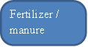Fig 1 flow diagram of CO₂ emission reduction with the help of conversion techniques from food waste and paper waste
Food Waste
Anaerobic digestion
Chemical reaction
Hostel
Manure conversion machine
Heating and stirring
CH₄, CO₂ and fertilizer Production
For gardening
CO₂ emission reduction
Paper (Academic)
SE/ 20 pages
End/ 44 pages
Each student waste averagely 2 pages
Each student waste averagely 4 pages
Estimated waste of exam paper
Proposed method- paper minimization
4. Waste profile of the University:
In our university there are 5 hostel messes. In these messes waste emerges from student’s food waste and raw material from the cooking. The following table 1 gives the wastage of each hostel.
Hostel name | Wastage in kg/day
Hostel I | 45
Hostel II | 60
Hostel III | 60
Hostel IV | 70
Hostel V | 50
Total | 285
Table1. Food wastage of hostel

For current scenario approximately 285 kg/day of food wastes are sold to outside contractor at a cost of Rs 1, 10,000 per annum for a total of 57000 kg/ annum. (285*200 day). The wastage is directly used as food to pigs with the help of the contractor. Fig 1 describes the flow diagram of CO₂ emission reduction strategy with the help of conversion techniques from food waste and paper waste. The new techniques can be adopted to improve the level of our university and use the valuable food waste into biogas and manure conversion with convenient payback period.
The college conducts 3 sessional examinations and a final examination for evaluating the performance of the students. Students are leaving 2 pages in sessional examination and 4 pages in end examination unwritten. It will consume energy and wastage of man power also. This wastage of unused sheets in the answer script should be minimized by reducing the number of pages in the answer script.Answer script are distributed in a booklet form which contains fixed no of 20& 40 pages for sessional and final examination. It is observed from that a total no of 133239 answer booklet are used/ year which means weight of the papers is around 5.79 tonnes

5.0 DEVELOPMENT OF MATHEMATICAL EQUATION
The mathematical equationsneeded for the estimation of total earnings per annum, return on investment, tree savings and co₂ emission reduction are formulated by the authors.
5.1 Biogas production by using anaerobic digestion:
The proposal of installing biogas plant in our hostel messes:
5.1.1 Total food wastes from hostel messes:
The total food wastes generated inside the hostel messes are calculated by the following equation. (1)
FW_{t} = $\sum_{n=1}^{h}{{FW}_{h}}$ (1)
Where, FW_{t}= Total food waste generated (kg/ day)
FW_{h}= waste generated in each hostel (kg/ day)
n= no of hostels
FW_{t} = F₁+ F₂+F₃+F₄+F₅
5.1.2 Gas produced from food waste:
Gas produced from hostel mess food waste are calculated by the following equation (2)
Gas produced from hostel mess food waste(G) = FW_{t}× ν× ρ_{biogas} (2)
5.1.3 Equivalent to LPG (Liquid Petroleum Gas)
Equivalent to LPG is calculated by the following equation (3)
Equivalent LPG (E_{LPG}) = FW_{t} × ν×e (3)
5.1.4. Gas generation cost(G_{c}):
Gas generation cost are calculated by the following equation (4)
Gas generation cost = E_{LPG}×INR (4)
5.1.5 Cost Compost generated from slurry (C):
Compost generated from slurry are calculated by the following equation (5)
Cost of Compostgenerated from slurry = c inkg× INR/ kg (5)
5.1.6 Energy & compost recovered from the plant (E)
Energy & compost recovered from the plant are calculated by the following equation(6)
Energy & compost recovered from the
Plant/ day (E) = G_{c}+ C (6)
5.1.7 Total Earnings per annum (TEC)
Total Earnings per annum are calculated by the following equation (7)
Total Earnings per annum = E× N_{W} (7)
5.1.8 Economic analysis:
Return on Investment are calculated by the following equation (8)
Total cost obtained from the plant (TC) = total earnings per annum (TEC) - total
Operating cost (OC)
Return on investment $=\frac{I}{TC}$ (8)
Savings from the plant are calculated by the following equation (9)
Savings from the plant = TC-CE (9)
5.2 Paper waste:
5.2.1 Weight of sessional and End semester Examination papers:
Weight of sessional examination papers are calculated by the following equation (10)
Weight of sessional examination papers (W_{TP1}) = $\sum_{i=1}^{n}{( E_{si}×w_{p1})}$ (10)
Total sessional exam papers used are calculated by the following equation (11)
Total sessional papers ($E_{si}$) = E_{S1}+ E_{S2}+ E_{S3} (11)
Weight of end examination papers are calculated by the following equation (12)
W_{TP2} = E_{E}$×w_{P2}$ (12)
Total weight of the paper are calculated by the following equation (13)
W_{TP} = W_{TP1}+W_{TP2} (13)
5.2.2 Total Tree savings:
Tree cutting for paper usage = P_{usage}× T_{paper}
Total tree savings are calculated by the following equations (14)
Total tree savings (TTS) = N_{cp}- N_{pp} (14)
5.2.3 Total CO2 emission Reduction estimation:
Total CO2 emission Reduction are estimated by the following equation (15)
T_{CO2} = $\sum_{i=1}^{n}{{CE}_{i}}$ (15)
CE_{i} = CE₁+ CE₂
CE ₁ calculated by the following equation (16)
CE ₁ = C_{LPG}× E. F (16)
C_{LPG} calculated by the following equation (17)
C_{LPG} = T_{LPG}× N_{w} (17)
CE ₂calculated by the following equation (18)
CE ₂ = TTS × T_{CO2} (18)
6. Proposals and analysis of food waste& Paper waste:
Three methods are used to convert the food waste and paper waste into useful product such as biogas, manure and tree savings which are described below.
6.1 Biogas plant Performance Analysis:
Total food waste generated from the hostel messes are calculated from the equation (1)
FW_{t} = 45+60+60+70+50
= 285 kg/day
Gas produced in kg per day from 285 kg food waste are calculated from the equation (2)
(G) = 285×0.3×1.15 = 98.325 kg/ day
Equivalent to LPG are calculated from the equation (3)
(E_{Lpg}) = 285×0.3×0.45 = 38.475 kg/ day
Gas produced in terms of rupees are calculated from the equation (4)
G_{c} = 38.475×60 = Rs 2308.50/ day
Compost generated from slurry are calculated from the equation (5)
C = 30× 4 = 120 kg/ day
Energy & compost recovered from the plant (E) are calculated from the equation (6)
E = Rs 2308.50+ Rs 120 = Rs 2428/ day
Total Earnings per annum (TEC)are calculated from the equation (7)
TEC = Rs 2428×200 = Rs 4865600
Return on Investment are calculated from the equation (8)
Total cost obtained from the plant (TC) = Rs 4865600-Rs 6965 = Rs 478635
= $\frac{Rs 550000}{Rs 478635}$ = 1.2 years
Savings from the plant are calculated from the equation (9)
Savings from the plant = 478635- 110000
= Rs 368635
6.2 Paper Waste analysis:
Present scenario  Sessional examination paper = 20 pages  End semester paper = 44 pages  Total sessional exam papers used are calculated from the equation (11)  E_{Si} =32647+32647+32647 = 97941  W_{P} = 33.0125 g  Weight of sessional examination papers are calculated from the equation (10)  W_{TP1} = 97941× 33.0125  = 3.23 tonnes  Weight of end examination papers are calculated from the equation (12)  Total scripts used for end semester and arrear examination ( E_{E}) = 35298  Weight of the 1 script ($w_{P2}$) = 72.6275 g  = 35298* 72.625  Total weight (W_{TP2}) = 2.56 tonnes  Total weight of the exam paper are calculated from the equation (13)  (W_{TP}) = 3.23+ 2.56  = 5.79 tonnes  Tree cutting for paper usage are calculated from the equation (14)  N_{cp}= 5.79* 24 = 139 trees | Proposed measures  Sessional examination paper = 18 pages  End semester paper = 40 pages  Total sessional exam papers used are calculated from the equation (11)  E_{Si} =32647+32647+32647 = 97941  W_{P} = 29.7 g  Weight of sessional examination papers are calculated from the equation (10)  W_{TP1} = 97941× 29.7  = 2.9 tones  Weight of end examination papers are calculated from the equation (12)  Total scripts used for end semester and arrear examination ( E_{E}) = 35298  Weight of the 1 script ($w_{P2}$) = 66.025 g  = 35298* 66.025 g  Total weight (W_{TP2}) = 2.3 tones  Total weight of the exam paper are calculated from the equation (13)  (W_{TP}) = 2.9+ 2.3  = 5.2 tonnes  Tree cutting for paper usage are calculated from the equation (14)  N_{pp} = 5.2* 24 = 125 trees
Total tree savings are calculated from the equation (14)
Total tree savings (TTS) = 139- 125 = 14 trees
6.3 Manure Conversion machine installation:
The solid state fermentation is a fermentation process that involves microorganism that grows on solid material in the absence of liquid. This process involves inoculation and growth of microorganism on porous particulate solid substrate that contains low moisture content. The nutrients and water content that present in solid substrate support the growth of microorganism and cause the microorganism to produce useful enzyme when grows on solid substrate.
A trial experiment was conducted to convert the food waste into manure by using a food waste converting machine of 50 kg capacity. It is observed that the machine produced 13.65 kg of manure with 11% moisture and 27 liter of gardening water.
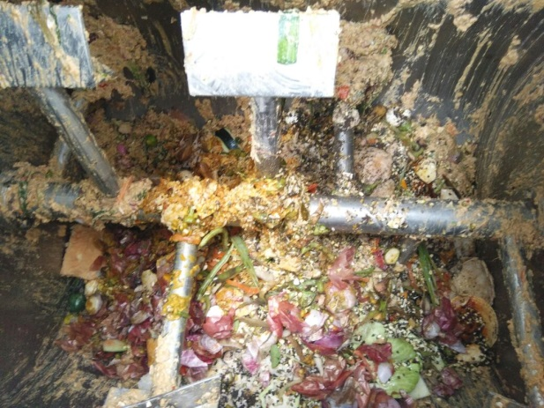

Fig 2. Waste Food Feed of the conversion machine
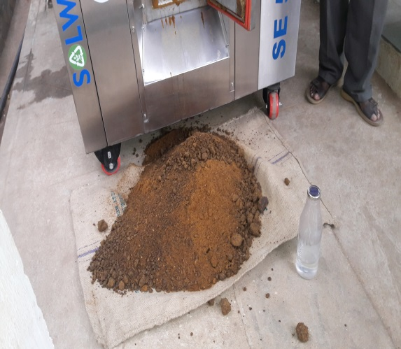
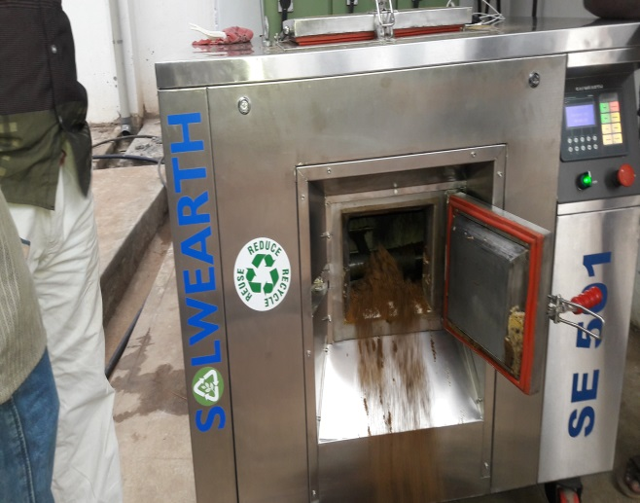

Fig.3 food waste to fertilizer conversion machine Fig. 4 fertilizer and water from machine
Fig 2 describes that the waste food is inducted into the food converting machine that includes kitchen waste such as raw material from the kitchen and food waste from each student which were directly dumped into itup to the maximum capacity (50 kg). Fig 3shows the conversion of food waste to fertilizers.The conversion machine consists of several sequential phases. The waste is first ground and pulverized by a combination of actuated and fixed hardened blades. The mixture is then heated with the help of heater inside the machine. Power consumption of this machine is 8 kWh/ Day. The machine has to run for 8 hours for conversion of waste food into useful product. i.efertilizer. This machine was run for 8 hrs and the benefits derived are shown in the fig 4.
6.4 Total CO₂ emission Reduction estimation:
Total LPG Consumption/ year (T_{LPG}) are calculated from the equation (17)
T_{LPG} = 190×200= 38000 kg/ year
CE ₁calculated from the equation (16)
CE ₁ = 38000 kg/ year× 3
= 114 tonnes CO₂/ year
CE ₂calculated from the equation (18)
CE ₂ = 14 × 0.024 tonnes
= 0.336 tonnes/year
Total CO2 emission Reduction are estimated from the equation (15)
T_{CO2} = 114 tonnes/ year +0.336 tonnes/year
= 114.336 tonnes of CO₂/year
7.0 CONCLUSION
From the above study, it can be concluded that each hostel mess wastes food around 50 kg, from which it is possible to produce biogas and manure. Installation of an anaerobic digestion plant and manure conversion machine which produces biogas, manure and water are the possible outcomes of these products which may be used forcooking purposes in hostelmess and amanure and water for gardening purposes.
From the paper waste we are reduce the no of pages in sessional and end examination paper effectively to reduce the cutting of trees and emission also.
The results from the above study areuseful to save energy, money and natural resources (14 trees). By using kitchen waste in biogas plant and manure conversion, we can not only save energy but also reduce the CO₂ emissionto the tune of 114.332 tonnes/ annum
Now a days the government has taken strong initiative for fulfilling themottofollowing Reduce (1R), Recycle (2R), Reuse (3R).Our Kalasalingam University is also proud to be a role model for other universities by moving towards this motto.
At Kalasalingam University we are reducing (1R) the food waste step by step by calculating food waste daily setting it up in notice board and spreading the awareness of food savings among the students. In the hostel the holdings and banners are also placed to create awareness of food savings. The food waste has been reused in making feeding food waste to the machine or food to pig and thus reuse has been used in our university. The food waste has been converted into useful fertilizer, thus recycle (R) has been used in our university.
The findings of this work though pertaining kalasalingam university, this can be implemented in similar system followed in other universities, elsewhere.

References
- Ananthakrishnan. R. Sudhakar, Abhishekgoyal and s.satyssravan (2013) economic feasibility of substituting LPG with biogas for man IT Hostels, international conference on Global scenario in environment and energy, Vol. 5., No 2., pp 891-893
- Conservatree, Expert Advice & Leadership on Paper Choices.
- Cunsheng Zhang, HaijiaSu, JanBaeyens, TianweiTan(2014) reviewing the anaerobic digestion of food waste for biogas production, renewable and sustainable energy reviews, Vol. 38: 383-392
- Danielle P. Smyth, Arthur L. Fredeen, Annie L. Booth (2010) Reducing solid waste in higher education: The first step towards ‘greening’ auniversity campus
- Green Clean Guide- Carbon footprint calculation- A small introduction of ISO 14064
- Hamed M. El-Mashad, Ruihong Zhang (2010) biogas production from codigestion of dairy manure and food waste, bio resource technology Vol. 101: 4021
- JobienLaurijssen, Marc Marsidi, AnnitaWestenbroek, Ernst Worrell, Andre Faaij (2010)Paper and biomass for energy?The impact of paper recycling on energy and CO2 emissions
- Leonidas Matsakas, QiujuGao, StinaJansson, Ulrika Rova, Paul Christakopoulos(2017) green conversion of municipal solid wastes into fuels and chemicals, electronic journal of biotechnology, Vol. 26:69-83
- LiseAppels, Jan Baeyens , Jan Degre`ve , RafDewil(2008) Principles and potential of the anaerobic digestion of waste- activated sludge, progress in energy and combustion science, Vol. 34(6): 755-781
- Rao M.S, S.P. Singh, A.K. Singh, M.S. Sodha (2000) bioenergy conversion studies of the organic fraction of MSW: assessment of ultimate bioenergy production potential of municipal garbage, applied energy, Vol.66(1): 75-87
- Sun-Kee Han and Hang-Sik Shin (2004) performance of an innovative two stage process converting food waste to hydrogen and methane. Journal of the air& waste management association, Vol. 54
- Tarek A. Hamad (2014) solid waste as renewable source of energy: current and future possibility in Libya, case studies in thermal engineering, Vol. 4. 144-152
- Wani K. A, Mamta , R.J. Rao(2013) bioconversion of garden waste, kitchen waste and cow dung into value added products using earthworm eiseniafetida Saudi journal of biological sciences Vol. 20(2):149-154
- Xiguang Chen, Rowena T. Romano, Ruihong Zhang (2014) development process and probable future transformations of performance of an innovative two stage process rural biogas in china, renewable and sustainable energy reviews, Vol. 55:703-712
- Abushammala, H.; Masood, M.A.; Ghulam, S.T.; Mao, J. On the Conversion of Paper Waste and Rejects into High-Value Materials and Energy. Sustainability 2023, 15, 6915. https://doi.org/10.3390/su15086915

