Futuristic Trends in Healthcare Management: Integrating Corporate Social Responsibility for Sustainable Patient-Centric Practices

Author: Radha Subramaniam

Affiliations: University of Toronto

Abstract: This chapter scrutinizes the symbiotic relationship between futuristic trends in healthcare management and the integration of Corporate Social Responsibility (CSR) principles. Focusing on sustainable patient-centric practices, the analysis unveils how technological advancements, ethical imperatives, and socio-economic considerations intertwine to shape the healthcare ecosystem. Drawing from the convergence of these factors, the study underscores the potential benefits and challenges of implementing CSR-driven healthcare management strategies, further elucidating how such integration can cultivate sustainable, patient-centric healthcare services.

Keywords: healthcare management, Corporate Social Responsibility, CSR integration, patient-centric practices, technological trends.

INTRODUCTION:

The trajectory of healthcare management embarks on an enduring odyssey, navigating through the ever-shifting landscapes of technological breakthroughs, evolving ethical paradigms, and the conscientious embrace of socio-economic perspectives. These multifaceted dimensions, each wielding its own potency, converge to create a dynamic tapestry that magnifies the significance of incorporating the principles of Corporate Social Responsibility (CSR) into the very essence of healthcare management strategies. As healthcare stands as a sentinel of human welfare, a sanctuary for the vulnerable, and a bastion of healing, its journey is not merely a clinical pursuit but a moral endeavor that resonates with the fabric of society itself.

Within the realm of healthcare management, the infusion of corporate social responsibility unfurls a complex interplay of concepts. It parallels the strategic management practice of aligning organizational values with societal expectations, as elucidated by Porter and Kramer's concept of "Creating Shared Value" [1]. The healthcare organization's pursuit of shared value through CSR principles draws parallels to the optimization theories outlined by Baumgartner and Ebner [2], who expound on sustainability strategies and their role in the management of organizational resources. These concepts converge into a symphony where ethical values intersect with strategic decision-making, paving the way for patient-centric care.

In a world propelled by innovation, where technology is both the sculptor and the sculpture, healthcare management finds itself enveloped in a symphony of transformation. The clairvoyant integration of these technological crescendos with the principles of CSR fashions not a mere amalgamation of tools, but a covenant of care. It births an era where healthcare is more than diagnostics and treatments—it is a personalized narrative of compassion, a chronicle where patients are not just recipients but active protagonists. The rise of telemedicine, the symbiosis with artificial intelligence, the dawn of wearable health devices—they all acquire a deeper resonance when woven into the ethical tapestry of patient empowerment. The marriage of technology and CSR engenders a symphony where patient-centricity evolves from a noble philosophy to a tangible reality, where health decisions are founded on informed agency, and where patient dignity is preserved as an immutable principle.

Within this transformative narrative, a clarion call emerges for healthcare management to traverse beyond the walls of institutions and embrace the heartbeats of communities. The ethos of CSR beckons healthcare managers to don the mantle of community engagement, to imbue healthcare accessibility with the hue of equity, and to dissolve socio-economic barriers with compassion. Through initiatives that resonate with the lived experiences of neighborhoods, healthcare managers become architects of change, crafting platforms where healthcare transcends being a mere service to becoming a cherished human right. Community health disparities cease to be mere statistics; they become the impetus for action, the heartbeat of transformation, and the fertile soil where CSR sows seeds of hope.

However, the call of responsibility transcends the human realm; it extends to the planet that cradles us. CSR unveils another facet of its persona—the champion of environmental stewardship. As healthcare organizations acknowledge their environmental footprint, they embrace the role of ecological custodians. The orchestration of green healthcare infrastructure, the optimization of resource utilization, and the judicious management of waste are no longer ancillary endeavors but ethical mandates. Healthcare managers, guided by the imperatives of CSR, initiate a symphony of sustainable healthcare practices that resonate with the harmony of nature. The patient-centric care ethos now harmonizes with the tenets of environmental well-being. It speaks of a holistic healthcare journey that extends not only to the bedside but also to the very air we breathe, to the water we drink, and to the earth that cradles us.

As the chapters of healthcare management unfold, they reveal not just opportunities but challenges, not just achievements but the landscapes they are sculpted upon. Integrating CSR mandates within healthcare management is a pursuit of balance, often walking the tightrope of resource allocation. It entails navigating the labyrinthine corridors of regulations, adeptly aligning CSR strategies with legal contours. The quest to measure the intangible impact of CSR efforts poses a formidable challenge—how does one quantify compassion, measure community upliftment, or assess the resonance of a greener healthcare ecosystem? Moreover, the integration of CSR is not merely a technical transition; it is a transformation that confronts the inertia of conventional paradigms, necessitating the alchemy of change management.

In the tapestry of healthcare management, the interplay of futuristic trends and the symphony of CSR integration delineate a new chapter—an era that transcends the mundane to embrace the extraordinary. This convergence does not merely weave together concepts; it fashions a narrative of sustainable patient-centric practices. As the horizon beckons, the fusion of ethics, technology, and social consciousness stands poised to paint a portrait of healthcare excellence—a portrait where the canvas extends beyond diagnostics and prescriptions to encompass empowered patients, equitable communities, and a rejuvenated planet. As we venture forth into this new epoch, the trajectory of healthcare management finds its North Star in the confluence of CSR principles and the ethereal promise of tomorrow.

This chapter delves into the realm of sustainable patient-centric practices, where the amalgamation of CSR and futuristic healthcare trends harmoniously cultivates a healthcare landscape that is ethically attuned, technologically progressive, and socio-economically equitable.

Corporate Social Responsibility: A Broadening Lens

Corporate Social Responsibility (CSR) is a multifaceted business initiative that extends beyond conventional profit-centric goals. It encompasses ethical considerations, sustainability, and societal impact. CSR acts as a compass to navigate the intricate landscape of societal welfare, fostering a relationship between organizations and the greater good they serve. As healthcare and CSR intersect, a remarkable potential emerges to shape a new paradigm that places patients, society, and environmental well-being at the forefront of healthcare management. [3]
Within the broader scope of CSR, there exist four primary dimensions that warrant exploration: Environmental Social Responsibility, Ethical and Human Rights Social Responsibility, Philanthropic Corporate Responsibility, and Economic Corporate Responsibility. Each dimension brings a unique perspective to the overarching theme of societal well-being, contributing to a comprehensive approach that transcends traditional business boundaries.

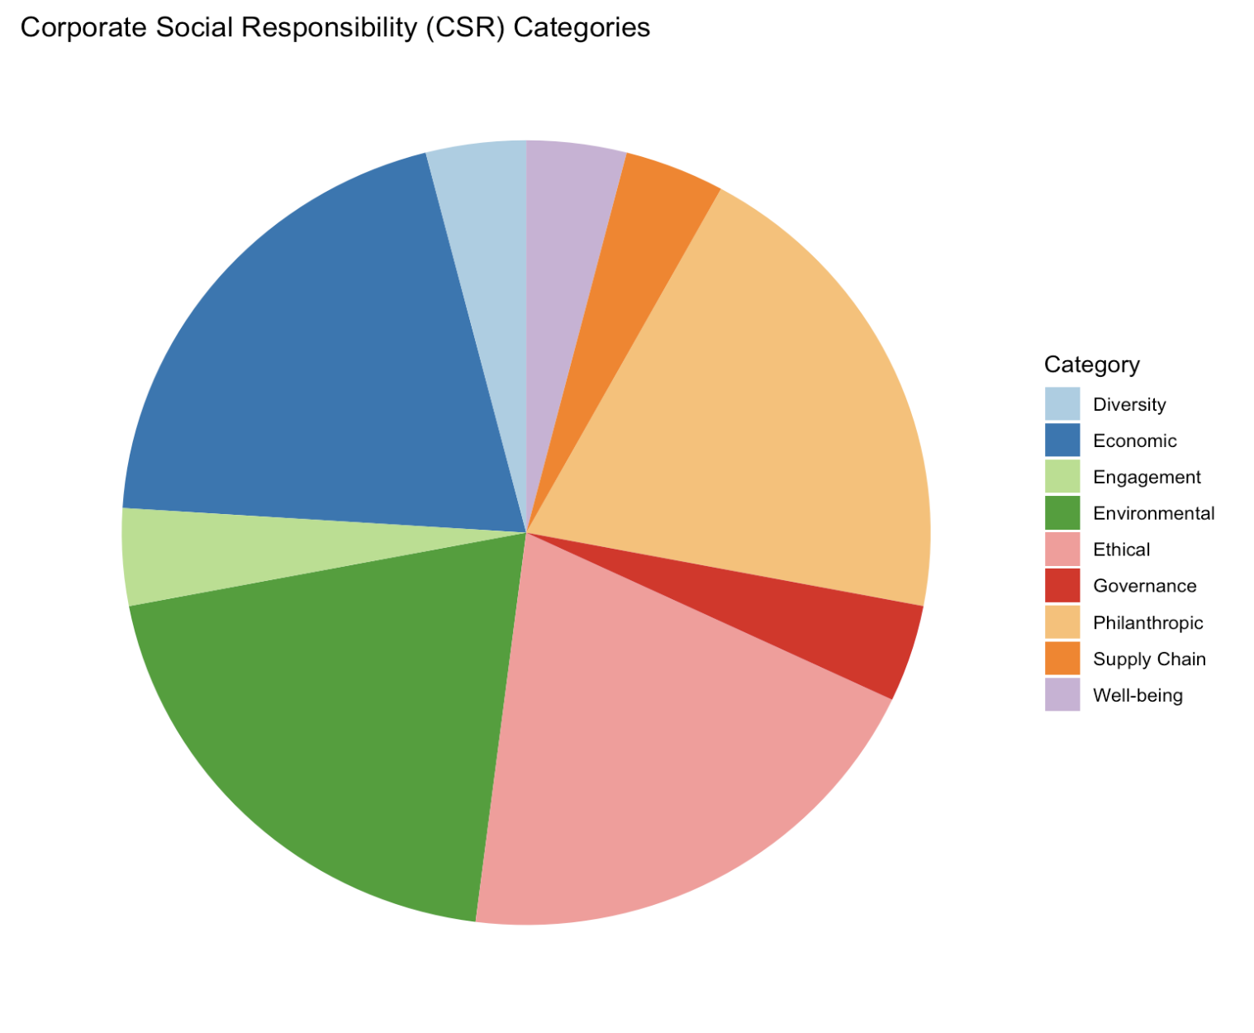
Fig1. The various sectors of Corporate Social Responsibility

II. EMBRACING CSR IN HEALTHCARE MANAGEMENT

A. Technological Advancements and Patient-Centric Care-

The landscape of healthcare management is undergoing a seismic transformation fueled by a wave of technological innovations. These innovations are not merely tools but are beacons of change that illuminate the path towards patient-centric care. Within this context, the integration of Corporate Social Responsibility (CSR) principles serves as a compass, guiding the ethical alignment of these technological marvels with the broader goals of societal welfare.

Technological advancements, often characterized as the Fourth Industrial Revolution, have led to a reimagining of healthcare delivery. The integration of telemedicine, for instance, allows healthcare services to transcend geographical boundaries, offering patients access to medical expertise irrespective of their physical location. This convergence of telemedicine and CSR encapsulates the essence of patient-centric care by addressing not just medical needs but also considerations of social equity. By reaching underserved communities and enabling consultations for those otherwise restricted by geographical constraints, healthcare organizations infused with CSR principles are able to actualize their commitment to universal healthcare access.

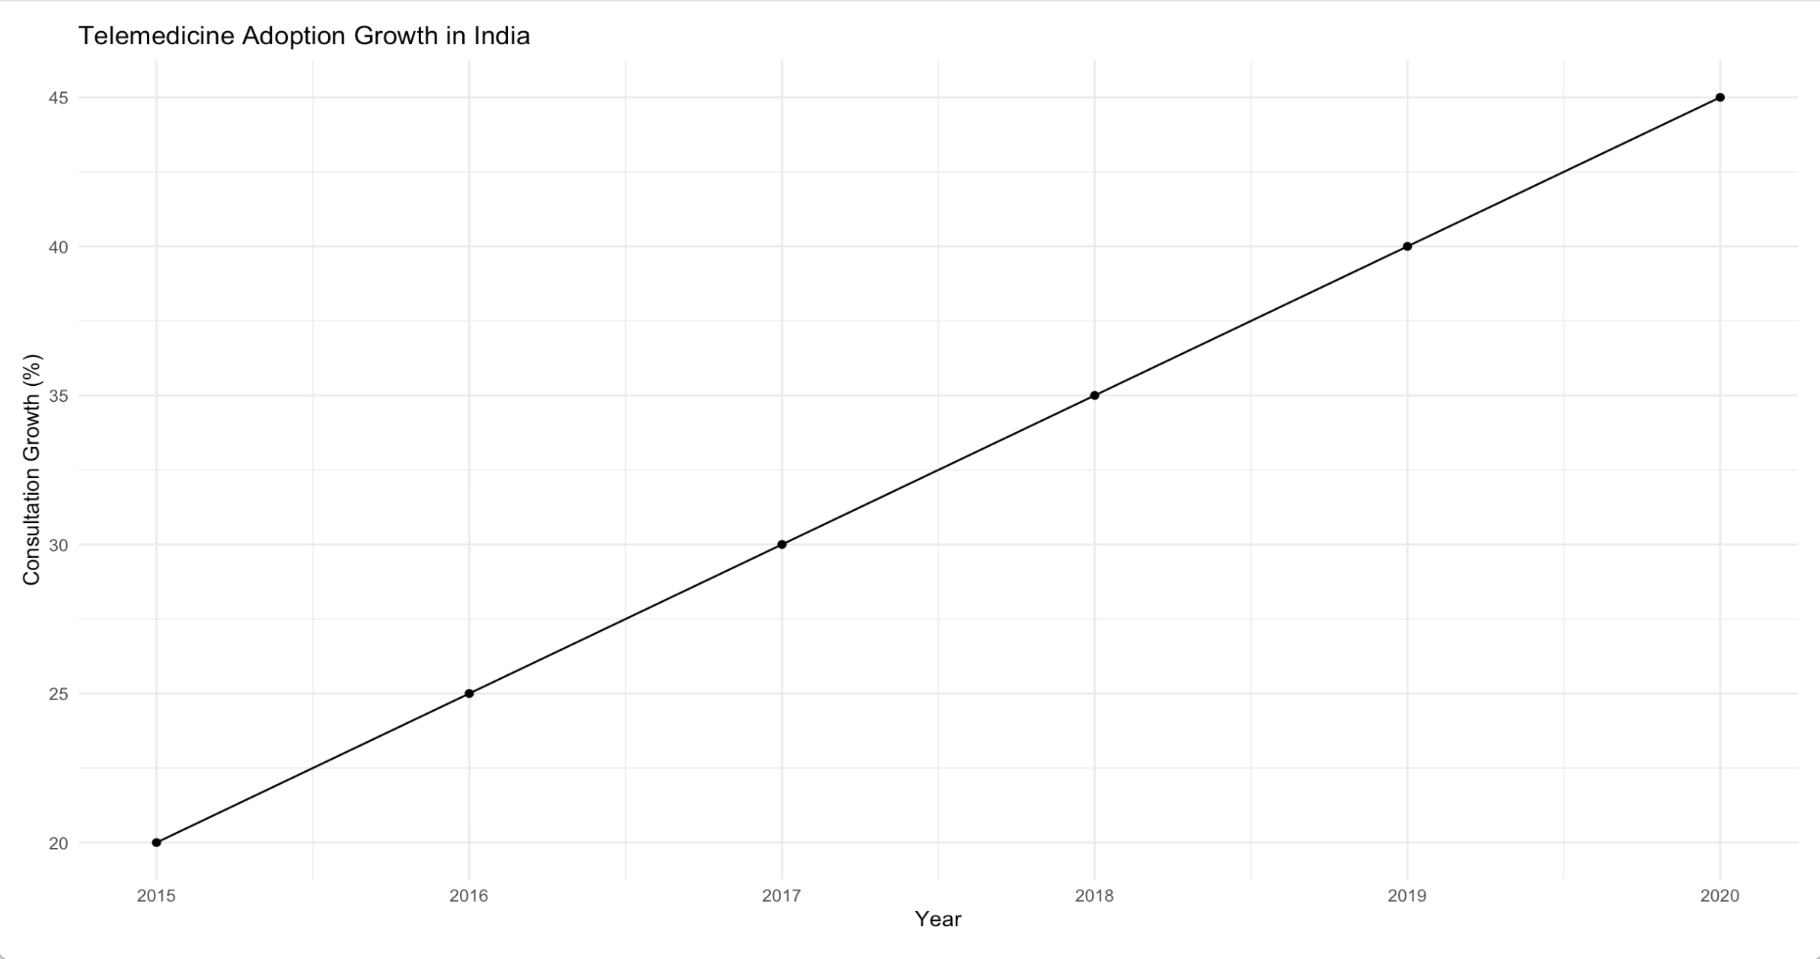
Fig2: Growth of Telemedicine in India over the years

Moreover, the realm of artificial intelligence (AI) has ushered in a new era of diagnostic precision and predictive analytics. Yet, the narrative surrounding AI's integration into healthcare is not devoid of ethical concerns. The transformative potential of AI can inadvertently compromise the sanctity of human connection, eroding the empathetic foundation of patient care. Integrating CSR with AI-based healthcare management serves as a counterbalance, ensuring that even as technology augments diagnostic capabilities, it does not erode the essence of humanistic healthcare. This synthesis of AI and CSR creates a nuanced ecosystem where cutting-edge diagnostics are harnessed to augment the physician's clinical acumen, not replace their empathetic touch.

In conclusion, the union of technological strides and CSR principles within healthcare management heralds an era of patient-centric care. The incorporation of CSR not only augments the reach of telemedicine, making it an instrument of equity, but also tempers the potential dehumanization by AI, preserving the essence of compassionate healthcare. In this synthesis, healthcare management emerges as a conduit not only for medical progress but also for ethical responsibility—an embodiment of holistic patient-centricity for a technologically driven age.

B. CSR-Infused Community Engagement for Equitable Access

Healthcare, standing as a foundational pillar of societal well-being, shoulders the profound responsibility of confronting disparities in healthcare access. In a world where the distribution of health resources is often marred by inequity, the strategic integration of Corporate Social Responsibility (CSR) within healthcare management emerges as a catalytic force for transformative change. It lays the cornerstone for a profound paradigm shift through community engagement strategies that transcend the physical confines of healthcare institutions and resonate deeply within the neighborhoods they serve. By crafting grassroots initiatives that empower underserved communities, devising tailored health education programs that empower individuals to be the architects of their own health, and orchestrating proactive health interventions that pre-emptively address potential health challenges, healthcare managers cultivate an equitable platform. This platform transcends healthcare as a service, elevating it into an ethical covenant, a social compact that ensures every individual's right to health is not just acknowledged but tangibly realized.

India faces significant challenges in healthcare access, with a doctor-population ratio of approximately 1:1457, significantly lower than the World Health Organization's recommended ratio of 1:1000 (Source: National Health Profile 2021). This imbalance contributes to disparities in healthcare delivery, particularly in rural communities where healthcare resources are scarce.

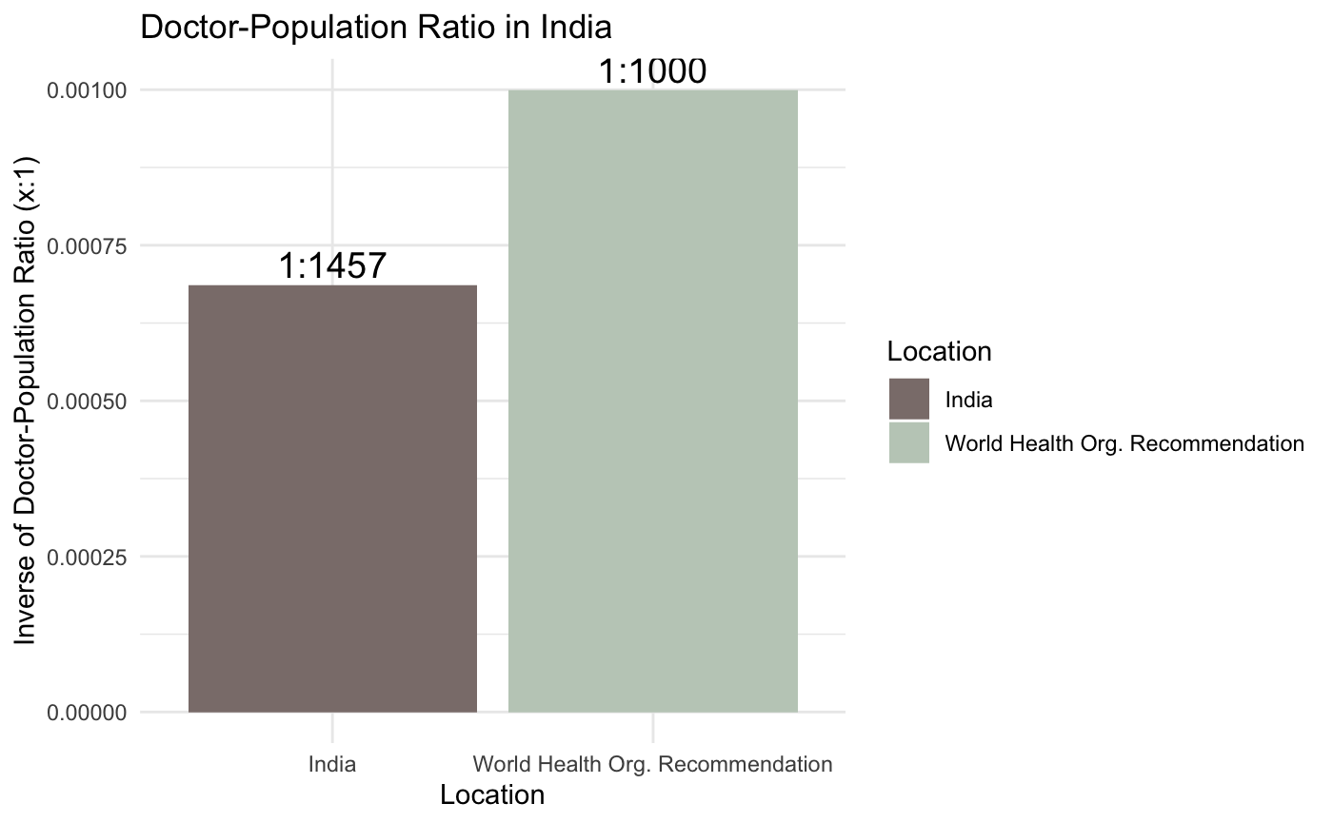
Fig3 : Challenges to Healthcare access in India

The strategic fusion of CSR and community engagement unearths the potential to dismantle the barriers of socio-economic disparities. It aligns with the principles of strategic management that highlight the pivotal role of stakeholder engagement in achieving organizational objectives. By immersing themselves in the communities they serve, healthcare managers exercise the very essence of stakeholder engagement, forging relationships that transcend the transactional and extend into the transformational. Inherent within these relationships is an exchange—a reciprocal transaction where healthcare managers offer not just medical interventions but also empathy, cultural understanding, and a commitment to the collective well-being. This holistic approach resonates with the Sustainable Livelihoods Framework proposed by Scoones, which accentuates the importance of contextual understanding and community engagement in fostering sustainable development [4]. In this context, CSR-infused community engagement is not just a strategy—it's a philosophy, an ethos that manifests through actions and reverberates through outcomes.

C. Environmental Stewardship and Sustainable Healthcare Practices

The essence of Corporate Social Responsibility (CSR) extends its embrace to encompass a paramount imperative—environmental stewardship. This recognition is grounded in the profound understanding that the well-being of humanity is intrinsically interwoven with the health of the planet. Healthcare institutions, enlightened by the embrace of CSR, transmute their operational paradigms from being passive entities into the vanguards of eco-consciousness. This transformation is not just an isolated act; it is a systemic overhaul that reverberates through the ethos of healthcare operations, infrastructure, and practices.

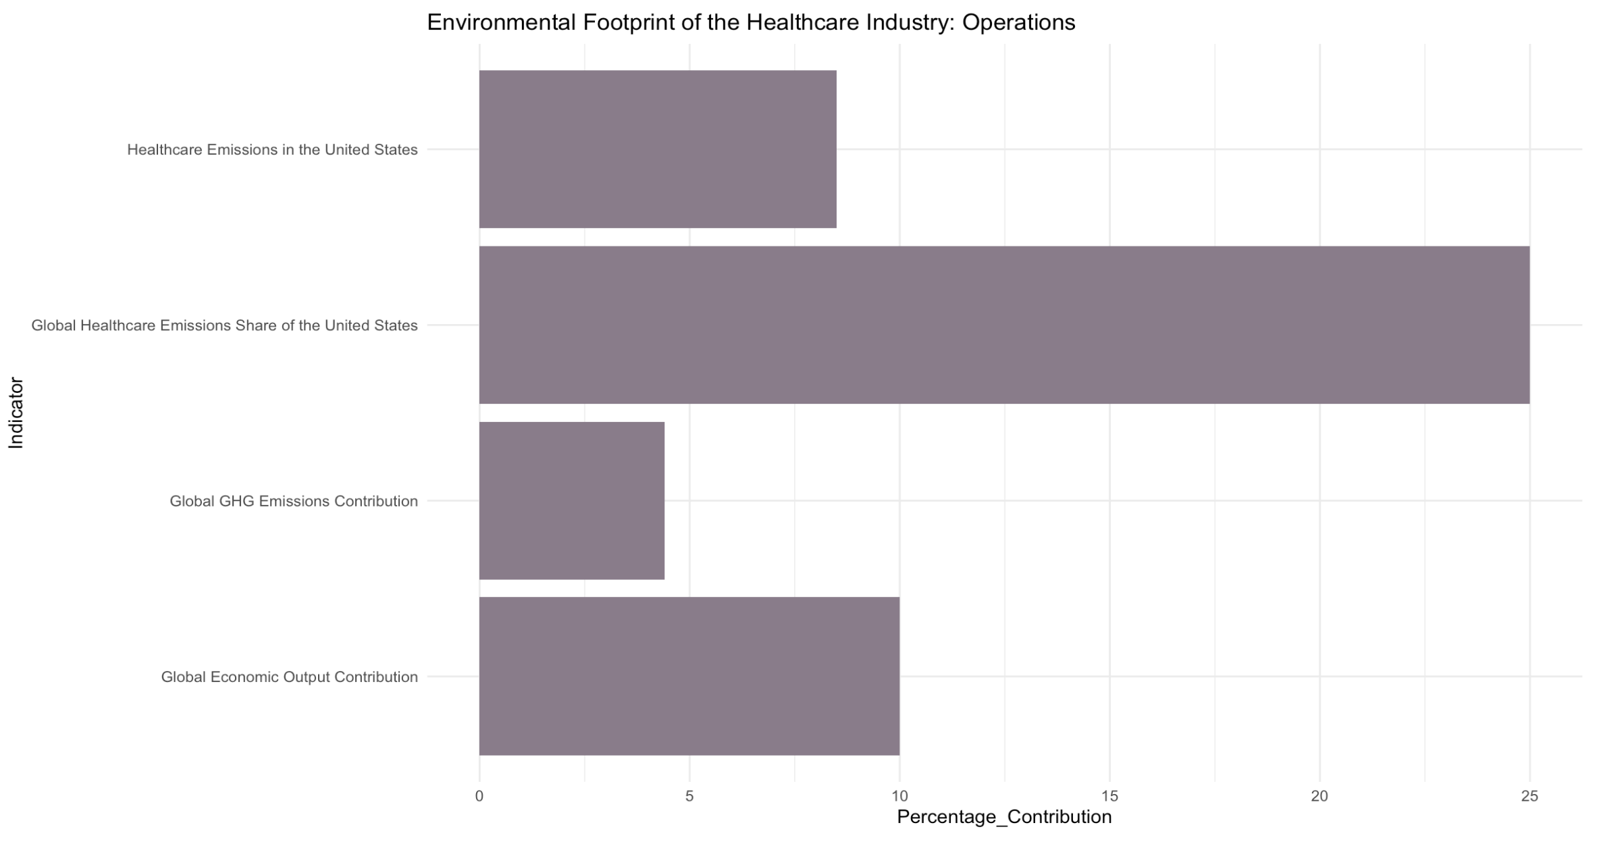

Fig4 : Global environmental footprint of the healthcare industry

Resource optimization becomes a cornerstone of this transformation, echoing the principles of Operations Management. Healthcare managers, driven by CSR mandates, meticulously orchestrate the judicious utilization of resources, minimizing waste and maximizing efficiency. This mirrors the Lean Healthcare principles, where the reduction of wasteful practices aligns with the overarching goal of enhancing patient care [5]. The orchestration of sustainable supply chains, in turn, aligns with the principles of Strategic Supply Chain Management, where the integration of CSR mandates into supply chain practices fosters a virtuous cycle of ethical sourcing, reduced environmental impact, and enhanced patient safety [6].

The greening of healthcare infrastructure serves as another testament to this commitment to environmental stewardship. The concept of green healthcare infrastructure echoes the principles of Green Building Management, where energy-efficient designs and sustainable materials not only reduce operational costs but also lessen the carbon footprint [7]. It's an architectural symphony where the edifices of healthcare stand as a testament to the fusion of technological innovation, ethical responsibility, and sustainable practices. The amalgamation of these CSR-driven initiatives culminates in a healthcare ecosystem that not only heals but harmonizes with nature, exemplifying that the tenets of ethical healthcare extend not just to patients but to the very planet that cradles us all.

D. Addressing Healthcare Disparities:

The healthcare landscape in India presents a complex web of challenges, particularly in rural areas. As evidenced by the statistics presented in Table 2, access to quality healthcare is marred by significant disparities. These disparities are manifested in various aspects, from the concentration of health infrastructure in urban areas to the long distances that individuals in rural communities must travel to access medical facilities.

Table 2: Healthcare Disparities and Challenges in Rural India

Healthcare Indicator | Statistics
Access Disparities
Proportion of Indian Population in Rural Areas | 75%
Concentration of Health Infrastructure in Urban Areas | 75% infrastructure for 27% of the population
Average Distance Traveled for Medical Visits in Rural Areas | Over 100 km
Percentage of Medical Visits from Rural Areas | 86%
Out-of-Pocket Healthcare Costs in Rural Areas | 70-80%
Primary Health Centers without Doctors (2015) | 8%
Community Health Centers without Surgeons (2015) | 83%
Informal Healthcare Providers without Medical Qualifications | 67%
Health Expenditure Borne by the State | 17%
Health Expenditure Paid Out-of-Pocket | 82%
Percentage of Poor Households Selling Assets for Healthcare | 40%

These challenges are deeply intertwined with socioeconomic factors, resulting in limited healthcare utilization and inadequate access to proper medical attention. The financial burden of healthcare is a significant hurdle for many rural households, pushing them into debt or requiring them to sell assets to cover medical costs. Furthermore, the shortage of qualified healthcare professionals in rural areas contributes to the quality disparities between urban and rural healthcare services.
Addressing these challenges requires a multi-dimensional approach that combines technological advancements, community engagement, and a commitment to environmental stewardship. By integrating Corporate Social Responsibility (CSR) principles into healthcare management, we have the opportunity to mitigate the impact of these disparities and foster a more equitable and sustainable healthcare landscape.

CONCLUSION:

In the ever-evolving landscape of healthcare management, the integration of Corporate Social Responsibility (CSR) principles emerges as a transformative force that harmonizes technological innovations, ethical imperatives, and socio-economic considerations. This dynamic fusion creates a symphony where patient-centric care evolves from a conceptual aspiration to a tangible reality, encompassing compassion, equity, and sustainability.

In a world shaped by technological marvels, the integration of telemedicine and artificial intelligence transforms healthcare into a personalized narrative of empowerment. The clairvoyant fusion of technological breakthroughs with CSR principles ensures that the advancements resonate with ethical foundations, preserving patient dignity and compassionate care. The rise of telemedicine and wearable health devices underscores the equitable reach achieved by healthcare organizations guided by CSR mandates.
Community engagement emerges as a powerful instrument to dismantle healthcare disparities. The principles of stakeholder engagement, as articulated by Freeman [9], find resonance in CSR-infused initiatives that empower underserved communities, ensuring that healthcare access is not just a service but an ethical covenant. The harmonization of grassroots initiatives, health education, and proactive interventions forms the bedrock of equitable healthcare delivery, reflecting the principles of the Sustainable Livelihoods Framework [4].
Environmental stewardship becomes a defining hallmark of healthcare management as organizations acknowledge their environmental footprint [8]. The orchestration of green healthcare infrastructure and sustainable supply chains exemplifies the commitment to responsible resource utilization. The greening of healthcare facilities aligns with the principles of Green Building Management, reflecting a holistic approach where healthcare's healing extends to the environment it coexists with.
In navigating this complex landscape, challenges arise, ranging from quantifying the intangible impacts of CSR efforts to addressing resource allocation intricacies. However, the alchemy of change management, as advocated by Reinhardt, Stavins, and Vietor [10], ensures that the integration of CSR transcends technical transitions to become a transformative journey.
As the tapestry of healthcare management unfolds, it reveals a new era—an era where CSR principles weave sustainable patient-centric practices into the very essence of healthcare strategies. This convergence cultivates a landscape where patient empowerment, equitable communities, and a rejuvenated planet converge to paint a portrait of healthcare excellence. The North Star of healthcare management finds its brilliance in the confluence of CSR principles and the promise of tomorrow.
In conclusion, the integration of Corporate Social Responsibility within healthcare management transcends the conventional boundaries of business, ushering in a paradigm that celebrates patients, society, and the environment. The symphony of ethics, technology, and social consciousness composes a narrative that transforms healthcare into an ethical covenant, a beacon of compassion, and a testament to the potential of collective well-being.

REFERENCES-

[1] Porter, M. E., & Kramer, M. R. (2011). Creating shared value. Harvard Business Review, 89(1/2), 62-77.

[2] Baumgartner, R. J., & Ebner, D. (2010). Corporate sustainability strategies: Sustainability profiles and maturity levels. Sustainable Development, 18(2), 76-89.

[3] Waddock, S. (2004). Parallel universes: Companies, academics, and the progress of corporate citizenship. Business and Society Review, 109(1), 5-42.

[4] Scoones, I. (1998). Sustainable rural livelihoods: A framework for analysis. IDS Working Paper, 72.

[5] McClean, S. I., & Anthony, C. (2009). Lean thinking in healthcare. International Journal of Health Care Quality Assurance, 22(4), 382-392.

[6] Epstein, M. J., & Roy, M. J. (2003). Improving sustainability performance: Specifying, implementing, and measuring key principles. European Management Journal, 21(2), 256-267.

[7] Carter, C. R., & Rogers, D. S. (2008). A framework of sustainable supply chain management: moving toward new theory. International journal of physical distribution & logistics management.

[8] Kibert, C. J. (2016). Sustainable construction: Green building design and delivery. John Wiley & Sons.

[9] Freeman, R. E. (2010). Strategic management: A stakeholder approach. Cambridge University Press.

[10] ] Reinhardt, F. L., Stavins, R. N., & Vietor, R. H. K. (2008). Corporate social responsibility through an economic lens. Review of Environmental Economics and Policy, 2(2), 219-239.

