POWERFUL TOOLS IN LINEAR ALGEBRA - ARTIFICIAL INTELLIGENCE AND DATA SCIENCE(AIDS) .

Mrs. Kimaya Kaustubh Indulkar

Assistant Professor, Datta Meghe college of engineering ,Airoli, Thane, India

...........................................................................................................................................................
ABSTRACT:
Linear algebra plays a vital role in better understanding artificial intelligence and quantum computing, as currently BFSI is heading towards advanced tools and techniques of deep learning, a subset of artificial intelligence. In the context of data science, linear algebra plays a crucial role in various areas, including data manipulation, machine learning, and data analysis. Linear algebra, widely considered as the “guru of mathematics”, is a computational tool for science, engineering, and data analytics
The objective of above paper is to throw light on one to one relation between linear algebra & data science with the help of some basic application .
KEYWORDS: Introduction of Linear Algebra, Application .

INTRODUCTION :
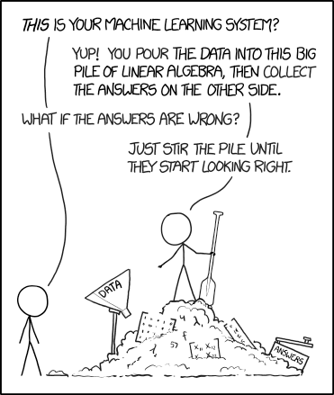

WHY LINEAR ALGEBRA?

Linear Algebra is a branch of algebra that deals with the study of matrices , vectors & linear transformation .In short we can say it is the study of linear combinations. It is used in essentially all scientific field such as engineering ,physics ,chemistry, astronomy etc. & in this case data science and machine learning. Understanding linear algebra enables data scientists to efficiently manipulate and analyze data, apply transformations, build and optimize machine learning models, and extract meaningful insights. It forms the backbone of many data science techniques and is essential for a deeper understanding of the field.
..............................................................................................................................................................................................

HERE ARE SOME KEY ASPECTS OF LINEAR ALGEBRA IN DATA SCIENCE:

1. Vectors and Matrices: Vectors are fundamental elements in linear algebra. In data science, vectors can represent various entities such as data points, features, or parameters. Matrices, on the other hand, are collections of vectors and are widely used to represent datasets, transformations, and relationships between variables.
2. Linear Transformations: Linear transformations are mathematical operations that map vectors from one space to another while preserving certain properties. In data science, linear transformations are applied to perform operations such as dimensionality reduction, feature extraction, and data normalization.
3. Matrix Operations: Linear algebra provides a set of operations for manipulating matrices, including addition, subtraction, multiplication, and inversion. These operations are extensively used in data science for tasks such as matrix factorization, singular value decomposition. With the help of adjency matrix & Solving systems of linear equations we can find current flowing in electric circuit and also arrangement of traffic flow .
4. Linear Regression: Linear regression is a commonly used statistical technique in data science for modeling the relationship between variables. It utilizes linear algebra concepts to estimate the coefficients that define the linear relationship between the dependent and independent variables.
5. Eigenvalues and Eigenvectors: Eigen vector is a vector that maintain its direction after undergoing a linear transformation & an eigen value is the scalar that the eigenvector was multiplied by during the linear transformation. They are used in feature extraction techniques such as principal component analysis which is an algorithm used to reduce dimensionality while training a machine learning model.
..............................................................................................................................................................................................

CONCLUSIONS:
In this paper we introduced to some terms of Linear Algebra with small definition with its one to one application in data science. A part of linear algebra like matrices ,vectors are something Machine Learning experts can’t live without. Linear algebra ideas and methods are easiest to comprehend while solving interesting problems, it will help to understand abstract concepts the best.
..............................................................................................................................................................................................REFERENCES:
1. D. Dwivedi, "Machine Learning For Beginners," towardsdatascience., 7 5 2018. [Online]. Available: https://towardsdatascience.com/machine-learning-forbeginners
2. dev, "The best programming language for Artificial Intelligence and Machine Learning," [Online]. Available: https://dev.to/duomly/the-best-programming

3." Linear Algebra for Computational Sciences and Engineering" Ferrante Neri.

4. "Essential Math for Data Science", Thomas Nield

5. Gennady Grabarnik, Luiza Kim-Tyan, Serge Yaskolko, “Addressing Prerrequisited for STEM Classes Using an Example of Linear Algebra for a Course in Machine Learning”, The Twelfth International Conference on Mobile, Hybrid, and On-line Learning, 2020, pp. 21_26

..............................................................................................................................................................................................

