ANTIBIOTIC KNOWLEDGE AND AWARENESS AMONG HEALTHCARE PROFESSIONAL STUDENTS IN CHENNAI –A QUESTIONNAIRE-BASED ONLINE SURVEY
^{1*}BHAVANI GANAPATHY, Associate professor &Vice-Principal, Department of Pharmacology, Faculty of allied health sciences, ACS Medical College, Dr. M.G.R. Educational and Research Institute, Maduravoyal, Chennai, Tamil Nadu, India.
²D.E. NIRMAN KANNA, Perfusionist, Department of Cardio-Thoracic Surgery, Faculty of Allied Health Science, Meenakshi Academy of Higher Education and Research, West KK Nagar, Chennai, Tamil Nadu, India.
³DR. DEEPA RAJENDIRAN, Associate Professor, Department of Biochemistry, Madha Dental College and hospital, Chennai, Tamil Nadu, India.

Corresponding Author,
^{1*}BHAVANI GANAPATHY,
Associate professor &Vice-Principal,
Department of Pharmacology,
Faculty of allied health sciences,
ACS Medical College,
Dr. M.G.R. Educational and Research Institute university,
Maduravoyal, Chennai, Tamil Nadu, India.
Mobile: 9940019626
Email: bhavani.ezhilan@gmail.com

ABSTRACT
Background: Antibiotic resistance had become the greatest threat to modern medicine due to misuse and abuses of antibiotics, when resistance develops against the antibiotics by the microorganism, there will be a need for use of new generation, higher efficacy, and more expensive antibiotics. Therefore, Every Health Care Professionals, especially every health care professional student should be having an adequate Knowledge about antibiotics, its indications and contraindications and be aware of antibiotic resistance to prevent harmful effects of antibiotics.
Objective: To assess the level of knowledge and awareness of antibiotics among healthcare professional students and to educate knowledge about antibiotics, and to create awareness of antibiotic resistance among healthcare professional students.
Methodology: A cross-sectional study was conducted at Chennai, on June28^{th,} 2021. Permission was obtained from IRB; a well-organized questionnaire was executed with 20 items using Google Forms. Pre- structured questions were pre-validated by Experts. Google form contains the details such as socio-demographic, knowledge, and awareness-based questions. The Completed data were collected and entered into an excel sheet and the results were analyzed with the proper statistical method.
Results: According to the statistical analysis of data received, only61.34% of healthcare professional students are aware of antibiotics and only 66.26% of healthcare professional students have adequate knowledge about antibiotics.
Conclusion: This study highly suggests that awareness camps, webinars, seminars, conferences, and lectures, etc., need to be organized for health care professional students to enable them to gain knowledge and awareness about antibiotics. Our study concludes that every Health Care Professional student should be Knowledgeable about antibiotics and be aware of antibiotic resistance to prevent harmful effects of antibiotics.

KEYWORDS: Antibiotics, Knowledge, Awareness, Healthcare Professional Students, Antibiotic resistance.

INTRODUCTION:
Antibiotics are defined as the group of drugs derived from natural, semi-synthetic and synthetic sources. Antibiotics are the most common drugs used worldwide, which can kill or inhibit the growth of bacteria to fight against bacterial infections. Penicillin is the first antibiotic, a natural compound produced by microorganisms, (Penicillin extracted from the Penicillium notatum culture) ^{[1]}. Antibiotics are classified in three ways. Based on their chemical structure, antibiotics are initially categorized into five classes, they are β-lactams, Macrolides (MAs), Fluoroquinolones (FQs), Tetracyclines (TCs), and sulfonamides (SAs). Also, antibiotics are divided into different classes according to their spectrum of activity, such as narrow-spectrum antibiotics, broad-spectrum antibiotics, and extended-spectrum antibiotics ^{[2]}.

Fig. 1 Classification of antibiotics
Additionally, Antibiotics can be categorized into two classes according to their mechanisms of action, such as bactericidal action (killing bacteria) and bacteriostatic action (inhibiting the growth of bacterial cells) ^{[3]}.

Fig. 2 Classification of Antibiotics based on Mechanism of Action
For example, β-lactam antibiotics (including penicillins and cephalosporins) kill the bacteria by inhibiting the synthesis of bacterial cell walls; MAs and TCs have broad-spectrum activities which inhibit bacterial growth by inhibition of bacterial protein synthesis; FQs are synthetic broad-spectrum antibiotics which kills the bacteria through the interference with bacterial DNA synthesis; SAs are synthetic broad-spectrum bacteriostatic antibiotics which produce their effects by inhibiting the production of tetrahydrofolic acid required for nucleic acid synthesis ^{[4,5].}
For billions of years, microbes are the oldest extant organisms in the world. A wealth of data provided by microbial genomics indicating that antibiotics are resisted by genes of bacterial genomics which allow them to become resistant ^{[6]}. Due to close contact with all types of toxic molecules during their existence, they become resistant to antibiotics ^{[7].} The concept of an “antibiotic resistome” was developed by microbial genomics, which includes all antibiotic resistance genes (ARGs) and their precursors in both pathogenic and nonpathogenic bacteria ^{[8]}.
Clinically effective doses of antibiotics are identified using pharmacokinetics and the pharmacodynamics of antibiotic determines the effective dose. Dosing of an antibiotic is to cure an infectious disease which is a determined function of the peak concentration of the antibiotic and the efficacy of a delivered dose over time, usually 24 hours ^{[9]}.
Before initiating antibiotic therapy, drug hypersensitivity is an important factor that should be considered, and injecting a minimal amount of test dose via intra dermal route before initiating antibiotic therapy, is a common strategy is to avoid giving medications to the patient when a high adverse severe reaction exists. The major concerns include IgE-mediated, or type I, reactions, anaphylaxis, Stevens-Johnson syndrome, and toxic epidermal necrolysis ^{[10]}.
Antibiotic resistance is defined as the ability of a microorganism to survive and resist exposure to antimicrobial drugs, threatening the effectiveness of the successful treatment of infection. Resistance can be genetically transferred from one microorganism to another ^{[11]}.
The acquisition of antibiotics and self-administering them (or administering them to others) with the aim of treating perceived infection, which is the acquisition of antibiotics and self-administering them (or administering them to others) with the aim of treating perceived infection is called as is called as self-medication which is the major cause of antibiotic resistance. Globally irrational antibiotic use has led society to antibiotic resistance which is a serious health problem ^{[12]}.
Globally 3/4 of all oral antibiotics are obtained and used without a prescription from Registered Medical Practitioners and are inappropriately used for diseases such as tuberculosis, malaria, pneumonia, and for mild childhood infections ^{[13,14,15]}.
Due to misuse and abuses of antibiotics, antibiotic resistance had become the greatest threat to modern medicine. November 13 to November 17, 2017 is considered as “World Antibiotic Awareness Week”, which was declared by the World Health Organization (WHO), with the objective of improving “awareness and understanding of antimicrobial resistance through effective communication, education, and training ^{[15]}. When resistance develops against the antibiotics by the microorganism, there will be a need for use of newer, higher efficacy, and more expensive antibiotics. Therefore, antibiotics must be used wisely and in a responsive way to the prevention and treatment of infectious diseases ^{[16,17]}.
There is evidence indicating that the long-term use of antibiotics might be related to alterations in the resident oral micro biota and a possible increase in the occurrence of opportunistic microorganisms, such as enteric bacilli, Pseudomonas, Staphylococcus, and yeasts ^{[18]}.Sometimes antibodies attack the body’s red blood cells and cause them to break down too early which will be led to anemia. Drugs that cause hemolytic anemia are cephalosporins, levofloxacin, penicillin, and its derivatives ^{[19, 20]}.
The factors contributing to antibiotic resistance are patient demand, physician preferences, a longer time for culture and sensitivity testing, pharmacists and healthcare providers giving it as-a-counter drug, lack of quality medicine, the sub therapeutic dose of antibiotic usage in animal husbandry, and promotional activities from pharmaceuticals companies. Another important factor is the lack of knowledge and proper awareness among society and healthcare professionals ^{[21, 22]}.
Increasing knowledge of antibiotics among the general population can help achieve appropriate use, better treatment adherence, and results, and consequently, reduce bacterial resistance ^{[23, 24, 25]}.

OBJECTIVES:
- To assess the level of knowledge and awareness of antibiotics among Health Care Professional Students,

- To educate knowledge about antibiotics and create awareness on antibiotic resistance among Heath Care Professional Students.

METHODOLOGY:
Study Type: Observational Questionnaire Based Research Study.
Study Design: The target population selected was full-time undergraduate Health Care Professional students in Chennai.
Data collection:
- The study was conducted through virtual mode in Chennai during the last week of June 2021. Permission was obtained from the Institutional Review Board (IRB), Dr. M.G.R. Educational and Research Institute, Maduravoyal, Chennai, Tamil Nadu.
- We designed and implemented an online data collection tool using Google Forms via(docs.google.com/forms) ^{[25].} The questionnaire assesses knowledge and awareness of antibiotics, which is pre-designed and pre-validated by professional experts in the field.
- Google forms include socio-demographic details such as name, gender, year of study and course of the study, Institution name, Place, and Informed Consent in one part and the next section contains 20 Questions to check the knowledge and awareness of antibiotics among the health care professional students.
- Participants were asked to select the appropriate option, for each correct response 2 marks will be given, the total score was converted into a percentage, completed data were collected, entered in an excel sheet and the results were analyzed with the proper statistical method.

Table 1: Survey Questionnaire
SI.NO. | Questions | Options are given for scoring
 | Antibiotics are derived from plants, microbes, and chemicals | - True  - False
 | Certain microbes become unresponsiveness to antimicrobial agents due to repeated use is referred to as bacterial resistance. | - True  - False
 | Hypersensitivity reactions to antimicrobial agents are common. | - True  - False
 | Co-Trimoxazole is an antibiotic | - True  - False
 | Opportunistic infection is the new infection that appeared as a result of antimicrobial therapy | - True  - False
 | “Static drugs” are not effective in immunocompromised individuals | - True  - False
 | Glucocorticoids aggravate superinfection | - True  - False
 | Fluoroquinolones cause severe Psychiatric disorders | - True  - False
 | Stevens-Johnson Syndrome (SJS) is the adverse effect of amoxicillin | - True  - False
 | Penicillin G can be administered through the oral route | - True  - False
 | Vancomycin is a cell wall synthesis inhibitor but not a beta-lactam antibiotic | - True  - False
 | The use of antibiotics to prevent infections during surgery or other invasive procedures is called combination therapy | - True  - False
 | Antibiotics kill beneficial microbes and cause secondary infection in the host | - True  - False
 | Restoration of colonic bacteria in conditions like diarrhea is called probiotics | - True  - False
 | Viral infection requires antibiotic treatment | - True  - False
 | I will save the leftover antibiotics for future use | - True  - False  - Maybe
 | I will take antibiotics only when my doctor prescribes me | - True  - False  - Maybe
 | I will stop taking antibiotics if I start feeling better | - True  - False  - Maybe
 | I will check the expiry date of the antibiotic before using it | - True  - False  - Maybe
 | I will take large doses of antibiotics for better and quick action | - True  - False  - Maybe

Results:
A survey on knowledge and awareness of antibiotics was conducted on health care professional students of I-year, II-year, III-year, Final year, and Interns which includes MBBS, BDS, Nursing, BPT, and other health care professional students in Chennai. Around 251 students from various colleges in Chennai responded to this survey.
Among the251 responses, 69.7% of responders were from other AHS, 20.3% of responders were from Nursing, 8% of responders were from BDS,1.2%of responders were from MBBS, and 0.8%ofresponders were from BPT.

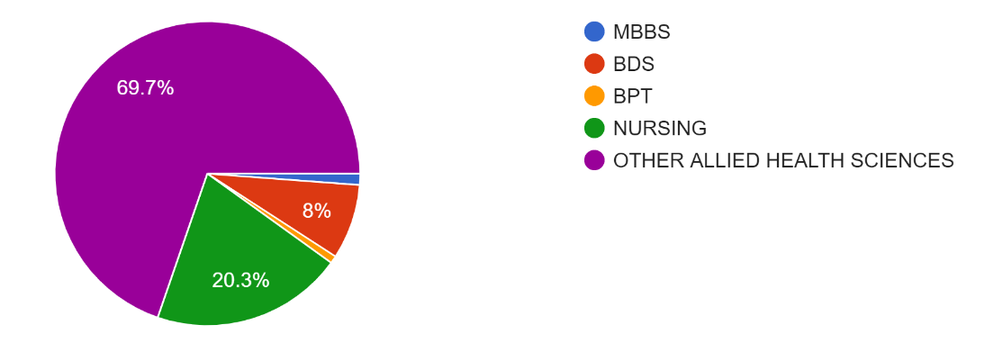
Fig. 3: Responses showing the course of study of health care professional students who participated in the study.

According to the statistical analysis of data received, 76.9% of the responders were in the second year, 18.7% of the responders were in the third year, 3.6% of the responders were in the fourth year, 0.4% of the responders were in the fifth year and 0.4% of responders were Interns.

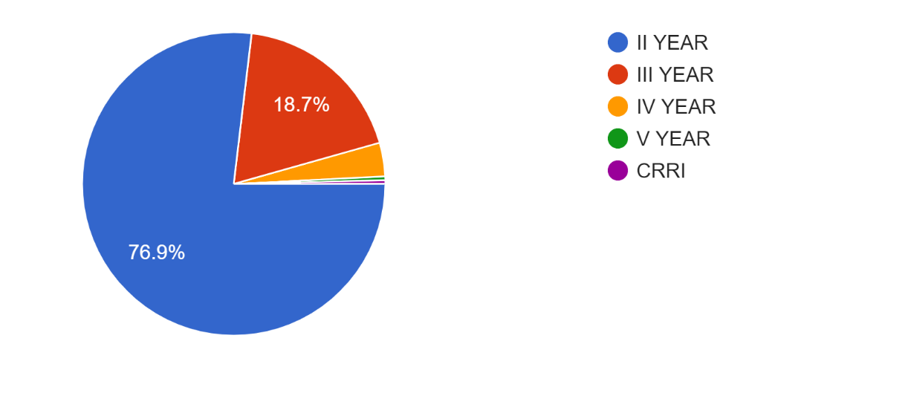
Fig. 4: Responses showing the year of study of health care professional students who participated in the study.

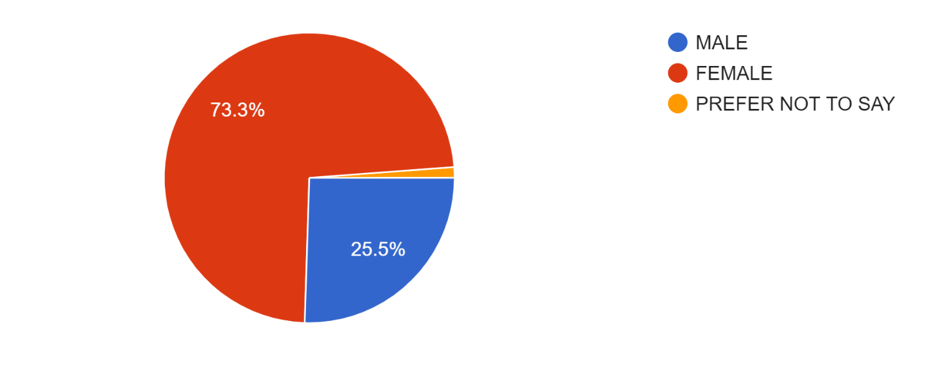
Fig. 5: Responses showing the gender of health care professional students who participated in the study.

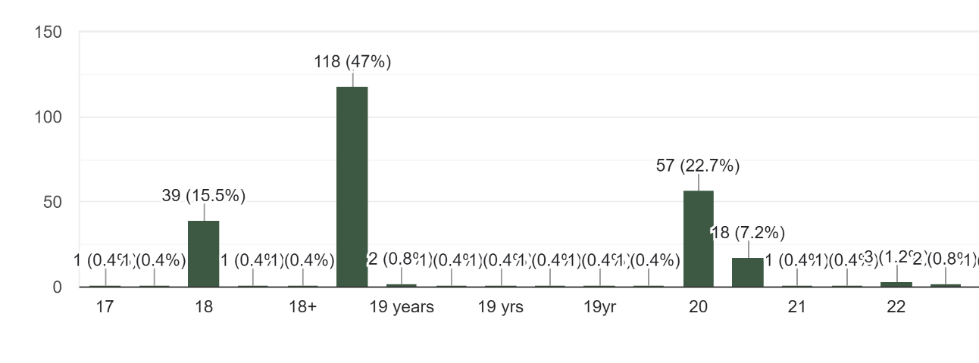
Fig. 6
Fig. 6: Responses showing the age of health care professional students who participated in the study.

Fig. 7 represents the knowledge and awareness of antibiotics among health care professional students who participated in the study.

DISCUSSION:
Antibiotic resistance had become the greatest threat to modern medicine due to misuses and abuses of antibiotics, when resistance develops against the antibiotics by the microorganism, there will be a need for use of newer, higher efficacy, and more expensive antibiotics. When resistance develops against the antibiotics by the microorganism, there will be a need for use of newer, higher efficacy, and more expensive antibiotics. Therefore, antibiotics must be used wisely and responsive way in order for the prevention and treatment of infectious diseases.
The study was started and conducted online during last week of June, 2021.This questionnaire aimed at assessing the knowledge and awareness of antibiotics among health care professional students in Chennai.
According to the statistical analysis of data received, it results, only 61.34% of healthcare professional students are aware of antibiotics and only 66.26% of health-care professional students have adequate knowledge about antibiotics. Nearly 38.66% of healthcare professional students are unaware of antibiotics and 33.74% of health-care professional students doesn’t have adequate knowledge about antibiotics.
Antibiotic resistance is an emerging concern with serious public health repercussions in terms of morbidity and mortality and is regarded as a major worldwide health crisis, especially as health care professional students are future clinicians, teachers, and researchers who will be at the forefront in educating and treating the general public. In addition to the minor importance some respondents attached to the problem of bacterial resistance to antibiotics, the incorrect use of antibiotics, such as keeping remaining stocks for future use or throwing them away, were perceptible in this study.
An alarming find in our study was that when people felt better, they stopped taking antibiotics instead of completing the course, which will develop microbial antibiotic resistance. A vast majority of respondents (81.3%) in this study exhibited appropriate attitude towards obtaining antibiotics with a doctor's prescription.
This study highlighted the gaps in knowledge and awareness of the health care profession students regarding antibiotic use and resistance. Technical education is needed to make them aware of the difference between bacteria and viruses. This will help in improving the erroneous use of antibiotics in correct way and prevents antibiotic resistance.
CONCLUSION:
This study highly suggests that awareness camps, seminars, conferences, lectures, etc., need to be organized for health care professional students to enable them to gain knowledge and awareness about antibiotics. Our study concludes that every Health Care Professional student should be Knowledgeable about antibiotics and be aware of antibiotic resistance to prevent harmful effects of antibiotics.

CONSENT TO PARTICIPATE:
Written informed consent was obtained from all participants and from a parent and/or legal guardian.

ACKNOWLEDGEMENT:
We thank all the students who participated in the study.
DECLARATION
This article was previously posted to the Research square preprint server on 09 Jan, 2023.
https://doi.org/10.21203/rs.3.rs-2453544/v1

References:
- Yang Q, Gao Y, Ke J, Show PL, Ge Y, Liu Y, Guo R, Chen J. Antibiotics: An overview on the environmental occurrence, toxicity, degradation, and removal methods. Bioengineered. 2021 Dec;12(1):7376-7416. doi: 10.1080/21655979.2021.1974657. PMID: 34612807; PMCID: PMC8806427.
- Polianciuc SI, Gurzau AE, Kiss B, et al. Antibiotics in the environment: causes and consequences. Med Pharm Rep. 2020; 93:231–240.
- Kovalakova P, Cizmas L, McDonald TJ, et al. Occurrence and toxicity of antibiotics in the aquatic environment: a review. Chemosphere. 2020; 251:126351.
- Singh SP, Qureshi A, Hassan W, Mechanisms of action by antimicrobial agents: a review. 2021;19(1).
- Dowling A, O’Dwyer J, Adley C, Antibiotics: mode of action and mechanisms of resistance. 2017; 1:536–545.
- Spagnolo F, Trujillo M, Dennehy JJ. Why Do Antibiotics Exist? mBio. 2021 Dec 21;12(6):e0196621. doi: 10.1128/mBio.01966-21. Epub 2021 Dec 7. PMID: 34872345; PMCID: PMC8649755.
- Wright GD. 2007. The antibiotic resistome: the nexus of chemical and genetic diversity. Nat Rev Microbiol 5:175–187. doi: 10.1038/nrmicro1614.
- Wright GD. 2010. Antibiotic resistance in the environment: a link to the clinic? Curr Opin Microbiol 13:589–594. doi: 10.1016/j.mib.2010.08.005.
- Drlica K, Perlin DS. 2011. Antibiotic resistance: understanding and responding to an emerging crisis. Pearson Education Ltd, Upper Saddle River, NJ.
- Davey P. Legendre, Christina A. Muzny, Gailen D. Marshall, Edwin Swiatlo, Antibiotic Hypersensitivity Reactions and Approaches to Desensitization, Clinical Infectious Diseases, Volume 58, Issue 8, 15 April 2014.
- Kandelaki K, Lundborg CS, Marrone G. Antibiotic use and resistance: a cross-sectional study exploring knowledge and attitudes among school and institution personnel in Tbilisi, Republic of Georgia. BMC Res Notes. 2015 Sep 29; 8:495. doi: 10.1186/s13104-015-1477-1. PMID: 26420302; PMCID: PMC4589112.
- Samreen Soomro*, Hanan Oqla Alshammari and Yaqin Abdullah Alabbas, Awareness and Knowledge about Antibiotic Use and Resistance among Students of Northern Border University Saudi Arabia.
- Gannon J (2000) The global infectious disease threat and its implicationsfor the United States. National Intelligence Council, Washington. p. 52.
- Grigoryan L, et al. Attitudes, beliefs and knowledge concerning antibiotic use and self-medication: a comparative European study. Pharmacoepidemiol Drug Saf. 2007;16(11):1234–1243. doi: 10.1002/pds.1479.
- Waaseth M, Adan A, Røen IL, Eriksen K, Stanojevic T, Halvorsen KH, Garcia BH, Holst L, Ulshagen KM, Blix HS, Ariansen H, Nordeng HME. Knowledge of antibiotics and antibiotic resistance among Norwegian pharmacy customers - a cross-sectional study. BMC Public Health. 2019 Jan 15;19(1):66. doi: 10.1186/s12889-019-6409-x. PMID: 30646892; PMCID: PMC6332570.
- Sowmya Sham Kanneppady, Aung Myo Oo1, Ohn Mar Lwin2, Al-Abed Ali Ahmed Al-Abed3, Sham Kishor Kanneppady4, Knowledge, Attitude, and Awareness of Antibiotic Resistance among Medical Students.
- André M, et al. A survey of public knowledge and awareness related to antibiotic use and resistance in Sweden. J Antimicrob Chemother. 2010;65(6):1292–1296. doi: 10.1093/jac/dkq104.
- Querido SM, Back-Brito GN, Dos Santos SS, Leão MV, Koga-Ito CY, Jorge AO. Opportunistic microorganisms in patients undergoing antibiotic therapy for pulmonary tuberculosis. Braz J Microbiol. 2011 Oct;42(4):1321-8. doi: 10.1590/S1517-838220110004000012. Epub 2011 Dec 1. PMID: 24031759; PMCID: PMC3768714.
- Nirman Kanna De1*, Dhanush S2, Reshma B2, Bettina Lavanya Magdaline3, Subbulakshmi Packirisamy3, A questionnaire-based online survey on knowledge and awareness of anaemia among female health-care professional students in Tamil Nadu, DOI: 10.22159/ajpcr.2022v15i8.44979.
- Singh A, Singhania N, Sharma A, Sharma N, Samal S. Ceftriaxone-Induced Immune Hemolytic Anemia. Cureus. 2020 Jun 17;12(6):e8660. doi: 10.7759/cureus.8660. PMID: 32699660; PMCID: PMC7370697.
- Om C, Daily F, Vlieghe E, McLaughlin JC, McLaws ML. “If it’s a broadspectrum, it can shoot better”: Inappropriate antibiotic prescribing inCambodia. Antimicrob Resist Infect Control 2016; 5:58.5. Jamshed SQ,
- Elkalmi R, Rajiah K, Al-Shami AK, Shamsudin SH,Siddiqui MJ, et al. Understanding of antibiotic use and resistance amongfinal-year pharmacy and medical students: 2014;8:780-5.
- Vallin M, et al. Knowledge and attitudes towards antibiotic use and resistance - a latent class analysis of a Swedish population-based sample. PLoS One. 2016;11(4):e0152160. doi: 10.1371/journal.pone.0152160.
- McCullough AR, et al. A systematic review of the public's knowledge and beliefs about antibiotic resistance. J Antimicrob Chemother. 2016;71(1):27–33. doi: 10.1093/jac/dkv310.
- You JH, Yau B, Choi KC, Chau CT, Huang QR, Lee SS. Public knowledge, attitudes and behavior on antibiotic use: a telephone survey in Hong Kong. Infection. 2008 Mar;36(2):153-7. doi: 10.1007/s15010-007-7214-5. Epub 2008 Jan 29. PMID: 18231717.
- McNulty CA, Boyle P, Nichols T, Clappison P, Davey P. Don't wear me out--the public's knowledge of and attitudes to antibiotic use. J Antimicrob Chemother. 2007 Apr;59(4):727-38. doi: 10.1093/jac/dkl558. Epub 2007 Feb 16. PMID: 17307770.
- Wutzke SE, Artist MA, Kehoe LA, Fletcher M, Mackson JM, Weekes LM. Evaluation of a national programme to reduce inappropriate use of antibiotics for upper respiratory tract infections: effects on consumer awareness, beliefs, attitudes and behaviour in Australia. Health Promot Int. 2007 Mar;22(1):53-64. doi: 10.1093/heapro/dal034. Epub 2006 Oct 17. PMID: 17046966.
- Gunjan Kumar1 , Dhirendra Kumar Singh2 , Suranjana Jonak Hazarika1 , Diplina Barman3 , Payal Dash1 , Prateeti Swain4 , Knowledge and attitude of antibiotic resistance in the time of COVID-19 among patients attending a dental hospital in Bhubaneswar city.
- Islahudin F, Tamezi AM, Shah NM. Knowledge, attitudes and practices about antibiotic use among the general public in Malaysia. Southeast Asian J Trop Med Public Health 2014; 45:1474-82.
- Agarwal S, Yewale VN, Dharmapalan D. Antibiotics use and misuse in children: A knowledge, attitude and practice survey of parents in India. J Clin Diagn Res 2015;9:C21-4.
- Zaidi M, Zaidi SK, Bhutto M, Umer MY. Amoxycillin and clavulanic acid induced Stevens-Johnson syndrome: A case report. EXCLI J. 2017 May 18; 16:748-751. doi: 10.17179/excli2017-345. PMID: 28827990; PMCID: PMC5547378.

