SYNTHESIS, METHODOLOGY AND CHARACTERIZATION OF SILVER NANOPARTICLES
¹Mr. Vikas Chaubey, ²Dr. Aakash Singh, ³Dr. Atul Kumar and ⁴Dr. Shailendra Sinha
¹ vikaschaubey0111@gmail.com ² aakashsingh.ucst@gmail.com ³ atulkumar.iitr@gmail.com ⁴ shailendra.sinha@ietlucknow.ac.in
^{1,2,3}IET, Dr. Shakuntala Misra National Rehabilitation University, Lucknow, Uttar Pradesh.
⁴Institute of Engineering and Technology, Lucknow, Uttar Pradesh.
1. Introduction:
1.1 Nanotechnology:
Nanotechnology is a significant and rapidly growing field of research focused on designing, synthesizing, and manipulating particles ranging from approximately 1-100 nm in one dimension. This technology has opened new frontiers in various areas, including fundamental research and practical applications. Nanoscale materials possess unique physicochemical and optoelectronic properties that make them highly valuable in numerous industries. The applications of nanotechnology are vast and diverse. It plays a crucial role in sectors such as healthcare, cosmetics, food and feed, environmental health, mechanics, optics, biomedical sciences, chemical industries, electronics, space industries, drug-gene delivery, energy science, optoelectronics, catalysis, reorography, single electron transistors, light emitters, nonlinear optical devices, and photo electrochemical applications. Overall, nanotechnology's progress and its applications promise exciting opportunities for advancements across various fields and industries [1-2]. Nanomaterials offer promising solutions to various technological and environmental challenges in solar energy conversion, catalysis, medicine, and water treatment. As the world strives to reduce hazardous waste, the growing demand for nanomaterials necessitates the development of green synthesis methods. Nanotechnology is revolutionizing the synthesis of materials and fabrication of devices. Utilizing a "bottom-up approach," nanoscale building blocks can be assembled into functional structures and multifunctional devices. The exploration of nanosized materials' synthesis is particularly intriguing due to their distinct properties, such as optoelectronic, magnetic, and mechanical characteristics, which differ from bulk materials [3]. "Nanotechnology is bringing about a fundamental transformation in the synthesis of materials and fabrication of devices. It enables the incorporation of nanoscale building blocks into functional assemblies and the development of multifunctional devices using a 'bottom-up approach.' The research on synthesizing nanosized materials is particularly captivating due to their distinctive properties, including optoelectronic, magnetic, and mechanical attributes that set them apart from bulk materials."
1.2 Nanoparticles:
The term "nanoparticles" refers to particles with sizes ranging from 1nm to 100nm, at least in one of their three dimensions. Within this size range, nanoparticles exhibit distinct physical, chemical, and biological properties compared to both individual atoms/molecules and bulk materials. These nanoparticles can be composed of various materials, including metals, metal oxides, silicates, non-oxide ceramics, polymers, organics, carbon, and biomolecules. They come in different shapes such as spheres, cylinders, platelets, and tubes. Additionally, surface modifications are commonly applied to nanoparticles to suit specific applications.
With the rapid industrialization and urbanization, our environment is experiencing significant damage, leading to the release of hazardous and unnecessary chemicals, gases, or substances. Therefore, it has become crucial to explore the secrets present in nature and its products to advance the synthesis processes of nanoparticles. Nanotechnology applications are particularly well-suited for biological molecules due to their unique properties. Controlled assembly of biological molecules has been found to be reliable and eco-friendly for synthesizing metal nanoparticles [4]. The synthesis of metal and semiconductor nanoparticles is an extensive area of research owing to its immense potential for applications and its role in the advancement of novel technologies [5]. Nanotechnology is a rapidly emerging area of research in modern material science. Nanoparticles exhibit unique and enhanced properties, including size, distribution, and morphology. As a result, novel applications of nanoparticles and nanomaterials are continuously emerging across various fields [6]. Metal nanoparticles possess a notable specific surface area and a significant fraction of surface atoms. These nanoparticles exhibit distinctive physicochemical characteristics, which encompass catalytic activity, optical properties, electronic properties, antibacterial features, and magnetic attributes [7-10]. Metal nanoparticles have become a subject of great interest among scientists due to their innovative synthesis methods. In recent years, research on the synthesis of metal nanoparticles has been a crucial focus in modern material science. Among these, nano-crystalline silver particles have shown tremendous potential in various applications, including high sensitivity biomolecular detection, diagnostics, antimicrobials, therapeutics, catalysis, and micro-electronics. However, there is a pressing need for an economically viable and environmentally friendly synthesis route for silver nanoparticles. Silver is renowned for its inhibitory effect on many bacterial strains and microorganisms commonly found in medical and industrial processes [11]. In the medical field, both silver and silver nanoparticles find extensive applications, including their use in skin ointments and creams to prevent infection in the case of burns and open wounds [12], Medical devices and implants often utilize silver-impregnated polymers for their preparation [13]. In the textile industry, the implementation of silver-embedded fabrics has become prevalent, especially in the manufacturing of sporting equipment [14].
Nanoparticles can be synthesized through various approaches, such as chemical, physical, and biological methods. Although the chemical method allows for rapid synthesis of large quantities of nanoparticles, it necessitates the use of capping agents to stabilize their size. Unfortunately, the chemicals used for synthesis and stabilization are often toxic and produce non-eco-friendly byproducts. As a result, there is a growing interest in exploring biological approaches that eliminate the use of harmful chemicals and their byproducts. This increasing demand for environmentally non-toxic synthesis protocols for nanoparticles has spurred the development of green nanotechnology [15]. Numerous biological methods for synthesizing nanoparticles, both extracellular and intracellular, have been reported to date. These methods involve the use of microorganisms, including bacteria, fungi, and plants [16-17]. Plants offer an excellent platform for synthesizing nanoparticles because they are free from toxic chemicals and provide natural capping agents. Additionally, using plant extracts reduces the cost of isolating and culturing microorganisms, making nanoparticle synthesis more cost-competitive compared to using microorganisms [17]. At times, utilizing various plants and their extracts for nanoparticle synthesis can offer advantages over other biological processes, which often involve complex procedures for maintaining microbial cultures [18-19]. Numerous experiments have already been conducted, including the synthesis of various metal nanoparticles using fungi like Fusarium oxysporum [20] and Penicillium sp. [21], as well as some bacteria such as Bacillus subtilis [22-23]. However, the most widely adopted method for green, eco-friendly nanoparticle production is through plant extracts. This approach holds a special advantage as plants are widely distributed, easily accessible, safer to handle, and serve as a source of several metabolites [24]. Numerous experiments have been conducted to synthesize silver nanoparticles using medicinal plants such as Oryza sativa, Helianthus annus, Saccharin officinarum, Sorghum bicolour, Zea mays, Basellaalba, Aloe vera, Capsicum annuum, Magnolia kobus, Medicago sativa (Alfalfa), Cinamomum camphora, and Geranium sp., particularly for pharmaceutical applications and biological industries. Additionally, investigations on the green synthesis of silver nanoparticles using a methanolic extract of Eucalyptus hybrida were also performed [25]. Recently, silver nanoparticles have been successfully synthesized from naturally occurring sources and their products, including green tea (Camellia sinensis), Neem (Azadirachta indica), leguminous shrub (Sesbania drummondii), various leaf broths, natural rubber, starch, Aloe vera plant extract, lemongrass leaves extract, among others [26]. Regarding the antimicrobial properties of silver nanoparticles, they attach to the cell wall of microbes, disrupting its permeability and cellular respiration. The nanoparticles may also penetrate deep inside the cell wall, causing cellular damage by interacting with phosphorus and sulfur-containing compounds, such as DNA and proteins. The release of silver ions from the particles contributes to the bactericidal properties, conferring antimicrobial activity [27]. The antibacterial effects are influenced by the size of the nanoparticle, with smaller particles showing higher antibacterial activities due to equivalent silver mass content. Furthermore, nanoparticles synthesized through biological means, either intra or extracellularly by microorganisms like diatoms, fungi, bacteria, and yeast, tend to be more biocompatible, holding potential for clinical applications [28].
1.3 Classification of Nanoparticles:
Nanoparticles are commonly categorized into organic, inorganic, and carbon-based types.
- Organic Nanoparticles-
Dendrimers, micelles, liposomes, and ferritin are examples of organic nanoparticles or polymers. These nanoparticles possess favorable characteristics such as biodegradability, non-toxicity, and some, like micelles and liposomes, have a hollow core, referred to as nanocapsules, making them sensitive to thermal and electromagnetic radiation, such as heat and light [29]. These unique properties make them well-suited for drug delivery applications. The drug carrying capacity, stability, and delivery systems, whether through entrapped or adsorbed drugs, play a crucial role in determining their field of applications and efficiency, in addition to their normal characteristics like size, composition, and surface morphology. Organic nanoparticles are widely used in the biomedical field, particularly in drug delivery systems, as they offer efficiency and the ability to target specific parts of the body, known as targeted drug delivery.
- Inorganic Nanoparticles-
Inorganic nanoparticles are particles that do not contain carbon. Nanoparticles made of metals and metal oxides are typically classified as inorganic nanoparticles.
    - Metal Based-
Metal-based nanoparticles are synthesized from metals, reducing their sizes to nanometric scales through destructive or constructive methods. Virtually all metals can be transformed into nanoparticles [30]. Commonly used metals for nanoparticle synthesis include aluminum (Al), cadmium (Cd), cobalt (Co), copper (Cu), gold (Au), iron (Fe), lead (Pb), silver (Ag), and zinc (Zn). These nanoparticles exhibit distinct properties, with sizes as small as 10 to 100nm and unique surface characteristics, such as high surface area to volume ratio, pore size, surface charge, and surface charge density. They can also adopt crystalline or amorphous structures and various shapes like spherical and cylindrical, displaying different reactivity and sensitivity to environmental factors like air, moisture, heat, and sunlight.
    - Metal oxide Based-
Metal oxide-based nanoparticles are synthesized to modify the properties of their corresponding metal-based nanoparticles. For instance, iron (Fe) nanoparticles readily oxidize to iron oxide (Fe2O3) in the presence of oxygen at room temperature, which enhances their reactivity compared to iron nanoparticles. Metal oxide nanoparticles are primarily synthesized for their increased reactivity and efficiency [31]. Commonly synthesized metal oxide nanoparticles include Aluminum oxide (Al2O3), Cerium oxide (CeO2), Iron oxide (Fe2O3), Magnetite (Fe3O4), Silicon dioxide (SiO2), Titanium oxide (TiO2), and Zinc oxide (ZnO). These nanoparticles possess exceptional properties when compared to their metal counterparts.
    - Carbon Based-
Nanomaterials composed predominantly of carbon often adopt forms such as hollow spheres, ellipsoids, or tubes. Fullerenes refer to spherical and ellipsoidal carbon nanomaterials, while cylindrical ones are called nanotubes. Nanoparticles entirely composed of carbon are categorized as carbon-based [32]. These carbon-based nanomaterials include fullerenes, graphene, carbon nanotubes (CNT), carbon nanofibers, carbon black, and sometimes activated carbon in nano size. These particles hold great potential for various applications, such as enhancing films and coatings, producing stronger and lighter materials, and finding uses in electronics.
- Fullerenes-
Fullerenes (C60) are carbon molecules that possess a spherical shape and are composed of carbon atoms bonded together through sp2 hybridization. These spherical structures contain approximately 28 to 1500 carbon atoms, with single-layer fullerenes having diameters up to 8.2 nm and multi-layered fullerenes ranging from 4 to 36 nm.
- Graphene-
Graphene is a carbon allotrope consisting of a two-dimensional planar surface with a hexagonal network of carbon atoms arranged in a honeycomb lattice. Typically, the thickness of a graphene sheet is approximately 1 nm.
- Carbon Nano Tube (CNT)-
Carbon Nanotubes (CNT) are formed by rolling a graphene nanofoil, which is a sheet with a honeycomb lattice of carbon atoms, into hollow cylinders. These nanotubes have diameters as small as 0.7 nm for single-layered CNTs and 100 nm for multi-layered CNTs, with lengths ranging from a few micrometers to several millimeters. The ends of carbon nanotubes can be either hollow or closed by a half fullerene molecule.
- Carbon Nano Fiber-
Graphene nanofoils are also utilized to produce carbon nanofibers, similar to CNTs, but they are wound into a cone or cup shape instead of regular cylindrical tubes.
- Carbon Black-
An amorphous material composed of carbon, typically exhibiting a spherical shape with diameters ranging from 20 to 70 nm. The interaction between the particles is significant, leading them to bind together in aggregates, forming agglomerates of around 500 nm in size.
1.4 Synthesis of nanoparticles:
Nanoparticles are synthesized through various methods, which can be categorized as either bottom-up or top-down approaches. The top-down approach involves starting from a bulk material and scaling it down to incorporate critical nanoscale details. For example, a complex biomaterial can be engineered by breaking it down into its component parts, like creating small crystals from a bulk mineralized hard tissue using acid-etching. On the other hand, the bottom-up approach involves assembling materials from the nanoscopic scale, such as molecules and atoms, to construct larger structures.
1.4.1 Bottom-up method-
The bottom-up or constructive method involves building up materials from atoms to clusters and finally to nanoparticles. Commonly used bottom-up methods for nanoparticle production include sol-gel, spinning, chemical vapor deposition (CVD), pyrolysis, and biosynthesis.
  - Sol-gel-
The sol-gel method involves a colloidal solution of solids suspended in a liquid phase. The gel is a solid macromolecule submerged in a solvent. It is one of the most preferred bottom-up methods due to its simplicity, and it allows for the synthesis of many nanoparticles. The sol-gel process is a wet-chemical technique in which a chemical solution acts as a precursor for a system of discrete particles. Typically, metal oxides and chlorides serve as the precursors in the sol-gel process [33]. In this method, the precursor is dispersed in a host liquid through shaking, stirring, or sonication, resulting in a system containing both liquid and solid phases. Nanoparticles are recovered from this system through phase separation, which can be achieved using methods like sedimentation, filtration, and centrifugation. Subsequently, the moisture is removed through drying [34]. The process involves converting monomers into a colloidal solution, which acts as the precursor for an integrated network (or gel) of discrete particles or network polymers.
  - Spinning- The synthesis of nanoparticles using spinning is carried out in a spinning disc reactor (SDR). The SDR consists of a rotating disc inside a chamber or reactor where various physical parameters, such as temperature, can be controlled. To prevent chemical reactions and remove oxygen, the reactor is typically filled with nitrogen or other inert gases [31]. During the process, the disc is rotated at different speeds while the precursor liquid and water are pumped in. The spinning action causes the atoms or molecules to fuse together, leading to precipitation. The nanoparticles are then collected and dried [35]. The characteristics of the synthesized nanoparticles from the SDR depend on various operating parameters, such as the liquid flow rate, disc rotation speed, liquid-to-precursor ratio, location of the feed, and disc surface.
  - Chemical Vapor Deposition (CVD)-
Chemical Vapor Deposition (CVD) is a process where a thin film of gaseous reactants is deposited onto a substrate. This deposition takes place in a reaction chamber at ambient temperature, where gas molecules combine and undergo a chemical reaction when in contact with a heated substrate [32]. As a result, a thin film of the product forms on the substrate surface, which can be collected and utilized. The substrate temperature plays a crucial role in the CVD process. Some of the advantages of CVD include the production of highly pure, uniform, hard, and strong nanoparticles. However, it also comes with certain disadvantages, such as the requirement of specialized equipment and the generation of highly toxic gaseous by-products [36].
  - Pyrolysis-
Pyrolysis is a widely used process in industries for large-scale nanoparticle production. It entails burning a precursor with a flame. The precursor, which can be either liquid or vapor, is fed into the furnace at high pressure through a small hole, where it undergoes combustion [37]. The resulting combustion or by-product gases are then air classified to recover the nanoparticles. Some furnaces utilize laser and plasma instead of a flame to achieve high temperatures for easy evaporation [38]. Pyrolysis offers several advantages, including its simplicity, efficiency, cost-effectiveness, and continuous nature with high yield.
  - Biosynthesis-
Biosynthesis is an eco-friendly approach to nanoparticle synthesis that utilizes bacteria, plant extracts, fungi, and other biological agents along with precursors to produce nanoparticles. This green method is nontoxic and biodegradable [39]. The biosynthesized nanoparticles possess unique and enhanced properties, making them suitable for various biomedical applications.
1.4.2 Top-Down Method-
The top-down or destructive method involves reducing bulk materials to nanometric scale particles. Various nanoparticle synthesis methods fall under this category, including mechanical milling, nanolithography, laser ablation, sputtering, and thermal decomposition.
a. Mechanical Milling-
Mechanical milling is a widely used top-down method to produce various nanoparticles. It involves milling and post-annealing of nanoparticles during synthesis, where different elements are milled in an inert atmosphere [40]. Plastic deformation leads to particle shape, fracture leads to a decrease in particle size, and cold-welding leads to an increase in particle size.
b. Nanolithography-
Nanolithography is the process of fabricating nanometric scale structures with at least one dimension in the range of 1 to 100 nm. Different nanolithography processes include optical, electron-beam, multiphoton, nano imprint, and scanning probe lithography [41]. The process involves printing a required shape or structure on a light-sensitive material, selectively removing a portion of the material to create the desired shape and structure [42].
c. Laser ablation-
Laser Ablation Synthesis in Solution (LASiS) is a common method for nanoparticle production from various solvents. The irradiation of a metal submerged in a liquid solution by a laser beam forms a plasma plume that produces nanoparticles [43]. It offers an alternative solution to conventional chemical reduction for synthesizing metal-based nanoparticles.
d. Sputtering-
Sputtering is a process of nanoparticle deposition on a surface by ejecting particles from it through collisions with ions [44]. Typically, a thin layer of nanoparticles is deposited, followed by annealing. The shape and size of the nanoparticles depend on factors such as layer thickness, annealing temperature, duration, and substrate type [45].
e. Thermal decomposition-
Thermal decomposition is an endothermic chemical process in which heat breaks chemical bonds in a compound [30]. Nanoparticles are produced by decomposing the metal at specific temperatures, resulting in a chemical reaction that produces secondary products.

Table- 1.1 Categories of the Nanoparticles synthesized from the various methods
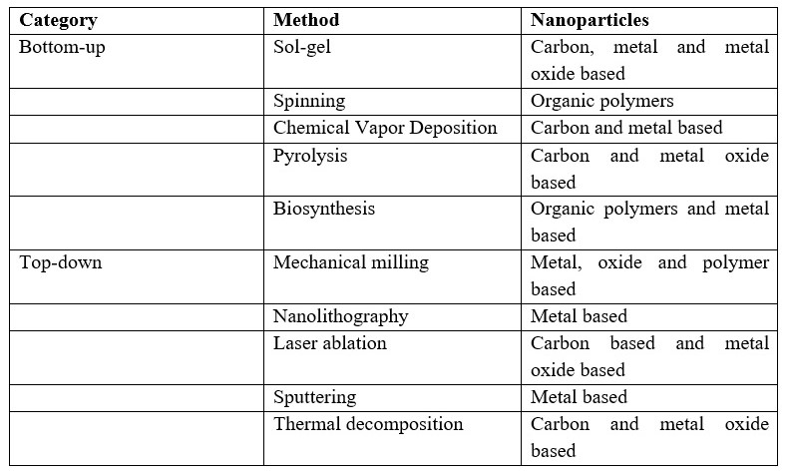
1.5 Properties of Nanoparticles:
The properties of nanoparticles can be categorized into physical and chemical aspects.
1.5.1 Physical Properties-
The physical properties of nanoparticles include optical characteristics, such as color, light penetration, absorption, and reflection capabilities. They also exhibit unique mechanical properties, such as elastic, ductile, tensile strengths, and flexibility, which are crucial factors in their applications. Additionally, nanoparticles possess properties like hydrophilicity, hydrophobicity, suspension, diffusion, and settling characteristics, making them valuable in various modern applications.
Nanoparticles' large surface area dominates the contributions compared to the small bulk of the material. For instance, zinc oxide nanoparticles have superior UV blocking properties compared to their bulk counterparts, making them useful in sunscreen lotions. Examples of other physical properties of nanoparticles include:
Color: Nanoparticles of yellow gold and gray silicon appear red in color.
Melting Point: Gold nanoparticles have lower melting temperatures (~300 °C for 2.5 nm size) than gold slabs (1064 °C).
Solar Radiation Absorption: Nanoparticles absorb more solar radiation in photovoltaic cells compared to thin films of continuous sheets of bulk material due to their smaller size.
1.5.2 Chemical Properties-
Chemical properties determine nanoparticles' reactivity with specific targets, as well as their stability and sensitivity to factors such as moisture, atmosphere, heat, and light. These properties have implications for various applications, including biomedical and environmental fields. Nanoparticles may exhibit antibacterial, anti-fungal, disinfection, and toxicity properties, among others, which contribute to their diverse uses.
1.5.3 Formation of Suspensions-
An important physical property of nanoparticles is their ability to form suspensions. The strong interaction of the particle surface with the solvent overcomes density differences, allowing nanoparticles to remain suspended in liquids.
1.5.4 Optical Properties of Nanoparticles-
Nanoparticles often demonstrate unexpected optical properties due to their small size, confining their electrons and producing quantum effects. For example, gold nanoparticles appear deep red to black in solution.
1.5.5 Diffusion Properties of Nanoparticles-
Nanoparticles exhibit diffusion properties, especially at elevated temperatures. Sintering, which can lead to agglomeration, occurs at lower temperatures and over shorter time scales for nanoparticles compared to larger particles.
1.5.6 Magnetization and Other Properties of Nanoparticles-
Nanoparticles exhibit unique properties such as quantum confinement in semiconductor particles, surface plasmon resonance in some metal particles, and super paramagnetism in magnetic materials. However, specific properties like magnetization may not always be desirable in nanoparticles, depending on their intended applications.
1.6 Why Silver?
Silver is a naturally occurring element that possesses several advantageous properties. It is slightly harder than gold, highly ductile, and malleable. Silver has the highest electrical and thermal conductivity among all metals, with the lowest contact resistance. The element can be found in different oxidation states, but metallic silver (Ag0) and silver ions (Ag2+, Ag3+) are the most common, while the latter are unstable in aquatic environments [46]. Metallic silver is insoluble in water, but silver salts like AgNO3 and silver chloride are soluble (WHO, 2002). Silver is used in various applications, including surgical prostheses, fungicides, and coinage. Soluble silver compounds have been used in the treatment of mental illnesses, epilepsy, nicotine addiction, gastroenteritis, and infectious diseases like syphilis and gonorrhea [46]. While acute toxicity of silver in the environment depends on the availability of free silver ions, investigations have shown that these concentrations are generally too low to cause toxicity (WHO, 2002). Metallic silver poses minimal risk to health, while soluble silver compounds can be more readily absorbed and potentially produce adverse effects [47]. Due to its various uses, silver can enter the body through multiple routes, such as ingestion. It is not considered toxic to the immune, cardiovascular, nervous, or reproductive systems, nor is it considered carcinogenic, making it relatively safe [48, 49].
1.7 Synthesis of Silver Nanoparticles by Plants:
The utilization of plant extracts for silver nanoparticle synthesis offers several advantages, such as their easy availability, safety, and non-toxic nature. Plants contain a wide range of metabolites that aid in the reduction of silver ions and contribute to quicker synthesis compared to microbial methods. Phytochemicals, including terpenoids, flavones, ketones, aldehydes, amides, and carboxylic acids, play a significant role in plant-assisted reduction and capping processes during nanoparticle synthesis. Specific phytochemicals, such as flavones, organic acids, and quinones, are responsible for the immediate reduction of silver ions. Studies have highlighted the presence of anthraquinones and benzoquinones in xerophytes and mesophytes, respectively, which participate in the formation of silver nanoparticles. The phytochemicals directly engage in the reduction of ions and the subsequent formation of silver nanoparticles [50].
1.8 Need for Green Synthesis:
The biosynthesis of nanoparticles follows a bottom-up approach, primarily involving reduction/oxidation reactions. The need for the biosynthesis of nanoparticles arose due to the costliness of physical and chemical processes. Traditional chemical synthesis methods often result in the presence of toxic chemicals absorbed on the nanoparticle surface, which could have adverse effects in medical applications [51]. This concern is addressed when using biosynthesized nanoparticles via the green synthesis route. Scientists turned to microbial enzymes and plant extracts (phytochemicals) for their antioxidant or reducing properties, which play a crucial role in reducing metal compounds into nanoparticles. Author A. Singh previously reported a number of greener approaches in a series of heterocyclic bioactive compounds as well as nanoparticle synthesis as a green catalyst in good to be excellent yields and conclude that green synthesis offers several advantages over chemical and physical methods, such as cost-effectiveness, environmental friendliness, easy scalability for large-scale synthesis, and the absence of high pressure, energy, temperature, and toxic chemicals [52].
1.9 Nano-Silver:
Nano-silver is a key substance used in nano formulations due to its antimicrobial properties. It has been incorporated into filters to purify drinking water and clean swimming pool water. The generation of nano-silver involves engineering metallic silver into ultrafine particles through various methods, including spark discharging, electrochemical reduction, solution irradiation, and cry-chemical synthesis [53]. Most nano-silver particles are smaller than 100 nm and consist of about 20-15,000 silver atoms [53]. They can be produced in different nanostructures, such as tubes, wires, multicasts, or films. At the nano-scale, silver particles exhibit unique physicochemical properties, including pH-dependent partitioning to solid and dissolved particulate matters, and different biological activities compared to regular metals [54]. Due to their remarkable antimicrobial activity, nano-silver is increasingly utilized in consumer and medical products, such as food packaging materials, food supplements, odor-resistant textiles, electronics, household appliances, cosmetics, medical devices, water disinfectants, and room sprays.
1.10 Why Thuja Occidentalis Plant?
The Thuja Occidentalis plant has medicinal uses, with its leaves and leaf oil employed in various treatments. It is used for respiratory tract infections like bronchitis, bacterial skin infections, and cold sores. Additionally, it is utilized for relieving painful conditions, including osteoarthritis and trigeminal neuralgia, a nerve disorder affecting the face. Some people use thuja as an expectorant to loosen phlegm, an immune stimulant to boost the immune system, and a diuretic to increase urine flow. Moreover, it has been historically used to induce abortions. Topically, thuja is applied for joint pain, osteoarthritis, muscle pain, and to address skin diseases, warts, and cancer. The plant's fragrance is also utilized in cosmetics and soaps during manufacturing.

2. Literature Survey:
The history of nanomaterials stretches back several decades, with significant developments in nanoscience occurring in the last two decades. The concept of nanotechnology was first introduced by Noble laureate Richard Feynman in his famous lecture at the California Institute of Technology on December 29, 1959. He discussed the idea of nanomaterials in an article titled "There is plenty of room at the bottom" published in 1960. Norio Taniguchi first defined the term "Nanotechnology" in 1970. Nanoparticles find applications in various fields such as electrical, biological, textiles, and chemistry. The shape and size of colloidal metal particles play a crucial role in different applications, including magnetic and electronic devices, wound healing, antimicrobial gene expression, preparation of bio composites, and noble metal colloids with optical and catalytic electromagnetic properties.
Nanotechnology, dealing with the design, synthesis, and manipulation of particles ranging from approximately 1-100 nm in one dimension, has witnessed remarkable growth and has opened new fundamental and applied frontiers. It finds applications in diverse fields such as healthcare, cosmetics, food and feed, environmental health, mechanics, optics, biomedical sciences, chemical industries, electronics, space industries, drug-gene delivery, energy science, optoelectronics, catalysis, reprography, single electron transistors, light emitters, nonlinear optical devices, and photo electrochemical applications [26-27]. Nanomaterials are seen as solutions to many technological and environmental challenges in solar energy conversion, catalysis, medicine, and water treatment. The demand for nanomaterials must be met with green synthesis methods in the context of global efforts to reduce hazardous waste. Nanotechnology is revolutionizing materials synthesis and device fabrication through a "bottom-up approach." Research on nanosized materials is of great interest due to their unique optoelectronic, magnetic, and mechanical properties compared to bulk materials [28].
The history of nanotechnology has a long-standing foundation, with silver nanoparticles being historically used to provide colored glass windows with a yellow tint. Nanoparticles are in high demand due to their fascinating properties and various technological applications [Liz-Marzan and Kamat, 2003]. The properties of nanoparticles change as their size is reduced from the macro/micro scale to the nanoscale [Caruso, 2004]. Reduced dimensions lead to an increase in surface area per unit mass, altering the physical and chemical properties of materials. Nanocrystals have a large fraction of surface atoms and surface energy, influencing their thermal stability and catalytic properties. Nanoparticles exhibit lower melting points and higher mechanical strength due to crystal defects compared to bulk materials [Buffat and Borel, 1976; Allen et al., 1986; Meyers et al., 2006].
2.1 Characterization Techniques:
a) UV-Vis Spectroscopy –
This technique measures the optical properties of a solution by sending light through the sample and measuring the amount of absorbed light. The absorbance can be used to determine the concentration of a solution using Beer-Lambert's Law.
b) Fourier Transform Infrared (FTIR) Spectroscopy –
FTIR measures infrared intensity vs. wavelength of light and is used to identify functional groups and structural features of biological extracts with nanoparticles.
c) Scanning Electron Microscope (SEM) –
SEM provides high-resolution images of a sample's surface and is useful for understanding the morphology of materials.
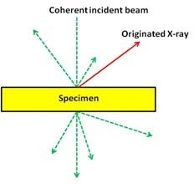
d) Energy-Dispersive X-Ray Spectroscopy (EDX) –
EDX is used to analyze the elemental composition of silver nanoparticles by measuring the X-rays emitted from the sample when bombarded with charged particles or X-rays.
Fig-2.1 X-Ray Emission

Diagram showing the X-ray emission originated when striking the sample with an electron beam. All different kinds of electron scattering from a thin specimen are also shown as broken arrows.
The XEDS uses silicon, Si, as a semiconductor so as to transform the energy of X-ray into electric signals. Specifically, when X-rays hit the semiconductor, electrons are transferred from the valence to the conduction band, creating thousands of electron-hole pairs. Since the number of the created electron holes is directly proportional to the energy of the X-ray photon and this energy depends on the element in which the X-ray has been generated, it is possible, as aforementioned, to analyze the chemical composition of the specimen.
e) X-Ray Diffraction (XRD)-
X-ray diffraction is a conventional technique used for determining the crystallographic structure and morphology of materials. The intensity of X-rays diffracted from the sample provides information about its composition. XRD is employed to establish the metallic nature of particles, obtain information on translational symmetry, size, and shape of the unit cell from peak positions, and analyze the electron density inside the unit cell based on peak intensities.
f) Antibacterial Activity-
Various analytical methods have been utilized to assess the antibacterial activity of silver nanoparticles. One commonly used method is the broth dilution method, where plates with serial culture broth dilutions containing bacteria and silver nanoparticles are incubated in suitable agar medium. It has been observed that the antibacterial activity of silver nanoparticles is size-dependent, with smaller particles exhibiting increased efficacy against bacteria. The mechanism of action involves the penetration of silver nanoparticles into bacterial cells, leading to the generation of reactive oxygen species that damage the cells and inhibit their functions. The soft acid nature of silver nanoparticles allows them to interact with sulfur and phosphorus present in bacterial cells and DNA, leading to cell death and disruption of bacterial signal transduction.
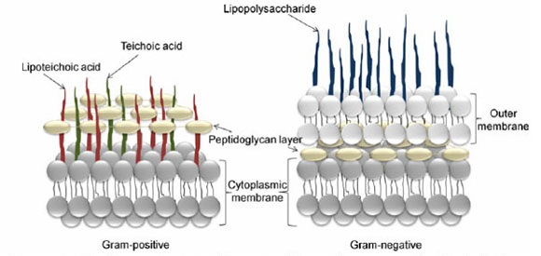
Fig. 2.2 Membrane structure of gram-positive and gram-negative bacteria
(Reproduce with permission from Espitia et.al., 2012)
Overall, nanotechnology has paved the way for the development of antibacterial textiles, where silver nanoparticles play a vital role due to their strong antibacterial properties. These nanoparticles, whether chemically or biologically synthesized using plant leaf extract, have been shown to effectively inhibit bacterial growth and offer promising applications in various fields.
The literature survey highlights the significant advancements in nanotechnology and the potential applications of nanomaterials in various fields. The utilization of green synthesis methods is emphasized to meet the increasing demand for nanomaterials while reducing hazardous waste. The use of silver nanoparticles in history and their unique properties at the nanoscale are also discussed. Various characterization techniques play a vital role in understanding and analyzing nanoparticles in terms of their size, shape, and elemental composition.

3. Methodology:
In this study, we employed a green synthesis approach to produce silver nanoparticles under standard laboratory conditions. The synthesis and characterization experiments were conducted at the Faculty of Engineering and Technology, Dr. Shakuntala Misra National Rehabilitation University, Lucknow Uttar Pradesh and Institute of Engineering & Technology, Lucknow, Uttar Pradesh, as well as the Materials Research Center (MRC), Malviya National Institute of Technology, Jaipur.
3.1 Materials:
The chemical reagents used in the synthesis process included:
Silver Nitrate - Obtained from a departmental store.
Nutrient Agar Powder - Acquired from chemical suppliers.
Sample Collection:
Fresh leaves of Thuja occidentalis were collected from the campus at Dr. Shakuntala Misra
National Rehabilitation University, Lucknow Uttar Pradesh in March. Following collection, the samples were carefully dried and Stored in a refrigerator.
De-ionized Water:
De-ionized water used in the experiments was collected from the DI plant to ensure the
purity of the water used during the synthesis process.

Table - 3.1- Instrument Required
S.No | Instrument
1 | Heating mantle and Muffle Furnace
2 | Magnetic Stirrer
3 | Uv-Vis Spectrophotometer
4 | Weighing balance
5 | Autoclave and Laminar air flow

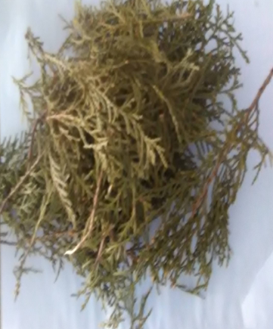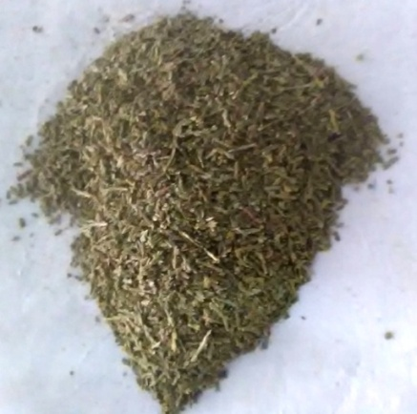
Fig-3.1Thuja Occidentalis Plant Fig-3.2 Powdered form Fig-3.3 Preparation of Leaf Extract

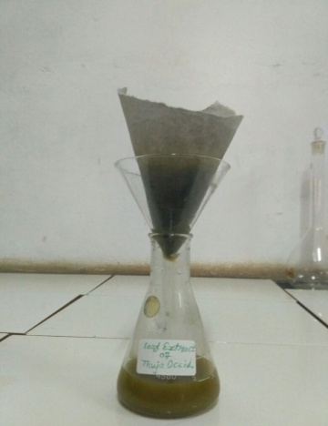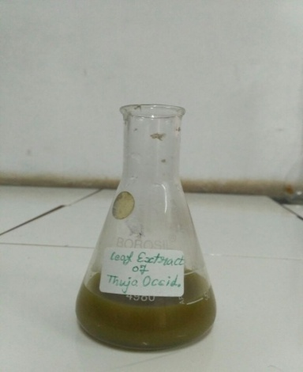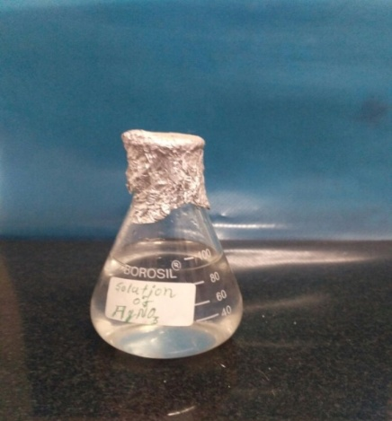
Fig-3.4 Filter of plant extract Fig-3.5 Leaf extract Fig-3.6 AgNO₃ Solution

Table- 3.2 Apparatus Required
S.No. | Apparatus | Make
1 | Round bottom flask | Borosil
2 | 250 ml Beaker | Borosil
3 | Measuring Cylinder | Borosil
4 | Conical Flask | Borosil
5 | 100ml Beaker | Borosil
6 | Glass rod | Borosil
7 | Test tube | Borosil
8 | Petri dish | Borosil
9 | Funnel | Borosil

3.2 Preparation of Thuja Occidentalis Plant Extract:
Fresh Thuja leaves were gathered from the Dr. Shakuntala Misra National Rehabilitation University, Lucknow Uttar Pradesh. After washing the leaves with distilled water, they were dried in an oven at 50°C for three hours. Once dried, the leaves were finely powdered using a mortar and pestle. Five grams of the powdered leaves were mixed with 100 ml of distilled water in a 250 ml conical flask and then heated to 60°C for 30 minutes. The resulting extract was filtered using Whatman filter paper and stored at -4°C in a refrigerator for future use.

3.3 Preparation of Silver Nitrate Solution:
To prepare a 0.1M stock solution of AgNO3 in chloride-free distilled water, 1.6 grams of AgNO3 was accurately weighed and transferred into a 100 ml volumetric flask. The flask was then filled with double-distilled water drop by drop, while continuously stirring until the salt dissolved and the solution reached the mark on the flask. The prepared solution was protected from light by wrapping the containers with carbon paper and stored in a dark place.

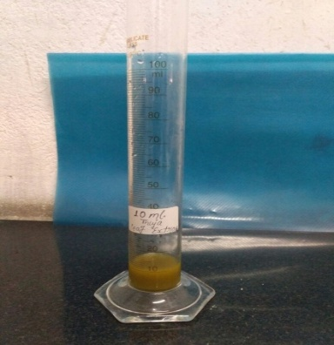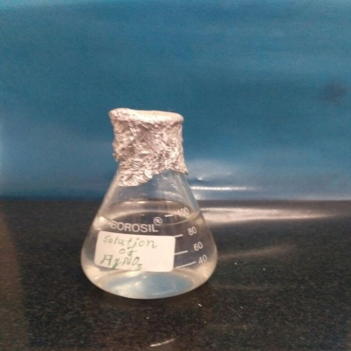
Fig-3.7 10 ml Leaf Extract Fig-3.8 100 ml ${AgNO}_{3}$ solution

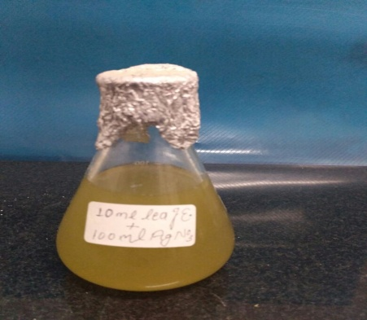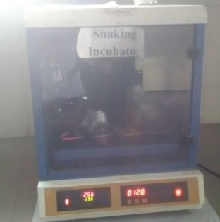
Fig-3.9 Leaf Extract+ ${AgNO}_{3}$sol. Fig-3.10 Solution in shaking incubator

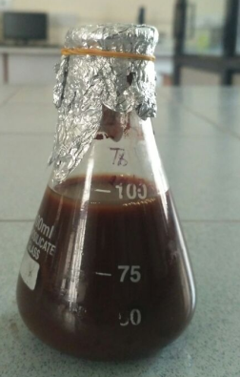
Fig-3.11 Solution after incubated

3.4 Green Synthesis of Silver Nanoparticles:
In a conical flask, 10 ml of leaf extract and 100 ml of AgNO3 solution were combined. The mixture was then placed in a shaking incubator. After 24 hours, the experimental sample (a combination of silver nitrate and leaf extract) changed to a light, dark-brown color, which indicated the successful formation of silver nanoparticles. To further purify the sample, it was centrifuged using a research centrifuge at 9000 rpm for 20 minutes at 0-4°C.
4. Results and Discussion:
The research titled 'Synthesis and Characterization of Silver Nanoparticles' focused on investigating the green synthesis of silver nanoparticles using plant extracts and studying the impact of various reaction conditions. The obtained results have been presented in the form of tables and figures, which are discussed in detail in this chapter.
4.1. UV-Vis Spectroscopy:
UV-Vis spectroscopy is used to determine the absorption of radiation by molecules, exciting electrons from lower to higher energy orbitals. The maximum absorption wavelength on the intensity versus wavelength graph provides valuable information. In the case of silver nanoparticles, the position and shape of the surface Plasmon band are dependent on the particles' size and shape. Larger particle sizes cause the absorption band to shift towards longer wavelengths. Typically, silver nanoparticles have absorbance within the range of 300 to 800 nm, with sizes of 20 to 30 nm showing greater absorbance between 420 and 460 nm.
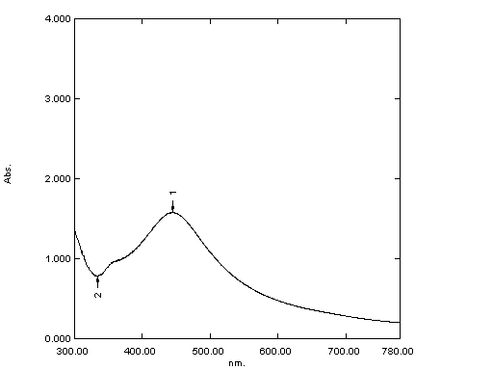
Fig- 4.1 UV-Vis Spectra of synthesized AgNPs of Thuja plant
4.2 Fourier Transform Infrared (FTIR) Analysis:
FTIR analysis was conducted to identify the biomolecules responsible for capping and stabilizing the synthesized metal nanoparticles efficiently. The FTIR spectrum of aqueous silver nanoparticles displayed distinctive transmittance peaks at specific wavenumbers: 3412 cm-1 (O-H stretching due to alcohol groups), 1384 cm-1 (-CH2 bending alkenes), 1121 cm-1 (C-O stretch alcohols), 610 cm-1 (C-H bend alkenes). Furthermore, the peak observed at 1631 cm-1 confirmed the successful formation of silver nanoparticles.
The results indicated that the synthesized nanoparticles were surrounded by proteins and metabolites, such as terpenoids, which possess functional groups. Analysis of the FTIR data revealed that the carbonyl groups from amino acid residues and proteins exhibited a strong ability to bind to the metal, suggesting that the proteins could act as capping agents for the silver nanoparticles. This capping action prevents agglomeration and ensures stabilization in the medium. Thus, the biological molecules play dual roles in the formation and stabilization of silver nanoparticles in the aqueous medium.
The presence of carbonyl groups indicated that flavanones or terpenoids may have been absorbed on the surface of the metal nanoparticles, possibly interacting through carbonyl groups or π-electrons in the absence of other strong ligating agents in sufficient concentration. Additionally, reducing sugars in the solution might have been responsible for the reduction of metal ions and the subsequent formation of the corresponding metal nanoparticles. Moreover, terpenoids could have contributed to the reduction of metal ions through the oxidation of aldehydic groups in the molecules, leading to the formation of carboxylic acids.
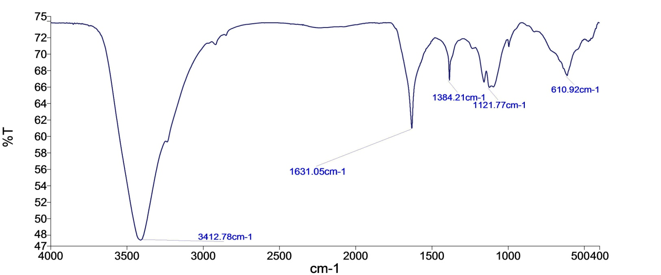
Fig- 4.2 FTIR Spectral representation of synthesized silver Nanoparticles
4.3 Scanning Electron Microscopy (SEM) Analysis:
Scanning Electron Microscopy (SEM) was employed to investigate the morphological characteristics, shape, size, and surface of the silver nanoparticles. As shown in Figures 4.3 and 4.4, SEM images depicted the silver nanoparticles synthesized from the leaf extract of Thuja occidentalis. The SEM analysis revealed that the silver nanoparticles exhibited an average size of approximately 54 nm, displaying distinct spherical and uniform shapes.
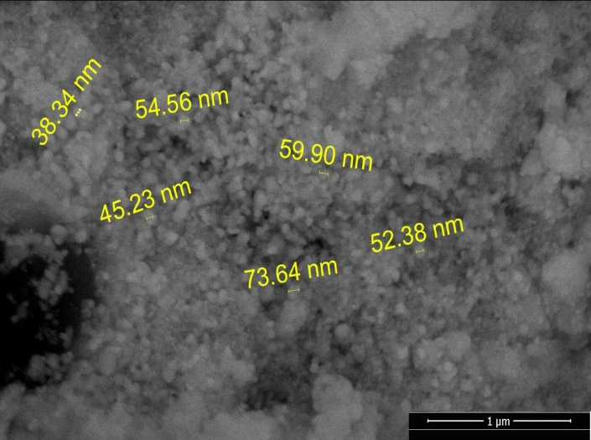
Fig-4.3 SEM Image of synthesized silver Nanoparticles
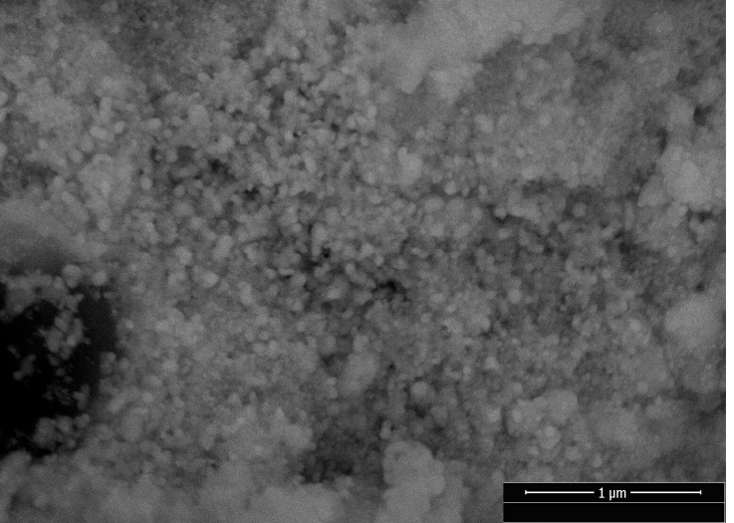
Fig-4.4 SEM image of synthesized silver Nanoparticles
4.4 Energy Dispersive X-Ray (EDX) Analysis:
Energy Dispersive X-Ray Analysis (EDX), also known as EDS or EDAX, is an x-ray technique utilized for identifying the elemental composition of materials. EDX systems are integrated into Electron Microscopy instruments, such as Scanning Electron Microscopy (SEM) or Transmission Electron Microscopy (TEM), where the microscope's imaging capability focuses on the specimen of interest. Through EDX analysis, spectra are generated, showing peaks that correspond to the elements present in the true composition of the sample being analyzed. The data obtained from EDX analysis provides valuable insights into the elemental makeup of the material under investigation.

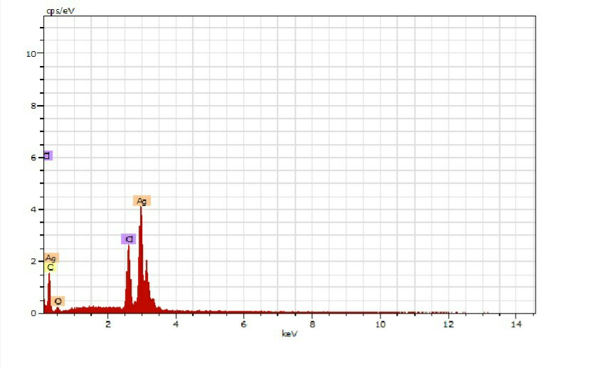
Fig- 4.5 EDX spectra of synthesized silver Nanoparticles
The data obtained from Energy Dispersive X-Ray (EDX) analysis reveals the elemental composition of silver nanoparticles, as well as the presence of oxygen, carbon, and chlorine, which provide insights into the metallic structure of the nanoparticles.
4.5 X-Ray Diffraction (XRD) Analysis:
X-Ray Diffraction (XRD) was employed to analyze the crystal structure and phase composition of the synthesized silver nanoparticles, as illustrated in Figure 4.6. XRD is a primary characterization tool widely used in nanoparticle research to obtain crucial information such as crystal structure, crystallite size, and strain. In the case of Nano-crystalline materials, the diffraction peaks appear broadened due to the randomly oriented crystals. This broadening is attributed to the absence of total constructive and destructive interferences of X-rays in a finite-sized lattice. Additionally, inhomogeneous lattice strain and structural faults can contribute to peak broadening in the diffraction patterns. For this study, X-ray diffraction spectra were obtained using a Bruker D8-Advance diffractometer equipped with a monochromatic Cu Kα1 radiation source (λ = 1.54056 Å).

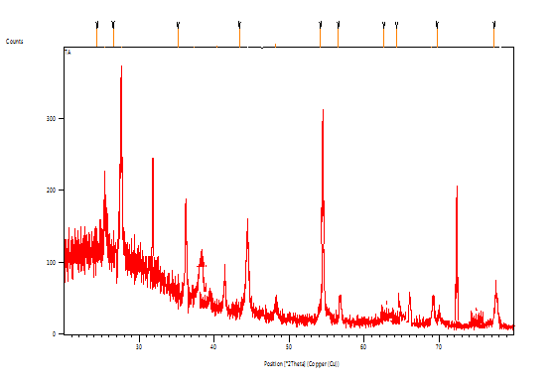
Fig- 4.6 XRD Spectra of synthesized silver Nanoparticles
The XRD analysis of the prepared nanoparticles was conducted using a PANalytical X’Pert Pro Software. The XRD pattern indicates that the synthesized nanoparticles consist of a mixture of metallic silver. The silver nanoparticles were obtained through a green synthesis method. The broadening of the X-ray diffraction lines observed in the figure is a clear indication of the nanoscale nature of the sample.
The XRD pattern displayed in the figure confirms the formation of silver nanoparticles with a face-centered cubic structure (JCPDS 036-0664 & 08-01268). The diffraction data reveals characteristic peaks at 37.23º, 44.44º, 64.58º, and 77.58º, corresponding to the crystal planes (111), (200), (220), and (311), respectively. These distinct peaks further support the successful synthesis of silver nanoparticles with specific crystallographic orientations.
5. Conclusion:
Within the gift take a look at, AgNps have been biosynthesized by the usage of Thuja Occidentalis plant extract and it turned into showed by preliminary shade alternate from pale yellow to brown. UV-VIS spectra of Ag nanoparticles were determined at 444nm. The bond analysis was achieved by means of the use of FTIR spectrum. FTIR spectra of AgNps confirmed the presence of the IR peaks band at round 3415cm-1, 1384cm-1, 1631cm-1, 1114cm-1 and 621cm-1. The characteristics of the received Ag-NPs have been studied the use of FTIR, XRD, UV-seen, SEM and EDX strategies.
6. Future Guidelines:
The suggestions for future work can include numerous topics as from instruction of the steel doped nanoparticles to diverse packages. The use of exclusive forms of capping and lowering retailers, shape, size and morphology of silver nanoparticles can be controlled. Improvement of a stepped forward separation/purification procedure of the synthesized nanoparticles to boom the yield, whilst lowering the amount of solvent waste generated from washing. To save you the silver nanoparticles from oxidation an inert gas environment want to evolve for acquiring favored natural metal nanoparticles. Based totally on this have a look at, some other nano powder that may be prepared in future.
7. Conflicts of Authors:
There is no any kind of author conflicts.
8. Acknowledgment:
Mr. Vikas Chaubey, Dr. Aakash Singh and Dr. Atul Kumar are grateful for the cooperation provided by research laboratory, IET, Dr. Shakuntala misra national Rehabilitation University, Lucknow, Uttar Pradesh and Dr. Shailendra Sinha thanks to Institute of Engineering and Technology, Lucknow, Uttar Pradesh for providing all valuable resources in this work.

References:
- Colvin, V.L.S., M.C. & Alivisatos, A., "mild emitting diodes made from cadmium selenide nanocrystals and a semiconducting polymer.". Nature, 1994. 370: p. 354-357.
- Wang Y.H.N., "Nanometer-sized semiconductor clusters: materials synthesis, quantum size consequences, and photophysical properties.". J Phys Chem, 1991. Ninety five: p. 525-532.
- Atul. R. Ingole, S.R.T., N.T. Khati, Atul V. Wankhade, D. Okay. Burghate "green synthesis of selenium nanoparticles under ambient condition.". Chalcogenide Letters, 2010. 7: p. 485-489.
- Harekrishna Bar, D.Okay.B., Gobinda sahoo P, priyanka Sarkar, Sankar PD., "green synthesis of silvernanoparticles the use of latex of Jatropha curcas.". Colliod surface A, 2009. 39(3): p. 134-139.
- Cassandra D, N.N., Jodi H, Linfeng G, Tan, Li, et al. , "inexperienced synthesis of gold and silver nanoparticles from plant extracts.".
- Kaviya S, S.J., Viswanathan B., "inexperienced Synthesis of silver nanoparticles the use of Polyalthia longifolia Leaf extract together with D-Sorbitol.". Magazine of nanotechnology, 2011: p. 1-five.
- Catauro M, R.M., De Gaaetano FD, Marotta A, "Sol–gel processing of drug shipping substances and launch kinetics.". J Mater Sci Mater Med, 2005. 16(three): p. 261-265.
- Crabtree JH, B.R., Siddiqi Ra, Huen IT, Handott LL, Fishman A, "The efficacy of silver-ion implanted catheters in reducing peritoneal dialysis-related infections.". Perit Dial Int, 2003. 23(four): p. 368-374.
- Krolikowska A, ok.A., Michota A, Bukowska J, "SERS research at the shape of thioglycolic acid monolayers on silver and gold.". Surf Sci, 2003. 532: p. 227-232.
- Zhao G, S.J., "a couple of parameters for the comprehensiveevaluation of the susceptibility of Escherichia coli to the silver ion.". Biometals, 1998. 11: p. 27.
- Jiang H, M.S., Wong ACL, Denes FS, "Plasma more advantageous deposition of silver nanoparticles onto polymer and metal surfaces for the generation of antimicrobial characteristics.". J Appl Polym Sci, 2004. Ninety three: p. 1411-1422.
- Duran N, M.P., Alves OL, De Souza GIH, Esposito E, "Mechanistic components of biosynthesis of silver nanoparticles by way of numerous Fusarium oxysporum strains.". J Nanobiotechnol, 2005. Three: p. 8-14.
- RO, B., "Silver ions inside the treatment of neighborhood infections.". Met based capsules, 1999. 6: p. 297-300.
- Klaus T, J.R., Olsson E, Granqvist C-G, "Silverbased crystalline nanoparticles, microbially fabricated.". Proc Natl Acad Sci usa, 1999. Ninety six: p. 13611-13614.
- Garima Singhal , R.B., Kunal Kasariya , Ashish Ranjan Sharma , Rajendra pal Singh, "Biosynthesis of silver nanoparticles the usage of Ocimum sanctum (Tulsi) leaf extract and screening its antimicrobial hobby.". J Nanopart Res, 2011. Thirteen: p. 2981-2988.
- Mukherjee P, A.A., Mandal DS, Senapati S, Sainkar R, Khan MI, Parishcha R, Ajaykumar PV, Alam M, Kumar R, Sastry M, "Fungus-mediated synthesis of silver nanoparticles and their immobilization within the mycelial matrix: a singular organic method to nanoparticle synthesis.". Nano Lett, 2001. 1: p. 515-519.
- Spring H, S.Okay., "diversity of magnetotactic bacteria.". Syst Appl Microbiol, 1995. 18(2): p. 147-153.
- Sastry M, A.A., Islam NI, Kumar R., "Biosynthesis of metal nanoparticles the use of fungi and actinomycetes.". Modern-day Sc., 2003. Eighty five(2): p. 162-a hundred and seventy.
- Sastry M, A.A., Khan MI, Kumar R., "Microbial nanoparticle manufacturing in Nanobiotechnology.". Nanobiotechnology, 2003. 85(2): p. 163-169.
- Nelson D, P.D., Oswaldo la, Gabriel IHDS, Elisa E., "Mechanical components of biosynthesis of silver nanoparticles with the aid of several Fusarium oxysporum lines.". Journal of Nanobiotechnology, 2005. Three: p. 8.
- Hemanth NKS, k.G., Karthik L, Bhaskara RKV., "Extracellular biosynthesis of silver nanoparticles the usage of the filamentous fungus Penicillium sp.". Arch Appl Sci Res, 2010. 2(6): p. 161-167.
- Natarajan okay, S.S., Ramchandra M., "Microbial manufacturing of silver nanoparticles.". Dig J Nanomat Bios, 2010. 5(1): p. One hundred thirty five-140.
- Elumalai EK, P.T., Hemachandran J, Vivivan Therasa S, Thirumalai T, David E., "Extracellular synthesis of silver nanoparticles the use of leaves of Euphorbia hirta and their antibacterial activities.". J Phram Sci, 2010. 2(nine): p. 549-554.
- Ankamwar B, D.C., Ahmad A, Sastry M., "Biosynthesis of gold and silver nanoparticles the usage of Emblics Officinalis Fruit extract and their section switch and Transmetallation in an natural solution.". J nanosci nanotechnol, 2005. 5(10): p. 1665-1671.
- Kasthuri J, k.Okay., Rajendran N., "Phyllanthin assisted biosynthesis of silver and gold nanoarticles a unique biological method.". J Nanopart Res, 2009. 11: p. 1075-1085.
- Vijayaraghavan okay, k.N.S., Udaya Prakash N, Madhankumar D., "Biomimetic synthesis of silver nanoparticles via aqueous extract of Syzygium aromaticum.". Colloids Surf B Biointerfaces, 2012. 75: p. 33-35.
- Amarendra DD, k.G., "Biosynthesis of silver and gold nonoparticles using Chenopodium album leaf extract.". Colloid floor A, 2010. 369(3): p. 27-33.
- Guidelli EJ, R.M., Zaniquelli D, Baffa O., "green synthesis of colloidal silver nanoparticles the usage of herbal rubber latex extracted from Hevea brasiliensis.". Mol Biomol Spectrosc, 2011. Eighty two(1): p. A hundred and forty-145.
- Tiwari D ok, Behari J and Sen P 2008 application of Nanoparticles in Waste Water treatment 3417–33.
- Salavati-niasari M, Davar F and Mir N 2008 Synthesis and characterization of metallic copper nanoparticles thru thermal decomposition Polyhedron 27 3514–8.
- Tai C Y, Tai C, Chang M and Liu H 2007 Synthesis of Magnesium Hydroxide and OxideNanoparticles using a Spinning Disk Reactor 5536–forty one.

- Bhaviripudi S, Mile E, Iii S A S, Zare A T, Dresselhaus M S, Belcher A M and Kong J 2007CVD Synthesis of single-Walled Carbon Nanotubes from Gold Nanoparticle Catalysts 1516–7.
- Ramesh S 2013 Sol-Gel Synthesis and Characterization of 2013.
- Mann S, Burkett S L, Davis S A, Fowler C E, Mendelson N H, Sims S D, Walsh D and Whilton N T 1997 Sol - Gel Synthesis of organized depend 4756 2300–10.
- Mohammadi S, Harvey A and Boodhoo k V okay 2014 Synthesis of TiO 2 nanoparticles in aspinning disc reactor Chem. Eng. J. 258 171–eighty four.
- Seek H, Journals C, contact A, Iopscience M and cope with I P Nanoparticle Synthesis byIonizing supply gasoline in Chemical Vapor Deposition Nanoparticle Synthesis by way of IonizingSource gas in Chemical Vapor Deposition 77 four–7.
- Kammler B H okay, Mädler L and Pratsinis S E 2001 Flame Synthesis of Nanoparticles 24 583–96.
- Amato R D, Falconieri M, Gagliardi S, Popovici E, Serra E, Terranova G and Borsella E 2013 journal of Analytical and applied Pyrolysis Synthesis of ceramic nanoparticles by laserpyrolysis : From studies to programs J. Anal. Appl. Pyrolysis 104 461–9.
- Kuppusamy P, Yusoff M M and Govindan N 2014 Biosynthesis of metal nanoparticles using plant derivatives and their new avenues in pharmacological programs - An up to date document SAUDI Pharm. J.
- Yadav T P, Yadav R M and Singh D P 2012 Mechanical Milling : a pinnacle Down technique for the Synthesis of Nanomaterials and Nanocomposites 2 22–48.
- Pimpin A and Srituravanich W overview on Micro- and Nanolithography techniques and theirApplications 16 37–fifty five.
- Hulteen J C, Treichel D A, Smith M T, Duval M L, Jensen T R and Duyne R P Van 1999Nanosphere Lithography : size-Tunable Silver Nanoparticle and floor Cluster Arrays 3854–sixty three.
- Amendola V and Meneghetti M 2009 Laser ablation synthesis in answer and length manipulation of noble metal nanoparticles 3805–21.
- Shah P and Gavrin A Ã 2006 Synthesis of nanoparticles the usage of high-stress sputtering formagnetic domain imaging 301 118–23.
- Lugscheider E, Bärwulf S, Barimani C, Riester M and Hilgers H 1998 Magnetron-sputteredhard material coatings on thermoplastic polymers for clean room packages Surf. CoatingsTechnol. 108-109 398–402.
- M Ramya, M.S.S., "inexperienced Synthesis of Silver Nanoparticles". Int. J. Pharm. Med. & Bio. Sc., 2012. 1.
- J, D.P.L.A.H.K., “publicity-associated health results of Silver and Silver Compounds: A assessment”. Ann Occup Hyg., 2005. 49: p. 575-585.
- C, F.A.A.S.M., “inaction of two Noble Metals as cancer causing agents”. J. Environ Patho. Toxicol, 1978. 1: p. Fifty one-57.

- Chen X , S.H.J., “Nanosilver: A Nanoproduct in scientific applications”. Toxicol Lett. , 2008. 176: p. 1-12.
- K, Prasad, k, Kulkarni, AR, "Plant gadget: nature's nanofactory". Colloids Surf. B Biointerfaces, 2009. Seventy three: p. 219-223.
- Parasharu k, S.A.S.A., “Bioinspired Synthesis of Silver Nanoparticles”. Digest journal of Nanomaterials and Biostructures, 2009. 4: p. 159-166. (b). Begum N A, M.S.A.B.L.R.A., “Mondal Colloids and floor B”. Biointerfaces, 2009. 71: p. 113-118.
- (a) D. Bhardwaj, A. Singh, R. Singh, Eco-compatible sonochemical synthesis of 8-aryl-7,8-dihydro- [1,3]- dioxolo[4,5-g] quinolin-6(5H)-ones using green TiO2. Heliyon, vol. 5, no. 2, 1256-62, 2019. (b) S. Munjal, A. Singh, Facile and Green Synthesis of Iron and Silver supported Iron Nanoparticles from Novel Plant Extract of Aegle marmelos: Anti-bacterial and Anti-fungal Activity, Journal of Drug Delivery and Therapeutics, vol 9, no(3-s), 334-341, 2019. (c) S. Bhatt, A. Singh, S. Munjal and P. Kumar Poonia, Plant mediated bio synthesis of silver nanoparticles: Characterization and antimicrobial activity. Int. J. Chem. Stud.,vol 6, no 6, 2163-2167, 2018. (d) S. Munjal, P. Srivastava, A. Singh, P. Jyani, P. S. Gour, Synthesis And Bio-Physical Characterization Of Mg Doped Zn Nanoparticles From Novel Plant , IJIRG, vol 9, no 3, 13-20, 2020. (e) R. Singh, S. A. Ganaie, A. Singh, A. Chaudhary, Carbon-SO₃H catalyzed expedient synthesis of new spiro-[indeno[1,2 b]quinoxaline-[11,2′]-thiazolidine]-4′-ones as biologically important scaffold, Synth. Commun. 2019, 49, 80–93. (f) R. Singh, A. Singh and D. Bhardwaj, Selective and Solvent‐Free Synthesis of Isoxazole‐Containing Spiro Thiazolidinones Using TiO₂‐SO₃H as Solid Catalyst Chemistry Select, 2019, 4, 9600–9607.
- J, C.X.A.S.H., “Nanosilver: A Nanoproduct in medical packages”. Toxicol Lett., 2008. 176: p. 1-12.
- C, L., "Proteomic analysis of the mode of antibacterial movement of silver nanoparticles". J Proteome Res, 2006. Five: p. 916-924. Nanoparticles via thermal decomposition Polyhedron 27 3514–eight.

