AGRICULTURE REVOLUTION 4.0 - WAY FORWARD
K. Mounika¹, D. Rafi¹, Sangappa¹
¹ICAR-IIMR, Hyderabad
Ph: 9440990801, email: kosgimounika08@gmail.com

Abstract:
First Agriculture revolution promoted advent of using new tools in Farm, the second revolution made the growth of crop production and yield by using mechanised tools and the third revolution or the Green Revolution was for developing genetically modified crops. Agriculture Revolution 4.0 involves the application of various technologies such as the Internet, artificial intelligence, robotics, drones, big data analytics, and precision agriculture. These technologies enable farmers to collect and analyse real-time data, make data-driven decisions, and optimize their farming practices.
Keywords: Green revolution, Agriculture revolution, artificial intelligence, precision agriculture
Introduction:
An agricultural revolution is the period where the farming techniques improved which leads to a greater production of food and made human allow to work on other types. The First Agriculture revolution promoted using farming tools. The second revolution promoted the use of mechanised tools in farming practices, increasing the rate of production as well as the quantity of crop yield. The Green Revolution which is the third Agriculture Revolution where the genetically modified crops were widely used and lead to the maximization and expansion of crop produce.. The future of the agricultural industry has never looked brighter, or more profitable, especially in farming operations. With a worldwide focus on Agriculture 4.0, which aims to grow precision farming and tech advancements within the agricultural sector at a mass scale, farming operations are not only becoming more profitable but also productive.
Agriculture 4.0, also known as the fourth agricultural revolution, differs from precision farming in that it adopts technology in all aspects of farming, from crop yields to harvesting to logistics and transportation. The main focus of Agriculture 4.0 is to increase technology adoption rates in farming, driving effective and efficient change, that increases productivity in a sustainable and eco-friendly way. It also focuses on using robotics and artificial intelligence (AI), Internet of Things,, vertical farms, drones, and solar energy in farming practices. This adoption ultimately leads to increased crop yields, cost and manual labour reductions, along with reducing the wastage of water, pesticides and fertilizer.
The Fourth Agriculture Revolution brings out a new path for the use of the scientific technologies in agriculture and production where it uses Artificial Intelligence,, block chain and the Internet of Things to the agriculture for higher production and high yields at lower costs and minimal environmental harm.These all made the new innovations in palnts and agriculture which tolerate to any other climate changes. Techniques like land enclosure, field drainage, selective breeding, trailed metal cultivations replacing wooden tillage, and nitrogen supplementation provided food for a human population which is increasing. The mechanization and rationalization of agriculture was a key factor of the Agricultural Revolution.
Fourth agricultural revolution is a related with more and more technologies, in media and policy documents.So that the benefits of productivity was prioritised with less interventions of social consequences but the impacts were presented positively. Farmers and advisers experienced many benefits of technologies and some predicted higher-tech futures. Every country is following the food system, in which the typology differs with the community and region changes mainly there are five categories of the food system These types are mutually exclusive and changes on time. The countries included in the typology represent 97% of the global population, 93% of global land area, and 97% of global GDP.
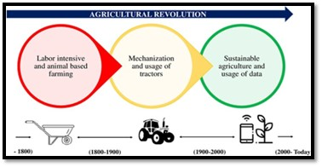
Figure: 1 Overview of Agriculture Revolution
Agriculture Revolution which itself can be say as the phase where we can grow the crops and sold it in the market locally, which includes all the aspects of the farming and in marketing .
This phase will make a darstic change where the innovations made will be the future of agriculture for its growth as well in the economic sectors.
Improved wages, migration of people from rural to urban, New technologies, more factories, employment and more changes will going to be happen in the fourth Agriculture Revolution.
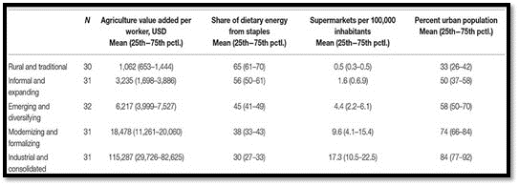
Figure:2 Food System Types across the country’s

What Is Agribusiness?
There were many changes happened during and after the Globalisation in which it effected the agriculture sector and changed from the subsistence one to sustainable one.Those all changes made the agriculture sector from traditionally farming to modern farming which made a great growth in Agricuture.Globalisation of agribusiness made a high competition, fast technological changes, mobility of capital and rapid dissolving of barriers in the international trading of goods and services. All these demand for increasing professionalism in the management of agriculture and allied activities. Agribusiness managemnet which made the interested agribusiness entrepreneurs to work on and develop their cognitive skills for the institutional and individual basis.. Agribusiness men are making better strategies and managerial techniques for value added agriculture to improve its quality and quantity. The global character of perfectly competitive market demands,generalised products, need of input supply to output marketing., broadening the view of agriculture including farming activities.From the perspective of globalization, identifying main areas which need specialized mechanization techniques and exploring the prospects of agribusiness , and examining the challenges of agribusiness in the present globalization scenario and suggesting the measures to improve the effectiveness of agribusiness and in the change of the global means . It includes all the steps required to send an agricultural goods to market and in production, processing, and distribution. The agriculture industry in India also includes animal husbandry horticulture, sericulture, and also many other subsectors related to the agriculture and cultivation.
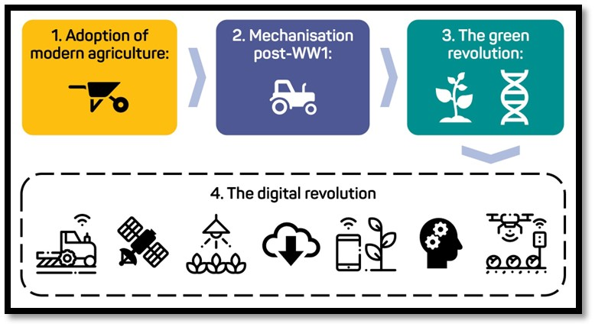
Figure: 3 Evolution of Digital Agriculture Revolution
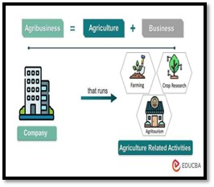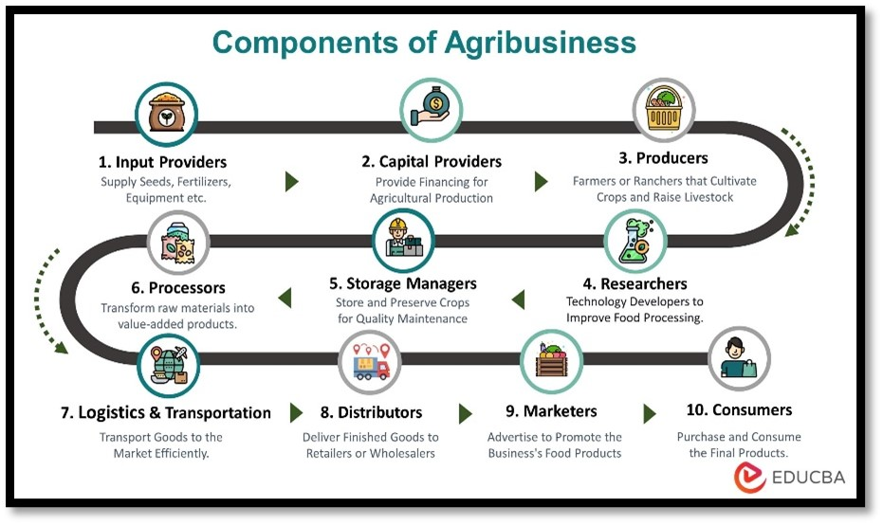
Figure: 4 Components of Agribusiness

Suggestive measures:-
Addressing the socio-economic imbalances particularly at the base level.Avaialability of the modern and effective technologies and reducing the bureaucracy in government procedures more transparent and Good governance in agribusiness is needed to meet the crises and challenges, It will ensure the development of infrastructure to improve standard of living and help in growth of economic performance and Empowerment and equity in the agricultural sector.
The Objects of Surge in Agri Business:-
- Growing Population: The global population continues to increase, leading to a greater demand for food and agricultural products. Agribusinesses have capitalized on this demand by expanding production and finding innovative ways to meet the needs of the larger population.
- Increasing Urbanization: Urbanization has led to a shift in consumer preferences and lifestyles. As more people move to cities, there is a greater demand for convenience and ready-to-eat food products. Agribusinesses have responded by developing technologies and practices that enable efficient production and distribution of processed and packaged foods.
- Technological Advancements: The advancements in agricultural technology have revolutionized the industry and made it more attractive for entrepreneurs. Precision farming techniques, automation, remote sensing, and data analytics have increased productivity, reduced costs, and improved overall efficiency in agribusiness operations.
- Rising Awareness of Health and Sustainability: Consumers are increasingly concerned about their health and the environmental impact of food production. This has led to a growing demand for organic, natural, and sustainably produced agricultural products. Agribusinesses that focus on producing high-quality, environmentally friendly food have gained popularity and market share.
- Government Support and Policies: Many governments around the world have recognized the importance of agriculture and have implemented policies to support and promote agribusiness. These policies may include financial incentives, subsidies, infrastructure development, and research and development support, all of which contribute to the growth of the sector.
- Market Opportunities: Agribusinesses have identified and tapped into various market opportunities. These include niche markets for specialized products such as organic, locally sourced, or ethically produced food, as well as international markets where agricultural products from one region are in high demand in another.
- Changing Consumer Preferences: Consumer preferences and tastes have evolved over time. There is an increasing demand for diverse and exotic food products, as well as convenience foods that cater to busy lifestyles. Agribusinesses have adapted to these changing preferences by diversifying their product offerings and introducing new varieties and Flavours.
- These factors, among others, have contributed to the surge in agribusiness and have created opportunities for entrepreneurs and investors in the agricultural sector.
With the consistent rise of Economic platforms created an opportunity for agriculture entrepreneurs to start their own farms with the help of advising persons for development and growth in their business. The growth in the population has increased the demand for food produce Start-up’s with the innovative idea of agri business related which are included many small businesses.Production resources, which include inputs to agriculture field and the Agricultural commodities like produce and Food items. Facilitative services like insurance, marketing, credit, processing, storage, packaging, transportation. So that starting an agricultural business also needs systematic planning and ability to make strategies in order to achieve the goal. These factors, among others, have contributed to the surge in agribusiness and have created opportunities for entrepreneurs and investors in the agricultural sector.
References:
- Asveld, L., Ganzevles, J., and Osseweijer, P. (2015). Trustworthiness and responsible research and innovation: the case of the bio-economy. J. Agric. Environ. Ethics 28, 571–588. doi: 10.1007/s10806-015-9542-2
- Bear, C., and Holloway, L. (2015). Country life: agricultural technologies and the emergence of new rural subjectivities. Geogr. Compass 9, 303–315. doi: 10.1111/gec3.12217
- Blok, V., Scholten, V., and Long, T. B. (2018). Responsible innovation in industry and the importance of customer orientation: introduction to the special issue. IFAMA 21, 455–461. doi: 10.22434/IFAMR2018.x001
- Bronson, K. (2018). Smart farming: including rights holders for responsible agricultural innovation. Tech. Innov. Manage. Rev. 8, 7–14. doi: 10.22215/timreview/1135
- Burall, S. (2018). Rethink public engagement for gene editing. Nature 555, 438–439. doi: 10.1038/d41586-018-03269-3
- Carbonell, I. (2016). The ethics of big data in big agriculture. Int. Policy Rev. 5, 1–13. doi: 10.14763/2016.1.405

