IoT for Agritech

Authors:
Ms. Taruna Singh
Assistant Professor,
tarunasingh@dtu.ac.in
Department of Design,
Delhi Technological University

Mr. Reetesh Varsney
IoT specialist Sr solution Architect,
reetesh@amazon.com
Amazon Web Services

Ms. Awani Sankritya
Research Scholar,
Sanawani905@gmail.com
Department of Design
Delhi Technological University

Ms. Shraddha Pundir
Research Scholar,
chadhashraddha@gmail.com
Department of Design
Delhi Technological University

1 Introduction................................................................................ 04
2 Internets of Things [IoT]. . . . . . . . . . . . . . . . . . . . . . . . . . . . . . . 05
2.1 IoT Timeline . . . . . . . . . . . . . . . . . . . . . . . . . . . . . . . . . . . . . 07
2.2 Aspects of IoT………………………………………………… 08
3 Agritech..................................................................................... 10
3.1 IoT for Agriculture (Agritech)................................................ 12
3.2 Why it is important.................................................................. 13
3.3 Benefits of Agritech................................................................. 15
3.4 How will it work ...................................................................... 16
3.5 Possible limitations and future scope………………………….. 18
4 Conclusion .. . . . . . . . . . . . . . . . . . . . . . . . . . . . . . . . . . . . . . . . .. 20
5 References . . . . . . . . . . . . . . . . . . . . . . . . . . . . . . . . . . . . . . . . . . 20

ABSTRACT
Due to the widespread use of new digital technologies, virtually every sector of the economy, including agriculture, is now affected by digital transformation. Farming and how farmers operate are changing as a result of the rising usage of the Internet of Things (IoT) and information and communications technology (ICT). This concept is known as Agritech. Smart data may be utilised for seed characteristics and to cure soil conditions, and using new technology can provide conveniences never before possible while also enhancing the management and standard of agricultural production. The agriculture sector will increasingly rely on modern information systems and services to maintain and boost productivity, competitiveness, and profitability. However, widespread usage of technology has certain unavoidable drawbacks. This chapter talks about IoT and how IoT can be useful for the farmers to sustain ever changing conditions around them using Agritech.

- INTRODUCTION
Our physical and digital worlds are now intertwined in ways that were previously unthinkable recognition to the Internet of Things, or IoT as it is commonly known. It includes a wide network of linked gadgets, things, and sensors that converse and exchange information online, improving functionality, convenience, and efficiency in a variety of fields and areas of everyone’s everyday life.
IoT is fundamentally an intricate ecosystem of gadgets with connection and sensors that can gather and distribute data on their own. Simple domestic items like thermostats, refrigerators, and smart lights can be included in this category, as well as more complex ones like industrial machinery, automobiles, and complete smart cities. These devices produce data, which is transmitted to the cloud where it may be processed, analysed, and used to automate decisions and make intelligent ones.
IoT's potential is apparently endless as it develops further. Reduced latency and real-time decision-making without primarily depending on cloud computing will be made possible by advancements in edge computing, where data processing takes place closer to the source. With greater data transfer speeds and lower latency offered by 5G networks, IoT applications will become even more responsive and effective. Additionally, IoT and AI integration will provide more advanced, context-aware systems. In order to enable predictive and adaptive behaviour in different IoT devices and applications, AI algorithms will be able to learn from IoT data.
Our world is being transformed in previously unimaginable ways by the Internet of Things. IoT has the ability to usher in a more connected, intelligent, and effective future by revolutionising industries and improving people's quality of life. To utilize a powerful tool like IoT we can solve a lot of grass root level problems like uncertain and unpredictable weather conditions, farming issues, increasing pollution etc. One of such problems that have been catered by IoT is called Agritech. Agritech helps farmers to get better connectivity and affluent future for future generations by sensibly adopting and expanding IoT technology.
For millennia, agriculture has been a key component of human civilization, providing nourishment and economic success. O. Friha et al., 2021 talks about developing technologies for smart agriculture based on the internet of things. Aerial vehicles, wireless technologies, open-source IoT platforms, SDN and NFV technologies, cloud and fog computing, and middleware platforms were among the new technologies we listed for agricultural IoTs. However, the need for sustainable and effective agricultural practises has never been more pressing given the continued growth in the world's population and the extraordinary problems posed by climate change (A. R. de Araujo Zanella. Et al., 2020) fortunately, the fusion of agriculture and technology has created a new industry called agritech, which aspires to revolutionise the way we grow, manage, and distribute food. We shall examine the relevance of Agritech and its ability to influence the direction of agriculture in this article.
For thousands of years, agriculture has been a key component of human civilization, supplying food and fostering economic growth. But with the world's population still growing and climate change posing new problems, the need for sustainable and effective farming practises is more important than ever (J. Nikander. et. al., 2020). Fortunately, the fusion of agriculture and technology has produced Agritech, a ground-breaking industry that seeks to revolutionise how we grow, handle, and distribute food. Smart agriculture, which combines agriculture with information technology, is emerging as a trend in agricultural growth as a result of the quickly growing state of contemporary technology. (X. Yang et al., 2020). In this article, we'll examine the relevance of Agritech and how it could influence agriculture in the future. We shall examine the idea, importance, uses, and difficulties of the Internet of Things for agriculture in this chapter.

- INTERNET OF THINGS (IoT)
The Internet of Things (IoT) has the ability to greatly improve our living by bringing connection, efficiency, and convenience to a variety of facets of our lives. IoT is proving to be a beneficial part of in daily lifestyle. Talking about fe examples like Smart houses. IoT makes it possible to build smart houses with linked, remote-controllable equipment and appliances. For instance, smart lighting systems may be operated with voice commands or mobile applications, smart security systems can monitor and safeguard houses, and smart thermostats can alter temperature settings based on occupancy or weather conditions. Why just homes but: IoT can transform urban infrastructure, enhancing the effectiveness, sustainability, and liability of metropolitan areas. Various factors, including as traffic flow, energy consumption, trash management, and public safety, may be monitored and managed by connected sensors and equipment.
IoT devices may be quite helpful in assessing and enhancing individual health and fitness. Activity, heart rate, and sleep habits may all be tracked by fitness trackers and smart watches. The use of connected health devices can help with remote patient monitoring, allowing medical professionals to keep an eye on vital signs and make prompt treatments.
Environmental Monitoring: IoT sensors may be used to monitor environmental factors such as air pollution, water pollution, and weather. Making educated judgements and putting these facts into practise can help with environmental conservation (N. Etemadi et. Al., 2020). IoT devices may assist maximise energy use and advance sustainability through energy management. Real-time data on energy consumption may be provided via smart energy metres, allowing customers to track and optimise their usage. Energy expenditures can be decreased by scheduling connected appliances to run during off-peak times. By monitoring and managing numerous aspects including soil moisture, temperature, and crop health, IoT may play a significant role in precision agriculture. This enables farmers to make wise decisions based on real-time data, maximise resource use, and boost crop yields (A. Yazdinejad et al., 2021).
The Internet of Things (IoT) has the potential to revolutionise healthcare by providing real-time health tracking, remote patient monitoring, and personalised therapy. Using connected devices, healthcare providers may better diagnose patients, deliver more effective treatments, and provide better care overall.
Industry 4.0, often known as the fourth industrial revolution, is being driven by IoT. IoT offers intelligent automation, predictive maintenance, and optimised production processes by linking machines, sensors, and systems, which boosts productivity and efficiency in sectors including manufacturing, logistics, and energy. Further moving to Logistics and transportation by allowing linked cars, intelligent traffic control, and effective fleet operations, IoT may improve transportation systems. It may enhance supply chain visibility, cut down on gasoline use, and optimise logistical procedures.
IoT can offer personalised and engaging shopping experiences by using information from connected devices and beacons in the retail and customer experience sectors. It can boost consumer satisfaction overall, facilitate targeted marketing, and improve inventory management.
Privacy and security is another useful aspect of IoT, As it grows, protecting privacy and security will be essential (L. Barreto and A. Amaral, 2018). To reduce risks and preserve sensitive data, advancements in encryption, authentication, and data protection are necessary.
IoT will have a significant impact on a variety of industries and applications in the future. We can anticipate greater connection, smarter systems, and data-driven insights as technology continues to advance, which will alter industries and enhance our daily lives (K. Demestichas et al., 2020).

2.1 Time-line in IoT
IoT, is expanding exponentially with large number of new sensors and gadgets going both offline and online each month. The Internet of Things has been around for a while, but it has only lately begun to take off due to the availability of inexpensive, energy saving components, broad Internet access. Both the corporate and consumer sides are gaining a lot of curiosity about IoT. That explains why it could seem like you've been hearing about it a lot recently (Braun, 2023).
We use a wide range of technology, including intelligent thermostats, autonomous vehicles, clever toasters, and intelligent cities. But where did it all originate? How did it all start? Every-time we are having more connected devices than there are people on the earth now? While by no means thorough, the timeline below should give you a basic idea of where IoT has come from and where it is headed in the future. A timeline of IoT is depicted graphically in Figure 3.1 shows a graphical information about time-line of IoT.
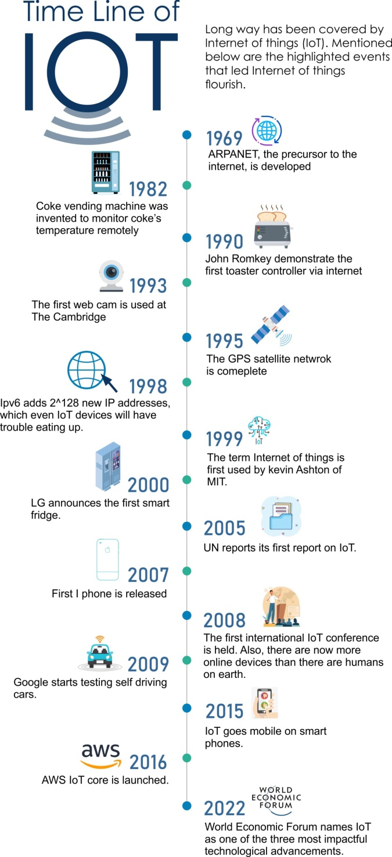

2.2 Aspects of IoT
The Internet of Things (IoT) is a network of physically interconnected objects, such as machines, vehicles, appliances, and other items, that include sensors, software, and networking capabilities. These devices collect and exchange data, enabling communication between them and with the wider digital world. These are some essential IoT components:
Various communication technologies: Including Wi-Fi, Bluetooth, cellular networks, and low-power wide-area networks (LPWAN), are used to link IoT devices. Devices can talk and work together because to this connection, which allows them to send and receive data.
Data and Sensors: IoT devices have sensors that collect data about their surroundings. These sensors can pick up on information such as location, motion, light, temperature, and humidity. Following processing and analysis, the obtained data is utilised to inspire actions or produce insights.
IoT enabling to automate and control systems and device: Users may command Internet of Things (IoT) devices, collect real-time data, and automate procedures through remote monitoring and administration. Smart thermostats, for instance, may modify temperature settings based on occupancy and environmental factors.
Data analytics and insights are made possible: By the enormous volume of data that IoT devices produce, it’s now possible to use advanced analytics methods, such as machine learning and artificial intelligence, to extract valuable insights from IoT data, facilitating better decision-making and optimisation.
Applications in Different sectors: IoT has numerous uses in various sectors. IoT, for instance, can enable supply chain management improvements, real-time equipment monitoring, and predictive maintenance in the manufacturing industry. IoT devices in healthcare may facilitate telemedicine, monitor patient vitals, and improve medical equipment management.
Security and privacy: As IoT devices spread; security and privacy issues take front stage. IoT devices may be subject to cyber-attacks, and the gathering and storing of personal data may provide data privacy problems. In IoT deployments, it's crucial to put strong security measures in place and adhere to privacy-by-design principles.
IoT systems need to be scalable in order to support a high number of devices and handle the expanding amount of data. To enable seamless communication and collaboration among multiple parties, interoperability is essential.

- AGRITECH
The use of technology and digital tools in agriculture is known as Agritech, often referred to as Agritech, digital agriculture, or Agritech. Automation, biotechnology, information monitoring, and data analysis are just a few of the many technologies that are included in it.
Agritech may be utilised to raise sustainability, lower costs, increase yields, and improve efficiency. Recent years have seen a rise in its importance as a result of rising food demand and an ever-present danger from climate change to food security. There are many issues faced by farmers on daily bases like shown in fig:

These are only a few of the issues that farmers encounter. All of the issues have solutions that are connected. Increased infrastructure spending, the purchase of fertilisers and manures, and the use of cutting-edge farming equipment are a few ways to bring agricultural yields and practises into the twenty-first century. All Agritech is utilised in forestry, aquaculture, and by winemakers for viticulture, while it is mostly employed in horticulture and agriculture. Let’s discuss few modern farming practises come to mind and how can IoT help in agriculture enhancement or Farming? Referring to fig:

Precise Montering: To monitor crop health and soil conditions, various internet of things (IoT) sensors are combined with satellite and drone pictures. These devices' data may be used to anticipate weather trends, improve watering schedules, and digitise pest treatment.
Automated machinery: A wide range of functions, including GPS navigation, automatic steering, and hydraulic attachments, are included in today's highly automated tractors. Tractors with autonomous systems operate more efficiently and need less labour from humans. Crop picking, monitoring, and planting are also done with the aid of robotic machinery. For instance, Iron Ox’s crop-assisting mobile robots can transport more than 1,000 pounds of product, utilise on-board laser scanning to navigate a grow space, and assess the health of individual plants.
Smart greenhouses: Intelligent greenhouses assist in establishing the closely regulated environment required for vertical farming, which saves space, extends the growing season, and yields greater crop yields in locations that would not otherwise be suited for plant growth. Crop confinement also contributes to the abolition of farmer-native species conflict.
Farm management: Systems for managing livestock employ sensors and other technological advancements to monitor the wellbeing of farm animals. Cows may set their own milking schedules thanks to automated milking devices, giving farmers greater freedom and enabling cows to maintain their own circadian cycles.
Supply chain Management: Agricultural supply chain management is centred on the effective fusion of food production and distribution network's producers, suppliers, distributors, and customers. Block chain, big data analysis, and machine learning are examples of supply chain technology that can assist farmers, growers, and manufacturers in following their food from field to table. Improved supply chain management results in more effective resource usage, less waste, more precise forecasting, and higher levels of customer satisfaction.
Biotechnology: By giving plants features that are advantageous for their growth and development, biotechnology has been utilised to boost crop yields. Crops that are more resistant to pests, drought, and other environmental stresses can be produced through genetic engineering. Marker-assisted selection, one of the new breeding techniques, can assist farmers in choosing plants with desired traits. For instance, plants can be genetically altered to yield more or have better nutritional qualities. It's also possible to design fertiliser. For instance, the Agritech business Azotic uses nitrogen-fixing bacteria instead of nitrogen fertilisers as a more ecologically friendly alternative.

3.1 IoT for Agritech
Even though the globe now produces enough food to feed everyone, 13% of people still go hungry, and 1/3 of the food we produce is wasted. Combine this with the forecasted population increase, which is expected to reach around 10 billion people by the year 2050, and our food resources are put under even more pressure. By that time, 70% more food must be produced, which is no easy task in and of itself, but when you include in the complexity of falling arable land, climate change, the loss of natural resources, and a dwindling workforce, you start to see the possibility of a food crisis.
About 58% of Indians rely mostly on agriculture for their livelihood. Due to its enormous potential for value addition, particularly within the food processing industry, the Indian food industry is set for huge expansion, increasing its contribution to the global food trade every year. One of the major sectors in India, food processing contributes 32% of the nation's total food market and is rated fifth in terms of production, consumption, export, and projected growth. The Government of India is launching a new AGRI-UDAAN initiative to mentor start-ups and help them connect with prospective investors in order to foster innovation and entrepreneurship in agriculture.
Due to increased investments in agricultural infrastructure, such as irrigation facilities, warehousing, and cold storage, the agriculture industry in India is anticipated to produce higher momentum in the next years. Additionally, the increased adoption of novel varieties and agricultural mechanisation would probably increase Indian farmers' yields. In the next several years, India is anticipated to produce enough pulses, oilseeds, maize, and other commodities to meet its own needs.
Our daily lifestyle has been greatly impacted and enhanced in numerous ways by The Internet of Things (IoT). Speaking about how IoT can be integrated into our daily lives: be it is a smart home or managing security & privacy, automation & controlling, connected entertainment, health and fitness monitoring etc. IoT may lead to a more intelligent lives, do various tasks more effectively. IoT is vital for business in addition to providing smart home automation devices. With the help of the Internet of Things, businesses can monitor the operation of their systems in real-time, gaining knowledge on anything from equipment performance to logistics and supply chain procedures. IoT helps businesses to automate processes and reduce staff costs. Additionally, it improves customer service, minimises waste, cuts production and transportation costs, and offers data on client interactions. The Internet of Things (IoT) will keep growing as one of the most important contemporary technologies as more businesses discover how connected gadgets may help them remain competitive.
Speaking of a developing country like India, which is facing several sustainable issues due to its large population, rapid economic growth, and diverse socio-economic conditions. We are still trying to balance environmental, social, and economic considerations to create a thriving and resilient society so that our future generation will not have to compromise to meet their basic needs.

3.2 Why it is important
IoT has always existed alongside IoT since it is a particular use of the technology, but in 2010, sensor prices fell to the point where they could be utilised widely. More than any other reason, this made IIoT possible since IoT needed a substantial number of devices to function. According to Statist, the following graph displays the average cost of industrial Internet of Things (IoT) sensors from 2004 to 2020. According to the 2023 "Feeding the Economy" study, Agritech is revolutionising the agriculture and farming sectors, which account for around 20% of U.S. economic activity.
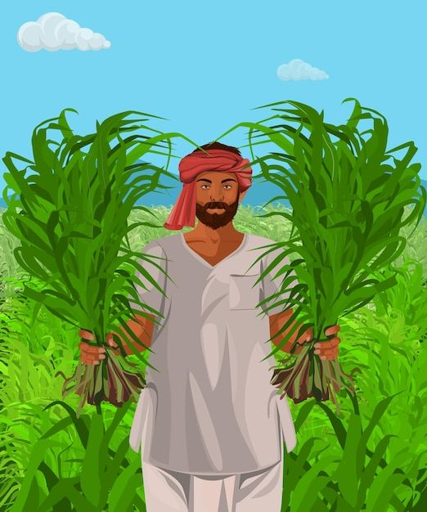
Fig: (Source freepik)
Agritech is used to investigate novel approaches to farming and to enhance current methods. It can leverage the data gathered from farming to enhance forecasts and automate the manual labour required for farming and agriculture. By examining vast volumes of crop production data, data analytics and machine learning are utilised to enhance decision-making in the agricultural sector. The field applications of the obtained insights are used to develop and improve automated procedures.
The environment benefits from efficient agricultural production because it enables farmers to adopt eco-friendly strategies that lower their carbon footprints and boost revenues. The UN's 2022 World Population Prospects predict that by 2050, there will be approximately 10 billion people on the planet, and Agritech can assist fulfil their food demands.
As we deal with a variety of issues, such as the downward pressure brought on by climate change, the availability of water and energy, and pests and illnesses, Technology and science are now more important than ever. as a result, technology the fields of precision agriculture. Our food supply must be improved genetically at a faster rate than the perceived current scenario.

  - Benefits of Agritech

Every interaction in agriculture will first need IoT data. The information needed to get insights for agricultural operations is all available through IoT networks. As a result, sensor data is the cornerstone of an agronomic data lake and the beginning of every Agritech clients' digital journey. The production of food is being revolutionised by Agritech, which offers farmers a number of advantages and benefits, such as the following:

Increased productivity and efficiency in agricultural activities: Tools that are automated use fewer resources. For instance, automated irrigation systems decrease water waste by precisely managing and conserving water by monitoring soil moisture levels using smart sensors.

Enhanced data gathering and analysis: These tools enable improved decision-making and direct farmers towards operational improvement opportunities. Because farmers can properly anticipate yield outcomes in advance or spot early indicators of stress in crops before it's too late to take action, this also helps them become more robust in the face of climate change.
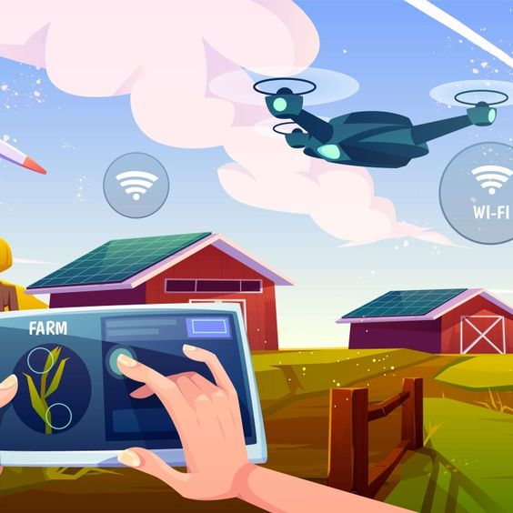
Fig: (Source equinoxsdrones.com)
Reduced labour cost and improved working condition: Automated farm machinery increases operational efficiency for farmers by reducing the amount of manual labour required for a farm's operation.

Precision farming with sustainable approach: In addition to increasing yields, precision farming techniques also minimise negative environmental consequences such pesticide runoff into rivers or groundwater sources or emissions from agricultural equipment. Farmers may avoid blanket-spraying entire fields with fertiliser by correctly mapping fields down to the individual plants using technology like satellite imaging and remote sensor data. As a result, throughout the growing season, less fertiliser is lost to runoff and leaching into rivers.

Increased supply chain awareness and fairness: By offering real-time visibility into production processes from the farm till distribution at retail stores or restaurants, agri-tech increases transparency in the food chain. Producers can more effectively satisfy consumer requests when they are transparent, and it also improves food traceability in case there are problems during transport or storage. Additionally, it ensures that customers receive correct information about the origin of their food so they may make knowledgeable purchasing decisions on sustainability issues like pesticide usage during production.

3.4 How Will it work?
The Internet of Things (IoT) ecosystem is made up of a variety of web-enabled smart devices, including communication tools, processors and sensors that can gather, exchange, and act on environmental data. These gadgets occasionally communicate with other devices that are similar to them and take action based on the information they share. Even though individuals may engage with the devices to set them up, give directions, or retrieve data, the devices do the majority of the job without their help. Farmers may profit a lot by the help of IoT in agriculture by having their work made easier. In order to automate agricultural practises, sensors can collect information on the chemical composition of the soil, air temperature and humidity, rainfall, and other variables.
IoT can help by allowing for the monitoring of infrastructure-related operations. To monitor changes or developments in the structural components of buildings, bridges, and other infrastructure, for example, sensors may be utilised. It provides immense advantages such as cost reduction, time savings, improvements to the paperless workflow and workflow's quality of life.
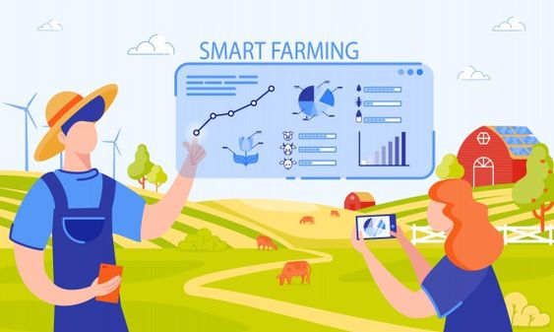
Fig: (Source freepik)
Further, IoT may also engage artificial intelligence (AI) and machine learning to help make data collection procedures simpler and more effective. A few advantages of connected technology include improved communication between connected electronic devices, the ability to transfer data packets over a network saving time and money, the availability of information anywhere, anytime, on any device, the ability to automate tasks enhancing the quality of a business's services and reducing the need for human intervention (hexagonview.com, 2023).
Example: Everyone is aware that plants require water to grow. However, if they receive either too little or too much water, plants become stressed. Therefore, the key is to water "just right." The farmer may establish the best possible balance between crop growth and water use with the appropriate amount of water. We are aware that the expense of water is one of the major obstacles traditional agriculture has in providing food for billions of people.
By burying a smart sensor in the ground, the farmer may get information on the soil's current conditions on an hourly, daily, or demand basis. The sensor is giving back data right away, which saves the farmer time by preventing them from having to go.
The sensor can simultaneously assess a large number of other soil characteristics, giving the farmer a more complete picture of the soil's condition.
The farmer can determine how water moves through the soil from the top to the root by planting three sensors closely together in the soil. The farmer may immediately determine the depth and length of the water's percolation into the soil with these sensors. If water accumulates above the root but below the surface, the roots could not be receiving enough nutrients. The farmer would know that less water is needed if the water is penetrating far deeper than the root. Less water equals less revenue, therefore creating a better solution.

3.5 Possible limitations and future scope

Although Agritech may be an effective tool for enhancing farming operations, it is crucial to think about any potential disadvantages before purchasing any Agri-tech equipment. The following are the difficulties faced by Agritech:

High start-up and operating expenses: Some small farms may find the high setup and maintenance expenses of Agritech systems unaffordable. Farmers may find it expensive to maintain Agritech equipment even when they can initially afford the expenditure.
Possibility of cyber-attacks: Agritech has historically connected low-tech items to the internet, opening doors for hacking farm equipment including tractors, combines, and cotton harvesters.
Lack of uniformity: It is now difficult to compare goods or transmit data between Agritech systems since there is a lack of standardisation, especially uniform data architecture. This raises the danger of cyber security as well.
Excessive reliance on technology: For instance, crops may suffer if an automated watering system fails without the required redundancy or recovery measures, and nobody may notice until it is too late. Similar to this, the cost of operating an Agritech system may increase due to the requirement for routine maintenance and upgrades.
Ethical Issues: The Internet of Things (IoT) poses ethical issues such data ownership, permission, transparency, and the possible effect on employment. For responsible and inclusive IoT implementations, it is crucial to address these ethical concerns.

Future of Agritech
Although there are certain obstacles to adoption, farmers are prepared to invest in Agritech. A 2022 McKinsey poll found that 43% of farmers were interested in experimenting with novel products to boost productivity. Farmers may employ Agritech to reduce climate change and food hunger if they can overcome its cost, security, and standardisation hurdles. The Agritech sector is projected to draw more investments and witness the birth of creative companies due to the rising need for sustainable and effective agriculture. These firms could introduce industry-disrupting technology and concepts, advancing development.
There are potential to move to more effective and sustainable food systems thanks to precision agriculture, which is supported by artificial intelligence, intelligent sensors, and data analytics. Several technologies were identified in a 2018 World Economic Forum (WEF) report as having the potential to dramatically enhance food systems by 2030. Many of the technologies the WEF highlighted five years ago are currently in use and altering agriculture, farming, and food systems. The technologies include food sensing for supply chain transparency and traceability, big data analytics, and food safety, quality, and traceability technology.

4. CONCLUSION
In conclusion, Internet of Things (IoT) is expected to be filled with exciting advancements and transformative changes across various industries and aspects of our lives. If we accept the Gartner Hype Cycle, our expectations will need to be revised over the next several years. But in the long run, IoT will probably just become the new standard. It's quite cool to be able to control your home with your smartphone. It's also really cool to have a real-time image of every item in your supply chain. And who doesn't enjoy posing silly queries to Alexa?
In order to make our devices more autonomous and better networked, technologies like AI and block chain are increasingly being used. The term "edge computing" has become more popular as a result of the realisation that the proliferation of IoT devices makes the lengthy round-trip journey to the cloud and back impractical for local users. However, anything that calls for widespread hardware adoption takes time. The transition to an Internet of Things will thus be slow. This is likely advantageous as well since it will give us more time to address the privacy and security concerns that will unavoidably arise as more activities go online.
A "management concept focused on providing the agricultural industry with the infrastructure to leverage advanced technology, including big data, the cloud, and the internet of things (IoT), for tracking, monitoring, automating, and analysing operations," according to Tech Target's definition of the term "smart farm." This is a collaborative systems endeavour, and the components range from simple sensors like soil monitors, weather stations, pest traps, images from fixed cameras or drones, grain monitors, etc., to comprehensive solutions for plant monitoring, smart barns.

REFERENCES
https://www.fao.org/home/en
https://www.techtarget.com/whatis/definition/agri-tech
http://www.abhinavagri.com/abhinavagri/html/foodprocessing.html
“AQUASTAT,” [Online]. Available: http://www.fao.org/aquastat/en/overview/methodology/water-use. Accessed on: Mar. 24, 2020.
“World population prospects 2019: Highlights,” [Online]. Available: https://population.un.org/wpp/Publications/Files/WPP2019_Highlights.pdf. Accessed on: Jul. 02, 2023.
“More people, more food, worse water?” [Online]. available: http://www.fao.org/3/ca0146en/CA0146EN.pdf. Accessed on: Jul. 02, 2020.
“The future of food and agriculture: Alternative pathways to 2050,” [Online]. Available: http://www.fao.org/3/CA1553EN/ca1553en.pdf. Accessed on: Jul. 04, 2023.
Internet of things [ONLINE]. Available: https://hexagonview.com/2022/07/11/internet-of-things/. Accessed on: Jul. 12, 2023.
History of IoT [ONLINE]. Available https://www.iottechtrends.com/history-of-iot/. Accessed on: Jul. 18, 2023.
J. M. Talavera, L. E. Tobón, J. A. Gómez, M. A. Culman, J. M. Aranda, D. T. Parra, L. A. Quiroz, A. Hoyos, and L. E. Garreta, “Review of IoT applications in agro-industrial and environmental fields,” Comput. Electron. Agr., vol. 142, pp. 200–225, Nov. 2017. doi: 10.1016/j.compag.2017.09.015
P. P. Ray, “Internet of things for smart agriculture: Technologies, practices and future direction,” J. Ambient Intell. Smart Environ., vol. 9, no. 4, pp. 309–413, Jun. 2017. doi: 10.3233/AIS-170440
O. Friha et al., "Internet of Things for the Future of Smart Agriculture: A Comprehensive Survey of Emerging Technologies", IEEE CAA J. Autom. Sinica, vol. 8, no. 4, pp. 718-52, 2021.
X. Yang et al., "A Survey on Smart Agriculture: Development Modes Technologies and Security and Privacy Challenges", IEEE/CAA J. Automatica Sinica, vol. 8, no. 2, pp. 273-302, 2020.
L. Barreto and A. Amaral, "Smart farming: Cyber Security Challenges", 2018 Int'l. Conf. Intelligent Systems (IS), pp. 870-76, 2018.
M. Gupta, M. Abdelsalam, S. Khorsandroo and S. Mittal, "Security and Privacy in Smart Farming: Challenges and Opportunities", IEEE Access, vol. 8, pp. 34,564-84, 2020.
K. Demestichas, N. Peppes and T. Alexakis, "Survey on Security Threats in Agricultural IoT and Smart Farming", Sensors, vol. 20, no. 22, pp. 6458, 2020.
A. R. de Araujo Zanella, E. da Silva and L. C. P. Albini, "Security Challenges to Smart Agriculture: Current State Key Issues and Future Directions", Array, pp. 100048, 2020.
J. Nikander, O. Manninen and M. Laajalahti, "Requirements for Cybersecurity in Agricultural Communication Networks", Computers and Electronics in Agriculture, vol. 179, pp. 105776, 2020.
Yazdinejad, A., Zolfaghari, B., Azmoodeh, A., Dehghantanha, A., Karimipour, H., Fraser, E., ... & Duncan, E. (2021). A review on security of smart farming and precision agriculture: Security aspects, attacks, threats and countermeasures. Applied Sciences, 11(16), 7518.
Ferrag, M. A., Shu, L., Yang, X., Derhab, A., & Maglaras, L. (2020). Security and privacy for green IoT-based agriculture: Review, blockchain solutions, and challenges. IEEE access, 8, 32031-32053.
Etemadi, N., Borbon, Y. G., & Strozzi, F. (2020). Blockchain technology for cybersecurity applications in the food supply chain: A systematic literature review. Proceedings of the XXIV Summer School “Francesco Turco”—Industrial Systems Engineering, Bergamo, Italy, 9-11.

