IoT-based Secure Wireless Medical Sensor Networks using Multifactor Authentication

Manish Bali
Department of Computer Science and Engineering
Presidency University
Bengaluru, India
balimanish0@gmail.com

Anuradha Yenkikar
Department of CSE (AI)
Vishwakarma Institute of Information Technology
Pune, India
anu.jamkhande@gmail.com

ABSTRACT

Wireless Medical Sensor Networks (WMSN) integrated with the Internet of Things (IoT) have the potential to revolutionize the medical sector, offering remote patient monitoring and personalized healthcare services. Security is of paramount importance due to the wireless nature of communication. Since vital sign parameters are highly sensitive to a patient's health status and should only be accessible to healthcare experts, maintaining patient privacy is a major concern for WMSN applications. A fundamental and widely accepted approach to address security and privacy issues in WMSNs is through user authentication while ensuring anonymity. This chapter introduces a multifactor authentication system that tackles these challenges by utilizing a combination of smart cards, passwords, and the biometrics of a healthcare professional (user). This approach aims to enhance the effectiveness, security, and scalability of IoT-based WMSNs for better patient care. Our findings suggest that the proposed system can withstand common attacks and offers more functionality compared to existing alternatives.

Keywords—authentication; internet of things; smart card; biometrics; wireless medical sensor networks

INTRODUCTION

In recent decades, human life expectancy has significantly increased due to better living conditions and advancements in public health. For instance, in 1960, the average life expectancy for Indians was only 39.93 years. However, over the years, it has risen as indicated in Figure 1. As individuals age, the likelihood of developing chronic illnesses rises, leading to a challenge in self-care and placing a significant burden on their dependents and medical system. To address this challenge, remote monitoring has emerged as a promising solution within the healthcare system, as mentioned in references [1] [2]. Wireless body area networks (WBANs), a vital component of remote monitoring setups, have attracted considerable interest from both academia and industry researchers. This is due to their potential to enhance the quality of healthcare services.
IoT is a disruptive technology that has the power to transform various sectors, including healthcare. Integrating IoT with WMSNs for remote patient monitoring stands out as one of the most promising applications of IoT in the healthcare field. This connection opens up vast possibilities for enhancing patient care, advancing medical diagnostics, and revolutionizing healthcare delivery.

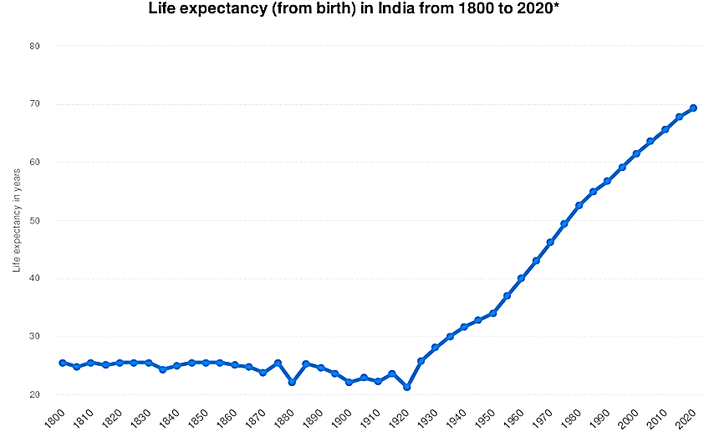
Figure 1: Life expectancy in India over the years
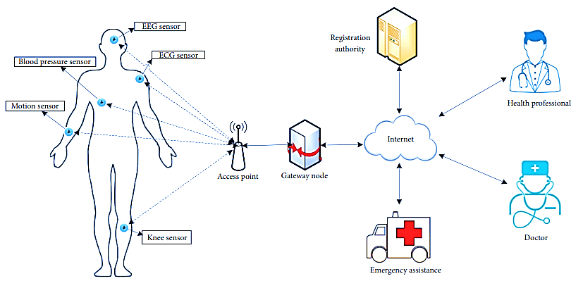
Figure 2: Network model for remote patient monitoring

Remote patient monitoring, made possible by IoT connected Wireless WMSNs, involves the continuous and non-invasive collection of patient data from various medical sensors placed on or inside the patient's body. Figure 2 illustrates an overall schematic for remote patient monitoring using WMSNs, adapted from references [3] [4] [5].
These sensors can measure vital medical parameters. The collected data is then transmitted wirelessly via IoT communication protocols to a centralized platform or a cloud-based server for real-time analysis and storage. However, there is a potential risk of malicious actors intercepting, modifying, inserting, or deleting communications transmitted through unsecured public channels [6]. Additionally, unauthorized users transmitting commands to halt the operation of wearable devices, especially those critical to a patient's survival (like cardiac pumps), poses a significant danger.
IoT-enabled WMSNs offer numerous advantages, ensuring secure remote monitoring of patients' health status. Some of these benefits include:
- Continuous Monitoring: Unlike traditional in-person visits, remote patient monitoring allows continuous data collection, giving a comprehensive and dynamic view of a patient's health. This facilitates early detection of anomalies or changes in vital signs, enabling timely interventions.
- Improved Patient Outcomes: IoT-based WMSNs enable early detection of health issues, leading to prompt medical interventions. This proactive approach can result in better patient outcomes and fewer hospital readmissions.
- Increased Efficiency and Cost Savings: By reducing unnecessary hospital visits and simplifying patient care, remote patient monitoring optimizes healthcare resource utilization. This has the potential to significantly reduce costs for both healthcare providers and patients.
- Personalized Healthcare: The continuous data stream from IoT-enabled sensors empowers healthcare professionals to customize treatment plans and medical interventions based on each patient's unique health requirements.
- Remote Accessibility: Patients in remote or rural areas, as well as those with limited mobility, can receive high-quality healthcare without frequent visits to healthcare facilities.
- Real-time Data Analytics: IoT-based WMSNs generate vast amounts of patient data. Utilizing data analytics and machine learning techniques, healthcare providers can extract valuable insights from this data, enabling evidence-based decision-making.
- Early Disease Detection: IoT-enabled WMSNs can assist in detecting early signs of deteriorating health, enabling timely preventive measures and potentially reducing the severity of certain health conditions.

Numerous authentication systems have emerged in recent years to establish secure and efficient healthcare monitoring of patients utilizing Wireless Body Area Networks (WBANs). However, due to the limited energy and processing capabilities of wearable sensor nodes, authentication techniques leveraging public key encryption techniques like elliptic curve cryptography (ECC) [7] and the Rabin cryptosystem [8] [9], come with high computational costs and are not suitable for practical applications. Consequently, employing lightweight procedures such as symmetric encryption/decryption and hash functions becomes a more feasible approach to address the limitations of public key encryption. However, upon closer scrutiny, it becomes apparent that most existing systems based on lightweight cryptographic primitives are susceptible to security vulnerabilities and are ill-suited for practical use. These systems fail to ensure forward secrecy and are vulnerable to several known attacks.
The primary contribution of this chapter is a novel, secure, and efficient user authentication scheme designed specifically for healthcare applications in WMSNs. The remaining sections of this chapter are summarized as follows: Section II: This section explores relevant studies in this field, Section III: It delves into the methodology and presents the recommended authentication schema, Section IV: This part discusses the outcomes and their implications, Section V: The conclusion of the chapter and References: The reference section at the end provides the sources cited throughout the chapter.

RELATED WORKS

Significant research has taken place in this domain, offering valuable insights into the current landscape of research and developments. These studies encompass various facets, including architecture, data analytics, security, clinical applications, and interoperability, thus providing a comprehensive understanding of the evolving field of modern healthcare. In this section, we'll highlight some recent literature in this area. [10] offers an extensive review of the latest advancements in IoT-enabled Wireless Medical Sensor Networks (WMSNs) for remote patient surveillance. It explores different IoT-based architectures, communication protocols, and data analytics techniques utilized in these networks. The authors analyze the potential advantages and challenges of incorporating IoT in healthcare, emphasizing how remote patient monitoring can enhance patient outcomes. [11] is a systematic review that focuses on IoT-enabled wearable medical devices used in remote patient monitoring. The study evaluates the accuracy and reliability of these devices in measuring vital signs and assesses usability and user acceptance. Furthermore, it addresses security and privacy concerns associated with wearable IoT devices, proposing potential solutions. [12] presents a case study centered on the application of IoT-based WMSNs in cardiac monitoring. The authors discuss the network's design and implementation, the selection of suitable sensors, and the integration with existing healthcare infrastructure. The study highlights the effectiveness of remote patient monitoring in detecting cardiac anomalies, ultimately leading to improved patient outcomes. These studies collectively contribute to a deeper understanding of the potential of IoT-enabled WMSNs in healthcare, shedding light on its benefits, challenges, and practical applications across various aspects of patient monitoring and care.
To delve into the diverse data analytics techniques used in IoT-enabled Wireless Medical Sensor Networks (WMSNs) for real-time health surveillance, [13] provide an overview of various machine learning algorithms, data fusion methods, and anomaly detection approaches employed to analyze patient data and enable timely medical interventions. The paper also examines the challenges and opportunities within the realm of data analytics for remote patient monitoring. [14] concentrate on the crucial security and privacy aspects of IoT-based healthcare systems, including WMSNs for remote patient surveillance. The authors review potential vulnerabilities and attack vectors targeting IoT devices, proposing security measures to safeguard patient data and ensure the confidentiality, integrity, and availability of information. [15] undertake an analysis of clinical trials and studies that have evaluated the effectiveness of IoT-based remote patient monitoring, specifically in chronic disease management. The paper focuses on conditions such as diabetes, hypertension, and respiratory diseases, demonstrating the impact of IoT-enabled WMSNs in enhancing patient adherence to treatment plans and reducing the need for hospital visits. [16] address the interoperability challenges inherent in IoT-based healthcare systems, which extend to Wireless Medical Sensor Networks. The authors review existing standards and protocols for seamless data exchange among heterogeneous medical devices and propose solutions to achieve interoperability. The paper underscores the significance of interoperability in facilitating data sharing and medical decision-making in remote patient monitoring scenarios.
These studies contribute to the comprehensive understanding of the technical, security, clinical, and interoperability aspects of IoT-enabled WMSNs for healthcare applications, shedding light on both the potential benefits and the challenges that need to be addressed for effective implementation in modern healthcare systems.

METHODOLOGY

IoT-enabled Wireless Medical Sensor Networks (WMSNs) are specifically designed to enable the real-time collection, transmission, and analysis of patient data for remote patient monitoring and other healthcare applications. This architecture involves the integration of hardware components, network protocols, and data management systems to ensure seamless and secure communication between medical sensors and the healthcare infrastructure. Figure 2 illustrates a typical WMSN design, which has been adapted in this chapter to align with the proposed authentication schema.

In this network model, medical sensors are strategically placed on a patient's body, creating a WBAN. These sensors actively record the individual's physiological data and transmit it wirelessly to the handheld devices of health professionals, which could include devices like personal digital assistants (PDAs), iPhones, laptops, and similar devices [17]. Consequently, physicians can access this data from the medical sensors, providing them with a more comprehensive and up-to-date assessment of the patient's health status as and when needed. The physiological data collected may encompass parameters like heart rates, body temperature, blood pressure, blood oxygen levels, and so forth. This setup allows for efficient remote patient monitoring, enabling healthcare professionals to make informed decisions and take timely actions based on the real-time patient data.

Threat model
Through power analysis attacks, an assailant can gain access to sensitive information stored within the memory of a lost or stolen smart card. To assess these security concerns, we utilize the Dolev-Yao threat model [18], which assumes that any two parties communicating can do so over an unsecured public channel. In our approach, we adopt a similar threat model where communication channels are considered insecure, and the endpoints (sensor nodes) are inherently untrustworthy. However, we trust the base station (designated as the gateway node or GWN), and the assumption is that an adversary (attacker) will never compromise the base station, as doing so would compromise the entire network. This assumption is crucial due to economic constraints, as sensor nodes implanted on patients' bodies lack tamper-resistant hardware. Consequently, if an adversary physically seizes a sensor from a patient's body, they will gain access to all sensitive information contained within that sensor's memory.
We selected the Dolev-Yao model due to its portrayal of the Intruder as the most potent attacker. This attacker is depicted as an active saboteur, omnipotent in the sense that they can intercept, eavesdrop on, or manipulate all network traffic. Furthermore, the attacker can impersonate a valid communication partner, enabling them to initiate contact with any network participant. However, it's important to note that a Dolev-Yao attacker is incapable of compromising or breaking cryptographic primitives.

Notations
Table 1 describes the terminology used in this chapter.

Table 1: Terminology used

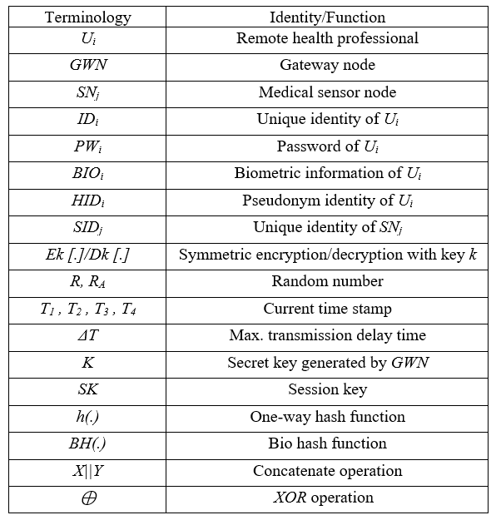

Proposed scheme”

The scheme comprises five distinct phases:
1. Professional Registration Phase: In this phase, professionals (users) are registered, with the registration authority being a trusted entity within the network.
2. Patient Registration Phase: Patients are registered in this phase.
3. Pre-deployment Phase: Actions taken prior to deployment of the authentication system are covered in this phase.
4. Login Phase: The phase where users attempt to log into the system.
5. Authentication and Session Key Agreement Phase: Once the login is successful, authentication is performed, and session keys are agreed upon.
The design of this scheme is based on following assumptions:
- The registration authority is trusted within the network.
- The gateway (GW) node maintains three secret keys, A, B, and C, each consisting of 256 bits.
- All entities within the WMSN are synchronized with their clocks.
- A "fuzzy extractor" technique [19] is employed to counter privileged-insider attacks and flaws in the password change phase, as observed in some other proposed schemes.
- The fuzzy extractor can derive a uniformly distributed random key, R_{i}, from biometric input BIO_{i} in a tolerant manner to errors. If another biometric input BIO_{i}* is reasonably similar to BIO_{i}, the extracted random key R_{i} remains unchanged with the assistance of an auxiliary string P_{i}.

The fuzzy extractor comprises two procedures:
- Gen(BIO_{i}): A probabilistic generation procedure that extracts random key R_{i} and auxiliary string P_{i} from biometric input BIO_{i}.
- R_{i}* = Rep(BIO_{i}*, P_{i})**: A deterministic reproduction procedure that reproduces random key R_{i} from any biometric input BIO_{i}* closely resembling BIO_{i}, with the aid of auxiliary string P_{i}.

(i) Professional Registration Phase

In this registration phase, a health professional (referred to as U_{i}) aims to become a legitimate user of the WMSN. This process involves a series of steps:
Step 1: U_{i} selects an identity (IDi) and a password (PW_{i}). Additionally, U_{i}'s personal biometrics (BIO_{i}) are recorded using a specific device.
Step 2: Ui generates a 1024-bit random number (k_{i}) and computes the following:
- ($σ_{I}$, $τ_{i}$) = Gen(BIO_{i}), where $σ_{I}$ represents biometric key data, and$τ_{i}$ is the reproduction public parameter.
- RPW_{i} = h(ID_{i}||k_{i}||PW_{i}), where h denotes a cryptographic hash function.
U_{i} sends a registration request message {ID_{i}, RPW_{i}} to the Gateway (GW) through a secure channel. Notably, $σ_{I}$ and $τ_{i}$ are parts of the biometric data, and RPW_{i} incorporates U_{i}'s identity, a random number, and the chosen password.
Step 3: Upon receiving U_{i}'s registration request, the GW performs the following:
- Generates a random number (r_{g}) and a new identity (IDg).
- Computes $C_{ij}=E_{J}\left[r_{g}\left|\left|ID_{i}\right|\right|ID_{g}\right]$, where $E_{J}$ represents encryption using the secret key J.
- Computes J, $N_{i}=h\left(ID_{i}\left|\left|ID_{g}\right|\right|K\right)⨁RPW_{i}$, where K is the GW's secret key.
The GW then sends a smart card (SCi) to U_{i} through a secure channel. The smart card SCi contains parameters including $\left\{C_{ij}, N_{i},h\left(.\right),Gen\left(.\right),Rep\left(.\right),t\right\}$. This smart card plays a vital role in the user's authentication process.
Step 4: Upon receiving the smart card SCi from the GW, U_{i} performs the following computations:
- Computes $e_{i}=h\left(ID_{i}\right)⨁k_{i }$
- Computes $V_{i}=h\left(ID_{i}\left|\left|RPW_{i}\right|\right|σ_{i}\right)$
- Computes $N_{i}^{*}=N_{i}⨁h(k_{i}|\left|σ_{i}\right)$
U_{i} then updates the smart card SCi with the following information: $\left\{C_{ij},N_{i}^{*},h\left(.\right),Gen\left(.\right),Rep\left(.\right),t,τ_{i}, ei,Vi \right\}$. The updated smart card now contains these additional parameters, which are crucial for the authentication process in the subsequent phases.
(ii) Patient Registration Phase
In this phase, for a patient to access healthcare applications, they are required to register at the hospital's registration center (RC) through the following three steps:
Step 1: The patient initiates the process by sending their name to the registration center (RC). This initial communication establishes the patient's intent to register for healthcare services.
Step 2: The RC, upon receiving the patient's name, proceeds to select an appropriate sensor kit based on the patient's needs and requirements. Additionally, the RC designates healthcare professionals who will be responsible for overseeing the patient's healthcare needs.
Step 3: The RC completes the registration process by submitting the patient's unique identity (IDpt) and relevant information about the chosen medical sensors to the healthcare professionals it has designated. This step ensures that the designated professionals are aware of the patient's registration and the specific sensors that will be employed for healthcare monitoring and management.
By completing these three steps, the patient is officially registered in the hospital's system, enabling them to access and benefit from the various healthcare applications offered within the network.
(iii) Pre-Deployment Phase
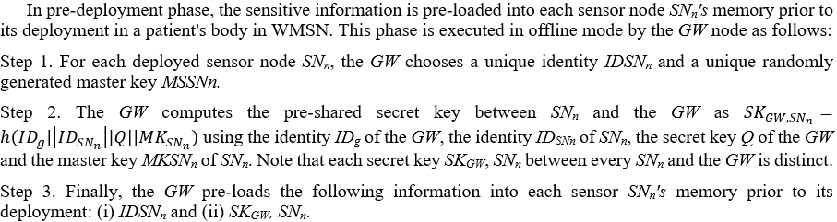
In the pre-deployment phase, sensitive information is pre-loaded into the memory of each sensor node (SN_{n}) before its deployment within the WMSN. This phase is carried out in an offline mode by the Gateway (GW) node and involves the following steps:
Step 1: For each sensor node (SN_{n}) that will be deployed, the Gateway (GW) node selects a unique identity (IDSN_{n}) for that sensor node. Additionally, a unique randomly generated master key (MSSNn) is assigned to each sensor node.
Step 2: The GW node calculates the pre-shared secret key between the specific sensor node (SNn) and the GW as follows:
- ${SK}_{GW,{SN}_{n}}=h(ID_{g}|\left|ID_{SN_{n}}\right||Q||MK_{SN_{n}}$,
where:
- $ID_{g}$ is the identity of the GW,
- $ID_{SN_{n}}$ is the identity of the specific sensor node (SN_{n}),
- Q is the secret key of the GW,
- $MK_{SN_{n}}$ is the master key of the sensor node SN_{n}.
It's important to note that each secret key (SK) between every sensor node (SN_{n}) and the GW is distinct, ensuring unique communication between each sensor node and the GW.
Step 3: Finally, the GW pre-loads the following information into the memory of each sensor node (SN_{n}) before its deployment:
1. The unique identity of the sensor node (ID_{SNn}).
2. The pre-shared secret key (SK_{GW}, SN_{n}) that was computed in Step 2.
By completing these steps, each sensor node (SN_{n}) is equipped with the necessary information to establish secure and unique communication with the Gateway (GW) node once deployed within the WMSN.

(iv) Login Phase
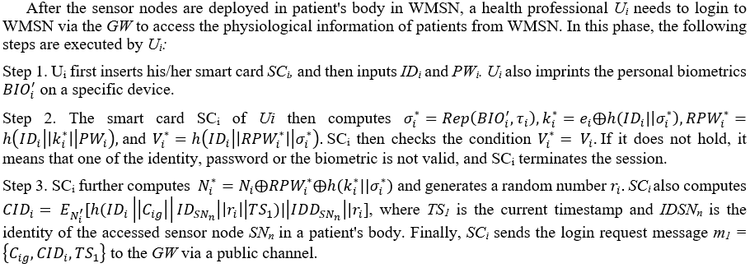
After the sensor nodes are deployed within a patient's body in the WMSN, a health professional (referred to as U_{i}) needs to log in to the WMSN through the Gateway (GW) to access the physiological information of patients. In this login phase, U_{i} follows these steps:
Step 1: U_{i} initiates the login process by first inserting their smart card (SC_{i}). U_{i} then inputs their identity (IDi) and password (PW_{i}). Additionally, U_{i} records their personal biometrics (${BIO}_{i}^{'}$) using a designated device.
Step 2: U_{i}’s smart card (SC_{i}) performs the following computations:
- $σ_{i}^{*}=Rep\left({BIO}_{i}^{'}, τ_{i}\right)$: Reproduction of the biometric key $σ_{i}^{*}$ using the stored $τ_{i}$parameter.
- $k_{i}^{*}=e_{i}⨁h(ID_{i}|\left|σ_{i}^{*}\right)$: Computation of a derived key $k_{i}^{*}$ based on $e_{i}$, the identity $ID_{i}$, and $σ_{i}^{*}$.
- $RPW_{i}^{*}=h\left(ID_{i}\left|\left|k_{i}^{*}\right|\right|PW_{i}\right)$: Calculation of an updated $RPW_{i}^{*}$ using $ID_{i}$, $k_{i}^{*}$, and $PW_{i}$.
- $V_{i}^{*}=h\left(ID_{i}\left|\left|RPW_{i}^{*}\right|\right|σ_{i}^{*}\right)$: Generation of an updated $V_{i}^{*}$ using $ID_{i}$, $RPW_{i}^{*}$, and $σ_{i}^{*}$.
The smart card (SC_{i}) verifies the condition $V_{i}^{*}= V_{i}$. If this condition is not met, it indicates that one of the elements (identity, password, or biometric) is invalid, leading to the termination of the session.
Step 3: SC_{i} continues with further computations:
- $N_{i}^{*}=N_{i}⨁RPW_{i}^{*}⨁h(k_{i}^{*}||σ_{i}^{*})$: Calculation of an updated $N_{i}^{*}$ using $N_{i}$, $RPW_{i}^{*}$, $k_{i}^{*}$, and $σ_{i}^{*}$.
- Generation of a random number $r_{i}$.
- Computing $CID_{i}= E_{N_{i}^{'}}[h(ID_{i}\left|\left|C_{ig}\right|\right|ID_{SN_{n}}\left|\left|r_{i}\right|\right|TS_{1})|\left|I{DD}_{SN_{n}}\right||r_{i}$], where $TS_{1}$ is the current timestamp, $ID_{SN_{n}}$ is the identity of the accessed sensor node SN_{n} within a patient's body.
Finally, SC_{i} sends the login request message m₁ = $\left\{C_{ig},CID_{i},TS_{1}\right\}$to the Gateway (GW) through a public channel.
These steps ensure secure authentication and access to the WMSN, allowing the health professional U_{i} to retrieve physiological information from the deployed sensor nodes within the network.
(v) Authentication and Session Key Agreement Phase
In this phase, a health professional (Ui) and an accessed sensor node (SN_{n}) establish a session key for their future secure communication after mutual authentication via the Gateway (GW) in the WMS). This phase is composed of the following complex steps:
Step 1: The GW receives a login request message m1 = $\left\{C_{ig},CID_{i},TS_{1}\right\}$ from Ui at time $TS_{1}^{*}$. The GW validates the timestamp $TS_{1}$ in the message by checking the inequality $TS_{1}^{*}-TS_{1}≤∆T$. If the timestamp is not valid, the GW terminates the session.
Step 2: The GW performs several computations:
- $\left(r_{g}^{'}\left|\left|ID_{i}^{'}\right|\right|ID_{g}^{'}\right)=D_{j}\left[C_{ig}\right]$: Decryption of the received $C_{ig}$.
- $N_{i}^{”}=h\left(ID_{i}^{'}\left|\left|ID_{g}^{'}\right|\right|K\right)$: Computation of $N_{i}^{”}$ using the identity $ID_{i}^{'}$, $ID_{g}^{'}$, and the secret key K.
- $\left(h_{1}\left|\left|ID_{SN_{n}}^{'}\right|\right|r_{i}^{'}\right)=D_{N_{i}^{”}}\left[CID_{i}\right]$: Decryption of the received $CID_{i}$.

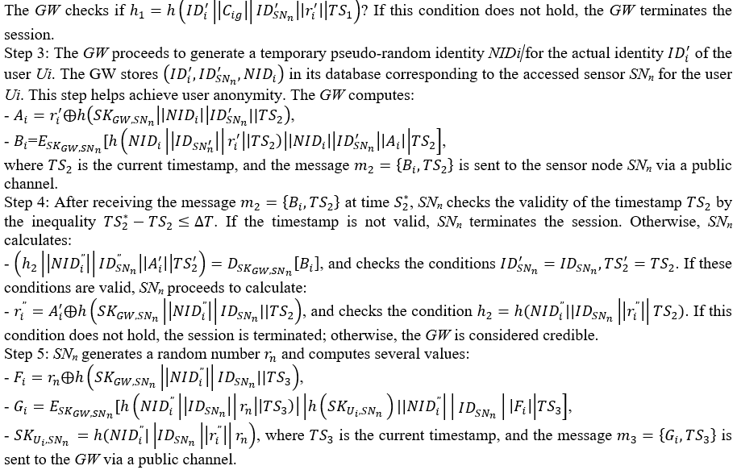
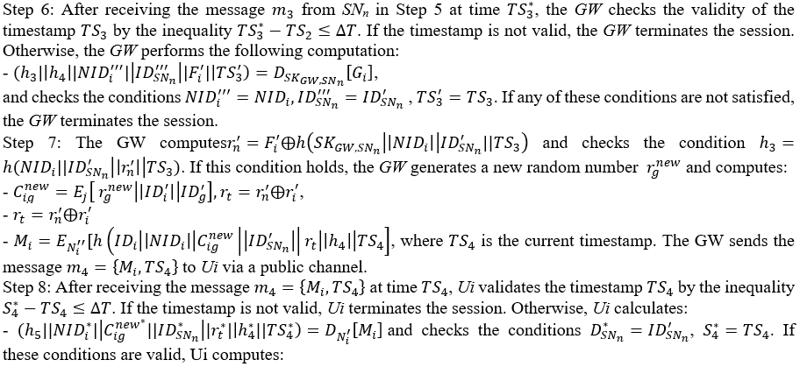
- $r_{n}^{''}=r_{i}^{*}⨁{r_{i}}$ ,
- $SK_{U_{i,SN_{n}}}^{*}=h(NID_{i}^{*}|\left|ID_{SN_{n}}\right||r_{i}|\left|r_{n}^{”}\right)$.
Ui and SN_{n} both store the session key $SK_{U_{i,SN_{n}}}^{*}$ (which is also equal to $SK_{U_{i,SN_{n}}}$) for future secure communication.
This elaborate series of steps ensures the establishment of a session key between the health professional Ui and the accessed sensor node SN_{n}, allowing secure communication within the WMSN.
The informal analysis aims to evaluate the proposed schema's ability to withstand common attacks and to assess its functionality features. Given that the schema involves wireless communication, ensuring secure communication is of paramount importance in WMSNs. The hypothesis being tested is whether the proposed protocol (PP) demonstrates attack resilience (AR) against well-known attacks, which implies that it results in a secure WMSN. This hypothesis is expressed in terms of a null hypothesis (H₀) and an alternative hypothesis (H₁) as follows:
- Null Hypothesis (H₀):
(AR)_{PP} = (AR)_{PPH0} (1)
This hypothesis assumes that the proposed protocol is not significantly more attack resilient than the hypothesized baseline level of attack resilience.
2. Alternative Hypothesis (H₁):
(AR)_{PP} $≠$ (AR)_{PPH0} (2)
This hypothesis suggests that the proposed protocol demonstrates a significant level of attack resilience beyond the hypothesized baseline level, making it more secure than expected.
In other words, the null hypothesis states that the proposed protocol's attack resilience is not significantly different from the baseline (expected) level, while the alternative hypothesis asserts that the proposed protocol indeed exhibits a higher level of attack resilience than expected. The goal is to gather evidence through testing and analysis to determine whether the proposed protocol enhances the security of WMSNs by effectively countering common attacks, thereby validating the alternative hypothesis.

RESULTS AND DISCUSSION

In Table 2, we compare the performance of the suggested schema to that of various state-of-the-art models.

- Privileged Insider Attack: This type of attack involves a privileged insider collecting user credentials and attempting to use them on behalf of a legal user. The schema ensures security by securely conveying user credentials, such as ID_{i}, PW_{i} and Bio_{i}, using a one-way hash function and a random secret key k_{i}. Even if an attacker gains access to the smart card SC_{i}, the password guessing attack will fail since k_{i} is unknown. Similarly, without knowledge of Bio_{i}, the attacker cannot acquire the biometric key data $σ_{I}.$ Therefore, the schema effectively withstands the privileged insider attack.

Table 2: Comparison of security and functionality features

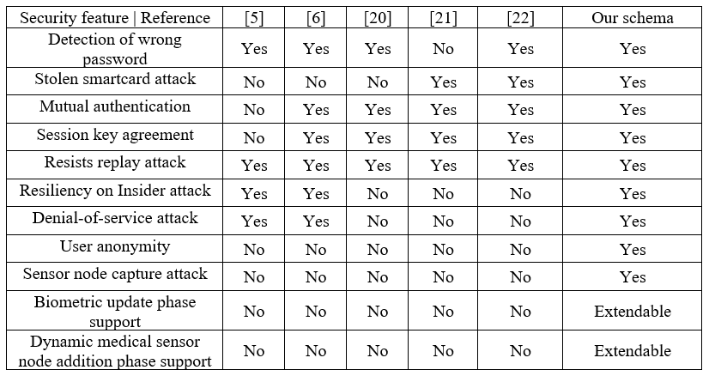

- Stolen Smart Card Attack: If a user's smart card SC_{i} is stolen or lost, an attacker may attempt to extract information from it. However, the schema's design ensures that the user identification (ID_{i}) and password (PW_{i}) are protected using the secret biometric key data $σ_{I}$ and the secret random number k_{i}. Deriving the user credentials is computationally infeasible, making the schema resistant to smart card theft.
- Stolen Verifier Attack: This attack involves an attacker stealing user information from the GW. However, the proposed schema doesn't save any information on the user's password or biometrics in the GW. As a result, this type of attack is not feasible within the architecture of the schema.
- Password Guessing Attack: The schema employs a technique that effectively protects the user's identity (ID_{i}) and password (PW_{i}) by utilizing personal biometrics (BIO_{i}) and a random secret key (k_{i}) stored in the smart card SC_{i}. Additionally, during the session setup, encrypted identification is transmitted. This approach ensures that attackers cannot deduce the user's identity or password from the smart card or the sent messages during the login, authentication, and session key agreement phases. Thus, the schema effectively guards against identity and password guessing attacks.
- Replay Attack: For preventing replay attacks, the schema incorporates timestamps in each communication message throughout the login, authentication, and session key agreement phases. These timestamps enable the involved entities (U_{i}, GW, and SN_{n}) to determine the freshness of each message and mutually authenticate, creating a secure session between U_{i} and SN_{n}. This feature efficiently detects message replays, enhancing the overall security of the system.
- User Anonymity: The schema acknowledges the importance of user anonymity, particularly in security-critical applications. By utilizing the user's secret biometric key data and a random number, the smart card safeguards the user's identity. Furthermore, the identity remains secured in communication messages through symmetric-key encryption. As a result, determining the user's identity within this scheme is computationally impossible, ensuring user anonymity, a vital aspect of the system.
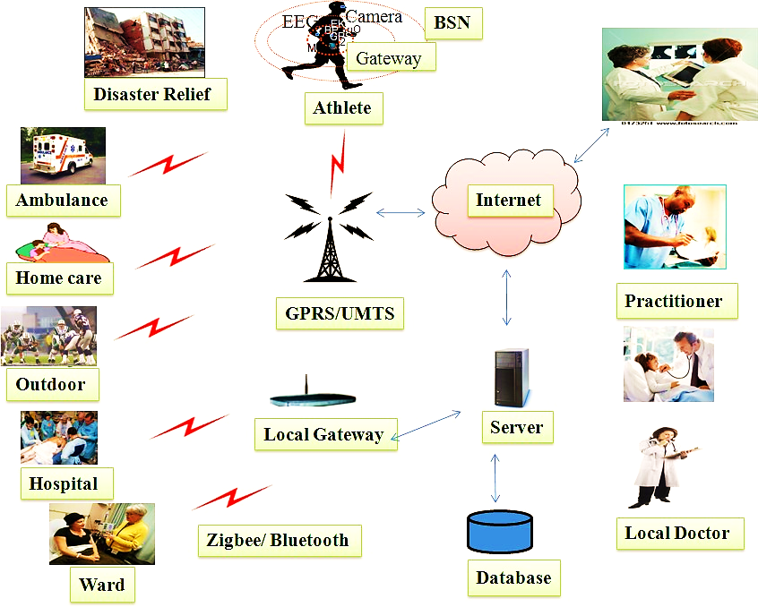

Figure 3: Usage of proposed schema in Healthcare applications
- Forgery Attack: The scheme is resistant to forgery attacks. Even if an impersonator tries to decipher the message ($m_{1}$) and tries to act like a legitimate user, they can't produce a valid request without knowing the symmetric keys (J and $N_{i}^{'}$.). This property ensures that the schema is safe against counterfeit attempts.
- Unauthorized Login Detection with Wrong Password: The authentication mechanism in the scheme efficiently identifies unauthorized login attempts with incorrect credentials. This feature helps prevent denial of service to legitimate users by quickly detecting and rejecting improper login credentials, adding an additional layer of security.
- Efficient Password Change: The schema allows users to select their own passwords during registration, and it enables password changes to be made locally on the smart card without the need to visit the registration department. This approach enhances the user experience by offering an efficient and user-friendly process for password replacement.
These aspects collectively demonstrate that the proposed schema addresses key security concerns, provides efficient mechanisms for detecting unauthorized login attempts, and offers a user-friendly approach for password management, making it a robust and practical solution for secure authentication in the context of WMSNs.
According to informal examination, the schema has a good level of security and functionality when compared to other contemporary alternatives. As a result, we accept the null hypothesis.

H₀= (AR)_{PP} = (AR)_{PPH0} = Secure WMSN

Specifically, the suggested protocol (PP) is attack resilient (AR) against a variety of well-known threats, i.e. (AR)_{PP} equals the hypothesized attack resilience (AR)_{PPH0} when utilizing multifactor authentication, resulting in secure WMSNs.

CONCLUSION

This chapter addresses a crucial requirement in healthcare applications that utilize WMSNs. The proposed solution involves a robust three-factor user authentication schema, which leverages a smart card, a password, and the biometrics of health professionals (users). A comprehensive comparison was conducted between the suggested schema and various state-of-the-art user authentication techniques. The results demonstrate that the proposed schema exhibits robustness against a wide range of common attacks while offering superior functionality compared to existing alternatives. The findings from this study suggest that the proposed schema is highly suitable for diverse healthcare applications that rely on WMSNs, as depicted in Figure 3. Furthermore, the study provides insightful recommendations for future research. These suggestions include incorporating biometric updating mechanisms and dynamic addition stages for medical sensor nodes. With such enhancements, the proposed protocol can be adapted to other domains. In summary, the proposed three-factor user authentication schema offers a secure and functional solution for healthcare applications in WMSNs. Its potential for further expansion and adaptation to other critical domains makes it a valuable contribution to the field of WSNs and opens doors to even broader applications.

REFERENCES

- J. Srinivas, D.Mishra, and S.Mukhopadhyay, “A mutual authentication framework for wireless medical sensor networks,” Journal of Medical Systems, vol. 41, no. 5, article 80, pp. 80–99, 2017.
- Raza S, Duquennoy S, Chung T, Yazar D, Voigt T, Roedig U. “Securing communication in 6LoWPAN with compressed IPsec.” International Conference on Distributed Computing in Sensor Systems and Workshops (DCOSS), p.1–8, 2011.
- Q. Jiang, J. Ma, X. Lu, and Y. Tian, “An efficient two-factor user authentication scheme with unlinkability for wireless sensor networks,” Peer-Peer Netw. Appl.; vol. 8, no. 6, pp. 1070-1081, 2014.
- P. Gope and T Hwang, “A realistic lightweight anonymous authentication protocol for securing real-time application data access in wireless sensor networks,” IEEE Trans. on Indust. Electron; vol. 63, no. 11, pp. 7124–7132, 2016. DOI: 10.1109/TIE.2016.2585081
- H. L. Yeh et al.,“A secured authentication protocol for wireless sensor networks using elliptic curves cryptography,” Sensors, 11(5):4767-4779, 2011.
- W. Shi and P. Gong. “A new user authentication protocol for wireless sensor networks using elliptic curves cryptography,” International Journal of Distributed Sensor Networks, 2013:1-7, 2013.
- J. Song, G. Li, B. Xu, and C.Ma, “A novel multiserver authentication protocol with multifactors for cloud service,” Security and Communication Networks, vol. 2018, pp. 1–13, 2018.
- T. Truong, M. Tran, and A. Duong, “Improved chebyshev polynomials-based authentication scheme in client-server environment,” Security and Communication Networks, vol. 2019, Article ID 4250743, 11 pages, 2019.
- Javeria Ambareen and Prabhakar M, “Secured Wireless Sensor Network Protocol using Rabin-assisted Multifactor Authentication,”,
I. J. Computer Network and Information Security, 4, 60-74, 2022. DOI:10.5815/ijcnis.2022.04.05
- Smith, A., Johnson, B., Williams, C., "A Comprehensive Review of IoT-enabled Wireless Medical Sensor Networks for Remote Patient Monitoring," Journal of Medical Devices and Communications, 2018
- Lee, D., Kim, J., Park, S., "IoT-enabled Wearable Medical Devices for Remote Patient Monitoring: A Systematic Review," Journal of Healthcare Technology, 2019
- Chen, L., Wang, H., Liu, R., "Enhancing Patient Care through IoT-based Wireless Medical Sensor Networks: A Case Study in Cardiac Monitoring," in: Proceedings of the International Conference on IoT and Healthcare, 2020
- Gupta, S., Sharma, R., Kumar, P., "A Review of Data Analytics Techniques for Real-time Health Monitoring in IoT-enabled WMSNs," IEEE Internet of Things Journal, 2019
- Zhang, Y., Liu, Y., Chen, T., "Security and Privacy in IoT-based Healthcare Systems: A Survey," IEEE Communications Surveys & Tutorials, 2021
- Johnson, M., Brown, L., Patel, S., "IoT-based Remote Patient Monitoring for Chronic Disease Management: A Review of Clinical Trials and Studies," Journal of Telemedicine and Telecare, 2018
- Kim, H., Park, J., Lee, S., "Interoperability Challenges and Solutions in IoT-based Healthcare Systems: A Review," Journal of Healthcare Informatics, 2022
- R. Amin et al., “Design of an anonymity-preserving three-factor authenticated key exchange protocol for wireless sensor networks,” Comput. Netw., vol. 101, no. C, pp. 42–62. DOI: 10.1016/j.comnet.2016.01.006, 2016.
- Dolev, D.; Yao, A. C. (1983), "On the security of public key protocols" (PDF), IEEE Transactions on Information Theory, IT-29 (2): 198–208, doi:10.1109/tit.1983.1056650, S2CID 13643880
- Elijah, Olakunle, et al. "An Overview of Internet of Things (IoT) and Data Analytics in Agriculture: Benefits and Challenges." IEEE Internet of Things Journal, 2018.
- D. He, N. Kumar, J. Chen, C.-C. Lee, N. Chilamkurti, and S.-S. Yeo. “Robust anonymous authentication protocol for health-care applications using wireless medical sensor networks,” Multimedia Systems, 21(1):49{60, 2015.
- P. Kumar, S. G. Lee, and H. J. Lee. “E-SAP: Efficient-strong authentication protocol for healthcare applications using wireless medical sensor networks,” Sensors, 12(2):1625{1647, 2012.
- J. Song, G. Li, B. Xu, and C.Ma, “A novel multiserver authentication protocol with multifactors for cloud service,” Security and Communication Networks, vol. 2018, pp. 1–13, 2018.

