The Impact of Cloud Computing on Social Networking Platforms: Exploring Potential Benefits and Obstacles
Dr. Rahul Deo Sah¹, Dr. Tanya Sharma², Dr. Ashish Gupta³, Dr. Indra Nath Sahu⁴
Dr. Shyama Prasad Mukherjee University, Ranchi¹³⁴
Magadh Mahila College, Patna (Patliputra University, Patna)²
Abstract
Social networks are more than just a platform for people to engage and form personal relationships. Instead of constructing and maintaining computing infrastructures, cloud computing allows social networking companies to consume compute resources as a utility. Nowadays, the "cloud" and "social" collaborate to provide social network members with a sustainable resource sharing environment. This paper presents internet-based cloud computing while also delving into the characteristics, service models, and benefits and problems of employing cloud computing in social networks. Traditional storage devices, for example, hard disks, flash drives, and other physical storage devices, are gradually becoming obsolete. The reason for this is that the global development of organizations expects information to be exchanged across representatives for cooperative functioning. On the client's personal usage front, numerous clients these days have various gadgets, for example, at least one portable/phone, tabs, workstations, work area PCs, and so on. As a result, cloud storage provides a way to access one's personal information across all of one's personal devices. As a result, a rising number of people are opting for the more convenient option of storing their data in the cloud. The ability to access files from remote locations with simply a consistent web connection provides the cloud an advantage over conventional storage alternatives.
- INTRODUCTION
Cloud computing plays a significant role in the IT industry at both middle level and enterprise level, facilitating the allocation of resources and services. Cloud-based services encompass various components, including hardware infrastructure and resource pooling, which are exemplified by platform as a service (PaaS) and software as a service (SaaS). Cloud computing has significantly enhanced the utilization of virtual machines and data centers across various service applications. In order to achieve optimal utilization of virtual machines and data center resources, the implementation of job scheduling and load balancing is necessary in the context of cloud computing. The management of job scheduling and load balancing is a highly significant concern within the context of cloud computing environments. The process of redistributing the overall workload among the individual nodes of a collective system aims to optimize resource utilization and enhance job response time. This process addresses the issue of imbalanced load distribution, wherein certain nodes are burdened with excessive load while others are underutilized. A dynamic load balancing algorithm disregards the system's previous state or behavior and instead relies solely on the current behavior of the system. When developing an algorithm, it is crucial to take into account various factors such as load estimation, load comparison, system stability, system performance, node interaction, nature of work to be transferred, node selection, and other relevant considerations [4]. The load under consideration encompasses various aspects, including CPU load, memory utilization, delay, and network load. The cloud storage works is that it stores the clients private files on the storage workers, and clients have the opportunity of getting to their files from any area. The entirety of a user’s devices, for example, tablets, workstations, cell phones, work area PCs and other innovation devices can be utilized to store and access files put away on the cloud. Networks can likewise profit by cloud storage by having the option to improve efficiency significantly with the assistance of cloud storage. Cloud storage consequently dispenses with the requirement for conveying physical storage devices. Another preferred position of cloud storage is that clients can store a wide range of files, for example, text reports, pictures, spreadsheets, recordings, PDFs and so forth.
The cloud is a widely adopted technology for file storage. This will facilitate the conservation of significant amounts of memory on the device with ease. The storage of secure data is crucial at all times. Consider a hypothetical situation wherein an application is designed to enable users to securely store their files using cryptographic techniques. Indeed, the utilization of hybrid cryptography application enables the feasible implementation of secure file storage. This presents itself as a fascinating endeavour with potential for global implementation and ongoing development. The files can be easily stored using this cloud-based application. Users can easily rely on this application.
There is a tendency among individuals to disregard certain important tasks that need to be completed at specific dates and times. The rationale for this phenomenon can be attributed to the hectic work schedules prevalent in contemporary society. The storage of individual data can be easily facilitated through the implementation of encryption techniques, which provide a safeguard for the stored information. The user interface should possess a high degree of simplicity and clarity, ensuring that it remains easily comprehensible to individuals of average cognitive abilities. This application will enable users to input data in a more straightforward and user-friendly manner. If one desires to enhance the visual appeal of the application, it is possible to easily configure the themes for said application. Individuals The salient features to be noted for secure file storage using hybrid cryptography application are as follows.:
• The user interface of this application will be designed in a simplistic manner, ensuring ease of comprehension for users.
• Enhanced data security: The data stored within the files will be entrusted to a more robust and secure system.
• Accessibility: The application can be accessed from anywhere in the world at any time.
• Dependable: This application exhibits a straightforward and robust user interface, ensuring ease of use without any complications.
I.i. A SUMMARY OF STORAGE IN THE CLOUD
- The term "cloud storage" refers to a service that remotely monitors, manages, and backs up data. Customers can gain access to this information via a firm, typically the Internet. The vast majority of people who use cloud storage do so at their own risk. The fee charged to a customer is frequently determined by how much that individual uses the service, and it is typically paid on a monthly basis.
- Cloud storage is fundamentally identical to an external hard disc in terms of purpose and capability. As a result, clients select the data they want to store and then move it from an internal hard drive to another location. Cloud storage, on the other hand, runs via an Internet connection, whereas an external storage device operates via a USB cable connection.The cloud is just a group of computers. It refers to a collection of PCs held by a single person or group where other individuals or groups can store their data. Everything is saved on your computer's hard disc, which is a single physical storage device. The phrase "cloud storage" refers to a virtual storage area that can span many physical storage devices. When you use cloud storage, part of your data may be stored on a physical person in New York, while other files may be stored on a physical person in California. Because most consumers have no knowledge where their physical data are stored, cloud storage can be compared to a mysterious, unreachable item, much like the cloud itself.
- The majority of the data you view online that isn't saved on your PC is critical for the cloud. For example, if you use a web-based email service such as Gmail, Yahoo, or Live, you may view your email from any location with an internet connection. This is because the information is saved on employees who are claimed by many email suppliers rather than on your local workstation. Your email is stored in the cloud. Even if the "cloud" is more of a notion than something you can touch, the PCs that comprise it require real space. Server farms are the structures that house the real cloud equipment. You may also come across the phrase "worker ranch" on occasion. Server farms can be located anywhere on the plane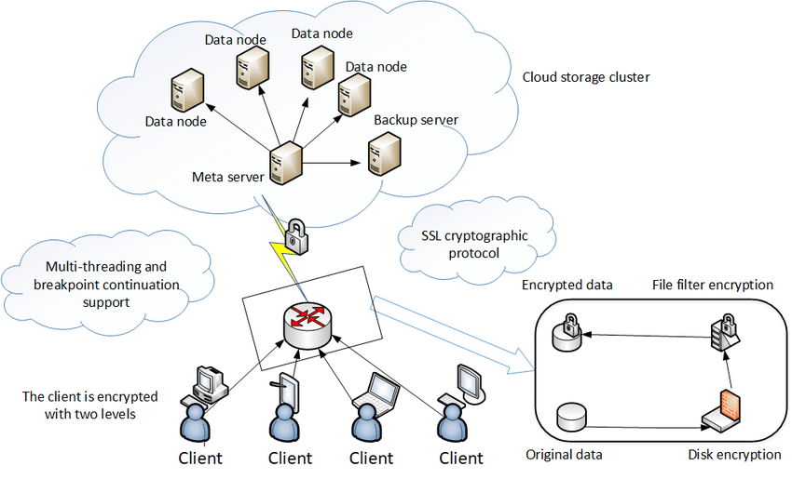
Figure 1.1: General architecture of Cloud Computing

- characteristics Of the Cloud Ccomputing

The "five essential characteristics" that delineate cloud computing have been delineated by the National Institute of Standards and Technology (NIST).
The notion of on-demand self-services pertains to the delivery of services that can be accessed and utilized by individuals at their own discretion and without requiring direct human involvement. Cloud service providers offer a range of computer services, including email, applications, network, and server services, which can be accessed and utilized without requiring direct human interaction with each specific service provider. The aforementioned services are provided by well-established companies such as Amazon Web Services (AWS), Microsoft, Google, IBM, and Salesforce.com.
Cloud capabilities provide extensive network access, enabling users to conveniently access them via diverse platforms, including mobile phones, laptops, and PDAs.
Resource pooling refers to the practice of combining the computing resources of a provider in order to serve multiple consumers. This is achieved through a multiple-tenant model, where various physical and virtual resources are allocated and reallocated based on the varying demands of the consumers. The available resources encompass a variety of components, such as storage, processing capabilities, memory capacity, network bandwidth, virtual machines, and email services, among others. The consolidation of resources leads to the development of economies of scale, as stated by Gartner.
Rapid elasticity refers to the ability of cloud services to be swiftly and flexibly provisioned, often through automated means, in order to rapidly expand their capacity and subsequently released to efficiently reduce their scale. From the perspective of the consumer, the provisioning capabilities may seem boundless, with the ability to acquire them in any desired quantity and at any given moment.
The utilization of cloud computing resources facilitates the monitoring, regulation, and documentation of resource usage, ensuring transparency for both the service provider and the service recipient. Cloud computing services utilize a metering capability that facilitates the management and optimization of resource utilization. This suggests that IT services are charged based on usage metrics, following a "pay per use" model, similar to how electricity is billed. As the degree of utilization increases, so does the corresponding financial obligation.
The advent of cloud services has enabled users to conveniently share, store, and host data on the Internet, thereby circumventing the need for local machines such as personal computers or hard drives. This emerging sector comprises a collective of synchronized laborers that enable users to complete sophisticated computational tasks. The frameworks facilitate the transfer of essential data to a cloud provider, enabling indirect access and reducing the need for local storage on personal hard drives.
An increasing number of individuals are opting to utilize cloud providers for their information storage needs due to the potential cost savings and convenience it offers. This shift also contributes to simplifying tasks such as accounting, financial management, and personnel administration. Many individuals are utilizing cloud services as a means to safeguard their important data and share accounts, as well as photos, with others. It is essential to determine the specific type of cloud storage that aligns with one's requirements. There exist three primary categories: hybrid, public, and private.

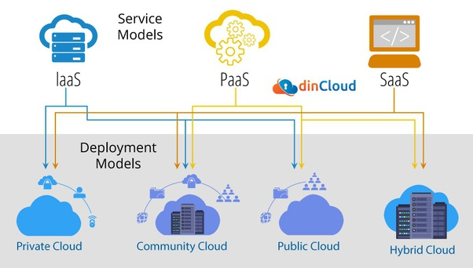

Figure 1.2: Deployment models of cloud
Following are the four main categories of cloud models. Each offers benefits and drawbacks that have a big impact on any firm looking at or actively considering a cloud deployment.
- The public cloud refers to a cloud computing paradigm that enables universal online accessibility to services such as storage and applications. Public cloud services can be offered through a pay-per-use model or alternative payment structures. IBM's Blue Cloud serves as a notable example of a public cloud infrastructure.
- A private cloud refers to a virtualized data centre that operates within the confines of a firewall. Private clouds are distinguished by their high levels of virtualization, extensive integration of IT infrastructure into resource pools, and the presence of private ownership and management.
- A hybrid cloud is a computing environment that integrates both public and private clouds.
A community cloud refers to a shared infrastructure that is utilized by multiple organizations within a specific community.
PRIVATE CLOUD STORAGE
Private cloud storage refers to a type of data storage that is exclusively dedicated to a single organization or entity. This proposed structure is designed for an individual or organization that is specific to your requirements. Cloud storage solutions are available in two formats: on-premise and remotely hosted. Both work exceptionally well, but primarily for organizations rather than individuals, unless you are operating a smaller home-based business. As an administrator, you possess greater control over the system's administration and have the ability to tailor its design to effectively meet the specific requirements of your business.
Advantages
- High protection and security
- Improved unwavering quality
- More control
- Energy and cost proficiency
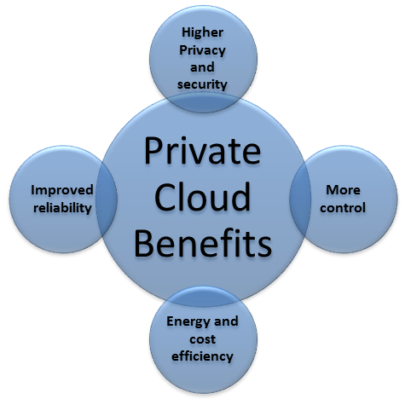
Figure 1.2: Private cloud Benifits
High protection and security: Information is a valuable resource for every organization, so it is crucial to secure it from internet trolls. Relationships all over the world are working hard to send the greatest advanced shield capabilities using information technology (IT).
In essence, affiliations are concerned with ensuring three crucial aspects, namely people, cycles, and progress. This crucial point ensures academic capital, the fundamental framework, client information, brand, and much more. Information security is significant for all organizations. Cybercriminals may also have information security as a secondary objective since it has become a fundamental component of computers, tablets, and mobile devices.
Attackers frequently use remote devices that interface with an association to access sensitive data. At this point, endpoint security, which aids in ensuring and maintaining the devices that are partners in the association, turns out to be arguably the most important aspect.

As PC networks grow, it is projected that data leaks and programmed attacks would increase in frequency over time. The proper Data Security Solutions must be set up in order to counter the problematic threats.
The Significance of Data Security
When connected to the web, information security programming protects a PC or network from online dangers. The information security software may also ensure multiple districts, such as projects or the operation of a whole application. There will likely be guidelines and exercises to use in defending against attacks on web security. There are several different types of security, including:
Protocol IPSec
The IPSec Protocol was initially developed to protect TCP/IP-based collaboration. The information is altered using security methods, and it was designed by the IETF. It provides security and affirmation by utilizing cryptography methodology. Authentication Header (AH) and Encapsulating Security Payload (ESP) are the two crucial modifications that constitute the rationale for IPSec.
Organizational Security Layer
The cryptographic techniques also protect the TCP/IP (Internet protocol) network and other planned web protocols for securing online messages. The approach uses PGP for email security, SSL and TLS for site traffic, and IPSec for network security.
Framework security versus information security
Information security refers to the measures taken by an organization to ensure that the data stored isn't unintentionally accessed, indirectly deleted or balanced, manipulated, or otherwise misused for illicit financial gain. Information security and building security are closely related. System security ensures all of the things that a partnership has to ensure in its partnerships and resources. In essence, information security is supposed to ensure the information, whereas structure security is what ensures the information containing the devices and associations.
Email Security
Email security refers to the careful procedures required to safeguard the content and format of an email record or administration. At its most basic level, electronic mail is created, saved, and transmitted using a variety of small-step processes that begin with the message's structure. To protect ally email records and information from programmers, the administration provider runs an email security writing computer software.
More control
Computerized storage provisioning:
- Improves storage productivity through right-estimating;
- Identifies and re-apportions unused storage,
- Increases limit of by improving use of existing storage.
- 3Data Compression.
Information pressure has been used for a while to reduce the amount of information stored and to restrict transmission traffic. In fact, an ongoing investigation found that a majority of IT managers used information pressure. 4 Be aware that some file formats (such JPEG, MPEG, and MP3, among others) are already compressed and that information should be packed before encryption on composes and unscrambled before decompression on readers. Though the process of packing and unpacking the information requires energy, compacting information does not. Rarely accessed files are a better candidate for pressure than frequently accessed files. The estimated investment returns from storage pressure range from 15 to 30 percent.
Vitality and cost effectiveness
The point of this postulation is to propose techniques that "improve the vitality productivity of cloud datacenters" without diminishing the exhibition of uses and services facilitated by those datacentres
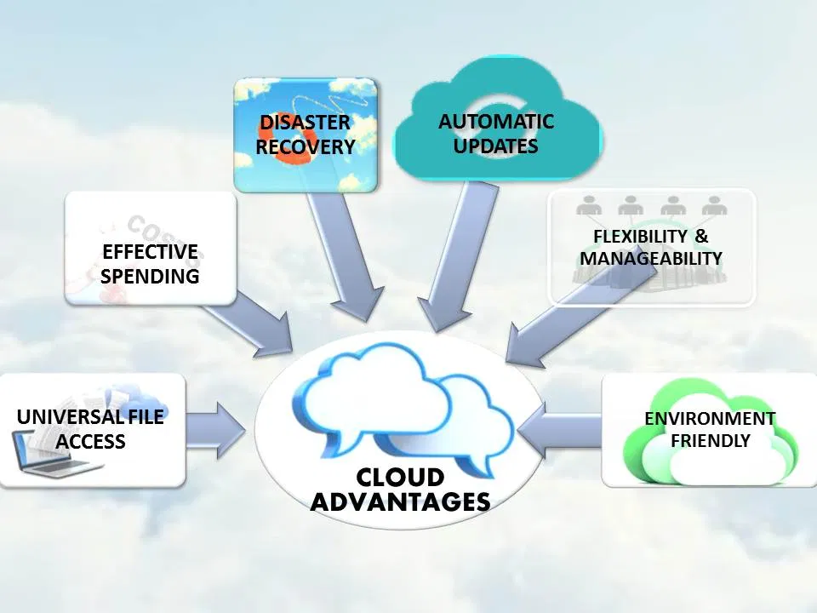

Figure 1.3: Cloud benefits
So as to satisfy expanding need for cloud services new datacenters might be built, or the capacities or existing datacenters might be extended. Be that as it may, extending datacenter ability isn't generally doable because of efficient and physical imperatives, for example, fixed limit of intensity creating offices and restricted attainable worker thickness [106]. Building new datacenters can cost a huge number of dollars, essentially expanding the complete expense of proprietorship, both regarding capital consumption (capex) needed to develop another office and summit needed to run the datacenter [106]. An option in contrast to growing existing datacenters or building new datacenters is to examine and recognize wellsprings of failures in order to improve the abilities of existing offices.
There are a few reasons why the expenses related with the vitality utilization of a datacenter might be higher than should be expected. The chief explanation is the problematic utilization of vitality by sub-segments of datacenters, bringing about vitality misfortune or vitality wastage [39]. Vitality misfortune alludes to vitality provided to the framework that isn't directly absorbed by computing activities, such as energy loss due to impact transfer and change, cooling, lighting, and so forth. The Power Usage Effectiveness (PUE) indicator is typically used to estimate energy misfortune. The PUE statistic compares the total force consumed by an office (including employees, network hardware, and storage devices) to the total force consumed by IT equipment. Figure 1.3 displays the typical distribution of energy usage in a conventional datacenter with a PUE of 2. A PUE of 2 indicates the datacenter consumes twice as much energy as is necessary solely to manage the employees, meaning that the IT equipment uses up half of the total office electricity and the remaining half is an overhead.
Low IT asset use in datacenters is another cause of vitality deficiency. Only 45% of the available memory and less than 20% of the CPU were regularly used, according to an analysis of a large Twitter group [62]. For workplaces that don't compile the remaining tasks at hand, usage indicators are considerably lower (5 to 12%) [157].
Explanations for low consumption in a cloud infrastructure include: the use of coarse-grained asset distribution [152], execution disengagement issues [62], and over-provisioning of assets to allow applications to remain responsive despite fluctuations in the number of clients. Since universally beneficial workers in datacenters don't work in a vitality related way and can be shifted from one computer to the next without having any effect, low asset utilization leads to helpless vitality proficiency. Whether or not you are scaling, this provides a ton of benefits.
- STORAGE IN THE PUBLIC CLOUD
This is a cloud service that doesn't need much supervision and can be accessed online by anyone you give permission to. You get the same level of security, but you don't have to worry as much about keeping the system up to date as you would with a private cloud. You don't have to worry about an inflexible balance between your business wants and your private storage worries.
Google, Amazon, Microsoft, and others offer public cloud services that can be used right away. Public cloud services offer infrastructure and services to the public, and you or your company can get a piece of that infrastructure and organization. People share assets with hundreds or thousands of other people. Public cloud services are things like Gmail and U of I Box. In April 2017, Google said that it had 1 billion monthly users. Your email account is protected by a password, but the computer that stores it is used by more than a billion other people.
You benefit from sharing the assets of different organizations because the consistency of rules and infrastructure investments are probably better than what the average SMB could get. Several things stand out about the public cloud:
• Very flexible
• Cost-effective
• Dependable
• Expert observation
• No help needed
- SELECTION OF A CLOUD PROVIDER
Following your decision on the type of cloud service you should use, you must select the supplier. This can be a difficult decision, but our experts in cloud storage have completed a quality assessment of each cloud service. The primary experts organized our quality evaluation, and we narrowed down the lengthy number of cloud providers to the top ten services based on a wide range of models. You can read our various articles to learn about the methods we employ to evaluate these cloud service providers. We even offer a tool that you can use to compare and choose amongst your chosen vendors or find the services that can help you with your problems. Nevertheless, the clouds on our list of the top clouds offer the greatest services and are simple to use. Customers can store and sync their data to an online worker using cloud storage. The fact that files are stored in the cloud rather than on a local device allows for cross-platform access. This enables access to files from many PCs, just like mobile devices allow for viewing, editing, and commenting on files. Workarounds like messaging your own archives are replaced by it. Your hard drive's backup system can be complemented with cloud storage. A wide range of file types are supported by cloud storage systems. Regularly upload files to include:
Text records, images, videos, and audio files are all included.
The most user-friendly cloud storage frameworks combine with many programs to provide quick alterations, playing, and sharing. People use cloud storage to manage their own information, and businesses use it for file sharing and backup. While certain qualities may not be relevant to people, they are crucial to organizations. For example, administrator and security features are designed for corporate projects where information security and accessibility are concerns for files stored in the cloud.
- Service Models

When a cloud is built, the economic models used to provide its cloud computing services can vary based on requirements. The most prevalent service models in use (see Figure 1) are referred to as:
Software as a Service (SaaS) – A subscription fee is typically required to use a service or program that is hosted in the cloud. As was mentioned before, Salesforce.com is a good example of this because it stores all of the data needed to handle customer support interactions in the cloud. As part of the cloud computing option for Microsoft® Office 2010, Microsoft is expanding its presence in this market and making its Office Web Apps available to customers through its cloud-based Online Services.
Platform as a Service (PaaS)- allows customers, for a fee, to host their own apps and services on the cloud. There may be restrictions on what kinds of apps can be installed, and the user has no control over the underlying operating system or the network connection.
Infrastructure as a services (IaaS) Customers manage and control the systems in terms of the operating systems, applications, storage, and network connectivity through infrastructure as a service (IaaS), but they do not manage the cloud infrastructure themselves.

TABLE I SERVICE MODELS
Service  Models | Who uses it? | Examples
Software as a Service (SaaS) | Business  Users | E-mail, Virtual desktop, communication games
Platform as a Service (PaaS) | Developers  and  Deployers | Executable  runtime, databases, webservers
Infrastructure as a service (IaaS) | System  Managers | Virtual  machines, servers, storage, load  balancers, networks

- HYBRID CLOUD STORAGE
Hybrid cloud storage combines public and private clouds. The mentioned storage framework uses public and private cloud storage according to their benefits and utilization. Private clouds store basic and business data, while public clouds exchange additional data. Hybrid cloud storage has all the benefits of regular cloud storage. Security, transmission capacity, IP, control, etc. This cloud storage system efficiently manages company data. Server farms become more flexible, reliable, and financially savvy. Hybrid cloud storage is a straightforward way for managing local and off-site assets. It uses cloud apps, storage equipment, and infrastructure to create coordinated storage engineering. Hybrid cloud infrastructure and machines depend on SaaS applications. "Storage as a Service" virtualizes public cloud data and increases security. PO, KPO, E-Commerce, and other companies must maintain large data bases. Thus, such organizations use hybrid cloud storage to adjust the cutoff and kind of data stored for private or public. Such a large organization needs an online reinforcement service that automatically updates information. Hybrid cloud storage provides all the features and services such enterprises need. Security, data transport, IP, control, reinforcement, etc.
Hybrid cloud design:
Building up a hybrid cloud requires the accessibility of:
• A public infrastructure as a service (IaaS) platform like Amazon Web Services, Microsoft Azure, or Google Cloud Platform; the development of a private cloud, either on premises or through a facilitated private cloud supplier; and enough wide area network (WAN) between those two situations.
A business may use a public cloud for process examples, storage, or other services like massive data analysis clusters or serverless figure capacities.
However, an organization has no immediate control over public cloud design, therefore a hybrid cloud association must model its private cloud to match the ideal public cloud or clouds. The worker ranch needs workers, stockpiles, LANs, and weight balancers.
A virtualization layer, or hypervisor, is then needed to create and support virtual machines (VMs) and sometimes partitions. IT groups must then offer a private cloud programming layer, such as OpenStack, on top of the hypervisor to provide cloud capabilities like self-management, robotization and association, constant quality and quality, and billing and chargeback. Private cloud modelers usually offer a menu of nearby services, such as measure cases or data base cases.
Hybrid clouds work best when the hypervisor and cloud programming layers are compatible with the desired public cloud's APIs and services. Events migrate reliably across private and public clouds using realistic programming and services. A professional can also create complex apps leveraging public and private services and resources.
Hybrid cloud advantages and use cases
Hybrid cloud computing empowers an endeavor to convey an on-premises private cloud to have touchy or basic outstanding burdens, and utilize an outsider public cloud supplier to have less-basic assets, for example, test and improvement remaining tasks at hand.
Hybrid cloud is likewise especially important for dynamic or profoundly alterable remaining tasks at hand. For instance, a conditional request passage framework that encounters noteworthy interest spikes around the Christmas season is a decent hybrid cloud applicant. The application could run in private cloud, however use cloud blasting to get to extra computing assets from a public cloud when computing requests spike.
Large-scale data preparation is another application for hybrid clouds. Hybrid cloud storage can be used to store a company's business, sales, test, and other data, and then exploratory questions can be conducted in the public cloud, which can grow a Hadoop or other examination bunch to assist demanding distributed computing tasks. A business can use a wider variety of IT services thanks to the flexibility provided by the hybrid cloud. A company might, for instance, keep a critical backend process running in a private cloud while also making use of a public cloud provider's data storage and analysis capabilities.
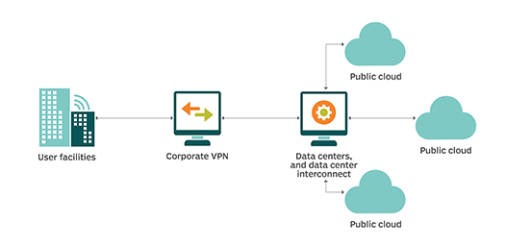
Figure 1.4: Architecture of Hybrid cloud
Hybrid cloud difficulties
Despite its benefits, hybrid cloud computing might cause commercial, board, and specialized issues. Hybrid cloud involves API similarity and robust organization network since private cloud burdens must access and cooperate with public cloud suppliers.
Hybrid cloud public cloud availability, service-level agreements (SLAs), and other service outages are possible. Hybrid cloud projects that interoperate with public cloud providers help mitigate these risks. This can complicate task planning and testing. Sometimes a company must enhance hybrid cloud workloads to handle public cloud APIs.
Hybrid cloud computing requires skilled local IT and cloud planners to build and maintain the private cloud. Databases, helpdesk systems, and other software can confuse a private cloud. The project is responsible for private cloud technical support and must eventually adopt public cloud APIs and service updates.
Hybrid cloud executive devices
Embedded devices like B. Egenera PAN Cloud Director, Right Scale Cloud Management, Cisco Cloud Center, and Scalar Enterprise Cloud Management Platform let firms create work processes, service inventories, load, and hybrid cloud-identified companies. BMC Cloud Lifecycle Management, IBM Cloud Orchestrator, Abiquo Hybrid Cloud, Red Hat Cloud Forms, and VMware vCloud Suite are also hybrid cloud appliances. Given the variety of options, users should thoroughly test and assess applications for hybrid cloud status before committing to a device.

- CLOUD COMPUTING IN SOCIAL NETWORKING SITES

Facebook: There were 1.39 billion energetic users of this social media platform as of December 2014. It gives users a personal space to share information and media, notifies them when friends like and comment on their posts, facilitates the usage of games and applications, and provides extras like friend lists and discussion forums. [4] Thanks to integration with the personal file storage company Dropbox, Facebook now permits users to share files to Facebook Groups using Dropbox's cloud-based storage service. [5]
Facebook has also collaborated with Heroku, a cloud computing platform that is part of the Dev App. Developers familiar with PHP, Ruby, or Python may get started with Heroku's free starter project and get writing in their preferred language right away. [6]. Community management, content marketing, audience onboarding, and ad tech are all areas where Salesforce.com and Facebook have collaborated.[7]
Twitter: On this social media site, users can talk to their pals and share their thoughts. As of December of 2014, there were 284 million consistent Twitter users.You may read the latest news, Experience the magic of the Oscars and the World Cup from behind the scenes.Through the utilization of various media types, Use hashtags (like #NFL) to find more Tweets on related topics and share them on social media sites like Facebook, WhatsApp, and LINE. Send each other links to videos and photos you've found on YouTube and Instagram.[8]
Advertisers will be able to grow their Twitter campaigns with greater effectiveness through streamlined creative workflows, while brands and agencies will see a boost in return on investment (ROI) from optimized creative, bids, and targeting. [9]
LinkedIn
Users are given access to a profile page where they can keep track of their relationships to other service users. Job advertisements and resume posting are further features. There were more than 200 million users on LinkedIn's network as of January 2013. The architecture of LinkedIn is made up of various elements. Batch processing of off-line data is done with Hadoop, Hive, and Pig for features like People You May Know. The distributed data store Voldemort also powers services like rate limitation and product recommendations. According to Auradkar (2012), LinkedIn has ten Voldemort clusters spread across more than 100 nodes.
YouTube
- YouTube is a video-sharing website where users may add, watch, like, and comment on videos posted by other users. The user's videos and messages are displayed on their profile page. Users can subscribe to one another in order to be notified of updates to the users' videos and comments. Up to 1 billion unique users visit YouTube each and every month. YouTube stores its video content in a delivery cloud for ease of access. YouTube uses two methods to balance the load across this cloud. Based on the user's location, relevant video cache servers are suggested. They can be moved to another cache during peak hours if they are in a high-traffic area. The second method simply transfers control to a different user if the currently used server is overloaded. This distribution cloud features a cache of physical servers, video servers, and dedicated ID storage for videos. The video id is a string of characters that is unique to each video. The video server infrastructure is represented by a set of DNS namespaces, each of which corresponds to one of a set of logical video servers. According to Adhikari (2011), physical servers are organized into a hierarchy of primary, secondary, and tertiary locations to form the physical server cache.
IX. TYPES OF CLOUD STORAGE USED BY PHOTOGRAPHERS
For photographers, there are numerous varieties of cloud storage accessible right now:
Web-based public or community cloud storage allows you to upload data to the cloud using your browser or other third-party application, and then instantaneously access those files through a web-based user interface. Popular photo-sharing services like Flickr and Smugmug employ this technique.
Local/hybrid folder synchronization: A client is installed that keeps an eye out for changes to a certain folder on your machine. Each time a new file is created in that folder, it is immediately uploaded over your Internet connection to the cloud. Services that can do this include Dropbox, Live drive, and Live Mesh, which you may have heard of.
Dedicated/private cloud storage allows you to purchase as much cloud space as you require and utilize it however you see fit. You have two options for uploading your files: manually or by installing client software that automatically syncs selected computer directories. Whether you choose to preserve a local copy of your backup or not is entirely up to you. The space you purchase is exclusively yours; unlike Flickr, it is not shared. Many different businesses, including Amazon, offer cloud storage services. There are many different methods for storing and retrieving data, but using them effectively may call for technical knowledge. This kind of cloud storage can get very pricey depending on how much space you use. Some websites that cater to photographers, like Mosaic Archive, offer direct image uploading using Lightroom. Another variety of cloud storage is geared exclusively toward photographers. A community web-based cloud storage like Photo Shelter, for instance, includes a web-based interface for uploading and downloading files. You can utilize plugins for Aperture and Lightroom to export photos straight into your account, and you can access your account via FTP. The upload of RAW images is also supported. These services are quickly gaining popularity and offer a fantastic substitute for well-known websites like Flickr.
- OPPURTUNIES IN CLOUD COMPUTING
A. Flexibility: Due to the large capacity of the service's remote servers, a cloud-based service can rapidly match the demand. In fact, this adaptability is so essential that, according to a survey by InformationWeek, 65% of respondents cited "the ability to quickly meet business demands" as a key factor in their decision to switch to cloud computing.
B. Disaster recovery: Once businesses begin utilizing cloud-based services, they no longer require elaborate disaster recovery procedures. The majority of problems are handled quickly and efficiently by cloud computing companies. According to research by Aberdeen Group, firms using the cloud were able to address problems on average in 2.1 hours, which is roughly four times quicker than businesses not using the cloud (8 hours). According to the same study, mid-sized enterprises recovered the fastest of all, taking only about half the time of bigger businesses.
C. Automatic software updates: Managing on-site security alone took up 18 working days per month for UK businesses in 2010. However, cloud computing providers handle all server upkeep, including security upgrades, on their own, freeing up their clients' time and resources for other duties.
D. Capital expenditures are not required because cloud computing services are normally pay as you go. Additionally, organizations have low project start-up costs and predictable continuous running costs because to cloud computing's quicker deployment.
E. Improved teamwork: Cloud computing improves teamwork by enabling all workers, no matter where they are, to sync up and work on shared documents and apps simultaneously, as well as follow colleagues and records to get important updates in real time. Companies that engaged in collaborative technology had a 400% return on investment, according to a Frost & Sullivan survey. Work from anywhere: Employees can do business from any location as long as they have access to the internet. The productivity and work-life balance of knowledge workers are favourably impacted by this flexibility. According to one survey, 42% of working adults would forgo some of their earnings and, on average, take a 6% pay decrease if they could telecommute.
F. Document control: A research found that 73% of knowledge workers regularly communicate with individuals from various time zones and geographic locations.If a business doesn't use the cloud, employees are forced to transmit files back and forth via email, which limits how many people may work on a file at once and results in a variety of names and file formats for the same document.With cloud computing, everyone uses a single central copy of all the files that are kept in one place. While working together to make adjustments, employees can even converse with one another. The entire process strengthens collaboration, which boosts productivity and boosts a company's bottom line.
G. Security: Just at airports, almost 800,000 laptops go missing annually. Even if a system malfunctions, data can still be retrieved when it is saved in the cloud, which can have some significant financial implications.
H. Competitiveness: SME access to enterprise-class technology is made possible by the cloud. Additionally, it enables tiny companies to react quicker than powerful, well-established rivals. According to a disaster recovery research, businesses that don't use the cloud are forced to rely on sluggish, arduous tape backup techniques and complicated recovery procedures, which allows David to once again outwit Goliath.
I. Greener: Companies that use cloud computing only use the server space they require, reducing their carbon footprint. When compared to on-site servers, adopting the cloud reduces energy use and carbon emissions by at least 30%. Again, SMEs benefit the most: for small businesses, the reduction in energy use and carbon emissions is about 90%.

- CHALLENGES IN CLOUD COMPUTING

- Privacy and Trust
The lack of privacy on social media platforms is a huge issue. Different social media sites provide varying levels of privacy protection for its users. Some services, like Facebook, encourage the use of real names so that users' online profiles may be linked to their offline ones. Sites like dating ones provide the barest of privacy at best, requiring either a first name or a user-generated handle. Facebook does not provide anonymity but does provide ways to restrict access to only those you approve. Concerns have been raised regarding how these social networking services may use the vast amounts of data their users are supplying and how those details may be shared with third parties. Market researchers could utilize this data to serve more relevant ads to specific consumers. Users' privacy may be at stake because it is unclear what details are being scrubbed from the data before it is made public. Information quality in data analysis and mining may suffer if data is tampered with or omitted. This is due to the fact that individual identities can be established from the structure of the social network graph. These challenges raise questions about how these social media sites balance the needs of its users with those of third-party data consumers. That year's Bianco.
- Ownership of Content
The vast majority of the data on social networking services is produced by users. Different social networking platforms have various rules. Facebook, for instance, states in its policies that it will use user information for marketing purposes or in conjunction with its service. When dealing with objects like photos, the content is kept private if the user's preferences have been set to private. However, unlike the image-sharing website Flickr, Facebook does not offer a wide range of copyright settings or preferences. With Flickr, users can set various rules using licenses, such as no derivative works or creative commons. Although license agreements based on the use of the services' network may permit these sites to store data even after users initiate removal or deletion, users may still be the proprietors of this data (McCarthy, 2009)
- Data Retention and Failures in the Cloud
Although cloud technologies offer many benefits, there are a number of issues with data centralization and data control on the cloud. There isn't much that can be done to restore important data that has been lost in the cloud. This is the same as the conventional model where the organization itself manages the data. Organizations must, however, have faith in the cloud service provider to correctly manage the data because, when sending that data into the cloud, they give up some of their control. In 2009, the social bookmarking service Ma.gnolia experienced system failures on both its primary and backup servers, ultimately erasing all user data (Bianco, 2009). This is one example of a similar disaster.

References

- Adhikari, V K., Jain, S., & Zhi-Li, Z. (2011). Where Do You “Tube”? Uncovering YouTube Server Selection Strategy. Computer Communications and Networks (ICCCN), 2011 Proceedings of 20th International Conference on (pp. 1-6). http://dx.doi.org/10.1109/ICCCN.2011.6006028
- Behl, A. (2011, December). Emerging security challenges in cloud computing: An insight to cloud security challenges and their mitigation. In Information and Communication Technologies (WICT), 2011 World Congress on (pp. 217-222). IEEE. http://dx.doi.org/10.1109/WICT.2011.6141247
- Bianco, J. (2009). Social Networking and Cloud Computing: Precarious Affordances for the ‘Prosumer’.
- Cassavoy, L. (n.d.). Box.net OpenBox Service: Facebook. Retrieved March 22, 2011, from http://www.pcworld.com/article/233949/boxnet_openbox_service_facebook.html
- Chard, K., Caton, S., Rana, O., & Bubendorfer, K. (2010, July). Social cloud: Cloud computing in social networks. In Cloud Computing (CLOUD), 2010 IEEE 3rd International Conference on (pp. 99-106). IEEE. http://dx.doi.org/10.1109/CLOUD.2010.28
- Chiguluri, S., & Parsamyan, G. (2012). How eHarmony Turns Big Data into True Love. Retrieved from https://community.informatica.com/mpresources/Communities/IW2012/Docs/bos_65.pdf
- Falahi, K. A., Atif, Y., & Elnaffar, S. (2010, December). Social networks: Challenges and new opportunities. In
- Proceedings of the 2010 IEEE/ACM Int’l Conference on Green Computing and Communications & Int’l Conference on Cyber, Physical and Social Computing (pp. 804-808). IEEE Computer Society. http://dx.doi.org/10.1109/GreenCom-CPSCom.2010.14
- Lee, C. (n.d.). Facebook and Heroku: an even easier way to get started. Retrieved September 2011, from http://developers.facebook.com/blog/post/558/
- McCarthy, C. (2009). Facebook faces furor over content rights. Retrieved from http://www.cnn.com/2009/TECH/02/17/facebook.terms.service/
- Menon, A. (2012). Big data @ facebook. In Proceedings of the 2012 workshop on Management of big data systems (MBDS '12) (pp. 31-32). New York, NY, USA: ACM. http://dx.doi.org/10.1145/2378356.2378364
- Motta, G., Sfondrini, N., & Sacco, D. (2012, May). Cloud Computing: An Architectural and Technological Overview. In Service Sciences (IJCSS), 2012 International Joint Conference on (pp. 23-27). IEEE. http://dx.doi.org/10.1109/IJCSS.2012.37
- Pattishall, D. (2008). Federation at Flickr: Doing Billions of Queries per Day. Retrieved from http://www.scribd.com/doc/2592098/DVPmysqlucFederation-at-Flickr-Doing-Billions-of-Queries-Per-Day
- Ryaboy, D. (n.d.). Twitter at the Hadoop Summit. Retrieved June 2012, from http://engineering.twitter.com/2012/06/twitter-at-hadoop-summit.html
- Taylor, C. (n.d.). Facebook Integrates With Dropbox to Power File-Sharing Within Facebook Groups. Retrieved September 26, 2012, from http://techcrunch.com/2012/09/26/facebook-integrates-with-dropbox-to-power- file-sharing-within-facebook-groups/
- Ting, I. H., Lin, C. H., & Wang, C. S. (2011, July). Constructing A Cloud Computing Based Social Networks Data Warehousing and Analyzing System. In Advances in Social Networks Analysis and Mining (ASONAM), 2011 International Conference on (pp. 735-740). IEEE.
- http://dx.doi.org/10.1109/10.1109/ASONAM.2011.25
- Tran, D. H., Nguyen, H. L., Zha, W., & Ng, W. K. (2011, December). Towards security in sharing data on cloud-based social networks. In Information, Communications and Signal Processing (ICICS) 2011 8th International Conference on (pp. 1-5). IEEE. http://dx.doi.org/10.1109/ICICS.2011.6173582
- Vakali, A., Giatsoglou, M., & Antaris, S. (2012, April). Social networking trends and dynamics detection via a cloud-based framework design. In Proceedings of the 21st international conference companion on World Wide Web (pp. 1213-1220). ACM. http://dx.doi.org/10.1145/2187980.2188263
- Wooten, R., Klink, R., Sinek, F., Bai, Y., & Sharma, M. (2012, May). Design and Implementation of a Secure Healthcare Social Cloud System. In Cluster, Cloud and Grid Computing (CCGrid), 2012 12th IEEE/ACM International Symposium on (pp. 805-810). IEEE. http://dx.doi.org/10.1109/CCGrid.2012.131

