**Recent Trends in Artificial Intelligence and IoT based Air Quality Monitoring System – A Review**

**S. G. Karad Dr. D. S. Karanjkar S. G. Hingmire S. S. Swami**

**Dr. Babasaheb Ambedkar Technological University, Lonere, Raigad, Maharashtra**

**ABSTRACT**

Systems for monitoring air quality are essential for determining and controlling the effects of air pollution on the environment and human health. The significance of air quality monitoring and the many technologies used for it are discussed in this study. It goes over the need of keeping an eye on air pollutants such particulate matter, gases, and volatile organic compounds as well as their consequences on ecosystems and human health. The study examines current developments in artificial intelligence (AI) and Internet of Things (IoT) based air quality monitoring devices. The need of reliable and accurate air quality monitoring systems is emphasised in the paper's conclusion in order to ensure effective pollution management methods, sustainable development, and community well-being.

1. **INTRODUCTION**

Due to its adverse impact on human health, the environment, and general quality of life, air pollution is an increasing global concern. Numerous pollutants have been released into the atmosphere as a result of rapid industrialisation, urbanisation, and increased vehicle emissions, posing serious hazards to human health and ecosystems. As a result, there is a critical need for efficient air quality monitoring devices.

Air pollution has grown to be one of the biggest issues because of the number of cars on the road today, as well as the consequences of industry and urbanisation. An air quality indicator that may be frequently utilised is the Air Excellence Guide (AEG). Air pollutants including CO and NO2 molecules that are harmful to the environment and human health make up the computation and basis of the Air Quality Indicator (AQI). The Air Quality Indicator's range might offer the finest representation of a particular air unused matter at any given time.

The assessment and management of air pollution levels, the identification of pollution sources, and the development of effective mitigation methods all depend heavily on air quality monitoring systems. These systems offer useful information on the levels of contaminants, their distribution over space and time, and any potential effects they may have on the environment and human health. Policymakers and authorities can protect the public's health, uphold legal requirements, and encourage sustainable development by keeping an eye on the air quality and using that information to inform their decisions.

Their variety and detrimental impacts serve as a reminder of the significance of monitoring air pollution. Fine particles suspended in the air, known as particulate matter (PM), can enter the respiratory system deeply and cause cardiovascular and respiratory disorders. Gaseous pollutants, including ozone (O3), nitrogen dioxide (NO2), and sulphur dioxide (SO2), can cause smog and have serious effects on respiratory health. Including eye and throat discomfort, nausea, and even cancer, volatile organic compounds (VOCs) released by industrial processes and automobile exhaust can have both immediate and long-term health impacts.

Systems for monitoring the quality of the air are essential for regulatory compliance as well as protecting human health. To safeguard the environment and the general public's health, governments and environmental organisations set air quality guidelines. Monitoring makes it possible to evaluate whether these requirements are being followed, allowing policymakers to take the appropriate action to lower pollution levels. This guarantees that businesses, transportation networks, and other sources of pollution abide by the established restrictions and implement the necessary pollution control methods.

In addition, air quality monitoring is necessary for infrastructure development and urban planning. Urban planners can identify regions with low air quality and evaluate the efficacy of pollution mitigation strategies by analysing air quality data. This knowledge can help to prioritise initiatives like increasing green spaces, putting in place effective transportation networks, and designing sustainable cities.

Systems for monitoring air quality help scientists gain a better knowledge of the trends, patterns, and effects of air pollution. Researchers examine monitoring data to determine the efficacy of pollution control measures, research the long-term impacts of exposure to pollutants, and create cutting-edge models for forecasting changes in air quality. The creation of evidence-based policies and strategies for efficient pollution management is supported by this information.

This chapter aims to provide an overview of air quality monitoring systems. It will discuss the IoT, AI and Arduino based monitoring systems. Section 2 of the chapter discuss important components of air quality measurement system. Various air quality parameters are discussed in section 3 of this chapter. IoT based Air Quality Monitoring System (AQMS) are presented in section 4 whereas section 5 discussed various AI assisted air quality systems.

1. **IMPORTANT COMPONENTS OF AIR QUALITY MONITORING SYSTEM**

An air quality monitoring system typically consists of several important components that work together to measure, collect, analyze, and report air quality data. The key components of an air quality monitoring system include:

1. Sensors: Sensors are the primary components that detect and measure various air pollutants. Different types of sensors are used to measure parameters such as particulate matter (PM), gases (e.g., nitrogen dioxide, sulfur dioxide, ozone), volatile organic compounds (VOCs), and other specific pollutants. These sensors employ various technologies such as optical, electrochemical, and catalytic methods to accurately measure pollutant concentrations.
2. Data Collection and Transmission: This component involves the collection of data from the sensors. Data loggers or data acquisition systems are used to record the measurements from the sensors at regular intervals. The collected data may be transmitted in real-time or stored locally for later retrieval and analysis. Transmission methods can include wired connections, wireless networks, or satellite communication, depending on the monitoring system's design and requirements.
3. Quality Assurance and Control: To ensure the reliability and accuracy of the collected data, quality assurance and control measures are implemented. This includes regular calibration of sensors, routine maintenance, and periodic checks to verify the accuracy and precision of the measurements. Quality control procedures help identify and address any issues or drift in the sensor performance, ensuring the integrity of the collected air quality data.
4. Data Analysis and Processing: The collected air quality data undergoes analysis and processing to derive meaningful information. Data analysis techniques may include statistical analysis, data mining, machine learning, and modeling approaches. These analyses help identify pollution trends, spatial and temporal variations, and correlations between pollutants. The processed data can provide valuable insights for decision-making, policy development, and identifying sources of pollution.
5. Reporting and Visualization: Air quality monitoring systems often include reporting and visualization capabilities to communicate the data effectively. This component involves generating reports, graphical representations, and visualizations that present the air quality information in a user-friendly manner. This can include maps, charts, graphs, and other visual displays that help stakeholders, policymakers, and the public understand the air quality status and trends.
6. Integration with Information Systems: Air quality monitoring systems are often integrated with larger information systems or platforms for data management and dissemination. This integration allows seamless data sharing, storage, and retrieval. It also enables integration with other environmental and health databases, facilitating comprehensive analysis and decision-making across different domains.
7. Communication and Alert Systems: A critical component of air quality monitoring systems is the ability to communicate air quality information to relevant stakeholders and the public. This may involve real-time alerts, notifications, or public announcements in cases of high pollution levels or health risks. Communication systems can utilize various channels, including websites, mobile applications, social media platforms, and even traditional media outlets.

Figure 1 shows the block schematic of air quality monitoring systems.

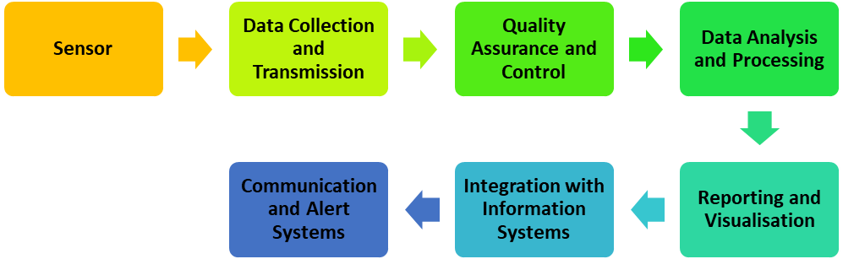

**Fig. 1 Block Schematic of Air Quality Monitoring Systems**

By integrating these components effectively, air quality monitoring systems enable the measurement, analysis, and communication of air quality data, facilitating informed decision-making, pollution control, and the protection of public health and the environment.

1. **AIR QUALITY PARAMETERS**

The important air quality parameters that plays vital role in the monitoring systems include:

* Carbon Dioxide (CO2) – CO2 is a gas that has no colour, no smell, and cannot burn. Additionally, it is measured within the category of smother gases, which have the capacity to interfere with the tissues' ability to get oxygen. Because it is one of the most important elements in the developing photosynthesis process, which transforms solar energy into chemical energy, carbon dioxide is a gas that is essential to life as we know it.
* Sulphur Dioxide (SO2) – Sulphur dioxide is a colourless gas that has a recognisable smell and taste. Similar to CO2, it is mostly caused by the combustion of fossil fuels and industrial operations. High attention levels, especially in sensitive populations like asthmatics, may result in respiratory issues. It makes an impact on acid rain.
* Nitrogen Dioxide (NO2) – Nitrogen dioxide is a brownish gas that is extremely corrosive and highly oxidant. It is a byproduct of the burning of fossil fuels. Frequently, chemical mechanisms turn NO into NO2 once it is released into the atmosphere. High absorptions of NO2 may be the cause of respiratory issues. Similar to SO2, it causes acid rain.
* Smoke – About 1 million people are in custom of tobacco smoking globally of which majority Population is from rising countries.
* Temperature and humidity play a significant role in human safety and have an impact on our ability to function in daily life. By measuring temperature and comparing historical and contemporary temperature variations, particularly since the industrial revolution, greenhouse effects can be shown. A particular form of gas called humidity protects us from the sun's UV rays and helps Earth's atmosphere retain heat, making the planet's environment comfortable for life. However, when humidity rises, Earth's temperature rises as well, making life on Earth miserable. For many storage and food processing facilities, humidity is crucial.

1. **INTERNET OF THINGS (IOT) BASED SYSTEMS**

IoT is becoming more and more popular, and standards are soon to follow. As a result, gathering data on air quality is simpler. We can evaluate how terrible air pollution is on a daily basis through the analysis of monitoring data. a huge network of "Things" connected by the Internet of Things, numbering in the billions or trillions. The Internet of Things (IoT) involves the development of new communication modes and a complete utilisation of existing technologies, not a rebel revolution against them. By bringing together several ideas and technical elements, such as pervasive networks, fewer devices, mobile communication, and new ecosystems, the Internet of Things (IoT) combines the virtual and physical worlds. IoT involves the structural planning and use of applications, services, middleware components, networks, and end nodes in whole new ways. IoT offers a way to examine complex processes and transactions. The Internet of items (IoT) suggests symbiotic connectivity between the physical and digital worlds: items acquire context awareness and have digital counterparts for real objects.

A real-time Air Quality Monitoring System (AQMS) design that uses cloud computing and the Internet of Things (IoT) is provided in [1]. AQMS is self-powered and environmentally friendly because it operates independently and autonomously using a solar panel and battery pack. AVR Microcontroller (Atmega32) and GSM Modem (Sim900) are the foundations of AQMS, which uses them to connect to cloud applications. Around 50 of these devices can be deployed on roundabouts in commercial, residential, and industrial locations thanks to the design's low cost and scalability. The AQMS will collect data on a regular basis, and as that data grows after a month or a year, cloud applications will be able to use data mining, data analytics, and AI to gain insights from the data. This will enable Root Cause Analysis (RCA), high-level decision-making, and control strategies, which will help to mitigate airborne pollution and keep the city clean and green.

Our comprehension of the monitoring and administration of AQ may be improved by a thorough analysis of the various sensors and AQ management systems given in [2]. As a result, the current analysis provides information on the sensors and systems that are available for AQ evaluation, management, and monitoring. a vapour Based on our own conceptualization of five key categories, we examined the various sensors and systems available for managing air quality, including ground-based AQS (wet chemistry) systems, ground-based digital sensors systems, aerial sensors systems, satellite-based sensors systems, and integrated systems.

The proposed pollution monitoring system in [3] includes sensors for temperature, humidity, suspended particulate matter (SPM), NOx, and CO. Commercially available standard pollution gas sensors built into a mote have been used to create the whole state-of-the-art monitoring system. To create the measurements of sensing employed in the built network, a precise LabVIEW programme is created. IoT allows for system monitoring from a distance. Due to the advancement of technology, there is a tendency for gadgets to become smaller, which necessitates the development of robust, expensive sensors with low power requirements. As a result, Wireless Sensor Networks (WSN) have become more important in a variety of applications, including farming, domestic life, business, and environmental monitoring.

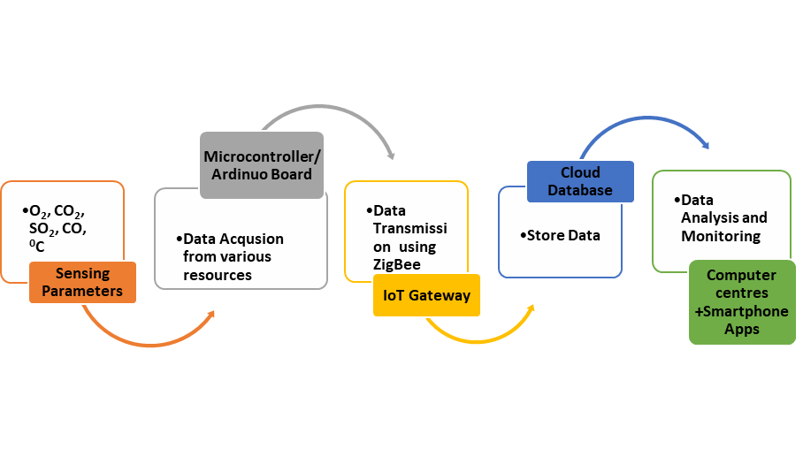

**Fig. 2 IoT based AQMS**

A web server and the "Smart-Air" air quality sensor comprise an IoT-based indoor air quality monitoring platform that is shown in [4]. This platform uses cloud computing and the IoT sensors to track indoor air quality at any time. A Smart-Air was created to effectively monitor air quality and send data to a web server through LTE in real time. Additionally, testing using the platform were carried out and showed that it performed as expected and was user-friendly.

Presented in [5] is an IoT architecture that regular people, without the necessary engineering expertise, can utilise to conduct an environmental monitoring research. Users have the option to add or subtract sensors from this architecture based on their own needs. A case study of an open-plan office with a variety of sensors for monitoring various IAQ and thermal comfort parameters has been used to illustrate this.



**Fig. 3 Configuration of IoT based Indoor Air Quality Monitoring System [4]**

Living things as well as the entire ecosystem are dangerously at risk from air pollution. In [6], a self-configurable air pollution monitoring system is created that uses Internet of Things (IoT) and data mining technologies to track and forecast air pollution. The device's self-configurability is its capacity to adjust monitoring frequency in accordance with pollution estimates. Regression is a data mining approach used to forecast the degree of pollution. The device's mode of operation is then determined by these expected values. MATLAB is used to perform additional analysis on the monitored data sent to ThingSpeak.

Real-time air quality monitoring system at a minimal cost is designed in [7]. For the purpose of monitoring gaseous contaminants, the system makes use of carbon monoxide and air quality sensors. Additionally, the system makes use of an Arduino Nano development board with a WiFi module to efficiently transmit readings to a ThingSpeak internet channel platform for immediate and real-time air quality display. The ThingSpeak uses HTTP protocols to send emails to inform people about the bad air. With the use of ThingSpeak, the level of focus is graphically tracked through channels to facilitate distant communication. A cutoff point is established. As a result, the system triggers an alarm and alerts the authorities through email when contaminants reach unhealthy and dangerous levels.

The authors in [8] describes the development of an air quality monitoring system utilising an Arduino microcontroller to measure the various atmospheric factors, including carbon monoxide, temperature, humidity, and methane, using the appropriate sensors. In order to analyse the results, the measurements were made using parts per million (PPM) metrics, and the data were gathered using sensors-based LCD/serial monitors. The user can have a better knowledge of the pollutant level in the air and take the necessary action by using both graphical and numerical representations of findings.

1. **AI BASED SYSTEMS**

An Artificial Intelligence utilizes experimental or theoretical prediction analysis, expected atmosphere automatic checking systems have sky-scraping accurateness, so far huge data collection and cost effective with multiple channels to perform unique outstanding roof, make it enormous balanced predictions, in the way intelligent agent prediction method to communicate with the Internet of Things (IoT) into the field of environmental online or offline resources from various real-time operations sources like pollution calculations in current and existing environment, in these paper advance a sorting of continuous air pollution observe and monitor by utilize Internet of Things, proposed system container reduce the necessary equipment real-time cost into 2/3 since in past, required disaster convey procedures know how to be in use to boundary misfortune in practical request.

Authors in [9] introduced an outline of the outcome of Artificial Intelligence measures scheduled the classification and upgrading of Environmental Decision Support Systems (EDSS), a powerful insurance of our condition be near a great extent conditional on the environment of the nearby statistics used near resolve on a proper preference.

In order to inform residents of the dangers posed by the air they breathe, it is crucial to regularly monitor the air quality in metropolitan areas. However, due to their high costs, establishing conventional monitoring networks would not be practical in developing nations. Additionally, in order to prevent overexposure, it's crucial for the citizen to be aware of the existing and upcoming air quality in his current location. A low-cost approach that has been implemented in Lima city was reported in [10] and is made up of cheap IoT stations, AI models, and a web application that can offer anticipated air quality information in a graphical style (pollution maps).

In [11], a hybrid methodology based on the Internet of Things (IoT) and Artificial Intelligence (AI) is suggested to forecast the Air Quality Index (AQI) using a real-world case study using open data sets. To gather information on air quality, the sensor node is placed across the city. Additionally, this sensor node communicates to the cloud server via a WiFi/5G network built within the raspberry controller in order to collect data at the Firebase Real-Time Database. To monitor the AQI of the areas, carbon monoxide (CO) and fine particulate matter PM2.5 sensors are combined into a sensor node. To eliminate undesired noise from the data gathered by the sensor node, a Kalman filter was also implemented. Various AI based prediction models have been utilised to predict the AQI.

The implementation and strategy for using artificial intelligence (AI) approaches in Internet of Things (IoT)-based Air Pollution Monitoring and Forecasting are provided in [12]. Also developed was an online dashboard for 'firebase' from the Google cloud server for real-time monitoring of Air pollutants (both live and predicted data). Information about the ozone (O3) layer, ammonia (NH3), and carbon monoxide (CO) layers is gathered through IoT-based sensor nodes in the Vijayawada Region. The aforementioned specific air contaminants were predicted using time series modelling techniques such the Naive Bayes Model, Auto Regression Model (AR), Auto Regression Moving Average Model (ARMA), and Auto-Regression Integrating Moving Average Model (ARIMA).

Using machine learning techniques and deep learning approaches, an end-to-end air quality forecasting model for smart city applications was developed in [13]. The air quality data for different pollution markers, including PM2.5, PM10, O3, and CO, were taken into account by the model. The study uses training to estimate the amount of contaminants in the air and emphasises the role of feature optimisation in predicting air quality through feature dimension reductions.

1. **CONCLUSION**

In conclusion, the recent trends in Artificial Intelligence (AI) and Internet of Things (IoT) based Air Quality Monitoring Systems show promising advancements and innovations in the field of environmental monitoring. The integration of AI with IoT has enabled more efficient and accurate data collection, analysis, and interpretation, leading to better insights into air quality conditions.

The use of advanced sensor technologies has made air quality monitoring more accessible and cost-effective, allowing for widespread deployment of monitoring devices in various settings. Real-time data visualization and predictive modeling capabilities have empowered individuals, communities, and policymakers to make informed decisions to safeguard public health and mitigate the impacts of air pollution.

**REFERENCES**

[1] M. Hussain, F. Ghazanfar, S. Aleem, M. Hai, A. Karim, and K. Hussain, “Design of Low Cost, Energy Efficient, IoT Enabled, Air Quality Monitoring System with Cloud Based Data Logging, Analytics and AI,” *2020 Int. Conf. Emerg. Trends Smart Technol. ICETST 2020*, 2020, doi: 10.1109/ICETST49965.2020.9080705.

[2] D. Singh, M. Dahiya, R. Kumar, and C. Nanda, “No Title,” *J. Environ. Manage.*, vol. 289, 2021.

[3] T. H. Mujawar, P. Prabhakar, V. Chaudhary, and L. Deshmukh, “Design and Development of Air Quality Monitoring System for Solapur City Using Smart Technologies: WSN and IoT,” *Intech*, vol. 11, p. 13, 2016, [Online]. Available: https://www.intechopen.com/books/advanced-biometric-technologies/liveness-detection-in-biometrics.

[4] J. Jo, B. Jo, J. Kim, S. Kim, and W. Han, “Development of an IoT-Based indoor air quality monitoring platform,” *J. Sensors*, vol. 2020, pp. 13–15, 2020, doi: 10.1155/2020/8749764.

[5] A. Yasin, J. Delaney, C. T. Cheng, and T. Y. Pang, “The Design and Implementation of an IoT Sensor-Based Indoor Air Quality Monitoring System Using Off-the-Shelf Devices,” *Appl. Sci.*, vol. 12, no. 19, 2022, doi: 10.3390/app12199450.

[6] M. S. Binsy and N. Sampath, *Self Configurable Air Pollution Monitoring System Using IoT and Data Mining Techniques*, vol. 26. Springer International Publishing, 2019.

[7] A. H. Kelechi *et al.*, “Design of a low-cost air quality monitoring system using arduino and thingspeak,” *Comput. Mater. Contin.*, vol. 70, no. 1, pp. 151–169, 2021, doi: 10.32604/cmc.2022.019431.

[8] S. Vishwas *et al.*, “Design and development of arduino based portable air quality monitoring systems,” *1st Odisha Int. Conf. Electr. Power Eng. Commun. Comput. Technol. ODICON 2021*, no. July, 2021, doi: 10.1109/ODICON50556.2021.9428954.

[9] B. Sambana, “An Artificial Intelligence based Air Pollution Prediction and Monitoring System using Internet of Things,” *J. Xidian Univ.*, vol. 14, no. 7, 2020, doi: 10.37896/jxu14.7/187.

[10] L. Montalvo, D. Fosca, D. Paredes, M. Abarca, C. Saito, and E. Villanueva, “An Air Quality Monitoring and Forecasting System for Lima City With Low-Cost Sensors and Artificial Intelligence Models,” *Front. Sustain. Cities*, vol. 4, no. July, pp. 1–15, 2022, doi: 10.3389/frsc.2022.849762.

[11] A. Kataria and V. Puri, “AI- and IoT-based hybrid model for air quality prediction in a smart city with network assistance,” *IET Networks*, vol. 11, no. 6, pp. 221–233, 2022, doi: 10.1049/ntw2.12053.

[12] G. Mani, J. K. Viswanadhapalli, and P. Sriramalakshmi, “AI powered IoT based Real-Time Air Pollution Monitoring and Forecasting,” *J. Phys. Conf. Ser.*, vol. 2115, no. 1, 2021, doi: 10.1088/1742-6596/2115/1/012016.

[13] E. X. Neo *et al.*, “Artificial intelligence-assisted air quality monitoring for smart city management,” *PeerJ Comput. Sci.*, vol. 9, 2023, doi: 10.7717/peerj-cs.1306.