**Comparative Analysis of Mathematical Models for Non-Newtonian Stress Relaxation Flow of Blood in an Artery with Multiple Stenosis**

Goutam Dasa, Bhawna Agrawalb and SanjeetKumarc

*a ,bDepartment of Mathematics,Rabindranath Tagore University, Bhopal (M.P), India*

[*mailmeatgoutam@gmail.com*](mailto:mailmeatgoutam@gmail.com)*,* [*bhawnakhushiagrawal@gmail.com*](mailto:bhawnakhushiagrawal@gmail.com)

*c Department of Mathematics Lakshmi Narain College of Technology & Science, Bhopal (M.P), India*

[*sanjeetkumarmath@gmail.com*](mailto:sanjeetkumarmath@gmail.com)

**Abstract:** In this research, a mathematical model is developed to investigate the stress relaxation flow of blood through a stenosed artery with multiple constrictions. The study derives analytical expressions for flux and velocity, considering suitable boundary conditions. The research conducts a quantitative analysis of flux, flow velocity, resistive impedances, and temporal variations in wall shear stress. The axial velocity is graphically presented for various values of the Jeffrey parameter within the narrowed region of the artery.

**Keywords:** Stress relaxation, tapered artery, multiple constrictions, flux, wall shear stress, axial velocity, Jeffrey parameter.

**Introduction:**

Stenosis refers to the abnormal and unnatural growth inside an artery's lumen, which disrupts the flow pattern. Such constricted arteries can block 50%-90% of the area. The mathematical modeling and analysis of arteries with multiple stenoses are highly valuable for Bio-mathematicians and medical scientists, as they explore various characteristics of blood flow. The main objective of this theoretical research is to investigate the mechanics of non-Newtonian blood flow in an artery with multiple stenoses. This investigation is crucial within the realm of medical sciences, where precise information about various blood flow parameters is lacking.

There is compelling evidence supporting the significant role of fluid dynamics components such as resistance of flow, wall shear stress and apparent viscosity, in the evolution and advancement of arterial stenosis. Recently, numerous theoretical and analytical studies have been conducted on the basis of blood flow within narrow arteries with stenosis, with a predominant focus on non-Newtonian blood behavior. Mathur and Jain (2013) investigated the mathematical model for non-Newtonian flow of blood through arteries with stenosis and blood is considering as a power-law fluid. The results they obtained demonstrated that within the selected non-Newtonian model, both pressure drop and shear stress escalate as the size of the stenosis increases. Ramesh Babu and Savita (2019) studied the flow of Jeffrey fluid through narrow arteries with multiple stenoses, exploring variations in flow velocities and volumetric flow across distinct flow regions under various boundary conditions. Halder et al. (2017) conducted studies on both Newtonian and non-Newtonian pulsatile flows of blood through arterial stenosis. They presented three-dimensional modeling and analyzed the blood flow in stenosed arteries to simulate atherosclerosis artery disease under various pulsatile flow scenarios. Sriyab (2020) analyzed the non-Newtonian behavior of blood and effects of stenotic geometry in arterial stenosis. Their mathematical model considered several stenosis shapes, such as shape of a bell and cosine shape and identified stenosed artery geometry, length of stenosis, stenosis thickness and power law index (in non-Newtonian behavior) as primary factors influencing the flow of blood through the stenosed artery. Shit et al. (2012) conducted a mathematical model for the circulation of blood in constricted, overlapping arteries with changing viscosity. They observed that hematocrit as well as magnetic field and artery shape significantly influenced pressure gradient, velocity profiles and wall shear stress. Blood's variable viscosity was treated as a porous medium, and they analytically solved the problem using the Frobenius method. Nanda and Bose (2012) investigated a mathematical model for flow of blood through the narrow arteries with multiple stenoses. They studied rheological parameters, length of stenosis and fluid yield stress, which strongly influenced flow characteristics both qualitatively and quantitatively. Nanda and Mallik (2012) analyzed a two-phase non-Newtonian fluid model for blood flow through narrow arteries under stenotic conditions. They performed large-scale numerical simulations and developed computer codes to study measurable flow variables with physiological significance. Mandal et. al. (2007) formulated a mathematical framework that accounts for blood's non-Newtonian behavior, employing the comprehensive power-law model which encompasses both shear-thickening and shear-thinning characteristics. Their proposed model considered the pulsating pressure gradients generated by the heart's rhythmic activity, addressing the fluctuating flow within narrowed arteries. The elastic cylindrical tube representing the arterial wall included a stenosis within its inner passage.

The primary aim of this study is to theoretically explore the mathematical modeling of blood flow with non-Newtonian stress relaxation through an artery afflicted by multiple stenosis. The study focuses on deriving analytical results for flow velocity and flux. These analytical expressions are then utilized to examine the variations in flow velocities and volumetric flow across distinct flow regions.

**Mathematical model:**

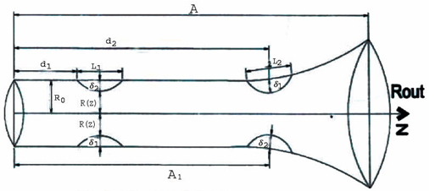

**Figure 1: Physical model of multiple stenosis**

In this scenario, we are examining the steady movement of a Jeffrey fluid within a tube of varying cross-sectional shape, encompassing two gentle and axially symmetric constrictions. In order to depict the tube's shape, we employ a cylindrical polar coordinate system denoted as (r, z). Here, z signifies the dimension along the axis of the tube, while r is oriented perpendicular to the tube's axis. The tube's radius is considered to be...

andwhere

where

 where

where 

where 

 where  (1)

Here, lengths of the two stenoses are (where i=1,2) and the optimal width of two stenoses are (where i=1,2) and the criteria for the mild stenosis are fulfilled.





Where

The fundamental equation governing the flow is...

 (2)

Where is Jeffrey parameter,is the pressure gradient, is the viscosity of the fluid, is the radius of the tube Here, the Jeffrey parameter is represented by  , while signifies the pressure gradient. Additionally, stands for the fluid's viscosity and corresponds to the tube's radius.

The conditions at the boundaries are

 where  (3)

 where  (4)

Introducing the subsequent dimensionless variable

 (5)

Making the governing equations dimensionless by eliminating the bars:

 (6)

The dimensionless boundary conditions are:

 where  (7)

 where  (8)

**Solution of the problem:**

**Velocity Distribution:**

By integrating equation (1) while enforcing boundary conditions (7) and (8), the axial velocity can be derived as follows:

 (9)

The volumetric flow rate is determined as:

 (10)

**Pressure Difference:**

The pressure gradient ∆p across the entire length of the tube is expressed as follows:

 (11)

**Result and Discussion:** We have examined the axial velocity variation as a function of r for different values of the Jeffrey parameter $μ_{1}$, using equation (9) within the constricted regions  and . These results are depicted in figures (2) and (3). Importantly, it was observed that the velocity diminishes with an increase in the Jeffery parameter $μ_{1}$ for both constriction areas.

Furthermore, we derived the volumetric flux in the constricted regionusing equation (10) for various Jeffery parameterand its depiction is visualized in figure 4. The curve adopts an inverted parabolic configuration, and significantly, it is worth noting that the lowest flux rate transpires precisely at the midpoint () of the stenosis.

Similarly, for the constricted region, we computed the volumetric flux across various Jeffery parameters and this is depicted in figure (5). Under these circumstances, the flux rate diminishes as the Jeffery parameter increases within the constricted region.

Volumetric flux is computed across a range of k values, as depicted in figure (6). For numerical computation, it is assumed within the third constricted region that:

 where 

and .

In this observation, we have noted an escalation in flux as the value of k increases. The alteration of Q flow rate concerning various values of Jeffery parameter within the third constricted, as depicted in figure (7). In this instance, it is evident that the flux declines with an escalation in the Jeffery parameter.

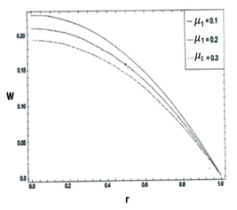

**Figure 2:** Variations of Flow Velocities for various values of Jeffery parameter in first constricted region 

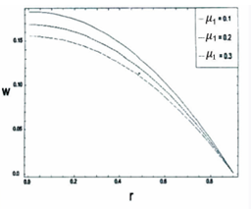

**Figure 3:** Variations of Flow Velocities for various values of Jeffery parameter in second constricted region 

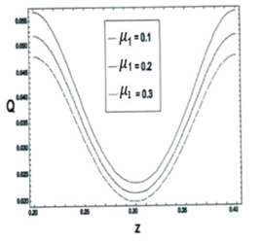

**Figure 4:** Volumetric Flux for various values of Jeffery parameter in first constricted region 

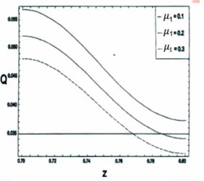

**Figure 5:** Volumetric Flux for various values of Jeffery parameter in second constricted region 

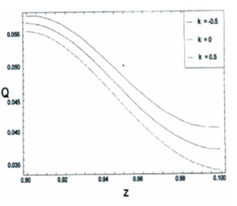

**Figure 6:** Volumetric Flux for various values of  in the third constricted region 

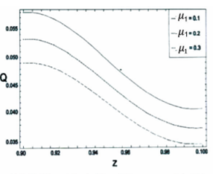

**Figure 7:** Volumetric Flux for various values of Jeffery parameter in the third constricted region 

**References:**

1. Chakravarty, S. and Mandal, P.K. (2000), Two-dimensional blood flow through tapered arteries under stenotic conditions, International Journal of Non-Linear Mechanics, vol. 35(5), pp. 779-793.
2. Dash, R.K., Jayaraman, G. and Mehta, K.N.(1999), Flow in a catheterized curved arterywith stenosis, Journal of Biomechanics, vol. 32(1), pp. 49–61.
3. Diwakar, C. and Kumar, S. (2016), Effects of axially symmetric stenosis on the blood flow in an artery having mild stenosis, International Journal of Mathematics Trends and Technology, vol. 35(3), pp. 163-167.
4. Halder, P., Husain, A.,Zunaid, M. and Samad, A. (2017), Newtonian and non-Newtonian pulsatile flows through an artery with stenosis, The Journal of Engineering Research, vol. 14(2), pp. 191-205.
5. Hye, M.A. and Paul, M.C. (2015), A computational study on spiral blood flow in stenosed arteries with and without an upstream curved section, Applied Mathematical Modelling, vol. 39(16), pp. 4746–4766.
6. Joshi, P., Pathak, A. and Joshi,B.K. (2009), Two-layered model of blood flow through composite stenosed artery, Applications and Applied Mathematics, vol. 4(2), pp. 343-354.
7. Kumar, A. and Awasthi, U. (2010), A mathematical model for blood flow in a multiple stenosis artery, InternationalJournal of Math. Analysis, vol. 4 (50), pp. 2465 – 2472.
8. Kumar, S., Kumar, S. and Kumar, D. (2021), Comparative study of non-Newtonian physiological blood flow through elastic stenotic artery with rigid body stenotic artery, Series on Biomechanics, vol. 34 (4), pp.26-41.
9. Liu,Y. and Liu, W. (2019), Blood ﬂow analysis in tapered stenosed arteries with the inﬂuence of heat and mass transfer, Journal of Applied Mathematics and Computing, vol. 63, pp. 523-541.
10. Mathur, P. and Jain, S. (2013), Mathematical modeling of non-Newtonian blood flow through artery in the presence of stenosis, Advances in Applied Mathematical Biosciences, vol. 4(1), pp. 1-12.
11. Mekheimer, K.S., Haroun, M.H. and Elkot, M.A. (2011), Effects of magnetic ﬁeld, porosity, and wall properties for anisotropically elastic multi-stenosis arteries on blood ﬂow characteristics, Applied Mathematics and Mechanics, vol. 32(3), pp. 1047-1064.
12. Mishra, S., Siddiqui, S.U. and Madhavi, A. (2011), Blood flow through a composite stenosis in an artery with permeable wall, Applications and Applied Mathematics, vol. 6(11), pp. 1798 – 1813.
13. Misra, J.C. and Shit, G.C. (2006), Blood flow through arteries in a pathological state: A theoretical study, International Journal of Engineering Science, vol. 44(10), pp. 662-671.
14. Nanda, S.P. and Bose, R.K. (2012), A mathematical model for blood flow through a narrow artery with multiple stenoses, Journal of Applied Mathematics and Fluid Mechanics, vol. 4(2), pp. 233-242.
15. Nanda, S.P. and Mallik, B.B. (2012), A non-Newtonian two phase fluid model for blood flow through arteries under stenotic condition, International Journal of Pharmacy and Biological Sciences, vol. 2(1), pp. 237-247.
16. Ponalagusamy, R. (2007), Blood Flow through an Artery with Mild Stenosis: A two – layered model, different shapes of stenoses and slip velocity at the wall, Journal of Applied Sciences, vol. 7, pp. 1071-1077.
17. Pralhad, R.N. and Schultz, D.H. (2004), Modeling of arterial stenosis and its applications to blood diseases, Mathematical Biosciences, vol. 190(2), pp. 203-220.
18. Ramesh Babu, V. and Savita, T. (2019), Flow of Jeffrey fluid through an artery with multiple stenosis, International Journal of Engineering Development and Research, vol. 7(2), pp. 473-477.
19. Shah, S.R., Siddiqui, S.U. and Singh, A. (2016), Mathematical modeling and numerical simulation of blood Flow through tapered artery, International Journal of Innovative Science, Engineering & Technology, vol. 3 (2), pp. 710-717.
20. Shit, G. C., Roy, M. and Sinha A. (2012), Mathematical modeling of blood flow through a tapered overlapping stenosed artery with variable viscosity, Applied Bionics and Biomechanics, vol. 11 pp. 185-195.
21. Singh, B., Joshi, P. and Joshi, B.K. (2010), Blood flow through an artery having radially non-symmetric mild stenosis, Applied Mathematical Sciences, vol. 4(22), pp. 1065-1072.
22. Srivastava, V. P. (2003), Flow of a Couple Stress Fluid Representing Blood through Stenotic Vessels with a Peripheral Layer, Indian Journal of Pure and Applied Mathematics, vol. 34, pp. 1727-1740.
23. Srivastava, V. P. and Rastogi, R. (2009), Effects of hematocrit on impedance and shear stress during stenosed artery catheterization, Applications and Applied Mathematics, vol. 4(1), pp. 98-113.
24. Sriyab, S,(2020), The effect of stenotic geometry and non-Newtonian property of blood flow through arterial stenosis, Cardiovascular & Hematological Disorders-Drug Targets, vol. 20(1), pp.16-30.