MICROCANTILEVER FABRICATION AND CHARACTERIZATION FOR BIOSENSING APPLICATIONS
Miranji Katta^{1*}, Sandanalakshmi R², Ravikumar M³, Yamini Komati⁴, Srilakshmi Gubbala⁵
^{1,3,4}Dept. of ECE, Sir C R Reddy College of Engineering, Eluru, Andhra Pradesh-534007, India
^{1,2}Dept. of ECE, Puducherry Technological University, Puducherry, Pondicherry- 605014, India
⁵Dept. of ECE, Vishnu Institute of Technology, Bhimavaram, Andhra Pradesh-534201, India
¹miranji.katta@gmail.com, ²sandanalakshmi@ptuniv.edu.in,³mrk1976@sircrrengg.ac.in⁴ yamini.komati@gmail.com, ⁵srilakshmi.g@vishnu.edu.in
Corresponding Author: miranji.katta@gmail.com
Abstract
In this chapter presents, a micro-cantilever array chip designed using MEMS technology was considered for the development of a biosensor. This device is fabricated with four gold-coating embedded polysilicon layers. The polysilicon coating serves as a piezoresistor, causes quantifiable deformation according to applied tensile and compression forces. The detection range of resistance between 0 and 56 kilo Ohms. It is observe that maximum resistance change is obtained for biotin adsorption concentration greater than 80µg/mL. However, resistance changes related to biotin adsorption is achieved at concentrations. With this experimental analysis the device is found suitable for use as biosensor.
1 Introduction
For the characterization of fabricated biosensor, microcantilevers silicon beam with dimension 225µm×50µm×0.650µm with piezoresistive (W_{pz}) thickness of 30µm has been considered based on the analysis[1]. Using MEMS technology, cantilevers have one end fixed to substrate (Fig 5.1) along with downsizing of plunging width. For the measurement of deflection, optical detection methods are preferred. It is worth noting that even though optical detection is a high resolution technique, high accuracy makes the process expensive[2].
According to [3], the bending of microcantilever develops mechanical stress on the resistive element which develops proportional change in output voltage. So far, piezoresistive microcantilevers have been used for biosensors to give high sensitive transduction[4]. Basically, the surface of the microcantilever has been suitably changed to achieve the target resolution by immobilization of a particular receptor[5].
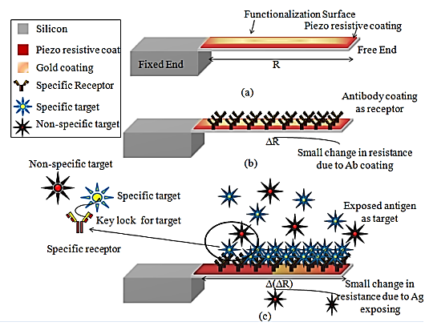
Figure 1: Basic microcantilever functional information (b) Changes in resistance receptor coating and target exposure, and (c) additional changes in cantilever resistance
Principle of Operation
Figure 1 shows that the differential change in the resistance could be monitored for detecting the level of interaction between bio-receptor and target molecule. It is pertinent to note that mechanical bending and change in resistance of the piezoresistor in the microcantilever are due to the forces caused by bio-molecular adsorption [6],[7]. According to [8],[9],[10] bioreceptor immobilization is a significant factor impacting the biosensors. The critical factor for design consideration is the response due to change of resistance caused by biotin absorption.
2. Microcantilever Fabrication Methods
Bulk micromachining, surface micromachining, or a mix of both techniques are frequently used in the fabrication of microcantilevers[10]. A solid structure is removed from the wafer during each micromachining procedure to produce a free-standing beam that is anchored at one end. The cantilever is detached from the substrate of the wafer during bulk micromachining[11]. The cantilever is detached from a surface layer during surface micromachining. It is possible to create a single cantilever or a series of cantilevers using any micromachining technique[12]. The electrical circuitry and other MEMS components necessary to connect with the cantilevers can likewise be manufactured and integrated using these methods[13].
2.1 Piezoresistive microcantilever fabrication
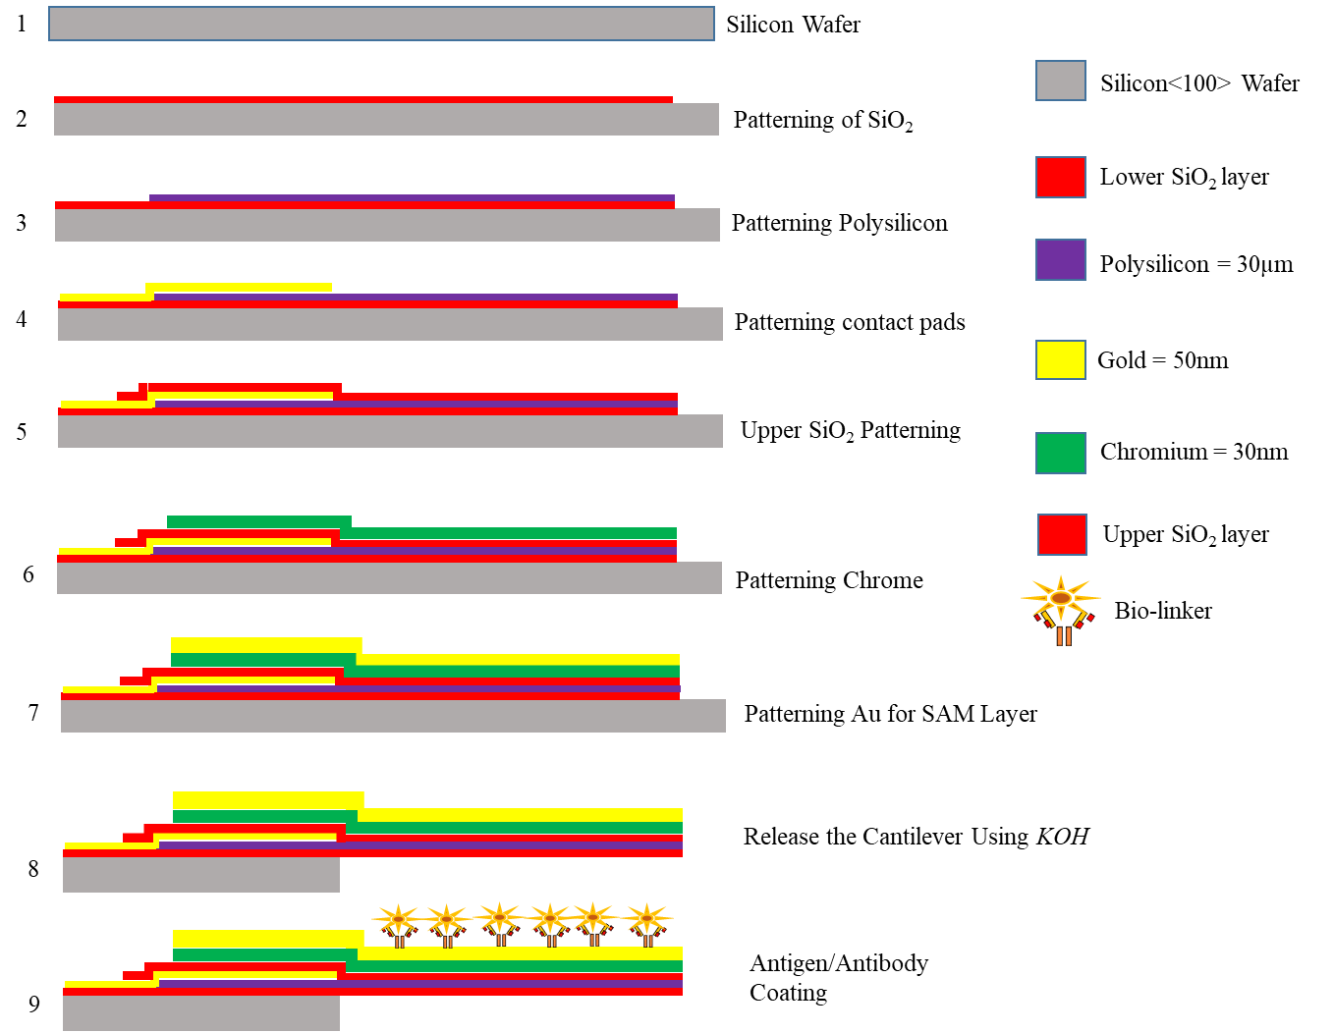
Figure 2: Process flow for fabrication of Piezoresistive microcantilever
Figure 2 shows the conventional flow in fabrication of piezoresistive cantilever based BioMEMS.The micro-machined piezoresistive sensor was developed by the Nano Sniff Technologies. Conventional MEMS fabrication process were used throughout the development process. A P-type silicon substrate with a stack of Si, ${SiO}_{2}$, polysilicon is used to make this cantilever. The top surface of this device needs to be chemically functionalized before it can be used in a BioMEMS application. As a consequence of it is mandatory to apply an Au–Cr coating all over the top surface of the microcantilever to make it biocompatible. The modified microcantilever is made up of a stack of materials with the following composition, as shown in figure 2: Au/Cr/SiO₂/B-doped polysilicon/Si. In order develop structure it is necessary to execute a various procedures, such as depositing, masking, patterning, and etching etc. The process begins with thermal oxidation, which is carried out in an oxidation furnace at a temperature of 1,000°C in order to create a layer of thermally generated silicon dioxide (SiO₂). After this step, the appropriate design is created by the subsequent processes of masking and etching. In the field of photolithography and patterning, it is common practice to carry out a pre-bake at a temperature of 90°C immediately after the spin-coating of the photoresist, and then a post-bake at a temperature of 120°C. After one minute the exposure to ultraviolet (UV) light. A low-pressure carbon dioxide vapour deposition furnace with a boron concentration of 10¹⁸cm⁻³ is used to deposit polysilicon at 630°C. In order to carry out the doping process, the implantation of ions at 35keV is employed. In order to oxidize polysilicon, an oxidation furnace is used, which leads to the formation of the ${SiO}_{2}$layer at the top. The piezoresistor and the Au–Cr layer are kept apart from one another by the top layer of ${SiO}_{2}$, which acts as an electrical barrier between the two layers. This greater ${SiO}_{2}$ layer helps to prevent the piezoresistive layer from accidently shorting out in high wet environment. Gold and chromium are deposited onto the substrate with the help of a portable sputter coater that was built by Milman. The thickness of the gold layer is 50nm, while the thickness of the chromium layer is 30nm. Following the steps outlined in [14], the${ SiO}_{2}$, polysilicon, and Cr–Au etching procedures were carried out using the wet etching technique. The procedure concludes with an etching step performed with potassium hydroxide (KOH). This step serves the purpose of separating the microcantilever beams from the silicon substrate. The method of micromachining that was used was the standard approach for KOH bulk micromachining, and it was performed at a temperature of 85°C in a set up that contained a reflux condenser, so that the concentration of KOH could be maintained at a stable level[15]. The double side-mask aligner is used for both sides of wafer and the KOH etch in order to accomplish the task of releasing the microcantilever that is seen in Figure 2 step 8.
Figure 3 displays both an image of a printed circuit board (PCB) taken with an Optical Microscope (OM) as well as a Field Emission Scanning Electron Microscopy (FESEM) picture of the released Au/Cr/SiO2/B-doped polysilicon/SiO₂ piezoresistive microcantilever structure. The formation of SAM on the Au/Cr thin layer was responsible for the majority of the surface alterations that were observed. After the Au/Cr layer has been deposited, it is imperative that the sensor be calibrated as soon as possible because of the aforementioned reason[16]. According to the findings of recent studies, the thickness of the gold surface may range anywhere from 10 to 200nm. Below 10nm, the thickness of the film is inconsistent, and it may also have a range of other surface imperfections. Additionally, there is a possibility that the film is defective in other ways. As a result of this, an Au/Cr thin layer on top of the piezoresistive MEMS cantilever respectively, with a thickness of 50/30 nm
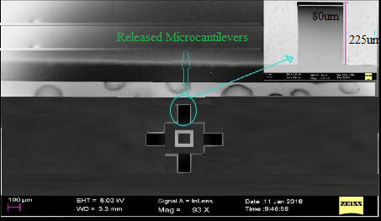
(a)
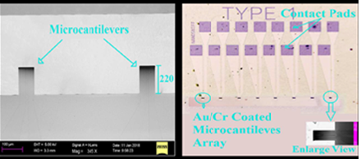
(b)
Figure 3: SEM Images of released microcantilever (a) Microcantilever array
(b) Highlighted microcantilever and contact pads
3. Piezoresistive cantilever calibration
The primary objective of carrying out calibration is to determine the spring constant (stiffness) of the produced piezoresistive cantilever in order to evaluate the device's viability for use in BioMEMS applications. AFM was used to make a thin coating of Au/Cr on the top surface piezoresistive sensors. It is very difficult to calibrate this sort of sensor due to the microcantilevers thinness and fragility. The calibration curves of the piezoresistive MEMS sensors with and without an Au/Cr coating are shown in Fig. 4 for the M1, M2, M6, and M7 microcantilevers, respectively. Table 3 summarises the results of a comparison between the maximum displacement of microcantilevers with and without Au/Cr coating when subjected to a maximum applied force of 512 nN using AFM for the M1, M2, M6, and M7 microcantilevers. The microcantilever begins to deflect the applied force reaches 150–200 nN, as seen in Fig. 4. Also, the AFM tapping mode causes the cantilever to vibrate at first, so it is best to ignore the initial displacement. The linear deflection of these microcantilevers begins with an applied force of 150 nN with or without Au/Cr. These graphs illustrate the change in deflection as a function of the input to the sensor, which in this case refers to the force that was applied to the free end of a microcantilever.
The simulation results reveal that the piezoresistive MEMS sensor calibration data provide a linear response to the applied force and are also extremely stable. Due to an increase in thickness in comparison with Table 3, the Au/Cr thin layer that was placed on the top surface of the biosensor was modified, which resulted in a reduction in the biosensor's deflection as well as its sensitivity.

For the purpose of ensuring that the developed microcantilever is able to detect the very low amount of surface stress due to molecule binding, the stiffness is going to be determined by the calibration procedure. AFM determines the microcantilevers stiffness (k) without an Au/Cr thin layer is in the range of 90 - 110µN/m. using the COMSOL simulation the stiffness of the piezosensor was calculated to be 112.6µN/m when there was no Au/Cr thin film present. The values obtained via simulation and those obtained through this experiment are comparable.

Table 1: Change in stiffness as a result of Au/Cr coating
Microcantilever | Deflection (µm) |  | Stiffness(µN/M)
 | Without Au/Cr | With Au/Cr | Without Au/Cr | With Au/Cr
ARM-1 | 0.29 | 0.12 | 94 | 142
ARM-2 | 0.31 | 0.19 | 103 | 137
ARM-3 | 0.28 | 0.14 | 107 | 138
ARM-4 | 0.26 | 0.16 | 110 | 149

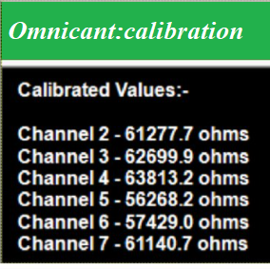
Figure 4: Cantilever Calibration output

4. Microcantilever Cleaning Procedure
In the fabrication process, the wafer is cleaned using RCA (Radio Corporation of America) technology, which eliminates organic impurities from the wafer surface such dust particles, silicone gel, grease, ions, and heavy metals. This high-quality wafer cleaning method must be used at elevated temperature. The two steps of this RCA cleaning are known as SC-1 and SC-2. Ammonium Hydroxide (NH₄OH) and 120 ml of distilled water should be combined and heated for five minutes to 75ºC in accordance with (SC-1) Standard Clean-1. The wafer should then be heated for 7 minutes with 35ml of hydrogen peroxide before cooling for 20 minutes. To eliminate the organic impurities, a second DI water dip was employed before the HF (hydrofluoric acid) dip. Standard Clean-2 (SC-2) procedure is used to get rid of the metal traces impurities on the surface of the wafer. For this procedure, combined with 20ml of NH₄OH with 120ml of distilled water, and heated for 4 minutes at 75ºC. After that, add 40ml of H₂O₂, heat the wafer for 5 minutes, and then let it cool for 10 minutes. After that, dip in DI (De Ionized) water for 50 seconds, then dip in HF (Hydro Fluoric acid). Then, any metal contaminants that were present on the wafer surface were removed using a DI water dip[11].
5 Surface functionalization procedure
For the interaction of bio-chemicals, antigen and antibody that are applied to the sensor’s surface to interact the bottom layer of the cantilever need to be stable and immobilized. Surface Functionalization cannot be achieved without a superconductive coating. Gold is preferred because of its stability and low resistance (Au). Titanium pre-evaporated to 180nm thickness was coated with 300nm gold on the silicon wafer. Piranha solution is required for at least 3 minutes to remove any remaining materials, followed by DI water and drying in nitrogen (N) flow, and finally being submerged in C₂H₅OH (ethanol solution) and C₁₁H₂₂O₂S (11-mercaptoundecanoic acid) for a period of 9 hours. Washing with ethanol eliminated the extra C₁₁H₂₂O₂S component. Finally, activated Au substrate were dried under nitrogen flow to complete the activation process before being submerged in a 200ml solution of either N-hydroxysuccinimide (NHS) or 1-ethyl-3-dimethylaminopropyl carbodiimide (EDC) for 4 hours. Further the activated Au substrate was washed with CH₃OH before being dipped in buffer solution.
Figure 2 shows the standard procedure for covalent immobilization on a functionalized gold surface[17] using a phosphate-buffered saline (PBS) solution to maintain consistent PH.
For the detection of particular biomarkers, a biosensor based on cantilever arrays was batch-fabricated using MEMS technology that is compatible with ICs. On the free end of the cantilever, a microcantilever was developed for local antibody immobilization using the micro-printing technology. This immobilisation method has the potential to significantly minimise the influence of adsorption-induced changes in the stiffness coefficient k. These basic characteristics provide a number of advantages, like high sensitivity, high throughput, high mass detection accuracy, and high specification. In addition, the techniques of surface functionalization were often used in the field of biological detection. The immobilisation period of the microcantilever antibodies as well as the culture process were improved in order to create high active, localized, and dense antibody surface then cantilever is ready for functionalization[18].

6 Volt-Ampere characteristics of the cantilever
AFM study was conducted on the microcantilever after released from {100} silicon wafer. Figure 5 shows the AFM (Atomic Force Microscope) reports. Figure 5(a) and 5(b) depicts the Volt-Ampere characteristics and respective experimental setup required to compute the static and dynamic resistances from graphical techniques. The results are linear and compatible to compute static and dynamic resistances. Form the calculation it is observed that the static resistance approximately 56kΩ and dynamic resistance varies from 55 to 62 kΩ. The calibrated values from Omnicant also similar to results.
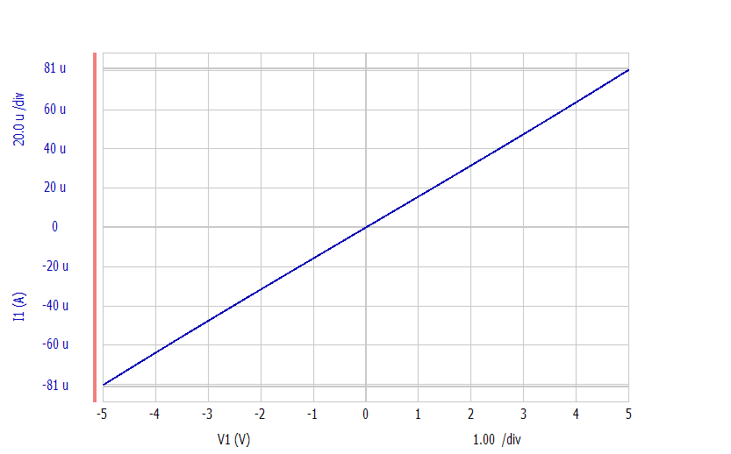
(a)
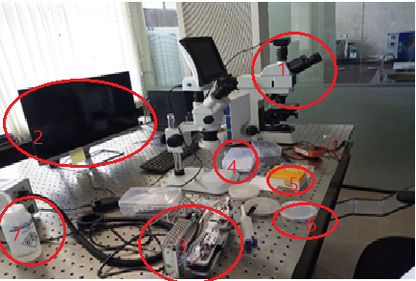
(b)
Figure 5: Characterization(a)V-I Characteristics of the micro cantilever
(b) Experimental setup
1-Microscope, 2- GUI, 3-4-5-Purchased Antibodies, 6-Cleaner
7 Preliminary testing on biosensor
For the preliminary testing of developed biosensor, here consider biotin and anti-biotin combinations for further experimental analysis of cantilever characteristics. During the experimentation several dosages between 0-80µg/ml were applied for an hour to measure the biotin concentration on the MPA-modified surface. Microcantilevers were rinsed with DI water to remove any dust particles, and then let to air dry overnight before the experimentation. A Clean room temperature was maintained across the whole area. The resistance change in the cantilever after biotin adsorption provides the significant change in resistance and associated parameters are measured below.
7.1 Effects of resistance change
The relation between change in resistance (∆R) in kΩ and biotin concentration in µg/ml as well as deflection of cantilever has been depicted in figure 7(a) and 7(b). It is worth noting that the downward bending of the microcantilevers is represented by a negative number. As per the prediction by theory, Microcantilever deflection linearly increases with resistance until it reaches a plateau at 56kΩ. Therefore, the value of 56 kΩ is taken as the constraining limit for the initial resistance of the micro cantilever used as biosensors.

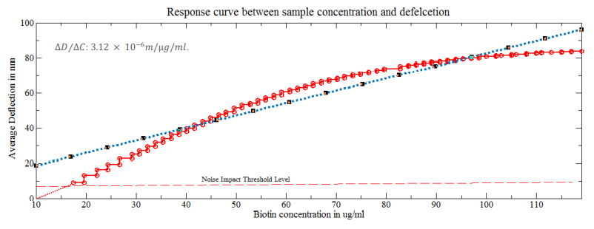
(a)
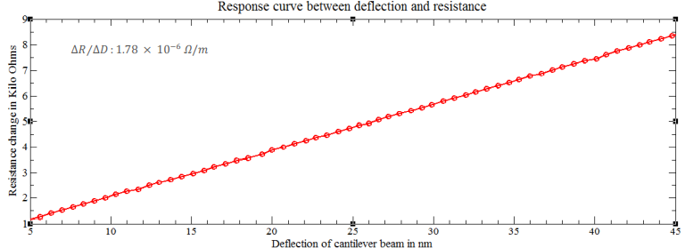
(b)
Figure 6: (a) Load versus Resistance (b) Beam deflection versus change in resistance
Figure 6 shows that average deflection change with respect to change in biotin concentration. Ultimately, the biotin layer in the microcantilevers facilitates the investigation for utilization of Piezoresistive based device in biosensor technology.

Figure 7: Change in the cantilever resistance
7.2 Linearity and Dynamic range of sensor
Figure 8 depicts the linearity and dynamic range of biotin and anti-biotin studies conducted with a functionalized cantilever surface. From the analysis, it is observed that the fabricated biosensor's initial sensitivity is quite high owing to the entire surface's availability for anti-biotin binding but that it becomes saturated at increasing concentrations. Consequently, the microcantilever-based sensor is always employed in situations where greater selectivity and sensitivity are required for molecular applications. The change in resistance for biotin and anti-biotin is around 56kΩ–120kΩ for all microcantilevers in the array.
Previous techniques needed complex analytical instruments for measurements with greater LOD. In medical diagnostics, the immediate benefit of miniaturisation and molecular level detection methods is reduced sample quantities, which enhance the LOD, accuracy, selectivity, and sensitivity while decreasing the cost of detection. As a result of miniaturisation, it is possible to create portable devices, and detection at the molecular level is feasible in comparison to previous techniques.
Figure 8: Response of each arm as a result of biotin and Anti-biotin reaction
8 Conclusion
The primary objective of this study is to fabricate and characterise a piezoresistive sensor for the low-pressure range in order to target biomolecules at lower concentrations. In this work, we use the AFM instrument in tapping mode to calibrate the piezoresistive sensors for 5µN/m, and the stiffness of the developed sensors is calculated. The stiffness (k) of a microcantilever without an Au/Cr thin layer was measured using AFM and was found to be between 90.7 and 110.4µN/m. The rigidity of the microcantilever with Au/Cr thin film is 124–156µN/m, significantly below the upper limit (50µN/m) for BioMEMS applications. According to the results of the experiments, piezoresistive MEMS sensors have a lower LOD than other techniques [89]. The stiffness of the produced piezoresistive sensor without the Au/Cr layer is the lowest (90.7µN/m) and comparably better than other sensors without the Au/Cr thin film. Findings demonstrate that the nominal resistance of produced cantilevers is 56K, with a maximum force constant of 5N/m, a sensitivity to force ratio of 1.78 x 10⁻⁶ Ω/m, a sensitivity to displacement ratio of 3.12 x 10⁻⁶ m/g/ml, and a sensitivity to change in resistance of 1.72 x 10⁻⁶ Ω/g/ml. As a result, it enhances sensor performance and facilitates good responsiveness for other samples also.
References:
[1] M. Katta and R. Sandanalakshmi, “Simultaneous tropical disease identification with PZT-5H piezoelectric material including molecular mass biosensor microcantilever collection,” Sens. Bio-Sens. Res., vol. 32, p. 100413, Jun. 2021, doi: 10.1016/j.sbsr.2021.100413.
[2] C. Grogan, F. R. McGovern, R. Staines, G. Amarandei, and I. Naydenova, “Cantilever-Based Sensor Utilizing a Diffractive Optical Element with High Sensitivity to Relative Humidity,” Sensors, vol. 21, no. 5, p. 1673, Mar. 2021, doi: 10.3390/s21051673.
[3] D. Ramos, J. Mertens, M. Calleja, and J. Tamayo, “Study of the origin of bending induced by bimetallic effect on microcantilever,” Sensors, vol. 7, no. 9, Art. no. 9, Sep. 2007, doi: 10.3390/s7091757.
[4] L. Fu, S. Li, K. Zhang, I.-H. Chen, Valery. Petrenko, and Z. Cheng, “Magnetostrictive Microcantilever as an Advanced Transducer for Biosensors,” Sensors, vol. 7, no. 11, Art. no. 11, Nov. 2007, doi: 10.3390/S7112929.
[5] DST Women Scientist ,Research Scholar, Departmnet of Instrument Technology, Andhra University Visakhapatnam., K. D. Aparna*, Prof. D. V. R. Koti Reddy, Departmnet of Instrument Technology, Andhra University Visakhapatnam., Dr. B. R. kumar, and Associate Professor, Department of EIE, Gitam University Visakhapatnam, “MEMS Piezoresitive cantilever mass sensor response for detection of volatile organic compounds using Omnicant experimental platform,” Int. J. Recent Technol. Eng. IJRTE, vol. 8, no. 3, pp. 1387–1390, Sep. 2019, doi: 10.35940/ijrte.B3540.098319.
[6] . K., J. Rahul, and R. Kumar, “Micro-cantilevered MEMS Biosensor for Detection of Malaria Protozoan Parasites,” J. Comput. Appl. Mech., no. Online First, Art. no. Online First, Feb. 2019, doi: 10.22059/jcamech.2019.276035.362.
[7] J. Ali, J. Najeeb, M. Asim Ali, M. Farhan Aslam, and A. Raza, “Biosensors: Their Fundamentals, Designs, Types and Most Recent Impactful Applications: A Review,” J. Biosens. Bioelectron., vol. 08, no. 01, Art. no. 01, 2017, doi: 10.4172/2155-6210.1000235.
[8] . K., J. Rahul, and R. Kumar, “Micro-cantilevered MEMS Biosensor for Detection of Malaria Protozoan Parasites,” J. Comput. Appl. Mech., no. Online First, Art. no. Online First, Feb. 2019, doi: 10.22059/jcamech.2019.276035.362.
[9] R. Bashir, “BioMEMS: state-of-the-art in detection, opportunities and prospects,” Adv. Drug Deliv. Rev., vol. 56, no. 11, Art. no. 11, Sep. 2004, doi: 10.1016/j.addr.2004.03.002.
[10] A. Boisen and T. Thundat, “Design & fabrication of cantilever array biosensors,” Mater. Today, vol. 12, no. 9, Art. no. 9, Sep. 2009, doi: 10.1016/S1369-7021(09)70249-4.
[11] M. Katta and R. Sandanalakshmi, “MEMS Piezoresistive Cantilever Fabrication And Characterization,” in 2021 2nd Global Conference for Advancement in Technology (GCAT), Bangalore, India: IEEE, Oct. 2021, pp. 1–6. doi: 10.1109/GCAT52182.2021.9587807.
[12] Miranji Katta and Sandanalakshmi R, “A Technology Overview and Future Scope of Bio-Mems in Tropical Disease Detection: Review,” Int. J. Eng. Technol., vol. 7, no. 3.12, Art. no. 3.12, Jul. 2018, doi: 10.14419/ijet.v7i3.12.16446.
[13] X. Li et al., “Integrated MEMS/NEMS Resonant Cantilevers for Ultrasensitive Biological Detection,” J. Sens., vol. 2009, pp. 1–10, 2009, doi: 10.1155/2009/637874.
[14] N. P. V. Krishna, T. R. S. Murthy, K. J. Reddy, K. Sangeeth, and G. M. Hegde, “Design and Fabrication of Piezoresistive Based Encapsulated Poly-Si Cantilevers for Bio/chemical Sensing,” Phys. Procedia, vol. 19, pp. 319–324, 2011, doi: 10.1016/j.phpro.2011.06.168.
[15] Y. Zhou, Z. Wang, C. Wang, W. Ruan, and L. Liu, “Design, fabrication and characterization of a two-step released silicon dioxide piezoresistive microcantilever immunosensor,” J. Micromechanics Microengineering, vol. 19, no. 6, Art. no. 6, Jun. 2009, doi: 10.1088/0960-1317/19/6/065026.
[16] K.-U. Kirstein et al., “Cantilever-Based Biosensors in CMOS Technology,” in Design, Automation and Test in Europe, Munich, Germany: IEEE, 2005, pp. 1340–1341. doi: 10.1109/DATE.2005.90.
[17] K. Neethu and K. J. Suja, “Sensitivity Analysis of Rectangular Microcantilever Structure with Piezoresistive Detection Technique Using Coventorware FEA,” Procedia Comput. Sci., vol. 93, pp. 146–152, 2016, doi: 10.1016/j.procs.2016.07.194.
[18] “Micro- and Nanosensors for Medical and Biological Measurement,” Sens. Mater., p. 275, 2012, doi: 10.18494/SAM.2012.793.

