Gonococcal and Chlamydial Urethritis
Tanisha Bharara^{1*,} Preena Bhalla², Abhishek Yadav³
- *Assistant Professor, Department of Microbiology, NDMC Medical College and Hindu Rao Hospital
- Ex-Professor, Department of Microbiology, NDMC Medical College and Hindu Rao Hospital
- Assistant Professor, Department of Microbiology, NDMC Medical College and Hindu Rao Hospital
Corresponding author: Dr. Tanisha Bharara
Urethritis forms a major bulk of sexually transmitted infections (STI) among adult males. Its prevalence is rising throughout the worldwide which makes it a subject of continuous research.¹ A characteristic sign of urethritis is mucopurulent / purulent urethral discharge. ² Urethral inflammation may be confirmed in the laboratory by direct Gram stain of urethral secretions demonstrating >5 polymorphonuclear leukocytes (PMN) per oil immersion field.³ CDC, on the other hand, considers a lower cut off value of 2 PMN / oif.⁴
Neisseria gonorrhoeae and Chlamydia trachomatis cause majority of cases. The main aim of diagnosis and subsequent treatment is to prevent onward transmission of infection. Treatment of symptoms, prevention of complications, reducing transmission of co-infections (like human immunodeficiency virus), treatment of contacts, and behavioural change are the various considerations while treating such patients.⁵
Traditionally urethritis is classified into gonococcal and nongonococcal based on the presence of gram-negative intracellular diplococci (GNID) in direct Gram stain of urethral discharge. More often than not both gonococcal and nongonococcal infections coexist, thus mystifying this whole classification.⁵
Gonococcal urethritis (GU) usually presents with profound symptoms like profuse purulent / mucopurulent discharge along with erythematous and oedematous external urethral meatus. While, nongonococcal urethritis (NGU) patients are usually less symptomatic. However laboratory support is indispensable in making definitive diagnosis. ⁶
Aetiology of NGU remains an enigma in majority patients, with no pathogen identified in a significant proportion of cases (20%–50%). In a study conducted by Catriona et al C. trachomatis for identified in 30%–50% of cases of NGU while, Mycoplasma genitalium in 10%– 30%.⁷ Ureaplasma urealyticum, Streptococcus species, Haemophilus species, Gardnerella vaginalis, herpes simplex virus (HSV) and adenoviruses have been reported in a few cases of NGU.^{8,9} In a similar study of 52 patients carried out by CM Gupta et al. from Pune, India, incidence of GU and NGU were found to be 65% and 35% respectively. In this study also the commonest organism causing NGU was found to be C.trachomatis (28%).¹⁰ Another study conducted at a tertiary care hospital in New Delhi, India reported N. gonorrhoeae and C. trachomatis in 58.1%, and 14% cases respectively. ¹¹
Unless the diagnosis can be narrowed down on one organism, combined treatment for gonorrhoea and chlamydia is recommended among all patients with urethritis.¹²
GONOCOCCAL URETHRITIS
Gonorrhoea is one of the most common notifiable disease in the west.¹² The Centers for Disease Control and Prevention (CDC) estimates that more than 15,68,000 persons in the United States acquire gonorrhoea each year.¹² Gonorrhoea control and prevention is further threatened by rise in antimicrobial resistance against Neisseria gonorrhoeae isolates, thus making it a grave public health threat.¹³
STIs have been known to affect the economically productive age group with over a million infections acquired every day. As per WHO data Chlamydia trachomatis, Neisseria gonorrhoea, Treponema pallidum and Trichomonas vaginalis accounted for over 370 Million new cases of STI in 2020.¹³
Despite exponentially rising world statistics, an Indian study conducted by Manju Bala et al., reported a decrease in the number of N.gonorrhoeae isolates over the years. The author speculated that the reason could be an actual decrease in the incidence of infections over the years or easy accessibility of general public to over the counter antibiotics due to less stringent law in the country.¹⁴
The incubation period ranges from 1 to 14 days. While, urethral discharge and dysuria are predominant symptoms among men, majority of women remain asymptomatic.^{15,16,17} Although majority of cases of gonococcal urethritis resolve, few might progress to complications including epididymitis, prostatitis, seminal vesiculitis, and infections of Cowper’s and Tyson’s glands.¹⁸
Gonorrhoea is a disease of sexually active population, with majority of cases reported under 30 years of age.¹⁹ High risk factors for gonorrhoea include early sexual maturity, low socioeconomic state, past history of gonorrhoea and men who have sex with men.^{20,21} For GU is known to increase transmission of HIV by increasing viral shedding.²²

CHLAMYDIAL URETHRITIS
NGU patients form a bulk of STI clinic attendees throughout the world.²³ Majority of patients are known to be co-infected with both gonorrhoea and chlamydia. Among these, 80% or more develop symptomatic post gonococcal chlamydial urethritis due to use of Chlamydia sparing antibiotics.^{24,25}
C. trachomatis is an obligate intracellular parasite with an interesting lifecycle.²⁶ The organism has over 18 serovars and more than 29 variants.²⁷ Serovars D, E, F, G, H, I, J, and K are most common among sexually transmitted infections.^{28,29}
Majority of cases of NGU are due to C.trachomatis.³⁰ NGU is characterised by a longer incubation period (7 to 21 days) and milder symptoms as compared to GU.³¹ However, NGU is known to cause long term sequelae and facilitate HIV transmission like GU.³²
LABORATORY DIAGNOSIS OF URETHRITIS
Urethritis is known to affect economically productive age group with high worldwide incidence of both GU and NGU. With over 25 million and 50 million reported cases of gonorrhoea and chlamydia respectively, it is imperative to diagnose the cases timely.³³
Gram stain is highly sensitive and specific point-of-care test for diagnosing urethritis and is strongly recommended. However, in case of non-availability of diagnostic facility, patients should be treated with a combined drug regimen covering both gonorrhoea and chlamydia.³⁴
LABORATORY DIAGNOSIS OF GONOCOCCAL URETHRITIS
The diagnosis of gonococcal urethritis in the laboratory can be established by
- Direct microscopy
- Isolation of N.gonorrhoeae by culture on selective and non-selective medium
- Nucleic Acid Amplification Tests
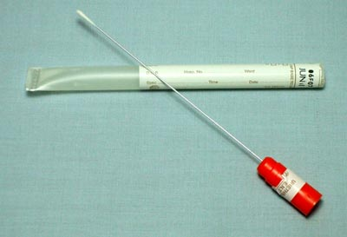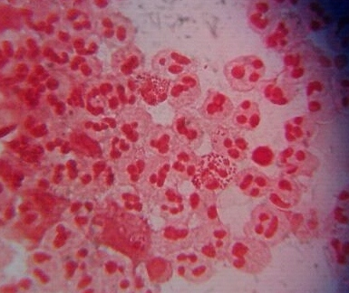
1a. 1b.
Figure 1a: Urethral swab Figure; 1b: Direct Gram stained smear of urethral discharge showing intracellular gram negative diplococci within polymorphonuclear leucocytes

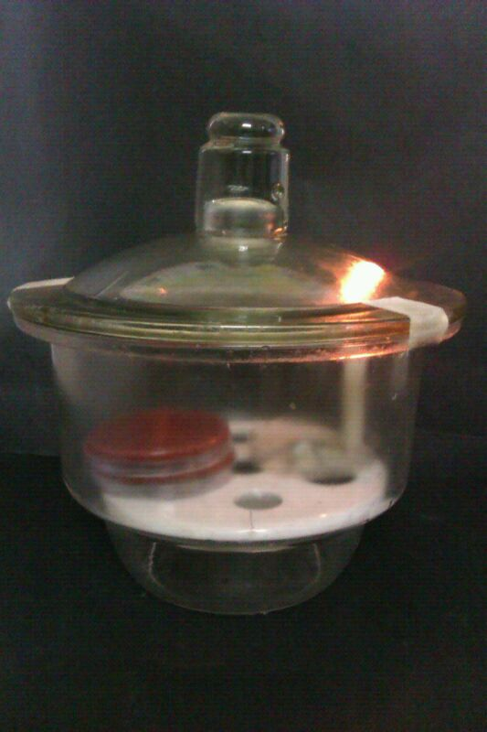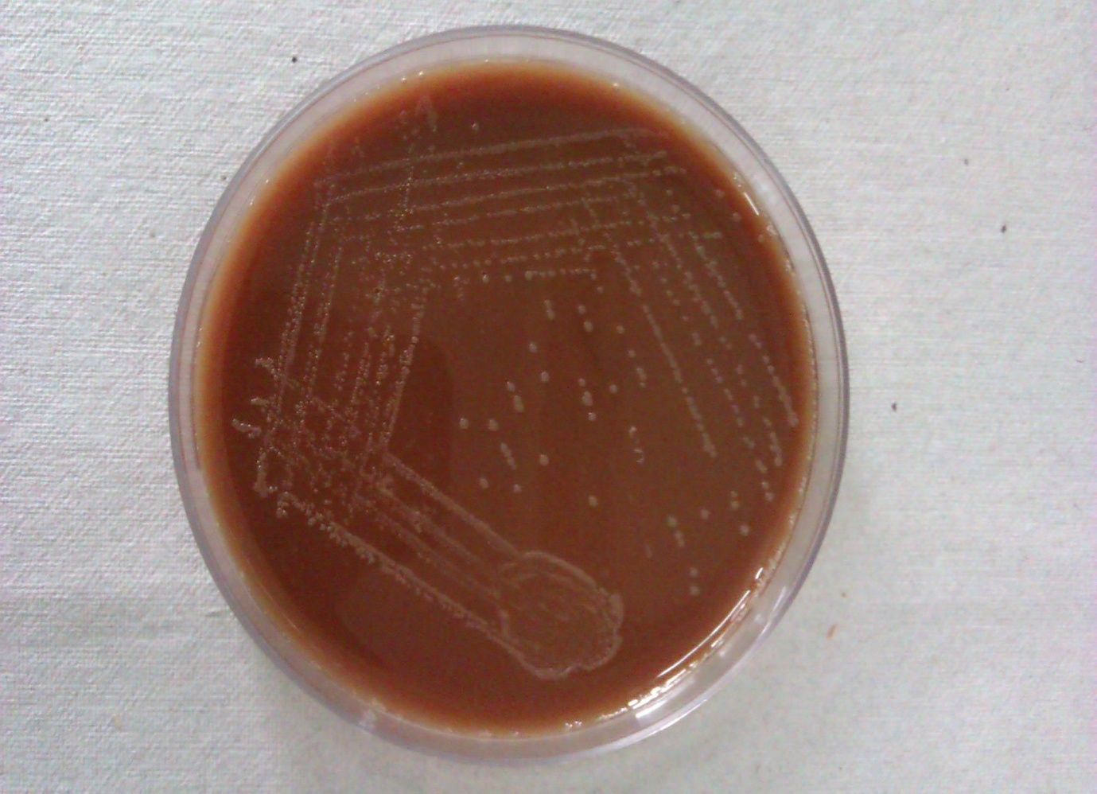
- b.
Figure 2a: Candle jar used for incubation of culture plates in the laboratory; 2b: Growth of N.gonorrhoeae on Modified Thayer Martin medium
Conventional diagnosis of N.gonorrhoeae infection requires isolation on selective media or observation of gram-negative diplococci in Gram smears of urethral discharge.³ Gram staining of urethral smear is highly sensitive and specific point-of-care test for diagnosis of urethritis as well as its classification into GU and NGU. El-Gamal et al found over 99% correspondence between Gram staining and PCR. CDC and WHO guidelines recommend Gram staining for definitive diagnosis of urethritis among symptomatic men, however, direct microscopy is not useful among asymptomatic patients. ³⁵
Specific diagnosis of GU can be made by testing urethral discharge or urine sample.²¹ Culture is the conventional method of diagnosis of urethritis. It has low sensitivity (50-84%) due to several reasons including fastidious nature of the organism, loss of viability of organism during transport, low concentration of organisms or sampling error and prior antimicrobial therapy.³⁶ Gonococci are very fastidious; therefore, best results are achieved by direct inoculation of culture plates followed by immediate incubation under suitable conditions.³⁷
Many C0₂-enriched transport media are available like TransGrow (TG) system, John E. Martin Biological Environmental Chamber (JEMBEC). In a study conducted by Dowda et al. the two systems were found to be comparable, however, direct plating method was found to be significantly better.³⁷
Werthheim was one of the first scientists who deciphered the basic constituents required for growth of N. gonorrhoeae in 1891.³⁸ Thayer-Martin medium was prepared by adding antibiotics to chocolate agar base resulting in a selective medium for isolation of gonococci.³⁹
Modified TM medium (MTM) contained double the quantity of agar, increased concentration of dextrose, and 5.0 mg of trimethoprim per ml.⁴⁰ Another media employed for culture of N.gonorrhoeae is New York City medium (NYC). It readily supports growth of pathogenic gonococci as well as Mycoplasma.⁴¹
Wherry, Oliver and Chapin pointed out the significance of a partial carbon dioxide environment promoting growth of gonococcus.⁴² Keefer and Spink further re-instated the fact.⁴³ Candle jar is the one most widely used method even today for incubating primary plates of gonococci. Although inexpensive, candle jar method is cumbersome and requires a large incubator space, thus restricting its use.⁴⁴ Martin et al recommended the use of a plastic bag with carbon dioxide tablet, for providing partial carbon dioxide environment.⁴⁵
Antimicrobial susceptibility testing forms a significant part of gonococcal diagnosis. Although agar dilution test is considered gold standard for antibiotic sensitivity testing, when performed correctly, the disk-diffusion and Epsilometer test (E-test) can be used as useful alternatives.⁴⁵
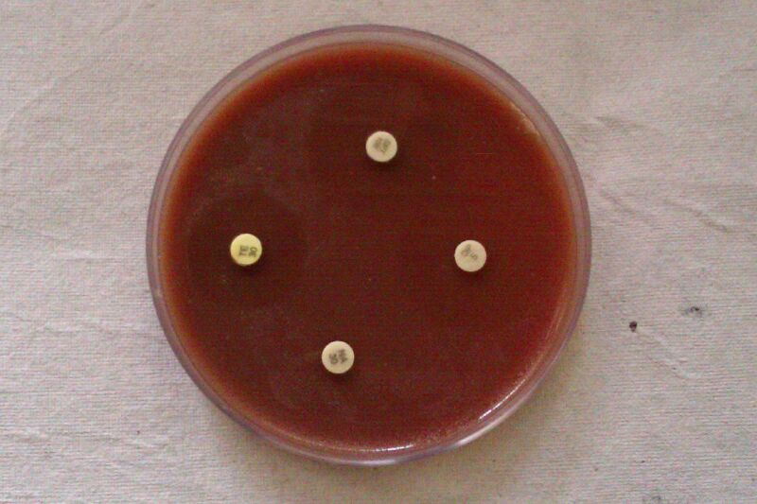
Inhibition zone diameter
Figure 3: Antimicrobial susceptibility testing for N.gonorrhoeae by disc diffusion method

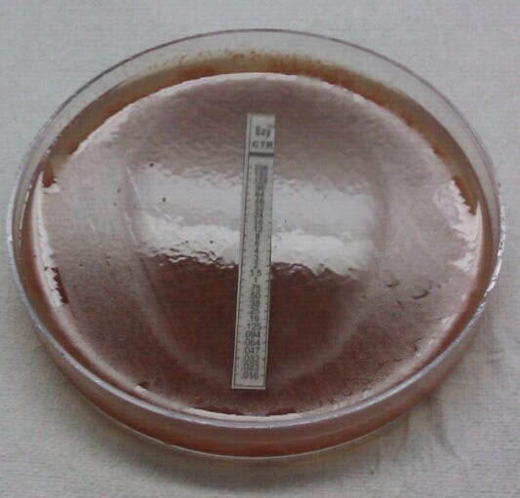
Figure 4: Minimum Inhibitory Concentration (MIC) of ceftriaxone by E test
Asymptomatic gonococcal infections are responsible for transmission of gonorrhoea in the community.⁴⁶ Community screening followed by treatment and education can play a vital role in curtailing the spread of infection.⁴⁷
Nucleic acid amplification tests (NAATs) are very sensitive and can be performed on urine / rectal swabs / urethral swabs. NAATs have proven useful among asymptomatic carriers.⁴⁷ Kimberly et al. reported sensitivity of N. gonorrhoeae PCR to be 94.4% and 97.3% for urine and urethral swab specimens respectively, while, culture was positive in only 76.6% patients.³⁴
However, qualitative NAATs do not give any information on antimicrobial susceptibility of N. gonorroheae isolates, therefore no prognostic significance.⁴⁸ NAAT specificity is a major concern in extra-genital specimens due to genetic relatedness between pathogenic and commensal Neisseria spp.⁴⁹ Probes using nucleotide sequences of various gonococcal genes have been used. The oligonucleotide probes against 16 S ribosomal RNA have been found to have a high sensitivity and specificity.⁵⁰

LABORATORY DIAGNOSIS OF CHLAMYDIAL URETHRITIS
Diagnosis of Chlamydial urethritis in the laboratory can be established by
- Direct microscopy
- Cell line Culture
- Enzyme Linked Immunosorbant Assay (ELISA), Direct Fluorescent Antibody Test (DFA)
- NAATs

Increased number of polymorphonuclear cells in the direct Grams smear of urethral discharge establishes a diagnosis of nongonococcal urethritis.⁵¹ Specific diagnosis of C.trachomatis is enhanced due to availability of highly sensitive and specific NAATs.
Since C.trachomatis is an intracellular parasite of columnar epithelial cells, diagnostic specimen should be collected by vigorous swabbing or scraping of the involved sites.⁵²
Culture for C.trachomatis was earlier considered the gold standard however the procedure is combursome.³⁴ HeLa-229, McCoy, BHK-21, and Buffalo green monkey kidney cells are the common cell lines used for culturing C. trachomatis.
Staining monolayers with Giemsa / iodine / DFA can be used for detecting C. trachomatis in cell lines. Shell vial method of Ripa on McCoy cell line stained with fluorescein-conjugated
monoclonal antibody is highly sensitive method.⁵³
Owing to the technical difficulties of culture, many non-culture techniques have been developed for C. trachomatis. DFA and EIA tests are the most widely used methods with sensitivity ranging between 60% and 85%.⁵⁴ While Major Outer Membrane Protein (MOMP) is the main target in DFA test, antibody against chlamydial elementary body (EB) are detected by EIA. The advantage of these tests is a faster turn-around-time and lower cost per test, whereas their disadvantages are limited number of specimens that can be processed in a day and skilled interpretation (10 or more elementary bodies are seen in a background of reddish-brown counterstained cells). Immunoassays have unsatisfactory positive and negative predictive values in populations with a low prevalence of chlamydial infections. Moreover it is difficult to distinguish between a past and current infection on the basis of a positive antibody test alone.^{55,56,57}

Figure 5: MicroTrak® Chlamydia trachomatis Direct Specimen- Positive slide showing brick red fixed mammalian cells and apple green fluorescent elementary bodies
NAATs are demanding with respect to initial laboratory set up, but standardized easy-to-use kits are readily available with high sensitivity and specificity compared to culture.^{58,59}
Since 30 to 70% of all chlamydial infections may be asymptomatic, NAAT testing on first-void urine (FVU) specimens is considered a major breakthrough in detection of chlamydial urethritis. The method is especially beneficial in population with low prevalence of infection.^{59,60}
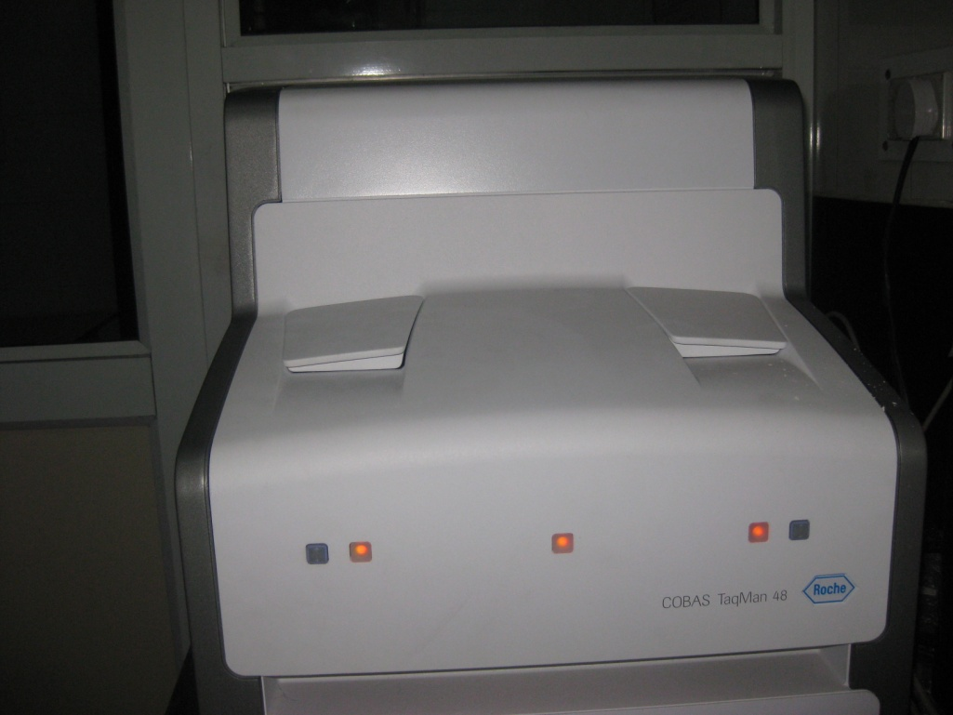
Figure 6: COBAS® TaqMan® 48 Analyzer
New variant of C. trachomatis (nvCT), carrying a 377 bp deletion within the plasmid, was reported from Sweden in 2006. Failure to detect nvCT in specimens resulted in false-negative results throughout Sweden and eventual widespread of infection due to nvCT. This led to development of Abbott RealTime CT/NG and the Roche Cobas TaqMan CT v2.0 targetting additional genetic sequences. Similar isolates have been reported from India recently^{26, 29}

TREATMENT OF URETHRITIS
While WHO promotes syndromic approach, especially among high prevalence population with limited resources; CDC strongly recommends testing to determine the specific aetiology among patients with urethritis as both chlamydia and gonorrhoea are reportable to the health departments.^{13,60}
Azithromycin is the drug of choice for mycoplasmal, ureaplasmal, and chlamydial infections.⁶² In areas with a high prevalence of trichomoniasis, metronidazole or tinidazole may be added to usual regimens.⁶³ Sex education forms a major part of the management of these patients and expedited partner treatment is highly recommended by CDC. ^{4,60,61,62}

GONOCOCCAL URETHRITIS
Galen coined the term Gonorrhoea in the second century. It means “flow of semen.” Neisser demonstrated N. gonorrhoea in 1879, and Leistikow and Loffler cultured the organism in 1882.⁶³
USE OF ANTIMICROBIAL AGENTS AND EMERGENCE OF RESISTANCE
Sulfanilamide was used to treat gonorrhoea between 1937 and 1940.⁶⁴ Penicillin was a breakthrough drug in treatment of gonorrhoea.⁶⁵ The mechanism for transmissible penicillin resistance among gonococcal isolates is the elaboration of ß-lactamase enzyme (PPNG). In a study conducted by Manju Bala et al. an alarming increase in antimicrobial resistance in N. gonorrhoeae to penicillin and ciprofloxacin was reported between from 1996 to 2001.¹⁴ A study from Africa showed ciprofloxacin to be 100% effective in treating gonococcal infections.⁶⁶ However, ciprofloxacin resistance emerged soon.⁴⁵ Another drug that was used for treatment of gonococcal urethritis was tetracycline. Plasmid borne tetracycline resistant isolate was reported in 1984 (TRNG, MIC, > 16 pg/ml), which spread quickly throughout the world.^{14,67} Spectinomycin, was another drug used against N. gonorrhoeae, however, resistant isolates were soon to emerge.⁴⁵
Third generation cephalosporins especially Ceftriaxone is highly effective against gonorrhoea. A single intramuscular dose is highly effective against gonococcal infections and therefore the treatment recommended by the CDC.^{45,12}
Cefixime, an oral cephalosporin, is quite effective too. However treatment failures have been reported throughout the world.^{45,68,69} High-level ceftriaxone resistance have been reported from Europe and USA.^{70,71} In a recent study published in lancet, AMR rates of 22% for cephalosporins, 60% for azithromycin, and 100% for ciprofloxacin were reported among gonococcal isolates.⁷²
CURRENT RECOMENDATIONS FOR TREATMENT
Both WHO and the CDC recommend single-dose, affordable regimen for treatment of N. gonorrhoeae.⁷³
Centers for Disease Control and Prevention recommends single dose of 500 mg ceftriaxone intramuscularly. In case of cephalosporin allergy, gentamicin 240 mg IM plus azithromycin 2 g orally can be given.¹²
CHLAMYDIAL URETHRITIS
Macrolides like azithromycin and doxycycline are highly effective for chlamydial infections.¹²
CDC recommends Azithromycin 1g orally in a single dose or Doxycycline 100 mg twice daily for 7 days for treatment of Chlamydial urethritis.¹²
Several studies have been conducted indicating that antimicrobial resistant C. trachomatis isolates become less fit and do not survive in cell lines, therefore indicating towards low level of antimicrobial resistance observed among C.trachomatis isolates clinically.⁷⁴
REFERECES
- Masari V, Retel O, Flahault A. A recent increase in the incidence of male urethritis in France. Sex Transm Dis. 2002;29:319-23.
- Maw RD, Robinson A. Asymptomatic urethritis: the case considered view. Int J STD AIDS. 2004;15:849-50.
- Vesic S, J. Vukicevic J, Ðakovic Z, Tomovic M, Dobrosavljevic D, Medenica L et al. Male urethritis with and without discharge: relation to microbiological findings and polymorphonuclear counts. Acta Dermatoven. 2007;16:53-7.
- Brill JR. Diagnosis and Treatment of Urethritis in Men. Am Fam Physician. 2010 April;81:873-8.
- Pavithran K. Urethritis in males. Indian J Dermatol Venereol Leprol 2001;67(5):255.
- Workowski KA, Bachmann LH, Chan PA, Johnston CM, Muzny CA, Park I, et al. Sexually transmitted infections treatment guidelines, 2021CDC. MMWR Recomm Rep. (2021) 70:1–187. doi: 10.15585/mmwr.rr7004a1
- Horner P, Thomas B, Gilroy CB, Egger M, Taylor-Robinson D. Role of Mycoplasma genitalium and Ureaplasma urealyticum in acute and chronic nongonococcal urethritis. Clin Infect Dis. 2001;32:995–1003.
- Schwartz MA, Hooton TM. Etiology of nongonococcal nonchlamydial urethritis. Dermatol Clin. 1998;16:727–33.
- Uuskula A, Raukas E. Atypical genital herpes: report of five cases. Scand J Infect Dis. 2004;36:37–9.
- Gupta CM, Sanghi S, Sayal SK, Das AL, Prasad GK. Clinical and bacteriological study of urethral discharge. Indian J Dermatol Venereol Leprol. 2001;67:185-7.
- Bharara T, Bhalla P. Study of gonococcal and chlamydial urethritis: Old culprits with a new story. Journal of Family Medicine and Primary Care. 2022 Sep;11(9):5551.
- Centers for Disease Control and Prevention. Sexually Transmitted Disease Surveillance 2021. Atlanta: U.S. Department of Health and Human Services, 2021. https://www.cdc.gov/std/statistics/2021/default.htm. [Last accessed on 2023 September 23].
- World Health Organisation. Sexually Transmitted Infections 2023. https://www.who.int/news-room/fact-sheets/detail/sexually-transmitted-infections-(stis). [Last accessed on 2023 September 23].
- Bala M, Ray K, Gupta SM, Muralidhar S, Jain RK. Changing trends of antimicrobial susceptibility patterns of Neisseria gonorrhoeae in India and the emergence of ceftriaxone less susceptible N. gonorrhoeae strains. J Antimicrob Chemother. 2007; 60(3):582-6.
- Harrison WO, Hooper RR, Wiesner PJ, Campbell AF, Karney WW, Reynolds GH, et al. A trial of minocycline given after exposure to prevent gonorrhoea. N Engl J Med. 1979;300:1074-8.
- Holmes KK, Johnson DW, Trostle HJ. An estimate of the risk of men acquiring gonorrhoea by sexual contact with infected females. Am J Epidemiol 1970;91:170-4.
- Handsfield HH, Lipman TO, Harnisch JP, Tronca E, Holmes KK. Asymptomatic gonorrhoea in men. Diagnosis, natural course, prevalence and significance. N Engl J Med. 1974;290:117-23.
- Shim BS. Current Concepts in Bacterial Sexually Transmitted Diseases. Korean J Urol. Korean J Urol. 2011 April;52:589-97.
- Centers for Disease Control and Prevention. Sexually Transmitted Diseases Surveillance, 2005. Atlanta, GA; U.S. Department of Health and Human Services, Public Health Service, Nov. 2006.
- Barnes RC, Holmes KK. Epidemiology of gonorrhoea: Current perspectives. Epidemiol Rev. 1984;6:1-30.
- Lafferty WE, Hughes JP, Handsfield HH. Sexually transmitted disease in men who have sex with men: Acquisition of gonorrhoea and nongonococcal urethritis by fellatio and implications for STD/HIV prevention. Sex Transm Dis. 1997;24:272-8.
- Cohen MS, Hoffman IF, Royce RA, Kazembe P, Dyer JR, Daly CC, et al. Reduction of concentration of HIV-1 in semen after treatment of urethritis: implications for prevention of sexual transmission of HIV-1. AIDSCAP Malawi Research Group. Lancet. 1997;349:1868-73.
- Handsfield HH. Nongonococcal Urethritis: A Few Answers but Mostly Questions. J Infect Dis. 2006;193:333–5.
- Oriel JD, Reeve P, Thomas BJ, Nicol CS. Infection with Chlamydia group A in men with urethritis due to Neisseria gonorrhoeae. J Infect Dis. 1975;131:376-82.
- Holmes KK, Handsfield HH, Wang SP, Wentworth BB, Turck M, Anderson JB, et al. Etiology of nongonococcal urethritis. N Engl J Med. 1975;292:1199-205.
- Unemo M, Smith HMBS, Cutcliffe LT, Skilton RJ, Barlow D, Goulding D et al. The Swedish new variant of Chlamydia trachomatis: genome sequence, morphology, cell tropism and phenotypic characterization. Microbiology. 2010;156:1394–1404.
- Bandea CI, Debattista J, Joseph K, Igietseme, Timms P, Black CM. Chlamydia trachomatis serovars among strains isolated from members of rural indigenous communities and urban populations in Australia. J Clin Microbiol. 2008;46:355–6.
- Brunham RC, Pourbohloul B, Mak S,White R, Rekart ML. The unexpected impact of a Chlamydia trachomatis control program on susceptibility to reinfection. J Infect Dis. 2005;192:1836-44.
- Barnes RC, Rompalo AM, Stamm WE. Comparison of Chlamydia trachomatis serovars causing rectal and cervical infections. J Infect Dis. 1987;156:953-8.
- Hillis SD, Coles FB, Litchfield B, Black CM, Mojica B, Schmitt K, et al. Doxycycline and azithromycin for prevention of chlamydial persistence or recurrence one month after treatment in women. A use-effectiveness study in public health settings. Sex Transm Dis. 1998;25:5-11.
- Schafer MA, Schachter J, Moncada J, Keogh J, Pantell R, Gourlay L, et al. Evaluation of urine based screening strategies to detect Chlamydia trachomatis among sexually active asymptomatic young males. JAMA. 1993;270:2065-70.
- Tait IA, Hart CA. Chlamydia trachomatis in non-gonococcal urethritis patients and their heterosexual partners: routine testing by polymerase chain reaction. Sex Transm Infect. 2002;78:286–8.
- Chernesky M, Castriciano S, Sellors J, Stewart I, Cunningham I, Landis S, et al. Detection of Chlamydia trachomatis antigens in urine as an alternative to swabs and cultures. J Infect Dis. 1990;161:124–6.
- Crotchfelt KA, Welsh LE, Debonville D, Rosenstraus M, Quinn TE. Detection of Neisseria gonorrhoeae and Chlamydia trachomatis in Genitourinary Specimens from Men and Women by a Coamplification PCR Assay. J Clin Microbiol. 1997;1536–40.
- El-Gamal AHF, Al-Otaibi SRS, Alshamali A, Abdulrazzaq A, Najem N, Fouzan AA. Polymerase chain reaction is no better than Gram stain for diagnosis of gonococcal urethritis. Indian J Dermatol Venereol Leprol. 2009;75:101.
- Buimer M, Doornum GV, Ching S, Peerbooms P, Plier P, Ram D et al. Detection of Chlamydia trachomatis and Neisseria gonorrhoeae by ligase chain reaction-based assays with clinical specimens from various sites: implications for diagnostic testing and screening. J Clin Microbiol. 1996;34:2395–2400.
- Dowda H, Nelson CF. Evaluation of Two Transport Systems for Gonorrhoea Cultures. J Clin Microbiol. 1979;9:441-3.
- Werthheim E. Reinzuchtung des gonococcus Neisser Mittels des Plattenverfahrens. Deut. Med. Wochenschr. 1891;17:1351.
- Martin JE, Billings TE, Hackney JF, Thayer JD. Primary isolation of N. gonorrhoeae with a new commercial medium. Pub Health Rep. 1967;82:361-3.
- Martin JE, Lester A. Transgrow, a medium for transport and growth of Neisseria gonorrhoeae and Neisseria meningitidis. HSMHA Health Rep. 1971;86:30-3.
- Faur YC, Weisburd MH, Wilson ME, May PS. NYC Medium for Simultaneous Isolation of Neisseria gonorrhoeae, Large-Colony Mycoplasmas, and T-Mycoplasmas. Applied Microbiol. June 1974;27:1041-5.
- Wherry WB, Oliver WW. Adaptation to certain tensions of oxygen as shown by the gonococcus and other parasitic and saprophytic bacteria. J Infect Dis. 1916;19:288-98.
- Spink WW, Keefer CS. Studies of gonococcal infection. J Clin Invest. 1947;16:169-76.
- Martin JE, Armstrong JH, Smith PB. New System for Cultivation of Neisseria gonorrhoeae. Applied Microbiol. 1974;27(4):802-5.
- Fekete T. Antimicrobial Susceptibility Testing of Neisseria gonorrhoeae and Implications for Epidemiology and Therapy. Clin Microbiol Rev. 1993;(6):22-33.
- Handsfield HH. Principles and practice of infectious diseases. 3rd edition. Mandell, Douglas RG, Bennett JE (Eds). Neisseria gonorrhoeae. Churchill Livingstone, New York. 1990;1613–31.
- Farrell DJ. Evaluation of Ampicor Neisseria gonorrhoeae PCR Using cppB Nested PCR and 16S rRNA PCR. J Clin Microbiol. 1999;37:386–90.
- Hjelmevoll SO. Molecular diagnostics and characterization of Neisseria gonorrhoeae. [Internet]. North Noeway; 2012. [cited 2012 January]. Available from: http://munin.uit.no/bitstream/handle/10037/3816/thesis.pdf?sequence=2
- Tabrizi, S. N., M. Unemo, A. E. Limnios, T. R. Hogan, S. O. Hjelmevoll, S. M. Garland, and J. Tapsall. Evaluation of Six Commercial Nucleic Acid Amplification Tests for Detection of Neisseria gonorrhoeae and Other Neisseria Species. J Clin Microbiol. 2011;49:3610-5.
- Ho BSW, Feng WG, Wong BKC, Egglestone SI. Polymerase chain reaction for the detection of Neisseria gonorrhoeae in clinical samples. J Clin Pathol. 1992;45:439-42
- Bradshaw CS, Tabrizi SN, Read TRH, Garland SM, Hopkins CA, Moss LM et al. Etiologies of Nongonococcal Urethritis: Bacteria, Viruses, and the Association with Orogenital Exposure. J Infect Dis. 2006; 193:336–45.
- Chernesky MA. The laboratory diagnosis of Chlamydia trachomatis infections. Can J Infect Dis Med Microbiol. 2005;16(1):39-44.
- Barnes RC. Laboratory Diagnosis of Human Chlamydial Infections. Clin Microbiol Reviews. 1989;2:119-36.
- Black CM. Current methods of laboratory diagnosis of Chlamydia trachomatis infections. Clin Microbial Reviews. 1997;10:160-84.
- Palmer HM, Gilroy CB, Thomas BJ, Hay PE, Gilchrist C, Robinson DT. Detection of Chlamydia trachomatis by the polymerase chain reaction in swabs and urine from men with non-gonococcal urethritis. J Clin Pathol. 1991;44:321-5.
- Langone JJ. Protein A from Staphylococcus aureus and related immunoglobulin receptors produced by streptococci and pneumococci. Adv Immunol 1982;32:157.
- Agrawal SK, Reddy BS, Bhalla P, Kaur H. Utility of Direct Fluorescent Antibody Test for detection of Chlamydia trachomatis and its detection in male patients with non gonococcal urethritis in New Delhi. Indian J Dermatol, Venereol Leprol. 2003;69:144-7.
- Chernesky MA, Jang D, Lee H, Burczak JD, Hu H, Sellors J, et al. Diagnosis of Chlamydia trachomatis infections in men and women by testing first-void urine by ligase chain reaction. J Clin Microbiol. 1994;32:2682–5.
- Puolakkainen M, Back EH, Reunala T, Suhonen S, Lahteenmaki P, Lehtinen M et al. Comparison of Performances of Two Commercially Available Tests, a PCR Assay and a Ligase Chain Reaction Test, in Detection of Urogenital Chlamydia trachomatis Infection. J Clin Microbiol.1998;36(6):1489-93.
- Centre for Disease Control and Prevention. Sexually transmitted infections treatment guidelines 2021. https://www.cdc.gov/std/treatment-guidelines/default.htm. [Last accessed on 2023 September 23]
- Kissinger P, Mohammed H, Richardson-Alston G. Patient-delivered partner treatment for male urethritis: a randomized, controlled trial. Clin Infect Dis. 2005;41(5):623-9.
- Fung M, Scott KC, Kent CK. Chlamydial and gonococcal reinfection among men: a systematic review of data to evaluate the need for retesting. Sex Transm Infect. 2007;83:304–9.
- Kampmeier RH. Identification of the gonococcus by Albert Neisser. Sex Transm Dis. 1978;5:71-2.
- Lich R, Rowntree GR. Sulfanilamide therapy in acute neisserian urethritis. Am J Syph Gonorrhea Vener Dis. 1939;23:323-31.
- Miller CP, Scott WW, Moeller V. Studies on the action of penicillin- The rapidity of its therapeutic effect on gonococcic urethritis. JAMA. 1944;125:607-10.
- Bryan JP, Hira SK, Brady W, Luo N, Mwale C, Mpoko G, et al. Oral ciprofloxacin versus ceftriaxone for the treatment of urethritis from resistant Neisseria gonorrhoeae in Zambia. Antimicrob Agents Chemother. 1990;34:819-22.
- Dewitt WE, Thomas ML, Johnson SR, Morse SA. Frequency and distribution in the United States of strains of Neisseria gonorrhoeae with plasmid-mediated, high-level resistance to tetracycline. J Infect Dis. 1987;155:819-22.
- Unemo M, Golparian D, Syversen G. Two cases of verified clinical failures using internationally recommended first-line cefixime for gonorrhoea treatment, Norway, 2010. Eurosurv. 2010;15(47).
- Ohnishi M, Saika T, Hoshina S. Ceftriaxone-resistant Neisseria gonorrhoeae, Japan. Emerg Infect Dis. 2011;17:148-9.
- Unemo M, Golparian D, Nicholas R, Ohnishi M, Galay A, Sednaoui P. High-level cefixime and ceftriaxone-resistant N. gonorrhoeae in Europe (France): novel penA mosaic allele in a successful international clone causes treatment failure. Antimicrob Agents Chemother. 2012;56(3):1273-80.
- Bolan GA, Sparling PP, Wassherheit JN. The emerging threat of untreatable gonococcal infection. N Engl J Med. 2012;366(6):485-7.
- Unemo M, Lahra MM, Escher M, Eremin S, Cole MJ, Galarza P, et al. WHO global antimicrobial resistance surveillance for Neisseria gonorrhoeae 2017-18: a retrospective observational study. Lancet Microbe. (2021) 2:e627–36. doi: 10.1016/ S2666- 5247(21)00171- 3.
- Newman LM, Moran JS, Workowski KA. Update on the Management of Gonorrhoea in Adults in the United States. Clin Infect Dis. 2007;44:84–101.
- Wang SA, Papp JR, Stamm WE, Peeling RW, Martin DH, Holmes KK. Evaluation of Antimicrobial Resistance and Treatment Failures for Chlamydia trachomatis: A Meeting Report . J Infect Dis. 2005;191:917–23.

