A Study On Hydraulic Fracturing Analysis Using FRACPRO

Devanandan Gogoi and Dhrubajyoti Neog
Department of Petroleum Technology, Dibrugarh University, Dibrugarh, India

ABSTRACT
Hydraulic fracturing is one of the most promising and cost-effective stimulation operations in the Oil and Gas industry. There are many factors that influence the design of hydraulic fracturing operations, which primarily include pump rate, size and concentration of proppants, fracture geometry, and conductivity. Other important parameters are the depth and thickness of reservoirs, faults, and natural fractures, which can vary significantly from location to location. All play a significant role and affect the reservoir's properties. The current work presents an extensive study on Hydraulic Fracturing design, which is based on the selection of proppants, hydraulic fracturing fluid, fracture model, and treatment size. Also, this study incorporates an analysis of the induced fractures using FracPro software to study the induced fracture conductivity for enhancing crude oil production.

Keywords—hydraulic fracturing; FRACPRO, stimulation; sandstone; formation; conductivity

INTRODUCTION

Hydraulic fracturing is conducted for the economic production of hydrocarbons from unconventional reservoirs such as shale gas, tight gas, or other very low-permeability reservoirs. Hydraulic Fracturing typically involves fracturing the formation first and then keeping it open using proppants. For this purpose, some sophisticated fracturing fluids, which primarily consist of water, chemical additives, and particulates (proppant), are designed for the entire hydraulic fracturing process to break the formation rock. The proppants are one of the main components that govern the conductivity of the fracture [1]. The proppants are transported inside the formation to keep the fracture open and enable the flow of oil and gas into the wellbore. In addition, the design of hydraulic fracturing fluid and the selection of adequate proppant material are crucial and may significantly vary from formation to formation. Hydraulic fracture treatments are used to increase the productivity index of a producing well or the injectivity index of an injection well. The productivity index is the volume of oil or gas that can be produced at a given pressure differential between the reservoir and the wellbore. The objectives of Hydraulic fracturing are:
Increase the flow rate of oil and/or gas from low-permeability reservoirs.
Increase the flow rate of oil and/or gas from wells that have been damaged.
Connect the natural fractures in a formation to the wellbore.
Decrease the pressure drop around the wellbore.
Increase the area of drainage or the amount of formation in contact with the wellbore.
Connect the full vertical extent of the formation to the wellbore.
Testing proppant is essential to determining when the proppant may fail and the effect of closure pressure on proppant during hydraulic fracturing [2] and [3]. This is also required to ensure that proppants provide better conductivity or pore channels after fracturing [4].

SELECTION OF PROPPANTS
In the current work, the selection of proppant followed the standard ISO 13503-2 requirements for the sand sample procured from Gujarat, India. This standard is based on six main parameters: sieve analysis, sphericity and roundness, turbidity, acid solubility, densities, and crush resistance [1, 2].

Characterisation of Proppants by Sieve Analysis
A set of sieves is stacked in decreasing sieve opening sizes from top to bottom, and the sand sample is poured onto the top sieve of the stack in order to be sacked for 10 minutes. The particle size, specific surface area, and weighted average surface are determined using the Granulometer [1, 5].

Sphericity & Roundness
Sphericity and Roundness are two important parameters for characterising the proppants. The proppants should have a higher roundness and sphericity so that a tighter throat of lesser porosity is not formed in the induced fractures. The most widely used method to determine roundness and sphericity is the Krumbein-Sloss chart. The proppant particles are randomly selected in the field of view of a 40x magnification microscope to determine the sphericity and roundness of each selected particle by comparison to the chart. Then, the arithmetic average is calculated for the recorded numbers to determine the average particle sphericity and roundness. The following equation is used to calculate the sphericity factor for accuracy on how close a proppant particle approaches the shape of a sphere [1, 5].
$Ψ=\frac{6}{d.a}$ ……… (Eq. 1)
where, d= mean volume diameter,
a= specific surface area

Acid Solubility
The acid solubility test is used to determine the suitability of proppant for use in applications where the proppant can come into contact with acids. The mixture acid solution of ammonium bifluoride (NH4F2), hydrochloric acid (HCl), and distilled water is added to (5 g/100 mL) dry proppant and placed in a water bath for 30 min. After filtration, solubility (S) is determined [1, 5].

Bulk Density
Bulk density describes the mass that fills a unit of volume and includes both proppant and porosity. It is used to determine the mass of a proppant needed to fill a fracture. It is measured with a low-viscosity fluid (toluene) that wets the particle surface and includes the pore space inaccessible to the fluid [1, 5].

Crush Resistance
This test is conducted in a Universal Testing machine, and it determines and compares the crush resistance and evaluates the amount of proppant fines at a given stress. The amount of proppant material crushed at each stress level is measured [1, 5]. In a test cell with an inside diameter of 50.8 mm, the proppant shall fill a volume of 24.7 cm³. The mass, mp, expressed in grammes, needed for this test is calculated by
$m_{p}=24.7 x q_{bulk}$ ……. (Eq. 2)
where qbulk is the bulk density.

Turbidity
In general, turbidity tests measure the optical property of suspension that results from the scattering and absorption of light by the particulate matter suspended in the wetting fluid. The results expressed in nephelometric turbidity units (NTU) are obtained using a MERCK TURBIQUANT 1500 T calibrated turbidimeter [1, 5].

EXPERIMENTAL WORK

In the current work, the physical properties of different sand samples from varied geographic locations in India were studied according to ISO 13503-2 recommendations, which provide standard testing procedures for evaluating the physical properties of proppants used in hydraulic fracturing [1, 2]. These standard parameters include sieve analysis, sphericity and roundness, acid solubility, proppant bulk and grain density, crush resistance, and turbidity.

Sieve analysis
A granulometric analysis was made using shakers and ASTM sieves ranging from mesh number 20 to mesh number 230. The sand sample was sorted, and mesh sizes 20/40 and 30/50 were found in the sample considered for the study. The diameter (mm) of the sand sample mesh sizes was given as below:

Table 1. Results for Sieve Analysis

Sand Type | Mesh Size | Range Size (µm)
Sand Based | 20/40 | 600 to 800
 | 30/50 | 300 to 600
Ceramic based | 20/40 | 600 to 800
 | 30/50 | - 600

B. Sphericity and Roundness
The tested sand sample for Roundness and Sphericity was found to be as per the recommended ISO requirement. So based on its sphericity and roundness, the sand sample in the current work can be recommended for use in hydraulic fracturing operations.

Table 2. Results for Roundness & Sphericity
Sand Type | Mesh Size | Roundness/Sphericity | ISO  requirement
Sand Based | 20/40 | 0.64-0.72 | 0.6
 | 30/50 | 0.62-0.7 | 0.6
Ceramic based | 20/40 | 0.80-0.95 | 0.6
 | 30/50 | 0.78-0.95 | 0.6
C. Acid Solubility
The acid solubility test is used to determine the suitability of a proppant for use in applications where the proppant can come into contact with acids. The mixture acid solution of ammonium bifluoride (NH₄F₂), hydrochloric acid (HCl), and distilled water is added to (5 g/100 mL) dried proppant and placed in a water bath for 30 min. After filtration, solubility (S) is expressed as a percentage [1, 3, 4]. The equation used for measuring acid solubility is referred to in equation 3.
$S=\frac{\left(m_{s}+m_{f}-m_{fs}\right)x100}{m_{s}}$ .. (Eq. 3)
where m_{s} is the sample mass, m_{f} is the mass of the filter, and m_{fs} is the dried mass of the filter, expressed in grammes. The tested sand sample for Acid Solubility was within the recommended ISO requirement. So based on its Acid Solubility, the sand sample can be recommended for use in hydraulic fracturing operations [1, 3, 4].

Table 3. Results for Acid Solubility

Sand Type | Mesh Size | Acid Solubility
Sand Based | 20/40 | 2
 | 30/50 | 2
Ceramic based | 20/40 | 1
 | 30/50 | 1

D. Proppant Bulk density & Proppant grain density
Proppant Bulk density and Proppant grain density were determined using a pycnometer in the current work.

E. Crush Resistance
The current work finds that, as per the API recommendations, the proppant sand can be used to withstand closure pressures until the proppant produces less than 10% fines. If at a depth the proppant sand produces >10% fines due to high closure pressures, the proppant sand type is not recommended. The amount of fines produced at varying pressures for our sand sample is given as below [1, 2, 4, 6]:

Table 4. Results for Crush Resistance

Sand Type | Mesh Size | % Fines at 4000psi | % Fines at 6000psi
Sand Based | 20/40 | 8.3 | 14.3
 | 30/50 | 8 | 13.8
Ceramic based | 20/40 | 2 | 6.1
 | 30/50 | 2 | 6

F. Turbidity
The results of the experimental work found that the tested sand sample for Turbidity was within the recommended ISO requirement. So based on its turbidity test results, it is preferable for use in hydraulic fracturing operations.

Table 5. Results for Turbidity

Sand Type | Mesh Size | Turbidity [NTU]
Sand Based | 20/40 | 250
 | 30/50 | 250
Ceramic based | 20/40 | <100
 | 30/50 | <100

Based on the experimental analysis of the proppants, the following conclusion can be drawn:
- The analysed samples from Gujarat had two proppant mesh sizes, which are 20/40 and 30/50. They are very common in hydraulic fracturing operations.
- The tested proppant sands are suitable for hydraulic fracturing operations with less acid.
- The proppant can be used with common fracturing.
- The proppants are to be recommended for fracturing shallow reservoirs with less than 5000 psi closure pressure.
From all the tests done on the sand samples and when compared to those of ceramic proppants, it is observed that the ceramic proppants have performed better than the sand proppants; however, the price of ceramic proppants is almost five times the price of sand proppants, as ceramic proppants are designed in the lab specifically to withstand higher closure pressures and impart better porosity in the induced fractures. Due to economic reasons, sand proppants are preferred over ceramic proppants unless extremely high closure pressures are encountered.

FRACTURING FLUID & FRACTURE MODEL
Based on previous research studies, it has been observed that for hydraulic fracture treatment design, the data required to run both the fracture design model and the reservoir simulation model can be divided into two types. The first type lists the primary data that includes the well completion details, treatment volume, pad volume, injection rate, fracture fluid viscosity, fracture fluid density, fluid loss additives, propping agent type, and propping agent volume. Secondary data that is measured or estimated includes formation depth, formation permeability, in-situ stresses in the pay zone, in-situ stresses in the surrounding layers, formation modulus, reservoir pressure, formation porosity, formation compressibility, and the thickness of the reservoir [7,8,9].

RESULT AND ANALYSIS
Carbo FracPro maintains one of the largest libraries for fracturing fluid and proppant data for hydraulic fracturing operations. For the simulation of the fractures, the fracturing fluid must be compatible with the formation fluids and proppants used in the hydraulic fracturing operation. The formation lithology should also be compatible with the procured sand sample from Gujarat, India, for recommendation for use in hydraulic fracturing operations below 5000 psi. Next, the performance of the fractures is analysed, i.e., fracture ` conductivity, and the results are compared with those of other proppants.
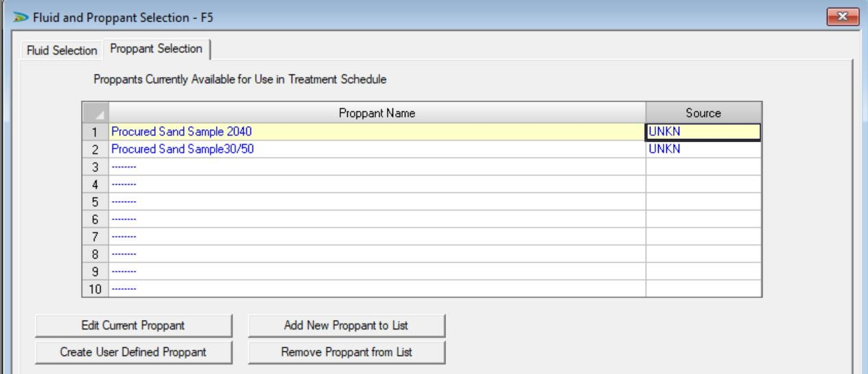
Figure 1: Fluid & Proppant Selection
For the fracture simulation, a case wherein a sandstone formation with 100 feet of thickness was between two shale formations was considered. The reservoir has ceased production due to the presence of a 60-foot layer of skin or formation damage near the wellbore, requiring hydraulic fracturing operations. Based on the situation, the KGD fracture model best fits the purpose. After defining the formation, wellbore configuration, fracturing fluid, and proppant, the FracPro study was performed.

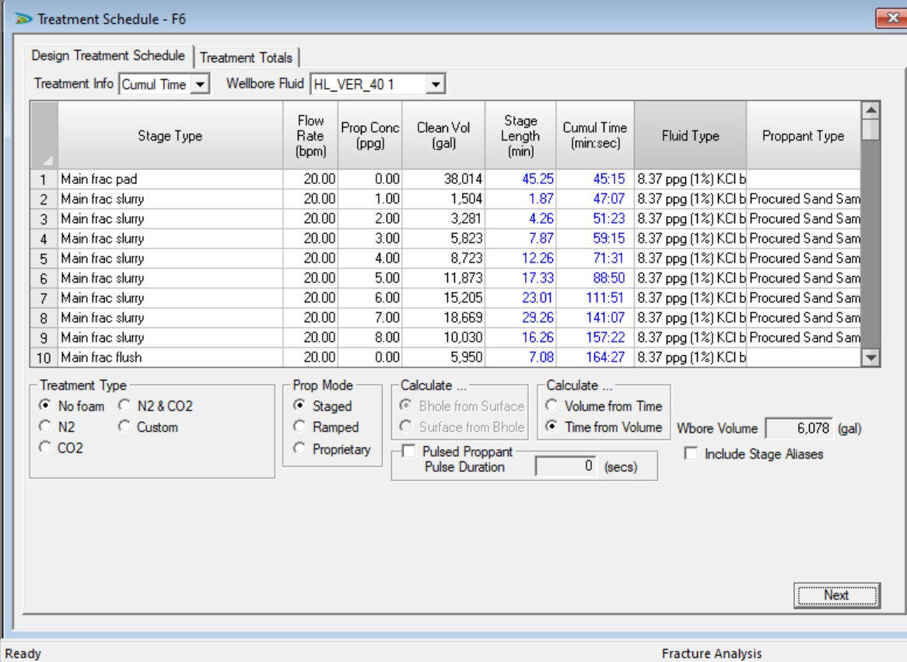
Figure 2: Treatment Schedule

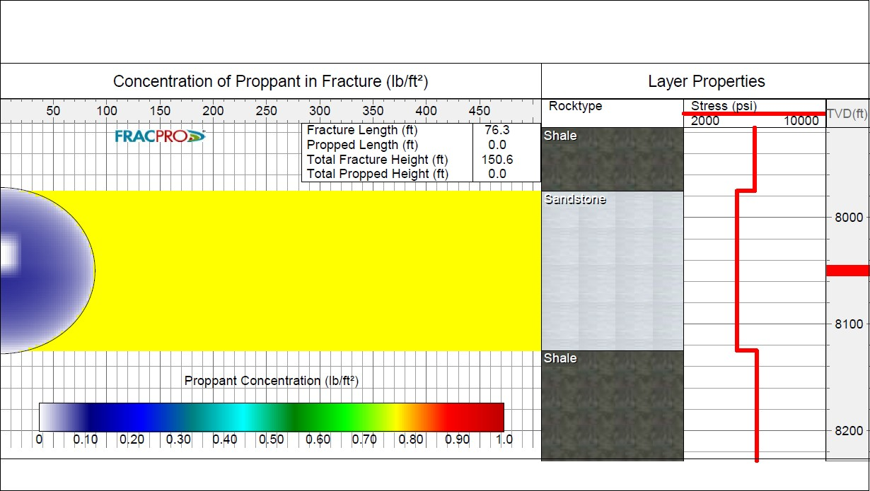
Figure 3: Fracture Profile after Pad stage
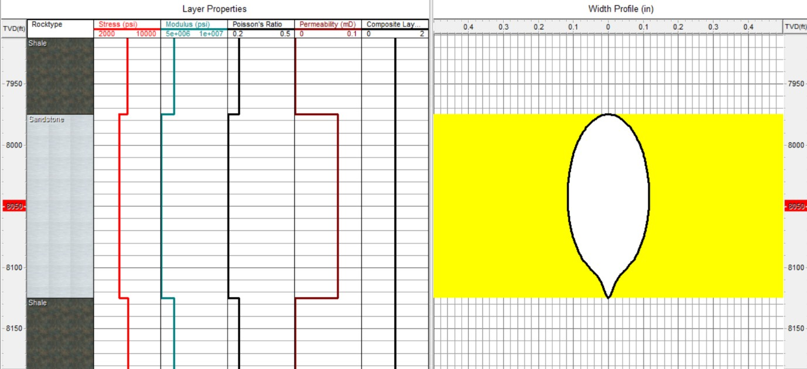

Figure 4: Width Profile after Padstage

The outcome of the current work reflects (Fugure 1-4) that post-pad stage, the slurry goes in and places the proppants into the fracture. With the obtained proppant sample, the post-fracture conductivity was analysed in the produced fractures and compared with various propping materials, from sand-type to ceramic-type proppants. For this, three different proppants were considered: Accupak 20/40 (a medium-strength resin-coated proppant), Ceramax 20/40 (a medium-strength ceramic proppant), and Bauxlite 20/40 (a high-strength ceramic proppant) from the FracPro library, and the fracture conductivity for the procured sand sample was compared. The fracture simulation and test were done for a sandstone formation with a depth of 8000ft and an in-situ stress of approx. 5000 psi, which was earlier recommended as the maximum permissible stress for the procured proppant sand.

Fig 4.8 Comparison of Fracture Conductivity with different proppants

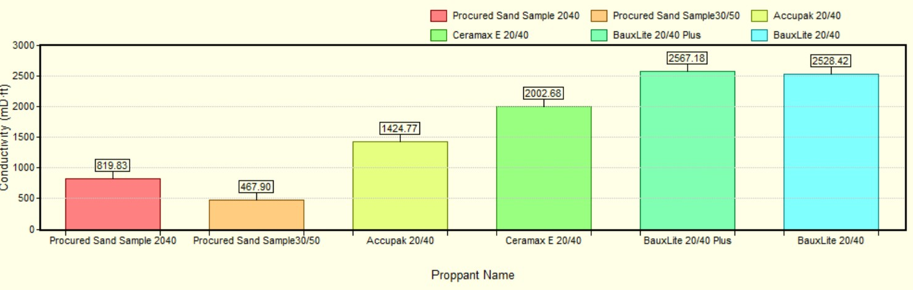
Figure 5: Comparison of Fracture Conductivity with different proppants

Figure 5 shows the fracture conductivity for the fractures with different proppants. From this, the significance of the crush resistance, or crushing strength, of the proppant sand can be understood. There is a reduction in conductivity noticed when used with the finer mesh grade "procured sand sample 30/50," which might be due to lower crushing strength and blocking of the pore spaces and fines produced due to the extreme high pressures. However, under the same circumstances, the resin-coated and ceramic proppants provide better conductivity in the induced fracture, meaning more stable conductive pathways due to the higher crushing strength of the proppant material.
The present study finds that sand-based proppants are much cheaper than resin-coated and ceramic proppants. The procured sand-based proppants cost Rs. 8/kg; however, the resin-coated and ceramic proppants were priced at Rs. 33/kg and Rs. 75/kg, meaning they cost 5 to 10 times more than sand-based proppants. For these economic reasons, for shallow reservoirs with lesser crushing pressure, sand-based proppants are recommended; however, at greater depths with high crushing strength, resin-coated or ceramic proppants are to be used.

CONCLUSION
An effective hydraulic fracturing design is key to achieving the expected results in terms of production from unconventional reservoirs. There is no universal method of hydraulic fracturing that can be applied anywhere in the world without proper formation evaluation of underground formations containing hydrocarbons. Based on the combined experimental, theoretical, and analytical study on hydraulic fracturing design, an in-depth understanding of hydraulic fracturing design can be gained from a field approach and practise. From the tested sand sample and fracture analysis, the following conclusions can be drawn:
- The analysed samples from Gujarat had two proppant mesh sizes: 20/40 and 30/50, which are preferable for hydraulic fracturing operations.
- The tested proppant sands are suitable for hydraulic fracturing operations with less acid.
- The proppants are to be recommended for fracturing shallow reservoirs with less than 5000 psi closure.
- From the analysis of the fracture conductivity on the sand samples and when compared to that of ceramic proppants, it is seen that the ceramic proppants have performed better than the sand proppants; however, the price of ceramic proppants is almost 5–10 times higher. Due to this, in shallow reservoirs with lesser crushing pressure, sand-based proppants are used.

REFERENCES

[1] Api, A. (1995). Recommended Practices for Testing Sand Used in Gravel Packing Operations, API RP 58. API RP, 58.
[2] Api, A. (1995). Recommended Practices for Testing High- Strength Proppants Used in Hydraulic Fracturing Operations, API RP 60. API RP, 60.
[3] Liang, F., Sayed, M., Al-Muntasheri, G. A., Chang, F. F., & Li, L. (2016). A comprehensive review on proppant technologies. Petroleum, 2(1), 26–39. https://doi.org/10.1016/j.petlm.2015.11.001
[4] Simo, H., Pournik, M., & Sondergeld, C. H. (Eds.). (n.d.). Proppant Crush Test: A New Approach”.
[5] Hydraulic fracturing proppants (Propantes para fraturamento hidráulico)”. (n.d.).
[6] EI-Sayed, A. A. H., Hemeida, A. M., & AI-Blehed, M. S. (Eds.). (n.d.). Testing of Saudi Sand-dunes for Potential Use in Hydraulic Fracturing of Hydrocarbon Reservoirs”.
[7] Coulter, G. R., & Wells, R. D. (1972). The advantages of high proppant concentration in fracture stimulation. Journal of Petroleum Technology, 24(06), 643–650. https://doi.org/10.2118/3298-pa
[8] Howard, G. C., & Fast, C. R. (1970). Monograph 2 - Hydraulic fracturing.
[9] Gidley, J. L., Penny, G. S., & McDaniel, R. R. (1995). Effect of proppant failure and fines migration on conductivity of propped fractures. SPE Production & Facilities, 10(01), 20–25. https://doi.org/10.2118/24008-pa

