Artificial Intelligence on Drug Repurposing for Food Borne Bacterial Diseases – A Medicine Approach
Gobalan Krishnasamy¹, Sudharsan Parthasarathy², Reshmadevi Ramesh³, Siva Vijayakumar Tharumasivam^{3*}
¹ Department of Biotechnology, Jamal Mohammed College (Autonomous), Trichy, Tamil Nadu, India
² Department of Forestry, Nagaland University (A Central University), Lumami, Nagaland, India.
³ Department of Biotechnology, Srimad Andavan Arts and Science College, (Autonomous), Trichy, Tamil Nadu, India
* Corresponding Author (shiva.bloom165@gmail.com)

Abstract:

Now a days artificial intelligence plays a vital role in the pharmaceutical and drugs, based industries. The AI tools will provide the accurate values, data and results to the subsequent problems. There are more than 250 known foodborne diseases. This study is fully focused on the drugs which is used for food borne diseases which approved by the FDA and their analysis. Our computational based drug repurposing analysis suggest that more than 135 FDA approved drug shows positive response against food borne pathogen this include 98 antibiotics, 18 Antiemetic and 19 Antidiarrheal drugs. Foodborne bacterial diseases pose a significant public health concern worldwide, necessitating the development of effective treatment options. Traditional drug discovery and development processes are often time-consuming and expensive. In recent years, artificial intelligence (AI) has emerged as a promising approach for drug repurposing, accelerating the identification of new therapeutic candidates. This study explores the application of AI in drug repurposing for foodborne bacterial diseases and discusses its potential to revolutionize the field of medicine. By leveraging AI algorithms, vast amounts of data can be analyzed to identify existing drugs that may be repurposed to treat foodborne bacterial infections. This approach can expedite the drug development process, provide cost-effective treatment options, and address the growing challenge of antibiotic resistance.

Keywords: Artificial Intelligence, Drugs, Food borne diseases, Medicine

Introduction
The ongoing emergence of drug-resistant bacteria poses a significant barrier to the treatment of infectious illnesses. The development of novel medicinal drugs and vaccines is typically time-consuming and expensive. Vaccine development normally takes 10 to 15 years; foodborne pathogens cause a large number of illnesses that have serious consequences for human health and the economy (Acheson et al., 2016). A sickness brought on by ingesting tainted food or drink. Food may be contaminated by a wide range of bacteria and hazardous compounds. More than 250 foodborne illnesses are recognised. All foodborne microorganisms and poisons enter the body via the gastrointestinal system, where they frequently induce the initial symptoms. Foodborne infections can cause nausea, vomiting, abdominal cramps, and diarrhoea. (Chen et al., 2017; Ferreira et al., 2014). Bacteria cause the vast majority of illnesses. Other foodborne infections are essentially poisonings induced by poisons or compounds in food. Food safety management systems based on the traditional hazard-based approach have been shown to be inefficient, and major researchers and organizations are now recommending a risk-based food safety strategy (Chen et al., 2009). A food safety management system should be created in this environment to evaluate the risks to human health posed by food intake and to identify, select, and execute mitigation techniques to limit and mitigate these risks (Fonteneau et al., 2017). Because many microorganisms may spread through more than one route, it is possible that an illness is not immediately apparent as being foodborne. The distinction is important because public health officials must understand how a disease spreads in order to take proper measures to halt it (Jaradat et al., 2014). Infections with Escherichia coli O157:H7, for example, can be obtained through contaminated food or contaminated drinking water. Furthermore, the implementation of appropriate food safety education programmes for all those engaged in food production and consumption is recommended.
Foodborne diseases are often infectious or poisonous in nature, caused by bacteria, viruses, parasites, or chemical compounds that enter the body via contaminated food or water. Foodborne pathogens can cause severe diarrhoea as well as serious diseases such as meningitis (Juliao et al., 2013). Bacteria are the most prevalent cause of foodborne illness, and they come in a wide range of forms, kinds, and qualities. Some hazardous bacteria, such as Clostridium botulinum, Clostridium perfringens, Bacillus subtilis, and Bacillus cereus, may generate spores and are therefore very heat resistant. Some bacteria can produce heat-resistant toxins (for example, Staphylococcus aureus and Clostridium botulinum). Most infections are mesophilic, with optimum development temperatures ranging from 20 to 45 degrees Celsius. Certain foodborne pathogens (psychrotrophs) such as Listeria monocytogenes and Yersinia enterocolitica, on the other hand, may grow under refrigerated settings or at temperatures below 10°C (Bacon and Sofos 2003). Salmonella, Campylobacter, and Enterohaemorrhagic Escherichia coli are among the most frequent foodborne infections, affecting millions of people each year, sometimes with serious and deadly consequences. Fever, headache, nausea, vomiting, stomach discomfort, and diarrhoea are some of the symptoms. Eggs, chicken, and other animal products are examples of foods implicated with salmonellosis epidemics. Campylobacter foodborne cases are mostly caused by raw milk, raw or undercooked chicken, and drinking water. Enterohaemorrhagic Escherichia coli is linked to raw milk, undercooked meat, and fresh fruits and vegetables. (Konishi et al., 2016; Lahti et al., 2017)

Materials and Methods

KEGG (Kyoto Encyclopaedia of Genes and Genomes) is a knowledge repository for systematic investigation of gene functions that connects genomic data with higher level functional data. The genomic data is saved in the GENES database, which is a collection of gene catalogues for all fully sequenced genomes and some incomplete genomes with up-to-date gene function annotation. The PATHWAY database, which comprises graphical representations of biological activities such as metabolism, membrane transport, signal transduction, and cell cycle, stores higher level functional information. The pathway database is augmented with a collection of ortholog group tables that provide information about conserved sub pathways (pathway motifs) that are frequently encoded by positionally related genes on the chromosome and are particularly valuable in predicting gene functions. LIGAND is a third database in KEGG that contains information on chemical compounds, enzyme molecules, and enzymatic processes. KEGG offers Java graphical tools for exploring genome maps, comparing two genome maps, and modifying expression maps, as well as computational tools for sequence comparison, graph comparison, and route computing (Laufer et al., 2015). The KEGG/PATHWAY database offers reference diagrams for biochemical pathways and complexes involving diverse cellular activities that may be easily combined with genomic data. A key to this integration is graph repre- sentation (Kanehisa, & Goto, 2000). A graph is defined mathematically as a collection of nodes and edges. In KEGG, the genome is a one-dimensional graph of genes, and the route is a graph of gene products (mainly proteins, but also RNAs and complexes) with more sophisticated patterns of connections. KEGG can predict networks of protein-protein interactions and related biological activities by matching genes in the genome with gene products in the pathway. The Genome Net is now run by Kyoto University's Bioinformatics Centre, which focuses on functional genomics and proteomics while maintaining serving the majority of significant molecular biology databases. The Kyoto Encyclopaedia of Genes and Genomes (KEGG) is the Genome Net's principal resource (EFSA 2016; FDA 2012).
Results And Discussion
Enrichment analysis

Pathways enrichment analysis for KEGG human pathway
The functional pathways of genes involved in foodborne pathogen response were analysed from Gene set library by Enrichr platform. Figure 1 represent Several diseases causing genes were analyzed, among those Calcium signaling pathway, IL-17 signaling pathway, Prostate cancer were highly aswell as equally enriched than other disease-causing genes with adjusted P-value of 0.005044. Calcium signaling pathways can suppress apoptosis and promote survival through two mechanistically distinct processes and it will be enriched with specific genes like CHRM2; CHRM3; HRH1; NOS2; NOS3; VDAC1; EGFR). The IL-17 family of cytokines contains six members, including IL- 17/IL-17A, IL-17B, IL-17C, IL-17D, IL-17E/IL-25, and IL-17F, which are produced by many different cell types and primarily promote pro-inflammatory immune responses and it will be enriched with specific genes like IKBKB; CHUK; IFNG; PTGS2; HSP90B1. Likely, Prostate cancer is the most common cancer in men and is known as the second most prevalent cause of death after lung cancer. The prostate is a small walnut-sized gland in the lower abdomen of males, located in front of the rectum and it is enrichrd with specific genes like IKBKB; CHUK; EGFR; MTOR; HSP90B1 (Longenberger et al., 2014; Ma et al., 2013; Wei et al., 2018; Wu et al., 2014).

Pathways enrichment analysis for Jensen diseases
The functional pathways of genes involved in host response, gene enrichment analysis was performed, using Jensen diseases using Enrichment platform. the top 10 enriched pathway is represented in figure 2, Here in enrichment analysis Arthritis, Lung disease, Neutropenia are enriched with Adjusted P-value 6.45E-06; 1.53E-05; 0.002255. in the Arthritis gene disease pathway i IKBKB; POMC; IFNG; NOS2; VDR; PLA2G1B; TRPV1; PTGS2; MPO; ELANE which is effectively targeted with our repurposed drug figure (2,3) in our enrichment analysis POMC; IFNG; NOS2; PLA2G1B; NOS3; PTGS2; MPO; ELANE are involved, the top to enriched disease pathway in our analysis are already reported in the pathogenesis of foodborne disease (Maki 2009; Martinelli et al., 2009; Scallan et al., 2011)

Pharmacological Network analysis
Network analysis of repurposed drugs with targeted food pathogenic bacterial gene The network pharmacology approach suggests genes-disease and effects of a drug containing multiple component (synergic effects of phytochemical compounds) pathways, that are capable of acting specific biological systems (targets), using this methodology we build a network to check the effectiveness of existing drugs approved by FDA (Angelo et al., 2017; Bennett et al., 2013). From this network we suggest the association of virulent pathogenic food borne bacterial gene with FDA drug targeted with human genes, (Figure.3) represents pharmacological network analysis, network has 108 node 173 edges, and the vertices of the network represent the association of pathogenic genes with drug target (Buchanan et al., 2017, Rasko et al., 2011). In our network analysis shows that antibiotic drugs have highly linked with the virulent gene of bacterial food borne pathogen. 98 Antibiotic class of drug interact with the pathogenic bacterial similarly 18 Antiemetic and 19 Antidiarrheal drug classes interact with food pathogenic bacteria effectively by analysing the network we can predict the efficiency of the drug class association and the pathogenicity each bacteria in our analysis by checking the level of interaction of pathogenic gene with the drug group (Berger et al., 2010; Bintsis, 2017).
Discussion
This study highlights the potential impact of artificial intelligence on drug repurposing for foodborne bacterial diseases. It emphasizes the advantages and challenges associated with this approach, as well as the future prospects in the field of medicine.
Advantages of AI in drug repurposing:
AI algorithms can efficiently analyze and integrate diverse sources of data, facilitating the identification of potential drug candidates. By repurposing existing drugs, the drug development process can be expedited, saving time and resources. AI models can predict the efficacy and safety of repurposed drugs, aiding in the selection of the most promising candidates. Drug repurposing offers cost-effective treatment options, as existing drugs have already undergone safety testing and regulatory approval.
Challenges and limitations:
The availability and quality of data play a crucial role in the success of AI-driven drug repurposing. Incomplete or biased data can impact the accuracy of predictions. AI algorithms rely on existing knowledge, and the identification of novel drug candidates may be limited by the existing data landscape. Experimental validation is necessary to confirm the efficacy and safety of repurposed drugs identified by AI, and potential challenges in obtaining suitable data for validation should be considered.
Future prospects:
AI can be integrated with other emerging technologies, such as high-throughput screening and precision medicine, to further enhance the drug repurposing process. Collaboration between researchers, pharmaceutical companies, and regulatory agencies is crucial to ensure the successful translation of AI-driven drug repurposing into clinical practice. Continuous updates and improvements in AI algorithms, as well as the expansion of data sources, can contribute to more accurate predictions and successful repurposing of drugs. By leveraging AI algorithms, the identification of repurposed drugs can be accelerated, offering cost-effective and timely treatment options. However, it also acknowledges the challenges and limitations associated with this approach and emphasizes the need for further research and collaboration to maximize its benefits in clinical practice.
Conclusion
In the last decade, substantial progress has been made in the development of repurposed drugs for the treatment of food pathogenic bacteria. Several compounds have yielded promising data but developmental efforts remain in the preclinical stage. Additional relevant issues should be take into account in the preclinical development of repurposing drugs including possible need for new formulations to increase their bioavailability and ADME tests if the administration route is changed, possible negative effect of the primary drug activity (especially for anticancer and antipsychotic drugs), and challenges for intellectual property rights. Moreover, further clinical studies are needed to address the urgent demand for new treatments targeting infections caused by food pathogenic bacteria. Our computational based drug repurposing analysis suggest that more than 135 FDA approved drug shows positive response against food borne pathogen this include 98 antibiotics, 18 Antiemetic and 19 Antidiarrheal drugs this data is supports by our enrichment analysis, further clinical and experimental data‘s are need to However, experimental validation including functional gene expression and purification is required to evaluate these therapeutic targets in the future.
Conflict of Interest
There is no conflict among the authors

Reference:
- Bacon RT, Sofos JN (2003) Characteristics of Biological Hazards in Foods, In: Schmidt RH, Rodrick GE, Editors, Food Safety Handbook, New Jersey: John Wiley & Sons, Inc., 157–195.
- Kanehisa, M. and Goto, S. (2000) KEGG: kyoto encyclopedia of genes and genomes. Nucleic Acids Res., 28, 27–30.
- Acheson P, Bell V, Gibson J, et al. (2016) Enforcement of science—using a Clostridium perfringens outbreak investigation to take legal action. J Public Health 38:511–515.
- Angelo KM, Conrad AR, Saupe A, et al. (2017) Multistate outbreak of Listeria monocyte genes infections linked to whole apples used in commercially produced, prepackaged caramel apples: United States, 2014–2015. Epidemiol Infect: 145:848–856.
- Bennett SD, Walsh KA, Gould LH (2013) Foodborne disease outbreaks caused by Bacillus cereus, Clostridium perfringens, and Staphylococcus aureus—United States, 1998–2008. Clin Infect Dis 57:425–433.
- Berger CN, Sodha SV, Shaw RK, et al. (2010) Fresh fruit and vegetables as vehicles for the transmission of human pathogens. Environ Microbiol12:2385– 2397.
- Bintsis, T. (2017). Foodborne pathogens. AIMS Microbiology, 3(3), 529-563. doi:10.3934/microbiol.2017.3.529
- BuchananRL, GorisLGM, HaymanMM, etal.(2017)AreviewofListeriamonocytogen es:An update on outbreaks, virulence, dose-response, ecology, and risk assessments. Food Control 75: 1–13.
- Chen J, Zhang R, Qi X, et al. (2017) Epidemiology of foodborne disease outbreaks caused by Vibrio parahaemolyticus during 2010–2014 in Zhejuang Province, China. Food Control 77: 110–115.
- Chen, J., Bardes, E.E., Aronow, B.J. and Jegga, A.G. (2009) ToppGene Suite for gene list enrichment analysis and candidate gene prioritization. Nucleic Acids Res., 37, W305–W311.
- EFSA (European Food Safety Authority) and ECDC (European Centre for Disease Prevention and Control) (2016) The European Union summary report on trends and sources of zoonoses, zoonotic agents and food-borne outbreaks in 2015. EFSA J 14:4634–4865.
- FDA, Bad Bug Book, Foodborne Pathogenic Microorganisms and Natural Toxins, Second Edition, 2012. Available from: https://www.fda.gov/Food/ Food borne Illness Contaminants/ Causes Of Illness BadBu gBook/.
- Ferreira V, Wiedmann M, Teixaira P, et al. (2014) Listeria monocytogenes persistence in food-associated environments: Epidemiology, strain characteristics, and implications for public health. J Food Protect 77:150–170.
- Fonteneau L, Da Silva NJ, Fabre L (2017) Multinational outbreak of travel- related Salmonella Chester infections in Europe, summers 2014 and 2015. Eurosurveill 22: 1–11.
- Jaradat ZW, Mousa WA, Elbetieha A, et al. (2014) Cronobacterspp.— opportunistic food-borne pathogens. A review of their virulence and environmental-adaptive traits.J Med Microbiol63:1023–1037.
- Juliao PC, Maslanka S, Dykes J, et al. (2013) National outbreak of type A foodborne botulism associated with a widely distributed commercially canned hotdog chilisauce.ClinInfectDis56: 376–382.
- Konishi N, Ishitsuka R, Yokoyama K, et al. (2016) Two outbreaks of Yersinia enterocolitica O:8 infections in Tokyo and the characterization of isolates. J Japan Assoc Infect Dis 90: 66–72.
- Lahti E, Löfdahl M, Agren J, et al. (2017) Confirmation of a Campylobacteriosis outbreak associated with chicken liver pâtè using PFGE and WGS. Zoon Public Health 64:14–20.
- Laufer AS, Grass J, Holt K, et al. (2015) Outbreaks of Salmonella infections attributed to beef—United States, 1973–2011. Epidemiol Infect 143: 2003–2013.
- Longenberger AH, Gronostaj MP, Yee GY, et al. (2014) Yersinia enterocolitica infections associated with improperly pasteurized milk products: southwest Pennsylvania, March–August, 2011. Epidemiol Infect 142: 1640–1650.
- Ma C, Deng X, Ke C, et al. (2013) Epidemiology and etiology characteristics of foodborne outbreaks caused by Vibrio parahaemolyticus during 2008–2010 in Guangdong Province, China. Foodborne Pathog Dis 11: 21–29.
- Maki DG (2009) Coming to grips with foodborne infection—peanut butter, peppers, and nationwide Salmonella outbreaks. New Engl J Med 360: 949–953.
- MartinelliD, FortunatoF, TafuriS, et al.(2013)Lessons learnt from a birthdayparty:aBacillus cereus outbreak, Bari, Italy, January 2012. Ann 1st Super Sanità49:391–394.
- Rasko DA, Webster DR, Sahl JW, et al. (2011) Origins of the E. coli strain causing an outbreak of hemolytic-uremic syndrome in Germany. New Engl J Med 365:709–717.
- ScallanE, Hoekstra RM, AnguloFJ, et al. (2011) Foodborne illness acquired in the United States—major pathogens. Emerg Infect Dis 17: 7–15.
- Wei Zheng, Wei Sun and Anton Simeonov. Drug repurposing screens and synergistic drug-combinations for infectious diseases. British Journal of Pharmacology (2018) 175: 181–191
- Wu Y, Wen J, Ma Y, et al. (2014) Epidemiology of foodborne disease outbreaks caused by Vibrio parahaemolyticus, China, 2003–2008. Food Control 46: 197– 202.

Figures:
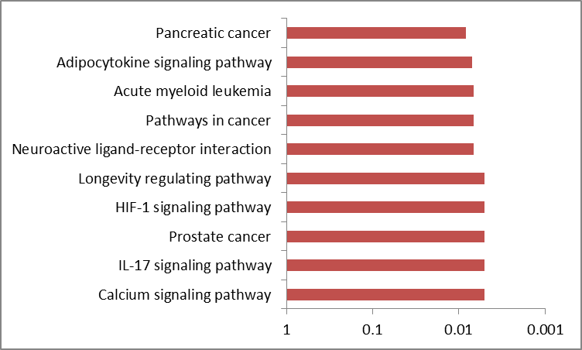
Figure 1: KEGG enrichment pathway graph for food pathogen associated gene with targeted drug pathway.
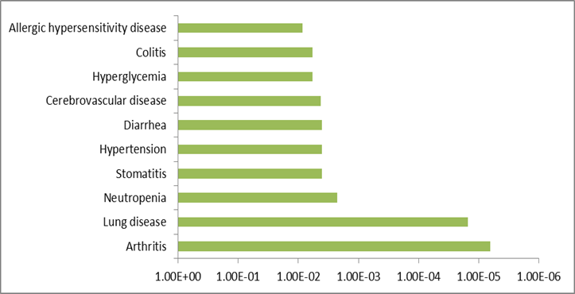
Figure 2: Jensen diseases enrichment pathway graph for food pathogen associated gene with targeted drug pathway.

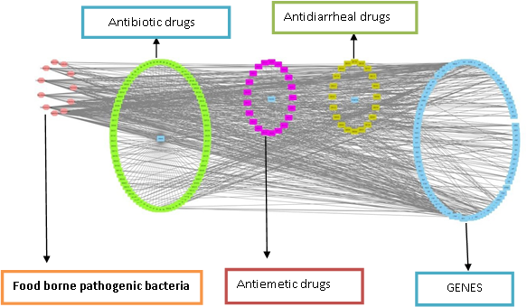
Figure 3: pharmacological network analysis of repurposed drugs with targeted food pathogenic bacterial gene

