RECENT ADVANCES IN MILLET PROCESSING AND VALUE ADDITION
Soumya C Meti¹, Udaykumar Nidoni², Sharanagouda Hiregoudar³ and Pramod Katti⁴
¹Research scholar, Department of Processing and Food Engineering, College of Agricultural Engineering, University of Agricultural Sciences, Raichur-584104.
²Professor and University Head, Department of Processing and Food Engineering, College of Agricultural Engineering, University of Agricultural Sciences, Raichur-584104.
³Professor and Head, Department of Processing and Food Engineering, College of Agricultural Engineering, University of Agricultural Sciences, Raichur-584104.
⁴Professor, Department of Agricultural Entomology, University of Agricultural Sciences, Raichur-584104.
Corresponding author: Soumya C Meti; Email: soumyacm97@gmail.com
Abstarct
The introduction to millets as smart cereals encompasses their growing importance in a global context, responding to the need for sustainable and nutritious food sources. This chapter begins by delineating the increasing demand for resilient foods worldwide, setting the stage for an exploration of millets' historical and contemporary significance in India's dietary landscape. It then delves into the taxonomy, structure, and unique traits that make millets intelligent crops, capable of thriving in diverse and challenging environments. The processing journey of millets, from field to table, is outlined, encompassing primary and secondary processing techniques that enhance their quality and shelf-life. The chapter also highlights the development of value-added products and quality standards, ensuring their nutritional integrity and safety. Lastly, the chapter underscores millets' potential in nutraceutical and functional foods, presenting them as versatile ingredients rich in bioactive compounds and nutrients that can contribute to holistic well-being.
Keywords: Millets, International Year of Millets, Value Addition, Functional Food, Nutraceuticals
1. Introduction
The word ‘millet’ gets its origin from the French word “mille’’ which means thousand, with a handful of millet containing up to 1000 grains. Millets are group of small-seeded grasses, belonging to the family Poaceae. These were the first crops to be cultivated by mankind in Asia and Africa, which eventually expanded across the world as a pivotal food source for human civilization. Cultivation of millets started in 2600 BC. Further domestication in other regions gave rise to secondary regions of diversity and adaptation and different end uses including animal feed. However, over time millets lost their place to other cereal crops such as rice and wheat which took precedence during the 1960s post-green revolution phase. Today, millets are mainly grown in arid lands in India and Africa by poor farmers.
Millets have agricultural superiority over other commercial crops, attributed to their ability to adapt under marginal and low input demanding cultivation. The C4 photosynthetic pathway and ability to withstand environmental stress makes them a suitable choice for future agricultural systems. In addition, millets have higher nutritional value with more balanced nutrients compared to cereals such as wheat and rice. This nutritional superiority makes them highly valuable not just as a source of food but also for diverse pharmaceutical use.
There has been a tremendous shift in food choices across the globe. Surge in the occurrence of diseases such as diabetes, obesity and cardiovascular problems such as heart attack, coronary artery disease and arrhythmias, has become a rising concern across the globe. The presence of high content of proteins, vitamins (A and B) and minerals such as calcium and iron in millets can help in avoiding such diseases. Consequently, millets are the best ﬁt for consumers who prefer to have nutrition rich healthy food with good palatability.
The cultivation and consumption of millets is declining in many countries and their potential to address food and nutritional security is not being properly realized. Given the growing focus on consumption of nutritious food on the consumption side and sustainability aligned production on the supply side, there is an urgent need to promote the nutritional and ecological benefit of millets to consumers, producers and decision-makers; improve millet production efficiencies, increase research and development investments, boost value addition and strengthen linkages of millets across the food sector. In 2013, India’s National Food Security Act incorporated millets (then defined as coarse cereals) and by 2018 millets were officially made part of the National Food Security Mission. The Government of India also declared 2018 as the National Year of Millets.
The proposal for an International Year of Millets (2023) was put forth by the Government of India and endorsed by Members of FAO Governing Bodies at the 26th Session of COAG; 160th Session of FAO Council and 41 FAO Conference. It was adopted by the 75th Session of the UN General Assembly in March 2021. About 70 countries have pledged to engage various stakeholders for promoting the wider usage of millets and improve production and productivity of millets across the globe. India, being the largest producer of millets and proposer of IYoM-2023, is leading efforts for reviving millets and has initiated a number of policy initiatives to promote their production. The International Year of Millets (2023) provides a unique opportunity for India to help create greater awareness of millet production, contribute to food and nutritional security, ensure sustainable livelihoods and incomes of farmers – particularly in regions that are drought-prone or threatened by climate change. There has been an increased interest in millets and its products owing to its nutritional composition, health beneﬁts and ease of cultivation. As a result, the UN declared the year 2023 as the ‘International Year of Millets’, which would further enhance the public awareness on the health beneﬁts of millets.

2. Global area and production of millets
In 2022, the global area under millets stood at 71.70 Mn ha. The global production of millets stood at 90.65 Mn MT in 2022, growing at a decadal (2012-2022) from 88.31 Mn MT in 2012. Fig. 1 and Fig. 2 depicts annual trends in global area and production under millets (2012-2022), respectiviely. As seen in the Table 1, India is the highest millets producing country in the year 2022 with 17.60 Mn MT production, contributing to 19.42% of the global production. It is followed by Nigeria (9.00 Mn MT; 10.01%), Sudan (6.50 Mn MT; 7.23%), US (6.21 Mn MT; 6.91%) and China (5.70 Mn MT; 6.34%). In 2022, global area under Sorghum was 40.44 Mn ha (56%) while area under other millets was 31.28 Mn hectares (44%). Sorghum contributed around 66% (60.13 Mn MT) to the global millets production while other millets (small millets, ﬁnger millets, pearl millets etc.) contributed the balance 34% production (30.52 Mn MT) (FAO, USDA).
Fig. 1. Annual trends in global area under millets (2012-2022)
Fig. 2. Annual trends in global production under millets (2012-2022)
Source: FAO, USDA

Table 1. Top 5 countries in millets production, 2022
Rank | Country | % Share of global production | Production (‘000 MT)
1  2  3  4  5 | India  Nigeria  Sudan  United States  China | 19.42  10.01  7.23  6.91  6.34 | 17600  9000  6500  6212  5700
Source: United States Department of Agriculture and YES BANK Analysis
3. Indian area and production of millets
In the year 2022, India produced 17.60 Mn MT of millets that included 4.40 Mn MT of sorghum and 13.20 Mn MT of other millets. Fig. 3 shows the area, production and productivity trends of millet in the last 10 years (2012-22). Millet production has grown from 16.03 Mn MT in 2012 to 17.60 Mn MT in 2022. The area under millets in India was 15.40 Mn ha in 2012 but declined to 14.00 Mn ha in 2022. The productivity of millets has risen from approximately 1.04 MT/ha in 2012 to 1.26 MT/ha in 2022 (USDA).
Fig. 3. Millet area, production and productivity in India, 2012-2022
Source: United States Department of Agriculture
Within India (Table 2), Rajasthan was the largest producer of millets with a production of 5.15 Mn MT in 2020-21, contributing to 28.61% to the national production. Karnataka was the second largest contributor, producing 2.56 Mn MT and contributing to 14.26% of national production. Other major millet producing states included Maharashtra (2.51 Mn MT (13.95%)), Uttar Pradesh (2.29 Mn MT (12.75%)), Haryana (1.36 Mn MT (7.58%)) and Gujarat (1.09 Mn MT (6.06%)). These top 6 states contributed more than 80% of India’s millet production in India in 2020-21.
Table 2. Top millet producing states in India, 2020-21
Rank | States | % share of production | Production (Mn MT)
1  2  3  4  5 | Rajasthan  Karnataka  Maharashtra  Uttar Pradesh  Haryana | 28.61  14.26  13.95  12.75  7.58 | 5.15  2.56  2.51  2.29  1.36

3.1. Trade: As the largest producer of millets, India plays a vital role in the global millets trade. In the year 2021, India exported millets worth USD 65.10 Mn (1.66% of global trade). In volume terms, India exported 1.68 lakh MT (0.45% of global trade)14. India witnessed exports rising from USD 55.22 Mn in 2011 to USD 65.1 Mn in 2021, registering a CAGR of 1.66%. In volume terms, exports declined at negative 0.52% from 1.76 Lakh MT in 2011 to 1.68 Lakh MT in 202115. Fig. 4 shows Indian millet export in value and volume terms from 2011-2021.
Fig. 4. Millet Export from India in Terms of Value (USD Mn) and Volume (000’ MT)
Source: ITC Trade Map and YES BANK Analysis
Fig. 5 depicts the category wise export of millets in terms of value and volume from India in the year 2021. Bajra (Pearl Millet) and Ragi (Finger Millet) together contributed 42.12% in terms of value (USD 27.42 Mn) and 54.41% in terms of volume (91,280 MT); followed by sorghum which contributed nearly 34% in terms of both value (USD 22.23 Mn) and volume (57,070 MT) in the year 2021. About 16,752 MT of other millets worth USD 14 Mn were exported in 2021.
Fig. 5. Category wise share of millets in India’s export in terms of value and volume (2021)
Source: ITC Trade Map and YES BANK Analysis
As depicted in Fig. 6, UAE, Saudi Arabia, Nepal, USA, Kenya and Bangladesh were among the top export destinations for Indian millets in 2021.
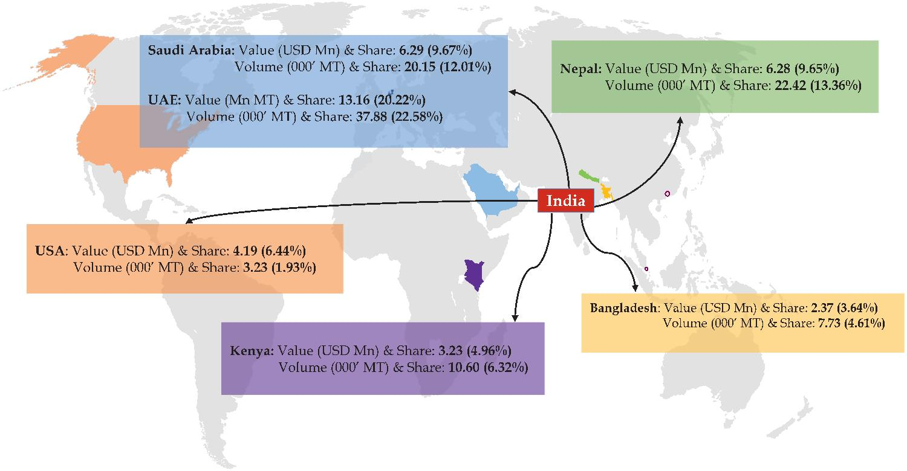

Fig. 6. Top export destinations for Indian millets in value terms, 2021
Source: ITC Trade Map and YES BANK Analysis
The top ﬁve export destinations for India in terms of value in 2021 were UAE with USD 13.16 Mn (20.22%), Saudi Arabia with USD 6.29 Mn (9.67%), Nepal with USD 6.28 Mn (9.65%), USA with USD 4.19 Mn (6.44%) and Kenya with USD 3.23 Mn (4.96%). In terms of volume, top ﬁve export destinations in the year 2021 were UAE with 37.88 thousand MT (22.58%), Nepal with 22.42 thousand MT (13.36%), Saudi Arabia with 20.15 thousand MT (12.01%), Kenya with 10.60 thousand MT (6.32%) and Bangladesh with 7.73 thousand MT (4.61%).
Fig. 7 provides a snapshot of the top 3 millet suppliers to India’s top 6 millet export destinations, depicting India’s rank in the supplier countries. India is among the top 3 suppliers to its top export destinations.
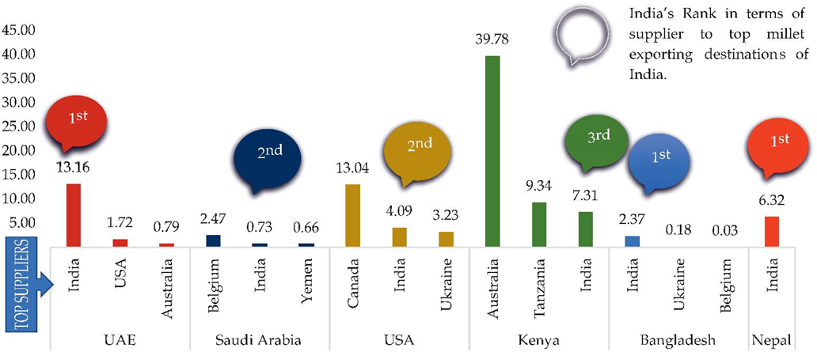
Fig. 7. Key suppliers to India’s top export destination in value terms (USD Mn), 2021
4. Types of millets
Millets are classiﬁed into two categories based on the seed size and use, namely sorghum (S. bicolor), pearl millet (P. glaucum) and finger millet (E. carocana) are considered as major millets and proso (P. miliaceum), kodo millet (P. scrobiculatum), foxtail millet (S. italica), little millet (P. sumatrense), barnyard millet (E. crusgalli) and browntop millet (B. ramose) are minor millets (Chandrashekar and Shahidi, 2012). Vernacular names of millets with their origin has been mentioned in the Table 3 and Table 4 depicts characteristics of different millet (Yousaf et al., 2022)

Table 3. Types of millets grown in India (Dayakar et al., 2017)
Scientific name | English | ಕನ್ನಡ |  | Origin
Sorghum bicolor | Sorghum | ಜೋಳ | जोवार | India
Pennisetum glaucum | Pearl millet | ಸಜ್ಜೆ | बजरा | Africa
Eleusine carocana | Finger millet | ರಾಗಿ | रागी | Africa
Panicum miliaceum | Proso millet | ಬರಗು | छेना | Eastern Asia
Paspalum scrobiculatum | Kodo millet | ಹರಕ | कोडों | India
Setaria italica | Foxtail millet | ನವಣೆ | काकुन | Eastern Asia
Panicum sumatrense | Little millet | ಸಾಮೆ | कुटक | Southeast Asia
Echinochloa crusgalli | Barnyard millet | ಊದಲು | साँवा | Japan
Brachiaria ramose | Browntop millet | ಕೊರಲೆ | छोटी कंगनी | South East Asia

Table 4. Characteristics of different millet (Yousaf et al., 2022)
Millet | Seed type | Size | Shape | Colour | Panicle | Grain
Sorghum | Caryopsis | 3 to 4 mm ø | Round | White, yellow, red or brown
Pearl millet | Caryopsis | 3 to 4 mm length | Oval | White, grey, slate blue or purple | 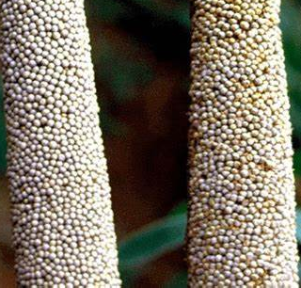
Finger millet | Utricle | 1 to 2 mm ø | Round | Yellow, white, red, brown or violet
Proso millet | Utricle | 2 to 3 mm length | Oval | Cream, yellow or orange
Kodo millet | Caryopsis | 1 to 2 mm length | Oval | Blackish brown to dark brown
Barnyard millet | Caryopsis | 3 to 4 mm length | Oval | Straw white, grey to dull white
Little millet | Caryopsis | 1.8 to 1.9 mm in length | Round | Grey to straw white
Foxtail millet | Utricle | 2 to 3 mm length | Oval | Red, black, white or yellow
Browntop millet | Caryopsis |  | Ellip-soid | Pale brown

5. Millets are smart cereals
ICRISAT introduced the term Smart food i.e., the food that fill the following criteria of being ‘Good for you’- These contain 7-12% protein, 2-5% fat, 65-75% carbohydrates and 15-20% dietary fibre and also a source of iron, zinc, calcium and other nutrients, tackling the problem of malnutrition and anaemia in India. A comparative study on nutritional value of millets has been depicted in Table 5 and Table 6. ‘Good for the planet’- Millets have a low carbon footprint, serves as a mitigation and adaptation strategy for climate change. ‘Good for the small farmer’- They can survive in high temperature, survive with very little water, climate resilient and have multiple uses (food, fodder, biofuel) (www.icrisat.org).

Table 5. Nutrient compositions of millets compared to wheat and rice
Grains | Carbohydrates  (%) | Protein (%) | Fat (%) | Crude fibre (%) | Ash (%) | Energy (kcal) | Amino acids (g/100 g of protein)
 |  |  |  |  |  |  | Methionine | Cystine
Rice | 78.2 | 6.8 | 0.5 | 0.2 | 0.6 | 345 | 0.12 | 0.05
Wheat | 71.2 | 11.8 | 1.5 | 1.2 | 1.5 | 346 | 0.18 | 0.23
Sorghum | 72.6 | 10.4 | 1.9 | 1.6 | 1.6 | 349 | 1.52 | 0.06
Pearl millet | 67.5 | 11.6 | 5.0 | 1.2 | 2.3 | 361 | 2.11 | 0.80
Foxtail millet | 60.9 | 12.3 | 4.3 | 8.0 | 3.3 | 331 | 3.06 | 0.45
Finger millet | 72.0 | 7.3 | 1.3 | 3.6 | 2.7 | 328 | 2.74 | 0.27
Barnyard | 65.5 | 6.2 | 2.2 | 9.8 | 4.4 | 307 | 2.20 | 0.10
Proso millet | 70.4 | 12.6 | 1.1 | 2.2 | 1.9 | 341 | 2.21 | 0.25
Kodo millet | 65.9 | 8.3 | 1.4 | 9.0 | 2.6 | 309 | 2.69 | 0.19
Little millet | 67.0 | 7.7 | 4.7 | 7.6 | 1.5 | 341 | 2.21 | 0.04
Browntop millet | 66.6 | 11.1 | 1.9 | 8.4 | 4.2 | 338 | 1.01 | 0.13
Source: Nutritive value of Indian foods, NIN 2007

Table 6. Minerals profile of millets compared to wheat and rice (mg/100 g)
Grains | Ca | P | Fe | Mg | K | Cu | Mn | Zn
Rice | 10 | 160 | 0.7 | 90 | - | 0.14 | 0.59 | 1.4
Wheat | 41 | 306 | 5.3 | 130 | 204 | 0.08 | 2.29 | 2.7
Sorghum | 25 | 222 | 4.1 | 171 | 131 | 0.46 | 0.78 | 1.6
Pearl millet | 42 | 296 | 8.0 | 137 | 307 | 1.00 | 1.15 | 3.1
Foxtail millet | 31 | 290 | 2.8 | 81 | 250 | 1.40 | 0.60 | 2.4
Finger millet | 344 | 283 | 3.9 | 137 | 408 | 0.47 | 5.49 | 2.3
Barnyard | 20 | 280 | 5.0 | 82 | - | 0.60 | 0.96 | 3.0
Proso millet | 14 | 206 | 0.8 | 153 | 113 | 1.60 | 0.60 | 1.4
Kodo millet | 27 | 188 | 0.5 | 147 | 144 | 1.60 | 1.10 | 0.7
Little millet | 17 | 220 | 9.3 | 133 | 129 | 1.00 | 0.68 | 3.7
Browntop millet | 27 | 276 | 8.9 | 94.5 | 60 | 1.23 | 1.99 | 2.5
Source: Nutritive value of Indian foods, NIN 2007
6. Millet Health benefits
- Millet acts as a prebiotic feeding microﬂora in your inner ecosystem
- Eﬀective in reducing blood pressure
- Eliminates problems like constipation, excess gas, bloating and cramping
- Helps to prevent type 2 diabetes
- Reduces risk of gastrointestinal conditions like gastric ulcers or colon cancer
- Prevents breast cancer
- Helps to optimize kidney, liver and immune system health
- Niacin (vitamin B3) in millet can help lower cholesterol
- Aids in treating respiratory conditions such as asthma
- Millets detoxify body

7. Millet processing
Millets have relatively poor digestibility, low bio-availability of minerals and low shelf-life of the processed rice. Thus, it necessitates the use of both traditional and non-traditional processing methods to enhance its dietary, sensory and shelf-life properties, as well as to aid in the reduction of anti-nutrients. Millet Processing can be defined as converting raw materials into usable or cooked form with an extending shelf life, specific flavor, improved texture and taste. Millet processing can be categorized into two stages: primary and secondary millet processing. Primary millet processing comprises of unit operations taking place at the farm/producer levels such as cleaning, dehulling, sorting, polishing and grading of millets. Secondary processing includes unit operations carried out after primary processing to transform millet grains into product for direct consumption, such as traditionally, milling, roasting, germination and fermentation for producing primary products such as millet rice, semi-polished rice, semolina, dehusked ﬂour and composite ﬂour and secondary products such as porridge, gruel, weaning and supplementary food. The advanced secondary food processing technologies such as malting, extrusion, baking, spray drying and popping are employed to produce instant mixes, convenient, ready-to-eat (RTE) and ready-to-cook (RTC) products (Ramashia et al., 2019).
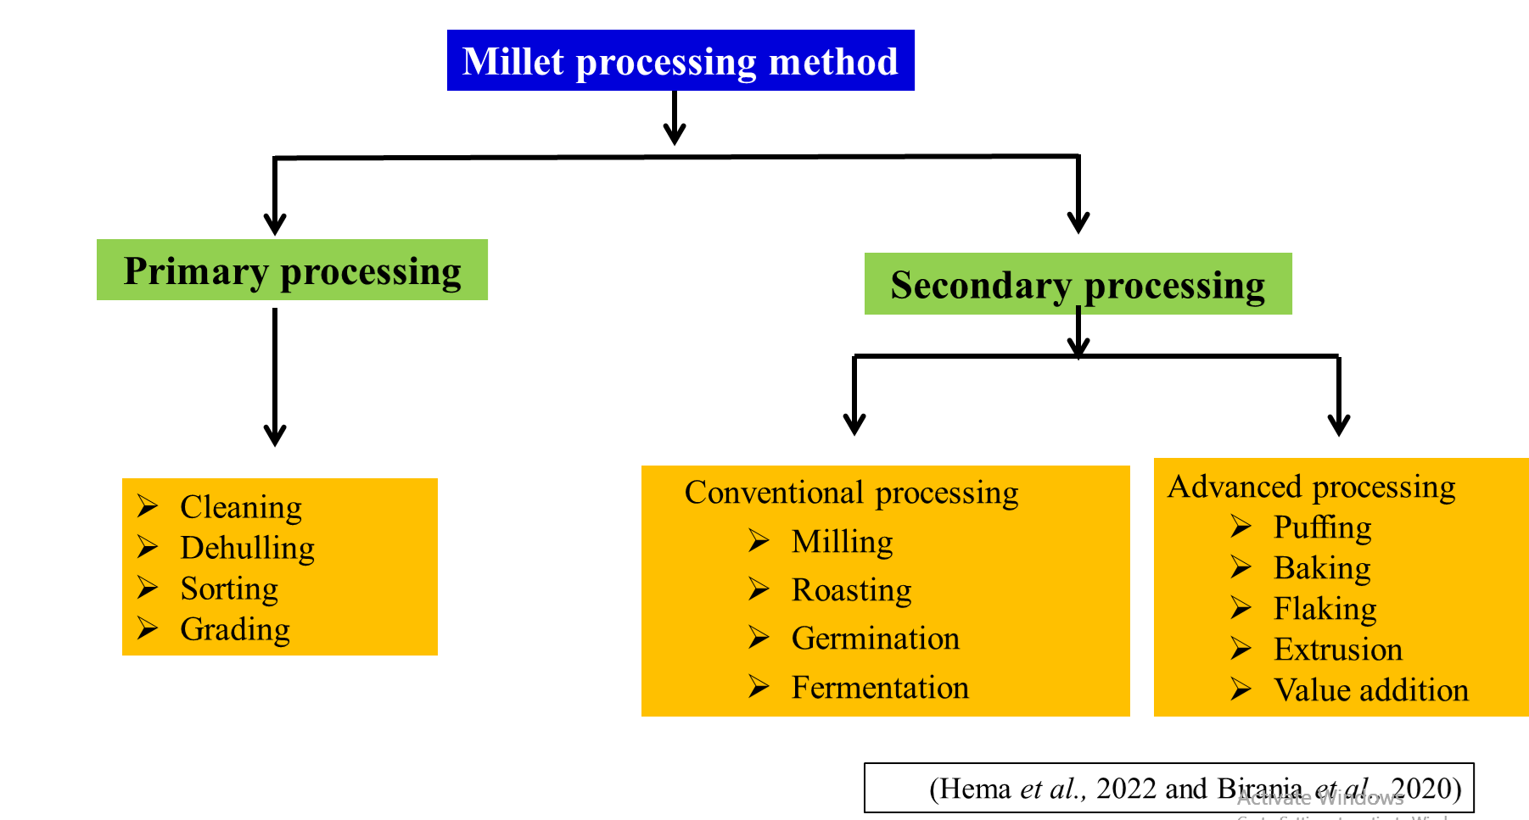

7.1 Primary processing operations

7.1.1 Cleaning
In this section, the input grains are cleaned off impurities. Impurities also known as material other than grain, may be in the form of dust, sticks, straw, sand, stones, ferrous and non-ferrous impurities. Separation is achieved by virtue of differences in their size, shape, terminal velocity and magnetic properties (Srinivas, 2022).

7.1.1.1 Cleaner
There are many different types of cleaners available for the grain processing industry which vary with the manufacturer and the grain being cleaned. Since the amount of impurities and mog (material other than grain) varies, a cleaner should be selected only after the representative samples have been tested by the manufacturer. Impurities come in various shapes, sizes and weight and differ in these attributes from that of the grain. A “typical” cleaner is as shown in Fig. 8. Grains are fed into this machine though the opening provided at the top. A suction fan draws air though the moving grain bed and separates all light impurities which are collected and discharged separately. Millets subsequently fall onto a vibrating sieve with large perforations to remove large impurities like straw, sticks and mud balls. Millets and remaining small impurities fall onto the bottom vibrating sieve with small perforations and smaller impurities are separated. The output of this sieve (grains) is subjected to an aspiration again, which removes any remaining light impurities and dust. When procuring cleaner for processing of millets, the manufacturer should be informed to supply sets of screens to handle the different types of millets, so that efﬁcient cleaning of the grains can be performed. These screens are easily replaceable to suit the size of grain being handled. In addition, the amount of air passing though the grain stream can be adjusted so as to remove only the lighter impurities (Srinivas, 2022).
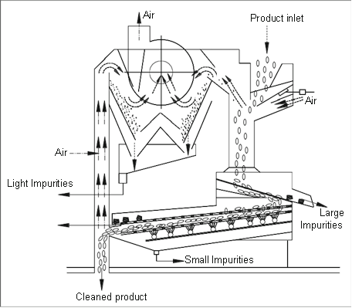
Fig. 8. Schematic diagram of a cleaner

7.1.1.2 Destoner
Destoner separates grains and stones based on the differences in their respective density. A cushion of air, either blown from below the reciprocating screen or sucked from the top. If air is blown from the bottom they are known as pressure type destoners and if air is sucked from the top they are vacuum destoners. In both the destoners, the air cushion though the vibrating deck is so adjusted that only the grains ﬂoat and the heavier impurities like stones, glass, brick pieces, non-ferrous impurities would settle on the deck and with the inertia of the deck, these impurities are discharged at the higher end of the deck. Floating grains are discharged at the lower end of the deck. Separation can be obtained by adjusting feed rate, air volume and sieve inclination (Fig. 9) (Srinivas, 2022).
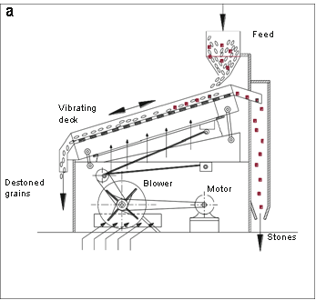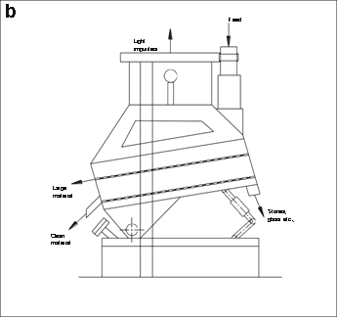
Fig. 9. Schematic diagram of (a) Pressure destoner and (b) Vacuum destoner

7.1.1.3 Magnetic separator
Magnetic (ferrous) impurities are separated from the grain stock using magnetic separators. Type A is a permanent magnet which comes in contact with grains having magnetic impurities. The ferrous impurities are attracted to the plate above the magnet and these should be cleared regularly. In order to overcome this situation, magnetic separators as shown in Fig. 10 (Type B) are preferred. In this system, a semi-circular magnet is enclosed by a rotating cylinder (made of non-ferrous material). When the mixture of grains and ferrous impurities are fed to the machine, grains ﬂow past the magnet due to gravity. However, magnetic impurities are held against the non-ferrous drum due to the action of the stationary magnet and automatically discharged when they come across a non-magnetic zone. Thus, such a system is cleaned automatically and requires practically no inspection (Srinivas, 2022).
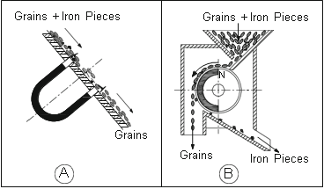
Fig. 10. Schematic diagram of magnetic separator

7.1.2 Dehusking
In this section, the cleaned grains are stripped off the husk layers in order to make the grains palatable. Since the millet grains differ from each other in their husk content and number of layers, the milling protocols and machine used for dehusking has to be done judiciously. There are two types of dehuskers employed for millets viz., centrifugal sheller and rubber roll sheller. The former type is employed for smaller capacities, say up to 1 TPH and the latter is used across the spectrum of milling capacities. Centrifugal shellers are easy to operate, maintain and require lesser operator skill and attention. Since the centrifugal sheller operates on the principal of friction and predominantly impact, chances of breaking the inner cotyledon is higher. Rubber roll sheller employs compression and shear forces to dehusk the grain and are preferred by millers who are conscious on maximizing head grain recovery. However, this sheller needs constant attention during processing and also a skilled operator (Srinivas, 2022).

7.1.2.1 Centrifugal sheller
The centrifugal sheller dehusks millets by rotating it with impellers or rotating blades, accelerating it radially by adding centrifugal force and dehulling the husk with the aid of pressure such as Coriolis force, frictional force from the blades, or impact force at collision with the blades and the peripheral surface. Due to the inertial (centrifugal) force in the radial direction, the grains are thown outward. Horizontal centrifugal sheller requires a feed screw to push the grains to the centre of the impeller, whereas in the vertical conﬁguration, gravitational forces are made use of for the same purpose. After dehusking, the husking fan acts as a thrower and blows the husked material to the port of the husk separator (Fig. 11).
Fig. 11. Schematic diagram of vertical centrifugal sheller

7.1.2.2 Rubber roll sheller
This sheller employs two rubber rolls rotating in opposite direction so that at the point of contact with grains the direction of motion is downwards. Dehusking is achieved due to compression and shear forces. Compressive forces are achieved by reducing the gap between the two rubber rolls. To achieve this, one rubber roll is ﬁxed and the other is moved laterally towards or away from the ﬁxed roll. The ﬁxed roll rotates faster than the movable roll by about 20–25%. The two rubber rolls are either spring loaded or inter-roll pressure is controlled pneumatically. The difference in peripheral speed along with the inter-roll pressure subjects the grains falling in to the nip of the rollers to compression and shear forces which strips off the husk. In other words, the portion of husk in contact with the faster roll moves faster than the other half of the husk thus bringing about dehusking. Since frictional forces are also present, it leads to generation of heat which is detrimental to the hardness of rubber. The rubber roll becomes soft due to heat and would thus wear out faster reducing its optimal life of use. During continuous operation, the temperature of rubber rolls would increase and hence they are cooled by blowing air on the surface of rolls. Due to difference in the speed of the two rolls, the wear of rolls is not uniform. The faster roll wears out faster than the other roll due to which there would be no difference in the circumferential speed between the rolls. In this condition, the shear forces required to strip off the husk layers would be zero and the grains would be compressed and discharged. Fig. 12 shows a schematic diagram of a rubber roll sheller with a built in aspirator.
Fig. 12 Schematic diagram of rubber roll sheller

7.1.2.3 Specific gravity separator
The basic principle of operation of the speciﬁc gravity separator takes advantage of the differences in size, shape and speciﬁc gravity of grains which need to be separated. In this machine, the porous table and air blown though the table are the main parts responsible for separation, which takes place in two steps. The ﬁrst is in the vertical direction in which stratiﬁcation of grains due to air takes place and the second is in the horizontal direction caused by motion of the table and gravity. If the grains are not stratiﬁed ﬁrst, then separation just due to the motion of the table will not take place. An example of this is to take a mixture of straw and sand of the same size and put them in a glass of water. The straw would ﬂoat on top of water and sand would sink below. The table has a compound inclination i.e., sloping downwards in the X and Y directions. Feed of the mixture of grains is at the highest point of the table. In other words, the table of the machine is slanted in two directions; from the feeding point to discharge point of heavy grains and also from the feeding point to discharge point of light grains. This slanting of table allows lighter grains to ﬂoat in air and ﬂow downhill by gravity, while the heavy materials, in contact with the table, are discharged slightly uphill. The design of the speciﬁc gravity separator is such that all points on the table do not have the same amount of air. This is because the depth of bed and weight of grains vary across the table. The greatest amount of air is given to the feed zone since the grain depth is maximum there. The least amount of air is at the light grain discharge point not only because the material is light but also the grain depth is the lowest in this zone. In addition, the area that requires a lot of air is at the heavy grain discharge area. The parameters that can be adjusted in a speciﬁc gravity separator are feed rate, air ﬂow rate though the table and inclination of the table in X and Y directions (Fig. 13).
Fig. 13. Schematic diagram of speciﬁc gravity separator

7.1.2.4 Colour Sorter
The colour sorter is a photoelectric particle separator. A solenoid air valve (ejector) is connected electrically to a sensor that distinguishes, on the basis of reﬂected light, the background from the rice grains falling from a conduit-shaped chute; the ejector discharges any grains that are discoloured. Grains are fed in a channel to fall one grain at a time. Each grain is then compared with the set standard. Should there be any deviation in the colour of the rice grain from the set colour, then the ejector blows a jet of air thus pushing the discoloured rice grain from the mass. It is possible to set the colour to any desired shade, thus making it possible to colour sort the rice grain to a uniform hue. Presently, colour sorters using CCD cameras are in vogue. The selected material is put into the machine hopper. A vibratory feeder ensures uniform feed across the channels or feed distribution channel. Individual grains pass though the observation cabinet between the monitor (camera) and background plate. With the right choice of light, the optoelectronic sensor receives the light from the material which makes the system produce an output signal to the ejectors. The ejectors are basically nozzles connected to an air compressor actuated by solenoid valves to blow off the “rejected” grain into the waste cavity of the receptacle and collected separately. The “accepted” grain continues to fall into the “good” product cavity and is taken for weighing and packing (Fig. 14).
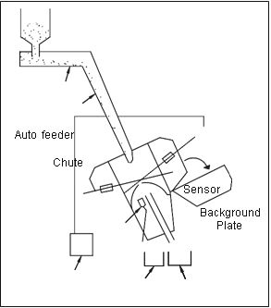

Fig. 14. Schematic diagram of colour sorter

7.2 Secondary processing operations
The secondary processing of millets involves value addition such as milling and sieving the millet grain into ﬂours, germination or malting, fermentation and roasting/popping or pufﬁng of millets, utilisation as a source of biofuels, extraction/preparation of novel nano-biochemical compounds and use in nanotechnologies.

7.2.1 Milling
Milling is the process of size reduction of cereal grains into ﬁne ﬂour. Presently, milling of millets is done by adoption of both wheat and rice milling technologies. Traditional mills use plate mills, roll mills (shear and crushing) and hammer mills (impact and pulverisation) working on principles of abrasion. These milling techniques are still in practice in small-scale units. The main drawbacks of conventional milling techniques are:
- Fine particle size of lesser than 400 μm is not produced.
- Moisture of raw material can decrease the milling efﬁciency.
- Operating area of mills are usually scattered with dust/ﬂour particles including the surroundings, leading to effects on respiratory system of human operators and causes surrounding environmental pollution.
The section below discusses on the different innovations and improvements to the various milling techniques, to overcome the above-mentioned drawbacks.
Innovation in Hammer Milling Technique with End Suction Lift Hammer mill being the most commonly used, a number of trials have been undertaken to address the problems above mentioned. The results of the trials showed that a hammer mill with an end suction lift was able to operate continuously without clogging. It increased milling percentage and particle size lower than 400 μm was produced, which are suitable for producing composite and basic ﬂours used in various food preparations. The design (hammer mill with end suction lift capability) included removing the sieves and introducing a mechanism to ensure that large particles are blown back again (using mechanical separators) for efﬁcient milling. To avoid ﬂour/dust particles from escaping into the surroundings sedimentation chambers are provided.
Brieﬂy, the operating concept of hammer mill with end suction lift is: The cereal grain is introduced into the feed hopper of hammer mill. Unidirectional ﬂow of raw materials to milling chamber is observed in the feed hopper. Milling chamber consists of hammers which pulverise the material to the desired particle size with help of mechanical separators, which rotate at the same speed as the shaft. The fan induces air/particle mixtures which are vented though the two ducts provided overhead. The two ducts are designed to increase the movement of the dust carrying air which reduce the sedimentation of the particles in the ducts. The velocity of particles is reduced as air from the overhead vents passes though cyclone. The ﬁne particles fall and are collected and bagged.
Air jet milling can be an alternate process to achieve desired particle size reduction of millet ﬂours (Protonotariou et al., 2014). With diminishing particle size there is more surface area available, which greatly affects the physiochemical properties of ﬂour. Air jet milling works on the principle of ﬂuid energy impact milling technique, which enables it to create particle sizes no more than 40 μm. With this method a ﬁnal particle size of around 1000 nm can be produced depending upon the material being processed. Materials are accelerated to high velocity air which produces superﬁne powders; inter-particle impact or collisions lead to the size reduction. Thus, air jet milling seems to be a promising milling technology that needs to be explored more to gain beneﬁts from it for milling of millets, especially to obtain millet ﬂours with improved physicochemical and functional properties.

7.2.2 Germination and Malting of Millets
Germination is a biochemical process (Chauhan and Sarita, 2018) where the seeds are transitioning from passive/dormant state to active state. The process increases the nutritive value of the grains with reduction in anti-nutrients and enhanced bioavalibility of nutrients. Malting involves steeping, germination and drying. During the steeping process, grains are soaked in water until sufﬁcient water is taken up by kernel to start the metabolic processes of germination. Germination is carried out in controlled conditions: temperature (25–30○C), moisture content and germination period (2–6 days). After germination, drying (kilning) is the last stage of the malting process where the moisture content and water activity of grains are reduced giving a shelf-stable product with active enzymes and enhanced nutritional traits. The grains can be powdered into ﬁne ﬂour to obtain highly nutritious malted ﬂour. Drying temperatures are between 50 and 60○C for about 24 h or higher depending upon the mode of drying used.

7.2.3 Germination and Fermentation of Millets
Recent development processes and studies involved using germination and fermentation as alternative to traditional germination and malting processes to obtain maximum beneﬁts from the millet grains. Nutritional and sensory evaluation of “Fura” was conducted (Inyang and Zakari, 2008) using germination (soaked for 12 h and sprouted for 48 h) followed by natural fermentation (for 48 h at room temperature) of pearl millet grains, which resulted in signiﬁcant reduction in phytic acid levels compared with the control. The phytic acid levels noted were 416 mg/100 g for the control TF (traditional Fura), 230 mg/100 g for GF (germinated Fura), 266 mg/100 g for FF (fermented Fura) and 220 mg/100 g for GFF (germinated and fermented) Fura.

7.2.4 Popping or Puffing of Millets
When grains (Mishra et al., 2014) are exposed to high temperature for short time, starch gelatinisation and simultaneous expansion occurs resulting in a process called “Popping”. It is a process in which the grain is cooked and expansion of endosperm occurs instantaneously breaking out the outer skin due to the escape of super-heated vapours produced. Similarly pufﬁng is carried out where the expansion is controlled. These methods are used for oil-free snacks and produce acceptable taste. Popping/ pufﬁng can be done using different methods. Traditional methods include use of sand and salt for heat transfer, dry heat and gun pufﬁng. Novel technologies like high temperature short time (HTST) and microwave pufﬁng are being used recently.

7.2.5 High Temperature Short Time (HTST) Popping of Millets
High Temperature Short Time (HTST) is a process where grains are heated at high temperature ranging between 230 and 270°C for a very short period of time. In a study (Kumari et al., 2018) several pearl millet varieties were popped to study nutritional and popping characteristics. Cleaned pearl millet grains were raised to a moisture content of 18% with addition of water and conditioned for 6 h. These grains were popped at 230°C in grain popper. The popping percent ranged from 43.0% to 85.0% depending on the pearl millet varieties. Higher the volume of the popped grains, higher was the pufﬁng index which ranged from 5.27 to 9.29 depending upon the varieties. Decrease in phytic acid content in popped millet was noted compared to raw millet. The study showed the suitability of popping of pearl millet, as an ingredient to obtain nutritious and healthy snacks.

8. Value-Addition of Millets
Value-Addition is the process of taking a raw commodity and changing its form to produce a high quality end product in order to meet the tastes/preferences of consumers. Value is added by changing their form, colour and increasing the shelf life of the product. The increasing population has proportionately increased the demand for food while satisfying the total calorie intake mainly from cereals. Despite contributing less than 2% of global cereal utilisation, millet is considered an important staple crop in many semi-arid tropical countries with poor soils and lower precipitation. The millets are nutritionally on par and or superior to major cereals with additional beneﬁts like gluten-free proteins, low glycaemic index, high ﬁbre and rich bioactive compounds. Millets have been utilised for human consumption in the form of culinary and medicinal purposes since prehistoric times. The studies conducted on processing and value addition of millets show encouraging outcomes in utilisation as number of traditional and convenience health foods. Consequently, many researchers have developed various millet products such as ﬂaked millet, popped millet, puffed millet, extrudates and roller-dried millet products, as well as fermented, malted, composite ﬂours and baby food (Mishra et al., 2014).

8.1 Millet rice
Millets generally have mild ﬂavour which makes them get blended with other food products. More often, in order to bring out its ﬂavour, it is combined with different grains and roasted before cooking. The signiﬁcant increase in the dietary ﬁbre, mineral, protein and antioxidants content was observed in the ﬁnal developed product by addition of millets (Ronda et al., 2015).

8.2 Millet ﬂour
Millets are ground into coarse or ﬁne ﬂour and used for preparation of chapatis and bakery products (Collar, 2016). Addition of millet ﬂour to baked foods will enhance texture, ﬂavour and richness of nutritional value. The possibility of making leavened pancakes called dosa and thinner, unleavened roti has also been reported.
Millets have been used in various food processing industries including biscuits and confectionary, beverages, weaning foods and fermented foods like beer (Laminu et al., 2011). Sorghum, maize and wheat composites are being made into soft biscuits and cookies, while millets are being used to create cakes and non-wheat bread, with encouraging results (Hama, 2012). Whereas, in spite of unlimited potential the progress in the infant weaning food sector has been slow due to limited installed capacity for industrial malting. A general process ﬂow chart for the production of composite food products from millets is presented in Fig. 15.
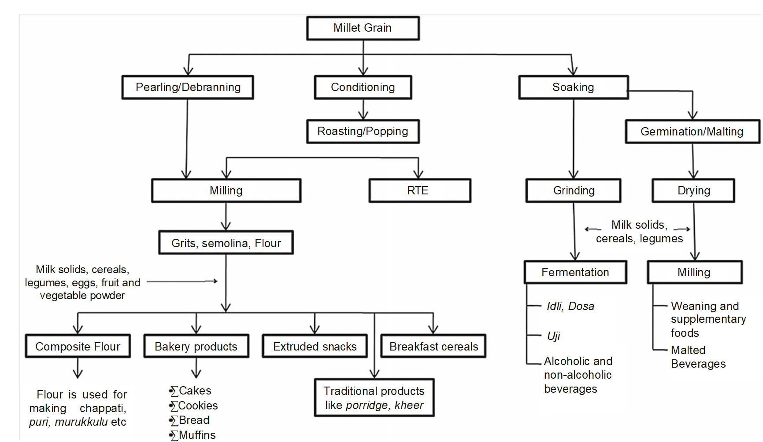

Fig. 15. Schematic diagram for developing millet-based food products (Source: Kumar et al., 2018).

8.3 Millet foods in India
In India, many different kinds of traditional foods are made and they form the staple diet for many rural and urban households. In several rural households, a vast variety of traditional snacks are made from ragi and other small millets. Milled small millets namely ragi, panivaragu, kuthiraivali, thinai, varagu and saamai are similar to rice in cooking properties and used in making several kinds of food items. The cooking style of these small millets in India are bhat, kheer (sweetened thin porridge), roti/chapatti (unleavened bread), gruel (thin porridge), mudde (stiff porridge), dosa (fermented pancake), shavige (noodles), hurihittu (popped grain ﬂour), sattu, pappad (deep fried or roasted), halwa (cooked sweet product), malted beverage and fermented beverages. Many other traditional foods are made from popped ragi ﬂour mixed with sugar or jaggery or ghee or milk or butter milk and salt. In south India traditional millet products namely, koozh-porridge also called kanji (made from ragi, bajra) puttu (jowar, maize, ragi), kali (ragi, bajra), adai/roti (ragi, bajra, varagu) are more popular (Hema et al., 2022).
Indian ﬂatbread or chapattis and phulkas are the most popular daily bread in various parts of North India. It can be prepared from millet ﬂour and millet composite ﬂour or blended with wheat ﬂour for making softer chapatti and lowering the retrogradation with shelf stability. It is an excellent substitute for whole meal wheat ﬂour or chakki atta as gluten-free alternatives will make the dough easy to roll and puff well on the pan and ﬂame. Millet chapattis have a higher amount of ﬁbre, rich in antioxidants and has essential minerals which are non-glutinous wholesome bread suitable for those with celiac disease and for those suffering from gluten associated inﬂammation and health risk (Hema et al., 2022).
Rice from decorticated saamai, thinai and ragi are most commonly consumed foods. Local sweet products like hurakki holige, halubai and sweet cheese from thinai (ginna), fried products like chakkali, dosa and hurihittu from ragi are some of the traditional foods having cultural signiﬁcance. Fermented and malted beverages of millets are also consumed by people at large quantities (Yenagi, 2007).
Ragi is normally consumed in the form of ﬂour-based foods such as roti (unleavened pancake), mudde and ambli and each of these foods have their own characteristics features (Kar, 2007).
The thin porridge or ambali of millets is normally a mild fermented product. For its preparation, the millet ﬂour is mixed with water along with a small quantity of buttermilk and the contents are left overnight for mild fermentation. The millet porridge is consumed in the summer season because of its soothing effect (Malleshi, 2007).
Idli and dosa which are conventionally prepared from rice can also be prepared using the millet as base. Dosa from batter prepared by soaking, grinding and fermenting parboiled and raw varagu grains, black gram dhal (3:1:2) and methi seeds were well appreciated. Idli prepared by soaking raw kodo and blackgram in the ratio of 2:1 was soft and well accepted. Uthappam was made from dosa/idli batters. Raw varagu grains were also made into kheer and substituted rice in traditional products like bhakri (unleavened bread), idli, dosa and uttapam. In view of the special nutritional features, nowadays even ready mixes of idli and dosa from ragi are available in the market (Yenagi, 2007).

8.4 Breakfast Cereals and Expanded Millet
Breakfast cereals are one of the most popular types of ready-to-eat cereals ﬂakes. Cereal ﬂakes are popular breakfast products and at present they are mostly made from corn and oats. A various process techniques are used in the preparation of ready-to-eat cereals from millets, including extrusion, ﬂaking, pufﬁng and shedding and granule formation (Desikachar, 1975). The expanded grain is a novel product from the millets which can be made into readily acceptable food product among non-traditional millet consumers. The expanded millet has a porous and crisp texture and is devoid of seed coat. It can be seasoned with spice and condiments or coated with desirable adjuncts for use as a snack food (Malleshi, 2007).
Finger millet flour (200 g), pearl millet flour (120 g) and wheat flour (300 g)  ↓  Pasta mixer-extruder  ↓  34 ml/ 100 g of water to composite flour  ↓  Cold extrusion  ↓  Extruded pasta dried at 60°C for 3- 4 h to attain moisture content to about 9% (db)  Fig. 16. Flowchart for preparation of for millet pasta  (Gull et al., 2015) | Browntop millet  ↓  Cleaning  ↓  Grinding and sieving (80 mesh)  ↓  Extrude at 150 °C, 360 rpm and 20% (feed moisture)  ↓  Browntop millet extrudates  Fig. 17. Flowchart for preparation of for browntop millet extrudates  (Sirisha et al., 2022)

Sorghum (100 g), kodo millet (100 g), rice (100 g), dhal (100 g), green gram whole (100 g), soya bean (100 g)  ↓  Cleaning, washing, drying, grinding  ↓  Sieving  ↓  Mixing  ↓  salt (20 g)  ↓  Mixing well  ↓  Instant adai or crepe mix (kind of dosa)  Fig. 18. Flowchart for preparation of for instant adai or crepe mix  (Balasasirekha and Santhoshini, 2016) | Finger millet flour (600 g), black gram flour (300 g)  ↓  Adding papad khar (seasoning) 25 g  ↓  Adding coarsely pounded cumin, pepper and red chilli (5 g) and salt (50 g)  ↓  Making dough with hot water and kneading with oil (30 min)  ↓  Dividing the dough into balls  ↓  Pressing papad press and drying in sun/shade  ↓  Deep frying/ roasting finger millet papads  Fig. 19. Flowchart for preparation of for finger millet papad (Prabhakar et al., 2016)

Foxtail millet flour (50 %) +wheat flour (50% )  ↓  Mixing thoroughly with water (35%), guar gum (1%) and edible oil (1%)  ↓  Cold extrusion  ↓  Tray drying at 50ºC for 3 h  ↓  Foxtail Millet Enriched Rice Analogue  Fig. 20. Flowchart for preparation of for foxtail Millet rice analogue | 600 g millet flour +400 g refined flour+ 100 g sugar  ↓  Mixing thoroughly with 700 ml of water and 100 ml of oil for 10 min  ↓  Shaping 180 g of mixed material into a pizza shape  ↓  Proofing for 15-20 min and baking at 160ºC  ↓  Millet pizza base  Fig. 21. Flowchart for preparation of for millet Pizza Base
Contributors : Er. Sudha Devi G , Dr. Udaykumar, Dr. Sharanagouda Hiregoudar Dr. Ambrish, G
Institute: PFE, CAE, UAS Raichur

8.5 Weaning and Supplementary Foods
One of the popular weaning foods namely “Malted Weaning Food” (MWF) can be prepared by blending two parts of malted millet with one part of malted green gram. It has superior nutritional qualities and textural properties. The food on reconstitution with water and heating to boiling forms nutrient dense slurry (low bulk) and under comparable consistency, malted weaning food contains twice the amount of nutrients than the roller dried weaning foods. It is important that the food sources selected for weaning mix should be grown locally, easily available in the market and of low cost. Considering these factors, Ragi becomes the best choice of millet for utilization in infant food formulation (Sarkar et al., 2015).
Supplementary foods are suitable during the infant’s weaning period which can be fed for older infants and young children and for feeding young children as a supplement to breast milk or breast milk substitutes. They are not suitable for use for infants before the beginning of the weaning period. These foods provide those nutrients which either are lacking or are present in insufﬁcient quantities in the base staple foods (Mal et al. 2010).
Ragi grain (70%) + wheat (15%) + green gram (15%)  ↓  Soaking (12-16 h)  ↓  Sprouting green gram (24 h), wheat and ragi (48 h)  ↓  Oven drying at 60°C  ↓  Conditioning (5% moisture, 10 min)  ↓  Milling and sieving (60 mesh)  ↓  Ragi malt  Fig. 22. Flowchart for preparation of ragi malt  (Sarkar et al., 2015) | Ragi grain  ↓  Soaking (8-12 h)  ↓  Grounding in a colloidal ball mill and filtering to get millet milk  ↓  Maltodextrin (30%)  ↓  Spray drying at feed rate of 0.4 kg/h, 120°C inlet temperature and outlet air temperature of 95°C  ↓  Ragi milk powder  Fig. 23. Flowchart for preparation of ragi milk powder  (Anitha and Sellamuthu, 2021)

Kodo millet (400g)  ↓  Cleaning, washing and sun drying (2 h)  ↓  Roasting (110°C for 3 min), powdering and sieving  ↓  Adding raw rice flour (400 g ) and black gram flour (200 g) and salt (0.75 g)  ↓  Adding water (50 ml)  ↓  Adding thick batter to boiling water (200 mL)  ↓  Cooking for 5 min  ↓  Millet gruel mix  Fig. 24. Instant gruel mix  (Thirumangaimannan and Gurumurthy, 2013) | Pearl millet (1 kg)  ↓  Cleaning and pearling  ↓  Roasting (90°C for 5 min)  ↓  Sieving  ↓  Adding sugar (½ kg), pepper (10g), dry ginger with cardamom (5g)  ↓  Pulverizing  ↓  Sathu maavu  Fig. 25. Instant health mix  (Vijayakumar and Mohankumar, 2009)

9. Commercially available millet products
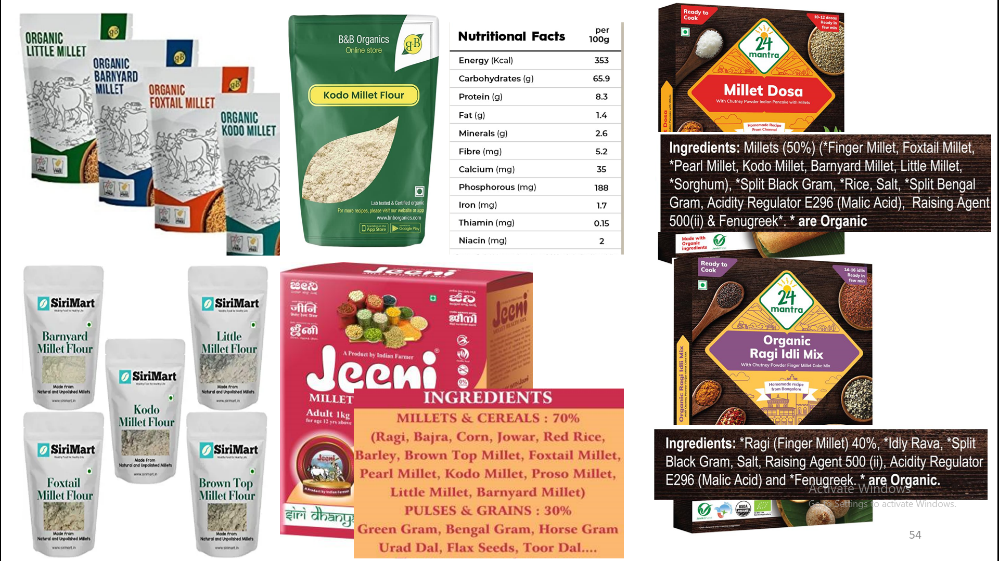
Plate 1. Commercially available millet products
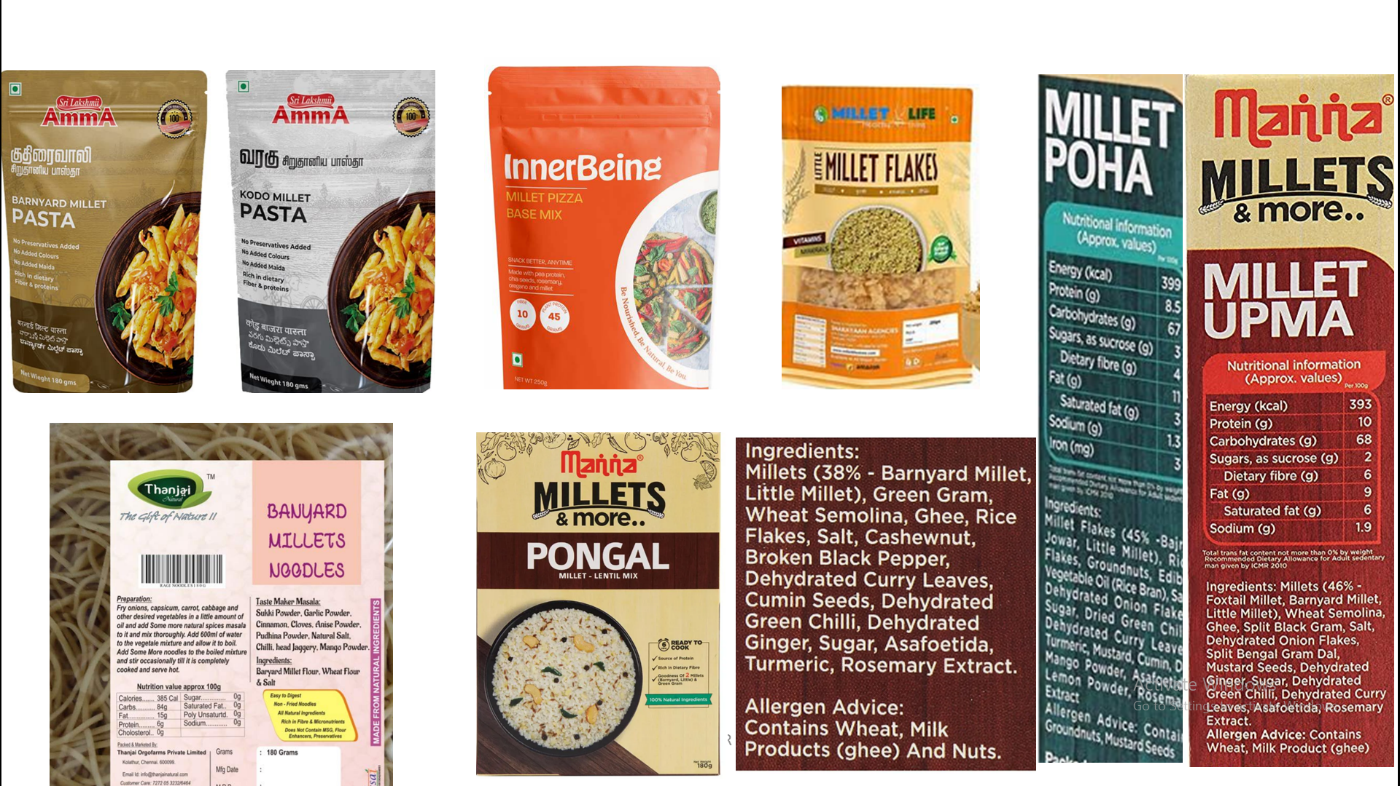
Plate 2. Commercially available RTC millet products
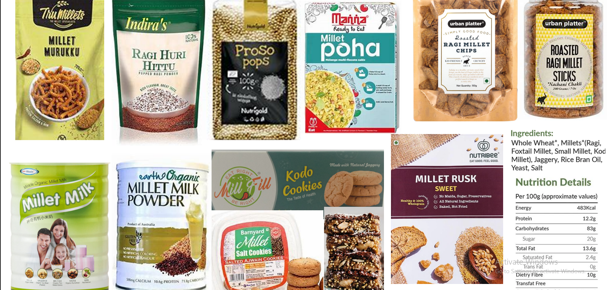
Plate 3. Commercially available RTE millet products

10. Millet processing technologies and millet-based value added products developed in the department of processing and food engineering, CAE, Raichur
- Fractionation and characterization of foxtail millet and its applicability in extruded products
- Development of rubber roll dehusker cum grader for foxtail millet
- Milllet enriched rice analogues
- Effects of different retail and wholesale packaging materials on the shelf life of dehusked foxtail millet
- Effect of gamma irradiation on nutritional quality parameters of dehusked foxtail millet (Setaria italica (L.) Beauv.)
- Studies on enhancing the shelf life of foxtail millet flour
- Millet processing unit ( 1 TPH)
- The University of agricultural Sciences Raichur and NABARD organized a “Millet Conclave” on 26 and 27 August 2022 at Raichur.
- Finance Minister Nirmala Sitharaman announced providing Rs 25 crore under the NABARD’s rural infrastructure development fund UAS, Raichur, Karnataka, for establishment of incubation centre for processing and value addition for promotion of millets.

11. CFTRI, Mysuru millet based value added products
- Bread (Ragi & Bajra)  - Convenience Flour for Mudde  - Cookies (Ragi & Bajra)  - Decorticated Ragi  - Expanded Bajra  - Ragi Snack  - Expanded Ragi  - Flaked Jowar RTE  - Germinated Ragi Drink Mix  - Ragi Vermicelli  - Multigrain Pasta  - Multigrain Sweet Mix (Halva) | - Ragi Pappad  - Ragi Roti  - Ragi Rusk  - Instant Beverage from Ragi  - Instant Ragi Semolina/Porridge  - Jowar Flakes  - Malted Ragi Flour-Enzyme Rich  - Millet based Upma & Halwa Mix  - Millet Semolina (Coarse & Fine)  - Multigrain Drink Mix  - Shelf Stable Bajra Flour  - Shelf Stable Jowar Flour

12. NIFTEM-IIFPT patented millet based value added products
- Arka Mushoom  - Millet Cookies  - Cookies from Kodo and Kutki Millets  - Fermented, Functional Food Product  - Gluten Free Chapatti Mix  - Gluten Free Potato-millet Cookies  - Gluten-Free Breads  - Idli and Dosa Dry Mix  - Kodo Kheer and Halwa Mix | - Millet Flaking Machine  - Millet Milk Powder  - Millet Edible Film  - Multi-Grain Flour with Low Glycemic  - Multi-grain Semolina, Gluten Free Cookies and RTE Extruded Snack  - Non-Dairy Millet Ice Cream  - Sprouted Pearl Millet and Green Gram Pasta  - Value Added Sorghum and Millets Products

13. A centre of excellence on small millets, UAS Bangalore millet-based products
- Foxtail millet butter biscuit  - Small millet churmuri  - Little millet phulka  - Foxtail millet burfi  - Proso millet rava idli mix  - Little millet idli  - Little millet ohmo biscuit  - Foxtail millet puliogare mix  - Proso millet vangibath  - Foxtail millet pulav  - Little millet upma mix  - Kodo millet curd rice  - Foxtail millet rotti  - Small millet pasta  - Foxtail millet flakes | - Foxtail millet melting moments  - Proso millet rava idli mix  - Barnyard millet rusk  - Foxtail millet vaemicelli  - Little millet onion pakoda  - Little millet flakes  - Little millet rusk  - Kodo millet rusk  - Barnyard millet doughnut  - Barnyard millet dosa mix  - Instant proso millet dosa mix  - Instant little millet dosa mix  - Instant kodo millet dosa mix  - Instant foxtail millet dosa mix  - Instant barnyard millet dosa mix

14. ICAR-Indian Institute of Millets Research (IIMR), Hyderabad millet – based value added product technologies developed
- Pearl millet flakes (thin)  - Jowar extruded snack  - Jowar Lassi  - Jowar cake  - Ragi cake  - Ragi based energy bar  - Ragi pizza base  - Zinc rich jowar vermicelli  - Zinc rich jowar pasta  - Zinc rich jowar cookies  - Iron rich jowar pasta  - Iron rich jowar vermicelli | - Ragi Bread  - Jowar muffins  - Jowar bread  - Almond based Jowar cookies  - Jeera based jowar cookies  - Ragi muffins  - Foxtail millet vermicelli  - Foxtail millet pasta  - Jowar khakha  - Multi millet bread  - Jowar choco chip cookies  - Jowar instant khichidi mix

15. Codex alimentarius international standards for millet

Table 7. Codex alimentarius international standards for pearl millet grains
Factor/description | Limit | Method of analysis
Appearance | Buyer preference | Visual examination
Brown, white or green
1000 kernel weight |  | None defined
- Whole millet grains | 5.0 to 10.0 g
- Decorticated millet grains | 4.0 to 8.0 g
1 litre weight | 750 to 820 g | None defined
Ash | 0.8 to 1.0% on a dry matter basis | AOAC 923.03
  - Decorticated millet grains
Protein (N x 5.7) | 8.0% on a dry matter basis | AOAC 920.87
Decortication | Max: 20% | None defined
Crude fibre |  | ISO 5498:1981
- Whole millet grains | 3.0 to 4.5% on a dry matter basis
- Decorticated millet grains | Max: 2.0% on a dry matter basis
Fat |  | AOAC 945.38f; 920.39c  ISO 5986:1983
- Whole millet grains | 3.5 to 6.0% on a dry matter basis
- Decorticated millet grains | 2.0 to 4.0% on a dry matter basis
Source: www.fao.org/fao-who-codexalimentarius/en

16. Use of millets in nutraceutical and functional food
The term “nutraceutical” combines two words“nutrient” (a nourishing food component) and “pharmaceutical” (a medical drug). The term‘‘nutraceutical’’ was coined in 1989 by the Foundation for Innovation in Medicine and defined as any substance that may be considered a food or part of a food and provides medical or health benefits including the prevention and treatment of disease. Health Canada states that a nutraceutical is a product that is “prepared from foods, but sold in the form of pills or powders, or in other medicinal forms not usually associated with foods. Example: phytochemicals, vitamins and minerals, amino acids or bioflavonoids.
American Dietetic Association defined functional food as “any modified food or food ingredient that may provide a health benefit beyond the traditional nutrients it contains”. Consumed as a part of the normal diet and is beneficial to health. It may reduce the risk of acquiring a disease but generally not prevent it, reduce the severity of symptoms of a disease and/or enhance physical performance.

Table 8. Disorders and nutraceuticals
Disorder | Nutraceutical | Reference
Cardiovascular disorder | Antioxidants, dietary fibers, omega-3 polyunsaturated fatty acids (N-3 pufas), polyphenols , α-lipoic acid, magnesium, vitamin B₆ (pyridoxine), vitamin C, nacetyl cysteine, Mg, K and lignin. | Garg et al. (2001) and Shukla and Singh (2009)
Obesity | Chitosan, vitamin C, linoleic acid, capsaicin and psyllium fiber | Li and Zhang (2001) and Bell and Goodrick (2002)
Diabetes | Phytoestrogens, isoflavones, omega-3 fatty acids, docosahexaenoic acid, lipoic acid, dietary fibers from psyllium.  Magnesium, chomium picolinate, calcium and vitamin D | McCarty (2005)
Cancer | Phyto-estrogens, carotenoids, retinoids, saponins, proanthocyanidins, ellagic acid, ferulic, caffeic, gallic acids and limonene | Gulcin et al. (2006)

Table 9. Food type and nutraceuticals
Food type | Nutraceutical | Reference
Immune boosters | Sulphides/thiols, phyto-estrogens, isoflavones | (Chanda et al., 2019)
Pregnant women | Β-carotene, vitamin A, thiomin, riboflavin, niacin, vitamin C, fiber, vitamin E, thiamine, niacin, riboflavin, pantothenic acid and pyridoxine. Minerals like magnesium, manganese, iron, calcium and phosphorous | (Wassells et al., 2019)
Malnutrition | Calcium, phosphorus, potassium, iron, magnesium, thiamine, niacin and riboflavin, fibers, polyphenols, valine, methionine, tryptophan and cysteine | (Charalampopoulos et al., 2002 )
Weaning food | Calcium and zinc | (Usman et al., 2016)
Anameic | Essential fatty acids, vitamin D, K, B₁₂ , Fe, iodine and flouride | (Pandey et al., 2010)
Sports | Whey proteins, branched chain amino acids, n omega-3 polyunsaturated fatty acid, calcium and vitamin D, iron, zinc, magnesium, β-carotene and selenium, conjugated linoleic acid, β-hydroxy β-methylbutyrate, methoxy-isolavone | (D’Angelo and Tafuri, 2020)
Table 10. Nutraceuticals and sources (Varma et al., 2016)
Chemical constituents | Source
Carotenoids
Lemonene | Guava, papaya, watermelon,tomato
β-Carotene | Vegetables, fruits, oats, Carrots
Lutein | Spinach, corn, avocado, egg yolk
Tocotrienol | Palm oil, different grains
Saponins | Beans like soya beans, chickpeas
Polyphenolic Compounds
Flavonones | All citrus fruits
Flavones | Fruits, soyabean, vegetables
Flavonols | Broccoli, tea, onions, fruits
Curcumin | Turmeric root
Resveratrol | Grapes, raisins, berries, peanuts
Glucosinolates | Cruciferous
Limonoids | Citrus fruits
Prebiotics/ Probiotics | Lactobacilli, bifidobacteria
Phytoestrogens
Isoflavones | Legumes, beans like soy beans
Lignans | Vegetables, rye and flaxseed
Dietary fibre
Soluble fibre | Legumes, cereals
Insoluble fibre | Whole grain, corn bran, nuts foods
Sulphides/Thiols | Cruciferous vegetables
Fatty Acids
Omega 3 fatty acids | Fish and flax seed
Monosaturated acids fatty | Present in tree nuts
Minerals like Zn, Ca, cu, K | Food
Polyols sugar alcohols | Food

Table 11. Some commercially marketed nutraceuticals (Sachdeva et al., 2020)
Category | Product | Claim | Manufacturer
Calcium supplement | Coral Calcium | Calcium and trace minerals | Nature's answer, Hauppauge, NY, USA
 | Calcirol D-3 | Calcium and vitamins | Cadilla healthcare limited, Ahmedabad, India
Immune Booster and immuno modulator | Celestial Healthtone | Dry fruit extract | Celestial Biolabs Ltd., India
 | Chyawanprash | Amla, Ashwagandha, Pippali | Dabur India Ltd., India
 | Amiriprash (Gold) | Chyawanprash Avaleha, Swarnabhasma and RasSindur | UAP Pharma Pvt. Ltd., India
 | Immulina | Bioactive microalgae complex | Nordic Phytopharma Group, Havdrup, Denmark
 | Emergen-C | Vitamin | Alacer Corp. California
 | Ester C | Vitamin | Ester-C, Bohemia, NY
Prebiotics | Cereals, drink mixes and cereal bars | Fiber | Kashi Company, La Jolla, CA, USA
 | Ensure Fiber | Fiber, digestive health | Abbott Nutrition, Columbus, OH, USA
 | Builder's Bar | Fiber | Clif Bar Inc., Berkeley, CA, USA
 | Helios Nutrition's Organic Kefir | Bifidogenesis, calcium absorption | Lifeway Foods, Morton Grove, IL, USA
 | Low-fat ice cream sandwiches | Fiber | Skinny Cow, Nestle SA, Vevey, Switzerland
Probiotics | DanActive® | L casei DN114001 | Danone Inc., Paris, France
Nutritional supplement | Weight smart™ | Vitamins and trace elements | Bayercooperation, Morristown, NL, USA
 | GRD® | Proteins, vitamins, minerals and carbohydrates | Zydus Cadila Ltd., Ahmedabad, India
 | Proplus® | Soy proteins | Campbell soup company, Camden, NJ, USA
Physical health and immune supplement | Nutricafe -Organic performance coffee | Cordyceps and Ganoderma | EnerHealth Botanicals, Longmont, CO, USA
Dietary supplement | Olivenol™ | Natural antioxidant hydroxytyrosol | Cre Agri, Hayward, CA, USA
Neuropathic pain supplement | PNer plus™ | Vitamin and other natural supplement | NeuroHelp, San Antonio, Texas, USA
Protein supplements | Theptin® Diskettes | Proteina and Vitamin | Raptakos, Brett and Co. Ltd., Mumbai, India
 | Proteinex® | Carbohydrates, minerals, proteins and vitamins. | Pfizer Ltd., Mumbai, India
Energy drink | Rox® | Caffeine, glucuronolactone and taurine. | Rox America, Spartanburg, SA, USA
Meal replacement beverage | Snapple-a-day™ | Vitamins and minerals | Snapple beverage group, White Plains, NY, USA
Amino acid supplement | WelLife® | Granulated-L-glutamine | DaesangAmerica Inc., Hackensach, NJ, USA
Neurotonic | Biovinca™ | Vinpocetine | Cyvex nutrition, Irvine, CA, USA
Anti-depressant | Pure Red Reishi | G. Lucidum | Terrasoul Superfoods, Fort Worth, TX, USA
Physical health supplement | Shiitake Gold | L edodes | Aloha Medicinals Inc., Carson City, NV, USA
Immunity supplement | Immune Assistcomplete | Blend of A. blazei, Coriolusversicolor, L. edodes, Grifola frondosa and G. lucidum. | Aloha Medicinals Inc., Carson City, NV, USA

Table 12. Functional properties of millets
Millet | Functional component | Potential health | Reference
Pearl millet | Phytonutrient – lignin, flavonoid, apigenin, myricetin, ferulic acid and catechin | Prevent hormone-dependent cancer and cardiac arrests, anti-fungal, anti-ulcerative properties | Bora et al. (2019)
Finger millet | Gallocatechin, epicatechin, epigallocatechin, taxifolin, vitexin, tricin, myricetin, leuteolin, quercetin, apigenin, kempherol, diadzein, pyrocyanidin B₁ and B₂, ferulic acid and catechin | Anti-turmogenic, anti-diabetic, anti- microbial and antioxidant properties | Chandrasekara and Shahidi (2011)
Foxtail millet | Catechin,quercetin, apigenin, kempherol, ferulic acid, chlorogenic acid, caffeic acid, p-coumaric acid, syringic acid, xanthophylls, zeaxanthin, ferulic and p-coumaric | Body detoxication, antioxidant property and anti-proliferative activity | Zhang and Liu (2015) and Pradeep and  Sreerama (2018)
Kodo millet | Apigenin, kempherol, vitexin, isovitexin, leutolin, quercetin, ferulic acid and catechin, naringin, taxifolin | Antithombotic,  anti-allergic, antimicrobial,  anti-inﬂammatory, antiviral, anticarcinogenic | Bora et al. (2019)
Barnyard millet | Luteolin, tricin, n-(p-coumaroyl) serotonin, p-coumaric and chlorogenic acids | Anti-diabetic,  anti- cancerous | Anis and Sreerama (2020)
Porso millet | Apigenin, kempherol,myricetin, ferulic acid and catechin | Anti-diabetic,  anti-rheumatic,  anti- cancerous | Chandrasekara and Shahidi (2011)
Little millet | Apigenin, ferulic and p-coumaric, ferulic acid and catechin | Anti-diabetic, anti-rheumatic, anti-cancerous | Pradeep and  Sreerama (2018)

Table 13. Composition of millet by-products generated by processing industries
By-product | Variety | Composition | Application | References
Seed coat matter | Finger millet | Dietary ﬁber, calcium , iron and zinc | Potential cereal food product development to enhance physical and functional properties | Amritha et al. (2018)
Bran | Foxtail millet | Oil, fermentable sugars, protein, dietary ﬁber and vitamin | Food packaging, healthcare and synthesis of chemicals | Chu et al. (2019)
Husk | All | Cellulose and ash | Concrete industries | Bheel et al. (2021)
Broken grains | All | Same as raw millet | Feed, millet analogues, fortification | Hanna and Wright (1995)

17. Conclusion
- Absence of appropriate primary processing technologies to prepare RTC products and also secondary processing technologies to prepare RTE value-added products have been the major limiting factors for millet diversified food uses and better economic status.
- Difficulties in millet grain processing present a challenge, but consumer demand for healthy foods provides opportunities for processing and development of suitable technology for newer products and process mechanization.
- Need to promote the diversity, nutritional and ecological benefit of millets to consumers, producers, value chain actors and decision makers is timely and can improve food sector linkages.
- As such, a proposal for an International Year of Millets (2023) was brought forward by the Government of India and endorsed by Members of FAO Governing Bodies, as well as by the 75th Session of the UN General Assembly.

21. References
Amadou, I., Amza, T., Shi, Y. H. and Le, G. W., 2011, Chemical analysis and antioxidant properties of foxtail millet bran extracts. Journal of Science and Technology, 33(5):1-13.
Amritha, G. K., Dharmaraj, U., Halami, P.M., Venkateswaran, G., 2018, Dephytinization of seed coat matter of ﬁnger millet (Eleusine coracana) by Lactobacillus pentosus CFR3 to improve zinc bioavailability. Food science and Technology, 87(2):562–566.
Anis, M. A. and Sreerama, Y. N., 2020, Inhibition of protein glycoxidation and advanced glycation end-product formation by barnyard millet (Echinochloa frumentacea) phenolics. Food chemistry, 315, p.126265. doi.org/10.1016/j.foodchem.2020.126265
Anitha, D. P. M. and Sellamuthu, P. S., 2022, Microencapsulation of probiotics in finger millet milk complex to improve encapsulation efficiency and viability. Food Science and Technology International, 28(3):216-232.
AOAC, 2005, Official methods of analysis (16th Edi.). Association of official analytical chemists, Washington, DC.
Balasubramanian, S., Kaur, J. and Singh, D., 2014, Optimization of weaning mix based on malted and extruded pearl millet and barley. Journal of Food Science and Technology, 51(4):682-690.
Balasasirekha, R. and Santhoshini, P., 2016, Development of RTE Millet Mixes with Dehydrated Vegetable Peel. International Journal of Current Microbiology and Applied Sciences, 5(11):24-37.
Bell, S. J. and Goodrick, G. K., 2002, A functional food product for the management of weight. Critical Reviews in Food Science and Nutrition, 42(2):163-178.
Bheel, N., Ali, M. O. A., Kirgiz, M. S., de Sousa Galdino, A. G. and Kumar, A., 2021, Fresh and mechanical properties of concrete made of binary substitution of millet husk ash and wheat straw ash for cement and fine aggregate. Journal of Materials Research and Technology, 13(2):872-893.
Bora, P., Ragaee, S. and Marcone, M., 2019, Effect of parboiling on decortication yield of millet grains and phenolic acids and in vitro digestibility of selected millet products. Food Chemistry, 274(2):18-725.
Chandrasekara, A. and Shahidi, F., 2012, Bioaccessibility and antioxidant potential of millet grain phenolics as affected by simulated in vitro digestion and microbial fermentation. Journal of Functional Foods, 4(1):226-237.
Charalampopoulos, D., Wang, R., Pandiella, S.S. and Webb, C., 2002, Application of cereals and cereal components in functional foods: a review. International Journal of Food Microbiology, 79(1-2):131-141.
Chauhan, E. S. and Sarita, 2018, Effects of processing (germination and popping) on the nutritional and anti-nutritional properties of ﬁnger millet (Eleusine Coracana). Current Research in Nutrition and Food Science, 6(2): 566–572.
Chanda, S., Tiwari, R.K., Kumar, A. and Singh, K., 2019, Nutraceuticals inspiring the current therapy for lifestyle diseases. Advances in pharmacological sciences, 2019. https://doi.org/10.1155/2019/6908716.
Chu, J., Zhao, H., Lu, Z., Lu, F., Bie, X. and Zhang, C., 2019, Improved physicochemical and functional properties of dietary fiber from millet bran fermented by Bacillus natto. Food Chemistry, 294(1):79-86.
Collar, C. 2016, Impact of visco-metric proﬁle of composite dough matrices on starch digestibility and ﬁrming and retrogradation kinetics of breads thereof: additive and interactive effects of non-wheat ﬂours. Journal of Cereal Sciences, 69(1):32–39.
D’Angelo, S. and Tafuri, D., 2020, Nutraceutical: their role in improving sports performance. Sport Science, 13(1):7-12.
Dayakar, R. B., Bhaskarachary, K., Arlene Christina, G. D., Sudha Devi, G. and Tonapi, A., 2017, Nutritional and health beneﬁts of millets. ICAR. Indian Institute of Millets Research (IIMR), Hyderabad, p 112.
Ganesan, S., 2015, Design and development of double chamber centrifugal dehuller for millets. (Thesis). Tamil Nadu Agricultural University, Coimbatore.
Gesudaraj, M., 2012, Development and performance evaluation of dehusker for foxtail millet. (Thesis). UAS, Raichur, India.
Gülcin, İ., 2006, Antioxidant and antiradical activities of L-carnitine. Life sciences, 78(8):803-811.
Gull, A., Prasad, K. and Kumar, P., 2015, Effect of millet flours and carrot pomace on cooking qualities, color and texture of developed pasta. LWT-Food Science and Technology, 63(1):470-474.
Hama, F., Icard‐Vernière, C., Guyot, J. P., Rochette, I., Diawara, B. and Mouquet‐Rivier, C., 2012. Potential of non‐GMO biofortified pearl millet (Pennisetum glaucum) for increasing iron and zinc content and their estimated bioavailability during abrasive decortication. International Journal of Food Science and Technology, 47(8):1660-1668.
Hanna, W. W. and Wright, D., 1995, January. Planting date, rust, and cultivar maturity effects on agronomic characteristics of pearl millet. In Proceedings of the First National Grain Pearl Millet Symposium (pp. 17-18).
Hassan, Z. M., Sebola, N. A. and Mabelebele, M., 2021, The nutritional use of millet grain for food and feed: a review. Agriculture and Food Security, 10(1):1-14.
Hema, V., Ramaprabha, M., Saraswathi, R., Chakkaravarthy, P.N. and Sinija, V.R., 2022, Millet Food Products. In Handbook of Millets-Processing, Quality, and Nutrition Status (pp. 265-299). Springer, Singapore.
http://niftem-t.ac.in/olapp/pmfme/web/material.php
Inyang, C. U. and Zakari, U. M., 2008, Effect of germination and fermentation of pearl millet on proximate, chemical and sensory properties of instant “Fura”-a Nigerian cereal food. Pakistan Journal of Nutrition, 7(1):9-12.
Kar, N., 2007, Processing and value addition of small millets with special reference to Paspalum, Setaria AND Panicum sp. In: Krishne Gowda KT, Seetharam A (eds) Food uses of small millets and avenues for further processing and value addition. Project Coordination Cell, All India Coordinated Small Millets Improvement Project, ICAR, UAS, GKVK, Bangalore
Krishnappa, S., Saravanan, S. and Natarajan, V., 2022, Development and performance evaluation of foxtail millet (Setaria italica L.) dehuller. Journal of Food Process Engineering, p.e13937.
Kumari, R., Singh, K., Jha, S. K., Singh, R., Sarkar, S. K. and Bhatia, N., 2018, Nutritional composition and popping characteristics of some selected varieties of pearl millet (Pennisetum glaucum). Indian Journal of Agricultural Sciences, 88(2):1222–1226.
Laminu, H. H., Modu, S. and Numan, A. I., 2011, Production, in vitro protein digestibility, phytate content and acceptability of weaning foods prepared from pearl millet (Pennisetum typhoideum) and cowpea (Vigna unguiculata). International Journal of Nutrition and Metabolism, 3(9):109-113.
Li, S. Q. and Zhang, Q. H., 2001, Advances in the development of functional foods from buckwheat. Critical Reviews in Food Science and Nutrition, 41(6): 451-464.
Mala, Roopa Bai, R. S., Nidoni, U., Sharanagouda, H. and Hanchinal, S. G., 2019, Effect of Gamma Irradiation on Nutritional Quality Parameters of Dehusked Foxtail Millet (Setaria italica (L.) Beauv.). International Journal of Current Microbiology and Applied Sciences, 8(11):568-579.
Malleshi, N. G., 2007, Nutritional and technological features of Ragi (ﬁnger millet) and processing for value addition. In: Krishne Gowda KT, Seetharam A (eds) Food uses of small millets and avenues for further processing and value addition. Project Coordination Cell, All India Coordi- nated Small Millets Improvement Project, ICAR, UAS, GKVK, Bangalore
McCarty, M. F., 2005, Nutraceutical resources for diabetes prevention–an update. Medical Hypotheses, 64(1):151-158.
Mishra, G., Joshi, D. C. and Panda, B. K., 2014, Popping and puffing of cereal grains: a review. Journal of Grain Processing And Storage, 1(2):34-46.
Muyanja, C. M. B. K., Kikafunda, J. K., Narvhus, J. A., Helgetun, K. and Langsrud, T., 2003, Production methods and composition of Bushera: A Ugandan traditional fermented cereal beverage. African Journal of Food, Agriculture, Nutrition and Development, 3(1):10-19.
Naik, M., Modupalli, N., Sunil, C.K., Rawson, A. and Natarajan, V., 2022, Major Millet Processing. In Handbook of Millets-Processing, Quality, and Nutrition Status, pp. 63-80. Springer, Singapore.
Pandey, S. and Singh, A., 2013. A cross sectional study of nutritional anemia among medical students in a medical college, at Bilaspur, Chhattisgarh. National Journal of Medical Research, 3(02):143-146.
Prabhakar, B., More, D. R., Shivashankar, S., Mallesh, S. and Babu, G. N., 2016, Physico-chemical and sensory evaluation of sorghum-finger millet papad. International Journal of Food and Fermentation Technology, 6(2):387-392.
Pradeep, P. M. and Sreerama, Y. N., 2018, Phenolic antioxidants of foxtail and little millet cultivars and their inhibitory effects on α-amylase and α-glucosidase activities. Food Chemistry, 247(1):46-55.
Protonotariou, S., Drakos, A., Evageliou, V., Ritzoulis, C., Mandala, I., 2014, Sieving fractionation and jet mill micronization affect the functional properties of wheat ﬂour. Journal of Food Engineering, 134 (1):24–29.
Ramashia, S. E., Anyasi, T. A., Gwata, E. T., Meddows-Taylor, S. and Jideani, A. I. O., 2019, Processing, nutritional composition and health benefits of finger millet in sub-saharan Africa. Journal of Food Science and Technology, 39(1): 253-266.
Ravindra, U., Vijayakumari, J., Sharan, S., Raghuprasad, K. and Kavaloor, R., 2008, A comparative study of postharvest processing methods for lit- tle millet (Panicum miliare L.). Tropical Agricultural Research, 20:115-122. www.pgia.ac.lk/files/Annual_congress/journel/v20/11_ Usha_Ravindra.pdf
Ronda, F., Abebe, W., Perez-Quirce, S. and Collar, C., 2015, Suitability of tef varieties in mixed wheat ﬂour bread matrices: a physico-chemical and nutritional approach. Journal of Cereal Science, 64(1):139–146.
Sachdeva, V., Roy, A. and Bharadvaja, N., 2020, Current prospects of nutraceuticals: A review. Current pharmaceutical biotechnology, 21(10):884-896.
Sahay, K. and Singh, K., 2004, Unit operations of agricultural processing. Delhi, India: Vikas Publishing House
Sarkar, P., Dhumal, C., Panigrahi, S. S., and Choudhary, R., 2015, Traditional and ayurvedic foods of Indian origin. Journal of Ethnic Foods, 2(3): 97-109.
Shukla, S., Mehta, A., John, J., Singh, S., Mehta, P. and Vyas, S.P., 2009, Antioxidant activity and total phenolic content of ethanolic extract of Caesalpinia bonducella seeds. Food and chemical Toxicology, 47(8):1848-1851.
Sirisha, K. S., Hymavathi, S. and Rani, R. N., 2022, Nutritional properties of browntop millet (Brachiaria ramosa). The Pharma Innovation Journal, 11(1): 729-733
Srinivas, A., 2022. Millet Milling Technologies. In Handbook of Millets-Processing, Quality and Nutrition Status (pp. 173-203). Springer, Singapore.
Thirumangaimannan, G. and Gurumurthy, K., 2013, A study on the fermentation pattern of common millets in Koozh preparation–a traditional South Indian food. Indian Journal of Traditional Knowledge, 12(3):512-517.
Tou, E. H., Mouquet-Rivier, C., Picq, C., Traoré, A.S., Trèche, S. and Guyot, J. P., 2007, Improving the nutritional quality of ben-saalga, a traditional fermented millet-based gruel, by co-fermenting millet with groundnut and modifying the processing method. LWT-Food science and Technology, 40(9):1561-1569.
Usman, M. A., Bolade, M. K. and James, S., 2016, Functional properties of weaning food blends from selected sorghum (Sorghum bicolor (L.) Moench) varieties and soybean (Glycine max). African Journal of Food Science, 10(8):112-121.
Varma, K. and Gopi, S., Concomitant Use of Natural Supplements on Hormonal Growth and Disorders from Recent Clinical Perspectives and Trend. In Clinical Studies on Nutraceuticals and Dietary Supplements (pp. 129-140). CRC Press.
Wanjala, W. G., Onyango, A., Makayoto, M. and Onyango, C., 2016, Indigenous technical knowledge and formulations of thick (ugali) and thin (uji) porridges consumed in Kenya. African Journal of Food Science, 10(12):385-396.
www.apeda.gov.in (viewed on 03/11/2022)
www.cftri.res.in/Millets (viewed on 08/11/2022)
www.fao.org/faostat/en/#search/millet (viewed on 03/11/2022)
www.fao.org/fao-who-codexalimentarius/en (viewed on 06/11/2022)
www.icrisat.org (viewed on 03/11/2022)
www.indiastat.com (viewed on 03/11/2022)
Yenagi, N. B., Handigol, J. A., Ravi, S. B., Mal, B. and Padulosi, S., 2010, Nutritional and technological advancements in the promotion of ethnic and novel foods using the genetic diversity of minor millets in India. Indian Journal of Plant Genetic Resources, 23(1):82-86.
Zhang, L. Z. and Liu, R. H., 2015, Phenolic and carotenoid profiles and antiproliferative activity of foxtail millet. Food Chemistry, 174(1):495-501.

