CHAPTER- 14
FOOD SCIENCE
Mamta¹*, Vaishnavi²
¹ Ph.D. Scholar, Department of Food Science, Nutrition and Technology, CSK Himachal Pradesh Krishi Vishvavidalaya, Palampur-176062
² Ph.D. Scholar, Department of Food Science, Nutrition and Technology, CSK Himachal Pradesh Krishi Vishvavidalaya, Palampur-176062

Introduction
The building blocks for growth and maintenance as well as the energy needed for all bodily processes are both provided by food. Even fully developed individuals need energy to generate and maintain body parts that are replacing themselves. The human stomach, for example, is continuously lost and replaced. Additionally, there is rise research that shows how important nutrition is in our fight against illness, particularly chronic illnesses like cancer and heart disease. Nutritional status and certain nutrients seem to have an impact on mental processes and behavioral dispositions. Foods are made up mostly of biochemicals (i.e., edible biochemicals) which are mainly derived from living sources such as plants and animals. Foods are primarily composed of three types of substances: carbohydrates, proteins, and lipids, as well as their derivatives. A variety of organic compounds, including vitamins, enzymes, emulsifiers, acids, oxidants, antioxidants, pigments, and flavours, are also present, although in relatively small amounts, along with inorganic and mineral components. Additionally, water is a constant and crucial component. The way in which these ingredients are combined in various foods determines the dishes’ structure, texture, flavour, colour, and nutritional content. Foods can occasionally include ingredients that, if ingested in sufficient quantities, can be harmful. A food's unique qualities are derived from both its overall make-up and the arrangement of its constituent parts. For instance, despite having roughly the same amount of water, whole milk and fresh apples behave differently due to the arrangement of their constituent parts. The previously mentioned ingredients are naturally present in food. Sometimes we add additional ingredients to foods to enhance one or more attributes such as structure, texture, flavour, colour, nutritional content, or maintaining quality. These could be manufactured or natural. For instance, we might flavour beverages with artificial or real fruit flavours.
Carbohydrate
Organic substances with the fundamental formula C_{x}(H₂0)_{y} are called carbohydrates (from the word "hydrates of carbon"). The sugars, dextrins, starches, cellulose, hemicellulose, pectins, and certain gums are among the most significant forms of carbohydrates in food. Chemically, carbohydrates contain only the elements carbon, hydrogen, and oxygen. Sugars are simple carbohydrates. Glucose, a six-carbon sugar, is one of the simplest types of carbohydrates. Glucose and other simple sugars can be found in the following ring structures:
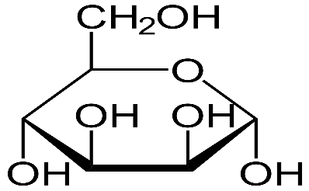
alpha d mannose alpha d glucose alpha d galactose

Each of these simple sugars has six carbon atoms, twelve hydrogen atoms, and six oxygen atoms. They differ in how oxygen and hydrogen are distributed around the ring. These variations in the way the components are arranged affect the solubility, sweetness, rates of microbial fermentation, and other aspects of these sugars.
A water molecule can be divided apart to form a connection between two glucose units. A disaccharide molecule, in this case maltose, is created as a result.
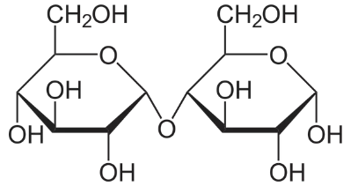
Maltose
Common disaccharides that are generated similarly include lactose, or milk sugar, which is made from glucose and galactose, and sucrose, or cane or beetroot sugar, which is made from glucose and fructose. The solubility, sweetness, susceptibility to fermentation, and other characteristics of these disaccharides vary from one another as well.
To create polysaccharides (Le., "many sugars"), more glucose units may be joined together in a polymer-like way. The polysaccharide amylose is one such example and is a crucial part of plant starches. Cellulose is a chain of slightly varied glucose molecules joined together. Simple sugars or their derivatives make up the disaccharides, dextrin, starches, celluloses, hemicelluloses, pectin, and carbohydrate gums. As a result, they can be divided into smaller components, including their simple sugars, through hydrolysis. The chemically reactive groups of sugars are the hydroxyl groups (-OR) around the ring structure, and when the ring is opened, the
Reducing sugars are those that have free aldehyde or ketone groups. Reducing sugars are included in all monosaccharides. The sugar is nonreducing when two or more monosaccharides are joined by their aldehyde or ketone groups, preventing these reducing groups from becoming released. Maltose, a disaccharide, is a reducing sugar while sucrose, a disaccharide, is a nonreducing sugar. Particularly reducing sugars can interact with other dietary components, including the amino acids in proteins, to create molecules that change the color, flavor, and other characteristics of food.
Characteristics of sugar
The following characteristics are present in variable degrees in all sugars, including glucose, fructose, maltose, sucrose, and lactose: They have the characteristics that follow: (1) they are typically used for their sweetness; (2) they are soluble in water and easily form syrups; (3) they crystallise when water is removed from their solutions (this is how sucrose is recovered from sugar cane juice); (4) they provide energy; (5) they are easily fermented by microorganisms; (6) they can be used as a preservative because they can stop the growth of microorganisms in high concentrations; (7) they darken in colour or caramelize on heating; (8) In a process known as the browning reaction, some of them mix with proteins to produce dark colours; (9) They provide solutions body and mouthfeel in addition to sweetness. The creation of enzymatic mechanisms for the conversion of glucose to its isomer, fructose, represents a significant advancement in sugar technology. Compared to glucose or sucrose, fructose is sweeter. This has made it possible to create sugar syrups from starch that have the sweetness and some other characteristics of sucrose. Typically, glucose is produced by hydrolyzing maize starch and is subsequently isomerized. With the help of this technology, the United States is producing large amounts of maize and is less dependent on imported sucrose, whose availability and cost can vary significantly.

Digestion of Carbohydrates
The principal sites of carbohydrate digestion are the mouth and small intestine. The dietary carbohydrate consists of: Polysaccharides, Starch, glycogen and cellulose; Disaccharides: Sucrose, maltose and lactose; Monosaccharides: Mainly glucose and fructose. Monosaccharides need no digestion prior to absorption, whereas disaccharides and polysaccharides must be hydrolyzed to simple sugars before their absorption.
Digestion in Mouth
Digestion of carbohydrates begins in the mouth. Salivary glands secrete α-amylase (ptyalin), which initiates the hydrolysis of a starch. During mastication, salivary αamylase acts briefly on dietary starch in random manner breaking some α-(1 → 4) bonds, α-amylase hydrolyzes starch into dextrin.
Digestion in Stomach
Carbohydrate digestion halts temporarily in the stomach because the high acidity inactivates the salivary α-amylase.
Digestion in Intestine
Further digestion of carbohydrates occurs in the small intestine by pancreatic enzymes. There are two phases of intestinal digestion.
1. Digestion due to pancreatic α-amylase
2. Digestion due to intestinal enzymes: sucrase, maltase, lactase, isomaltase.
Digestion due to pancreatic α-amylase
The function of pancreatic α-amylase is to degrade dextrin further into a mixture of maltose, isomaltose and α-limit dextrin. The α-limit dextrin are smaller oligosaccharides containing 3 to 5 glucose units.
Digestion due to intestinal enzymes
Enzymes responsible for the final phase of carbohydrate digestion are located in the brush-border membrane. The end products of carbohydrate digestion are glucose, fructose and galactose which are readily absorbed through the intestinal mucosal cells into the bloodstream.

Absorption of Carbohydrates
Carbohydrates are absorbed as monosaccharides from the intestinal lumen. Two mechanisms are responsible for the absorption of monosaccharides:
1. Active transport against a concentration gradient, i.e. from a low glucose concentration to a higher concentration.
2. Facilitative transport, with concentration gradient, i.e. from a higher concentration to a lower one.
Active Transport
The transport of glucose and galactose across the brush border membrane of mucosal cells occurs by an active transport. Active transport is an energy requiring process that requires a specific transport protein and the presence of sodium ions. A sodium dependent glucose transporter (SGLT-1) binds both glucose and Na+ at separate sites and transports them both through the plasma membrane of the intestinal cell. The Na+ is transported down its concentration gradient (higher concentration to lower concentration) and at the same time glucose is transported against its concentration gradient. The free energy required for this active transport is obtained from the hydrolysis of ATP linked to a sodium pump that expels Na+ from the cell in exchange of K+
Facilitative Transport
Fructose and mannose are transported across the brush border by a Na+ independent facilitative diffusion process, requiring specific glucose transporter, GLUT-5. The same transport can also be used by glucose and galactose if the concentration gradient is favorable.
Process of digestion and absorption

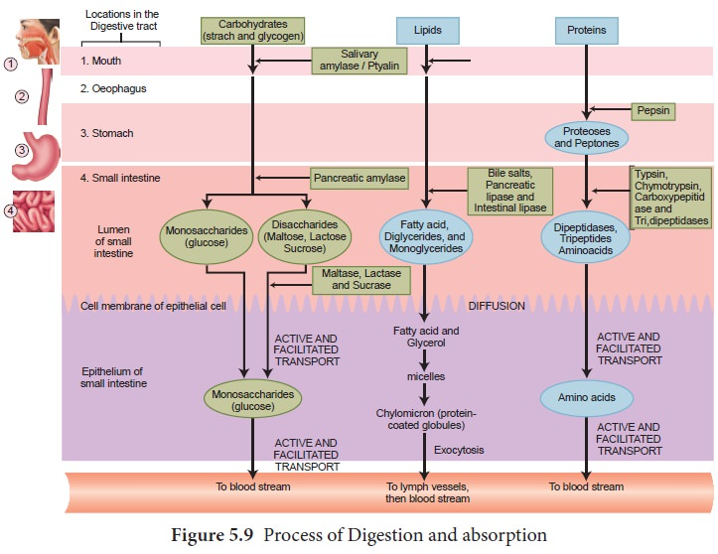
Protein
Long chains of individual amino acids are formed to form proteins. The main components of amino acids are carbon, hydrogen, oxygen, and nitrogen. Some amino acids also contain other substances, such sulphur. All living need proteins to function. In animals, they help in the formation of tissues that provide support and protection, such as cartilage, skin, nails, hair, and muscle. They are important components of numerous hormones, enzymes, antibodies, and bodily fluids like blood, milk, and egg white. The chemical formulae of typical amino acids are as follows:
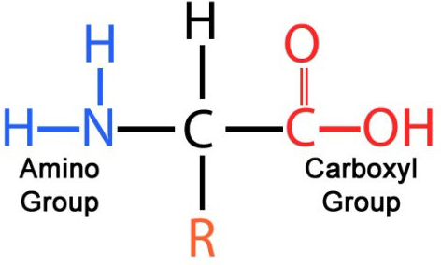
The -NH2 or amino group and the ---COOH or carboxyl group are both connected to the same carbon atom in amino acids. These groups can react with acids, bases, and a variety of other reagents because they are chemically active. Since the amino and carboxyl groups of amino acids are themselves basic and acidic, respectively, they mix easily with one another. As a result, a water molecule is eliminated, and a peptide bond is created, which has the following chemical structure:
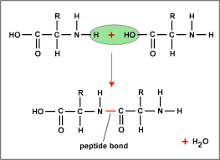
A dipeptide is created in this case when two amino acids react, with the peptide bond in its center. The remaining free amino and carboxyl groups at the ends can combine with other amino acids to create polypeptides in a similar way. These and other reactive groups on the chains of various amino acids can participate in a variety of interactions with a wide range of other dietary components. Human tissues, blood proteins, hormones, and enzymes are made up of 20 different major amino acids and a few minor ones. Eight of them are classified as essential amino acids because humans are unable to produce them in sufficient quantities to support growth and health, hence they must be obtained through food. The essential amino acids are leucine, isoleucine, lysine, methionine, phenylalanine, threonine, tryptophan, and valine. To this list of eight is added histidine to meet the demands of growth during childhood. The non-essential amino acids are alanine, arginine, aspartic acid, cysteine, cystine, glutamic acid, glycine, hydroxyproline, proline, serine, and tyrosine. The list of essential amino acids differs somewhat for other animal species.
The potential for variation among proteins is huge. This variety results from different amino acid combinations, variations in the order of amino acids within a chain, and variations in the forms that the chains take on. Regardless of whether they are folded, coiled, or straight. These variations are substantially to blame for the variations in flavour and consistency of chicken muscle, beef muscle, and milk curd.
Wool, hair, and the fibrous tissue of chicken breasts are examples of materials where protein chains can be arranged parallel to one another like the strands of a rope. Or they could be twisted up haphazardly like a tangled mess of yarn. As a result, proteins extracted from various foods, such as egg, milk, and meat, may have extremely comparable chemical analyses in terms of C, H, 0 and N, as well as in regards to their specific amino acids, yet contribute significantly diverse structures to the foods they are found in.
Digestion and absorption of protein
Since entire proteins cannot be absorbed, they must first be broken down into AAs or di- and tri-peptides before being absorbed. It's crucial to remember that the cytosol also undergoes some extra digestion.
Pancreatic proteases form the majority of the enzymes that carry out digestion, which starts in the stomach and is carried out by both gastric and pancreatic proteases. It's important to keep in mind that proteins have a wider range of structural variations than carbohydrates, requiring a wider variety of peptidases and transporters than those needed for carbohydrates. Beginning with the production of HCl from parietal cells and pepsinogen from main cells, the gastric phase of digestion gets started. In addition to working to denature proteins, HCl also turns inactive pepsinogen into active pepsin. Pepsin completes between 10 and 20 percent of protein digestion by cleaving proteins at major aliphatic or aromatic side groups. Pepsin is rendered inactive as the chyme enters the intestines (at pH > 4.5). This guards against auto-digestion in the intestines.
Clinical Correlation: The use of proton pump inhibitors, which keep the pH of the stomach above 4.5, has consequences for the requirement for an acidic pH to activate pepsinogen. There are no studies that show this has an impact on nutrition or causes deficiencies. Similar to this, the effects of gastric bypass are minimal.
The majority of proteolysis occurs during the intestinal phase, primarily as a result of the pancreatic proteases' activity. In the intestines, 70% of proteins are transformed into oligopeptides. The two primary types of pancreatic enzymes are ectopeptidase, which cleaves AA at the C-terminus, and endopeptidase, which cleaves internal bonds. Trypsin, chymotrypsin, and elastase are examples of endopeptidase. Carboxypeptidases A and B are examples of ectopeptidases. While carboxypeptidase B affects basic AA, carboxypeptidase A affects neutral AA. Pro-enzymes (zymogens) of pancreatic enzymes are stored in acinar cells and are activated by the self-activating trypsin. In addition to enterokinase, trypsin can also be produced on its own.
Trypsinogen Trypsin
Chymotrypsinogen Chymotrypsin
Procarboxypeptidase A and B Carboxypeptidase A and B
Proelastase Elastase
The amount of protein suitable for intracellular transport increases when additional protein digestion takes place at the brush boundary. Brush border peptidases are integral membrane proteins that break down tetrapeptides and bigger peptides into single amino acids and smaller peptides (di and tri-peptides). The brush boundary peptidases are not found in the crypts and are membrane-bound to the tips of the villi.
Dipeptides and tripeptides can also be broken down into single amino acids by intracellular cytoplasmic peptidases. However, some protein is retained in the enterocytes and used to sustain the cell. More than 99% of protein enters the bloodstream as single amino acids.
In the duodenum and jejunum, where oligopeptides (3 to 4 AA and shorter) and AA are delivered, the majority of protein absorption occurs. Compared to free amino acids, oligopeptides are absorbed more quickly. There are numerous different transporters with various operating principles. PEPT1 is an active transporter that connects to the sodium-hydrogen exchanger NHE3. The PEPT1 transporter can carry proteins of different shapes and charges. Several distinct processes, such as facilitated diffusion, Na+ -independent carriers, Na+ -dependent carriers, and proton co-transport, are used to transport free AA out of the lumen. Because several amino acids use the same transport route, consuming a lot of one can prevent the body from absorbing other amino acids.
The basolateral membrane of the enterocyte contains additional transporters which export amino acids from the cell into the blood by both diffusion and by both Na+ dependent and independent carriers.
Fat and Oil
In contrast to proteins and carbohydrates, fats are not made up of repeating molecular units to form polymers. They do not add to the structural strength of plant and animal tissues by forming lengthy molecular chains. Water cannot dissolve fats because they are greasy, smooth things.
For the animal or plant that contains it, or for the animal that eats it, fat is primarily a fuel source. About 2% more calories are included in it than in an equivalent dry weight of protein or carbohydrate. Because of this, replacing fat in foods with protein or carbohydrates helps to reduce their calorie load. The fat-soluble vitamins A, D, E, and K, the sterols cholesterol in animal fats and ergosterol in vegetable fats, as well as some naturally occurring lipid emulsifiers known as phospholipids because they contain phosphoric acid in their molecules, are all substances that are always present in fat-containing natural foods.
Glycerol and three fatty acids combine to form a typical fat molecule, are as follows:
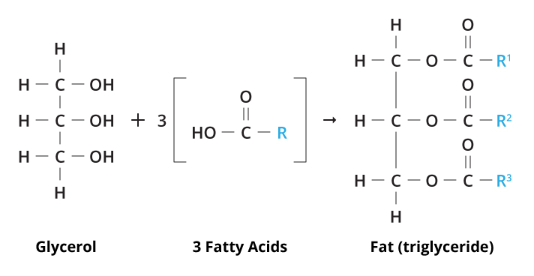
Fatty acids have one reactive carboxyl group, but glycerol has three reactive hydroxyl groups. As a result, each glycerol molecule can mix with three fatty acid molecules, resulting in the elimination of three water molecules. Triglycerides are the name for these fats.
In natural fats, glycerol is related to around 20 different common fatty acids. These fatty acids differ from one another in length and hydrogen atom content. The three shortest fatty acids are formic acid, acetic acid, and propionic acid. One of the lengthier regular fatty acids is stearic acid.
All three of glycerol's hydroxyl groups need not interact with fatty acids to form a triglyceride in order for fat molecules to exist. When two fatty acid molecules mix, the resulting molecule is known as a diglyceride; when glycerol unites with just one, the resulting fat is a monoglyceride. Diglycerides and monoglycerides are particularly effective emulsifiers.
Natural fats are mixes of different types of fat molecules, which might change in any of the previously mentioned ways. They do not consist only of one type of fat molecule. Today, the complex nature of fat chemistry is so well understood that custom-made fat blends with particularly unusual qualities are created for certain food applications.
Additional characteristics of fats that are crucial in food technology include the following:
- They do not have a sharp melting point; instead, they gradually soften when heated.
- When heated further, fats first start to smoke, then they flash, and finally they burn because they can be heated much over the boiling point of water. The smoke point, flash point, and fire point, respectively, are the temperatures at which these occur.
- This is crucial in industrial frying processes because fats can turn rancid when they react with oxygen or when enzymes release the fatty acids from glycerol.
- Fats combine with water and air to generate emulsions. In milk or cream, fat globules can be suspended in a lot of water, or in butter, water droplets can be suspended in a lot of fat. As an emulsion in fat, like in buttercream icing or whipped butter, air can be trapped.
- Fat has shortening power; that is, it connects between protein and starch structures and causes them to split apart easily and short rather than allow them to stretch long;
- Fat is a lubricant in foods; for example, butter helps you swallow bread. In this way, fat tenderizes both meat and baked items.
- Fats give dishes their distinctive flavors and, in little amounts, can make you feel full or satisfied.

Digestion and Absorption of fats
Like carbohydrates and protein, fats are broken into small components for absorption. Triglycerides and phospholipids are initially broken down in the mouth when they come into contact with saliva. Next, the physical process of chewing helps the digestive enzymes do their functions, along with the help of emulsifiers. The digestive process is started by the lingual lipase enzyme and a tiny amount of phospholipid acting as an emulsifier. The digestive enzymes can reach fats more easily as a result of these processes. As a result, the fats separate from the aqueous components and enlarge into tiny droplets.
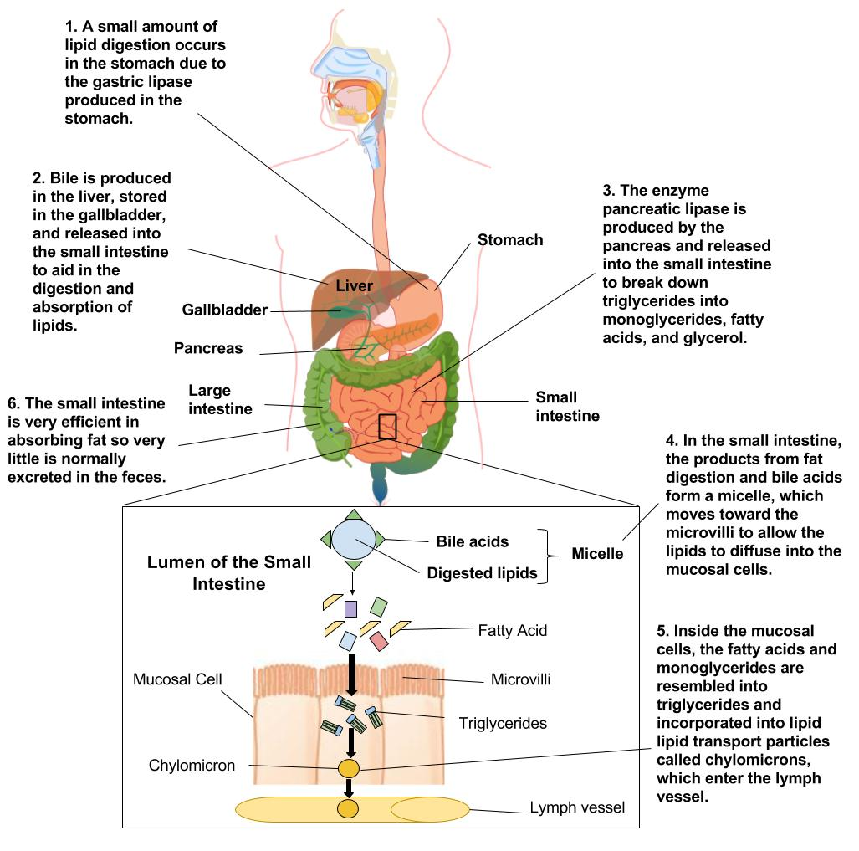
Triglycerides are first broken down into diglycerides and fatty acids in the stomach by the enzyme gastric lipase. Roughly 30% of the triglycerides are converted to diglycerides and fatty acids within two to four hours of consuming a meal. The contractions and churning of the stomach aid in spreading the fat molecules, and the diglycerides produced in this process serve as additional emulsifiers. However, despite all of this activity, only a little amount of fat breakdown takes place in the stomach. The digestive system begins to overcome a minor obstacle as stomach contents move into the small intestine, specifically, combining the separated fats with its own watery fluids. Bile is a solution to this problem. Bile serves as an emulsifier since it contains bile salts, lecithin, and compounds made of cholesterol. Water also attracts and holds onto it, and fat also attracts and holds onto it. Lipids' surface area is multiplied by a thousand during emulsification, increasing their accessibility to the digestive enzymes.
Fat-breaking enzymes then begin to operate on the triglycerides and diglycerides to separate the fatty acids from their glycerol bases once the stomach contents have been emulsified. Micelles are created when bile salts enclose fatty acids and monoglycerides. Micelles have a water-soluble shell and a fatty acid core. This enables speedy delivery to the intestinal microvillus. At this point, the fat components are liberated and distributed throughout the cells lining the digestive tube. The monoglycerides and fatty acids rearrange into triglycerides inside the intestinal cells. When combined with a protein carrier, phospholipids, cholesterol, and triglycerides create lipoproteins. Triglycerides and cholesterol esters, which are fatty acids attached to cholesterol, constitute the majority of the inner core of lipoproteins. The phospholipids that compose up the outer layer are laced throughout with proteins and cholesterol. Together, they create an enormous lipoprotein called a chylomicron, which is now entering the lymphatic system before being discharged into the bloodstream via the jugular vein in the neck. Food fats are perfectly transported by chylomicrons via the water-based environment of the body to particular locations like the liver and other bodily tissues. Compared to phospholipids and triglycerides, cholesterols are weakly absorbed. Increased dietary fat components promote cholesterol absorption, while high fibre content inhibits it. This is the rationale for the recommendation to consume a lot of fibre in order to lower blood cholesterol. Fresh fruits, vegetables, and oats are examples of foods high in fibre. These foods can bind bile salts and cholesterol, limiting their absorption and moving them out of the colon.
Vitamins
Other than essential amino acids and fatty acids, vitamins are organic substances that must be given to an animal in minute amounts to maintain health. The only major vitamin that the human body is known to be capable of producing is vitamin D, which is an exception to this rule. To maintain life and health, vitamin D must also be consumed by diet or as a dietary supplement since in some cases, it may not be synthesized in sufficient quantities. There is mounting evidence that vitamins have additional roles in preserving health beyond their activities in enzyme systems that aid in the metabolism of proteins, carbohydrates, and lipids. The vitamins are readily separated into two main categories: fat-soluble vitamins and water-soluble vitamins.
Vitamin A (Retinol)
Only animal products, such as meat, milk, eggs, and the like, naturally contain vitamin A in its pure form. Despite the absence of vitamin A in plants, f3-carotene is present. Both vitamin A and f3-carotene, which is easily converted to vitamin A, are essential for humans and other animals. Green leafy vegetables, as well as veggies that are orange or yellow, contain f3-carotene. Lack of vitamin A causes blindness, abnormal bone and teeth growth in children, disorders of the nose, throat, and eye epithelial cells and membranes, which can lower the body's resistance to infection. Although these illnesses are not frequent in the developed world, they are tragically all too common in some regions. Liver, fish oils, dairy products with butterfat, and eggs are foods high in vitamin A. Carrots, squash, sweet potatoes, spinach, and kale are sources of its primary precursor, f3-carotene. Like other vitamins, vitamin A and f3-carotene are produced synthetically.
Food vitamin A activity was previously measured in terms of international units (lU). The biological activity of a vitamin is quantified in IU. Total vitamin A activity can be expressed in terms of the equivalent weight of pure retinol to prevent confusion because the biological activity of preformed vitamin A (retinol), f3-carotene, and other carotenoids vary. As a result, "retinol equivalents" have taken the place of IU in several nations. 1 JLg of retinol or 6 JLg of f3-carotene are equal to one retinol equivalent. Additionally, it equates to 10.33 IU of vitamin A activity from f3-carotene and 3.33 IU of vitamin activity from retinol. For a healthy adult male in the United States, 1000 retinol equivalents (RE) of vitamin A activity are advised daily. The allowance for women is 80% of this because to their smaller stature, however it increases during lactation. Like many other nutrients, preformed vitamin A in excess can be harmful. Large carotenoid doses are not as damaging because the body will limit the conversion to vitamin A, but they may cause skin to turn yellow. To combat vitamin A deficiency, several countries in South America have passed laws that all sugar for home consumption be fortified with this vitamin. carotene.
Vitamin D
In the skin of both humans and animals, ultraviolet light from the sun or artificial UV light activation of sterols produces vitamin D. Ergosterol and cholesterol are two examples of sterols in play. Animals have cholesterol in and under their skin. Ergosterol from yeast that has undergone radiation treatment has been used to supplement milk and other meals with vitamin D. For calcium and phosphorus to be used effectively, vitamin D improves their absorption from the digestive tract. Rickets is the main bone abnormality brought on by vitamin D deficiency. When exposure to the sun is restricted, this deficiency could happen. The majority of foods are deficient in vitamin D, however liver, fish oils, dairy products, and eggs are good sources. Since 400 IU of vitamin D per day is thought to be the ideal amount for youngsters, milk is fortified with vitamin D at a rate of 400 IU every 0.946 liter (1 qt). For vitamin D, 400 IU is equal to 10 I-Lg of the vitamin's naturally occurring form found in animal tissues. Overconsumption of vitamin D has no positive effects and may even be detrimental.
Vitamin E
Vitamin E, also known as a-tocopherol, is an ant sterility agent in rats and necessary for canines and other animals to have proper muscular tone, but its importance for humans is still up in the air. Strong antioxidant vitamin E presumably serves this purpose in human metabolism. Excessive consumption of polyunsaturated fats in the diet might produce potentially hazardous quantities of peroxidized fatty acids. There is proof that vitamin E can stop this from happening. Additionally, vitamin E helps the body absorb iron and may help keep cellular membranes stable. Vitamin E's antioxidant abilities also allow it to protect carotene and vitamin A from oxidative damage. Vegetable oils are excellent suppliers of vitamin E, although under normal human nutrition circumstances, vitamin E insufficiency is uncommon. Large dosages of vitamin E have been touted as treatments for a variety of illnesses as well as a means to extend youth and boost sexual prowess. Such claims have little scientific support.
Vitamin K
Normal blood coagulation depends on vitamin K. Its absence typically coincides with improper fat absorption caused by liver dysfunction. Infants may also be lacking in it. Giving vitamin K to infants along with their formula helps to avoid this. Green vegetables like spinach and cabbage are excellent sources of vitamin K. Additionally, bacteria in the human digestive system produce vitamin K. Vitamin K and other vitamins produced by bacteria can therefore become deficient as a result of antibiotic therapy that kills intestinal organisms.
Vitamin C
The anti-scurvy vitamin is vitamin C. Its deficiency results in weak capillary walls, easy gum bleeding, loosening of the teeth, and illnesses of the bone and joints. It is essential for the healthy synthesis of the protein collagen, a crucial component of skin and connective tissue. Similar to vitamin E, vitamin C facilitates iron absorption. Vitamin C, commonly known as ascorbic acid, is the vitamin that is most frequently lost during food processing, storage, and cooking because it is quickly oxidised, particularly at high temperatures. To avoid losses, foods containing vitamin C must be shielded from oxygen exposure.
For both male and female people in the United States, 60 mg of vitamin C is advised daily. The recommended daily dosage has been 30 mg in the UK and Canada. There isn't full international consensus when it comes to other vitamin and mineral recommendations. Citrus fruits, tomatoes, cabbage, and green peppers are excellent sources of vitamin C. Because we eat a lot of potatoes, potatoes are also a fair source of vitamin C, despite having a low vitamin C concentration. Meats, milk, and cereals are poor suppliers of calcium.
Two of the more recent vitamin C claims are that it lowers blood cholesterol levels in rats and shields people from colds. The relevance of the rat research for people has not yet been determined. Some people have suggested taking daily tablets containing a very high quantity of one or more grammes of vitamin C to avoid colds. The FDA or the medical community, however, have not endorsed the efficacy of this treatment.
Vitamin B complex
The same primary food sources, including liver, yeast, and the bran of cereal grains, contain all of the vitamin B complex's components in general. All are necessary for fundamental metabolic processes, and several serve as integral components of working enzymes. A specific deficiency disease is caused by a particular B vitamin's absence.
Thiamin (Vitamin B1)
The B vitamin thiamin was the first to be understood. Where polished rice is a prominent dietary component, the disease beriberi, which is brought on by a thiamin deficiency, is widespread. This condition can be cured by thiamin fortification of rice or white bread. Thiamin serves as the coenzyme thiamin pyrophosphate, or cocarboxylase, in the oxidation of glucose, which is one of the most crucial roles of thiamin in the process of using carbohydrates to produce energy. The sensitivity of thiamin to sulfite salts and sulphur dioxide (S02), a frequent food preservation ingredient, is significant to the food technologist. The FDA and meat inspection standards forbid using sulphur dioxide to preserve foods that are significant sources of thiamin because it decreases the vitamin activity. The recommended adult daily allowance for thiamin is about 1.0-1.5 mg, depending on age and sex. Best sources are wheat germ, whole cereals containing bran, liver, pork, yeast, and egg yolk. Thiamin is stable to heat in acid foods but less so in neutral and alkaline foods, and this is taken into account in food processing.
Riboflavin (Vitamin B2)
The whey and skim milk's yellow-green pigment is called riboflavin. It contributes to live cells' oxidative activities and is crucial for cellular development and tissue upkeep. Humans typically experience deficiencies as skin disorders like mouth corner cracking. Adults should consume between 1.2 and 1.7 mg per day, depending on their sex and age. Good sources include eggs, milk, and liver. Riboflavin is moderately found in meats and green leafy vegetables. Because riboflavin is quite heating resistant but extremely light sensitive, brown milk bottles have only sometimes been used in the past. Paper cartons are more useful since they shield milk from light.
Niacin (Vitamin B3)
Nicotine from tobacco should not be confused with niacin, often known as nicotinamide in the UK. Niacin deficiency has a negative impact on glucose oxidation and tissue respiration, leading to the human condition known as pellagra. Disorders of the skin and mucous membranes, as well as depressive symptoms and bewilderment, describe this. Niacin or tryptophan, an important amino acid that the body uses to make niacin, can be given to treat pellagra. Niacin dosage for adults is between 13 and 20 mg per day, depending on sex and age. Yeast, pork, fish, chicken, peanuts, legumes, and whole grain cereals are excellent providers of this vitamin. Although niacin is extremely resistant to oxidation, heat, and light, it is still a water-soluble vitamin.
Pantothenic Acid (Vitamin B5)
Pantothenic acid is present in a wide variety of foods; hence it is uncommon for humans to experience overt signs of a deficit. However, very undernourished people or experimental animals on restricted diets may show signs of a deficit. In this instance, the person's overall wellbeing has decreased, showing indicators of despair, decreased resistance to illness, and perhaps decreased tolerance for stress. Although the daily amount of this vitamin needed by humans, including those who are pregnant and nursing, is not well known, it is thought to be around 5 mg. This is conveniently provided in a typical meal.
Pyridoxine (Vitamin B6)
Pyridoxine, pyridoxal, and pyridoxamine are all chemical compounds that are together referred to as vitamin B6. Although this vitamin is necessary for the human diet in order to support certain enzyme systems and normal metabolism, it does not directly contribute to any known diseases. Foods rich in vitamin B6 include muscle meat, liver, kale, green vegetables, and bran-containing grain cereals. Adults should consume about 2 mg per day, and 2.2 mg per day while pregnant or nursing. Higher amounts might be necessary for women on steroid-containing birth control tablets.
Cyanocobalamin (Vitamin B12)
Vitamin B12, commonly known as the anti-pernicious anaemia factor, is crucial for the synthesis of nucleic acids as well as for the metabolism of fats and carbohydrates. The largest vitamin molecule, vitamin B12, also known as cyanocobalamin, incorporates the mineral cobalt in its structure, necessitating its use in nutrition. Vitamin B12 is a manufactured by-product of the synthesis of antibiotics and is produced by bacteria and moulds. Liver, meats, and shellfish are excellent natural sources of this vitamin. Since vitamin B12 is almost entirely missing from plant tissues, strict vegetarians may not be getting enough of it from their meals. For adults, a daily allowance of 2.0 is advised. The activity of vitamin B12 is not confined to one component but is present in a number of structurally related substances.
Folacin
The names for similar molecules that demonstrate the vitamin action of folic acid are folate and folic acid, respectively. Similar to Vitamin B12, folacin aids in the production of nucleic acids, protects some types of anaemia, and is produced by microbes. Animal and plant foods, including liver, green vegetables, legumes, cereal grains, and nuts, contain folic acid. For adult males, 180 mg of folacin per day is advised, while 400 mg is advised during pregnancy. This allocation acknowledges the vitamin's limited biological availability from specific foods in a varied diet.
Biotin and Choline
Biotin and choline are two additional water-soluble compounds that are typically mentioned with the B complex vitamins. The metabolism is activated by biotin of amino acids and fatty acids. Choline plays a role in the transmission of nerve impulses and is a component of brain tissue and cell membranes. When the diet contains an acceptable amount of the other B vitamins, biotin and choline are rarely in short supply. These growth factors as well as others, such inositol and para-aminobenzoic acid, are additionally created by the regular bacteria of the intestine.
Minerals
Calcium And Phosphorous
The minerals that humans need the most are calcium and phosphorus amounts. Bone and dental disorders are the primary effects of deficiencies. Additionally, calcium is required for blood coagulation, the activity of specific enzymes, and the regulation of fluid flow via cell membranes. Every biological cell needs phosphorus to function. It is involved in the metabolic reactions that produce energy and are controlled by enzymes. Additionally, phosphorus aids in regulating the blood's acid-alkaline response. The young, pregnant women, and nursing moms have the highest needs for calcium and phosphorus. The percentage of these minerals that are absorbed into the bloodstream is just as significant as their food intake. Because they can interact and precipitate one another, calcium and phosphorus actually obstruct the efficiency of each other. Oxalates can precipitate calcium and cause it to harden in foods like rhubarb unavailable in terms of nutrients. Because milk and dairy products are such great suppliers of calcium and phosphorus, these nutrients are rarely insufficient in typical diets minerals. The role of calcium in reducing the loss of calcium from bones (also known as osteoporosis) has been researched recently. Older women are particularly prone to this disease. There is some evidence that increasing calcium consumption can help prevent osteoporosis later in life, especially when done when one is young. The digestive tract's ability to absorb calcium depends on vitamin D, and lactose is also excellent at facilitating this absorption. As a result, milk, particularly milk fortified with vitamin D, is a very valuable source of calcium.
Magnesium
Magnesium is needed for sustaining electrical potential in nerves and membranes, for the release of energy during muscular contraction, and for the regular metabolism of calcium and phosphorus. It is also crucial for the operation of various enzyme systems. In contrast to humans, whose diets often contain enough amounts of magnesium, farm and experimental animals, which may have a restricted diet, are more likely to experience deficiency symptoms.

Iron And Copper
Iron is necessary because it is a component of the oxygen-carrying haemoglobin in the blood and the oxygen-storing myoglobin in the muscles. Iron deficiency may be the most prevalent nutrient deficiency of all in the diets of the industrialised world. Copper aids in the synthesis of haemoglobin and the utilisation of iron. The rate of growth and blood loss are connected to the requirements for iron and copper. A large portion of the iron included in plant meals is not accessible because it is bonded to insoluble iron compounds like phytate and phosphate.
Iron from animal sources, as well as iron from soluble salts used in food enrichment and fortification, is typically more easily absorbed in digestion.
Cobalt
Cobalt is a component of vitamin B12, as was previously indicated; nonetheless, cobalt cannot satisfy a person's demand for vitamin B12 in humans.
Zinc
Zinc is a crucial component of enzymes involved in the metabolism of carbohydrates, proteins, and nucleic acids. Skin sores, loss of appetite, and decreased growth and development are all consequences of its shortage.
Sodium and Chloride
The body's main extracellular ions are sodium and chloride. They are largely responsible for preserving bodily fluid volume and osmotic balance. Additionally, the chloride ion is required for the gastric juice's hydrochloric acid to be produced. large losses occur in sodium and chloride when body fluids are lost, such as by sweating when exercising, and they must be supplied to prevent fatigue, nauseousness, and muscular cramps. The about 10 g of salt that an adult human consumes every day from food is more than enough to meet their needs, and may even be too much given that high sodium intake can raise blood pressure. Vegetarians and animals that eat grass typically need to supplement their diets with salt because vegetables have a comparatively low salt content.
Potassium
The main intracellular cation is potassium, which along with sodium helps control osmotic pressure and pH equilibrium. Additionally, it affects how cellular enzymes work. Even in the most basic diets, potassium is rarely a limiting nutrient.
Iodine
Iodine is a component of the thyroid hormone and is crucial for human goiter prevention. Where saltwater fish is consumed, there is never a lack of iodine. Away from the water, there is a lack of naturally occurring iodine in the central United States and several regions of South America. Iodized salt is widely used nowadays to avoid insufficiency, and in the US, there is fear that iodine levels won't get too high.
Fluorine
The fluoride ion is necessary for the growth of healthy teeth that are resistant to tooth decay. Since adding around 1 ppm of fluorine to water lessens the incidence of tooth decay, it appears that growing children's diets are deficient in this mineral. There are no additional known dietary needs for fluorine.
Other Components
Humans need a number of other trace minerals in at least trace levels, but regular diets typically contain these. Manganese is therefore necessary for healthy bone structure, reproduction, and central nervous system operation. The correct metabolism of glucose need chromium. Protein oxidation and metabolism are also impacted by molybdenum. Selenium, nickel, tin, vanadium, arsenic, and silicon requirements have also been shown in lab animals, although their functions in human nutrition are yet unknown.
Fiber
It has long been understood that indigestible plant materials play a crucial function in maintaining the health of the intestines by supplying roughage and volume. This function is served by celluloses, hemicelluloses, pectins, lignins, and other indigestible plant materials, which are together referred to as fibre or dietary fibre. These all tend to store water, soften faeces, and shorten the time it takes for faeces to pass through the large intestine. In addition to these advantages of consuming enough fibre in your diet, research over the past ten years has discovered other physiological activities of fibre under particular circumstances. These include reducing the incidence of colon cancer, lowering the amount of insulin needed by diabetics, and lowering plasma cholesterol levels. This has resulted in the promotion of numerous novel high-fiber food items and supplements as well as numerous inflated health claims for fibre that go beyond experimental findings. Despite the fact that the term "fibre" is used broadly, it is obvious that fibre from diverse dietary sources has varying quantities of various indigestible components, and these components do not all have the same physiological effects. Additionally, processing such as grinding can alter the particle size and other physical characteristics, which can then affect the water-holding capacity. If too much fibre is consumed, the binding of minerals may result in an imbalance and lack of vital minerals. Fibre may also bind minerals, rendering them unavailable for absorption. A modest intake of fruits, vegetables, and cereal grains will not likely result in a deficiency in fibre or an excess of mineral binding. Such diets would not be expected to benefit from high-fiber supplements in healthy individuals.
Water
A person's body contains about 60% water, measured by weight. Dehydration symptoms appear in a typical individual when 5–10% of their body weight is lost as water and is not quickly restored. Thirst, weakness, and mental disorientation are felt long before this happens. Further dehydration causes the skin and lips to become less elastic, the cheeks to turn pale and the eyes to droop, a decrease in urine volume, and eventually the cessation of respiration. A human can occasionally survive without water for longer than a few days, but they are rarely able to do so for more than around 5 weeks without food. At the molecular level, cellular level, metabolic level, and functional level, there is a requirement for water. The primary organic and inorganic chemical solvent for the metabolic reactions necessary for life is water. The main carrier of nutrients via membranes and bodily fluids to cell walls is water. The medium via which nitrogenous waste products from cells are ultimately eliminated is water. One key method for regulating and maintaining normal body temperature, crucial for the controlled rate of metabolic reactions and the person's physical comfort, is the evaporation of water from the skin. The total amount of water lost from the body has a direct correlation with the quantitative requirement for water. These include losses from respiration, sweating, and the excretion and removal of bodily wastes. Exercise, excitement, high temperatures, and low relative humidity are all elements that accelerate these processes, which raises the requirement for water replenishment. 400 litres of water may be consumed annually by an adult. The same quantity is derived from food. The body carefully controls its water content when there is enough water or water in excess. The body rarely experiences a water shortfall in the same way that it may experience a deficiency in other vital nutrients, unless there are exceptional circumstances of deprivation or illness. This is due to the fact that, in contrast to many other nutrients, a decrease in body water causes practically instantaneous discomfort, prompting the person to repair the situation.
Effects of heat on food- carbohydrates, proteins, fats, vitamins, minerals.
1. Action of heat on carbohydrates
When cooked in an aqueous media, monosaccharide, oligosaccharides, and polysaccharides go through a variety of changes. Over 100 chemicals are created as a result of the breakdown and epimerization of the sugars. These substances don't have any negative consequences. When sugar is cooked in water, syrups of varying strengths can be created. Sugar cookery can also reach the varied balls stage (soft, hard, and brittle). When heated in an aqueous or moist environment, starch molecules which are the principal source of calories in many diets swell, rupture, and burst. This causes starch to become gelatinized, which allows for more enzymatic digestion by enzymes like Amylases. Thus, cooking makes carbohydrates more palatable for digestion. When starch is exposed to dry heat at a temperature of 200°C or higher, it breaks down resulting in the formation of brown colored intermediate compound called dextrin and the process is called dextrinization. For example, toasting of bread.
2. Action of heat on protein
When heated, protein coagulates or sets. The egg white is a nice example. The coagulation process aids in retaining the food's nutrition inside, where it is sealed in by the development of an external covering. Consequently, when cooking items high in protein, like meat and fish, use hot water. Put the meat in an oven that is preheated to a moderate temperature before turning the heat down to roast it. The softening of muscle fibers is another effect of heat on meat. The elastin in connective tissue shrinks during normal cooking, and heat and water induce collagen to turn into gelatin, which causes the muscle fibers to separate and the meat to become soft. At a medium temperature compared to a high temperature, this is accomplished more successfully. As it cooks, meat shrinks as well. The shrinkage increases with increasing temperature. Foods containing protein become more digestible when cooked at medium temperatures. Meat is red because of the haemoglobin in the capillaries and myoglobin in the muscle tissues. Both of them break down when heated, giving cooked meat its characteristic brown colour. 65 °C (149 °F) is the temperature at which the transformation occurs. Since the protein itself is denatured at high temperatures, it loses some of its nutritional value
3. Action of heat on fats
When fat is exposed to heat, it melts. Fat breaks down into fatty acids and acrolein at high temperatures. High heat cooking, as well as the presence of carbonized breadcrumbs and other minute pieces of cooked food, all contribute to the darkening of fat. The smoke point of a fat is the temperature at which breakdown begins when the fat is heated. Repeated heating lowers the precise temperature at which this occurs, which varies depending on the type of fat. As a result of high heat, moisture, air, and the presence of carbonized crumbs and small food bits, fat degrades over time to the point that it will only bubble in the pan and is insufficient to carry out the task of frying. The breakdown is further aided by abnormal absorption brought on by cooking food at a temperature that is too low for too long. Additionally, fat starts to solidify and get gooey. Fat that has gone through this process, known as polymerization, is no longer suitable for usage.
4. Action of heat on minerals
The only significant mineral loss associated with cooking occurs when cooking liquid is discarded. Cooking makes some minerals readily available.
5. Action of heat on vitamins
The only vitamin that loses stability when heated is vitamin C, though some of it can be retained with careful cooking. Normal cooking techniques do not degrade vitamin A and D. When cooking at high temperatures, such as when making morning cereals or baking biscuits, adding baking soda or discarding cooking liquid, vitamin B may be damaged.
Methods of heat transfer- conduction, convection, radiation.
HEAT TRANSFER
Heat must be delivered from the heat source (such as a gas flame or heating element coil) to and through the food in order for it to cook. The regulation of the cooking process is aided by an understanding of the manner and rate of heat transfer. There are three ways to transfer heat: conduction, convection, and radiation.

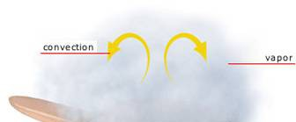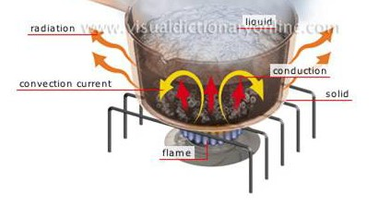

Conduction can happen in one of two ways:
- When heat transfers immediately from an object to anything it touches.
- When heat transfers from one area of an object to an area that is nearby.
The rate at which different materials transmit heat varies. Copper and aluminium conduct heat quickly, stainless steel more slowly, and glass and porcelain yet more slowly. Heat does not transmit well through air.
Convection - Convection is the process by which heat is dispersed through the movement of air, steam, or liquid (including hot fat). There are two types of convection:
- Natural. Cooler gases and liquids sink while hotter ones rise. Thus, there is a continuous natural circulation that distributes the heat in any oven, kettle of water, or deep fat fryer.
- Mechanical. Fans hasten the circulation of heat in steamers and convection ovens. As a result, the heat is distributed more quickly and evenly, which speeds up the cooking process.
Convection is mechanically affected by stirring. Natural circulation moves more slowly in thick liquids because they cannot move as quickly as thin ones.
Radiation - When energy is transported from the source to the food through waves, it is called radiation. Although the waves don't actually contain heat energy, they do when they hit the food being cooked.
In the kitchen, radiation is employed in two different ways:
- Infrared
The most well-known application of infrared cooking is broiling. In a grill, a ceramic or electric element heated by a gas flame heats to such a high temperature that it emits infrared radiation, which cooks the food. High intensity infrared ovens are another option for quickly heating meals.
- Microwave
When using a microwave oven, the radiation it produces partially penetrates the meal, agitating the water molecules there. The food is cooked by the immense heat produced by the friction this movement causes. A substance that is totally free of water will not warm up in the microwave because microwave radiation only impacts water molecules. Only the transfer of heat from the food causes plates to heat up. Additionally, since microwaves can only reach a depth of 2" into food, heat is conducted into the centre of huge portions.
Cooking methods- Moist & Dry
Cooking Methods
During cooking, heat is transmitted to the food by conduction, convection, and radiation. The kind of cooking method utilised depends on how heat is given to the food during cooking. The methods created can be divided into four categories:

Classification of Cooking Methods

Chemical, physical, and biological contamination that occur during food processing
Food Processing
Simply, food processing is the process of changing foods from one form to another so they can be sold, eaten, and consumed. Even if there are many advantages to food processing, it should always be carried out under strict oversight while taking all necessary safety measures. Foods laced with excessive chemicals, preservatives, colouring, etc. can harm your health if you eat them.
Purpose of food processing
Food goods that have undergone thorough processing could be more appealing and command a higher price. They are available on the market in a variety of forms, giving consumers choices. Nutritional value can be retained in processed foods for an extended period of time. There are many different reasons why food is processed; some of them are listed below.
- To transform fresh foods into culinary items.
- To improve the marketability of food.
- To rid food of hazardous ingredients. Many foods may contain toxins that are present naturally or in other ways. Processing can guarantee that the dangerous components that can result in illnesses and health issues that are life-threatening are removed, making the product safe for consumption.
- To make meals more easily digestible. Some foods could be difficult to digest. The right processing methods can improve their digestibility.
- To avoid food waste and spoiling. Different food processing techniques can extend the shelf life of foods by preventing them from going bad and being wasted when used effectively.
- To keep food's nutritional worth.
- To make food distribution, handling, handling, and storage easier.
There are ancient and modern procedures used in the food sector when it comes to food processing technologies. Following is a brief discussion of a few of the methods:
- Canning
Prior to packaging and airtight storage, food is cooked to a high temperature.
- Fermentation
Under anaerobic circumstances, carbohydrates are broken down. They are frequently employed in the alcoholic beverage production process.
- Freezing
Foods are cooked at a lower temperature to lessen the activity of dangerous microorganisms.
- Smoking
Foods prepared and flavoured through smoking.
Other forms
- Pickling
- Salting and sugaring
- Pasteurization
- Drying
- Proofing
- Mincing
- Peeling, chopping and slicing
Biological contamination
The presence of hazardous pathogens such germs, viruses, bacteria, mould, fungi, parasites, and others in food causes biological contamination. The main contributor to food waste, food spoilage, and foodborne illness is this kind of contamination. Before being consumed, the pathogens or disease-causing microbes swiftly grow in food products to hazardous levels.

High-risk items (meat and poultry, eggs, dairy products, seafood, etc.) should not be kept in the Temperature Danger Zone. They must adhere to all safety regulations when they purchase, store, defrost, prepare, cook, and serve the food. In addition to taking all required precautions, they should frequently clean and sanitise all surfaces and machinery that come into contact with food. They should also ensure a high degree of personal and general hygiene throughout the facility. According to this resource from FSSAI, “the range of temperatures between 5°C and 63°C is known as the Temperature Danger Zone”.
Physical contamination
When a foreign or dangerous object contaminates food, it is referred to as physical contamination. Any level of the production process could experience this. To mention a few, common types of things that might physically contaminate a food production process include hair, steel wool, nails, bandages, and plastic fragments. These items may even carry biological pollutants and present choking dangers. Physical contamination also upsets the individual who discovers the contaminated item. The experience of viewing the object is extremely upsetting, even if it is discovered before it is consumed. To avoid physical contamination, food enterprises can take a number of precautions. They ought to educate their staff about potential mishaps and proper cleanliness. All ingredients should be washed thoroughly. All possibilities of a foreign object entering the food products at any of the processing stages should be prevented. Workers should wear gloves and follow all safety guidelines.
Chemical contamination
Chemical contamination occurs when any kind of chemical contaminates food. Poisoning and chronic health problems may result from it, and it can be challenging to control. Cleaning supplies, pesticides and herbicides, naturally occurring poisons, heavy metals, antibiotics, etc. are typical examples of chemical pollutants. Chemical contamination must never occur; hence it is crucial to store chemicals aside from food and label them. Businesses that handle food must adhere to all safety regulations and educate their staff on how to prevent contamination.
Cross contamination
When biological, chemical, or physical pollution contaminates food items, making them potentially unsafe and dangerous for ingestion, cross-contamination happens in the food business process. Contamination is a significant problem. Every food industry organization should actively monitor the upkeep of the highest safety requirements when producing food goods. Failure to do so damages the company's reputation as a brand. It may result in litigation, fines, the closing of businesses, and severe legal action. Contamination presents a problem since it can come from a variety of sources. To prevent any potential of contamination, the food business enterprises must frequently check and sanitize their facilities and adhere to specific best practices and regulations. Each facility has distinct needs and various design goals. As a result, they must set up reliable procedures to handle new difficulties relating to food safety. Staff workers, tools, and equipment may transport dangerous contaminants when they move from one location to another. Establishing sanitation stations at each access point could aid in halting the spread of infection. Businesses can identify control points where contamination issues can be managed by performing a hazard analysis. Deep cleaning is another method for keeping spaces free of potentially infectious materials and clean. It is important to take precautions against pests, get rid of standing water, trim grass and weeds, and store items and equipment that are broken properly away from industrial operations. Regular inspections of the construction site are necessary to limit the likelihood of any kind of contamination and their sources. It is effective to regularly audit facilities and procedures to find any weaknesses before they become serious issues requiring expensive fixes. Establishments must adhere to the FSSAI regulations to maintain the safety and health of their food operations. According to regulatory requirements, competent handling of location and equipment selection, waste management, personal cleanliness, handling, storage, and transportation, among other things, is required.
References
- Hannelore Daniel. 2004. Molecular and Integrative Physiology of Intestinal Peptide Transport. Annual. Review of Physiology; 66: 361-384
- https://pressbooks-dev.oer.hawaii.edu/humannutrition/chapter/digestion-and-absorption-of-carbohydrates/
- https://pressbooks-dev.oer.hawaii.edu/humannutrition/chapter/digestion-and-absorption-of-lipids/
- https://www.ficsi.in/blog/food-processing-and-contamination-process-all-you-wanted-to-know/
- Mamta, Vaishnavi, Bhatt P and Vaid NR. 2023. Methods of cooking; frying, roasting, broiling. braising and stewing. Advances of food technology; 1: 249-260
- Potter NN and Hotchkiss JH. 2012. Constituents of Foods: Properties and Significance. Food Science, Fifth Edition: P 45-67
- R Montgomery and R Grand.2006. Development of the gastrointestinal tract. In:Wylie and Hyams, ed. Pediatric Gastrointestinal and Liver Disease. Philadelphia, PA. Elsevier Press:14-16.
- Sabharwal A. 2013. Biochemistry. Modern’s zoology biochemistry and mammalian physiology:3-225.

