Use of bioinformatics tools to study phylogenetic analysis and sequence similarity of Malassezia sp. a pathogen involved in Dandruff.
¹DrNamrata Khurana,²DrUday Singh Ningwal
¹Assistant Professor, ² Assistant Professor,
¹Madhay Pradesh higher education,
¹MAHARAJA BHOJ GOVERNMENT P.G.COLLEGE, DHAR, INDIA
¹ namratakhurana15@gmail.com, ²usningwal@gmail.com

Abstract—:-Malassezia species is one of the most abundant species of human skin micro biota is found to be associated with skin disorders such as seborrheic dermatitis and Dandruff. Despite the importance of Malassezia in common skin disease, little is known at the molecular level. Bioinformatics can help a lot in this process a BLAST P can be carried out of selected genes of malassezia species. Using blast as a tool of bioinformatics it was found out that M.restricta share similarity with plant pathogen Ustilago mayids and distant human pathogen Candida albicans. A tool of bioinformatics Culstal W can be carried out to find the convergent and divergent traits of Malassezia species. Scientist need to devise more effective bioinformatics tool inorder to devise a method for the treatment of increasing problem of dandruff and scalp pruritus among the human population.

IndexTerms—Malassezia,Ustilago, Candidaalbicans,CLUSTALW,BLAST,Dandruff,scalp pruritus.
________________________________________________________________________________________________________

Introduction
Malassezia species it is one of the most significant species of skin microbiota and is foun to be associated with various skin disorders like seborrheic dermatitis and dandruff.very little is known about the malassezia at molecular level. about 18 species of Malassezia has been identified which includes M.globosa,M.restricta are the most common species found in humans.malassezia is the eukaryotic biota of the human skin. Dandruff and seborrheic dermatitis are common skin problems associated with flaking of skin and itch. In dandruff the flakes are loose and inflammation is absent while in seborrheic dermatitis yellow flakes with with inflammation are observed. About 50% of the adults suffer from dandruff and other conditions due to the growth of the commensel malassezia.. The etiology of D/SD appears to be dependent upon three factors: sebaceous gland secretions, microflora metabolism and individual susceptibility. (DeAngelis et al., 2005; Ro and Dawson, 2005). This chapter will describe the most common matches of M.globosa sequence and its phylogenetic analysis using bioinformatics tools BLAST and CLUTALW. BLAST is a tool of NCBI . It finds region of similarity between two or more sequences, the sequences can be either protein or nucleotide. BLAST stands for basic local alignment search tool. Blast is basically used to find out evolutionary and functional relationship between two individuals.it is not a single program but a family of programme like BLAST p , BLAST n , BLAST x, tBLASTn etc. it also helps to identify the member of gene families. CLUTALW is a multiple sequence alignment tool for DNA and protein sequence.it is not a tool for pairwise alignment but generally good for comparing three to four sequences. it is tool of European bioinformatics institute.

The front page of CLUSTALW looks like this

SOURCE: https://www.genome.jp/tools-bin/clustalw

Similarly the front page of blast looks like:

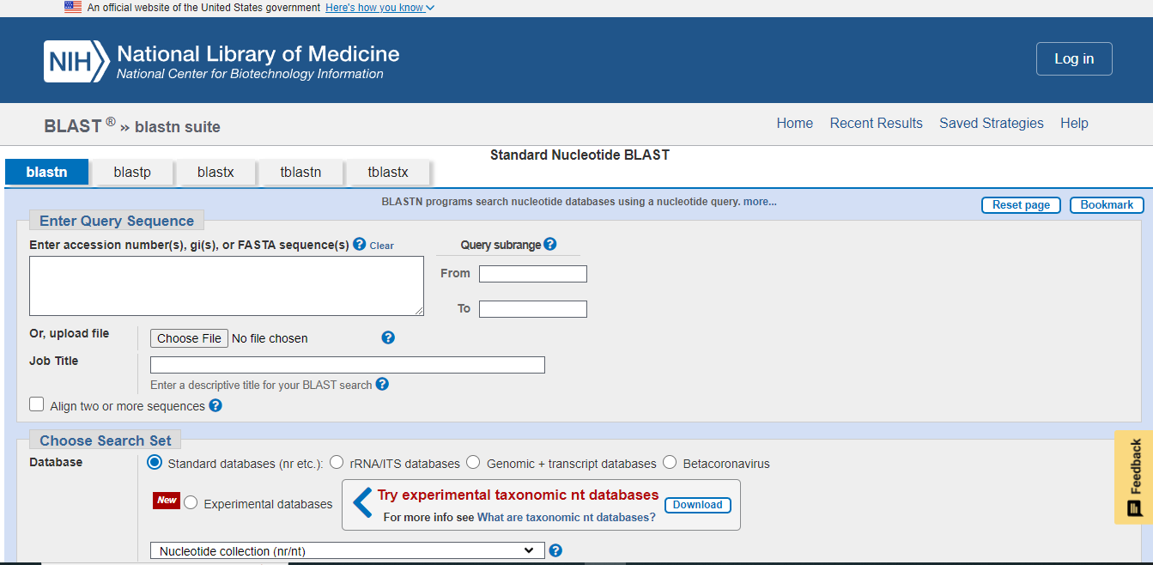
SOURCE: https://blast.ncbi.nlm.nih.gov/Blast.cgi?PROGRAM=blastn&PAGE_TYPE=BlastSearch&LINK_LOC=blasthome

Material and methods:
For alignment and homology searches, NCBI GENBANK BLAST server p 2.2.30 (http://blast.ncbi.nlm.nih.gov) was used (altschul et al.1997).The NCBI data base has complete sequence of all the 9 chromosome of Malasseziarestricta as well as the Malasseziarestricta mitochondrion, complete genome. A specific protein synthesized by each chromosome was selected viz lipase protein sequence from chromosome 1 zinc finger domain from chromosome 2 , chitin synthetase from chromosome 3 pyruvate synthetase from chromosome 4, carboxyl methyltransferase from chromosome 5, cell division cycle protein 37 of chromosome 6, NADH dehydrogenase (ubiquinone) Fe-S protein 4 of chromosome 7,arginase protein of chromosome 8, DNA repair protein REV1 of chromosome 9 and BLASTp was carried out and homology was identified. The database used for for comparison was non redundant protein databases. Multiple sequence alignment by CLUSTAL W with a K tupule word size of 1 was also carried out between secretory lipase enzymes sequences of Malassezia restricta,Ustilago maydis and Canadida albicans . A random sampling method and a questionnaire was also applied to about 243 subjects out of which 152 were females and remaining 91 were males.

RESULT AND CONCLUSION:

Protein BLAST of lipase protein sequence of chromosome 1 revealed similarity with Ustilagosps and most of the smut fungi. The zinc finger domain on chromosome 2 was found to be similar to plant pathogen Ceratobasidiumsp and Mycenasps.
The chitin synthase [Malasseziarestricta] was found to be highly similar to Testiculariasps. andScleroderma sps. andUstilagosps,again all plant pathogen. The pyruvate synthetase gene from chromosome 4 was found to be similar to Violaceomycespalustrisand Ustilagosps.Carboxyl Methyl transferase protein sequence of chromosome 5 was again found to be similar to Ustilagosps.Cell division cycle protein 37 protein sequence of chromosome of chromosome 6 was found to be 98% to Ustilagosps.NADH dehydrogenase (ubiquinone) Fe-S protein 4 of chromosome 7 showed 84% similarity with Ustilagosps.Arginase protein of chromososme 8 was found to be 98% similar to Ustilagomaydis.DNA repair protein REV1of chromosome 9 was found to be 96% to Rhizopussps.and 63% to Ustilagosps.M.restricta was found to more be closely related with the plant fungal pathogen Ustilagomyadis. A MSA between the secretory lipase of C.albicans, M.ristrictaandU.mayadis showed M.restricta and U.mayadis to be more convergent then C.albicans.
A detailed summary of the result is given below in the –

Table 1:summary of BLAST P analysis of M.resticta
Name | RefSeq | Protein | Functional Protein Selected | SIMILARITY % WITH Ustilagomyadis
Chr | I | 835 | lipase protein | 85%
Chr | II | 782 | zinc finger domain | Showed similarity withCeratobasidiumsps
Chr | III | 746 | chitin synthase
Chr | IV | 464 | pyruvate synthetase | 84%
Chr | V | 532 | carboxyl methyltransferase | 64%
Chr | VI | 410 | cell division cycle protein 37 | 98%
Chr | VII | 280 | NADH dehydrogenase (ubiquinone) Fe-S protein 4 | 84%
Chr | VIII | 233 | arginase protein | 98%
Chr | IX | 108 | DNA repair protein REV1 | 63%
name | RefSeq | protein | Functional Protein Selected | SIMILARITY % WITH Ustilagomyadis
Chr | I | 835 | lipase protein | 85%
Chr | II | 782 | zinc finger domain | Showed similarity withCeratobasidiumsps
Chr | III | 746 | chitin synthase
Chr | IV | 464 | pyruvate synthetase | 84%
Chr | V | 532 | carboxyl methyltransferase | 64%
Chr | VI | 410 | cell division cycle protein 37 | 98%
Chr | VII | 280 | NADH dehydrogenase (ubiquinone) Fe-S protein 4 | 84%
Chr | VIII | 233 | arginase protein | 98%
Chr | IX | 108 | DNA repair protein REV1 | 63%

.

A random sampling method and a questionnaire was also applied to about 243 subjects out of which 152 were females and remaining 91 were males.15.9% reported excessive scalp flaking. The prevalence of dandruff was found to decrease with age, more prevalence was found in the age group 25-34 years. Scalp pruritus was found to be more severe in patients with dandruff then with patients without dandruff. All kinds of antidandruff products and home remedies were found to be least effective among the subjects.

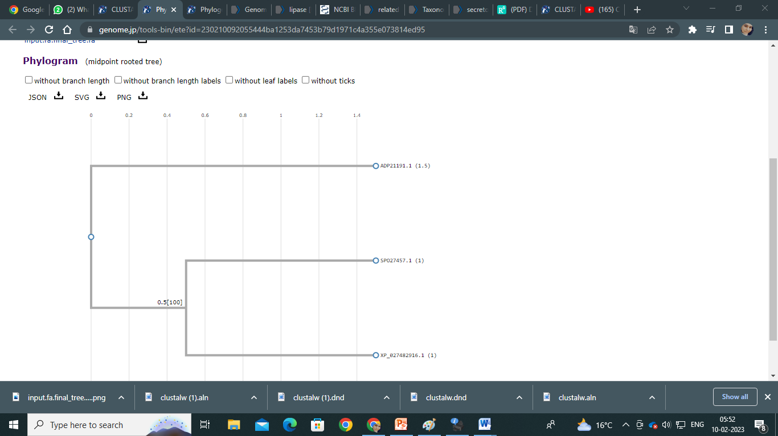
Figure 1: PhyML of secretory lipase

References

- American Academy of Dermatology. Acne-like breakouts could be folliculitis. (https://www.aad.org/public/diseases/a-z/folliculitis) Accessed 10/25/2022.mmy/myx134.
- Bart Theelen, Anastasia C Christinaki, Thomas L Dawson, Jr, TeunBoekhout, Vassili N Kouvelis, Comparative analysis of Malassezia furfur mitogenomes and the development of a mitochondria-based typing approach, FEMS Yeast Research, Volume 21, Issue 7, November 2021.
- Bart Theelen, Claudia Cafarchia, Georgios Gaitanis, IoannisDimitriosBassukas, TeunBoekhout, Thomas L Dawson, Jr, Malassezia ecology, pathophysiology, and treatment, Medical Mycology, Volume 56, Issue suppl_1, April 2018, Pages S10–S25, https://doi.org/10.1093/
- Mills KJ, Hu P, Henry J, Tamura M, Tiesman JP, Xu J. Dandruff/seborrhoeic dermatitis is characterized by an inflammatory genomic signature and possible immune dysfunction: transcriptional analysis of the condition and treatment effects of zinc pyrithione. Br J Dermatol. 2012 Jun;166Suppl 2:33-40. doi: 10.1111/j.1365-2133.2012.10863.x. PMID: 22670617.
- Xu, Jun & Saunders, Charles &hu, Ping & Grant, Raymond &Boekhout, Teun&Kuramae, Eiko&Kronstad, James &Deangelis, Yvonne & Reeder, Nancy &Johnstone, Kevin & Leland, Meredith &Fieno, Angela & Begley, William & Sun, Yiping& Lacey, Martin &Chaudhary, Tanuja&Keough, Thomas & Chu, Lien & Sears, Russell & Dawson, Thomas. (2007). Dandruff-associated Malassezia genomes reveal convergent and divergent virulence traits shared with plant and human fungal pathogens. Proceedings of the National Academy of Sciences of the United States of America. 104. 18730-5. 10.1073/pnas.0706756104.

