ABSTARCT
Shubham Gupta, Ayush Shukla, Vivek Raj, Yugant Raj Sankritya
Department of Mechanical Engineering
Thermodynamic analysis of Kalina Cycle
Dr. Prashant Saini
May,2023
This very thesis report based on the analysis of Kalina power Cycle, a constructive advance in the classical Rankine Cycle. The main objective of this course is to discuss the energy and exergy analysis that the Kalina Power Cycle showcases especially when employed with a low temperature heat source. An advanced equation solving software has been used for simulation, which is known as Engineering Equation Solver (EES). The main aim of this cycle is to show the use to the renewable energy sources such as sun and earth’s thermal energy to produce high grade energy. For this the temperature of heat source is taken as a constant value which can be output from a solar collector or a parabolic collector or some underground heat source. The report explores the thermodynamic properties of the working fluid mixture and discusses the impact of varying concentration ratios on cycle performance. Additionally, the study delves into parametric study and the effects of the parameters on the performance of the cycle.

LIST OF FIGURES

FIG NO. | DESCRIPTION | PAGE
1 | T-S Diagram of simple kalina cycle | 2
2 | Comparision of rankine and kalina cycle | 3
3 | Schematic diagram of proposed cycle | 10
4 | Effect of ammonia mass fraction on cycle | 14
5 | Effect of turbine expansion ratio on cycle | 15
6 | Effect of vapor generator pressure on cycle | 15
7 | Effect of temperature of heat source on cycle | 16
8 | Effect of PPTD regenerator on cycle | 17
9 | Effect of turbine inlet pressure on cycle | 17
10 | Effect of PPTD vapor generator | 18

LIST OF TABLES

TABLE NO. | DESCRIPTION | PAGE
1 | Mean values of input parameters | 12
2 | Thermodynamic properties at different states | 13
3 | Irreversibility of all components | 13
4 | T-S diagram for Kalina Cycle | 14

LIST OF SYMBOLS

Symbols
T | temperature (K)
P | pressure (kPa)
m | mass flow rate (kg/s)
Q | heat transfer rate (kW)
X | exergy destroyed (kW)
x | mass fraction NH₃ (kg/kg)
I | Irreversibility (kW)
s | specific entropy (kJ/K)
h | specific enthalpy (kJ)
W | work transfer (kW)
ηI | first law efficiency
ηII | second law efficiency

Subscipts
o | Reference or dead state
tur | turbine
pum | pump
vg | vapor generator
reg | regenerator
abs | absorber
con | condensor
sep | separator

TABLE OF CONTENTS
Page No.

List of Figures i
List of Tables ii
List of Symbols iii
Abstract iv
Table of Contents v

CHAPTER 1. INTRODUCTION 1
1.1 GENERAL INTRODUCTION 1
1.2 KALINA CYCLE 1
1.3 COMPARISION OF RANKINE AND KALINA CYCLE 2
1.4 OBJECTIVES 4

CHAPTER 2. LITERATURE REVIEW 5
CHAPTER 3 . THERMODYNAMIC ANALYSIS 8
3.1 CYCLE DESRIPTION AND ASSUMPTIONS 8
3.2 MATHEMATICAL MODEL 9
3.3 RESULT AND DISCUSSION 11
CHAPTER 4. PARAMETRIC STUDY 14-18
4.1 EFFECT OF AMMONIA MASS FRACTION
4.2 EFFECT OF VAPOR GENERATOR PRESSURE
4.3 EFFECT OF TEMPERATURE OF HEAT SOURCE
4.4 EFFECT OF PPTD REGENERATOR
4.5 EFFECT OF TURBINE INLET PRESSURE
4.6 EFFECT OF PPTD VAPOR GENERATOR

REFERENCES 19-20

1. INTRODUCTION

GENERAL INTRODUCTION

With the rise in demand of energy and depleting natural resources such as coal and petroleum, it has become necessary to find other means to produce energy through renewable resources and to increase the efficiency of current processes.
This project focuses on one such cycle i.e., Kalina cycle which can be used as a stand-alone process as well to increase the efficiency of current steam and gas turbines by replacing the Rankine cycle as bottoming cycle.
Kalina cycle was created by Dr. Alexander Kalina, a Russian scientist in 1983. Kalina cycle is a modified Rankine cycle which uses binary fluids mixture instead of a single fluid as in Rankine Cycle.

KALINA CYCLE

The Kalina cycle is one of the better cycles to convert renewable energy sources such as geo-thermal and solar energy to produce electrical energy. This cycle can effectively converts low temperature energy The Kalina cycle can increase thermal power output efficiencies by up to 30% in suitable installations, and is ideally suited for applications such as coal, oil refineries, steel plants and cement production plants.

The Kalina cycle is a modified Rankine cycle that uses mixture of two different compounds as the working fluid: water and ammonia while Rankine cycle uses pure water to produce energy. The Kalina cycle exergy efficiency is 15% higher as compared to the steam power cycle.

The concentration of ammonia provides the property to increase the exergy efficiency and decrease the irreversibility. The ammonia and water have large difference in their boiling points which makes it easy to separate while expanding or producing power and can easily be compressed as ammonia readily dissolves in water.

COMPARISION OF RANKINE AND KALINA CYCLE

Kalina cycle is a modified Rankine cycle, since it is a mixture of two fluids, the phase change does not take place at a constant temperature but at a varying temperature, as shown in the temperature(T) – entropy(S) diagram.
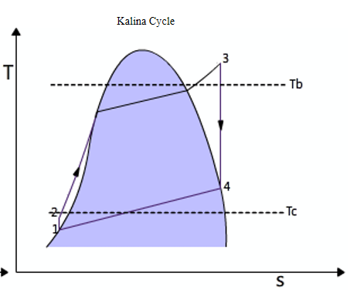
Figure 1-T-S Diagram for simple kalina cycle

1-2: Isentropic Compression (pump)
2-3: Isobaric Heat Supply
3-4: Isentropic Expansion (Turbine)
4-1: Isobaric Heat rejection

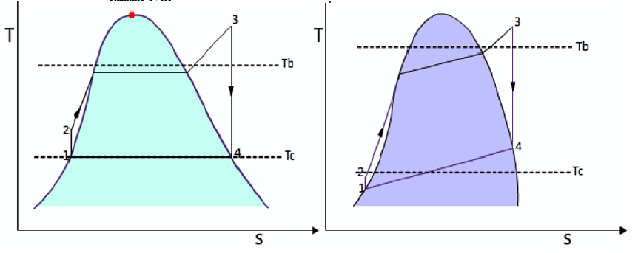
Figure 2-Comparison of simple Rankine and kalina cycle

Since the Kalina cycle operates in greater range than normal Rankine Cycle, its efficiency is also greater. As,
Thermal Efficiency = 1 – (T_{c}/T_{b})
The working fluid that is most efficient for using in kalina cycle is aqueous Ammonia (NH₃ -H₂O)

OBJECTIVES

- Mathematical modeling of Kalina cycle applying energy and exergy balance approach.

- To develop computer code in Engineering Equation Solver (EES) Package.

- To determine the energy and exergy efficiencies of the Kalina Power cycle.

2. LITERATURE REVIEW

The Kalina cycle, a promising thermodynamic process for power generation, has attracted significant attention in recent years due to its potential for enhanced efficiency and environmental sustainability. The first paper to be published on kalina cycle was back in 1984. Kalina [1] proposed a cycle based on binary mixture of NH₃/H₂O to utilize the waste heat which required a low boiling working fluid. The results demonstrated higher efficiency in comparison to rankine cycle as bottoming cycle.
In recent years, the demand of green energy also pitched kalina cycle as it can produce energy with low temperature heat sources such as geothermal, solar energy using solar collectors [2] and parabolic collectors. Sun et al. [3] has developed a cycle using KCS-11 system and verify the correctness of the model by sampling data from the Kumejima island in Japan. They based their cycle on solar collectors as the heat source and found out the exergy efficiency can be as high as 63.5 %.
The kalina cycle can also be used as combined cooling and power cycle Ghaebi et al. [4] has proposed on such cycle to use LNG (Liquified natural gas) as heat sink and thus easily transported to large distances. Energy, exergy and exergoeconomic analysis of the proposed system was conducted using EES package and first and second law efficiencies were calculated for the combined cooling and power cycle. Further effect of some key parameters was observed on the performance of the system. Rostamzadeh et al. [5] also proposed one combined cooling and power cycle (CCP) based on ammonia water binary mixture using ejector refrigeration cycle. The proposed cycle is cooling dominant. They obtained thermal efficiency as 17.6 %. They also found out the effect of key parameters such as turbine expansion ratio (TER), pinch point temperatures on the system.
Nag and Gupta [6] analysed Kalina cycle to reduce the exergy loss of the bottoming cycle in power plants. They found out that nearly 50% exergy loss takes place in heat recovery steam generator, and the cycle efficiency to be decreasing with increase in ammonia mass fraction and efficiency to increase with increase in turbine and separator temperature.
Ogriseck [7] integrated kalina cycle in a combined heat and power plant to utilize the heat of the flue gases exhausted in the power plant. He found the efficiency of the combined cycle in between 12.3% and 17.1% depending on the cooling water temperature. He also found out that the operation can be performed using conventional steam turbines. The cycle become is cheaper than other cycles such as organic rankine cycles as ammonia is easily available and inexpensive and its use in industrial process is already proven.
Rodríguez et al. [8] has done exergetic and economic comparison of organic rankine cycle (ORC) and kalina cycle for enhanced geothermal system in Brazil. For this they evaluated 15 different working fluids for ORC and three different compositions for ammonia-water mixture in kalina cycle. For simulation they used Aspen-HYSYS software package. They found out for 100 ºC the kalina cycle offers 18% more power output than ORC and requires 37% less mass flow rate of working fluid. The best performance was obtained for R-290 fluid in case of ORC and composition of 84% ammonia mass fraction in case of kalina cycle.
Lin et al. [9] also compared kalina cycle and organic cycle thermodynamically in their research they found the maximum power output in kalina cycle for temperature range 140-200 ºC. Bombarda et al. [10] in their paper have also compared kalina and ORC to recover heat energy exhausted from two diesel engines each with 8900 KW capacity. They concluded that kalina cycle requires very high maximum pressure to obtain high thermodynamic performance, the turbine is a critical component which must be either multistage or rotate at very high speed. They also found that the kalina components faced corrosion problems which must be considered for economic aspects.
Modi and Haglind in their paper have done optimisation and analysis of four different kalina layouts and compared them thermodynamically. They have optimised the kalina cycle for high temperatures around 500 ºC. The components are arranged according to different kalina systems for high temperatures and are labelled in that manner. They obtained maximum efficiency for kalina system KC1234 layout to be 31.47% at turbine inlet pressure 140 bar and mass fraction of ammonia as 0.8. They optimised the cycles for fixed generator power rating. The lowest efficiency they obtained was for the system KC234 which was 27.35%.
Shankar and Srinivas [12] have done their research for the cooling cogeneration aspect of kalina cycle. For this they have used ammonia-water and LiBr-water mixture as working fluid. The COP of the proposed cycle is in the range of 0.46-0.54 for the aqueous ammonia cycle and 0.74-0.82 for the LiBr-water cycle. They found that from the power generation angle LiBr-water cycle shows better performance than ammonia-water cycle while ammonia-water shows better performance in terms of solar collector area and cooling temperature.
The enthalpy, entropy and specific heat values for the ammonia mixture are obtained from the work of Ziegler and Trepp [13]. They have obtained the co-relation of equilibrium properties of ammonia-water mixtures up to 500 K temperature range and pressure range up to 50 bar.

3. THERMODYNAMIC ANALYSIS

3.1) CYCLE DESCRIPTION AND ASSUMPTIONS

- Kalina cycle comprises of a vapor generator, a separator, a turbine, a regenerator, a throttling valve, a condenser and a mixer and a pump.
The system operation is as follows-
- The vapor generator two-phase mixture (state 1) is fed to the separator which is separated into the rich ammonia-water mixture saturated vapor (state2) and the lean ammonia-water mixture saturated liquid (state 3).
- The saturated vapor is expanded through the turbine to a lower pressure (state 6) to produce turbine output power, and then enters the mixer.
- Meanwhile, the saturated liquid flows into the re-generator to heat the pressurized mixture (state 4), and then throttled back to the mixer (state 10) by a throttling valve (TV).
- The two two-phase flows combine with each other in the mixer, and then the mixed flow enters the condenser (state 7) while releasing its heating capacity to the environment thereafter (states 13 and 14).
- The saturated flow (state 8) then is pumped to the compressed liquid (state 9), and then reheated by the regenerator and sent back to the generator (state 5), completing the Kalina cycle process.
The thermodynamic analysis of the Kalina cycle used in this project is done using keeping various assumptions. The assumption used are as follows-

- Steady state operation of the cycle.
- Working fluid at the outlet of Condenser is saturated liquid.
- Working fluid at the inlet of the Turbine is saturated vapour.
- Throttling process is isenthalpic.
- Separator completely separates the liquid and vapour.
- Pressure losses and heat losses in pipes are neglected.
- All the devices are adiabatic.
- The kinetic energy and potential energy changes in the devices are neglected.
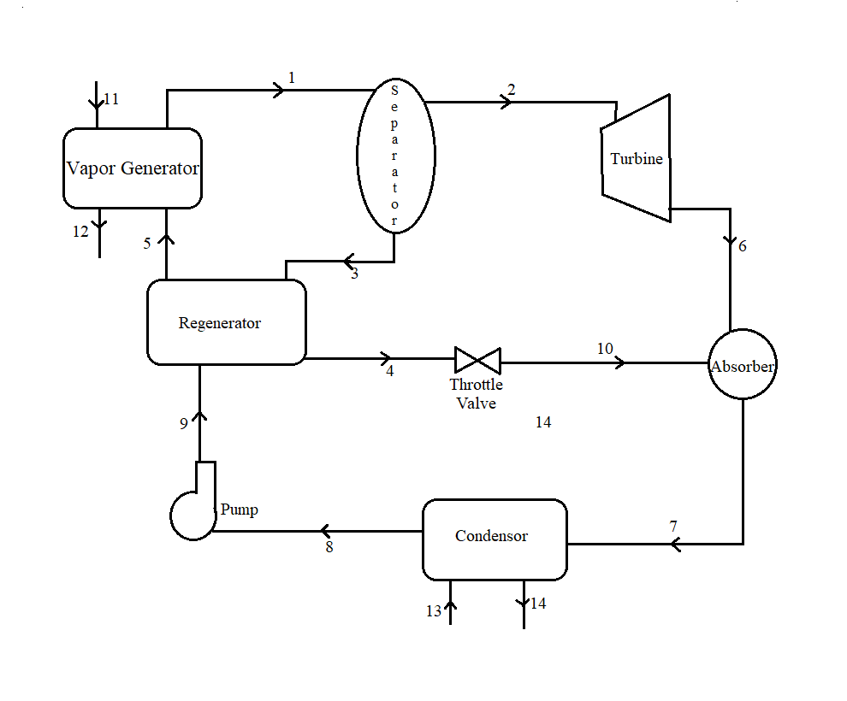

Figure 3-Schematic Diagram of Kalina Cycle

3.2) MATHEMATICAL MODEL

Mass Analysis and Energy analysis-

The mass balance equation for each component of the power cycle follows from the below written equation:
$\sum{min=\sum{mout} }$

The energy balance equation can be written as, neglecting kinetic and potential energy:
$\sum{\left(mh\right)in}-\sum{\left(mh\right)}out+Q – W$=0

For vapor generator –
m₁₁₌m_{12,} m₅=m₁
Q_{vg}=m₅(h₁-h₅) =m₁₁(h₁₁-h₁₂)

For separator –
m₁ = m₂ +m₃
m₁ h₁=m₂h₂+m₃h₃

For turbine-
m₂=m₆
W_{tur}=m₂(h₂-h₆)

For mixer-
m₇= m₆+ m₁₀
m₇h₇=m₆h₆+m₁₀h₁₀
For throttle valve-
m₄=m₅
h₄ =h₅

For condenser-
m₈=m₇; m₁₃= m₁₄
Q_{con}=m₇(h₇-h₈) = m₁₃(h₁₄-h₁₃)

For pump-
m₉=m₈
W_{pum} = m₈(h₉-h₈)

For regenerator
m₄=m₃ ; m₅=m₉
Q_{reg}=m₄(h₃-h₄)=m₉(h₅-h₉)

Exergy Analysis-

Exergy destroyed for a system can be written as
I=X_{in}-X_{out}-W_{cv}+(1-$\frac{T0}{T1}$)Q₁
where
X_{i} = m_{i}(h_{i}-h_{o}-T(s_{i}-s_{o}) ; here o subscript represents the reference state property.

For vapour generator -
I_{vg}=(X₅-X₁)-(X₁₁-X₁₂)

For separator –
I _{sep} = X₁-(X₂+X₃)

For turbine-
I _{tur}=(X₂-X₆)W_{tur}

For mixer-
I _{mix =} X₆+X₁₀ - X₇

For throttle valve-
I _{tv} = X₄ -X₅

For condenser-
I_{con}=(X₇-X₈)+(X₁₃-X₁₄)

For pump-
I_{pum} = (X₈-X₉)+W_{pum}

For regenerator
I_{reg}=(X₃+X₉)-(X₅+X₄)

First law efficiency= W_{net}/Qs
where W_{net} = W_{tur}-W_{pum} ; Qs= Q_{vg}

Second Law efficiency = (X_{in} - $\sum{I}$ ₀)/ X_{in}
Where $\sum{I}$ is the sum of exergy loss and Xin the exergy input at vapour generator

3.3) RESULT AND DISCUSSION

To find the performance of the proposed cycle, the code has been developed in Engineering Equation Solver (EES) based on iterative methods using the mathematical model shown previously. The input parameters for the model are given below-

Parameters | Values | Unit
Reference Temperature, T_{o} | 303 | K
Reference Pressure, P_{o} | 101.3 | kPa
Temperature of heat source, T_{hs} | 393 | K
Temperature of cooling water, T_{cw} | 293 | K
Pressure of vapor generator, P_{vg} | 3500 | kPa
TER | 5 | -
Mass flow rate of heat source | 35 | kg/s
TTDvg | 5 | K
PPTDreg | 5 | K
PPTDvg | 5 | K
Mass fraction of ammonia, (x) | 0.75 | %
Isentropic efficiency of turbine,(η_{tur}) | 0.85 | %
Isentropic efficiency of pump, (η_{pump}) | 0.85 | %
Table 1- Mean Values of input parameters

Based on input parameters thermodynamic properties at different states are found using EES software, these are presented in the table below-
And different results such as anergy efficiency, exergy efficiency, net work output, work at turbine, work by pump, Irreversibility of components are calculated.
State | T (K) | h (kJ/kg) | m (kg/s) | s (kJ/kg-K) | x (%) | P(kPa)
1 | 383.0 | 787.968 | 5.705 | 2.651 | 0.75 | 3500
2 | 383.0 | 1440.301 | 2.491 | 4.272 | 0.9819 | 3500
3 | 383.0 | 282.294 | 3.214 | 1.394 | 0.5703 | 3500
4 | 319.2 | -25.074 | 3.214 | 0.5235 | 0.5703 | 3500
5 | 360.3 | 196.866 | 5.705 | 1.199 | 0.75 | 3500
6 | 326.2 | 1306.950 | 2.491 | 4.344 | 0.9819 | 1167
7 | 329.6 | 556.589 | 5.705 | 2.196 | 0.75 | 1167
8 | 313.7 | 19.811 | 5.705 | 0.5266 | 0.75 | 1167
9 | 314.2 | 23.718 | 5.705 | 0.5285 | 0.75 | 3500
10 | 319.2 | -25.074 | 3.214 | 0.5269 | 0.5703 | 1167
11 | 393.0 | 505.466 | 35.00 | 1.523 | - | 3500
12 | 370.3 | 409.527 | 35.00 | 1.272 | - | 3500
13 | 293.0 | 83.301 | 30.50 | 0.294 | - | 101.3
14 | 317.2 | 184.359 | 30.50 | 0.6255 | - | 101.3

Table 2- Thermodynamic properties for proposed cycle

From the properties table-
Energy efficiency (ηI) is calculated to be 9.19 %.
Exergy efficiency (ηII) is calculated to be 50.76%.
Work output at Turbine (Wtur) is calculated to be 309.93 kW.
Net work output (Wnet) is calculated to be 332.22 kW.

The high energy and exergy efficiency is because of the varying boiling point of ammonia mixture. The loss of exergy in different components is shown next, which shows that the maximum exergy is destroyed in vapor generator followed by regenerator and condenser.
Component | Irreversibility | % Irreversibiity
Vapor Generator | 5187 | 89.31%
Separator | 3.62E-13 | 0.00%
Turbine | 54.31 | 0.95%
Absorber | 4.129 | 0.07%
Regenerator | 311.8 | 6.43%
Throttle Valve | 3.285 | 0.06%
Pump | 3.225 | 0.11%
Condenser | 7.22 | 3.09%
 | 5570.969 | 100.00%
Table 3- Irreversibility of all components in cycle.

Figure 4- T-S diagram for the proposed cycle

4. PARAMETRIC STUDY

4.1) Effect of Ammonia mass fraction on Cycle

Figure 5- Effect of Ammonia mass fraction on Work output and efficiency

On increasing the ammonia concentration (x), second law efficiency first increases then decreases with increase in Ammonia mass fraction, while first law efficiency increases throughout. The reason may be that for low values of x, the turbine irreversibility is high due to more entropy generation, resulting in low second law efficiency. For high values of x, the VG irreversibility is high, and it decreases with the increase of x.
Thus, the optimum value of x (Ammonia mass fraction at condenser output) can be calculated.

4.2) Effect of Turbine Expansion ratio on cycle

As the TER increases the working fluid expands more thus the increase in energy and exergy efficiency. TER value should be optimised further so that the capital required for the turbine can be minimised.

Figure 6- Effect of Turbine Expansion ratio on Work output and efficiency

4.3) Effect of Vapour Generator Pressure on cycle

Figure 7- Effect of Pressure in Vapour Generator on Work output and Efficiency

As the pressure in vapor generator increases energy efficiency almost remains constant while exergy efficiency increases. The net output decreases as the turbine expansion ratio is kept constant while the Pvg is increased so net loss in power output.

4.4) Effect of Temperature of heat source on cycle

Figure 8- Effect of Temperature of heat source on Work output and Efficiency

As the temperature of heat source increases the range of temperature in which the cycle works increases which increases the first law efficiency, but the exergy destroyed in vapor generator also increases which shows the reduction in exergy efficiency. This shows how the cycle would react to different heat sources such as parabolic or solar collectors.

4.5) Effect of Pinch point temperature at regenerator

As PPTDreg increases the heating curve and the boiling curve of ammonia-water mixture becomes far away so the heating becomes lesser efficient which is shown by decrease in energy and exergy efficiency.

Figure 9- Effect of Pinch point temperature at regenerator on work output and efficiency.

4.6) Effect of Turbine Inlet Pressure on cycle

Figure 10- Effect of Turbine Inlet Pressure on Work output and efficiency

As the turbine inlet pressure increases the energy efficiency decreases as the expansion ratio is same so turbine cannot take advantage of high pressures. The work required by pump also increases as the pump must pump to a higher pressure i.e., to the turbine pressure which can be seen by decrease in net work.

4.7) Effect of Pinch point temperature difference at Vapour Generator

Figure 11- Effect of Pinch point temperature difference at Vapour Generator on Work output and efficiency

As the pinch point temperature at vapor generator increases the heating efficiency decreases thus decreasing the work outputs. The effect on efficiencies is almost negligible.

REFERENCES

- Kalina I. A. Combined-cycle system with novel bottoming cycle. ASME Journal of Engineering Gas Turbine and Power 1984.
- Lolos PA, Rogdakis ED. A Kalina power cycle driven by renewable energy sources. Energy 2009.
- Sun F, Zhou W, Ikegami Y, Nakagami K, Su X. Energy-exergy analysis and optimization of the solar-boosted Kalina cycle system 11 (KCS-11). Renewable Energy 2014.
- Ghaebi H, Parikhani T, Rostamzadeh H. Energy, exergy and thermoeconomic analysis of a novel combined cooling and power system using low-temperature heat source and LNG cold energy recovery. Energy Conversion and Management 2017.
- Rostamzadeh H, Ghaebi H, Parikhani T. Thermodynamic and thermoeconomic analysis of a novel combined cooling and power (CCP) cycle, Applied Thermal Engineering 2018.
- Nag PK, Gupta AVSSKS. Exergy analysis of the Kalina cycle. Applied Thermal Engineering 1998.
- Ogriseck S. Integration of Kalina Cycle in a Combined Heat and Power Plant, A Case Study. Applied Thermal Engineering 2009.
- Rodríguez CEC, Palacio JCE, Venturini OJ, Lora EES, Cobas VM, Santos DMD, Dotto FRL, Gialluca V. Exergetic and economic comparison of ORC and Kalina cycle for low temperature enhanced geothermal system in Brazil. Applied Thermal Engineering 2012.
- Lin D, Zhu Q, Li X. Thermodynamic comparative analysis between ORC. and Kalina cycle. ICAE 2015.
- Bombarda P, Invernizzi C. M , Claudio Pietra C. Heat recovery from Diesel engines: A thermodynamic comparison between Kalina and ORC cycles
- Modi A, Haglind F. Thermodynamic optimisation and analysis of four Kalina cycle layouts for high temperature applications. Applied Thermal Engineering (2014).
- Shankar R. and Sriniwas T. Options in Kalina Cycle Systems. ICAER 2015.
- Ziegler B, Trepp C. Equation of state for ammonia–water mixtures. International Journal of Refrigeration 1984.

