A highly selective chromogenic probe
for Hg²⁺

Hossein Tavallali
Department of Chemistry
Payame Noor University, PNU
19395-4697 Tehran, Iran
tavallali@yahoo.com

Shiva Rajaei Dastghaib
Department of Chemistry
Payame Noor University, PNU
19395-4697 Tehran, Iran
shivarajaei@yahoo.com

Abstract
In this paper, indigo carmine (IC) was proposed as a highly accurate and sensitive colorimetric chemosensor for the determination and detection of mercury (II) (Hg²⁺), which is a very toxic and dangerous pollutant. The chromogenic probe (IC) in the aqueous medium shows a change of color from indigo to light blue in interaction with Hg²⁺. The linear range and detection limit of Hg²⁺ were 0.15-20.2 μM and 0.06 μM, respectively. Also, the relative standard deviation (RSD) based on ten replicates calculated for two different concentrations of 7.4 μM and 15.8 μM of Hg²⁺ was 2.1% and 1.4%, respectively. The proposed method has advantages such as: simplicity, low cost, high accuracy, wide linear concentration range, low limit of detection, high sensitivity and selectivity, without any separation and pre-concentration steps, can be used in neutral water media. The concentration of Hg²⁺ in tap water, mineral water and plasma samples can be easily detected and determined using this method. It should be noted that this ideal colorimetric chemosensor for Hg²⁺ is reported for the first time.
Keywords: chromogenic probe, chemosensor, Mercury (II) detection, Indigo Carmine (IC).

- Introduction
The development of selective and sensitive chemosensors is an important assignment for detecting transition metal ions, which play important roles in chemical, biological, medicinal, and environmental processes [1, 2]. Among them, the most toxic and ubiquitous heavy-metal ions of pollutants, Mercury ion (Hg²⁺) arising from a variety of natural and anthropogenic sources, has attracted a particular attention [3, 4]. Water-soluble divalent mercuric ion (Hg²⁺) can cause several serious diseases such as the brain damage, gastrointestinal system diseases, nephropathy and neurological diseases even at very low concentrations since they can easily enter the body through the skin or the esophagus [5, 6]. The United States Environmental Protection Agency (EPA) has set a maximum Hg²⁺ contaminant level in food and drinking water at 0.002 ppm (0.01 µM) [7].
Common methods for detecting Hg²⁺ include atomic absorption spectrometry (AAS) [8], inductively coupled plasma optical emission spectrometry (ICP-AES) [9], inductively coupled plasma mass spectrometry (ICP-MS) [10] and High-Performance Liquid chromatography (HPLC) [11] have been explored. These practices do not offer a cost-effective, rapid and real time-monitoring system for Mercury ions [12]. In this regard the colorimetric chemosensors are a powerful tool for the sensing of Mercury ions [13]. Therefore, development of simple colorimetric chemosensor that can selectively sense Hg²⁺ in aqueous media is significant.
Indigo carmine (3,3'-dioxo-2,2'-bis-indolyden-5,5'-disulfonic acid, IC) (scheme 1) is an available commercial dye with promising features that make it suitable for use as a chemosensor. Previously we have reported some spectroscopic applications of Indigo Carmine in the determination of some cations [14-16]. IC as a fluorescent and colorimetric chemosensor was used for the detection of Cu²⁺ and HPO₄²⁻ in H₂O/DMSO media [17].

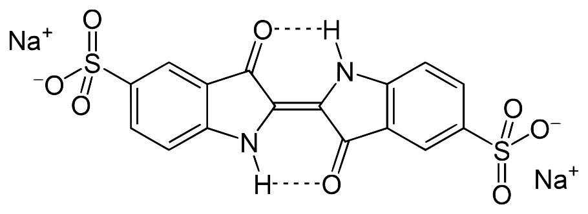
Scheme 1. Structure of IC.

- Experimental
- Chemical substances and reagents
All chemicals with analytical grade were purchased from Merck and used as soon as received. Indigo Carmine dye, di sodium salt, was used for preparing the solutions. The solution of Hg²⁺ and all cations, including Na⁺, K⁺, Mg²⁺, Ca²⁺, Sr²⁺, Ba²⁺, Fe²⁺, Fe³⁺, Co²⁺, Ni²⁺, Cu²⁺, Zn²⁺, Ag⁺, Cd²⁺, Pb²⁺ was prepared with its nitrate salt in deionized water.

- Apparatus
Shimadzu 1601 PC UV-Vis spectrophotometer with 10.0 mm diameter quartz cuvettes was used to record and measure all absorption spectra. Deionized water was used in the reference cell. A Jenway 3510 digital pH meter calibrated with two standard buffer solutions was used to measure pHs. Using a 50 μL Hamilton syringe, the desired amount of analyte solution was introduced into the cuvette.

- Measurement methods
Stock solutions of IC and Hg(NO₃)₂ were prepared with concentrations of 1.0 × 10⁻³ M and 1.0 × 10⁻² M in deionized water, respectively. Then, 3-540.0 µL of Hg(NO₃)₂ solution with a concentration of 0.1 mM was added to 2.0 mL of IC with a concentration of 25.0 µM. They were mixed and then the UV-vis spectra were taken at room temperature.

- Results and discussion

Different metal ions were added to the IC and the UV-vis absorption spectra were investigated. only Hg²⁺ showed a distinct spectral change at 610.0 nm and a color change from indigo to light blue. Other species like Na⁺, K⁺, Mg²⁺, Ca²⁺, Sr²⁺, Ba²⁺, Al³⁺, Cd²⁺, Sn²⁺, Pb²⁺, Bi³⁺, Ti²⁺, Cr³⁺, Mn²⁺, Fe²⁺, Fe³⁺, Co²⁺, Ni²⁺, Cu²⁺, Zn²⁺, Ag⁺, and Ce³⁺ did not show changes in the spectrum and color of IC solution (Fig.1).

(a)
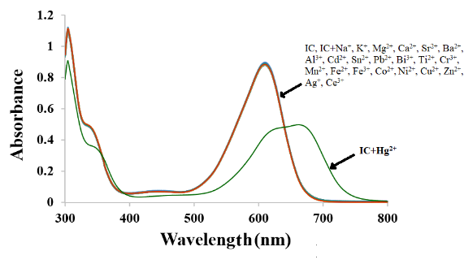
(b)
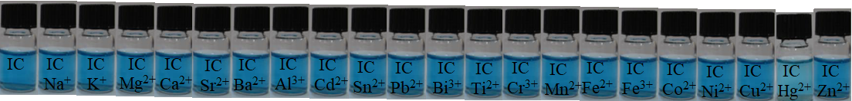
Fig. 1. (a) Absorption spectrum, (b) The color changes of IC (25.0 µM) with the different metal ions (1.0 equiv.) at 1.0 mM HEPES buffer solution (pH = 7.0) in aqueous media.

The interaction of IC with Hg²⁺ was studied by UV–vis titration (Fig. 2). Upon the addition of Hg²⁺ to IC, the absorption band at 610.0 nm gradually decreased and a new absorption band appeared at 666.5 nm. An obvious isosbestic point at 640.5 nm indicated the interaction between IC and Hg²⁺. The molar extinction coefficient of the peak at 610.0 nm is 3.58 × 10⁴ M⁻¹cm⁻¹ and the new peak at 666.5 nm is 4.36 × 10³ M⁻¹cm⁻¹, indicating a mercury-based d-d transition. Therefore, the blue color can be considered a metal-to-ligand charge transfer (MLCT) mechanism.

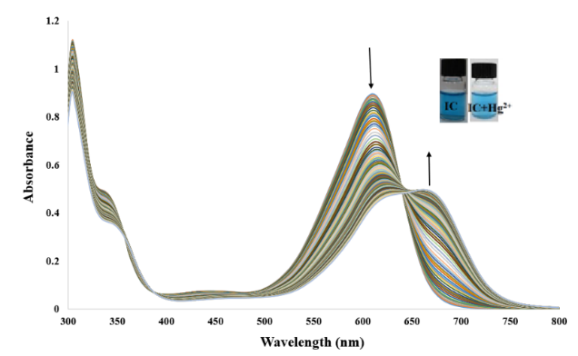

Fig. 2. UV–vis IC spectrum (25.0 μM) with stepwise addition of Hg²⁺ (0.15–21.26 μM) at pH = 7.0 (1.0 mM HEPES buffer solution) in aqueous media;
right inset: corresponding IC color change upon addition of 21.26 μM Hg²⁺ (left to right).

To determine the stoichiometry of IC binding with Hg²⁺, Benesi-Hildebrand analysis [18]. It was done using absorption titration data (Fig. 3). While suggesting that the complex formation between IC and Hg²⁺ has the stoichiometric ratio of 1:1 (Eq. 1). Based on the UV–vis titration data, the binding constant for IC with Hg²⁺ was estimated to be 2.77×10³ M⁻¹ from Benesi-Hildebrand equation.

Eq. 1 $\frac{1}{(A{-A}_{0})}=\frac{1}{{(A_{max}-A}_{0})}\left[\frac{1}{K_{ass}{\left[{Hg}^{2+}\right]}^{n}}+1\right]$

Fig. 3. Benesi-Hildebrand plot of IC (1/(A₀-A) change at 610.0 nm versus 1/[Hg²⁺] function) based on 1:1 binding stoichiometry with Hg²⁺.

In order to apply to the environmental systems, the pH dependence of IC in the absence and presence of Hg²⁺ was performed at different pH (2.5-12.6) (Fig. 4). In the pH range (2.5-7.0), IC showed no change without the presence of the Hg²⁺ ions. The increase of in absorption caused by the addition of Hg²⁺ ion was observed at pH 7.0. This result guarantees its use in environmental conditions (pH 5.2-9.0) without any change in Hg²⁺ detection. Therefore, pH 7.0 was chosen for all colorimetric measurements.

Fig. 4. Effect of the pH on the absorbance changes of IC (25.0 μM) in the absence and the presence of
Hg²⁺ (20.2 μM) at 610.0 nm in aqueous medium.

To evaluate the response time of the IC chemosensor to Hg²⁺, the interaction time of the IC sensor with Hg²⁺ is shown in Fig. 5. After adding Hg²⁺ to the standard IC solution, the reaction occurs within the first few seconds, and the adsorbance remains constant for the next 40 min and does not change significantly at 610.0 nm. Based on the above evidence, the IC sensor is able to detect Hg²⁺ in aqueous medium with a very very short response time.

Fig. 5. Time effect on the absorbance changes of IC (25.0 μM) in the presence of Hg²⁺ (20.2 μM)
at 610.0 nm during 40.0 min, at pH = 7.0 (1.0 mM HEPES buffer solution) in aqueous media.

There is a linear relationship between UV–vis absorbance and Hg²⁺ concentration in the range of 0.15–17.36 μM. The regression equation for the data is A_{610.0} = 0.8766–0.025C_{Hg} (μM), which is an acceptable perfect linear relationship with R² = 0.9901 (Fig. 6). The limit of detection (3δ/slope, δ: blank standard deviation) and the limit of quantification (10δ/slope) for the measurement of Hg²⁺ were calculated as 0.06 and 0.22 μM, respectively. The relative standard deviation for two concentrations of Hg²⁺, 7.4 and 15.8 μM (n = 10) was 2.1 % and 1.4 %, respectively.

Fig. 6. Linear proportional relationship between the absorbance of IC solution (25.0 μM) at 610.0 nm and Hg²⁺ concentration (μM), at pH = 7.0 (1.0 mM HEPES buffer solution) in aqueous medium.

The selectivity of IC during the detection of Hg²⁺ in the presence of metal cations was examined. As can be seen in Fig. 7, the presence of the above species in the media had no effect on the detection of Hg²⁺. Several studied species did not change the absorbance of the binary mixture of IC and Hg²⁺ (1:1) at pH = 7.0 in aqueous media. These results indicated that IC can be used as a potential chemosensor for the detection of Hg²⁺ with high selectivity.

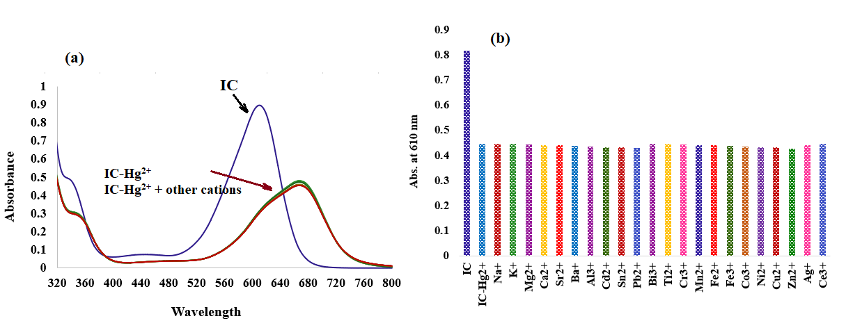
Fig. 7. Effect of coexisting substances on (a) Absorption spectrum, (b) absorbance of IC (25.0 μM) in the presence of Hg²⁺ (20.2 μM), at (1.0 mM HEPES buffer solution, pH = 7.0) in aqueous media.

To study the performance and application of the proposed method, different real samples were analyzed to further distiguish the effectiveness of the method. Due to the high sensitivity and selectivity, our method can be an achievement for the detection of Hg²⁺ in different samples. Since no amount of Hg²⁺ could be detected in the samples during the use of the sensor, recovery experiments with spiking Hg²⁺ were performed to validate the developed method. The samples were analyzed in triplicate and the relative standard deviation values in the recovery experiments indicate an acceptable level of precision for the proposed method. The obtained recovery values were satisfactory between 96.00 % and 103.90 %, which indicates the high accuracy and reliability of the present method. As mentioned in Table 1, it can be concluded that the proposed method is compatible and suitable for determining the concentration of Hg²⁺ in real samples. These results show that this chemosensor has a high potential for quantitative and qualitative analysis of Hg²⁺ in real samples.

Table. 1. Hg²⁺ recovery test in real samples at different spiking levels with our proposed method.
Sample  (n = 3) | Hg²⁺ (μM) |  | Average recovery (%) | Relative error (%)
 | Amount added | Amount found
Tap water | 0.00 | - | - | -
 | 4.00 | 3.98 ± 0.02 | 99.50 | -0.50
 | 8.00 | 8.31 ± 0.05 | 103.90 | 3.00
 | 10.00 | 10.15 ± 0.03 | 101.50 | 3.88
Mineral water | 0.00 | - | - | -
 | 4.00 | 3.95 ± 0.03 | 98.75 | -1.25
 | 8.00 | 8.08 ± 0.02 | 101.00 | 1.00
 | 10.00 | 9.76 ± 0.04 | 96.00 | -2.40
plasma | 0.00 | - | - | -
 | 4.00 | 4.01 ± 0.04 | 100.25 | 0.25
 | 8.00 | 8.06 ± 0.05 | 100.75 | 0.75
 | 10.00 | 10.10 ± 0.06 | 101.00 | 0.06

- Conclusion
In summary, we introduced a highly sensitive colorimetric chemosensor that provides the detection as well as determination of Hg²⁺ as an important toxic and hazardous pollutant with excellent selectivity and accuracy in aqueous media. More importantly, this sensor enables the detection of trace concentrations of Hg²⁺ qualitatively at room temperature. The high selectivity of the developed sensor for Hg²⁺ in the presence of different cations enables detection and determination of Hg²⁺ in complex matrices of samples. Compared to other methods, the proposed method has advantages such as simple, fast, without separation and pre-concentration, low costs, high accuracy, wide linear range of concentrations, low detection limit, high sensitivity, compatibility, and excellent selectivity. Therefore, these results indicate that IC may contribute to the development of a chemosensor to detect Hg²⁺ using a colorimetric method in an aqueous solution.

References

- B. Kaur, N. Kaur, S. Kumar, “Colorimetric metal ion sensors – A comprehensive review of the years 2011–2016,” Coord. Chem. Rev., vol. 358, pp. 13-69, 2018.
- G. Guzzi, A. Ronchi, P. Pigatto, “Toxic effects of mercury in humans and mammals,” Chemosphere, vol. 263, pp. 127990, 2021.
- H.F. Cheng, Y.A. Hu, “Mercury in municipal solid waste in China and its control: a review,” Environ. Sci. Technol., vol. 46, pp. 4695-4696, 2012.
- D. Naftz, C. Angeroth, T. Kenney, B. Waddell, N. Darnall, S. Silva, C. Perschon, J. Whitehead, “Anthropogenic influences on the input and bio-geo-chemical-cycling of nutrients and mercury in Great Salt Lake, Utah USA,” Appl. Geochem., vol. 23, pp. 1731-1744, 2008.
- T. Takeuchi, N. Morikawa, H. Matsumoto, Y. Shiraishi, “A pathological study of Minamata disease in Japan,” Acta Neuropathol., vol. 2, pp. 40-57, 1962.
- V. Bhardwaj, V.M. Nurchi, S.K. Sahoo, “Mercury toxicity and detection using chromo-fluorogenic chemosensors,” Pharmaceuticals, vol. 14, pp. 123, 2021.
- Mercury Update: Impact on Fish Advisories, EPA Fact Sheet EPA-823-S2-01-011, EPA, Office of Water, Washington, DC, 2001.
- C. Yu, “Interference from soluble iron on mercury determination in water by cold vapor atomic absorption spectrometry (CV-AAS) with sodium borohydride as reductant,” Anal. Sci., vol. 37, pp. 1181-1184, 2021.
- M. Faraji, Y. Yamini, M. Rezaee, “Extraction of trace amounts of mercury with sodium dodecyle sulphate-coated magnetite nanoparticles and its determination by flow injection inductively coupled plasma-optical emission spectrometry,” Talanta, vol. 81, pp. 831-836, 2010.
- G. Chen, H.W. Chen, X.Z. Jin, H.T. Chen, “Determination of ultra-trace amount methyl-, phenyl- and inorganic mercury in environmental and biological samples by liquid chromatography with inductively coupled plasma mass spectrometry after cloud point extraction preconcentration,” Talanta, vol. 77, pp. 1381-1387, 2009.
- Z.B. Gao, X.G. Ma, “Speciation analysis of mercury in water samples using dispersive liquid-liquid microextraction combined with high-performance liquid chromatography,” Anal. Chim. Acta, vol. 702, pp. 50-55, 2011.
- L.N. Suvarapu, S.O. Baek, “Recent studies on the speciation and determination of mercury in different environmental matrices using various analytical techniques,” Int. J. Anal. Chem., Vol. 2017, pp. 1-28, 2017.
- A. Loredo, L. Wang, S. Wang, H. Xiao, “Single atom switching as a general approach to designing colorimetric and fluorogenic probes for mercury ions,” Dyes Pigm., vol. 186, pp. 109014, 2021.
- H. Tavallali, E. Shaabanpur, P. Vahdati, “A highly selective optode for determination of Hg (II) by a modified immobilization of indigo carmine on a triacetylcellulose membrane,” Spectrochim. Acta A Mol. Biomol. Spectrosc., vol. 89, pp. 216-221, 2012.
- A. Massoumi, H. Tavallali, “Kinetic Spectrophotometric Determination of Vanadium by Catalytic Effect on the Indigo Carmine-Bromate Reaction,” Anal. Lett., vol. 31, pp. 193-206, 1998.
- H. Tavallali, A. Massoumi, “Simultaneous kinetic spectrophotometric determination of vanadium(V) and iron(III),” Talanta, vol. 47, pp. 479-485, 1998.
- H. Tavallali, G.Deilamy-Rad, A. Moaddeli, K. Asghari, “Indigo Carmine-Cu complex probe exhibiting dual colorimetric/ fluorimetric sensing for selective determination of mono hydrogen phosphate ion and its logic behavior,” Spectrochim. Acta A Mol. Biomol. Spectrosc., vol. 183, pp. 319-331, 2017.
- H. A. Benesi, J. H. Hildebrand, “A spectrophotometric investigation of the interaction of iodine with aromatic hydrocarbons,” J. Amer. Chem. Soc., vol. 71, pp. 2703-2707, 1949.

