Viscoelastic properties of Protein-Stabilized Emulsions and applications in various directions
Shreya Hari*
*Research scholar, Jadavpur University, Kolkata-700032

Abstract

Protein-stabilized emulsions have unique structural and functional properties and thus have a significant attention in various industries. The viscoelastic behavior of these emulsions plays a crucial role in determining their stability, rheology, and applicability in diverse applications such as food, pharmaceuticals, and cosmetics. The basic principles of emulsion stabilization using different types of proteins and their adsorption mechanisms at the oil-water interface are very interesting such as casein protein stabilized emulsions and whey protein stabilized emulsions. The several factors influencing the viscoelastic properties of these emulsions such as the concentration and type of protein, emulsification methods, pH, ionic strength, and temperature. The interplay between these factors and their effect on the mechanics of emulsions is of great interest to the researcher. Special attention is given to the implications for the design of emulsion-based food products, drug delivery systems, and personal care formulations. The applications of protein-stabilized emulsions are also important, emphasizing the connection between their viscoelastic properties and functionality in real-world products.

In conclusion, this chapter integrates the current understanding of the viscoelasticity of protein-stabilized emulsions, highlights the key factors influencing their rheological behavior, and sheds light on their applications in various industries. It not only serves as a valuable reference for researchers and practitioners in the field but also identifies critical knowledge gaps that require further investigation to advance the field of protein-stabilized emulsions. Finally, this chapter aims to provide a comprehensive analysis of the current state of knowledge on the viscoelasticity of protein-stabilized emulsions.

Introduction
Viscoelasticity defines as a property that is a combination of both viscous and elastic charectistics. To determine he stability and functionality of protein-stabilized emulsions viscoelastic properties play crucial role. Protein-stabilized emulsions display a complex rheological response, demonstrating sensitivity to shear rates and time-dependent deformation. The viscoelasticity arises from the protein’s ability to adsorb and rearrange at the oil-water interface, forming viscoelastic networks that resist flow and maintain purity of the structural conformation .This phenomenon is influenced by factors such as protein concentration, molecular weight, and conformational changes induced by environmental conditions. Understanding the viscoelastic properties of protein-stabilized emulsions is crucial for optimizing their formulation and application in various industries, including food, pharmaceuticals, and cosmetics. It allows for tailoring emulsion structure and stability, which ultimately impacts product texture, shelf life, and performance. These insights facilitate the design of novel protein-based emulsifiers, advancing the development of sustainable and functional emulsion systems.

Emulsions and Protein Stabilization
- Emulsion:
Emulsions are colloidal systems consisting of two immiscible liquids. In emulsions one liquid is dispersed as tiny droplets throughout the other . The most common example of emulsions are oil in water and water in oil .In contrast, a W/O emulsion features water droplets dispersed in oil, as seen in butter or mayonnaise. Emulsifiers are used to stabilize these mixtures by preventing the droplets from coalescing. Emulsions are mainly used for industrial purpose such as food , cosmetics and pharmaceutical.
- Emulsifiers:
Emulsifiers mainly used for stabilizing emulsions by reducing the interfacial tension between immiscible liquids, allowing them to form and maintain a stable mixture. By adsorbing at the oil-water interface, emulsifiers form a protective layer around the dispersed droplets, preventing coalescence and enhancing long-term stability. An example is lecithin, a common emulsifier found in mayonnaise. Lecithin’s hydrophilic and hydrophobic regions help it interact with both water and oil phases, creating a stable emulsion and preventing separation of the ingredients over time.

- Proteins as emulsifiers:
Proteins serve as exceptional emulsifiers due to their stability-enhancing abilities. As amphiphilic molecules, proteins possess both hydrophobic and hydrophilic regions which allows them to interact effectively with both oil and water phases in an emulsion. This results in the formation of stable and uniform mixtures, preventing phase separation and increasing shelf life. advantage of using proteins as emulsifiers is their natural origin, making them safe and suitable for various applications in the food, pharmaceutical, and cosmetic industries. Furthermore, proteins can undergo modifications or be combined with other ingredients to tailor their emulsifying properties to specific needs. Moreover, proteins stabilize emulsions by forming a protective layer around droplets, shielding them from coalescence and flocculation. This property is especially valuable in challenging conditions like high temperatures or extreme pH levels.

Viscoelasticity
- Definition:
Viscoelasticity is a material's property that exhibits both viscous and elastic behavior when subjected to stress. This unique characteristic arises from the material's ability to store energy when deformed and dissipate it over time.
- Properties of viscoelasticity:
- Time-dependent response: Unlike purely elastic materials, viscoelastic substances displaystime-dependent stress-strain behavior. The response depends not only on the applied stress but also on the rate and duration of loading.
- Stress relaxation: When subjected to a constant strain, a viscoelastic material experiences a gradual decrease in stress over time. This phenomenon is known as stress relaxation.
- Creep: Conversely, under a constant applied stress, the material's strain increases progressively with time. This phenomenon is termed creep.
- Hysteresis: During cyclic loading, viscoelastic materials show hysteresis, where the area between the loading and unloading curves represents energy dissipation as heat.
- Frequency dependence: Viscoelasticity is often sensitive to the frequency of the applied stress, with different responses observed at varying rates of deformation.
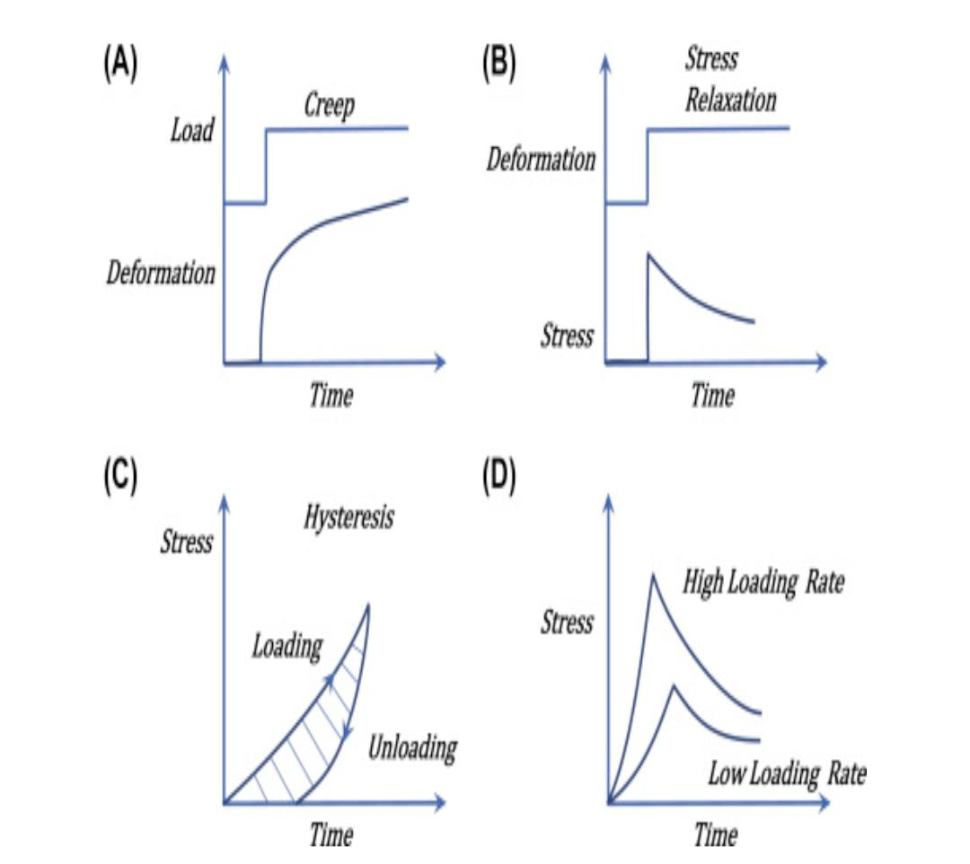

Importance of studying viscoelastic properties
- Rheology:
Rheology is the scientific study of determinimg flow and deformation of different materials under the influence of external forces or stress. It investigates the mechanical properties of substances and their responses to applied forces, such as viscosity, elasticity, and plasticity. Nowadays Rheology is crucial in various industries, including manufacturing, pharmaceuticals, and food processing, where the behavior of materials during processing or use is critical. By characterizing the flow and deformation behavior, engineers and researchers can optimize processes, ensure product quality, and design new materials with desirable properties. Hence rheology plays a fundamental role in shaping the development and application of numerous materials across various fields.
- The impact of viscoelasticity on the stability and texture of the emulsions:
Viscoelasticity plays a crucial role in the stability and texture of emulsions. Emulsions are mixtures of immiscible liquids, and their stability relies on phase separation. Viscoelastic substances exhibit both liquid-like flow and solid-like elasticity, allowing them to act as efficient emulsifiers and stabilize the dispersed phases. The viscoelasticity of the continuous phase influences droplet coalescence and creaming, impacting the emulsion’s long-term stability. Moreover, it influences the emulsion’s texture, influencing attributes like creaminess, mouthfeel, and spreadability. Controlling viscoelastic properties through the addition of stabilizers or emulsifiers can help optimize emulsion stability and texture, making them desirable in various industries, including food, cosmetics, and pharmaceuticals.

- Influence on sensory perception and mouthfeel in food products:
Sensory perception and mouthfeel play crucial roles in determining the overall consumer experience of food products. Sensory perception involves the ability to detect and interpret various properties such as taste, aroma, texture, and appearance. These charectistics collectively contribute to the flavor profile of the food.On the other hand , Mouthfeel refers to the physical sensations sunch ascreaminess, crispiness, viscosity, and astringency ,experienced in the mouth during consumption.
The influence of sensory perception and mouthfeel on food products is multifaceted. Texture modifiers like emulsifiers and stabilizers can enhance creaminess and prevent ingredient separation, while the addition of certain spices and flavorings impacts taste and aroma. Proper cooking techniques can create desirable textures and colors, enhancing visual appeal. The temperature of a food can influence its perceived taste and mouthfeel, for example, cold desserts feel refreshing.
Balanced sensory attributes make the eating experience pleasurable, which in turn impacts the acceptance of the product by the consumers and product success in the market. Food producers must carefully consider ingredient selection, processing methods, and packaging to create a harmonious blend of sensory characteristics that cater to consumer preferences.

Measuring Viscoelastic Properties
- Rheological Techniques:
Rheological techniques are vital for characterizing material behavior under various conditions. Stress/Strain curves evaluate how a material responds to applied stress, revealing its elastic and viscous properties. Oscillatory shear measures complex modulus, yielding insights into viscoelastic behavior, storage and loss moduli, and phase angle. Creep tests analyze a material's response to constant stress over time, indicating its viscoelastic creep compliance and relaxation behavior. These techniques aid in understanding the flow, deformation, and mechanical properties of materials, such as polymers, fluids, and soft solids. The data obtained from these tests are crucial for applications in various industries, including cosmetics, food, pharmaceuticals, and polymer processing, guiding material selection and optimizing product formulations.

- Characterization of storage (G') and loss (G'') moduli:
Storage modulus (G') and loss modulus (G'') are rheological properties used to characterize viscoelastic materials. G' represents a material's ability to store elastic energy, measuring its stiffness or solid-like behavior. It quantifies the material's resistance to deformation and is higher in solids. G'' represents the material's ability to dissipate energy as heat, indicating its viscous or liquid-like behavior. It is higher in liquids. Together, G' and G'' describe a material's viscoelasticity, where the ratio of G'' to G' indicates its damping behavior. These moduli are crucial for understanding and engineering materials in various fields, including polymers, foods, and biomedical applications.

- Frequency sweep analysis for studying linear viscoelastic regions :
Frequency sweep analysis is a technique used in rheology to study the linear viscoelastic behavior of materials. It involves subjecting a material to sinusoidal oscillations at various frequencies while measuring its response. The resulting data, typically storage modulus (elastic behavior) and loss modulus (viscous behavior) as functions of frequency, help identify the linear viscoelastic regions. In these regions, the material’s response is proportional to the applied stress or strain, and the effects of molecular relaxation dominate. Researchers can determine the material’s dynamic properties, such as its stiffness and damping, which are crucial for understanding and designing various products, such as gels, polymers, and biomaterials.

Factors Affecting Viscoelastic Properties
Viscoelastic property plays very important role in understanding the rheological behavior of emulsions . Several factors significantly influence the viscoelastic properties of emulsions:
- Concentration and type of protein emulsifier: The concentration of the emulsifiers affect the interfacial tension between the oil and water phases, impacting the stability and viscoelasticity of the emulsion. Caseins and whey proteins can act as emulsifiers and form viscoelastic films at the oil-water interface. These types of protein used can affect the thickness and stability of the interfacial phases, directly impacting the viscoelastic behavior of the emulsion.
- Droplet size and distribution within the emulsion: Droplet size is inversely proportional to the viscoelasticity of the emulsions. Smaller droplets produces a larger interfacial area, increasing the efficiency of emulsifiers in stabilizing the emulsion. A more uniform droplet size distribution also contributes to the overall viscoelastic properties.
- Temperature: viscoelasticity depends on temperature in both the continuous phase and the dispersed droplets. It can affect the mobility of the emulsifier molecules at the interface.temperature difference leads to phase transitions, phase separation, changing the viscoelasticity of the emulsion.
- pH conditions: The pH of the emulsion affects the charge of the emulsifier molecules and the droplet surfaces. At certain pH levels, emulsifiers may become less effective, leading to reduced stability and cause change in viscoelastic properties. Additionally, pH can influence protein conformation and interactions at the interface, further impacting viscoelastic behavior.
the interconnection between these factors is essential for controlling the viscoelastic properties of emulsions, which can significantly impact the stability, texture, and mouthfeel of emulsion-based products in various industries. Researchers and formulators must carefully consider these factors during the emulsion design process to achieve desired viscoelastic properties and product performance.

Applications of Protein-Stabilized Emulsions
Protein-stabilized emulsions have various applications across industries, including the food industry, pharmaceutical industry, and personal care sector. Their unique properties make them ideal for a range of applications.
- In the food industry, protein-stabilized emulsions are commonly used in the production of mayonnaise, dressings, and sauces. The proteins form a protective layer around oil droplets, preventing their coalescence and ensuring a stable, creamy texture. This enhances the overall sensory appeal and shelf life of these products.
- In the pharmaceutical industry, these emulsions serve as effective drug delivery systems. Encapsulating drugs within protein-stabilized emulsions allows for controlled release and targeted delivery, improving drug efficacy and reducing potential side effects.
- The personal care sector protein-stabilized emulsions are mainly used in the formulation of cosmetics and creams. These emulsions provide smooth textures, enhanced spreadability, and improved stability of active ingredients. Products like lotions, moisturizers, and sunscreens benefit from this technology, as it ensures even distribution and long-lasting effects on the skin.
Hence we can say that protein-stabilized emulsions play a vital role in enhancing the quality, stability, and performance of products in the food, pharmaceutical, and personal care industries. As research in the field continues, further applications and innovations are expected to emerge, driving advancements in these sectors.

Influence of different Protein Types
- Different proteins result in distinct viscoelastic properties:
The unique sequences and structures of different proteins result in distinct viscoelastic behaviors.
- Certain proteins such as elastin, provide high elasticity due to their ability to stretch and recoil. So these proteins are ideal for tissues requiring flexibility, such as blood vessels and skin. On the other hand proteins like collagen imparts strong resistance to tensile forces, contributing to the structural integrity of tissues like tendons and bones.
- Globular proteins , such as actin and myosin in muscle cells, portrays viscoelastic behavior when undergoing reversible conformational changes during muscle contraction and relaxation. These proteins create the unique ability of muscles to be both elastic and resist deformation during movement.
So it can be said the specific sequence, structure, and function of proteins contribute to the diverse viscoelastic properties observed in biological materials, enabling them to fulfill various mechanical roles within organisms.

- Casein-based emulsions vs. whey protein-based emulsions:
Property | Casein-based Emulsions | Whey Protein-based Emulsions
Protein Source | Casein | Whey Protein
Heat Stability | Excellent | Good
Viscosity | High | Low
Creaminess | Creamy | Less Creamy
Sensory Profile | Smooth, Rich | Light, Clean
Acid stability | Excellent | Limited
Digestibility | Slow | Fast
Application | Dairy products and sauces | Beverages dressing

- Implications for product formulation and stability:
Product formulation and stability are critical aspects of product development in various industries like pharmaceuticals, cosmetics, and food e.t.c . The formulation determines the composition and proportions of ingredients, impacting product efficiency and safety. Product Stability refers to the ability of a product to maintain its desired properties over time and under various conditions. Poor formulation or instability can lead to reduced shelf life, compromised quality, and potential hazards to consumers. It can also result in financial losses and damage to a brand's reputation. Proper understanding of the raw materials, manufacturing processes, and environmental factors is essential for ensuring product efficacy, safety, and longevity. Regular testing, quality control measures, and ongoing research are vital to address and prevent formulation and stability issues effectively.

Case Study: Mayonnaise
- Mayonnaise formulation and emulsion stability:
Mayonnaise is a stable emulsion comprising oil, water, egg yolks, vinegar, or lemon juice, and seasonings. Mayonnaise shows semisolid and viscoelastic behaviour oas it has high oil content, from 50% to 80% by weight. The emulsion stability is primarily governed by the balanced interaction between the hydrophilic and hydrophobic components. Egg yolk acts as an emulsifier, forming a protective layer around oil droplets, preventing coalescence. Vinegar or lemon juice contributes acidity, aiding in protein denaturation, further stabilizing the emulsion. The addition of water and careful, gradual blending of oil with other ingredients facilitate the emulsification process. To maintain stability, it is crucial to control temperature, pH, and ingredient quality. Proper storage at a cool temperature prevents phase separation and syneresis. Additionally, the use of stabilizers like mustard or xanthan gum enhances emulsion stability, ensuring a smooth, creamy texture and prolonged shelf life.
- Impact of egg protein vs. plant-based protein stabilizers:
In Mayonnaise, the proteins act as emulsifiers which help to create a stable mixture by preventing the oil and water from separating. Nowadays, there has been an increased interest in plant-based alternatives to egg-based stabilizers in mayonnaise, especially to cater to dietary restrictions and preferences. Here's some facts to compare between the impact of egg protein and plant-based protein stabilizers on mayonnaise
- Egg Protein Stabilizers:
the main ingredient of traditionally made mayonnaise is egg yolks, which contain a natural emulsifier called lecithin. This Lecithin helps to stabilize the emulsion by forming a protective layer around the oil droplets which prevents from coalescing and separating from the water phase. due to the presence of egg fats mayonnaise with egg yolks tends to have a richer flavor and a creamier texture and emulsifying properties of lecithin. But the only problem with egg-based mayonnaise is that it is not suitable for individuals with egg allergies or those following a vegan diet.
- Plant-Based Protein Stabilizers:
in mayonnaise Various plant-based proteins such as soy protein, pea protein, and mustard seed protein e.t.c. can be used as emulsifiers. Among them Soy-based mayonnaise is one of the most widely consumed plant-based alternatives on the market. The Plant-based mayonnaise is suitable for vegans and individuals with egg allergies, making it a valuable option for those with dietary restrictions. It can have a different mouthfeel and taste compared to traditional mayonnaise. Some people may find it slightly less creamy or may notice a different aftertaste which depends on the specific plant protein used and the manufacturing process.
Hence the choice between egg protein and plant-based protein stabilizers in mayonnaise depends on various factors ,including consumer preferences, dietary restrictions, desired texture and flavor e.t.c. though both options have their advantages and disadvantages, the manufacturers often use various additives and processing techniques to optimize the final product. For consumers who are concerned about the use of stabilizers, it’s always best to check the product label for the specific ingredients used in a particular mayonnaise brand. As the popularity of plant-based diets continues to grow, the market for plant-based mayonnaise is likely to expand, offering more diverse and improved options for consumers.
- Effects of viscoelasticity on texture and mouthfeel:
Viscoelasticity plays a crucial role in determining the texture and mouthfeel of mayonnaise. mayonnaise exhibits both viscous and elastic properties under deformation due to its viscoelastic properties. Due to the presence of emulsifiers, such as lecithin, Mayonnaise gets it's unique texture . The viscoelastic nature affects the spreadability, creaminess, and it's mouth-coating sensation. Higher viscoelasticity leads to a thicker and more cohesive texture, enhancing the perception of richness and creaminess. This smoothness enhances the mouthfeel, making it feel velvety and luscious. viscoelasticity also influences how mayonnaise flows on the palate and interacts with other food components, affecting the overall sensory experience. Controlling viscoelasticity is crucial in product development, as it directly impacts consumer acceptance and preference for mayonnaise, ensuring a desirable texture and mouthfeel in the final product.

Future Trends and Research Opportunities:
Nowadays the understanding of protein-stabilized emulsion behavior in various industries increasing for the requirement of stable emulsions . So there is a growing need to enhance our understanding of how proteins function as emulsifiers. Future research should focus on unraveling the molecular interactions and mechanisms that govern the stabilization of emulsions by proteins. This will help in the further development of novel emulsification techniques and the design of more efficient and stable emulsion systems.
- Tailoring viscoelastic properties for specific applications: Viscoelastic properties play an important role in the functionality and performance of many materials such as gels, foams, and biomaterials. The Future trends involve customizing these properties suitable for specific applications, such as in tissue engineering, drug delivery, and food texture modification. The Advanced research should focus on innovative techniques to control and manipulate the viscoelastic behavior of materials, exploring novel additives and processing methods to achieve desired properties for different industrial sectors.
- Exploring new protein sources and advanced characterization techniques: As the world faces challenges related to sustainability and resource scarcity, exploring alternative protein sources beyond conventional ones (e.g., soy, whey, and casein) is critical. The Future research should help to investigate proteins from non-traditional sources including algae, insects, and single-cell organisms. Advanced characterization techniques, such as proteomics and structural biology, will also help in understanding the functional properties and interactions of these proteins, opening doors to novel applications in food technology, biomaterials, and biotechnology.
So, future research in the fields of protein-stabilized emulsions, viscoelastic materials, and alternative protein sources should focus on advancing our fundamental knowledge and exploring cutting-edge techniques to address current and emerging challenges in various industries.

Conclusion
In conclusion, the protein-stabilized emulsions portrays intriguing viscoelastic characteristics that play a crucial role in product development and optimization. These properties, which result from the interplay of proteins at the oil-water interface, become immensely promising for numerous industries. By comprehending these viscoelastic behaviors, researchers and manufacturers can enhance the formulation and stability of emulsion-based products. Furthermore, the continuous advancements in understanding the science behind protein-stabilized emulsions are likely to pave the way for innovative applications in various sectors. This could lead to the development of novel materials, to improve delivery systems, and to enhance functionalities in existing products. Industries may find new methods to manipulate emulsions for tailored solutions, opening up opportunities for cost-effective and sustainable manufacturing processes. Hence, the potential benefits of unraveling the mysteries of protein-stabilized emulsions are vast and hold the key to significant progress and breakthroughs in multiple fields.

Bibliography
- Viscoelastic Properties of Protein-Stabilized Emulsions: Effect of Protein-Surfactant Interactions
Jianshe Chen and Eric Dickinson* ,Procter Department of Food Science, University of Leeds, Leeds LS2 9JT, United Kingdom , J. Agric , Food Chem , 1998, 46, 97-98
- Viscoelastic properties of sterically stabilised emulsions and their stability ;Tharwat Tadros ,89 Nash Grove Lane, Wokingham, Berkshire RG40 4HE, UK,2015
- Effects of temperature and pH on interfacial viscoelasticity, bulk rheology and tribological properties of whey protein isolate-stabilized high internal phase emulsions; Author Beibei Zhou , Stephan Drusch , Sean A. Hogan , Food Hydrocolloids , volume 142, September 2023, 108756
- Relationship between Rheology, Particle Size and Texture of Mayonnaise ; Kentaro MARUYAMA ,Toshiyuki SAKASHITA , Yoshio HAGURA and Kanichi SUZUK

Acknowledgement
I specially thank to all my professors of Department of chemistry, Sree Chaitanya College , Habra for guiding me throughout the project and helping me to gather important and essential informations. I would also like to thank all the non teaching staff and my fellow mates for their support and inspiration.

