Mapping of Soil Erodibility Factor (K) For central MPKV Campus Watershed
Kajal Bhausaheb Dhokale¹, B. K. Gvait², Suyog Balasaheb Khose³
¹M.Tech student, Department of Soil and Water Conservation Engineering, Mahatma Phule Krishi Vidyapeeth, Rahuri, 413722, Maharashtra, India.
²Deputy director of research, Mahatma Phule Krishi Vidyapeeth, Rahuri, 413722, Maharashtra, India.
³Research Scholar, Agricultural and Food Engineering Department, Indian Institute of Technology Kharagpur, Kharagpur, 721302, West Bengal, India.

Abstract
Soil is a complex mixture of minerals, organic materials, water, and living organisms covering the Earth's surface, exhibits varying degrees of susceptibility to erosion. The parameter used to quantify this susceptibility, known as the soil erodibility factor (K), is subject to fluctuations within a watershed due to distinct soil characteristics such as texture, structure, permeability, and organic matter content. It is the most important soil factor that cause the soil erosion. Soil erodibility influences the rate at which soil particles are detached and transported by erosive agents such as water and wind. This research endeavour was carried out within the central MPKV campus watershed, with the primary objective of determining the soil erodibility factor (K). For determination of soil texture and organic carbon, soil sampling was done and 51 soil samples were collected from points from the study area. The calculated soil erodibility factor (K) values were assigned to respective soil sample locations in soil map. This soil map was converted in grid format and then K factor map was generated using Inverse Distance Weighted (IDW) technique of interpolation in ArcGIS environment. The study revealed that the predominant soil type in the area was clay loam and sandy clay loam, comprising over 50% of the total area. The computed values for the soil erodibility factor ranged from 0.0396 to 0.0571 t-ha-h/ha-MJ-mm.
1. Introduction
Soil represents a multifaceted blend of minerals, organic substances, water, atmospheric gases, and a diverse range of microorganisms, collectively composing the uppermost layer of the Earth's crust (Anonymous, 2015). Soil degradation and erosion pose significant threats to agricultural productivity and food security. The state of Maharashtra loses about 773.5 million tonnes of soil every year due to erosion (Shejale et al., 2022). The soil erodibility factor (K) is linked to how rain, runoff and infiltration all work together to cause soil loss. Soil erodibility is the most important soil factor that cause the soil erosion. Soil erodibility plays a pivotal role in determining the pace at which soil particles are detached and conveyed by erosive forces, such as water and wind. This factor holds significant importance within soil erosion modeling frameworks, exemplified by the Universal Soil Loss Equation (USLE) and the Revised Universal Soil Loss Equation (RUSLE). These models, which have been instrumental in soil conservation planning since their introduction by Wischmeier and Smith, (1978). heavily rely on the parameter of soil erodibility. Soil erodibility also aids in identifying vulnerable areas and prioritizing erosion control measures (Sinshaw et al., 2021). Understanding its significance is vital for sustainable land use and environmental management.
In practice, K is the average long-term response of the soil and soil profile to the eroding power of rainstorms. It is the average annual value of the total response of the soil as well as soil profile to many erosion and water processes. The rate of soil erosion per rainy erosion index unit is used to figure out the K factor on a unit plot. The unit plot is 22.1m long and has a consistent slope of 9%. It is always kept in a clean-tilled waste state by tilling upslope and downslope (Wischmeier and Smith, 1978) Soil erodibility is a complicated property that is influenced by a wide range of interconnected parameters, but only some of these parameters can be linked to soil types (Veihe, 2002). So, the best way to get K-factors is to take readings directly on natural runoff plots. Long-term studies take a lot of time and money, though, so many people have tried to find a link between observed K-factor values and soil properties (Cohen et al., 2005). The most used and cited relationship is the soil erodibility nomograph (Wischmeier et al., 1971). Thus, understanding the significance of soil erodibility and the various assessment methods available is vital for sustainable land use and environmental conservation.
2. Materials and Methods
2.1. Study Area
The study area is the central MPKV campus watershed located in Rahuri taluka in Ahmednagar district of Maharashtra state, India. The location map of study area is shown in Figure 1. The study area is located between latitudes from 19° 21.77' N to 19° 18.73' N and longitudes from 74° 37.79' E to 74° 36.49’ E.
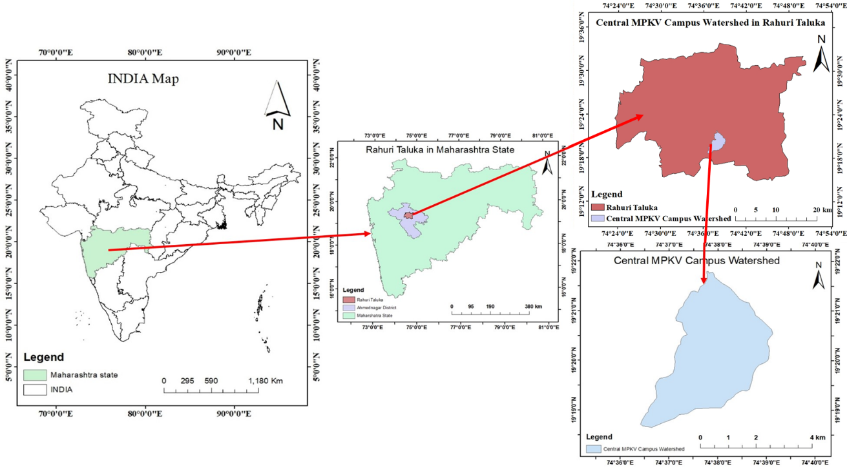
Figure 1. Location map of study area

2.2 Soil Erodibility (K) Factor
This factor pertains to the distinct soil characteristics that render a specific soil vulnerable to erosion, whether through water or wind forces. The soil erodibility factor (K) is quantified as the amount of soil loss, measured in tons per hectare, due to the erosive impact of rainfall on a field with a slope of 9% and a length of 22 meters, per unit of the rainfall erosivity index. To simplify the determination of this K factor, Wischmeier et al. (1971) devised an equation that relies on various soil parameters. A practical algebraic representation of this nomograph, which takes into account factors such as soil texture, structure, organic matter content, and permeability, was proposed by Wischmeier and Smith (1978) and later refined by Renard et al. (1997). This equation for estimating the soil erodibility factor (K) is outlined as follows,
K = $\frac{\{[2.1× 10-4 × M1.14 (12 -a) + 3.25 × (b-2) + 2.5× (c-3)] ×0.1317\}}{100}$ …(3.1)
Where,
K = Soil erodibility factor (t-ha-h/ha-MJ-mm),
M = (% silt + % very fine sand) × (100-% clay),
a = Organic matter content = Organic Carbon × 1.724,
b = Structural code of soil,
c = Permeability code of soil (determined from soil textural class).
The K factor is assessed on a scale ranging from 0 to 1, where a rating of 0 signifies soils with minimal susceptibility to water-induced erosion, while a rating of 1 denotes soils highly prone to erosion by water. In present study, the K factor was computed for watershed with the help of data obtained from soil analysis such as soil structure, soil texture, soil organic matter content and soil permeability. For determination of soil texture and organic carbon, soil sampling was done and 51 soil samples were collected from points shown in Figure 2 from the study area.
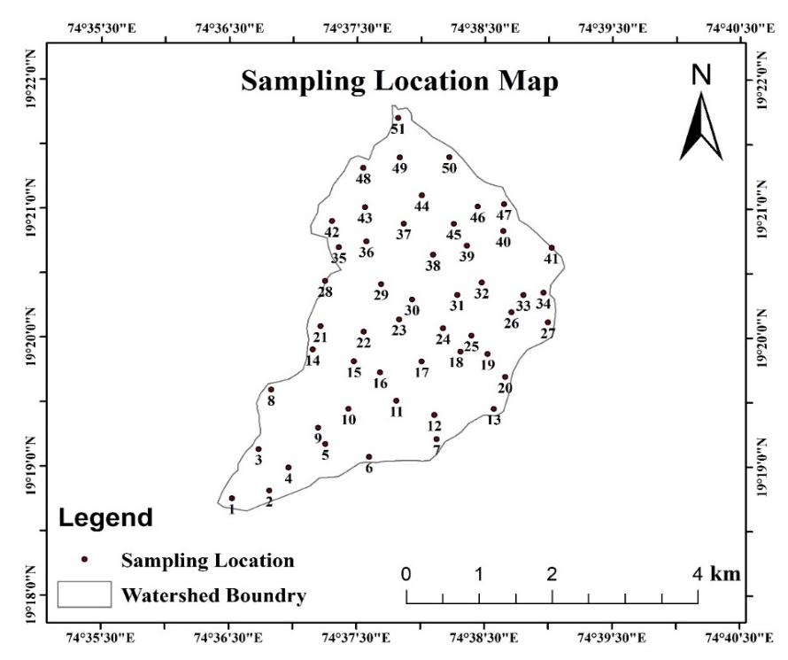
Figure 2. Sampling points location map
2.2.1. Soil Texture Determination
Soil texture refers to the inherent composition of a soil sample, which is determined by the relative proportions of sand, silt, and clay particles that constitute it. It is an inherent property of soil. The methodology adopted for determination of soil texture is discussed in this section. Texture analysis of soil samples was carried out by International Pipette method (Robinson, 1927; Kilmer and Alexander, 1949). The procedure is as follows:
- 20 gram of air-dried soil sample passed from 2 mm sieve in 500 ml capacity beaker.
- 100 ml of water was added in that beaker and it was stirred for 5 minutes.
- After adding 10 ml of 30% H₂O_{2,} it was boiled for 20 minutes by continuously swirling the suspension to reduce foaming.
- On adding 40 ml of Calgon solution again, it was boiled for 5 minutes and after cooling.
- The suspension was transferred through 70 mesh (0.2 mm) sieve to separate coarse sand by 1 litre capacity bottle.
- Coarse sand was transferred from sieve into pre-weighted aluminium or steel dish, extra water was then poured out from dish
- The dish with coarse sand was kept in oven for more than 105°C and weighted it (CS).
- 300 to 400 ml of water was added into the suspension left in the bottle and it was shaked for one hour on rotary shaker.
- Next day (morning) again, the bottle was shaked for 30 minutes and that suspension was transferred into measuring cylinder of 1 lit. capacity and volume were made 1 lit. by adding water, then temperature was recorded.
- Plung the solution with the help of plunger for 1 minute and kept for sedimentation for the time corresponding to the temperature of solution as per Table 2.1.
- After proper time international pipette was slowly immersed vertically into cylinder exactly up to the depth of 10 cm with the help of mechanical stand and 20 ml of fluid was pipette out into pre-weighted container dish and it was kept in an oven for drying. After drying, weights were taken again. Which gave the weight of silt + clay + Calgon solution (W1).
- After the first pipetting is over, the cylinder was kept undisturbed. The temp was measured and the sediment inside was set for the required time corresponding to the temperature. For clay separation as the time of sedimentation is over 20 ml of fluid was pipette out for clay separate in preweighted container and it was kept in oven for oven drying (W2).
- Decant the supernant fluid after every 4 minutes 48 second till the supernant liquid is very clear. Transferred the fine sand in preweighted container dish, kept it in oven for drying and weighted it (FS).
Calculation
Oven dry weight of calgaon solution of 40 ml (f) = 0.048 g/ 40 ml
% coarse sand = $\frac{CS}{20 g}×100$ … (3.2)
Per cent clay = $\frac{W2-(f)}{20 ml}×\frac{1000 \left(Vol. Made\right)}{1}×\frac{100 (\%)}{20 g}$ … (3.3)
Per cent silt = $\frac{W1-W2}{20 mL}×\frac{1000 }{1}×\frac{100 (\%)}{20 g}100$ … (3.4)
Per cent fine sand $=\frac{FS}{20 g}×100$ … (3.5)
Table 1. Sedimentation times for soil particles settling through a depth of 10 cm in water (Particle density 2.6 Mg m-³)
Temperature (°C) | Settling time with indicated particle diameter
 | 20 microns (Silt + Clay) | 2 microns (Clay)
 | Hour: Minute | Hour: Minute
20 | 4: 48 | 8:00
21 | 4: 41 | 7:49
22 | 4: 35 | 7:38
23 | 4: 28 | 7:27
24 | 4: 22 | 7:17
25 | 4: 16 | 7:07
26 | 4: 10 | 6:57
27 | 4: 04 | 6:48
28 | 4: 00 | 6:39
29 | 3: 55 | 6: 31
30 | 3: 49 | 6:22
31 | 3: 44 | 6:14
2.2.2. Soil Organic Carbon
The collected soil samples were then analysed to determine organic carbon in soil mechanics laboratory of SWCE department, Dr. Annasaheb Shinde College of Agricultural Engineering and Technology, MPKV, Rahuri. Organic carbon was determined by wet oxidation method of Walkley and Black Carbon Method (Nelson and Sommers, 1996) as follows;
- 1 gram of each soil samples were weighed and put in conical flasks (Take 2-3 blank reading i.e., reading without soil samples).
- Add 10 ml potassium dichromate and 20 ml concentrated sulphuric acid was added to each of them and kept undisturbed for 30 minutes.
- 200 ml distilled water was then added to each of them.
- Before titration added 3-4 drops of ferroin indicator.
- Titrated the content against 1 N Ferrous sulphate solution till colour changes from brown-green-blue to finally red.
- The burette reading was recorded and calculate the organic carbon by given formula.
Calculations
Organic matter content was calculated from organic carbon of soil by
Organic carbon= $\frac{(Blank-sample) ×Normality× (0.003×100)}{Weight of soil sample}$ …(3.6)
Correction Factor was taken as 1.3
Subsequently organic matter was calculated from organic carbon by following formula:
Organic matter = $organic carbon × 1.724$ …(3.7)
2.2.3. Soil Structural and Permeability Codes
The physical attributes of soil, such as its structure and permeability, are intrinsically linked to its textural composition. The soil structure, in particular, is a reflection of how individual sand, silt, and clay particles are organized within it. When these solitary particles amalgamate into larger groupings, they form what is referred to as aggregates. These aggregates can manifest in various patterns, thereby giving rise to different soil structures. To categorize these soil structures, codes are assigned based on soil texture classifications, as established by Schut and Denholm in 1993. This classification system is visually represented in Figure 3.
Soil permeability is primarily influenced by soil texture, representing its capacity to facilitate water flow. To assess soil permeability, it is common practice to reference permeability classes, as outlined in Anonymous (1983) and determined utilizing the SPAW model developed by Saxton and Rawals (2006) (see Figure 4). These permeability codes, which provide valuable insights into a soil's water passage characteristics, are presented in Table 2.
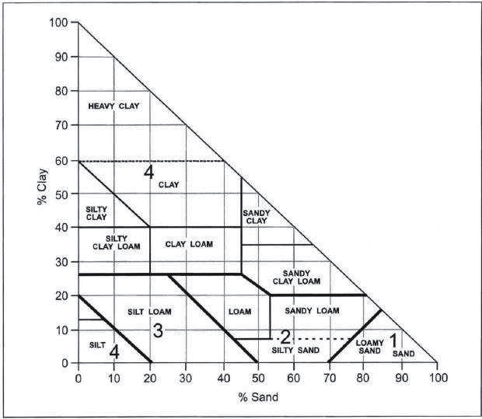
Figure 3. Soil structural code
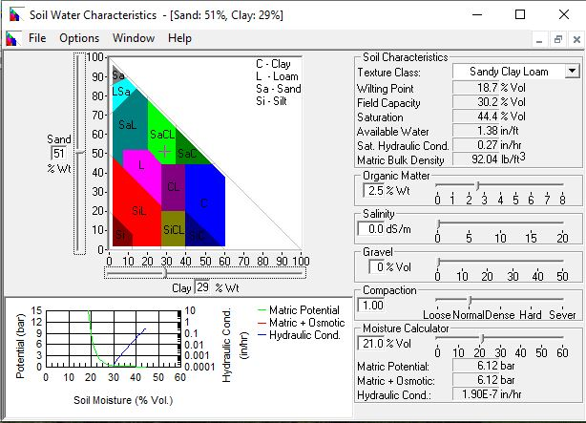
Figure 4. User interface of SPAW model
Table 2. Soil permeability code from soil texture class (National Soil Handbook USDA, 1983)
Soil texture | Permeability code
Heavy clay, clay | 6
Silty clay loam, sandy clay | 5
Sandy clay loam, clay loam | 4
Loam, silt loam | 3
Loamy sand, sandy loam | 2
sand | 1
2.2.4 Soil Erodibility Factor (K) Map
Soil erodibility reflects the soil's inherent properties that affect the capacity of the soil to resist or be displaced by erosive forces. There are a number of elements that affect how easily soil erodes, which depends on several factors such as soil texture, organic matter content, structure and permeability. The calculated soil erodibility factor (K) values were assigned to respective soil sample locations in soil map. This soil map was converted in grid format and then K factor map was generated using Inverse Distance Weighted (IDW) technique of interpolation in ArcGIS environment (Figure 3.1).
3. Results and Discussion
From soil textural analysis, it was found that central MPKV campus watershed has two major soil types: sandy clay loam, clay loam. The soil permeability codes for collected soil samples were taken from soil texture class as per the National Soil Handbook USDA, 1983 (Table 2.2). Soil permeability indirectly affect soil erodibility, as soils with high permeability may allow water to infiltrate more easily, reducing the amount of runoff and erosion. Soils that have high permeability rates tend to be less erodible than soils with low permeability. The soil structural codes determined based on soil textural classification (Ontario Centre for Soil Resource evaluation, 1993) (Figure 5). These selected permeability and structural codes were used for soil erodibility estimation.
Figure 5. Soil erodibility factor (K) map of watershed
In the context of the watershed under investigation, it is observed that various soil types exist, each exhibiting distinct erodibility characteristics. Specifically, the sandy clay loam soil type demonstrates the highest erodibility value, while the clay loam soil type exhibits the lowest erodibility value. Accordingly, K factor map of watershed was prepared using ArcGIS 10.3.1 environment using Inverse Distance Weighted (IDW) technique of interpolation (Figure 5). The generated maps of the soil erodibility factor (K) factor, shows the spatial variability within the watershed. The soil type, permeability code, structural code and soil erodibility were given in Table 3.
Table 3. Textural analysis of soil for K factor estimation
Sample No | % Coarse Sand | % Clay | % Silt | % fine Sand | OC | Textural Class | Permeability Code (c) | Structural Code (b) | K-Factor
1 | 38.12 | 32.50 | 28.70 | 27.49 | 0.68 | Clay Loam | 4 | 4 | 0.0479
2 | 39.44 | 29.33 | 30.57 | 28.08 | 0.66 | Clay loam | 4 | 4 | 0.0518
3 | 34.89 | 36.46 | 27.91 | 24.84 | 0.74 | Clay loam | 4 | 4 | 0.0428
4 | 32.53 | 33.00 | 33.50 | 23.49 | 0.98 | Clay loam | 4 | 4 | 0.0464
5 | 36.98 | 35.05 | 27.72 | 26.33 | 0.26 | Clay Loam | 4 | 4 | 0.0470
6 | 47.82 | 30.55 | 21.18 | 34.05 | 0.45 | Sandy Clay Loam | 4 | 4 | 0.0497
7 | 40.30 | 35.40 | 23.40 | 28.69 | 0.90 | Clay loam | 4 | 4 | 0.0422
8 | 37.75 | 29.59 | 32.30 | 26.88 | 0.36 | Clay loam | 4 | 4 | 0.0540
9 | 51.21 | 28.78 | 19.45 | 36.46 | 0.57 | Sandy Clay Loam | 4 | 4 | 0.0506
10 | 45.01 | 32.61 | 21.67 | 32.05 | 0.72 | Sandy Clay Loam | 4 | 4 | 0.0458
11 | 23.60 | 34.75 | 41.20 | 16.60 | 0.45 | Clay Loam | 4 | 4 | 0.0489
12 | 34.56 | 35.68 | 29.25 | 24.61 | 0.51 | Clay Loam | 4 | 4 | 0.0452
13 | 38.56 | 28.45 | 32.24 | 27.45 | 0.75 | Clay Loam | 4 | 4 | 0.0526
14 | 27.57 | 32.20 | 39.38 | 19.63 | 0.86 | Clay Loam | 4 | 4 | 0.0490
15 | 53.83 | 24.56 | 21.09 | 38.32 | 0.53 | Sandy Clay Loam | 4 | 4 | 0.0565
16 | 47.53 | 27.13 | 24.59 | 33.84 | 0.75 | Sandy Clay Loam | 4 | 4 | 0.0525
17 | 25.40 | 38.86 | 35.10 | 18.09 | 0.65 | Clay Loam | 4 | 4 | 0.0422
18 | 41.99 | 25.57 | 31.65 | 29.90 | 0.78 | Loam | 3 | 2 | 0.0439
19 | 38.97 | 30.06 | 30.58 | 27.75 | 0.39 | Clay loam | 4 | 4 | 0.0528
20 | 18.51 | 40.75 | 40.25 | 13.15 | 0.50 | Silty Clay | 5 | 4 | 0.0453
21 | 21.30 | 37.94 | 40.33 | 15.16 | 0.44 | Clay Loam | 4 | 4 | 0.0454
22 | 46.12 | 28.51 | 24.45 | 32.83 | 0.93 | Sandy Clay Loam | 4 | 4 | 0.0496
23 | 37.87 | 35.21 | 26.38 | 26.96 | 0.54 | Clay Loam | 4 | 4 | 0.0450
24 | 27.77 | 37.07 | 34.29 | 19.77 | 0.87 | Clay Loam | 4 | 4 | 0.0427
25 | 38.97 | 36.78 | 23.43 | 27.75 | 0.83 | Clay Loam | 4 | 4 | 0.0396
26 | 35.40 | 37.59 | 26.51 | 25.20 | 0.51 | Clay Loam | 4 | 4 | 0.0426
27 | 38.89 | 33.88 | 26.31 | 27.69 | 0.93 | Clay Loam | 4 | 4 | 0.0441
28 | 28.85 | 36.21 | 34.52 | 20.54 | 0.42 | Clay Loam | 4 | 4 | 0.0462
29 | 29.56 | 22.15 | 47.53 | 21.05 | 0.77 | Loam | 3 | 2 | 0.0524
30 | 30.76 | 39.53 | 29.02 | 21.90 | 0.69 | Clay | 6 | 4 | 0.0468
31 | 41.41 | 32.94 | 25.32 | 29.49 | 0.33 | Clay Loam | 4 | 4 | 0.0485
32 | 24.28 | 36.73 | 38.44 | 17.28 | 0.56 | Clay Loam | 4 | 4 | 0.0456
33 | 38.70 | 31.57 | 29.31 | 27.55 | 0.42 | Clay Loam | 4 | 4 | 0.0505
34 | 21.31 | 33.80 | 44.20 | 15.23 | 0.69 | Clay Loam | 4 | 4 | 0.0493
35 | 20.74 | 38.95 | 39.64 | 14.77 | 0.66 | Clay Loam | 4 | 4 | 0.0429
36 | 18.49 | 43.25 | 37.75 | 13.23 | 0.51 | Clay | 6 | 4 | 0.0456
37 | 55.14 | 24.75 | 19.75 | 39.22 | 0.36 | Sandy Clay Loam | 4 | 4 | 0.0571
38 | 55.53 | 23.55 | 20.05 | 39.53 | 0.87 | Sandy Clay Loam | 4 | 4 | 0.0549
39 | 46.72 | 28.62 | 24.13 | 33.27 | 0.53 | Sandy Clay Loam | 4 | 4 | 0.0521
40 | 51.53 | 24.52 | 23.21 | 36.69 | 0.74 | Sandy Clay Loam | 4 | 4 | 0.0555
41 | 41.55 | 28.94 | 28.87 | 29.58 | 0.65 | Clay Loam | 4 | 4 | 0.0520
42 | 35.37 | 32.79 | 31.47 | 25.18 | 0.38 | Clay Loam | 4 | 4 | 0.0498
43 | 39.51 | 33.93 | 26.09 | 28.13 | 0.47 | Clay Loam | 4 | 4 | 0.0467
44 | 37.60 | 35.55 | 26.16 | 26.77 | 0.69 | Clay Loam | 4 | 4 | 0.0437
45 | 26.13 | 31.75 | 41.25 | 19.00 | 0.87 | Clay Loam | 4 | 4 | 0.0501
46 | 46.42 | 27.39 | 25.51 | 33.05 | 0.68 | Sandy Clay Loam | 4 | 4 | 0.0529
47 | 52.37 | 35.00 | 11.75 | 37.68 | 0.89 | Sandy Clay | 5 | 4 | 0.0440
48 | 38.91 | 33.33 | 27.45 | 27.70 | 0.32 | Clay Loam | 4 | 4 | 0.0486
49 | 36.66 | 32.88 | 29.72 | 26.10 | 0.75 | Clay Loam | 4 | 4 | 0.0470
50 | 27.41 | 39.45 | 32.44 | 19.52 | 0.69 | Clay | 6 | 4 | 0.0475
51 | 19.70 | 42.50 | 37.25 | 14.27 | 0.55 | Clay | 6 | 4 | 0.0462
The soil erodibility factor (K) of the study area shows that value of K ranges from 0.0396 to 0.0571 t-ha-h/ha-MJ-mm. The greater value of K indicates higher erodibility, and a lower value indicates low erodibility. The soil erodibility factor (K) map of watershed is shown in Figure 3.1. This analysis reveals that the in variation of soil erosion, the variability in K factor plays major role.
4. Conclusions
The Central MPKV Campus Watershed is situated in Rahuri taluka within the Ahmednagar district of Maharashtra, India. Encompassing a total geographical expanse of 13.83 km² (1383 ha), this area falls within the semi-arid sub-tropical zone, experiencing an average annual precipitation of 592 mm. The determination of the soil erodibility factor was carried out through a thorough analysis of the soil samples collected from this watershed. The soil textural analysis was done by using the international pipette method. It was found that the major soil type of area is clay loam and sandy clay loam. Organic carbon content was calculated using Walkley black carbon method. It was found that the soil erodibility factor values vary from 0.0396 to 0.0571 t-ha-h/ha-MJ-mm. This method of estimating soil erodibility factor K can also be used for other watersheds. The spatial map of the soil erodibility factor shows the location wise variation in the K factor values. The spatial maps helpful for the planning and management of soil conservation measures.

5. References
Anonymous, (USDA, 1983). National Soil Survey Handbook. No. 430, US Department of Agriculture, USDA, Washington DC.
Anonymous, Food and Agriculture Organization (FAO, 2015), Healthy soils are the basis for healthy food production. http://www.fao.org/soils-2015/news/news-detail/en/c/277682
Cohen, M. J., Shepherd, K. D. and Walsh, M. G. (2005). Empirical reformulation of the universal soil loss equation for erosion risk assessment in a tropical watershed. Geoderma. 124(3-4): 235-252.
Kilmer, V. J. and Alexander, L. T. (1949). Methods of making mechanical analyses of soils. Soil Science. 68(1):15–24.
Nelson, D. W. and Sommers, L. E. (1996). Total carbon, organic carbon, and organic matter. Methods of Soil Analysis: Part 3 Chemical Methods. 5: 961–1010.
Renard, K. G., Foster, G. R., Weesies, G. A. and McCool, D. K. (1997). Predicting soil erosion by water: A guide to conservation planning with the Revised Universal Soil Loss Equation (RUSLE). Agricultural Handbook, 703.
Robinson, G. W. (1927). The grouping of fractions in the mechanical analysis. In First International Congress of Soil Science. 1927.
Saxton, K. E. and Rawls, W. J. (2006). Soil water characteristic estimates by texture and organic matter for hydrologic solutions. Soil Science Society of America Journal. 70(5): 1569–1578.
Schut, L. W. and Denholm, K. A. (1993). Field Manual for describing soils in Ontario. 4th edition. Ontario Centre for Soil Resource Evaluation. Publication. 93-1.
Shejale, S. V., Nandgude, S. B., Salunkhe, S. S., Phadtare, M. A., and Mahale, D. M. (2022). Soil Erosion and Crop Productivity Loss in Palghar and Thane Districts of Maharashtra.
Veihe, A. (2002). The spatial variability of erodibility and its relation to soil types: a study from northern Ghana, Geoderma. 106(1-2): 101-120.
Wischmeier, W. H. and Smith, D. D. (1978). Predicting rainfall erosion losses. Agriculture Handbook. United States Department of Agriculture Science and Education Administration. 537.
Wischmeier, W. H., Johnson, C. B. and Cross, B. V. (1971). Soil erodibility nomograph for farmland and construction sites.
Sinshaw, B. G., Belete, A. M., Mekonen, B. M., Wubetu, T. G., Anley, T. L., Alamneh, W. D., and Birhanu, M. M. (2021). Watershed-based soil erosion and sediment yield modeling in the Rib watershed of the Upper Blue Nile Basin, Ethiopia. Energy Nexus, 3, 100023.

