Oscillating Magnetic Field in Advanced Food Processing

Er. Sudarshan Borse¹, Dr. Suchita Gupta², Dr. Bhagyashree Patil³ and Er. Priyanka Jadhav⁴

Introduction:

Over the past two decades, food engineers and food scientists have concentrated on seeking alternative environmentally friendly, cost-effective process and preservation technologies capable of maintaining the quality attributes of food products. Several innovative non-thermal techniques, such as high-pressure processing and irradiation, are currently in the process of commercialization, presenting numerous benefits to consumers. Microbiological research on these new technologies has been done extensively worldwide, and post-processing studies on composition elements and sensory features have also been conducted. In order to guarantee the product's microbiological safety, the main goal of food processing is to render pathogenic bacteria and spores inactive, depending on the method used. For the purpose of inactivating bacteria, researchers are investigating the application of pressure, light, sound, other types of electromagnetic radiation, and other physical obstacles.
Food processing exhibits seasonality in both product demand and raw material availability. It involves the alteration of raw ingredients, employing physical or chemical methods, to create food or alternative food forms. This process amalgamates raw food components to generate consumer-friendly food products that can be readily prepared and served. There have been significant shifts in the study and advancement of food processing technology within the last 20 years. The non-thermal food processing category includes these most recent developments in food preservation technologies. Numerous strategies examined in this research are modifications of conventional thermal food processing processes. Food products can be preserved using non-thermal food processing methods, sometimes called minimal processing methods, without undergoing significant heating, which preserves the food's nutritional and sensory properties. Additionally, these methods extend the shelf life of products by either inhibiting or eliminating microorganisms. Consequently, they yield fresher-tasting and more nutritious products without the use of heat or chemicals. These innovative non-thermal processes have captured the interest of numerous food manufacturers seeking novel food processing approaches. Notably, these food processing technologies play a critical role in promoting environmental sustainability and ensuring global food safety. The fundamental necessity for food processing is –
- Removal of microbes, toxic materials from food

- To enable transportation
- To increase the shelf life
- For value addition
- To meet customer demand
- To improve the quality of food.
Research on non-thermal technologies, which constitute a novel area of food processing, is now being investigated globally, with a notable increase in the previous few years. Most of these new food processing methods are used in non-thermal environments. While temperature can be utilized in conjunction with certain innovative methods to boost their efficacy, a significant portion of the research is conducted at room temperature. Thanks to the remarkably brief processing durations, the food retains its freshness. The category of Non-thermal Food Processing Technologies encompasses –
- High Pressure Processing (HPP)
- Ultrasound
- Pulsed Electric Field (PEF)
- Pulsed Light
- Plasma Sterilization
- Irradiation
- Oscillating Magnetic Field (OMF)

Oscillating Magnetic Field-
- A magnetic field defines an area within which a magnetic material has the capability to magnetize neighboring particles. This induced magnetic field can exist in either a static or oscillating state. The generation of oscillating magnetic fields occurs when a varying electric current passes through electromagnets. High-intensity magnetic fields find applications in food processing. The utilization of oscillating magnetic fields (OMF) has been explored for their potential in microbial inactivation techniques. OMF is typically employed in the form of sinusoidal waves with either constant or decaying amplitude. These magnetic fields can exhibit homogeneity or heterogeneity. When there is a homogenous magnetic field, the field strength (B) stays constant in the region that is covered by the magnetic field coil. In contrast, B varies in a heterogeneous field, where intensities decrease with increasing distances from the coil's center.
When OMF is applied in the form of pulses, each pulse reverses the charge, and the intensity of each pulse gradually diminishes over time, reaching approximately 10% of its initial intensity.
Mechanism of OMF
- • The magnetic force (F) experienced by a charged ion or particle (q) moving into a magnetic field (B) at a specific relative speed (v) is computed as: F = q ( v × B ).
- When the vectors v and B align in parallel, the force F becomes zero. Conversely, when vector v is perpendicular to vector B, the ions follow a circular trajectory.
- The ions follow a helical route when v and B are oriented in orientations other than parallel or perpendicular.
- The gyro frequency (n) of an ion is the frequency at which it orbits within the magnetic field.
• The intensity of the magnetic field and the charge-to-mass ratio of the ions determine this frequency.
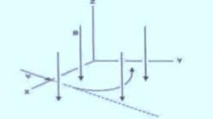

Fig. Charged particle in a magnetic field when v is normal to B
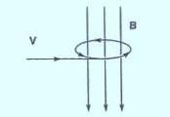
Fig. Charged particle moves in a circular path when v is parallel to B

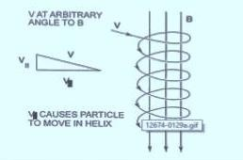
Fig. Charged particle moves in a helical path when v and B in other orientations Generation of high intensity magnetic fields-
In high magnetic field applications, superconducting coils are employed. These coils carry an electric current of up to 40kA. To initiate the process, a high-voltage DC power supply charges the capacitor. Upon closing the switch, this action generates oscillating current within the capacitor. Consequently, an oscillating magnetic field is induced in the food material placed within the magnetic coil.
To effectively deactivate microorganisms, a flux density ranging from 5 to 20 T (Tesla) is required, representing a high-intensity condition. This level of oscillating magnetic field (OMF) density can be generated using the method proposed by Gersdorf et al. in 1983:

  - superconducting coils
  - coils with produce DC fields
  - coils energized by the discharge of energy stored in a capacitor
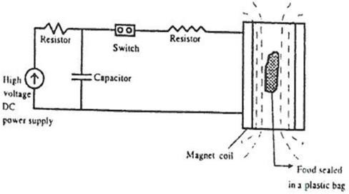

Fig. Electrical circuit generating oscillating magnetic field
When the core is inserted into the coil, made of paramagnetic or ferromagnetic material, it enhances the production of magnetic fields, making them more intense. To generate magnetic fields of up to 20 T, superconducting coils are required. To maintain the superconductor filaments below their critical temperature of 4.2K, liquid helium serves as the coolant for superconducting materials, while liquid nitrogen is utilized for higher temperatures. It is possible to create magnetic fields stronger than 30 T with this combination. As a result, the system uses a capacitor bank to store energy that is then released by creating an oscillating electrical current, which in turn creates an oscillating magnetic field (OMF). The capacitance of the capacitor, along with the resistance and inductance of the coil, dictate the frequency and intensity of the magnetic field.
Compared to resistive electromagnets, superconducting magnets provide a number of advantages. Usually, they keep the field more steady, which results in readings that are less noisy. Additionally, superconducting magnets can be smaller, giving designers additional options for how to arrange the device's other parts. Furthermore, they use a great deal less energy, with their steady-state power consumption being minimal (Asner, 1999). However, cooled resistive and hybrid magnets can reach higher fields because, at high fields, superconducting coils change into a normal, non-superconducting state, which causes Joule heating phenomenon
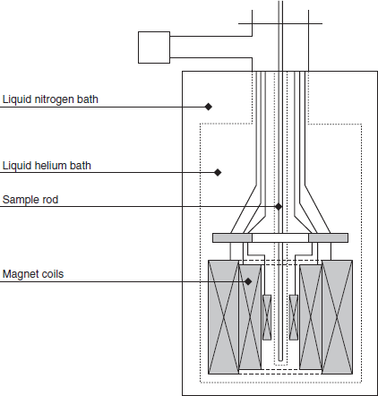

Fig. Schematic cross section of superconducting magnet Mechanisms of Microbial Inactivation
OMFs have the ability to render dietary microbes inactive. A number of theories have been put up to explain how magnetic fields affect biological systems. The net negative electrostatic charges on bacterial cell surfaces are a result of ions on external cell macromolecules that are exposed to the surroundings. The bacterial surface charge may be affected by changes to these substances' chemical makeup and structure. An ion current can be induced from one place to another by the force produced by a magnetic field inside a food system.
Food is treated with OMF by placing it in a plastic bag and subjecting it to one to one hundred OMF pulses at a frequency of five to five thousand hertz (kHz). Temperatures between 0 to 50ºC are experienced, and exposure times typically range from 25 to 100 ms. Higher frequencies than 500 kHz tend to heat the food material and are less effective in inactivating microorganisms. Either the induced electric fields or the magnetic fields themselves can be responsible for the stimulation or inhibition of microorganism growth when exposed to magnetic fields.Inactivation of micro-organisms due to magnetic field takes place by-

By loosening bonds between ions and proteins-
This suggests that the oscillating magnetic field has the potential to weaken the bonds between ions and proteins. Numerous proteins essential for cellular metabolism incorporate ions. When a steady magnetic field is present, the biological effects of OMF are more pronounced at specific frequencies. Consequently, this halts the metabolic activities of microbial cell components.

By vibration in the calcium bound proteins-
This examines the impact of an oscillating magnetic field on proteins bound to calcium. Under the influence of OMF, calcium ions experience continuous vibration around an equilibrium point within the binding site. The presence of a steady magnetic field induces a rotation or movement of the vibration plane in the direction of the magnetic field. This introduces a perturbing magnetic field at a specific frequency, leading to the disruption of the bond between calcium and the protein.By breakdown of covalent bonds in the DNA-
Energy becomes coupled with magnetically active segments of large molecules, such as DNA. In the range of 5-50 T, the energy per oscillation that couples with a single DNA dipole is approximately 10.2-10.3 eV. This series of oscillations can potentially weaken the molecular structure. The activation of OMF in the vicinity of the product leads to the breakdown of covalent bonds within the DNA molecules and impedes the growth of microorganisms.Critical Process Factors
Critical process variables such as magnetic field properties, electrical resistivity, microbiological kind, microbial development stage, treatment duration, and treatment temperature largely determine how well magnetic field treatments work on microbial populations.

Magnetic Field-
Exposure to a magnetic field has the potential to either stimulate or inhibit the growth and reproduction of microorganisms. Typically, a single pulse with an intensity ranging from 5 to 50 T and a frequency between 5 to 500 kHz leads to a reduction in the microbial population by at least 2-log cycles (Hoffman 1985). High-intensity magnetic fields can influence the fluidity of cell membranes and other cellular properties (Frankel and Liburdy,1995). Nevertheless, the inconsistent results observed in various inactivation studies prevent making definitive statements about the microbial inactivation efficiency of magnetic fields or making predictions about their effects on microbial populations. In the case of OMF specifically, exposure induces an electrical current in the treated product.
- Electrical Resistivity-
Electrical resistivity quantifies a material's resistance to the flow of electrically charged particlesHigh electrical resistivity—typically more than 10 to 25 ohms-cm—is required for foods to deactivate microbes when exposed to OMF. The electrical resistance and thickness of the food being magnetized determine how strong the applied magnetic field should be. Products with higher resistivity and thickness are treated with larger magnetic field strengths.
Microbial Growth Stage-
Tsuchiya and colleagues (1996) conducted research involving both homogeneous (7 T) and inhomogeneous (ranging from 5.2 to 6.1 T and 3.2 to 6.7 T) magnetic fields, revealing a growth stage-dependent response in Escherichia coli bacterial cultures. Initially, the ratio of cells exposed to a magnetic field compared to those under the geomagnetic field was less than 1 during the initial 6-hour treatment period but exceeded 1 after 24 hours. Additionally, these authors observed that cell survival rates were higher in inhomogeneous fields when compared to homogeneous fields. They postulated that magnetic fields might function as a source of stress. In order to study this, cells that were obtained during the stationary phase following a protracted magnetic field treatment or after 30 minutes of incubation under magnetic field treatment (lag or early lag phase) were heated to 54ºC. Remarkably, there were no appreciable variations found between the control and treatment samples. On the other hand, nothing is still known about how the stage of microbial growth affects a cell's sensitivity to magnetic fields.
Temperature-

Our understanding of the relationship between microorganism inactivation and temperature remains limited. In a study by Berk and colleagues (1997), the impact of 71 and 106 mT magnetic fields on three potentially pathogenic amoebae was assessed. Their findings indicated that, following a 72-hour exposure to magnetic fields at temperatures of 20ºC or higher, there was a significant reduction in the number of amoebae across all three species. The final counts of amoebae exposed to the magnetic field ranged from 9% to 72% lower than counts in samples that were not exposed to the magnetic field.

Case Study-
Oscillating magnetic fields are generated through the application of a fluctuating current to the electromagnets. These fields possess considerable strength when compared to the Earth's magnetic field, which is approximately in the range of 5 to 100 T. Frequencies falling within the range of 5-500 kHz are typically employed for durations ranging from 25μs to a few milliseconds, effectively leading to the inactivation of vegetative cells. However, should the frequencies exceed 500 kHz, it can result in heating of the food and render the inactivation process less effective. Recent research indicates that the impact on spores or enzymes is relatively minimal, and in certain cases, it may even stimulate the growth of vegetative cells. For instance, when subjecting milk to an oscillating magnetic field with a strength of 12 T at a frequency of 6000 Hz, cell counts decreased from 25,000 to 970 ml⁻¹ (Fellows, 2009).

In a 2017 study, Otero, Pérez-Mateos, Rodríguez, and Sanz examined how oscillating magnetic fields affected crab sticks. The freezing procedure was applied to crab sticks both with and without the use of an oscillating magnetic field, and it was observed over most of a year. Numerous quality attributes were thoroughly investigated during the course of this investigation. The results showed that the crab sticks were not significantly affected by the oscillating magnetic field. Specifications including water-holding capacity, toughness, whiteness, and drip loss did not change. Furthermore, the overall quality of the frozen samples remained unchanged. It's worth noting that the strength of the oscillating magnetic field used in this experiment was below 2mT, which is only two orders of magnitude higher than the Earth's natural magnetic field. The frequency range employed ranged from 6 to 59 Hz. Importantly, it should be acknowledged that varying the frequencies and magnetic field strengths in this study could potentially yield different results.
In a study conducted by James, Reitz, and James (2014), an examination was undertaken to explore the response of garlic bulbs when exposed to oscillating magnetic fields as opposed to conventional freezing methods. The outcomes of this investigation revealed notable cooling effects on the garlic bulbs during specific freezing trials. However, during the freezing stage, it became evident that the application of oscillating magnetic fields had a considerable impact on the garlic bulbs in comparison to the standard freezing procedure. Furthermore, the researchers deduced that super-cooling was more efficient when garlic bulbs were initially frozen at an ambient temperature of 21 ± 1ºC, as opposed to 4 ± 5ºC.

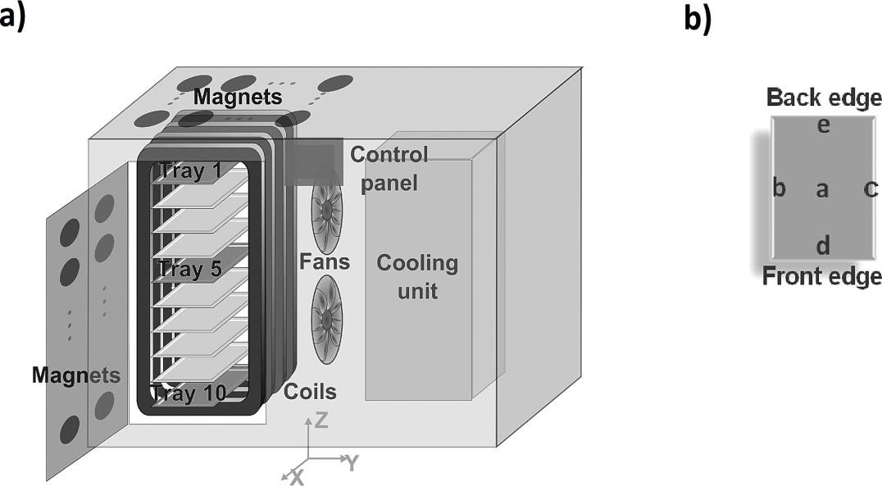

Fig. Schematic drawing of the CAS freezer
  - Main components,
  - Points at magnetic field measurements were performed in freezing trays 1, 5 and 10 T.
The impact of oscillating magnetic fields (OMFs) at different intensities (up to 100 mT) on the extension of supercooling in water was investigated in a study by Kang et al. (2021). The idea was to create an external supercooling chamber with specific air circulation to isolate the impact of OMF without supplying any heat. The results of the pendulum experiment demonstrated that water had a diamagnetic repulsion-induced tendency to move in the opposite direction of the applied OMF, with the degree of this displacement increasing as the OMF intensity rose. The supercooling probability results showed that ice nucleation in supercooled water was suppressed by OMF intensities of 50 mT while the water was kept at -11ºC. OMF intensities greater than 100 mT, on the other hand, caused freezing. For the purpose of supercooling the preservation of fresh-cut mango slices, an OMF with a field strength of 50 mT was utilized. The mango slices were kept at -5ºC for any length of time. The assessment of quality parameters, such as firmness and weight reduction, suggested that supercooling preservation might increase the shelf life of fresh-cut mangoes without sacrificing their original quality.Top of Form

Table- Effect of magnetic fields on microorganisms

Microorganism | Type of Magnetic  Field | Field Strength  (T) | Frequency of Pulse  (Hz) | Effect | Reference
E. coli | OMF | 0.15 | 0.05 | Inactivation of cells atconcentration  of 100 cells/mL. | Moore,  1979
Streptococcus  themophilus in milk | OMF | 12.0 | 6,000 (1  pulse) | Cell population reduced from 25,000 cells/mL to 970. | Hofmann, 1985
Saccharomyces  in yogurt | OMF | 40.0 | 416,000 (10  pulses) | Cell population reduced from 3,500  cells/mL to 25. | Hofmann,  1985
Saccharomyces  in orange juice | OMF | 40.0 | 416,000 (1  pulse) Cell | Population reduced from 25,000  cells/mL to 6. | Hofmann,  1985
Mold spores | OMF | 7.5 | 8,500 (1  pulse) | Population reduced from 3000  spores/mL to 1. | Hofmann,  1985

Magnetic Fields Applications in Food Preservation
OMFs have the capacity to be utilized for the preservation and stabilization of both solid and liquid food products. For solid food preservation using OMF, food is sealed in a plastic bag; for liquid food preservation, the foodstuff is continually pumped through a pipeline. The OMF treatment process entails exposing the product to a series of 1 to 100 pulses, with frequencies falling within the range of 5 to 500 kHz, while maintaining temperatures between 0 and 50ºC. This exposure typically lasts for a total duration of 25 to 100 ms (milliseconds). It's worth noting that frequencies exceeding 500 kHz are less effective when it comes to microbial inactivation and may result in the heating of the food material (Barbosa-Canovas et al., 1998b). Importantly, magnetic field treatments are conducted under atmospheric pressure and moderate temperature conditions.
The product undergoes a mild heating process, with temperatures typically falling in the range of 2 to 5ºC. As per Hofmann (1985), exposure to magnetic fields exceeding 2 T leads to the inhibition of microbial growth and reproduction. To achieve this effect, field intensities ranging from 5 to 50 T and frequencies between 5 and 500 kHz are applied to liquid media, resulting in a reduction of microorganism counts by at least 2 log cycles. Additionally, OMF technology can be effectively employed in conjunction with traditional processing methods, such as low pasteurization treatments, to enhance the quality and extend the shelf life of food products. It's important to note that there are no specific preparative steps required before subjecting food products to OMF treatment. However, it's worth mentioning that frequencies exceeding 500 kHz are less effective for microbial inactivation, as they can elevate the temperature of the food products due to Joule heating processes. It's worth noting that magnetic field treatments are considered safe, as the field's intensity rapidly diminishes beyond a very short distance from the coil in the treatment zone.
Research Needs
Each non-thermal technology possesses distinct applications tailored to the specific types of foods being processed. OMF technology exhibits potential utility in the processing of both liquid and solid foods. Nevertheless, a key limitation shared by most non-thermal technologies, including OMF, is their limited effectiveness in inactivating resilient microbial forms, notably spores. To comprehensively assess potential synergies between treatments, adopting a more integrated approach is imperative. There is currently a substantial dearth of information concerning the capacity of OMF treatment to effectively deactivate pathogenic microorganisms and their surrogates. A critical area that requires elucidation revolves around verifying the efficacy of magnetic field treatment as a microbial inactivation process. Even after establishing this, there remain considerable gaps in data that must be addressed before this technology can be safely and practically employed in the realm of food preservation. Some of the more prominent research requirements include:
• to assess the impact of magnetic fields on microorganism inactivation;
• to clarify the microbial inactivation kinetics under the influence of magnetic fields;
• to pinpoint resilient pathogens of significance;
• to unravel the underlying mechanisms driving microbial inactivation via magnetic fields;
• to discern crucial process factors and their effects on microbial inactivation;
• to validate the process, assess indicator organisms, and select suitable surrogates;
• to detect process deviations and devise strategies for rectifying them.
Top of Form

Concluding remarks:
  - OMF has demonstrated its ability to reduce energy consumption in processing. • It holds promise for treating foods within flexible film packaging to prevent post-harvest/process contamination.
  - In-depth investigations are needed to comprehend the impact of magnetic fields on food quality and the precise mechanism behind microorganism inactivation.
  - Further research is essential to establish a clear relationship between microorganism inactivation in food and OMF techniques.

References:

- Ašner F. M.(1999) High field superconducting magnets. Oxford University Press, Oxford, 264 pp
- Barbosa‐Canovas, G., Schaffner, D., Pierson, M., and Zhang, Q. (2000). Oscillating magnetic fields. Journal of Food and Science, 65:86-89.
- Barbosa-Canovas, G.V., Gongora-Nieto, M. M., and Swanson, B. G. (1998a) Non-thermal electrical methods in food preservation.Food Science and Technology International 4(5):363–370.
- Barbosa-Canovas, G.V., Pothakamury, U.R., Palou, E., and Swanson, B. G. (1998b) Nonthermal Preservation of Foods. New York: Marcel Dekker. Food bioprocess technol (2017) 10:2113–2122 DOI 10.1007/s11947-017-1983-3.
- Coughlan, A. and Hall, N. 1990. Howmagnetic field can influenceyour ions? New Scientist 8(4):30.
- Brian Wowk (2012)Electric and magnetic fields in cryopreservation. Cryobiology 64 (2012) 301–303.
- Gersdorf, R., deBoer, F. R., Wolfrat, J.C., Muller, F. A., Roeland and L. W. (1983) Thehigh magnetic facility of the University of Amsterdam, high field magnetism.Proceedings International symposium on High Field Magnetism. Osaka, Japan. 277-287
- Hofmann, G. A. (1985) Deactivation of Microorganisms by an Oscillating Magnetic Field.
- US Patent 4,524,079.
- James, C., Reitz, B., and James, S. (2014). The freezing characteristics of garlic bulbs (Allium sativum L.) frozen conventionally or with the assistance of an oscillating weak magnetic field. Food and Bioprocess Technology, 8(3):702-708

- Kinetics of microbial inactivation for alternative food processing technologies oscillating magnetic fields.Food and drug administration center for food safety and applied nutrition June 2, 2000.
- Lai, H. and Singh, N.P. 2004. Magnetic-field-induced DNA strandbreaks in brain cells of therat. Environmental Health Perspectives112(6):687–694.
- Lipiec, J., Janas, P., and Barabasz, W. (2004) Effect of oscillating magnetic field pulses on the survival of selected microorganisms. International Agrophysics 18(4):325–328.
- Moore, R. L. (1979) Biological effects of magnetic fields.Studies with microorganisms.Canadian Journal of Microbiology 25:1145–1151.
- Taiyoung Kang, Youngsang You, Raymond Hoptowit, Marisa M. Wall and Soojin Jun (2021) Effect of an oscillating magnetic field on the inhibition of ice nucleation and its application for supercooling preservation of fresh-cut mango slices. Journal of Food Engineering 300:1-8.

