PRELIMINARY PHYTOCHEMICAL SCREENING FOR VARIOUS MEDICINAL PLANT LEAF EXTRACTS

S.VIJIPRIYA, V.RAGURAMAN,
PG & Research Department of Physics, PG & Research Department of Physics,
Thiru. Vi. Ka. Govt Arts College, Edayantahngudy G. S. Pillay Arts and Thriuvarur- 610003. College, Nagapattinam-611002.
drsvip2022@gmail.com raguram.vr@gmail.com
ABSTRACT

Objective: Preliminary screening of phytochemicals is a valuable step, in the detection of the bioactive principles present in medicinal plants and subsequently may lead to drug discovery and development. In the present study, chief phytoconstituents of the five selected medicinal plants of different families were identified in order to relate their presence with bioactivities of the plants.
Methods: Phytochemical screening of five selected medicinal plants was performed for the presence of alkaloids, carbohydrates, glycosides, saponins, phenols, flavonoids, proteins and steroids using standard methods.
Result: All the selected medicinal plants leaf extract were found to contain phenols. Moreover, flavonoids were also present in all the selected plants except Ruellia prostrata. Saponins were present in all plants except Pongamia pinnata. In addition, alkaloids, cardiac glycosides, carbohydrates and steroids were present in all the selected plants except Ruellia prostrata, Erythrina variegata and Hygrophila auriculata. Whereas, proteins and terpenoids were absent in all the selected five plants.
Conclusion: It is evident from the study that Pongamia pinnata and Aegle marmelos leaf extract are having majority phytochemical compounds and Ruellia prostrata has lowest phytochemical constituents. Phenols, saponins and flavonoids are secondary metabolites that are almost present in all six medicinal plants have been reported to serve as a bio-reductants of metallic ions in aqueous medium and also act as reducing and capping agent for synthesis of metal and metal oxide nanoparticles.

Keywords: Medicinal plants, phytochemical, screening.

INTRODUCTION

Plant derived substances have recently become of great interest owing to their versatile applications. Medicinal plants are the richest bio-resource of drugs of traditional systems of medicine, modern medicines, pharmaceutical intermediates and chemical entities for synthetic drugs [1]. Phytochemicals are naturally occurring substances found in plants which provides health benefits. These are known as secondary metabolites and may often be created by modified synthetic pathways from primary metabolite or share substrates of primary metabolite origin [2]. Alkaloids, carbohydrates, glycosides, saponins, phenols, flavonoids, proteins, terpenoids, steroids and etc. they protect plants from disease and contribute for plant’s color, aroma and flavor. Further, they have a role in protection of human health when their dietary intake is significant. Dietary phytochemicals are found in fruits, vegetables, legumes, whole grains, nuts, seeds, fungi, herbs and spices. They have antioxidant, anti-inflammatory, anti-cancer and anti-bacterial properties [3].
In this chapter we discussed about extraction procedure and preliminary phytochemical screening test for five medicinal plants leaf extract.

MATERIALS

Aagle marmelous:
Common name: Bilwa or Bael
Tamil name: Vilvam
Botanical name: Aegle marmelos
Taxonomic Position:
Kingdom: Plantae
Class: Magnoliopsida
Order: Sapindales
Family: Rutaceae
Genus: Aegle
Species: A. marmelos

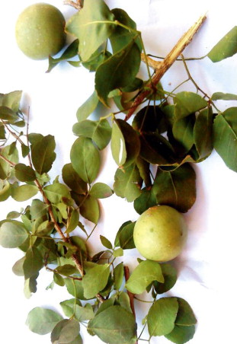
Figure 1.1 Aegle marmelos plant

Aegle marmelos commonly known as Bael belonging to the family Rutaceae, has been widely used in indigenous systems of Indian medicine due to its various medicinal properties. A spinous deciduous aromatic tree with trifoliate leaves and greenish-white flowers. Tree is also planted as an avenue tree near temples and in gardens. Fruit as well as bark of the tree are utilized [4].

Medicinal Uses:
- Aegle marmelos uses include dried fruit pulp being used in many parts of India in preparation of summer drinks, which helps overcome sunstrokes.
- Bael leaves are used in the preparation of salads.
- Bael can be used in the formulation of ayurvedic medicine for the loss of appetite.
- Bael extract oil is used to cure respiratory problems.
- Aegle marmelos is anti-inflammatory in nature. Its extracts when applied on the exposed area, help to cure inflammation.
- Aegle marmelos is rich in anti-oxidants which helps in insulin secretion which leads to low blood sugar levels [4].

Erythrina variegata:
Common name: Tiger’s claw or Indian coral tree
Tamil name: Kalyana murungai
Botanical name: Erythrina variegata

Taxonomic position:
Kingdom: Plantae
Class: Magnoliopsida
Order: Fabales
Family: Fabaceae (Legume family)
Genus: Erythrina
Species: E. variegata
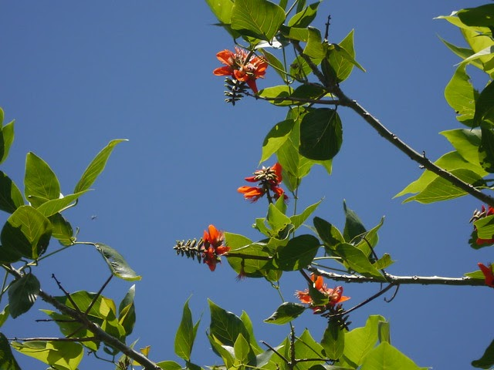
Figure 1.2 Erythrina variegata plant

Erythrina variegata also called as erythrina indica is a thorny deciduous tree growing to50- 60 feet tall and wide deciduous tree with green and yellow variegated, 6-inch-long leaves creates a broad canopy but has spiny branches. In spring, before the leaves appear, coral tree is decorated with showy red blossoms, each flower 2.5 inches long and arranged in dense, six-inch-long racemes. These blossoms are followed by 12-inch-long, red/brown seedpods which contain poisonous seeds [5].

Medicinal uses:
- Different parts of E. Variegta have used in traditional medicine as nervine sedative, febrifuge, anti-asthmatic and antiepileptic.
- In some experiments, it has potential effects for the treatment of some diseases like convulsion, fever, inflammation, bacterial infection, insomnia, helminthiasis, cough, cuts and wounds [5].

Hygrophila auriculata:
Common name: Hygrophila or Marsh barbel
Tamil name: Neermulli
Botanical name: Hygrophila auriculata

Taxonomic Position:
Kingdom: Plantae
Class: Magnoliopsida
Order: Lamiales
Family: Acanthaceae
Genus: Hygrophila
Species: H. auriculata
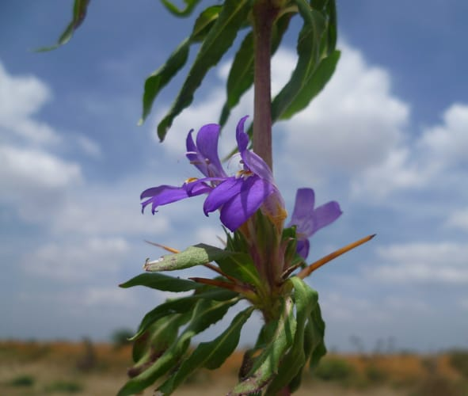
Figure 1.3 Hygrophila auriculata plant

Hygrophila or Marshal Barbel it is commonly used to call in Tamil as a Neermulli. An annual herbal plant grows up to 60 cm altitude. The plant stem is tetragonal, hairy and stiffened at the nodes. The bark is dark brown, although the leaves are elliptic-lanceolate and hispid. The flowers are violet and somewhat purple-blue. The fruit looks like a four-sided figure, linear, glabrous and about contains 1 cm long seeds which are orbicular hairy and brown in color [6].

Medicinal uses:
- Its leaf is useful in a cough.
- It is useful in an anal fistula.
- Its seed is useful in blood disorders.
- Intake of root decoction is useful in jaundice.
- Its vegetable is useful in anemia.
- Its root and a whole part decoction are useful in rheumatoid arthritis [6].

Pongamia pinnata:
Common name: Karanj, Indian beech tree, Pongam tree
Tamil name: Pungai
Botanical name: Pongamia pinnata

Taxonomic Position:
Kingdom: Plantae
Class: Magnoliopsida
Order: Fabales
Family: Fabaceae
Genus: Pongamia
Species: P. pinnata
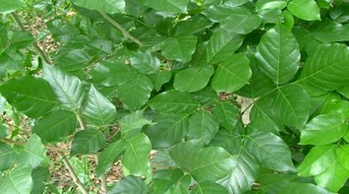
Figure 1.4 Pongamia pinnata plant

Pongamia pinnata belonging to the family Fabaceae (Papilionaceae), is widely distributed in tropical asia, Australia, Polynesia and Philippine Islands. Traditionally, different parts of Pongamia pinnata such as barks, leaves, seeds, roots, flowers and stem have been utilized in the native medicine systems of different civilizations [7].

Medicinal uses:
- The flowers of this plant have been found to possess anti-hyperglycemic and anti-lipid peroxidation properties.
- Its bark is used in piles, leaves are effective as a medicated bath and in rheumatic pains while the seeds are used in hypertension, bronchitis, whooping cough, skin diseases and rheumatic arthritis.
- Roots are used for cleaning gums, teeth, and ulcers and also effective in gonorrhea [7].

Ruellia prostrata:
Common name: Bell weed
Tamil name: Kiranthi nayagam, Pottakanchi
Botanical name: Ruellia prostrata

Taxonomical position:
Kingdom: Plantae
Class: Magnoliopsida
Order: Lamiales
Family: Acanthaceae
Genus: Ruellia
Species: R. prostrata
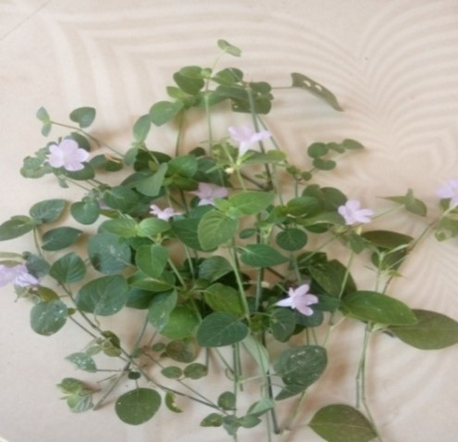
Figure 1.5 Ruellia prostrata plant

Bell weed is a prostrate perennial herb, with stems often rooting at the nodes. Ovate green leaves, 2-10 cm long, have lower surface conspicuously paler. Leaf stalk is 5-30 mm long. Flowers occur solitary in the leaf axils, each one subtended by oblanceolate to ovate bracts 1.5-2.3 cm long. Sepals 5, 6-10 mm long. Flowers are violet blue to occasionally nearly white, 2.4-3.2 cm long, densely covered with fine hairs [8].

Medicinal uses:
- Believed to be anticancer against the epidermis of the nasopharynx region and slightly hypoglycemic.

METHODS

Extraction procedure:
Extraction methods used pharmaceutically involves the separation of medicinally active portions of the plant tissues from the inactive/inert components by using selective solvents. During extraction, solvents diffuse into the solid plant material and solubilize compounds with similar polarity [9]. The purpose of standardized extraction procedures for crude drugs (medicinal plant parts) is to attain the therapeutically desired portions and to eliminate unwanted material by treatment with a selective solvent known as menstrum. The extract thus obtained, after standardization, may be used as medicinal agent as such in the form of tinctures or fluid extracts or further processed to be incorporated in any dosage from such as tablets and capsules. These products contain complex mixture of many medicinal plant metabolites, such as alkaloids, glycosides, terpenoids, flavonoids and lignans [10].

The general techniques of medicinal plant extraction include:
- Maceration
- Infusion
- Percolation
- Digestion
- Decoction
- Soxhlet extraction (hot continuous extraction)
- Aqueous-alcoholic extraction by fermentation
- Counter-current extraction
- Microwave-assisted extraction
- Ultrasound extraction (sonication)
- Supercritical fluid extraction
- Phytonic extraction (with hydroflurocarbon solvents) [10].

The basic parameters influencing the quality of an extract are:
- Plant part used as starting material
- Solvent used for extraction
- Extraction procedure [9]

Effect of extracted plant phytochemicals depends on:
- The nature of the plant material
- Its origin
- Degree of processing
- Moisture content
- Particle size [9]

The variations in different extraction methods that will affect quantity and secondary metabolite composition of an extract depends on:
- Types of extraction
- Time of extraction
- Temperature
- Nature of solvent
- Solvent concentration
- Polarity [9]

Choice of Solvents:
Successful determination of biologically active compounds from plant material is largely dependent on the type of solvent used in the extraction procedure. Properties of a good solvent in plant extractions includes, low toxicity, ease of evaporation at low heat, promotion of rapid physiologic absorption of the extract, preservative action, inability to cause the extract to complex or dissociate [11].
The various solvents that are used in the extraction procedures are:
- Water
- Acetone
- Alcohol
- Chloroform
- Ether [9]

In this study, we used water as solvent and Soxhlet extraction procedure were involved for extraction procedure.
Water is universal solvent, used to extract various medicinal plant products with antimicrobial activity. Though traditional healers use primarily water but plant extracts from organic solvents have been found to give more consistent antimicrobial activity compared to water extract [12].
Soxhlet extraction is only required where the desired compound has a limited solubility in a solvent, and the impurity is insoluble in that solvent. If the desired compound has a high solubility in a solvent, then a simple filtration can be used to separate the compound from the insoluble substance. The advantage of this system is that instead of many portions of warm solvent being passed through the sample, just one batch of solvent is recycled [13].

Preparation of various medicinal plant leaf extract:
The five selected medicinal plants of different family’s leaf were collected and washed thoroughly 2-3 times under running tap water and sterilized with double distilled water. The leaves samples were allowed to dry in room temperature in dust free condition. The dried leaves were crushed into finest powder. 5 g of the leaf powder were boiled with 50 ml of distilled water at 100 ⁰C for 5 hours. During the procedure of boiling, a light brown colored solution was formed and which was cool at room temperature, after that, the brown colored extract was filtered with Whatman filter paper and stored in refrigerator [14].

Qualitative techniques for the determination of phytochemicals:
The preliminary screening test was used to find the secondary metabolites presence in the various medicinal plants leaf extract according to the standard methods [15].

- Test for Saponins:
Froth test: 1ml of extract was slowly added to 2-3 ml of double distilled water. Then the mixture was shaken vigorously. Finally, formation of foam confirms the presence of saponins in the leaf extracts.

- Test for Alkaloids:
Each extract was dissolved individually in dilute hydrochloric acid and filtered.
Hager’s Test: A small amount of Hager’s reagent is added to each extract. The formation of yellow precipitate indicates the presence of alkaloids.

- Test for flavonoids:
Lead acetate Test: Each extract was treated with few drops of lead acetate solution. Formation of yellow color precipitate indicates the presence of flavonoids.
- Test for Phenol:
Ferric Chloride test: Extracts were treated with 3-4 drops of ferric chloride solution. Formation of bluish black color indicates the presence of phenols.

- Test for Proteins:
Xanthoproteic test: 2ml of extract was treated with few drops of concentrated nitric acid (HNO₃) acid changes the of the solution into yellow indicates the presence of proteins.

- Test for Cardial Glycosides:
Keller Killani test: 2 ml of leaf extract was treated with 2 ml of glacial acetic acid containing the drop of FeCl₃ a brown colored formation indicates the presence of cardial glycosides.

- Test for carbohydrate:
Extracts were dissolved individually in 5ml distilled water and filtered. The filtrates were used to test for the presence of carbohydrates.
Benedict’s test: Filtrates were treated with Benedict’s reagent and heated gently. Orange red precipitate indicates the presence of carbohydrates.

- Test for steroids:
2 ml of leaf extract was taken in a test tube and dissolved with 10 ml of chloroform. Equal volume of concentrated H₂SO₄ acid was added to the mixture through the side wall of the test tube. Steroid was confirmed by the changes in the upper layer of the solution as red and H₂SO₄ acid layer as yellow with green fluorescence.

IV. RESULT

Table 1.1 Preliminary qualitative screening analysis

S. No. | Test | Aegle marmelos | Erythrina variegata | Hygrophila auriculata | Pongamia pinnata | Ruellia prostrata
1 | Saponins | + | + | + | - | +
2 | Alkaloids | + | - | - | + | -
3 | Flavonoids | + | + | + | + | -
4 | Phenol | + | + | + | + | +
5 | Proteins | - | - | - | - | -
6 | Cardiac glycosides | + | - | - | + | -
7 | Carbohydrate | + | - | - | + | -
8 | Steroids | + | - | - | + | -

(+) = Presence
(-) = Absence

V. RESULT AND DISCUSSION

Plant origin has huge variety of phytochemicals and has been considered as a bioactive laboratory with multipurpose applications. Hence, these plant origins have importance from ancient time in tradition various diseases. In addition, the medicinal plants are cost effective, less side effects, simple effective and easily available. Investigation of phytochemicals in the plant origin can find the approach for its medicinal properties knowledge of the phytochemicals can established its medicinal importance leading to discovery and development of a new molecule [16].

Generally plant extract is used as a potential substitute for the stabilizing and reducing agent due to the combination of its bio-components such as terpenoids, alkaloids, phenolics, tannins, proteins, aminoacids, polysaccharides, enzymes, vitamins and saponins [17]. As shown in table 1.1, phenols, saponins and flavonoids are the major chemical constituents of the essential extract obtained from selected five medicinal plant of different families leaf extracts. Many reports have specified that phenols and flavonoids are involved in the bio-reduction, formation and stabilization of metal and metal oxide nanoparticles [18-20]. Presence of enormous OH groups in phenol and flavonoids are the responsible for reducing metal into metal oxide nanoparticles. Phenols, saponins and flavonoids in the aqueous leaf extract bind the surface of metal precursor to activate the formation of metal oxide nanoparticles [21]. The -OH groups from phenol, saponins and flavonoids are secondary metabolites can act as a reducing and capping agent for the synthesis of metal and metal oxide nanoparticles [22].
In this study, the phytochemical screening test was carried out by using five medicinal plant leaf extract of different family such as Aegle marmelos, Erythrina variegata, Hygrophila auriculata, Pongamia pinnata and Ruellia prostrata.
The phytochemical screening test result revealed that all of the selected medicinal plants have been found to contain phenols in their leaf extracts. However, it is important to note that Ruellia prostrata is the only plant among them that does not contain in flavonoids. Similarly, Pongamia pinnata is the only plant that does contain saponins. Furthermore, alkaloids, cardial glycosides, carbohydrates and steroids are present in all plants, except for Ruellia prostrata, Erythrina variegata and Hygrophila auriculata leaf extract. Lastly, it is worth mentioning that proteins are absent in all five medicinal plant leaf extract.

VI. CONCLUSION

The phytochemical screening of five selected medicinal plants clearly reveals that the maximum phytoconstituents are present in Aegle marmelos and Pongamia pinnata leaf extract as compared to other three selected plant extracts. Hence, these two plants leaf extract could be explored for its highest phytoconstituents play a significant role in reducing and capping agents during nanoparticle synthesis. The other three selected plants are equal importance due to the presence of the major phytoconstituents. Since these plants have been used for reducing and capping agent for the synthesis of metal and metal oxide nanoparticles. Nanoparticles can capture phytochemicals on their surfaces, which could improve solubility, prevent their oxidation/ degradation, and increase their absorption and bioavailability considerably while preserving medical effectiveness.

REFERENCE

[1] Ncube NS, Afolayan AJ, Okoh Al, African Journal of Biotechnology 2008; 7 (12): 1797-1806.
[2] Kabera JN, Semana E, Mussa AR, He X, Journal of pharmacy and pharmacology, 2014; 2:377-392.
[3] Gusthinnadura Oshadie De Silva, Achala Theekshana Abeysundara and Malamige Minoli Weroshana Aponso, Ameican Journal of Essential Oils and Natural Products, 2017, 5(2):29-32
[4] https://www.dabur.com/ayurveda/ayurvedic-medicnal-plants/bael
[5] A.Kumar, S.Lingadurai, A.Jain and N.R. Barman, Pharmacogn Rev.2010 Jul-Dec; 4(8): 147-152.
[6] L.Sarvananda, Amal D. Premarathna, Journal of Ayurvedic and Herbal medicine 2018; 4(4): 185-188.
[7] Zahid Iqbal Sajid, Farooq Anwar, Ghulam Shabir, Ghulam Rasul, Khalid M.Alkharfy and Anwarul-Hussan Gilani, Molecules 2012, 17, 3917-3932; doi:10.3390/molecules17043917
[8] http://www.flowersofindia.net/catalog/slides/Bell%20weed.html
[9] Tiwari P, Kumar B, Kaur M, Kaur G, Kaur H, Internationale Pharmaceutia Sciencia, 2011; 1(1):98-106.
[10] Handa SS, Khanuja SPS, Shrivastava DK, Journal of medicinal Plants Research 2010; 4(2): 104-111.
[11] Eloff JN, Journal of Ethnopharmacology 1998; 60: 1-8
[12] Das.K, Tiwari RKS, Shrivastava DK, Journal of Medicinal Plants Research 2010; 4(2): 104-111.
[13] Nikal SB, Dambe PA, Ghongade DB, Goupale DC, International Journal of Pharmaceutical Sciences 2010; 2(1): 30-32.
[14] K. Elumalai, S. Velmurugan, Applied Surface Science (2015), http://dx.doi.org/10.1016/j.apsusc.2015.03.176
[15] K. Senthilarasan, V. Raguraman, V. Senthilmurugan, D. Sowmiya, International Research Journal of Multidisciplinary Scope (IRJMS), 2022, 3(2): 35-40.
[16] A.Umamaheswari, S.Lakshmana Prabhu, S. Adharsh John, A. Puratchikody, Biotechnology Reports 29 (2021) e00595
[17] S. Ahamed, M.Ahmad, B. L. Swami and S.Ikram, Journal of Advanced Research, 2016, 7, 17-28.
[18] F. Luo, D. Yang, Z. L. Chen, M.Megharaj, R.Naidu, J. Hazard, Mater. 303 (2016) 145-153.
[19] A. K. Mittal, Y. Chisti, U.C. Banerjee, Biotechnol, Adv. 31 (2013) 346-356.
[20] X. Weng, M. Guo, F. Luo and Z. Chen, Chemical Engineering Journal, 2017, 308, 904-911.
[21] N. Bala, S. Saha, M. Chakraborty, M. Maiti, S. Das, R. Basu and P. Nandy, RSC Adv., 2015, 5, 4993-5003.
[22] K. Aoki, J. Chen, N. Yang, H. Nagasava, Langmuir, 2003, 19, 9904-9905.

