Chapter
Role of Exosomes in treating cancer cells as a Futuristic Chemotherapeutic Agent
Ms. Navjit Kaur Saini^{*1}, Ms. Noel Mankoo², Dr. Satnam Singh, Dr. Sharuti Mehta
Affiliations: - All Faculty at ASBASJSM College of Pharmacy, Bela
(An Autonomous College) Punjab.
Corresponding Author- Navjit Kaur Saini
Email:- navjitkaursaini19@gmail.com
Abstract: The need for novel, safe and efficient drug carriers for cancer treatment has increased over time. The current study shows that exosomes are effective drug carriers due to their immunogenicity, stability, and target ability as well as the generation of an anti-cancer immune response. Exosomes can cross the blood-brain barrier, allowing for the treatment of brain tumors However, drug delivery systems based on exosomes are still difficult to develop due to their heterogeneous nature, low yield and lack of drug loading efficiency. Blood, cerebrospinal fluid (CSF), urine, saliva, and other body fluids can all include extracellular vesicles known as exosomes. Exosomes perform a wide range of functions, including re-modelling the extracellular matrix (ECM) and serving as a conduit for the exchange of signals and chemicals between cells. The dual properties of exosomes in promoting and inhibiting cancer have been taken into consideration with the research of the many functions exosomes play in the course of cancer. Exosomes are a type of molecule produced by various cells. This article discusses how exosomes can be used as drug carriers for anti-cancer therapy. We also discuss the challenges and opportunities of exosome drug delivery systems for cancer treatment.
Keywords: - Exosomes, biomarkers, cancer therapeutics, Drug delivery, miRNA (microRNA) etc.
Intoduction:- Exosomes are small extracellular vesicles that play a crucial role in intercellular communication, and they have emerged as promising candidates for targeted drug delivery in cancer treatment. In the twenty-first century, technology in the medical area has advanced incredibly. Significant hurdles still exist in the early diagnosis and full recovery from malignant tumors. Cancer, a global problem, is the main cause for concern right today. To effectively treat cancer, chemotherapy is required. Despite this, most cancer patients do acquire drug resistance after going through a number of treatments, initially with one chemotherapeutic agent and then with others ^{[1]}. Chemo-resistance is a serious obstacle to effective cancer treatment. Exosomes produced by cancer are thought to contribute to chemo-resistance by giving cancer cells nucleic acids and proteins. Exosomes, which are almost always produced by endothelium and cancer cells, are present in a variety of body fluids, including blood plasma, urine, milk, saliva, amniotic, bronchioalveolar, synovial, and fluid from ascites. 80–90% of the exosomes that circulate in the blood come from immune cells such dendritic cells (DCs), lymphocytes, and platelets. Numerous exosome sources, such as epithelial cells, macrophages, mast cells, reticulocytes, neurons, B-cells, T-cells, oligodendrocytes, Schwann cells, and cancer cells, can be easily investigated. ^{[2]}.
Most eukaryotic cells secrete exosomes, a subclass of extracellular vesicles (EVs) that are encased in a lipid bilayer membrane. Exosomes were formerly thought to be cellular waste products before they were identified in the late 1980’s. The discovery that exosomes constitute a unique intercellular communication channel and play a role in a variety of biological processes in both health and illness, including cancer, has been made possible by the development of research methodologies and tools ^{[3]}.
Limitations of Traditional Chemotherapy: Traditional chemotherapy has several limitations including toxicity to healthy cells, drug resistance, limited effectiveness against metastatic cancer, and inability to specifically target cancer cells ^{[4]}.
Role of Exosomes in Targeted Drug Delivery:- Exosomes are small extracellular vesicles that can be utilized as a targeted drug delivery system, allowing for the precise delivery of therapeutic agents to specific cells or tissues, thereby enhancing treatment efficacy while minimizing off-target effects^{[5]}.
Advantages of Exosomes over Traditional Chemotherapy^{[6]}:-
- Exosomes are natural nano-particles that can deliver therapeutic agents directly to cancer cells, reducing off-target effects and improving drug efficacy.
- Exosomes can cross the blood-brain barrier, allowing for the treatment of brain tumors.
- Exosomes have the potential for targeted drug delivery, minimizing systemic toxicity.
- Exosomes can be engineered to carry specific therapeutic molecules, enhancing treatment specificity.
- Exosomes can act as immune-modulators, stimulating the immune system to attack cancer cells.
- Exosomes have the ability to transfer genetic material, allowing for the delivery of RNA-based therapeutics.
Diagnostic role of exosomes:- Exosomes are tiny vesicles that are released by all cells, but are most commonly released by stem cells. Exosomes are tiny messengers that transport essential signaling proteins and genetic data from one cell to another. As we age, our stem cells become less efficient at repairing tissues. When our cells communicate effectively with each other, they are able to rapidly travel to the injury site and repair it. However, as we age, our cells become less efficient in this process ^{[4]}. As a result, injuries heal more slowly and degenerative diseases become more common. Age isn’t the only factor that can affect the ability of stem cells to repair and reduce inflammation. Environmental factors, genetic defects, chronic diseases such as Lyme disease, autoimmune conditions, and chronic inflammation can disrupt or interfere with the communication between cells, preventing them from repairing and reducing inflammation. The primary function of exosomes is to facilitate communication between cells, whether they are close together or far apart. The information that exosomes carry tells our cells how to activate or inhibit certain functions or how to respond in a certain way ^{[7]}.
Mechanism of Exosomes:- Exosomes are biologically active because they may transport bioactive substances including lipids, metabolites, proteins, and nucleic acids to the target cells. Exosomes have been shown to be able to deliver various bio-molecules to recipient cells throughout the body and demonstrate a new method of cell-to-cell communication. Using this as a foundation, researchers have also been successful in engineering the exosome's contents to realise the system's potential as a natural drug delivery mechanism ^{[8]}. The exosome research community has recently begun to explore many of the described biological sources for the isolation of exosomes and their development as drug delivery vehicles ^{[9]}.
Exosomes are biologically active because they may transport bioactive substances including lipids, metabolites, proteins, and nucleic acids to the target cells ^{[10]}. Exosomes have the ability to transmit and convey various bio-molecules to recipient cells all over the body, indicating a new method of intercellular communication. In order to realize the promise of exosomes as a natural medication delivery mechanism, scientists have effectively altered the exosome contents. The development of drug delivery systems and therapeutics from many of the biological sources that have been reported for exosome separation has only recently begun ^{[11]}.
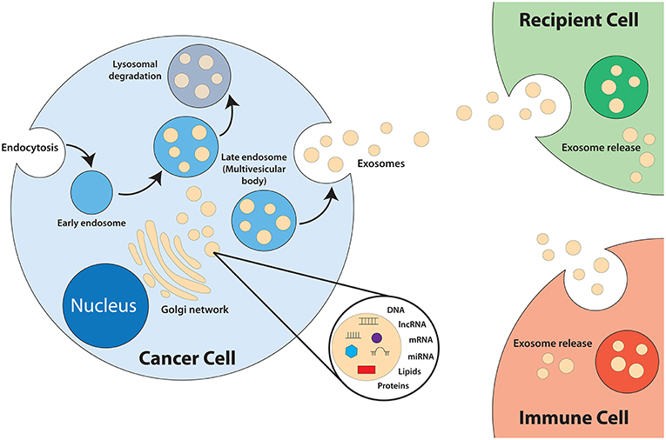
Figure-1
Milk-Derived Exosomes:-. Milk is an important part of a healthy diet because it is a rich source of several important minerals such as calcium, vitamin D, and protein. Exosomes were first successfully removed from breast milk in 2007 after extensive research. Exosomes have been found, for example, in the milk of cows, pigs, kangaroos, camels, rats, horses, pantos, yaks, sheep, and goats. Because they are readily available, produce large amounts of exosomes, and are less cytotoxic than exosomes from other sources, milk-derived exosomes are a promising natural source for exosome production ^{[12]}.
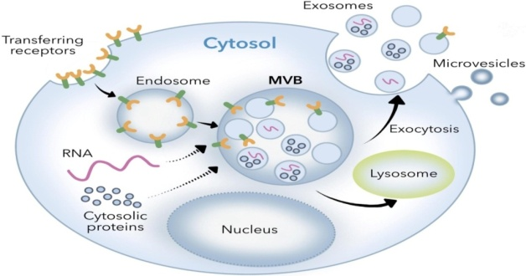
Figure-2
Benefits of Exosomes in Cancer Treatment:- Treatments for cancer can be divided into small molecules (small chemicals), macro-molecules (proteins and antibodies), cells, or organs. Based on their size and complexity, engineering challenge, diversity, and function, cancer treatments have been studied in these categories for decades. From small molecules blocking signaling pathways, to organ transplants, research has focused on these categories. While current research is focused on protein antibody drugs, more advanced therapeutic modalities need to be developed. Exosomes are organelles that can be classified as being in between a macromolecule and a cell. Exosomes have become increasingly popular as diagnostic markers as well as therapeutic agents ^{[13]}. Unlike a single protein or a small molecule, an exosome contains heterogeneous functions but lacks the complexity of a cell or an organ. As a result, it is considered appropriate to treat various diseases such as cancer. Exosomes also have many advantages in terms of bio-compatibility and immunogenicity as well as stability and pharmacokinetics as well as bio-distribution as well as cellular uptake mechanism. These advantages can increase the therapeutic index for exosome based cancer therapies by targeting tumor cells in a way that minimizes unwanted side effects ^{[14]}.
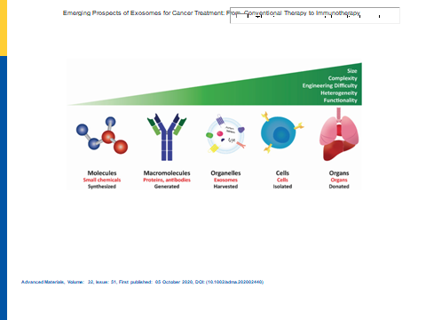
Figure- 3
Therapeutic role of exosomes:- The utilisation of exosomes as a biomarker, cell-free therapeutic agents, drug delivery mechanisms, basic research on exosome dynamics, and cancer vaccination are among their main clinical applications. Exosomes of different human or plant origins are used in a variety of therapeutic studies. Exosomes capacity to move intracellularly gives them a greater therapeutic potential for a range of diseases ^{[15]}. Exosomal pathogenicity in a variety of disorders can now be studied thanks to technical advances in nanomedicine. The continuous release of exosomes is a key component of the targeted drug delivery technique used in nanomedicine, which enables biological activity to be exerted at the desired area. Exosomes act as initiators or vectors for biological processes^{[16]}.
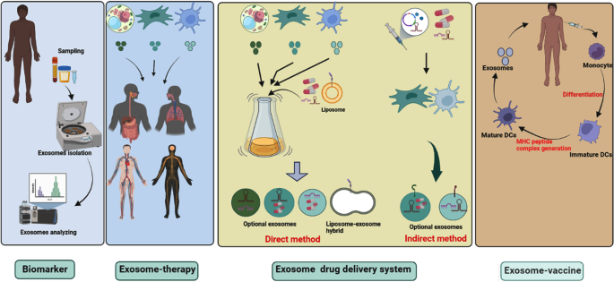
Figure-4
Challenges and Prospects in Using Exosomes as Drug Carriers:- In recent years, many publications have suggested exosomes as a potential drug delivery system in cancer therapy. The advantages of using exosomes in cancer treatment are that they are highly biocompatible, immunocompetent, quickly cross biological barriers, and do not accumulate in the body. Therefore, the development of an exosome-based drug delivery system has great scientific value and potential to be used in therapeutic settings ^{[17]}. However, as a drug carrier, exosomes face certain challenges in the therapeutic environment. For example, in addition to the heterogeneity of cell-derived exosomes, their size, composition, and functional properties can also vary, raising concerns about their safety. Therefore, to avoid anticancer effects, it is necessary to remove the normal content of exosomes before proceeding with clinical work. The modified exosomes are then loaded with anticancer drugs or can be modified with targeting moieties to form an engineered exosome ^{[18]}.
Future Directions and Potential Applications:- Exosomes have shown promising results in cancer treatment with their ability to effectively deliver targeted drugs while minimizing side effects, making them a potential futuristic chemotherapeutic agent. In the future, exosomes have the potential to revolutionize cancer treatment by enabling targeted drug delivery, early detection of cancer, monitoring of treatment response, and development of personalized medicine. Exosomes are interesting and potentially useful biological nanoparticles. With increasing acceptance and promising results, exosome therapy could theoretically easily replace current cellular therapies. Exosomes are still in the early stages of research and clinical trials for their use in therapeutic drug delivery; more information and systematic characterization techniques are needed ^{[19]}. The main disadvantages of using exosomes as a drug delivery mechanism are related to the lack of consistent extraction and loading techniques and the risk of carrying unwanted exosome-related cargo components. The lack of a standardized exosome isolation process results in low purity and batch-to-batch variability. Large-scale isolation of exosomes remains difficult and clinical trials are expensive. Therefore, the main disadvantages of using exosomes as cargo vehicles are their low loading efficiency and the lack of a defined drug loading method. There is a lack of information on proteomics and the nature of exosomes in disease situations. The study suggests that the adverse biological consequences of exosomes can lead to horizontal miRNA transfer, which would improve the resistance of cancer cells to therapy ^{[20]}.
Conclusion:- Although the term "organic exosome" is still in its infancy, it is an exciting area of ​​research for the development of products suitable for clinical applications. Clinical studies have shown that exosomes can be effective in the treatment of many diseases. However, more research is needed on these small bubbles. Our understanding of the mechanisms that drive the various identified exosomal roles is still very limited. Further studies are needed to fully understand the molecular mechanisms that drive exosome formation and exocytosis and their biological function in tumor progression. Only then will the promise of exosomes in diagnosis and treatment be realized in clinical practice. With continued research, we expect that exosomes as natural carriers will be fully utilized and their limitations overcome in the near future. Significant progress has been made in the development of exosomal cancer therapies for many cancer patients.

References:-
- Kalluri, R. & LeBleu, V. S. The biology, function, and biomedical applications of exosomes. Science367, https://doi.org/10.1126/science.aau6977 (2020).
- Arrighetti N, Corbo C, Evangelopoulos M, Pastò A, Zuco V, Tasciotti E. Exosome-like nanovectors for drug delivery in cancer. Curr Med Chem. 2019; 26(33):6132–48.
- Wu Q, Zhou L, Lv D, Zhu X, Tang H. Exosome-mediated communication in the tumor microenvironment contributes to hepatocellular carcinoma development and progression. J Hematol Oncol. 2019. May 29;12(1):53
- Yang D, Zhang W, Zhang H, Zhang F, Chen L, Ma L, Larcher LM, Chen S, Liu N, Zhao Q, Tran PHL, Chen C, Veedu RN, Wang T. Progress, opportunity, and perspective on exosome isolation - efforts for efficient exosome-based theranostics. Theranostics. 2020;10(8):3684–707.
- Ruivo, C. F., Adem, B., Silva, M. & Melo, S. A. The biology of cancer exosomes: insights and new perspectives. Cancer Res.77, 6480–6488 (2017)
- Skotland, T., Sandvig, K. & Llorente, A. Lipids in exosomes: current knowledge and the way forward. Prog. lipid Res.66, 30–41 (2017).
- Jung MK, Mun JY. Sample preparation and imaging of exosomes by transmission electron microscopy. J Vis Exp. 2018;131:e56482
- Bunggulawa EJ, Wang W, Yin T, Wang N, Durkan C, Wang Y, Wang G. Recent advancements in the use of exosomes as drug delivery systems. J Nanobiotechnol. 2018;16(1):1–13
- Lu J, Wu J, Tian J, Wang S. Role of T cell-derived exosomes in immunoregulation. Immunol Res. 2018;66:313–22
- Dadwal A, Baldi A, Kumar Narang R. Nanoparticles as carriers for drug delivery in cancer. Artif Cells Nanomed Biotechnol. 2018; 46(Suppl 2):295–305.
- Gurunathan S, Kang M-H, Jeyaraj M, Qasim M, Kim J-H. Review of the isolation, characterization, biological function, and multifarious therapeutic approaches of exosomes. Cells. 2019;8(4):307.
- Chopra N, Dutt Arya B, Jain N, Yadav P, Wajid S, Singh SP, Choudhury S. Biophysical characterization and drug delivery potential of exosomes from human Wharton’s jelly-derived mesenchymal stem cells. ACS Omega. 2019. August 20;4(8):13143–52
- Daassi D, Mahoney KM, Freeman GJ. The importance of exosomal PDL1 in tumour immune evasion. Nat Rev Immunol. 2020; 20:209–15.
- Huyan T, Li H, Peng H, Chen J, Yang R, Zhang W, Li Q. Extracellular vesicles–advanced nanocarriers in cancer therapy: Progress and achievements. Int J Nanomed. 2020;15:6485
- Ratajczak MZ, Ratajczak J. Extracellular microvesicles/exosomes: Discovery, disbelief, acceptance, and the future. Leukemia. 2020:1–10
- Xie J-Y, Wei J-X, Lv L-H, Han Q-F, Yang W-B, Li G-L, Wang P-X, Wu S-B, Duan J-X, Zhuo W-F. Angiopoietin-2 induces angiogenesis via exosomes in human hepatocellular carcinoma. Cell Commun Signal. 2020;18(1):1–13
- Han Q, Zhao H, Jiang Y, Yin C, Zhang J. HCC-derived exosomes: Critical player and target for cancer immune escape. Cells. 2019. June 8;8(6):558
- Antimisiaris SG, Mourtas S, Marazioti A. Exosomes and exosome-inspired vesicles for targeted drug delivery. Pharmaceutics. 2018;10(4):218
- Kim MS, et al. Engineering macrophage-derived exosomes for targeted paclitaxel delivery to pulmonary metastases: in vitro and in vivo evaluations. Nanomedicine. 2018;14(1):195–204.

