IoT Empowerment in Smart Grid to Enhance Efficiency, Reliability, and Security Through Innovative Applications
M.Ramachandran  Department of EEE  Sree Sowdambika College of Engineering  Aruppukottai  Tamilnadu,India  ramachandransat@gmail.com | G.Prabhakar  Department of ECE  Thiagarajar College of Engineering  Madurai  Tamilnadu,India  gprabhakar2488@gmail.com

ABSTRACT
The evolution of the Smart Grid, coupled with the Internet of Things (IoT) technologies, has opened new avenues for enhancing power system efficiency, reliability, and sustainability. This abstract explores three critical applications of IoT in the Smart Grid: Automatic Power Factor Correction (APFC) using Arduino, IoT-based Underground Cable Fault Detector, and Power Theft Detection and Billing utilizing IoT capabilities. Automatic Power Factor Correction (APFC) using Arduino is a dynamic solution to optimize power quality in the grid. By employing IoT-enabled sensors and controllers, the APFC system continuously monitors the power factor of electrical loads and robotically adjusts the reactive power compensation to keep a near unity power factor. This results in reduced energy losses, increased energy efficiency, and improved utilization of electrical assets. The IoT-based Underground Cable Fault Detector addresses the challenges associated with identifying and locating faults in underground power distribution cables. Leveraging advanced sensor technologies, the detector system can pinpoint the exact location of cable faults in real-time, minimizing downtime and service disruptions. Furthermore, with remote monitoring and alerts, maintenance crews can respond swiftly, resulting in improved grid reliability and reduced repair costs. Power Theft Detection and Billing using IoT introduces an innovative approach to tackle the pressing issue of electricity theft, which poses a significant financial burden on utilities. By integrating smart meters and IoT devices, the system can detect abnormal energy consumption patterns and unauthorized tampering with electricity meters. The gathered data is then analyzed to identify potential theft instances, allowing utilities to take appropriate actions, such as issuing accurate bills and implementing penalties. These applications present promising benefits to the Smart Grid; however, their successful deployment relies on addressing certain challenges. Ensuring the security and privacy of data transmitted across IoT networks is paramount to safeguarding sensitive grid information. Additionally, interoperability and standardization of IoT devices are critical to facilitating seamless integration and communication within the grid ecosystem.
IoT applications in the Smart Grid offer transformative solutions to enhance power system performance and operational efficiency. Automatic Power Factor Correction, Underground Cable Fault Detection, and Power Theft Detection and Billing demonstrate the potential of IoT technologies to revolutionize the energy sector. By adopting these advancements, utilities can optimize energy utilization, reduce downtime, mitigate revenue losses, and pave the way for a more resilient, sustainable, and intelligent power grid infrastructure.
Keywords- IOT; APFC; Power Factor; UG Cable fault detection
INTRODUCTION
The concept of the Smart Grid has revolutionized the way we envision and manage modern electrical power systems. Embracing cutting-edge technologies, the integration of the Internet of Things (IoT) into the Smart Grid has introduced novel and transformative applications that hold the promise of revolutionizing the energy sector. This paper delves into three significant IoT-driven applications within the Smart Grid framework: Automatic Power Factor Correction (APFC) using Arduino, IoT-based Underground Cable Fault Detector, and Power Theft Detection and Billing using IoT capabilities. The Smart Grid's evolution has been fueled by the urgent need for a more efficient, reliable, and sustainable energy infrastructure. The traditional power grid faces challenges such as energy losses, service disruptions due to cable faults, and financial losses from power theft. Addressing these challenges with innovative IoT solutions not only promises to improve power system performance but also fosters a more intelligent and interconnected energy ecosystem. The Automatic Power Factor Correction (APFC) system using Arduino is one of the key advancements in the realm of power quality management. By leveraging IoT sensors and controllers, the APFC system dynamically monitors and adjusts the power factor of electrical loads [1]. This real-time optimization enhances energy efficiency and reduces losses, benefitting both utilities and consumers alike. The IoT-based Underground Cable Fault Detector addresses another critical aspect of power distribution networks—identifying and locating faults in underground cables. The system's advanced sensor technologies enable swift and accurate fault detection, minimizing downtime and improving grid reliability [6]. With real-time alerts and remote monitoring capabilities, maintenance teams can promptly respond to faults, further enhancing the resilience of the power grid [7]. Power Theft Detection and Billing using IoT offers a robust solution to combat revenue losses caused by electricity theft. The integration of smart meters and IoT devices enables utilities to monitor energy consumption patterns and detect unauthorized tampering with meters. By identifying instances of power theft, utilities can implement accurate billing and take appropriate actions to curb such malpractices [11]. As these IoT applications continue to gain traction, it is essential to address certain challenges. Ensuring data security and privacy in IoT networks is of utmost importance, as grid data contains sensitive information. Additionally, promoting standardization and interoperability among IoT devices will facilitate seamless integration within the Smart Grid infrastructure.
Overall, these IoT-driven applications represent a transformative shift in the way we envision and manage electrical power systems. By embracing IoT technologies for Automatic Power Factor Correction, Underground Cable Fault Detection, and Power Theft Detection and Billing, the Smart Grid stands to become more efficient, resilient, and sustainable, ushering in a new era of intelligent and interconnected energy management.
Case 1 : Power factor correction through IoT automation
This study demonstrates the construction of an automated Power Factor Correction (APFC) system specifically designed for single-phase home loads in a cost-effective and straightforward manner [2]. The proposed system utilizes a relay to facilitate the switching of capacitor banks, aiming to adjust the power factor of inductive loads [3]. To control the relay's switching, an Arduino board is employed. By continuously monitoring and analyzing signals from Current Transformers (CT), Potential Transformers (PT), and Zero Cross Detectors (ZCD), the Arduino is programmed to calculate and maintain the power factor of the connected load well above the reference value of 0.9 [4]. This is achieved by energizing the capacitors in parallel to the load through Relay switching [5]. Additionally, the system provides real-time power factor values on an LCD display, along with the current readings before and after power factor improvement. To validate the proposed APFC design, a hardware prototype has been constructed and tested, yielding promising results. The experimental testing confirms the system's reliability and suitability for practical single-phase applications, ensuring a power factor close to unity.
BLOCK DIAGRAM
AC Supply
Inductive Load
CT
PT
Capacitor Bank
Relay
ARDUINO UNO
Relay Driver Unit
LCD

Fig 1 Block Diagram of APFC using IOT
The schematic representation of the planned APFC system showcases the central role of the Arduino board, created for the purpose of assessing and controlling the power factor of the connected load. To enable Arduino's computation, the voltage and current signals from a single-phase wire are appropriately scaled down to a lower power level using a potential transformer (PT) and a current transformer (CT). These downscaled signals are then fed into Arduino through sensor circuits and zero-cross detectors (ZCDs), facilitating the detection of current, voltage, and phase difference necessary for power factor and active power calculations.
In cases where a lagging power factor is detected, the Arduino sends a control signal to the circuit, energizing the capacitor bank in parallel with the load using TIAC (Thyristorized Interphase Auto-connected Capacitor) switching. This process is iterated until the power factor adjustment reaches the desired level. The resulting power factor value, both before and after the correction for the attached load, is displayed on an LCD with a brief pause.
Overall, the APFC system's schematic design highlights the utilization of Arduino's computing capabilities and sophisticated sensor circuits to achieve efficient power factor correction, leading to enhanced load performance and power quality.
WORKING MODULE
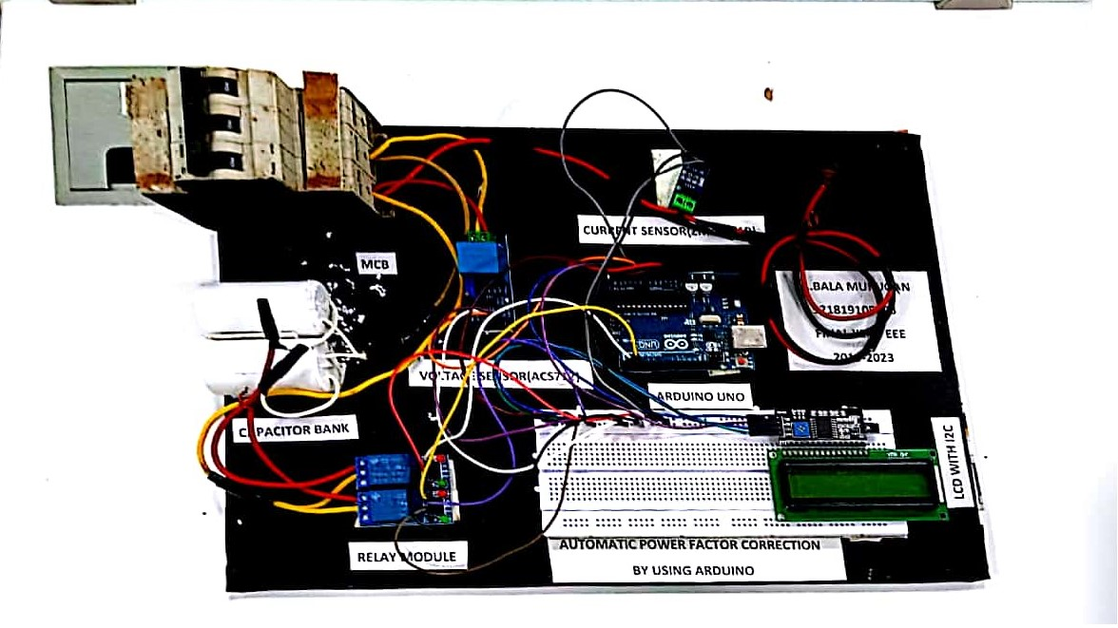

Fig 2 Working Module of APFC using IOT
The proposed APFC system's circuit design comprises several key elements that enable efficient power factor correction. Voltage, current, power factor, and power measurements of the connected load are acquired using appropriate sensor circuits and Zero Cross Detectors (ZCDs), with the signals being given to the analog pins of the Arduino board. The voltage signal from the Potential Transformer (PT) is first sent through a half-wave rectifier circuit to enable voltage monitoring. To power the entire APFC system, a 5V DC power source is utilized, ensuring the necessary power supply for the Arduino board and other peripherals. The system effectively employs PT and CT to capture voltage and current signals from the associated load, respectively. These signals are then used to activate the optocoupler by turning on the transistor. By adding the gate current, the optocoupler's output drives the relay, which, in turn, connects the capacitor bank to the load. The Arduino continuously evaluates the power factor improvement by detecting the signals from PT and CT after energizing the static capacitor in parallel with the load during the power factor adjustment. If the improved power factor value falls below the predefined set point, the microcontroller compares it to the reference value and initiates the power factor correction procedure again. This cycle persists until the targeted power factor adjustment is reached.. Upon successfully achieving the required power factor value, the microcontroller displays both the power factor value before and after the adjustment on the LCD, with a 5-second time gap between the two readings. This display feature provides users with clear information about the effectiveness of the power factor correction process.
In summary, the APFC circuit design effectively utilizes sensor circuits, ZCDs, PT, CT, an optocoupler, and a relay to achieve automatic power factor correction. The Arduino board serves as the central control unit, continuously monitoring and optimizing the power factor of the connected load, ensuring improved energy efficiency and power quality.
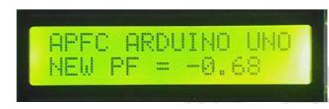
RESULT

Fig 3 Inductive load is connected in circuit
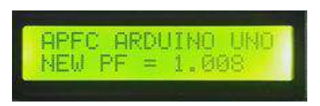

Fig 4 No load connected in circuit
Upon switching on the load, the LCD display initially shows the power factor value of the load before the power factor correction fig 3. As the displayed power factor value is smaller than the predefined reference value, the APFC system promptly takes action to improve the power factor. The system achieves this by inserting the necessary capacitor(s) in parallel with the load to rectify the power factor. Once the power factor correction process is completed, the LCD display then shows the adjusted power factor value, which should now be closer to the desired reference value fig 4. This real-time display of the improved power factor provides immediate feedback on the effectiveness of the APFC system's correction procedure. Overall, the APFC system's dynamic response ensures that the load's power factor is quickly rectified and maintained at an optimal level, resulting in enhanced energy efficiency and improved power quality. The real-time display on the LCD allows users to monitor the power factor adjustment and verify the successful implementation of the APFC system.
Conclusion
We successfully achieves its aim by demonstrating the design's output of the power factor. The APFC system's effectiveness in enhancing power factor values ensures more optimal power utilization, resulting in reduced energy wastage and improved system efficiency. With its application in industrial, power distribution, and residential settings, the automatic power factor corrector plays a crucial role in promoting sustainable energy practices and economic benefits. The APFC system stands as a key technology in achieving power factor correction and has proven to be an essential component for enhancing energy transmission efficiency across various sectors. Its successful implementation contributes to stable and cost-effective power distribution, making it a valuable asset in modern power management strategies.

Case 2: Revolutionizing Underground Cable Fault Detection
In the power system, the efficient transmission of generated electrical energy to consumer premises relies on both Overhead and Underground transmission systems. While the Underground system offers various advantages, such as reduced visual impact and lower susceptibility to weather-related damages, it presents challenges in precisely detecting fault locations when issues arise [8]. To address this issue, we propose a novel method called "Underground Cable Fault Location using IoT." By leveraging the capabilities of the Internet of Things (IoT), this method enables the accurate detection of fault locations remotely from a centralized base station. This breakthrough allows us to pinpoint the exact fault location in kilometers along the underground cable network [9]. Through the implementation of IoT sensors and advanced communication technologies, the system continuously monitors the underground cable network for any irregularities or faults. Once a fault is detected, real-time data is transmitted to the base station, enabling operators to analyze the information and determine the precise location of the fault in the underground cable network[10].
By adopting this innovative approach, power distribution companies and maintenance teams can respond swiftly to fault incidents, reducing downtime and minimizing disruptions to the power supply. This not only improves the overall reliability and performance of the Underground transmission system but also enhances the overall efficiency and stability of the power system.

Block diagram

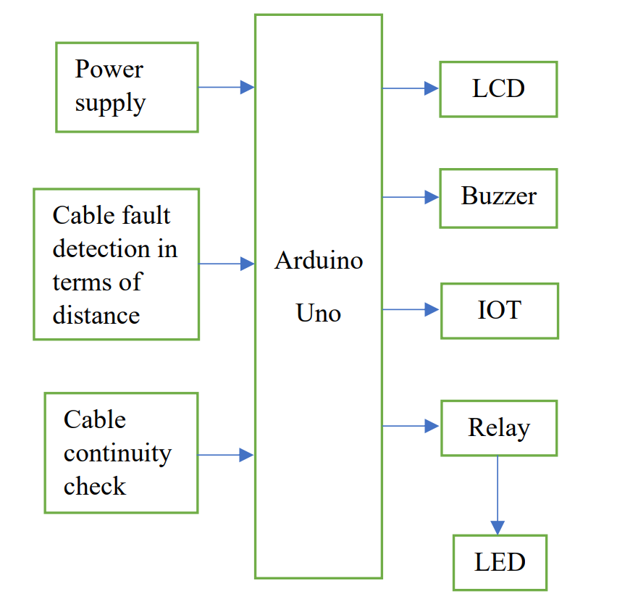

Fig 5 Block diagram for under ground cable fault detector using IOT

The system's block diagram comprises essential components fig 5, including Arduino Uno, LCD, Buzzer, IoT module, Relay, Indicator LED, and Power supply. Arduino Uno serves as the central control unit, executing all user-required operations through a pre-programmed code. The kit is activated when the power supply is turned on, and under normal conditions (no fault), there are no indications from the Buzzer, LED, LCD, etc.
In the event of a fault occurrence, the system provides multiple indications through the mentioned equipment. For voltage faults, the system emits sound, light, and displays relevant information on the LCD. Additionally, the IoT module sends fault information to the user's mobile device, enabling prompt actions to maintain system continuity by adjusting the power supply. For cable faults, the system generates indications through light, the Buzzer, and the LCD screen. Moreover, the IoT module transmits information about the exact fault distance from the base station to the user's mobile device. This helps the user accurately locate and address the fault along the underground cable network. Overall, this system's integration of Arduino Uno, IoT, and multiple indicators ensures efficient detection and reporting of voltage and cable faults in the underground cable network, enabling quick and targeted maintenance actions to ensure uninterrupted power supply. The UG Cable Fault Detection using IoT Kit has been constructed according to the circuit diagram. The assembled kit is described below.

Working module
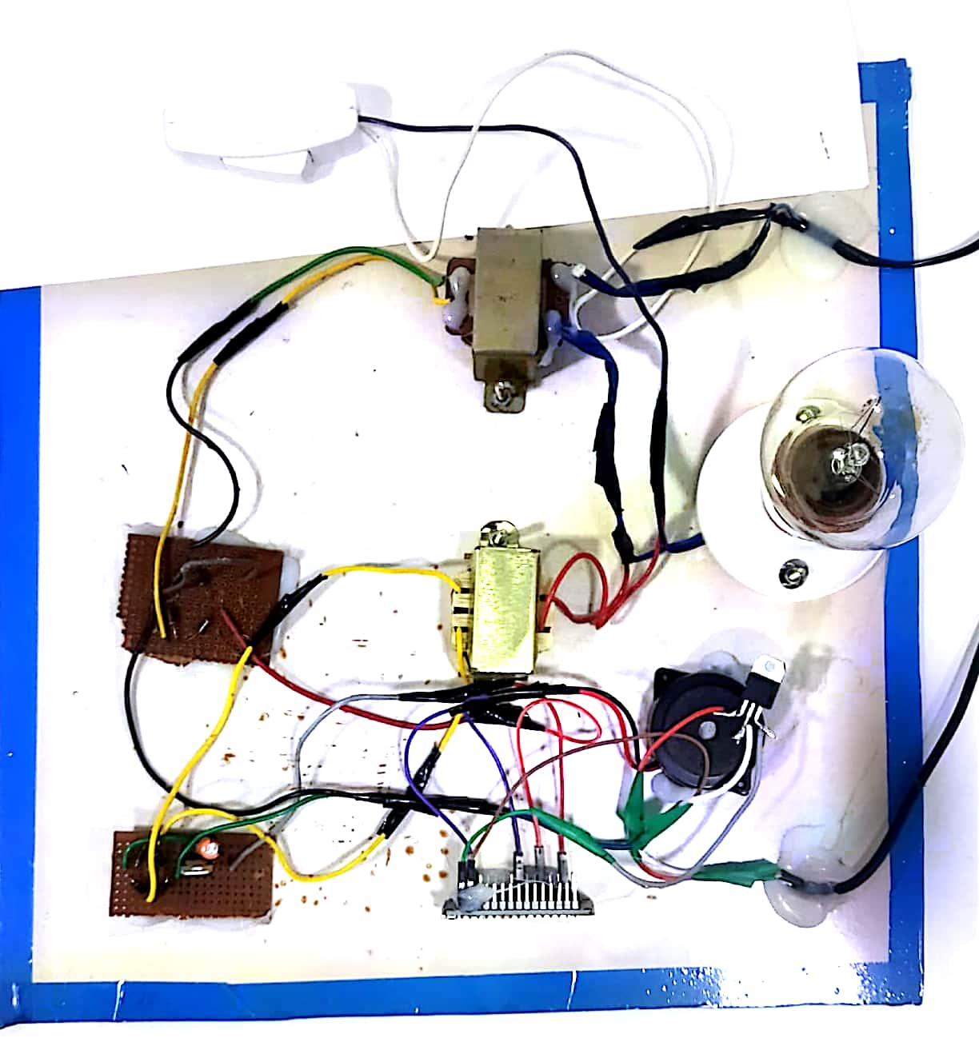
Fig 6 Working Module for under ground cable fault detector using IOT
Underground cables experience fewer disturbances in comparison to overhead transmission lines. In the event of a fault occurring in underground cables, we receive two distinct outputs. Initially, the display shows the condition under normal circumstances like fig 7.
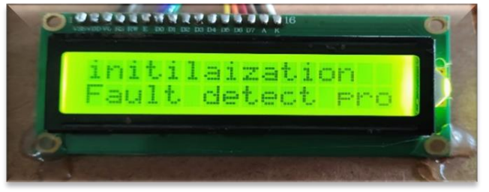

Fig 7: With out any fault

The initial indication is presented on the LCD display fig 8, signalling a voltage fault. Simultaneously, we receive information on our mobile device and display. This indication serves as a prompt for maintaining system continuity by replacing the faulty cable with a good one.
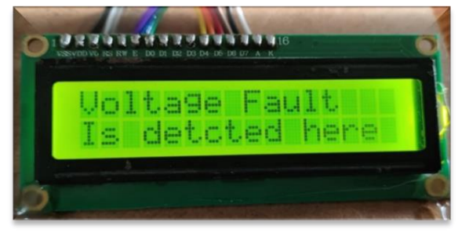

Fig 8: During Voltage Fault
The subsequent indication displayed on the LCD screen reveals the fault location in kilometers from the base station fig 9. This indication serves as a prompt for expedited and efficient repair of the faulty cable.
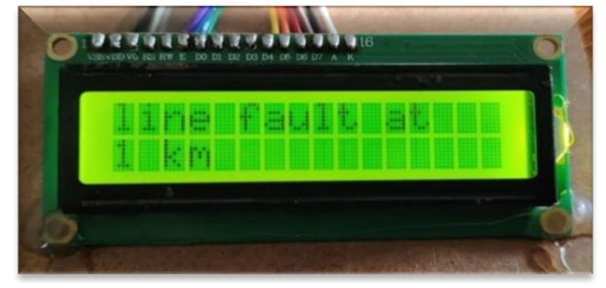

Fig 9 : Line Fault at 1 km
All the information displayed on the above-mentioned LCD screen is transmitted to the user's mobile device using the Blynk app. The Blynk app is specifically designed for controlling various electronic devices such as air conditioners, washing machines, fans, tube lights, etc. Additionally, it serves as a tool for monitoring and checking the output of projects created by students or scientists.
Conclusion
The Underground Cable transmission system encounters a limitation wherein the exact fault location cannot be determined from the base station. However, this limitation is addressed by the proposed method, enabling us to detect the fault location accurately, in kilometers, from the base station. This advancement simplifies the fault-clearing process for skilled personnel, significantly reducing the time required for repairs.

Case 3 : A Solution for Detecting Transformer Overloads and Addressing Power Theft
The technology of Internet of Things (IoT) is rapidly gaining popularity as a solution for various real-time challenges. This study proposes a real-time monitoring system for transformers and residential meters [12]. This system offers continuous and immediate access to energy consumption data for consumers, leveraging the advancements in IoT technology. The application of wireless technology in this system aims to address electricity theft, which often involves excessive power usage beyond the meter's designated limit [13]. Such practices lead to revenue losses for the government, transformer overloads, and damage. The primary objective of this research is to detect theft by identifying instances of transformer overloading [14]. The detection and control of power consumption involve calculating the energy utilized by users within a specific timeframe using the meter.
The proposed solution involves integrating a theft detection unit into the transformer. This unit alerts both the main supplier and the substation when high power consumption is detected. The information is then displayed on a webpage created by the supplier. The IoT operation is facilitated by a Wi-Fi device that transmits transformer data to the designated webpage. By utilizing the IoT framework, the Electricity Board can continuously monitor power consumption within a specific area, and this data can be visualized on an LCD display.
Block Diagram
Micro Controller ATmega328
LCD
RELAY
LOAD
METER
CURRENT SENSOR
SYSTEM
AC LOAD
KEYPAD
RFID
NODE MCU ESP8266

Fig 10 Block diagram for Power Theft Detection in Transmission line using IOT
Within the proposed framework, the power utility operates a server, and each consumer is equipped with a dedicated meter. For seamless communication, the server and meter rely on a local network and the IoT ESP8266 module. A visual overview of the envisioned power theft detection system is depicted in Fig 10. The composition of the electricity meter encompasses crucial elements, notably a microcontroller (ATmega 328), a current sensor, an LCD display, a relay, a keypad, and the IOT ESP8266 module. The current sensing sensor is adept at gauging the incoming current, which directly translates to power consumption. Essential data is pre-programmed and resides within the Electrical Erasable Read-Only Memory (EEPROM) of the AT89C52 microcontroller. This memory facility enables data storage that remains intact until the point of overwriting, ensuring that the stored information remains available until it is replaced. Upon resuming power supply, the meter reinstates its previous configured value, initially set by the supplier. The meter reading is prominently showcased on the LCD display, with a relay serving as an operative switch. By means of the Node MCU IoT ESP8266, the meter reading is seamlessly transmitted to the designated webpage managed by the electricity board.
Should the meter's power consumption exceed its designated limit, an alert regarding potential theft is promptly displayed on the electricity board's webpage [15]. Notably, this system empowers the supplier to remotely disconnect the connection when a high power utilization is detected within a particular sector. This advanced approach eradicates the necessity for manual intervention during load disconnection and reconnection processes. An additional significant benefit of this approach is its capacity to ensure that the entire system is exclusively accessible to authorized individuals. The Electricity Board section establishes a local host HTML webpage that adheres to specific conditions. This webpage presents the power consumption within a designated sector in units, while also indicating whether the power usage remains within acceptable limits or exceeds them. This is accomplished through the utilization of the IoT ESP8266 Wi-Fi module, which seamlessly transmits this information wirelessly.

Process Flow

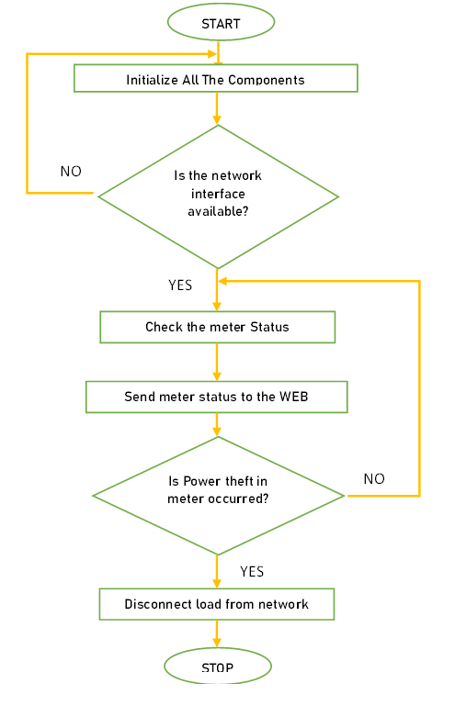

Fig 10 Process Flow for Power Theft Detection in Transmission line using IOT

The procedural sequence fig 10, distinctly outlines the precise design stages for identifying instances of theft. Upon activating the device, all components undergo initialization. The system undertakes an assessment of the operational status of the connectivity interface. If the connectivity interface proves functional, the system continuously monitors the occurrence of power theft within the meter. Concurrently, the meter reading is relayed to the designated webpage for display.
When a power theft event transpires, the sensor initiates a signal transmission to the processor. Consequently, the processor activates the connectivity interface, prompting it to dispatch a notification to the web platform, indicating elevated power consumption by the meter. This notification becomes visible on the webpage, and if the power usage surpasses a certain threshold, the supplier takes action to detach the load from the distribution network associated with the specific sector.
Working Module
Within this setup, the current sensor output pins establish a connection with the loads. The LCD's VDD and VSS pins are linked to the respective source and ground pins of the ATmega328 microcontroller. For data presentation, the D0-D7 pins of the LCD are interconnected with corresponding pins on the microcontroller. The meter's operational state is assessed through Proteus software under various circumstances. Notably, an increase in load correlates with an elevation in power.

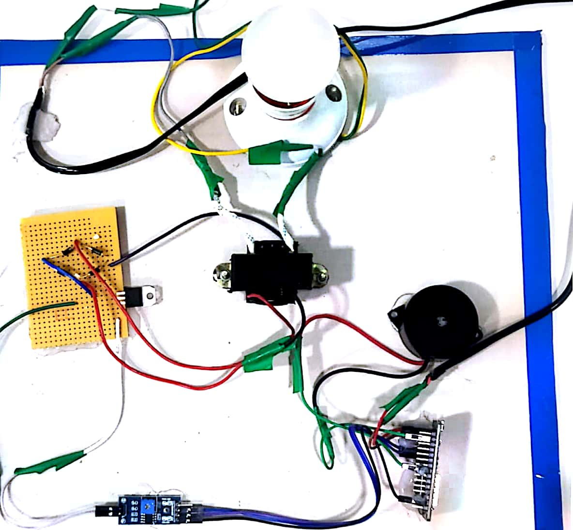
Fig 11 Working Module for Power Theft Detection in Transmission line using IOT

Result
The real-time readings from the meter are showcased on the webpage established by the electricity board department. This presentation includes the meter's power consumption and its status. As depicted in Fig 12, these details are also presented on the LCD display. When a power theft event unfolds, alerts concerning the theft are visibly presented both on the webpage, as illustrated in Fig 13. Notably, the system's resetting capability is now restricted from the consumer's end. Instead, an authorized representative from the designated agency is required to initiate a complete system reset.

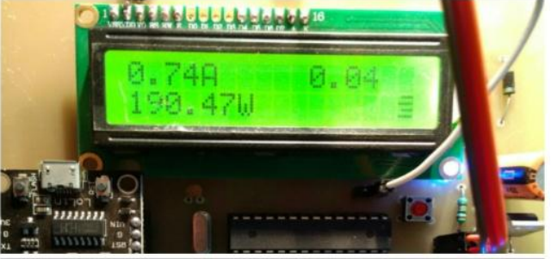
Fig 12 Power Consumed by a Consumer

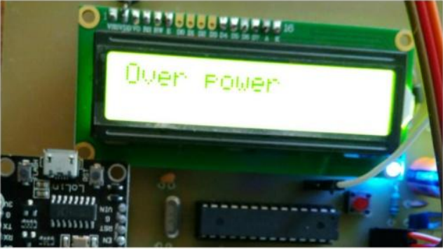
Fig 13 During Power Theft by a Consumer

Conclusion
This IoT-enabled wireless approach proves highly advantageous for the global detection of electricity theft. In efforts to mitigate revenue losses, detecting power theft beyond set limits becomes a critical endeavor for authorized personnel. This method is particularly effective worldwide when compared to other techniques of unauthorized electricity consumption. The system offers enhanced safety measures by empowering authorized individuals within the electricity board section to modify the transformer's limits. Furthermore, the system's capacity to cut off supply can solely be reset by these authorized personnel. Consequently, this framework substantially curtails the likelihood of human errors and establishes an outstanding means for identifying instances of energy meter bypass.

CONCLUSION
In conclusion, our efforts in implementing the Automatic Power Factor Correction (APFC) system have yielded significant benefits in power factor optimization, energy efficiency, and overall system performance. By consistently monitoring and adjusting reactive power compensation, the APFC system has demonstrated its capability to minimize energy losses and promote efficient power utilization across a diverse range of applications, from industrial to residential settings. This technology not only supports sustainable energy practices but also brings substantial economic advantages through reduced energy wastage and improved power transmission. The success of the APFC system showcases its pivotal role in modern power management strategies. By enhancing power factor values, the system contributes to stable and cost-effective power distribution, aligning with the goals of a smarter, more resilient grid. As a fundamental component in the energy sector, the APFC system continues to be a valuable asset, driving us towards a more efficient and sustainable energy future.
Our innovative approach to UG Cable fault detection using IoT has addressed a significant limitation in the current transmission system. By accurately pinpointing fault locations remotely from a centralized base station, we have revolutionized the fault-clearing process, saving precious time and resources for skilled maintenance personnel. This advancement is a critical step in improving the reliability and operational efficiency of underground power distribution networks. As we continue to evolve and optimize this method, we contribute to minimizing downtime, reducing service disruptions, and ultimately enhancing the reliability of power supply.
In the fight against electricity theft, our IoT-powered detection system represents a cutting-edge solution that surpasses other traditional methods. With its global applicability and effectiveness, this wireless approach allows authorized personnel within the electricity board to detect power theft beyond set limits, promoting fair energy consumption practices. The system's built-in safety measures, which allow only authorized individuals to modify transformer limits and reset the supply, substantially reduce the risk of human errors and instances of energy meter bypass. As a result, this framework not only helps mitigate revenue losses for utilities but also establishes a robust means for identifying and addressing instances of unauthorized electricity consumption.
Overall, our implementation efforts in these IoT applications for the power system have demonstrated the potential for transformative change. By embracing IoT technology, we are not only achieving immediate improvements in power factor correction, fault detection, and power theft prevention but also laying the foundation for a more sustainable, efficient, and intelligent power grid infrastructure. As we continue to overcome challenges, refine our methods, and collaborate with industry stakeholders, we can look forward to a future where these advancements are fully integrated into our power management practices, bringing lasting benefits to the energy sector and society as a whole.

REFERENCE

- M. Qu, K. Zhang and S. Sun, "Research on Accurate OTA Testing for Large-Form-Factor 5G IoT Devices in Medium-Sized Anechoic Chamber," in IEEE Antennas and Wireless Propagation Letters, vol. 21, no. 9, pp. 1837-1841, Sept. 2022, doi: 10.1109/LAWP.2022.3182381.
- Shih-Min Hsu, A. Ghosh and A. Joshi, "Discussion of "A new approach to load balancing and power factor correction in power distribution system" [Closure to discussion]," in IEEE Transactions on Power Delivery, vol. 15, no. 4, pp. 1325-1326, Oct. 2000, doi: 10.1109/61.891535.
- A. J. Sari, M. A. Murti and I. P. Dwi W, "Power Factor Correction Control Based on Internet of Things Using Lumped Compensation Capacitor Bank," 2021 IEEE International Conference on Internet of Things and Intelligence Systems (IoTaIS), Bandung, Indonesia, 2021, pp. 247-253, doi: 10.1109/IoTaIS53735.2021.9628423.
- P. Bhagavathy, R. Latha and E. Thamizhmaran, "Development of IoT Enabled Smart APFC Panel for Industrial Loads," 2019 10th International Conference on Computing, Communication and Networking Technologies (ICCCNT), Kanpur, India, 2019, pp. 1-5, doi: 10.1109/ICCCNT45670.2019.8944899.
- M. S. Rahman, A. Memy, M. A. Mahmud and S. Siddique, "Automatic Power Factor Measurement And Improvement Using Capacitor Bank," 2022 IEEE International Power and Renewable Energy Conference (IPRECON), Kollam, India, 2022, pp. 1-6, doi: 10.1109/IPRECON55716.2022.10059553.
- W. Zhang, X. Xiao, K. Zhou, W. Xu and Y. Jing, "Multicycle Incipient Fault Detection and Location for Medium Voltage Underground Cable," in IEEE Transactions on Power Delivery, vol. 32, no. 3, pp. 1450-1459, June 2017, doi: 10.1109/TPWRD.2016.2615886.
- A. Said, S. Hashima, M. M. Fouda and M. H. Saad, "Deep Learning-Based Fault Classification and Location for Underground Power Cable of Nuclear Facilities," in IEEE Access, vol. 10, pp. 70126-70142, 2022, doi: 10.1109/ACCESS.2022.3187026.
- Y. Wu, P. Zhang and G. Lu, "Detection and Location of Aged Cable Segment in Underground Power Distribution System Using Deep Learning Approach," in IEEE Transactions on Industrial Informatics, vol. 17, no. 11, pp. 7379-7389, Nov. 2021, doi: 10.1109/TII.2021.3056993.
- T. Gomathi, R. E, S. Sivasundarapandian, A. Aranganathan, S. P. R and V. Vedanarayanan, "Monitoring underground cable faults by inspecting the phase variation using the IoT and Node MCU," 2023 Eighth International Conference on Science Technology Engineering and Mathematics (ICONSTEM), Chennai, India, 2023, pp. 1-5, doi: 10.1109/ICONSTEM56934.2023.10142936.
- V. V. Teresa, K. Rajeshwaran, S. S. Kumar, S. Vishnupriyan and S. Dhanasekaran, "IoT-based Underground Cable Fault Detection," 2022 International Conference on Augmented Intelligence and Sustainable Systems (ICAISS), Trichy, India, 2022, pp. 1094-1100, doi: 10.1109/ICAISS55157.2022.10010910.
- Y. Peng et al., "Electricity Theft Detection in AMI Based on Clustering and Local Outlier Factor," in IEEE Access, vol. 9, pp. 107250-107259, 2021, doi: 10.1109/ACCESS.2021.3100980.
- R. Punmiya and S. Choe, "Energy Theft Detection Using Gradient Boosting Theft Detector With Feature Engineering-Based Preprocessing," in IEEE Transactions on Smart Grid, vol. 10, no. 2, pp. 2326-2329, March 2019, doi: 10.1109/TSG.2019.2892595.
- V. K. K, A. P, C. A, G. K. K and K. Deepthi, "A Review of Theft Diagnosis from Smart Energy Meter Using IoT," 2022 6th International Conference on Electronics, Communication and Aerospace Technology, Coimbatore, India, 2022, pp. 526-529, doi: 10.1109/ICECA55336.2022.10009567.
- P. K. Sebastian and D. K, "Internet of Things based Smart Energy Meter with Fault Detection Feature and Theft Detection," 2022 International Conference on Electronics and Renewable Systems (ICEARS), Tuticorin, India, 2022, pp. 494-500, doi: 10.1109/ICEARS53579.2022.9751828.
- R. P. Sethupathi, V. Vasanthan, M. S. Krishnaa and S. David, "Advanced Energy Theft Detection System in Smart Grid using IoT," 2023 2nd International Conference on Advancements in Electrical, Electronics, Communication, Computing and Automation (ICAECA), Coimbatore, India, 2023, pp. 1-6, doi: 10.1109/ICAECA56562.2023.10200576.

