Nutrient management for some major Pulse crops
Seerat un Nissa, Mehfooza Habib, Ajaz Lone, Efath Shahnaz, Fayaz bahar,Zahoor baba,Ansar ul haq, Zahida Rashid, Shahida Iqbal and Shamshir ul Hussan.
Nutrient imbalance is one of the major abiotic constraints limiting productivity of pulses. The inbuilt mechanism of biological N₂ fixation enable pulse crops to meet 80–90 per cent of their nitrogen requirements, hence a small dose of 15–25 kg N/ha is sufficient to meet out the requirement of most of the pulse crops. However, in emerging cropping systems like Rice - Chickpea, a higher dose of N (30–40 kg/ha) had shown beneficial effect - Phosphorus deficiency in soils is wide spread and most of the pulse crops have shown good response to 20–60 kg P₂O₅/ha depending upon nutrient status of soil, cropping system and moisture availability. Response to potassium application is location specific. In the recent years, use of sulphur (20–30 kg/ha) and some of the micronutrients such as Zn, B, Mo and Fe have improved productivity of pulse crops considerably in many pockets. B and placement of phosphatic fertilizers and use of bio-fertilizers enhance the efficiency of applied as well as native P. Foliar nutrition of some micronutrients proved quite effective. The amount and mode of appiication is determined by indigenous nutrient supply, moisture availability and genotypes. Balanced nutrition is indispensable for achieving higher productivity. At the same time, in view of increasing nutrients demand, there is immense need to exploit the alternate source of nutrients viz., organic materials and bio-fertilizers to sustain the productivity with more environment friendly nutrient management systems.
Practical recommendations and guidelines on nutrient management for specific crops are usually provided by the local research and extension services in each country. This is logical and also necessary because of the crop- and area-specific nature of such recommendations.

GRAIN LEGUMES

Chickpea (Cicer arietinum L.)

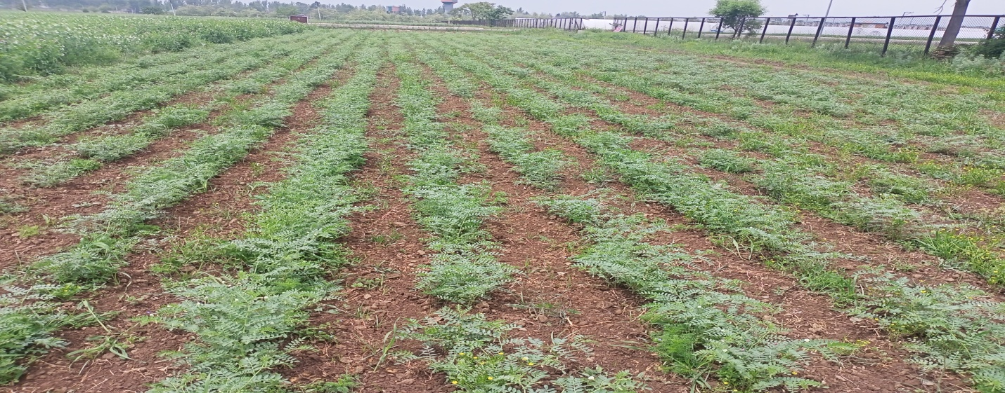
Chickpea is an important grain legume of the arid and semi-arid regions, where it is grown with or without irrigation. The grain contains about 20 percent protein and forms an essential part of human diet in many countries.

Nutrient requirements

A crop producing 1.5 tonnes of grain has been reported to remove the following amounts of major nutrients and micronutrients through total dry matter (Aulakh,2005):
􀂾 macronutrients (kg/ha): N 91, P2O5 14, K2O 60, MgO 18, CaO 39 and S 9;
􀂾 micronutrients (g/ha): Fe 1 302, Zn 57, Mn 105 and Cu 17.
A large part of the N is presumably derived from BNF.

Rhizobium inoculation

Being a legume, chickpea can benefit from BNF in association with Rhizobium.Therefore, inoculation with Rhizobium is often recommended to augment N supply by the soil. The benefit resulting from inoculation is broadly equivalent to the application of 20–25 kg N/ha.

Macronutrients

Even where the soil or the seed is treated with Rhizobium biofertilizer, an N application is necessary. This serves as a starter dose and meets the N needs of the crop until the N-fixation system becomes operational. For this purpose, 15–20 kg N/ha is generally recommended. In addition to N, application of 40–50 kg P2O5/ha is also recommended. The entire amount of N and P2O5 is normally given before planting. There is a strong positive interaction between the availability of moisture and nutrients. The benefits of supplying irrigation increase with increased nutrient application. In S-deficient soils, application of 20–30 kg S/ha through any of the conventional sulphate sources results in a significant increase in grain yields.

Micronutrients

In neutral to alkaline soils (where chickpea is usually grown), Zn and Fe deficiencies can be encountered. To correct Zn deficiency, soil application of zinc sulphate at a rate of 25 kg /ha is suggested under irrigated conditions. Fe deficiency can be corrected by providing foliar sprays with 2-percent ferrous sulphate solutions. In B-deficient soils, application of borax can increase the yield by an average of 350 kg grain/ha.

Soybean [Glycine max (L.) Merr]

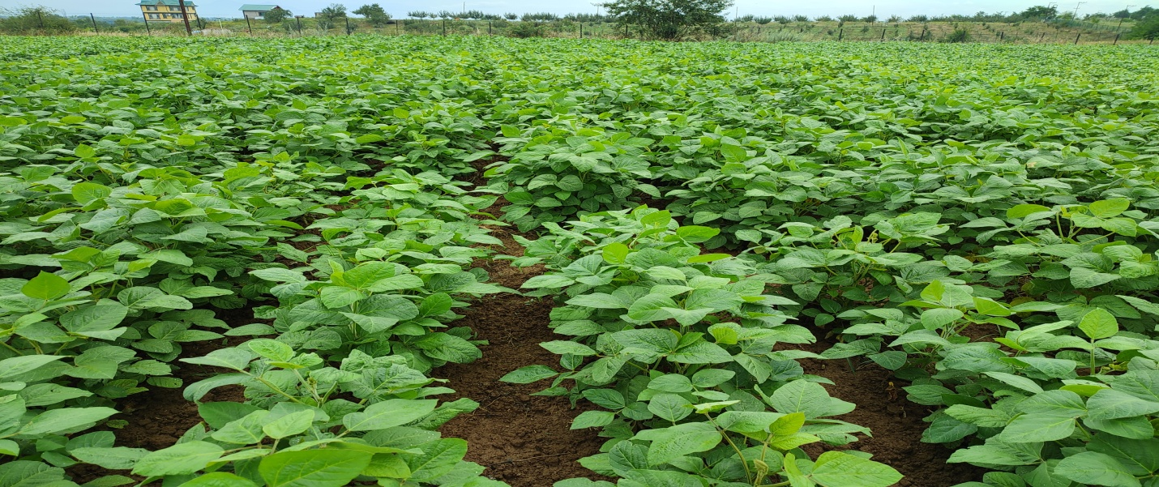

Soybean is a very energy-rich grain legume containing 40 percent protein and 19 percent oil in the seeds. The crop is adapted to a wide range of climate conditions. The highest soybean yields are produced in near neutral soils but good yields can be obtained also in limed acid soils. Under good growing conditions with adequate N fixation, grain yields of 3–4 tonnes/ha can be obtained.

Nutrient requirements

Total nutrient uptake by the plants per tonne of grain production can be taken as follows (IFA, 2008):
􀂾 macronutrients (kg): N 146, P2O5 25, K2O 53, MgO 22, CaO 28 and S 5;
􀂾 micronutrients (g): Fe 476, Zn 104, Mn 123, Cu 41, B 55 and Mo 13.
Under conditions favourable for N fixation, a significant part of the N uptake can be derived from BNF.

Rhizobium inoculation

Inoculation with Rhizobium japonicum (now known as Bradyrhizobium japonicum) culture is often recommended particularly where the crop has been introduced recently or the native Rhizobium population is inadequate and ineffective. Under good conditions, the soybean crop will fix 100 kg N/ha or more.

Macronutrients

N fixation can meet a large part of the N requirement of the crop, for which it is usually necessary to treat the seed with bacterial inoculant. The crop may respond up to the application of 100 kg N/ha in the absence of poor BNF. However, in most cases, a starter dose of 20–40 kg N/ha is recommended as it takes some weeks for the nodules to develop and N fixation to start. Large applications of N are needed where N fixation is very low. Fertilizer P and K requirements of soybean should be based on soil test values. Typical application rates for soils of low nutrient status are 50–70 kg P2O5/ha and 60–100 kg K2O/ha. In the soybean-growing areas of the United States of America, for an expected grain yield of 2.5–2.7 tonnes/ha, the recommended rates of P on low-fertility soils are 40–60 kg P2O5/ha, and 100–150 kg K2O/ha on soils with a low to normal clay content. Application rates are higher at higher yield levels in soils with a high clay content. As an example, for each additional tonne of grain yield, an extra 10–15 kg P2O5/ha and 20–30 kg K2O/ha is recommended. Soybean responds to the application of Mg and S depending on soil fertility status and crop growth conditions. Significant responses of soybean to S application have been found in many field trials in India. In several cases, it may be advisable to apply phosphate through SSP so that the crop also receives an S application. Where DAP is used, gypsum can be applied to the soil before planting at the rate of 200–250 kg/ha.

Micronutrients

Depending on soil fertility status and crop growth conditions, responses have been obtained to the application of Zn and Mn. Application of 5 kg Zn /ha on coarse-textured soils and 10 kg Zn /ha on clay soils can remedy Zn deficiency. On Mn-deficient soils, the application of manganese sulphate at a rate of 15 kg/ha to the soils or 1.5 kg through foliar spray increases yield.

PLANT NUTRITION AND PRODUCT QUALITY

Because only properly nourished plants can provide products of overall high quality, any fertilization that improves the supply of plant nutrients from deficiency to the optimal range raises the amount of nutritional substances. However, it is impossible to increase the concentrations of all valuable substances simultaneously. The nutrient supply required for high crop yields and for good food quality is nearly similar. In certain cases, e.g. baking quality of cereals or additional nutrient supply for highly productive animals, high-quality food and feed is produced by keeping supplies of some plant nutrients in the luxury supply range. The relationship between nutrient supply and the resulting change in quality of crop products has largely been established. In assessing the effects of added nutrients on produce quality, it should be remembered that: (i) increasing the nutrient supply from deficiency to the optimal range usually results in better produce quality; (ii) increasing supplies from optimal to the luxury range may increase, maintain or decrease quality; and (iii) extreme increases in supplies into the toxicity range reduce quality and must be avoided. Nutrients differ in their roles in plant production and produce quality. Such effects are discussed in brief below.

Nitrogen supply and product quality

The addition of N generally has the greatest effect on plant growth and also considerable influence on product quality, especially through increases in protein concentration and its quality. It also increases the concentration of several other valuable substances. However, where the N supply is excessive, harmful substances may be formed that decrease quality. Various N compounds in plants are important for quality assessment. The manner in which these are affected by N supplies is summarized below:
􀂾 Nitrate: Form of N taken up from soil; basis for protein synthesis; nitrate concentrations of plants are generally low, but it may be accumulated.
􀂾 Crude protein: This is an approximate measure of protein and some other N compounds. Crude protein concentration = N concentration × 6.25. The concentration of crude protein in wheat grain may be raised from 10 percent to more than 15 percent, thus improving the “baking quality” of the flour.
􀂾 Concentration of pure protein increases up to the optimal N supply level despite some counteracting dilution effect. Pure protein can be divided into several fractions:
􀁸 Prolamine and gluteline (low-value protein). Gluten is important for baking quality. N supply increases the prolamine content in grains, thus increasing the gluten concentration of grain kernels, which improves baking quality.
􀁸 Albumin and globulin (high-value protein), containing many essential amino acids. The concentration of albumen, which has high nutritional quality, increases with the concentration of pure protein.
􀂾 Essential amino acids: Nine protein constituents that are vital for humans and must be contained in food. Their concentration determines the biological value of the protein, expressed by the Essential Amino Acid Index (EAAI).
Vegetable proteins have values of 50–70 percent compared with 100 percent in case of egg protein. The concentration of essential amino acids often increases up to the optimal N supply level, but it sometimes decreases through dilution, especially where there is luxury N consumption.
􀂾 Amides: These are important storage forms of N (e.g. asparagine orglutamine) found in leaves and vegetative reserve organs. Amides have only small nutritional value for humans, but, if heated, may produce substances with an undesirable odour. They can be a source of protein for ruminants.
􀂾 Amines: Various N-containing compounds present in small concentrations in plants. Some, e.g. choline, have important functions, whereas others, e.g. nitrosamines and betaine, are unwanted.
􀂾 Cyclic N compounds such as chlorophyll; N-containing vitamins such as vitamin B1; alkaloids, such as nicotine in tobacco; purine derivates, such as theobromine in cocoa. Where N supplies are excessive, some unwanted N compounds may accumulate in vegetative plant parts. These are primarily the unutilized nitrate and amines. Nitrate can accumulate in leaves, especially where light intensity is reduced. Concentrations of nitrate-N (in dry matter) in vegetables should not exceed 0.2 percent in salad vegetables or 0.3 percent in spinach because of the risk of nitrite formation. Nitrite, which usually occurs in insignificant amounts, can be formed in leaves under reducing conditions, e.g. where spinach is stored without access to air. When food high in free nitrate is consumed, it may cause methemoglobinaemia. The best way to keep nitrate concentrations in vegetables low is to restrict N fertilization to a medium level and to apply total N in splits. Nitrosamines are formed from nitrite and secondary amines and some are carcinogenic (e.g. diethylnitrosamine). Their concentration in plants is normally insignificant and not a health problem. Betaine is an important constituent of the so-called “detrimental nitrogen”, which interferes with the crystallization of sugar from the juice of sugar beets and, thus, reduces sugar yield An increase in N supplies also causes several types of changes in other substances, e.g.: (i) the concentrations of carotene and chlorophyll increase up to the optimal N supply; (ii) the concentration of vitamin B1 in cereal grains increases until luxury N level; (iii) the concentration of vitamin C (ascorbic acid) decreases owing to the dilution effect; (iv) the concentration of oxalic acid, a harmful compound, increases in vegetables leaves (for human consumption) and in sugarbeet leaves (used as fodder for cattle), especially after fertilization with nitrate-N; and (v) the concentration of HCN in grass increases slightly – while its normal concentrations appear to promote animal health, higher doses are toxic.Thus, the concentrations of all N fractions increase with higher N supply, but in different ways. The highest biotic value is obtained in the optimal supply range. Luxury N supply improves only certain quality components and this is often accompanied by quality reductions of other kinds. Thus, intensive fertilization of cereals with N may improve baking quality, but it lowers the average protein value. Because plants normally absorb nitrate independently of the source from which it is applied, a direct influence of the form of N applied cannot be expected. However, where ammonium is applied and managed so that this is the form taken up by the plant, the nitrate concentration in leaves can be kept low. This can be achieved also by using slow-release fertilizers and nitrification inhibitors wherever their use is feasible and economic. Other influences observed on the qualitative composition resulting from the application of different N forms are mainly causedby side-effects, such as changes in soil pH.

Phosphorus supply and product quality

Owing to its many important roles in plant metabolism, the supply of P plays a central role in crop quality. Important quality indicators with respect to P are: (i) the P concentration and the composition of the plant P fraction; (ii) the concentration of other valuable substances that increase with better P supply; and (iii) the concentration of toxic substances that are often lower with increased P supply.
The major P-containing compounds that are important for crop quality are:
􀂾 Phosphate esters: These are the products of phosphorylization, i.e. bonding of phosphate anions as phosphoryl group (-H2P03) to organic molecules like sugars (R-O-H2PO3).
􀂾 Phytin: This is the main organic form of phosphate storage (Ca-Mg-salt of phytic acid, i.e. inositol hexaphosphoric acid). Phytin is the main P reserve of seeds and can constitute up to 70 percent of total P. The proportion of phytin in vegetables such as potatoes is about 25 percent, and phytin, like inorganic P, is utilized by all animals, but best by ruminants. However, for humans, phytic acid may reduce the bioavailability of Fe and Zn.
􀂾 Phosphatides or phospholipids: These are important constituents of cell membranes that contain phosphoryl groups (e.g. lecithin, a glycerophosphatide). These form only a small portion of total plant P. The P concentration of food and fodder is an important quality criterion because insufficient P intake causes “bone weakness” and deformations, which were common in cattle before the use of mineral P fertilization. In contrast to N, the P supply to crops remains in the “normal” range and rarely reaches the luxury range on most soils. In other words, there is practically no danger of overfertilization with P, which may cause problems owing to excess phosphate in food or feed. When the P supply increases from deficiency to the optimal level, the total P concentration increases in the vegetative and reproductive parts, thus improving crop quality. The concentration of nucleic P increases only slightly, while the concentration of phosphatide-P remains approximately constant, and both occur in low concentrations. There is also a higher concentration of other value-determining substances, such as: (i) crude protein in green plant parts and essential amino acids in the grains; and (ii) carbohydrates (sugar and starch) and some vitamins, e.g. B1. Seed quality improves with P nutrition, which results in greater seedling vigour. On the other hand, the concentration of some other substances such as nicotine in tobacco, oxalic acid in leaves or coumarin in grass can be reduced.

Potassium supply and product quality

Among plant nutrients, K is very closely associated with crop quality. It is required for good growth as well as for good crop quality, plant health, tolerance to various stresses and seed quality. By greatly affecting enzyme activity and through osmotic regulation, K affects the entire metabolism of the plant, especially photosynthesis and carbohydrate production. It improves the quality of several products including tubers, fruits and vegetables. Increasing K supplies to plants up to the optimal level brings about the
following changes:
􀂾 The concentration of carbohydrates increases owing to intensified photosynthesis, which results in larger concentrations of sugar, starch, fibres (cellulose), and also of vitamin C.
􀂾 The concentration of crude protein is reduced although the total amount is increased. This results from the dilution effect owing to the relatively greater increase in carbohydrate content. However, the more valuable fraction of pure protein may sometimes increase.
􀂾 The concentration of vitamin A and its precursor, carotene, increase.
􀂾 Losses of starch-containing tubers, such as potatoes, during storage are reduced through the prevention of decomposition of starch by enzymes.
􀂾 Unwanted “darkening” of potatoes is reduced. This phenomenon is caused by the formation of melanines and is particularly pronounced where K is deficient. Proper K supplies also prevent “black spotting” of potatoes upon cooking. Unlike P, the K concentration is not a quality-determining component. Food usually contains more K than is required by humans or animals. Luxury supply of K in leaves may occur as a result of high K uptake. This is not detrimental but excess absorption of K by plants tends to reduce the uptake/concentration of Ca, Mg and Na, resulting in an imbalanced supply of these regulators of cell activity. K-induced Mg deficiency can decrease crop quality. On grassland, this can result in Mg deficiency in grazing animals. Some effects of K fertilizers on crop quality are not caused by K itself but by the accompanying anion such as chloride or sulphate. Application of potassium sulphate results in a higher starch concentration in potatoes than where potassium chloride is applied. This is because chloride disturbs the transport of starch from the leaves to the storage organ (tubers). Similarly, in the case of cigarette tobacco, potassium sulphate is the preferred source of K over potassium chloride because excess chloride can reduce the burning quality of the leaf.

Calcium supply and product quality

A good Ca supply is essential for osmotic regulation and pectin formation. The Ca concentration of food and fodder is important for a proper balance of the major cations. Adequate supplies of Ca prevent a number of crop quality problems, such as inner decay of cabbage, brown spot and bitter pit in apples, and empty shells in groundnuts. Although Ca supply may not increase the oil content in groundnut, the total oil yield increases as a result of the favourable effect of Ca on kernel yield. Many of the benefits of liming on crop quality stem less from Ca itself but more from indirect effects caused by changes in soil pH that increase the supplies of other elements.

Magnesium supply and product quality

A good supply of Mg increases the concentration of carbohydrates and also chlorophyll, carotene and related quality components that are important for grazing animals. The Mg concentration is an important quality criterion because the major cations (K, Ca and Mg) should be balanced in order to ensure the best nutritional quality in cereals. Adequate Mg increases grain size and boldness. It is also reported to increase the oil content in oilseeds. For example, excess K in grass can result in Mg deficiency leading to hypomagnesaemia or grass tetany in grazing animals.

Sulphur supply and product quality

As S is an important constituent of some essential amino acids (cystein, cystine and methionine), S deficiency lowers protein quality. About 90 percent of plant S is present in these amino acids. Some plants (crucifers) contain S in secondary plant substances, e.g. oil, whose synthesis is inhibited where S is deficient. Mustard and onions rely for pungency and flavour on S-containing substances and these are also useful for increasing resistance against infections in the plant. An adequate supply of S improves: oil percentage in seeds; seed protein content; flour quality for milling and baking; marketability of copra; quality of tobacco; nutritive value of forages; grain size of pulses and oilseeds; starch content of tubers; head size in cauliflower; and sugar content and sugar recovery in sugar cane.

Micronutrient supply and product quality

Because micronutrients are involved in many metabolic processes, their adequate supply is a precondition for good food quality, especially with respect to the concentrations of proteins and vitamins. A survey of micronutrients in staple foods has been provided by Graham, Welch and Bouis (2001). The total concentration of the individual micronutrients is an important index of food and feed quality. However, some compounds containing micronutrients are utilized only partly by humans and animals. Because the concentrations of micronutrients are not determined routinely, their average concentrations are often considered for nutritional purposes although these may give only an approximate idea of actual concentrations. For example, in leafy vegetables, a wide variation may occur. The following concentrations (in milligrams per kilogram of dry matter) range from marginal deficiency to luxurysupply but are not toxic: Fe 20–800, Mn 15–400, Zn 10–200 and Cu 3–15. The consequences for health are clear. If a person is to be supplied with vegetables rich in Fe for better blood formation, then products with higher Fe concentrations are certainly preferable. Micronutrient concentrations should not be increased up to the toxicity level. Toxic concentrations are not only detrimental as such, but also negatively affect the composition of organic food constituents. The following comments on individual micronutrients relate to food quality:
􀂾 B is required in good supply for fruit and vegetable quality. B deficiency causes spots and fissures that substantially reduce produce quality and market value.
􀂾 Cu is required in optimal amounts for high concentrations and quality of protein and also to avoid spottiness in some fruits. A shortage of Cu partly combined with Co deficiency in grass retards the growth of grazing animals, and metabolic disorders manifest in the so-called “lick disease”.
􀂾 Fe in green-leaf vegetables such as spinach is an important source of Fe for humans. Soils with high pH tend to produce products low in Fe.
􀂾 Mn raises the concentrations of some vitamins, such as vitamin A (carotene) and C, in food and fodder crops. For good fertility, grazing animals require Mn concentrations that are about double those required for optimal grass growth.
􀂾 Mo deficiency decreases protein content and quality because of the important functions of Mo in BNF and N metabolism. Mo is also involved in the formation of healthy teeth.
􀂾 Zn is connected with plant growth hormones. Therefore, a good supply is required in order to obtain full-sized products, as in the case of citrus fruits. Compared with Cu, the optimal range of Zn is large but its toxicity can become a problem on soils with excessive Zn. Excess micronutrients reduce food quality properties. However, this rarely is the case on most soils. An excess of chloride can aggravate salinity problems, adversely affect salt-sensitive crops and lower the quality of crops such as potato, tobacco and grapes.

