A Case study on increasing fast food preferences among youth and its effect on health and well-being

Mr. Parvez Ahmad
Student, School of Hospitality & Tourism,
Galgotias University, Greater Noida

Prof. (Dr.) Vikas Singh
Professor, School of Hospitality & Tourism
Galgotias University, Greater Noida

Mr. Amit Kumar
Asst. Professor, School of Hospitality & Tourism
Galgotias University, Greater Noida

Mr. Yazuvendra Singh
Asst. Professor, School of Hospitality & Tourism
Galgotias University, Greater Noida

Prof. (Dr.) Rajiv Mishra
Dean, School of Hospitality and Tourism
Galgotias University, Greater Noida

Abstract
Purpose: This review article aims to investigate the increasing fast-food preferences among youth and its effect on their health and well-being.
Junk foods are unhealthy foods that are high in calories from fat or sugar and low in essential nutrients such as minerals, vitamins, protein and fibre. The exact definition of unhealthy food here varies by use. Some foods high in protein, such as meat prepared with saturated fat, are known as unhealthy foods. They are high in sugar, high in salt, and high in fat. Fast food restaurants are often equated with or cannot be described as successful junk food. It takes less time and served easily is known as fast food. This paper brings out the food preferences of the youth and various factors that are involved in their likes and dislikes.

Keywords: Food Preference, health, well-being,

I. Concept
Consumption of fast food among young adults is very high among young adults. Despite enough knowledge about the dangers of
junk food, teenagers in college still eat junk food because of its convenience and easy packaging. The government should strictly control and regulate advertising policies and wellness programs supported by unhealthy food companies. Appropriate interventions to improve eating habits are recommended for adolescents

II. Introduction
The United Nations defines YOUTH as persons between the age group of 15 to 24. Junk foods are unhealthy foods that are high in calories from fat or sugar and low in essential nutrients such as minerals, vitamins, protein and fibre. The exact definition of unhealthy food here varies by use. Some foods high in protein, such as meat prepared with saturated fat, are known as unhealthy foods. They are high in sugar, high in salt, and high in fat. Fast food restaurants are often equated with or cannot be described as successful junk food. It takes less time and served easily is known as fast food.
It is very attractive because it is cheap, easily available and tastes good. India represents different cuisine and cultures like north Indian south Indian etc. Different regions have different foods. Nowadays parents don’t have sufficient time to prepare a meal at home. Fast food has changed in component size, energy content, and nutrient profile over the last 30 years, Comparisons between portion size and calorie consumption.

Nowadays youth do not like home or traditional food in comparison to fast food because fast food is spicy, sweaty, flavorful aromatic.
Junk food is popular all over the world and consumption is steadily increasing. Traditional foods have largely been replaced by ready-to-eat, canned, and long-lived foods. The consumption of such foods has peaked in developed countries. However, it is increasing in developing countries of the world. South Asian countries are clearly on the rise in junk food consumption. Despite well-established evidence about the negative effects of junk food on the human body, junk food consumption remains popular among teens.
A street vendor sells ready-to-eat food or beverages on the street or in another public location, such as a market or an exposition. It's frequently sold from a mobile restaurant, a food cart, or a food truck, and it's ready to eat right away. Some street food is regional, but most of it has expanded well beyond its origins. Most street food is both finger food and quick food, and it is usually less expensive than restaurant cuisine.

Fast food and its consequences have become a major concern in the health world as it promotes health and increases risk. Although adverse health outcomes are evident in all age groups, children and adolescents are at greater risk. It can cause obesity and cause heart disease, heart disease, cancer, high blood pressure, and diabetes, etc. may increase the risk of noncommunicable diseases (NCDs), such as This study aims to investigate eating disorders and their effects among young students.

III. Objective
- To examine consumption habits.
- To identify ‘youngsters’ tastes and choices.
- To analyze the relationship between dependent and independent changes.

IV. Literature Review:
(Jaworowska, et al., 2013) describe in their study that the Intake of speedy meals keeps increasing in Western areas and is especially substantial among youth. The meal plays a vital role in the growth and anticipation of many diseases. Poor eating affects public health. the prevailing overview nutritional traits of convenience food and speedy-meals gadgets, such as their strength.

(Kaushik, 2011) says in their study that Fast food culture is a rising trend. The availability, flavour, low fee, advertising techniques and peer stress make it famous among our youths. Speedy meals restaurants are maximizing performance and conformity. The menu is standard and limits the ready time so that the customers to devour fast and depart. This angle delineates the emerging fast-food culture in India, its effect is the same on all.

(Ganasegeran, 2012) has discussed that Social and psychological factors affect people's eating habits. Poor eating habits with health problems for youngsters who have changed in universities and are experiencing stress and a lack of leisure time. Poor eating habits and drug abuse, for example, are barriers to healthy behaviour. Although this type of student behaviour is temporary because it is part of university life, negative behaviours that develop over time sometimes persist into adulthood.
Duffey, K. J. (2007) says that Differential associations of fast food and restaurant food consumption with 3-y change in body mass index: the Coronary Artery Risk in our youths. The observed differences are not always statistically significant, the effect of fast food on BMI.
Onurlubaş, E., & Yilmaz, N. (2013) discussed in their study that Eating habits have evolved as a result of technological advancements, changes in life circumstances, women's participation in the workforce, and time constraints for office workers. Due to a lack of time, the demand for fast food has skyrocketed.
(Rojekar,2019) described that the study shows that fast food affected students. Fast food has fewer vitamins, minerals, fibre, and amino acids, yet it is high in energy. It also contributes to dental cavities.

Kalakumari, (2020) says that The majority of individuals eat fast food to avoid the dangers of cooking. Smart people of all ages. People nowadays consume a wide range of quick cuisine. Consumers have a difficult time selecting a fast-food item. As a result, consumers are more selective in their fast-food purchases. In short, the majority of consumers are looking for high-quality, fresh fast meals. To suit their demands, most students rely on fast breakfast, lunch, and dinner.

De La Haye, K., Robins, (2013) discussed Adolescents’ intake of junk food: Processes and mechanisms driving consumption with friends. Youths consume low-nutrient, energy-dense meals This look examined whether found similarities in meals between friends. It results in unfit health. It shows that adolescent consumption becomes anticipated with their friends’ consumption.

V. Methodology:
This analysis is a detailed survey located on youth. the survey was conducted from January to May. stratification table Samples were selected as a method of publication and questionnaires were distributed. 52 copies (79.3% male students, 20.7% female students) out of a total of 100 copies.

Data Analyses

The result from a survey taken of 50 people. There are several questions in my questionnaire which I have mentioned above such as Demographic analysis in which I mentioned the age and email. id, and gender. Then I focused on the main preferences of emotional intelligence and its impact on job performance. Below mentioned is the interpretation of the data which I gathered from the youngsters.

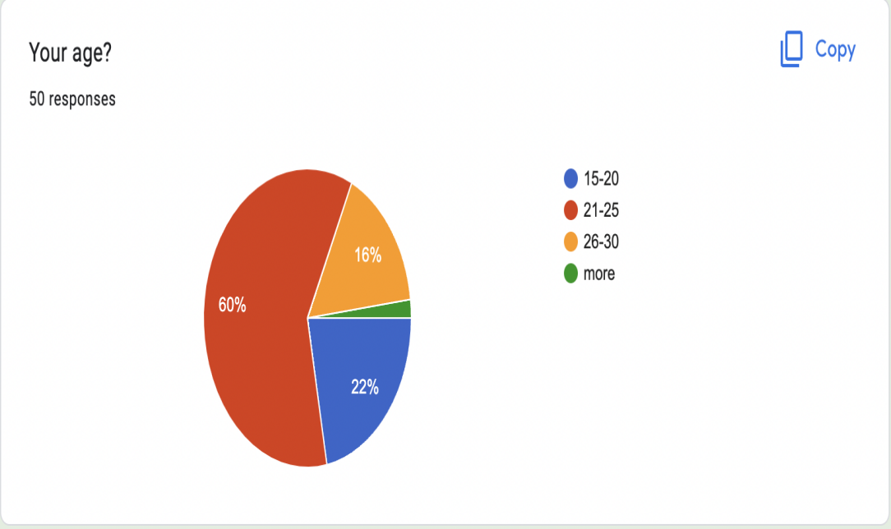
As the graph shows that age between 21-25 age, 22% of people are 15-20 age, 16% people are 26-30 age and the rest of all are other ages.

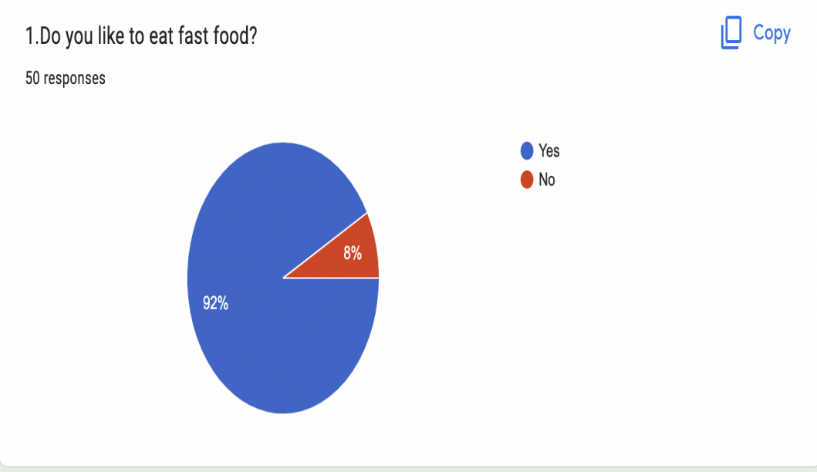

As per the graph, 92 % of people like to eat fast food, and 8% of people don’t like to eat fast food.

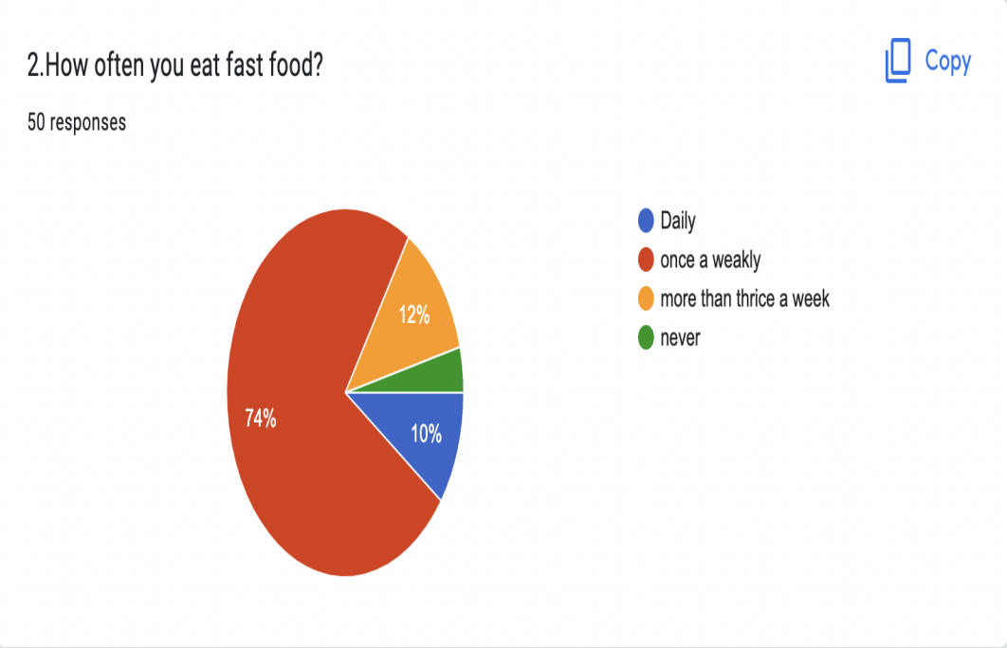

As per the graph, 74% of people eat fast food once a week,12% of people have fast food more than thrice a week, 10% of people would like to have fast food daily rest of the people never eat fast food

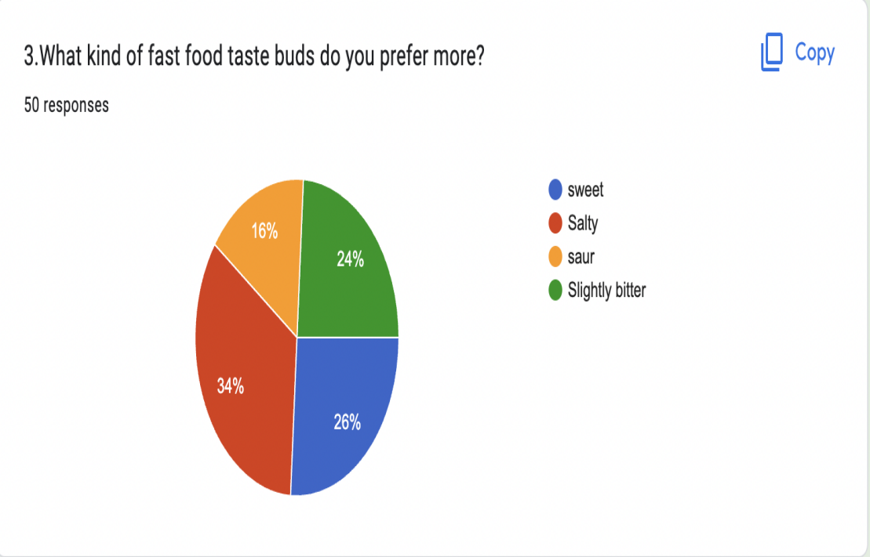
As per the graph 26% of people like the sweet taste, 34% people like the salty taste, 16% people like the Sour flavour 24% people like slightly bitter.

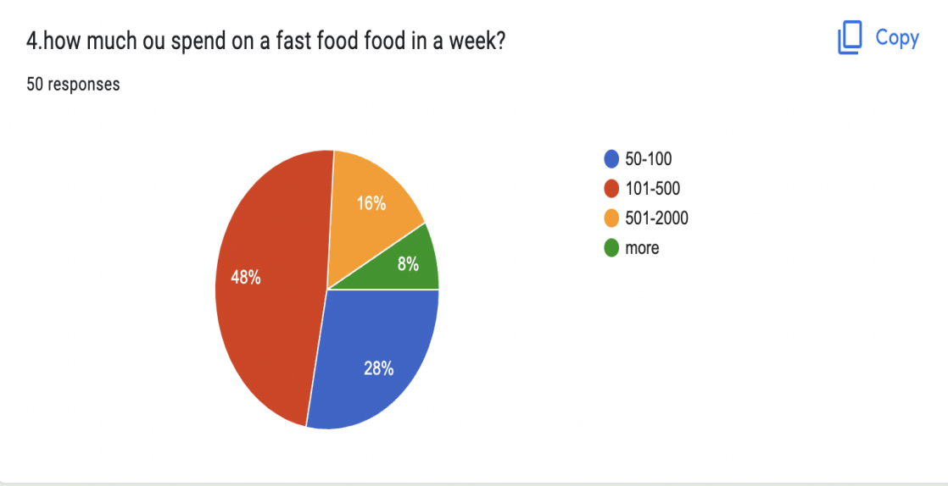
As per the graph, 48% of people spend 101-500 rupees on fast food in a week, 28% of people spend 50-100 rupees, 16% people spend 501-2000 rupees and 8% people spend more.
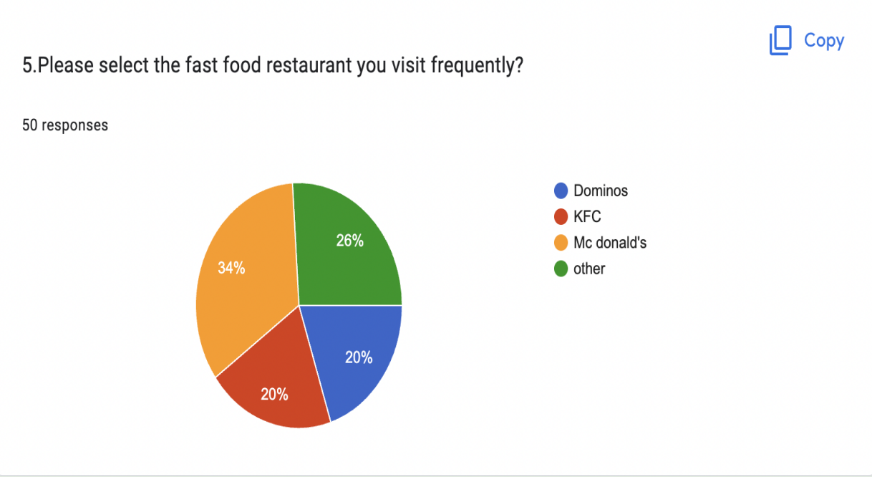
As per the graph, 34% of people would like to visit McDonald’s, 20% people like to visit KFC, 20% of people like to visit Domino, and 26% of people like to visit others.

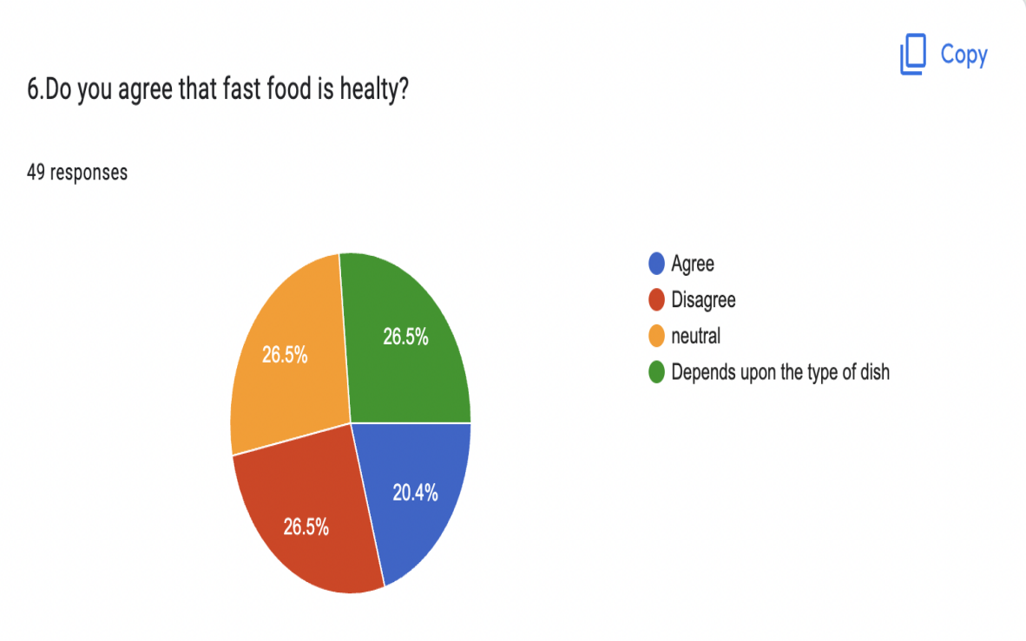

As per the graph, 20.4% say that the fast is healthy to consume, 26.5% people say that it is unhealthy to eat, 26.5% say that depends upon the type of the dish, rest of all neutral
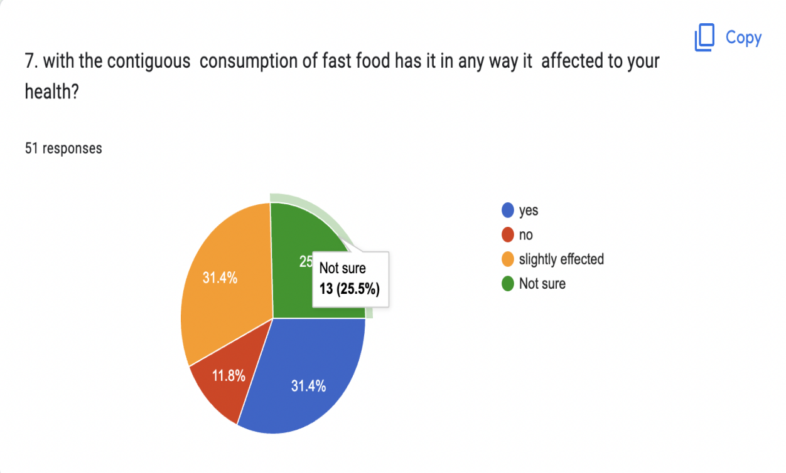

As per the graph, 31.4% of people say that the consumption of fast food is affected our healthy, 31.4% people say it is slightly affected, 25.5% people are not sure about it rest of all don’t agree.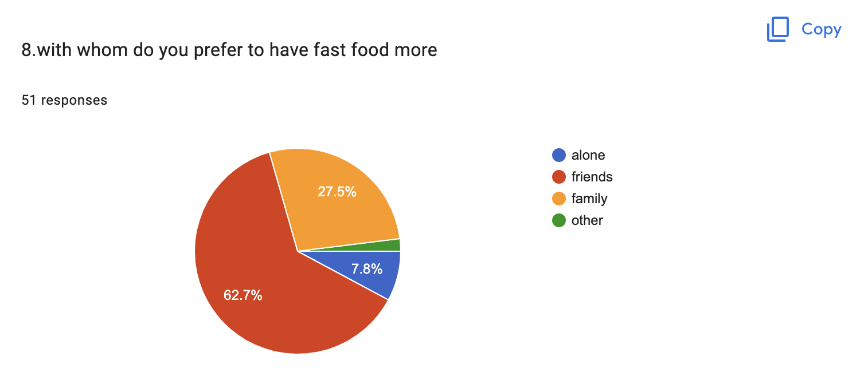

As per the graph, 62.7% of people would like to have fast food with their friends, 27.5% people like to have it with their family, 7.8% of people like to eat alone, rest of the people are neutral.

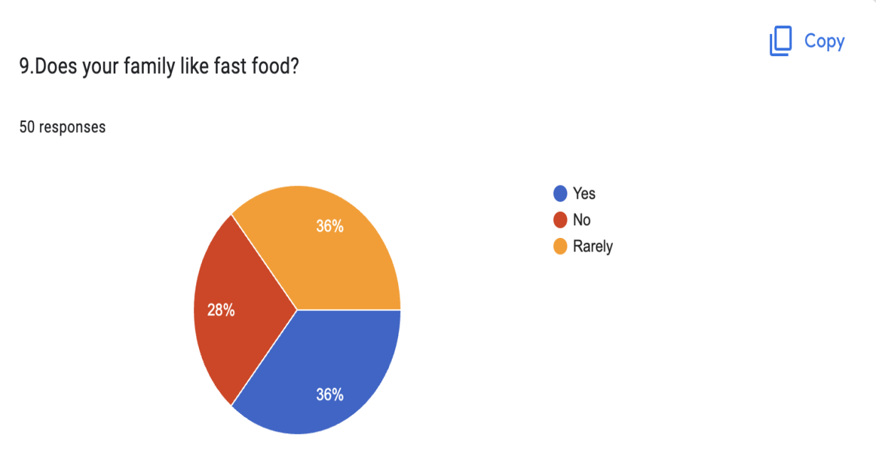

As per the graph, 36% of people like to have fast food with their family, 28% people don’t like to eat with their family, and 36% of people rarely eat fast food with their family.

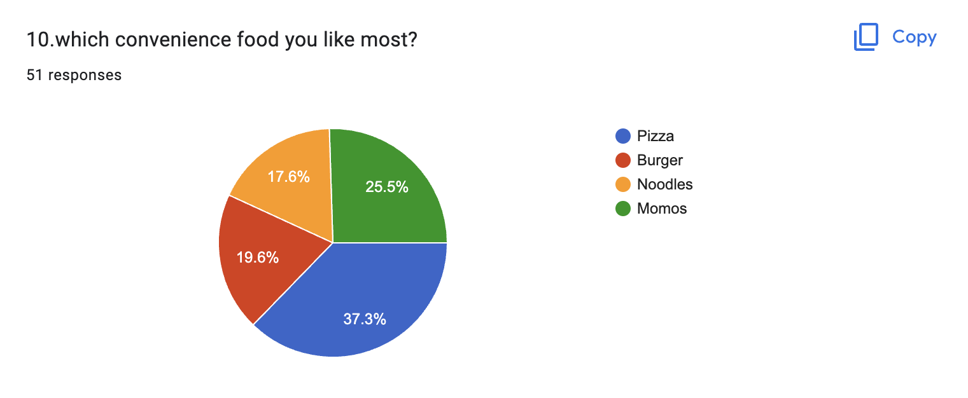

As per the graph 37.3% of people like pizza, 25.5% of people like momos, 19.6% people like burgers, rest of all like’s noodles.

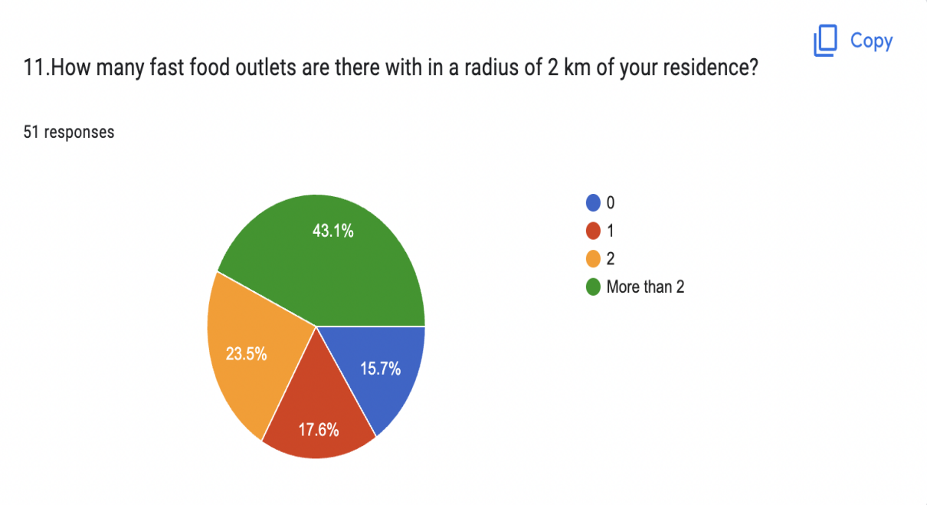

As per the graph 43.1% of people have more than 2 fast food outlets nearby 2km, 23.5% of people have 2 outlets, 17.6% people have 1 outlet, and 15.7% have no outlets.

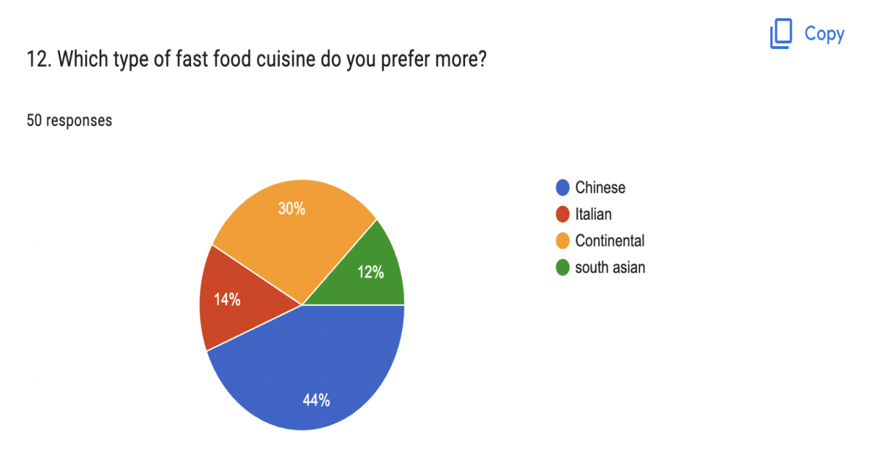

The graph represents that 44% of people like Chinese fast food, 30% of people like continental, 14% people like Italian, and 12% of people like South Indian fast food.

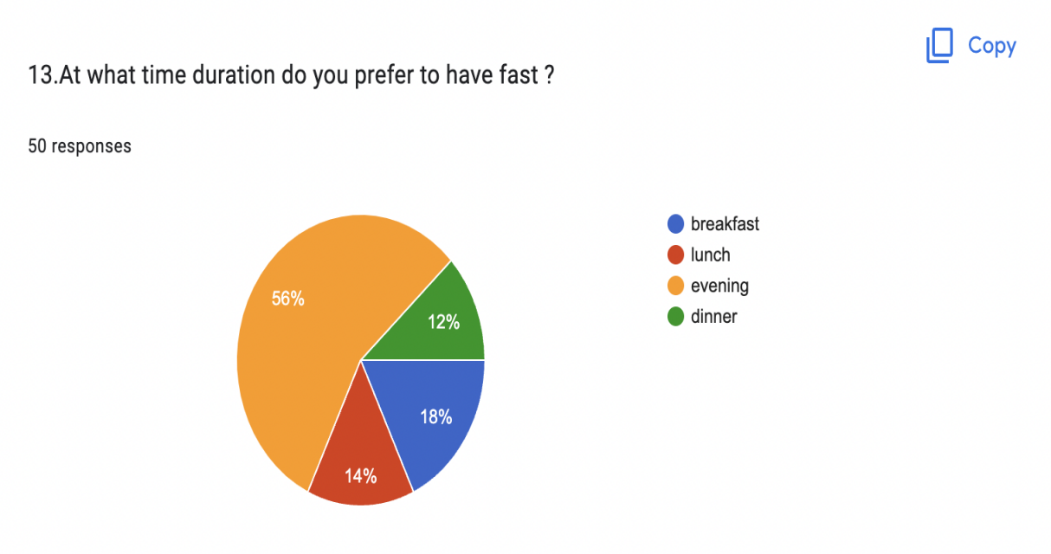

As per the graph, 56% of people prefer the evening time to eat fast food, 18% of people like breakfast time, 14% of people like lunchtime and 12% of people like dinner time

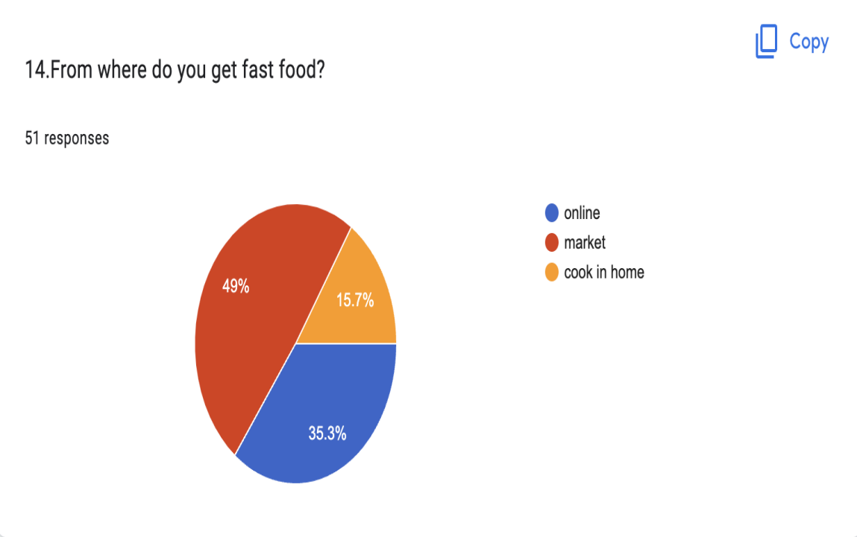

As per the graph, 49% of people prefer the market to eat fast food, 35.3% people prefer online and 15.7% people prefer home-cooked fast food.

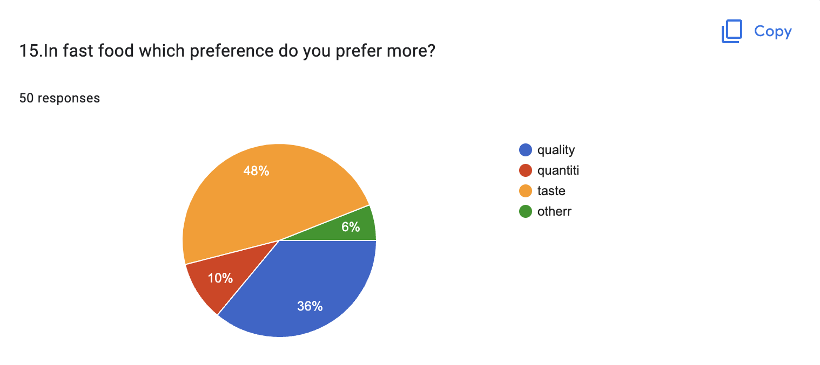

As per the graph, 48% of people prefer taste, 36% of people prefer quality, 10% people prefer quantity and the rest of all prefer other.

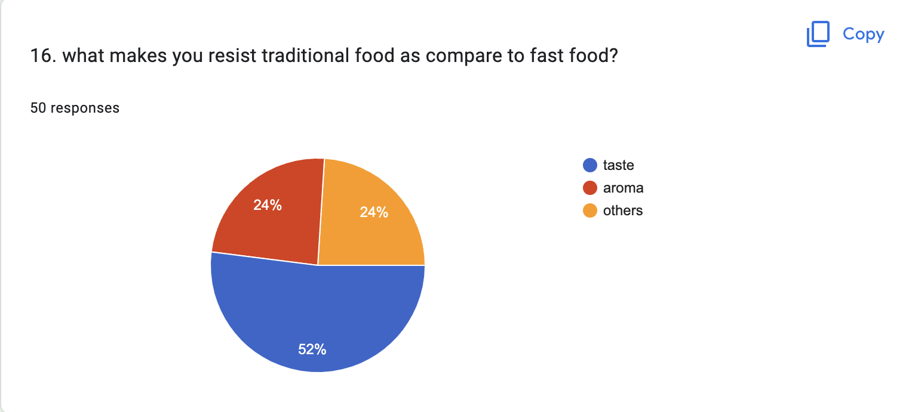

As per the graph 52% of people like the taste of fast food, 24% of people like the aroma and the rest all like others.

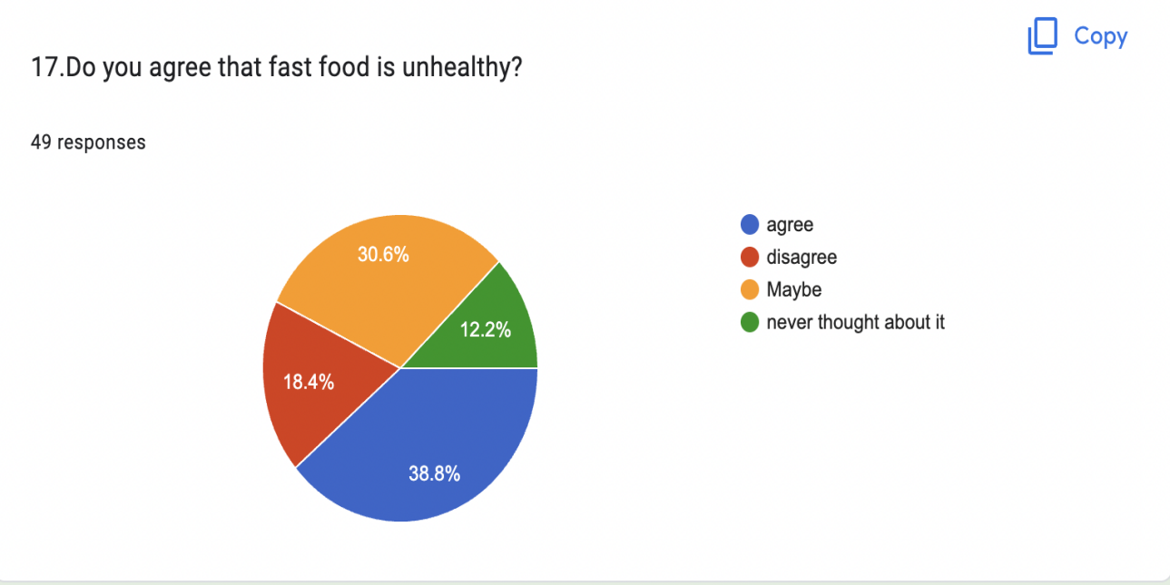

As per the graph, 38.8% of people agree that fast food is unhealthy, 18.4% of people disagree, 30.6% of people thought maybe and 12.2% people never thought about it.

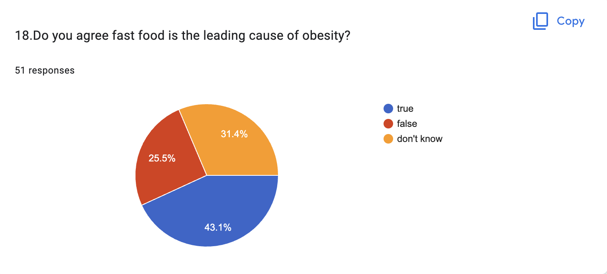

As the graph shows 43.1% of people say true that fast food is a leading cause of obesity, 31.4% people don’t know, and 25.5% people say no.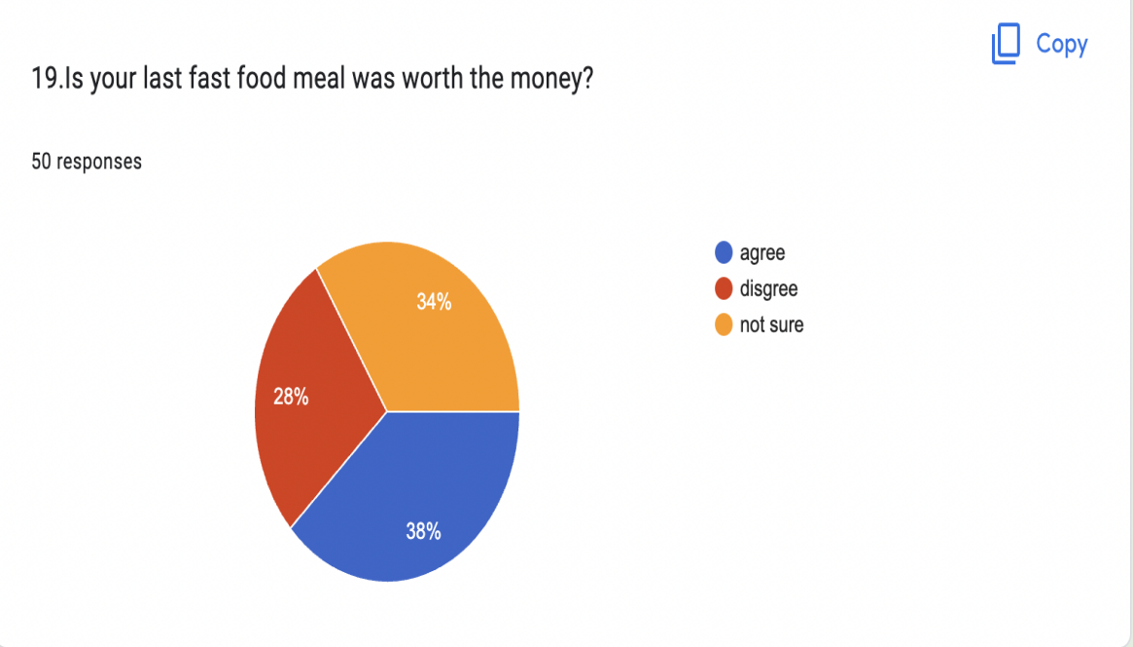

As per the graph, 38% of people say that spending on last fast food is worth the money, 34% people say not sure and 28% disagree.

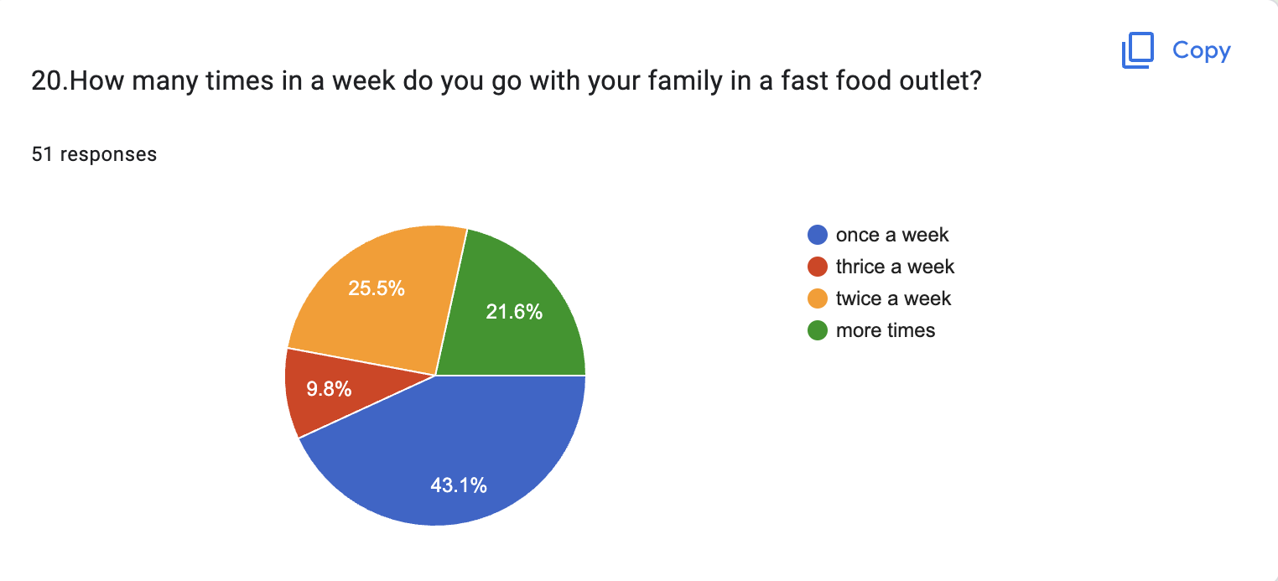

As per the graph, 43.1% of people eat fast food with their family in a week, 25.5% of people eat twice a week, 21.6% eat more times a week, and 9.8% of people eat thrice a week.

VI. Results
The examination configuration is an end-all strategy determining the strategies and methods for assortment and investigating the required data. It is a structure that designs the activity for the exploration project, just as to manage us in taking care of issues. Because of the high number of respondents who expressed interest, we used a quantitative study to guide this research centre. and where proof is assessed, and speculations are created. As a quantitative report, analysts need to appropriate the poll to respondents to make ends. Information is gathered by utilizing structure, easy-going examination structure and even-handed Results, and less specialist notice is included. What is more, the examination covered a more extensive populace in this way quantitative technique is more appropriate instead of subjective strategy where a little example is utilized and includes meet. Along these lines, it will be additionally tedious.

VII. Ethical Considerations
Ethical factors were taken into account in this comprehensive literature evaluation to guarantee responsible and ethical study conduct. We considered the following ethical concepts in particular:
Informed consent: We did not get informed permission from any participants since this study entailed a review of published literature.

A. Confidentiality and anonymity
We did not acquire any personal data from the selected studies, and we guaranteed the authors’ and participants’ confidentiality and anonymity by not releasing their names or other identifying information in this work.

B. Plagiarism and academic integrity
We verified that all sources were correctly credited and acknowledged and that the review process was
performed in a transparent and academically sound manner.

C. Conflict of interest
We reported any potential conflicts of interest that may have impacted the selection and interpretation
of the literature in this evaluation.

VII. Limitations
This study cannot be definitive due to its limited sample, mostly of college students to collect more information actual about it should be circulated on the worldwide platform for surveying. However, people feel lazy while feeling the survey questions. As we all know, we are always on the phone but it seems that they are less interested in filling out the survey which causes errors in collecting actual data. They may be filled out this survey without reading, in a hurry, or not having proper knowledge about the survey due to the busy demanding nature of the environment. The study was limited to the students of Delhi NCR. The food Preferences of the youth can vary for different regions.

IX. Conclusion

The report on the preference of youngsters shifting to Fast-food. The people have poor consuming behaviour (who prefer to eat fatty meals and sugar contain drinks, skip food, and many others). It is endorsed that you restrict your intake of food which contains nutritious ingredients and are healthy. wholesome selections each time feasible, dietary recommendations and powerful public consciousness campaigns can be initiated to cope with the unhealthy way of life of youngsters to improve their health mentally and physically. Families, public fitness professionals and the authorities are tons to cope with this public health trouble. They ought to be encouraged to offer students a variety of wholesome food and support.
Consumers must be aware of the consumption of fats speedy meals may additionally make contributions to higher strength and fat intake, and decrease the intake of healthy foods. the focal point of our locating consists of the views of youth on junk foods, individual possibilities, intake charges and the dangerous fitness effects of high consumption of junk meals merchandise.
From this study, it is revealed factors that are responsible for promoting bad eating include: First, With the help of TV ads we can aware the public.
Second, we can start public awareness program for most of the population who are strongly addicted to fast food. Third, youngsters and teenagers should have to aware of the information about various chemical additives that are introduced to enhance junk food taste.

References:

Duffey, K. J., Gordon-Larsen, P., Jacobs Jr, D. R., Williams, O. D., & Popkin, B. M. (2007). Differential associations of fast food and restaurant food consumption with 3-y change in body mass index: the Coronary Artery Risk Development in Young Adults Study. The American Journal of clinical nutrition, 85(1), 201-208.

Ganasegeran, K., & Al-Dubai, S. (2012). AR., Qureshi AM, Al-Abed AAA, Rizal AM, Aljunid SM. Social and psychological factor affecting eating habits among university students in Malaysia medical school: A cross sectional study.

Jaworowska, A., Blackham, T., Davies, I. G., & Stevenson, L. (2013). Nutritional challenges and health implications of takeaway and fast food. Nutrition Reviews, 71(5), 310-318.

Kaushik, J. S., Narang, M., & Parakh, A. (2011). Fast food consumption in children. Indian pediatrics, 48(2), 97.

Saputri, F. A., & Kusumaningrum, N. S. D. (2022). PERBEDAAN PERILAKU MAHASISWA LAKI-LAKI DAN PEREMPUAN DALAM KONSUMSI FAST FOOD (Doctoral dissertation, Universitas Diponegoro).
Rojekar, N. P., Sajjanar, A., Chavan, P., Shukla, H., & Bhattad, D. (2019). Assessment of Knowledge, Attitude and Factors affecting consumption of fast food in 8-12 Years of Children: A Cross Sectional Study. Journal of Advanced Medical and Dental Sciences Research, 7(8), 100-105.
Kalakumari, T., Mustafa, S. A., & Salindo, R. V. N. (2020). Emotional Experience of Consumption of Fast Food—A Study of College Students in Sultanate of Oman. Open Journal of Business and Management, 8(2), 452-466.De La Haye, K., Robins, G., Mohr, P., & Wilson, C. (2013).

