Comparative analysis of Action Observation Therapy and Mirror box therapy with functional motor training in post stroke subjects
Thummala S Pavani1*, S.Senthilkumar2, Annie Thomas 3.

1 Research scholar, Garden City University, Bangalore, Karnataka, Associate Professor, East Point College Of Physiotherapy, Bangalore, Karnataka, India. 2Professor and Research Supervisor, School of Health Sciences, Department of Physiotherapy, Garden City University, Bangalore, Karnataka, India. 3 Research Co-Supervisor, Professor, School of Health Sciences, Department of Physiotherapy, Garden City University, Bangalore, Karnataka, India.

Back ground: The intention of our study was to evaluate the effectiveness of Action observation therapy and mirror therapy with bilateral functional motor arm training which is two promising rehabilitation strategies, aimed at enhancing the motor learning and functional improvement of stroke patients through different patterns of visual feedback and observation.

Action observation improves excitability of the primary motor cortex and the encoding of motor engrams as well as motor-learning. Action observation therapy (AOT) is a developing neuro rehabilitative tool, which is activated not only during the execution of an action, but also during the observation of the same action based on the existence of the mirror neuron system (MNS).
Bearing in mind this “dual” activation, the AOT proposes that motor symptoms of different neurological disorders can improve with the observation and imitation of different actions.

The idea that the same brain regions responsible for the actual execution of actions are activated during action observation and execution is now widely acknowledged in the field of neurophysiology. The mirror neuron system is a term used to describe regions that have this action observation-action execution matching mechanism.

Objectives & aims: The objective of this study was to determine the effectiveness of Action Observation therapy and Mirror Box therapy and also we compared the effects of Action Observation therapy and Mirror Box therapy with bilateral functional motor training in improving the functional motor capacity of upper limb in patients with sub-acute stroke and chronic stroke subjects.

Methods/Design: An estimated thirty subjects with ischemic and haemorrhagic sub-acute stroke were recruited in this study. All participants were randomly assigned to receive AOT and MBT, with bilateral functional motor training intervention for 5 days a week training period of 3 months. Outcome measures were conducted at baseline, immediately after treatment, and at 3-month follow-up. The primary outcome was the Fore arm bisection task, Fugl-Meyer Assessment, and secondary outcomes included the Fugl Meyer assessment and Motor assessment Scale.

Video training was used to deliver and it was highly accepted by patients. 3 months of AOT and MBT that is fore arm bisection task was practiced on the subjects for the experimental group and motor functional training suggests improvements in the motor functioning of hand, distal shift in the pointing the middle of forearm, Video-therapy appears to be promising, as compared with bilateral functional arm training given for group B.

Results: The action observation therapy, Mirror box therapy group has showed improvements on the Fore arm bisection task, Fugl-Meyer Assessment, Motor assessment Scale, but has showed similar improvements on Box and Block Test. Moreover, the action observation therapy had a greater improvement on the Fore arm bisection task, However, the bilateral functional motor training group gained the least improvements on the Fugl-Meyer Assessment, Motor assessment Scale.

Conclusion: The preliminary results found that the patients in the action observation therapy and MBT has shown good improvements in task completion compared with functional motor training, further large-scale study with at least 30 patients in each group to validate the study findings is needed. Video training appears to be promising and is easy to deliver as an adjunct to neuro rehabilitation and highly accepted by patients. Six weeks of intervention suggests improvement of hand function measured based on Motor assessment scale.

Discussion: This study will provide scientific evidence of treatment effects on motor, functional outcomes, and neural activity mechanisms after AOT and MT in patients with sub-acute stroke. Further application and use of AOT and MT may include rehabilitation through web-based or video teaching.

Keywords: mirror neurons, neurological rehabilitation, rehabilitation interventions, action observation, motor recovery, Upper limb Video therapy

Introduction
Stroke is the sudden loss of neurological function caused by an interruption of blood flow to the brain, clinically a variety of focal deficits are possible, including the changes in loss of consciousness and impairments of sensory, motor, cognitive, perceptual and language functions .motor deficits are characterized by paralysis (hemiplegia) or weakness (hemiparesis) typically on the side of the body opposite to the site of lesion.¹ Stroke known medically as cerebro vascular accident or brain attack is rapidly developing loss of brain functions due to disturbance in the blood supply to the brain⁴¹. According to the world health organization in the 1970’s stroke is defined as a neurological deficit of cerebro vascular dysfunction that persists beyond 24 hrs (or) is interrupted by death in with 24 hrs.
There are two main categories of stroke of which 10% of hemorrhagic and 90% of ischemic stroke. The thrombotic type is the most common followed by embolic and lacunar types respectively. The major cause of the stroke is HTN, small heart disease ,diabetes and the stroke risk is increased by 4-6 times in patients with high blood pressure (elevated above 160/95 mm of hg),cardiovascular risk increased with high elevated total blood cholestral and low density lipoprotein cardiac diseases such as Rheumatic heart vascular disease, Endocardities and cardiac surgery.
WHO,s (1989) definition of stroke in adult, 16 years and older, was selected, and it is a rapidly developed clinical sign of focal disturbance of cerebral function of presumed vascular origin and of more than 24 hours duration³.
Stroke or apoplexy is the main cause of death and disability among older adults although most of the stroke survivors regain independent ambulation; many are having difficulty in performing activities of daily living especially their self-care and house hold duties⁴. Strokeoccurs due to thrombus, emboli, hemorrhage with an incidence of 203 cases per lakhpopulation in the age group more than 20 years with male to female ratio being 1:7 and 12% of stroke cases are seen in the age group below 40 years, it is also reported that 1.2% of total deaths are due to stroke in India and the cause of the disease depends up on the severity of the lesion.⁵
C V A as any disorders in which an area of brain is transiently or permanently affected by ischemia or bleeding or in which one or more blood vessels of brain are primarily impaired by a pathological process .To be classified as a stroke or hemiplegia the focal neurological deficits must be present for at least 24 hours and take longer than 3 weeks to resolve when the duration of signs and symptoms is less than 24 hrs. the event is classified as Transient Ischemic Attack and is considered as a warning that stroke will occur in the future if left un attended ¹³
Cerebral edema is the most common cause of death in acute stroke and is characteristics of large infarcts involving the M C A (Hachinski V, Norris J et al ; the acute stroke , 1985.)
Two main mechanisms results in stroke,Ischemic stroke – This is the most common type of stroke, accounting for almost 80% of all strokes. The most common cause of ischemic stroke in atherosclerosis, or gradual cholesterol deposition. It is caused by a clot or other blockage with in an artery leading to brain. (Www. Stroke center .com).

Intra cerebral hemorrhage- It is the abnormal bleeding in to extra vascular area of brain secondary to aneurysm or trauma. Intra cerebral hemorrhage occurs at all stages.hemorrhage stroke makes about 12-24% of all strokes .¹⁴The cerebral infarction (thrombosis, embolism) is the most common form of stroke, accounting for 70% of all strokes. Hemorrhages account for 20% and 10% remain unspecified .¹⁹
The three most commonly recognized risk factors for cerebral vascular disease are hyper tension, diabetes mellitus and heart disease. The most important of these factors is hyper tension . Systolic or diastolic blood pressure, pulse pressure and variabilityof pressures are all good predictors of stroke .Risk factors have been correlated to stroke include increased blood fat levels, obesity and cigarette smoking. Because high blood pressure is the greatest risk factor for stroke. ²⁰
Some hemorrhages develop inside areas of ischemia (hemorrhagic transformation) and it is unknown how many hemorrhages actually starts off as ischemic strokes¹⁶ the neurological deficits produced with systemic feature are global in nature with bilateral neurological deficitS.¹⁵Common impairments after stroke are impaired motor functions, balance, sensory deficits, cognitive limitations, visual deficits, aphasia, depression.⁶ People who survived the initial stages of stroke generally show some improvement over time in their ability to move perform functional tasks. A variety of mechanisms have been suggested to explain recovery that includes neuro plasticity and adaptive changes (warlow et al)⁷
Upper limb hemi paresis is one of the most debilitating effects of stroke and it is the primary impairment underlying functional disability following stroke.²¹ Upper limb hemi paresis is one of the most prevalent condition treated by physical therapist and occupational therapists²².Early mobilizations is favored because it lessens the complications like deep vein thrombosis, pressure sores.²⁷ The highest priorities of early stroke rehabilitation are to prevent recurrence of stroke , manage co morbidities and prevent complications.²⁶Early after stroke can enhance the recovery process and minimize functional disability. Improved functional out comesfor patients also contribute to patient satisfaction and can reduce potential costly long term care expenditures .Substantial evidence indicates that patients do better with a well-organized multidisciplinary approach to post-acute stroke cases.²⁴
It is evident that increased treatment intensity using repetitive task oriented methods improves motor and functional recovery compared to facilitative approaches.³⁴
Action Observation Therapy
The patients in the action observation therapy group were required to observe the upper limb movements or functional actions in video clips(i.e., the observation phase) and to execute what they had observed to the best of their ability (i.e., the execution phase).
Three common categories of movements and tasks were selected in the action observation therapy protocol based on the related literature and clinical expertise:
(a) Upper limb active range of motion (AROM) exercises
(b) Reaching movement or object manipulation, and
(c) Upper limb functional tasks.

The video movements were displayed from a first-person perspective to make the actions more intuitive and facilitate optimal cortico motor excitability [15]. The actors in the videos were healthy young people. Observing the actions from the first-person perspective means that the observers watch the actions as if seeing through the actor’s eyes. It looks like the observers are performing the actions themselves as the same directions and space dimensions of the actors performed
During phase 1 (10–15 minutes), the patients watched AROM exercises demonstrated in the video clips on a computer screen and executed the observed exercises with both arms and hands simultaneously.
In phase 2 (15–20 minutes), the patients were asked to observe one reaching movement or one object manipulation task, depending on the patient’s motor ability, for 2 minutes in a video clip, and afterwards to execute the movements that they had observed for 3 minutes. This sequence was repeated 3 times.
The reaching movements involved reaching for objects of different sizes and weights at different heights and locations. Object manipulation included in-hand manipulation, grasp and release, and transport and turning objects.
During Phase 3 (30 minutes) contained one functional task in each session, starting with easy tasks and continuing with increasingly complex tasks. Each functional task was divided into 3 motor acts.
For example, the action of cleaning the mouth with a tissue paper was decomposed into the following 3 motor acts: (1) moving hand toward a tissue paper, (2) taking a tissue paper, and (3) bringing the tissue paper toward the mouth and wiping.
After observing a motor act in a video clip for 2 minutes, the patients were asked to execute the action they had observed for 3 minutes.
For the next 15 minutes, the patients observed the functional task as a complete action for 2 minutes and then executed the entire task for 3 minutes; this sequence was repeated 3 times.
Examples of the functional tasks are folding a towel, wiping a table, drinking water, opening a small drawer, and using a mobile phone.

MIRROR BOX THERAPY
Patients sat on chair, with their forearms placed radially on a table. They were asked to indicate with their index finger the midpoint of their impaired arm, considering the tip of the middle finger and the elbow (olecranon) as the distal and proximal extremes.
Patients were requested to indicate the midpoint with a ballistic movement, with closed eyes. On each trial, a flexible ruler was used to measure the patient’s performance, setting the 0-cm point in correspondence of the tip of the middle finger.
15 trials of bisection pointing were recorded. Before starting the task, the arm length was measured. There was no time constraint for the bisection task, but corrections were not allowed.
Patients performed a total of 30 trials (15 before and 15 after each training) in every session, for a total of 60 trials per participant.
A percentage score was calculated for each forearm bisection trial using the following formula: [(p/arm length)∗ 100], where p indicates the subjective midpoint, measured with a flexible ruler on each trial. In this formula, a value of 0% corresponds to the tip of the middle finger, 100% corresponds to the elbow.

A value higher than 50% indicates a deviation of the subjective midpoint towards the elbow, i.e., proximal deviation, while a value lower than 50% indicates a deviation towards the hand, i.e., distal deviation (Sposito et al., 2012; Garbarini et al., 2015). For the analysis, we considered the difference between pre- and post-training bisections (pre-training minus post-training). The shift obtained with this formula, was positive in case of distal deviation and negative for proximal deviation.
Hand movements requested during 10 min of motor training, with or without the Mirror

Functional motor training
- The patients in this group received dose-matched bilateral arm training with mirror box provided, but no video input or for this group.
- In the active mirror box therapy intervention, the same 3 categories of movements and tasks as provided in the action observation therapy and mirror therapy groups were used.
- Treatment programs also included AROM exercises (10–15 minutes), reaching movement or object manipulation (15–20 minutes), and functional task practice (30 minutes).
- AROM exercises included bilateral shoulder, elbow, forearm, wrist, and finger movements. Object manipulation tasks were in-hand manipulation, grasp and release, and transporting and turning objects with both hands.

Examples of functional tasks were reading a magazine, folding clothes, wiping a table, and opening a small drawer with bilateral arm and hand movements. During training, the patients were required to move both of their arms and hands simultaneously as possible. Based on the patient’s level of motor ability and progress, the levels of movement and task difficulty could be adjusted accordingly.
AIM
To determine the effectiveness of action observation therapy & mirror neuron therapy on functional motor capacity of upper limb in acute post stroke subjects.

Objective of the study-To find out the effectiveness of Action Observation therapy in improving the motor function of arm and hand in post stroke on Fugl meyer assessment score and Motor assessment scale.

Methodology

Materials and methods

Source of data: East Point Hospital, Bidrahalli, Bangalore.

Method of collection of data:

Population : Stroke patients
Sample : Stroke subjects with hemiplegia Sample design : Convenience sampling
Study design : Pre and post experimental control design Sample size : 15 subjects.
Duration of the study: 12 Weeks.

Inclusion criteria:

- Age between 40- 60 years.
- Subjects with stroke less than one month.
- Subjects of both the genders.
- Subjects diagnosed as strokes confirmed by CT or MRI scan.
- Subjects with palpable wrist extension of grade I muscle power of MRC.
- Subjects who will be screening under fugl-meyer score.
- Subjects with stroke having active shoulder shrugging.
- Subjects with scores between 10- 57 under fuglmeyer score.

Exclusion criteria:

  - Subjects with MMSE score less than 20.
  - Subjects with receptive aphasia
  - Subjects with unstable cardio vascular status.
  - Subjects with psychiatric illness like severe depression, poor motivation.
  - Subjects with the presence of significant upper limb musculo skeletal and any other neurological conditions other than stroke.
  - Subjects with visual impairments.
  - Non cooperative subjects.

Assessment was conducted on the first day and last day of treatment session by using the followingparameters
Fugl Meyer Assessment (F M A),Motor Assessment Scale (M A S).

Duration:The duration of treatment was for one hour of prescribed exercises 5 days a week and can divide the exercises in to 2 to 30 minutes session for the duration of 3 months

Procedure:
Informed consent was taken from the subject. Subjects were then screened for inclusion and exclusion criteria by doing a routine neurological examination.
Subjects were also assessed for baseline data like age, gender, duration of onset of stroke, type of stroke. The subjects who fulfilled the inclusion and exclusion criteria were made to understand the purpose of the study in their own language.
Subjects were assigned in to the any one of the 2 groups randomly as follows-

The experimental group having 15 subjects received Action Observation therapy and Mirror box therapy the control group only conventional physiotherapy.
The group A subjects instructed to follow the treatment protocol as demonstrated in the videos and fore arm bisection training in front of mirror box.
The group B having 15 subjects was instructed to follow the conventional treatment which includes passive movements, sustained stretching, consistent range of motion exercises, positioning,

Outcome measures:
Fugl-Meyer Assessment and Upper Arm function component of Motor Assessment Scale for measuring upper arm function.

Data analysis and results

The following is the statistical analysis done in this study.
Descriptive statistical analysis has been carried out in the present study using software version SPSS 17 .Results are presented on Mean + or – S D (Min- Max) and results as categorical measurements are presented in number (%) level of significance is assessed at 5 % .Chi square, Wilcoxon signed rank test, Mann Whitney test, Paired t - test and Un paired t- test have been used to find the significance of study parameters.
Table 1: Base line data for demographic variables

 |  | Group A |  | Group B |  | P-value
Number of samples |  | 15 |  | 15 |  | -
Age in years ;  Mean ± SD |  | 49.40±4.17 |  | 50.00±5.26 |  | >0.732
0nset of treatment  in days; Mean ± SD |  | 13.20±3.21 |  | 14.53±3.74 |  | >0.304
FMA; Mean ± SD |  | 36.00±10.87 |  | 28.87±9.82 |  | >0.074
Gender; No (%)  Male  Female |  | 11 (73.3%  4 (26.7%) |  | 10 (66.7%)  5 (33.3%) |  | >0.690
Side involvement;  Right  Left |  | 9(60.0%)  6(40.0%) |  | 8(53.3%)  7(46.7%) |  | >0.713
Type of stroke;No (%)  Hemorrhagic  Ischemic. |  | 6(40.0%)  9(60.0%) |  | 10(66.7%)  5(33.3%) |  | >0.413
Table 2: Comparison of age distribution

Age in years | Group A |  | Group B |  | Total
 | No | % | No | % | No | %
40-49 | 8 | 53.33 | 7 | 46.67 | 15 | 50.0
50-60 | 7 | 46.67 | 8 | 53.33 | 15 | 50.0
Total | 15 | 100.0 | 15 | 100.0 | 30 | 100.0
Mean ± SD | 49.4 ± 4.17 |  | 50.0 ± 5.26 |  | 49.7 ± 4.67

As given in the table, mean age of group A is 49.40 ± 4.17, group B is 50.00± 5.26. Hence the samples are age matched with P = 0.73, which is not statistically Significant.
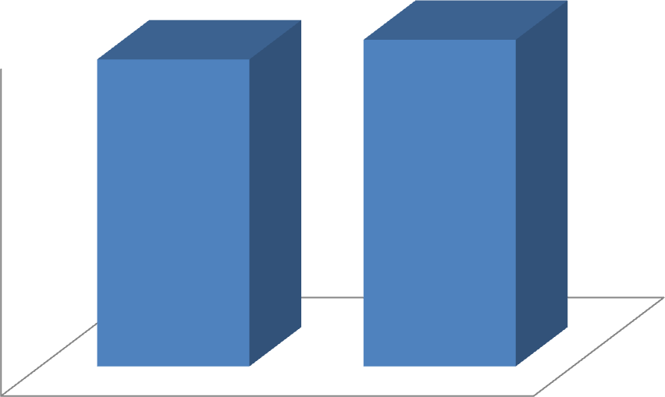
50
49.4
50

48

46

44

42

40
experimental
AGE
control
Graph 1: Age distribution of subjects studied Gender distribution of subjects studied
There are 11 males & 4 males in Group A; 10 males & 5 females in Group B The Gender distribution between the groups is not statistically significant with P value Of >0.69.

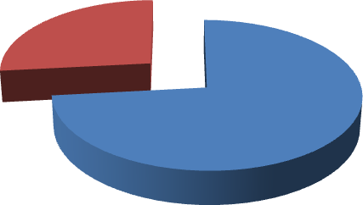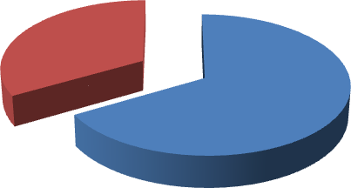

experimental

femal e 27%

male
73%

control

female
33%

male 67%

Graph 2: Percentage of gender distribution in group A Graph 3: Percentage of gender distribution in group B
Subject distribution in the 2 groups based on the side involved:

There are 9 subjects in group A and 8 subjects in group B with right side involvement. Whereas 6 subjects in group A and 7 subjects in group B with left side involvement.
The difference between the groups is not statistically significant for the side involved With the P value > 0.713.
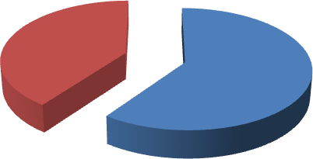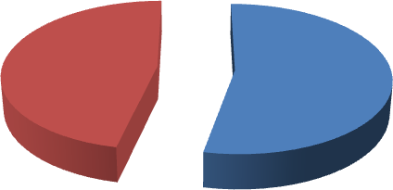
Experimental

Left
40%

Right
60%
Control

Left
47%

Right 53%
Graph 4 : Percentage of subject distribution based on the side involved in Group A Graph 5 : Percentage of subject distribution based on the side involved in Group B

Onset of treatment following stroke

As given in table 1, the mean onset of treatment after stroke occurrence in Group A is 13.20±3.21 and in Group B is 14.53±3.74 with P value of >0.304 which is not statistically significant.

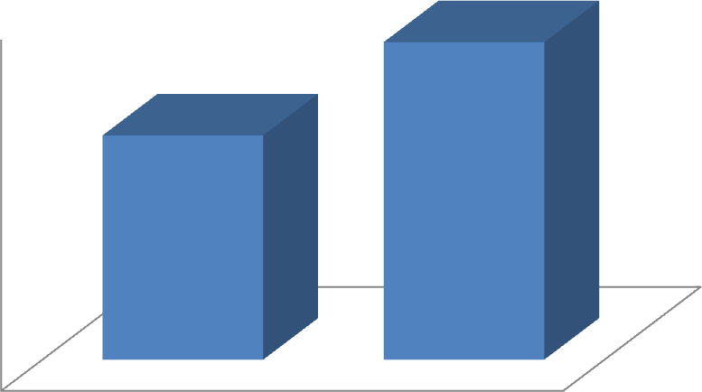
14.53
15
13.2
14

13

12

11

10
experimental
control
ONSET
Graph 6: comparison of onset of treatment between the groups.

Subject distribution in the two groups based on the type of stroke

There are 6 subjects in group A and 10 subjects in group B with hemorrhagic stroke. Whereas 9 subjects in group A and 5 subjects in group B with ischemic stroke .The difference between the groups is not statistically significant for the type of stroke with the P value >0.413.

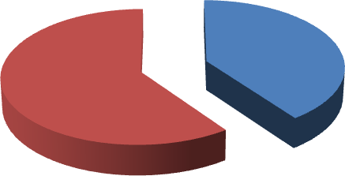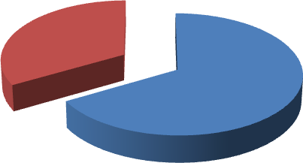
Experimental
IISH
60%
HEM
40%

Control

ISH 33%

HEM 67%

Graph 7: percentage of subject distribution based on the type of stroke in Group A Graph 8: percentage of subject distribution beads on the type of stroke in Group B

Base line score for Brunnstorm VGC As given in table 1 , the mean score of is 36.00 ± 10.87in Group A and in Group B is 28.87 ± 9.82 with P value of >0.074 which is not statistically significant.

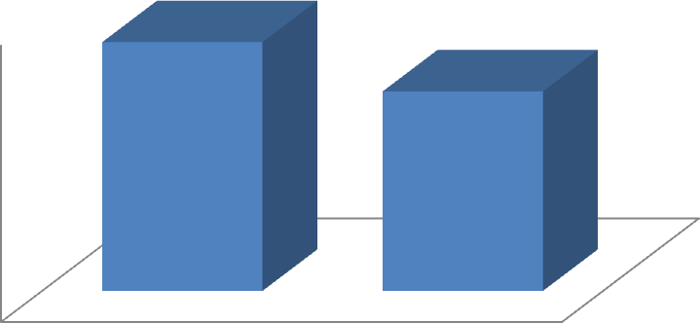
36
40
28.87
30

20

10

0
experimental
control
VGC

Graph 9: Comparison of base line score for Brunnstorm VGC in between the groups
Table 3: Base line data for outcome variables.

Base line data for outcome variables
Variables | Group A | Group B | P Value
M A S | 1.27 ± 0.80 | 0.80 ± 0.77 | >0.137
FMA | 1.20± 0.77 | 0.80 ± 0.62 | >0.130

Base line means score of M A S in group A is 1.27 ± 0.80 and in group B it is

0.80 ± 0.77 which is statistically not significant with the P value of >0.137. Base line score for FMA in group A is 1.20 ± 0.77 and in group B is 1.90 ± 1.28 which is statistically not significant with the P value <0.009.

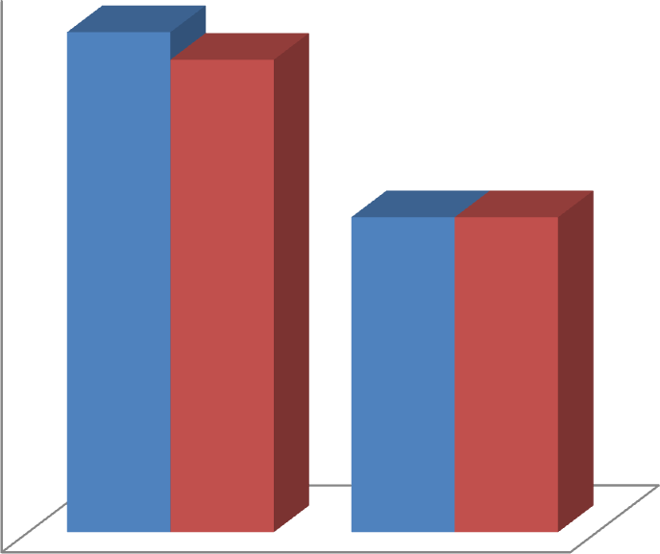
1.27
1.4
1.2
1.2

1
0.8
0.8
0.8

0.6

0.4

0.2

0
Experimental
Control
- MAS
- FMA

Graph 10: Base line data for outcome variables.

Within group analysis

Table 4: Evaluation of effect based on M A S

Motor Assessment Scale
Group | Pretest score | Post test score | P Value
Group A | 1.27 ± 0.80 | 1.67 ± 0.98 | <0.014.
Group B | 0.80 ± 0.77 | 0.87 ± 0.74 | >0.317.

In group A pretest score M A S is 1.27 ± 0.80 and post score is 1.67 ± 0.98 In group B pretest score is 0.80 ± 0.77 and post test score is 0.87 ±0.74.
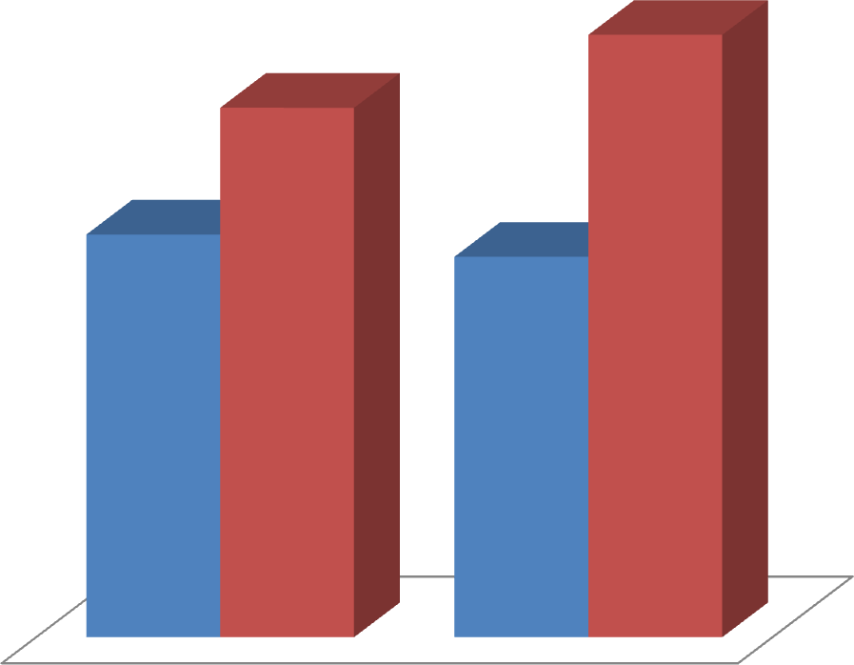

1.67

1.27

0.80
0.87

- Control ▪ EXP
Graph 11: Evaluation of effect based on M A S

Table 5: Evaluation of effect based on FMA

FUGL MEYER ASSESSMENT
Group | Pretest score | Post test score | P Value
Group A | 1.2 ± 0.77 | 1.9 ± 1.28 | <0.009.
Group B | 0.80 ± 0.62 | 1.03 ± 1.02 | >0.169.

In group A pretest score FMA is 1.2 ± 0.77 and post score is 1.9± 1.2 In group B pretest score is 0.80 ± 0.62 and post test score is 1.03±1.02.
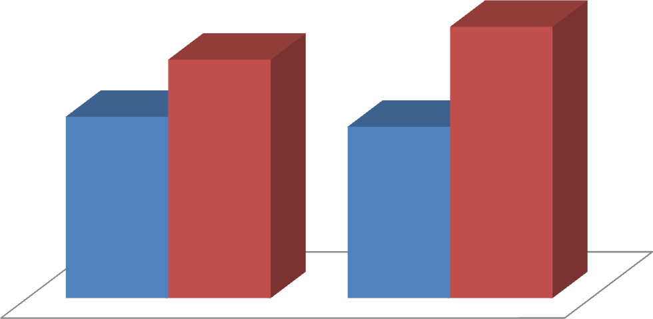
1.9
1.2
0.80
1.03
- Control
- EXP
Graph 12: Evaluation of effect based on FMA.

Between group analysis

Table 6: Difference of gain in between the groups

Difference of gain in improvement
Variables | Experimental | Control | P Value
M A S | 1.67 ± 0.99 | 0.86 ± 0.74 | < 0.029  .
FMA | 1.90 ± 1.28 | 1.03 ± 1.02 | < 0.05

The mean difference of gain between the pre and post test score of M A S in group A is 1.67 ±0.97 and in group B is 0.86 ± 0.74 with the P value of <0.29 which is statistically significant. The mean difference of gain in between the pre and posttest core of FMA in group A is 1.90 ± 1.28 and group B is 1.03 ± 1.021 with the P value of <0.05 which is Statistically significant .
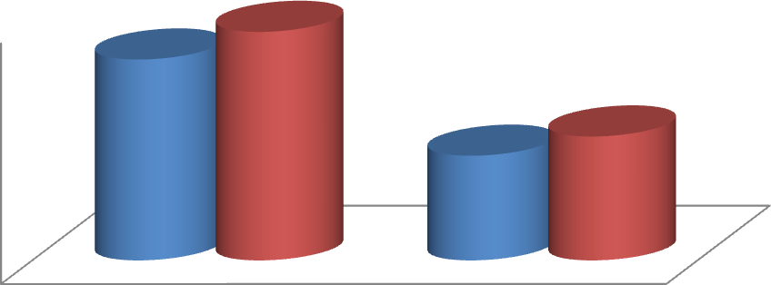
1.67
1.9
2
1.03
1.5
0.87
1
0.5
0
Experimental
Control
MAS FMA

Graph 13: Difference of gain in improvement in between the groups

Discussion

This study is intended to find out the effects of AOT & MBT in order to improve the motor function of arm and hand in post stroke subjects. So that based on this kind of studies.

The most significant finding in this study was that the long term administration of AOT & MBT improve the motor function of arm and hand during the 12 weeks study period self-administered exercise program requiring minimal therapist involvement .Feasible for subjects with no wrist or hand movement outcome measure is very applicable to real life situations.

Base line data for demographic, outcome variables were not significant from its P value with the samples matched. So homogeneity of sample was used to test the significant proportion of base line characteristics.

- In the experimental group the pretest score for MAS was 1.27± 0.8 which is increased significantly to 1.67 ± 0.9 with the P value <0.014.
- In the experimental group the pretest score for FMA was 1.2 ±0.77 which is increased significantly to 1.9 ± 1.28 with the P value <0.009.

More male subjects in experimental group, shows better functional out comes might be due to less number of females in group A and also the female subjects selected were all in the menopausal stage .According to Mathew J Reeves, PhD, Cheryl D Bushnell, Age-specific stroke rates are higher in men, but, because of their longer life expectancy and much higher incidence at older ages.

Functional outcomes and quality of life after stroke are consistently poorer in women, despite adjustment for baseline differences in age, pre-stroke function, and co-morbidities.
Below the age of 45 years,stroke mortality for women and men is similar, but women aged 45–74 years .Have a substantially lower risk of stroke mortality than do men. The most common biological explanation for sex differences in stroke is related to sex steroid hormones, particularly estrogen.

Estradiol has very potent effects on endothelia that promote dilation and blood flow, whereas testosterone has the opposite effects. Similarly, cerebrovascular reactivity is the most robust in premenopausal women, but postmenopausal women have poorer responses than age-matched men. In addition to vascular effects, estrogen has anti-inflammatory effects that might be modulated by antioxidant and ant apoptosis effects.²³

All of these findings suggest that women are protected by endogenous estrogens till the attainment of me no pause and also more number of ischemic stroke subjects in group A who had better functional recovery comparatively. According to, Vera P. M. Schepers, MD, PhD1, MarjolijnKetelaar, PhD2009.

Ischemic stroke has shown the better functional improvement than hemorrhagic stroke subjects observed in the first 2 months post-stroke is determined mainly by unknown processes attributed to “spontaneous neurological recovery” and possibly due to (i) recovery of penumbral tissue in which electrical failure has occurred but membrane homeostasis is maintained, (ii) resolution of functionally suppressed areas remote from the infracted area by diaschisis; and (iii) unmasking of latent synaptic pathways subjects with right hemisphere lesion were recovered soon than the left sided lesion though there were less number of subjects in group A with left side involvement .

A right hemisphere infarct does not commonly lead to aphasia. Patients can show problems with semantic comprehension (Lesser 1974) but 'phonological' skills can be spared. Generally straightforward receptive and expressive tasks are fine and also as the Auditory association cortex is in the left lateral temporal lobe. And in our study constant guidance and family support during the time of treatment may be the cause for the subjects with right hemispheric lesions were recovered soon.

More intensity of time was given for group – A for subjects who has shown better results when compared to control group (one hour of prescribed exercises 7 days a week and can divide the exercises in to 2 to 30 minutes session for the duration of 3 months).Timing and intensity of post stroke rehabilitation have been cited as important predictors of outcome. Earlier treatment initiation has been associated with greater functional outcome at discharge and long-term outcome. (Horn et al, 2005). (Kwakkel et al., 1997, 2004).

In this study we selected subjects with less than one month post stroke and was given immediate intervention for the duration of 3 months and which results in better out comes. Time course of upper limb recovery is well documented, According to (Parke et al., 1986; Nakayama et al., 1994).The mean time of recovery for motor impairment is three weeks post stroke but differs according to arm severity.

The study done was hospital based intervention in order to reduce burden and co morbidities on the family. (Bohannon et al., 1988; Intervention studies are needed to clarify the aspects of effective upper limb treatment post stroke in order to decrease the burden of disability on the individual, family, and society.

AOT & MBT includes the repetitive bilateral arm tasks movement require interaction between the right and left hemisphere and cortical and sub-cortical structures, thus reflecting the importance of both in the coordination, planning, and execution of movement (Hatakenaka et al).

The task training improves the functional outcomes of proximal upper limb muscles. whilelesions involving sub-cortical structures can affect the movement and function of proximal upper limb muscles (Hatekenaka et al., 2007;).Strengthening with specific sets of specific repetitions for the subjects in group –A shown the better functional out comes.

Studies have evaluated several different types of intervention, and varied duration of therapy to try and determine a superior method of promoting recovery and the optimal amount of time needed to achieve upper limb function.

Recent reviews (Teasell et al., 2005; Urton et al., 2007 ;) of upper limb treatment post stroke concluded that there was sufficient evidence to support the effectiveness of exercise therapy for upper limb function.

Limitations

  - The study was not made based on the side of the hemisphere involved which might have affected the overall outcome of the study.
  - Being hospital based intervention, supervision of subjects while doing the protocol was difficult to do, which may influence the study?

Recommendations
- Further studies should be done with larger sample size.
- The hemisphere involved may be considered in the future studies.
- Future studies can be done as a comparative study between AOT, MBT and the other facilitative approaches.
- And study can be done with the different sampling techniques

Conclusion
Though there is less supporting evidence from the literature, for the hospital based practice the outcomes of the study with significant statistical changes lead us to the conclusion that the AOT & MBT helps in reducing the motor deficits of arm and hand.

As the results show a significant difference between the groups, the experimental hypothesis is accepted which could be stated as the AOT & MBT is effective in improving the motor function of arm and hand for the long duration.

Summary
Motor deficits resulting from hemiplegia is a common complication after stroke The primary purpose of this study was to find out the efficacy of Action Observation therapy in improving the motor function of arm and hand. Fifteen individuals were randomly assigned into two groups for the study.
The control group received conventional physiotherapy for stroke rehabilitation whereas the experimental group was given the Action Observation therapy. Treatment effects were established by pre and post treatment assessment of motor function of arm and hand by using MAS score and FMA as an outcome measures.

REFERENCES

- Duncan P, Studenski S, Richards L, Gollub S, Lai SM, Reker D, et al. Randomized clinical trial of therapeutic exercise in subacute stroke. Stroke. 2003;34:2173–80.

- Hesse S, Waldner A, Mehrholz J, Tomelleri C, Pohl M, Werner C. Combined transcranial direct current stimulation and robot-assisted arm training in subacute stroke patients: an exploratory, randomized multicenter trial. Neurorehabil Neural Repair. 2011;25:838–46.

- Kwakkel G, Kollen BJ. Predicting activities after stroke: what is clinically relevant? Int J Stroke. 2013;8:25–32.

- Pollock A, St George B, Fenton M, Firkins L. Top ten research priorities relating to life after stroke. Lancet Neurol. 2012;11:209.

- Dobkin BH, Carmichael ST. The specific requirements of neural repair trials for stroke. Neurorehabil Neural Repair. 2016;30:470–8.

- Buccino G. Action observation treatment: a novel tool in neurorehabilitation. Philos Trans R Soc Lond B Biol Sci. 2014;369:20130185.

- Deconinck FJ, Smorenburg AR, Benham A, Ledebt A, Feltham MG, Savelsbergh GJ. Reflections on mirror therapy: a systematic review of the effect of mirror visual feedback on the brain. Neurorehabil Neural Repair. 2015;29:349–61.

- Ertelt D, Small S, Solodkin A, Dettmers C, McNamara A, Binkofski F, et al. Action observation has a positive impact on rehabilitation of motor deficits after stroke. Neuroimage. 2007;36:T164–73.

- Kim J, Lee B, Lee HS, Shin KH, Kim MJ, Son E. Differences in brain waves of normal persons and stroke patients during action observation and motor imagery. J Phys Ther Sci. 2014;26:215–8.

- Franceschini M, Ceravolo MG, Agosti M, Cavallini P, Bonassi S, Dall’Armi V, et al. Clinical relevance of action observation in upper-limb stroke rehabilitation: a possible role in recovery of functional dexterity. A randomized clinical trial. Neurorehabil Neural Repair. 2012;26:456–62.

- Sugg K, Muller S, Winstein C, Hathorn D, Dempsey A. Does action observation training with immediate physical practice improve hemiparetic upper-limb function in chronic stroke? Neurorehabil Neural Repair. 2015;29: 807–17.

- Kim E, Kim K. Effects of purposeful action observation on kinematic patterns of upper extremity in individuals with hemiplegia. J Phys Ther Sci. 2015;27: 1809–11.

- Sale P, Ceravolo MG, Franceschini M. Action observation therapy in the subacute phase promotes dexterity recovery in right-hemisphere stroke patients. Biomed Res Int. 2014;2014:457538.

- Cha YJ, Yoo EY, Jung MY, Park SH, Park JH, Lee J. Effects of mental practice with action observation training on occupational performance after stroke. J Stroke Cerebrovasc Dis. 2015;24:1405–13.

- Altschuler EL, Wisdom SB, Stone L, Foster C, Galasko D, Llewellyn DM, et al. Rehabilitation of hemiparesis after stroke with a mirror. Lancet. 1999;353:2035–6.

- Thieme H, Bayn M, Wurg M, Zange C, Pohl M, Behrens J. Mirror therapy for patients with severe arm paresis after stroke-a randomized controlled trial. Clin Rehabil. 2013;27:314–24.

- Wu CY, Huang PC, Chen YT, Lin KC, Yang HW. Effects of mirror therapy on motor and sensory recovery in chronic stroke: a randomized controlled trial. Arch Phys Med Rehabil. 2013;94:1023–30.

- Sathian K, Greenspan AI, Wolf SL. Doing it with mirrors: a case study of a novel approach to neurorehabilitation. Neurorehabil Neural Repair. 2000;14:73–6.

- Molenberghs P, Cunnington R, Mattingley JB. Brain regions with mirror properties: a meta-analysis of 125 human fMRI studies. Neurosci Biobehav Rev. 2012;36:341–9.

- Rizzolatti G, Craighero L. The mirror-neuron system. Annu Rev Neurosci. 2004;27:169–92.

- Buccino G, Binkofski F, Fink GR, Fadiga L, Fogassi L, Gallese V, et al. Action observation activates premotor and parietal areas in a somatotopic manner: an fMRI study. Eur J Neurosci. 2001;13:400–4.

- Cochin S, Barthelemy C, Roux S, Martineau J. Observation and execution of movement: similarities demonstrated by quantified electroencephalography. Eur J Neurosci. 1999;11:1839–42.

- Iacoboni M, Woods RP, Brass M, Bekkering H, Mazziotta JC, Rizzolatti G. Cortical mechanisms of human imitation. Science. 1999;286:2526–8.

- O Sullivan S B,Schmitz TJ. Physicalrehabilitation: assessment and treatment. 4thed. New Delhi: Jaypee Brothers Medical publishers; 2001

- Umphered D Ann, NeurologicalRehabilitation,3rded, Philadelphia: Mosby publication, 1995.

- WHO monica project, principal investigations, The world health organization Monica project, Journal of clinical epidemiology 1998; 41:105-14.

- S sunder, text book of rehabilitation, 2nd edition, New delhi , Jay pee publicatio
,2002 , page 351.
- Anandk ,choudhary D. Neuro epidemiology ; 2001; 20:208-211.
- kotila M et al ; The profile of recovery after stroke and factors influencing outcome Stroke 1984 ; 15 : 1039-1044.
- Susan B O Sullivan. Physicalrehabilitation: Assessment and treatment, 4thedition. Philadelphia:F. A .Davis; 2001.
- Dean C, Mackey F. Motor assessment scale scores as a measure of rehabilitation outcome following stroke. Australian Journal of physical therapy 1992; 38: 31-35.
- Ernst E .A Review of stroke rehabilitation and physiotherapy .Stroke 1990; 21: 1081-1085.
- Carr J H Sheppherd RB. Neurological Rehabilitation: Optimizing motor performance, first edition, Edinburgh:Elsevier; 1998.
- ThielmannGT, DeanCM, Gentile AM. Rehabilitation of recovery after stroke: Task related training versus progressive resistive exercise. Archieves of Physical medicine and Rehabilitation 2004 oct; vol 85, Issue 10, pages 1613 – 1618.

