Elevating Electrical Surveys: The Collaborative Force of IoT and Drones

Varshitha Gowda M
(20201EEE0008)
Electrical and Electronics Engineering
Presidency University
Bengaluru, India
Varshitha.20201EEE0008@presidencyuniversity.in

Pavan V 20211LEE0009 Electrical and Electronics Engineering Presidency University Bengaluru, India pavan.20211LEE0009@presidencyuniversity.in

Dr. Nakul Ramanna HOD & Professor Department of Civil Engineering Presidency University Bengaluru, India nakul@presidencyuniversity.in

Mr. Karthik M H Asst. Professor Department of Civil Engineering Presidency University Bengaluru, India
Karthik.mh@presidencyuniversity.in

Bibang Gwra Basumatary/ Research Scholar
Department of Civil Engineering
Presidency University
Bengaluru, India
bibang1999@gmail.com

ABSTRACT
The Internet of Things (IoT) refers to a network that connects different devices using the Internet. It enables the transmission of data, device tracking, and automation without physical intervention. This technology disrupts traditional approaches and offers business opportunities. Wireless communication standards play a crucial role in connecting sensors, actuators, and devices in our daily lives, making them "smart." IoT allows for the measurement and understanding of environmental factors, integrating wireless sensors and actuators. It envisions a future with countless internet-connected sensors generating vast amounts of data that can be analysed for valuable insights and innovation. One practical application of IoT is home or building automation, where devices can be connected and controlled remotely. IoT also enhances the quality of life through social communication. In the context of the COVID-19 pandemic, IoT has been used for contact tracing. Context-aware capturing involves modelling, interpreting, and storing sensor data linked to relevant variables. This chapter introduces IoT applications and discusses social and governance issues associated with its future vision. It addresses IoT as a key factor enabling the integration of various communication, identification, and tracking technologies
Keywords: Internet of Things (IoT), Unmanned Aerial Vehicles (UAV), Drones, Society, (SHM) Structural Health Monitoring, LiDAR, Survey.

INTRODUCTION
The Internet of Things (IoT) is a network that connects devices through the Internet and enables them to share data and automate tasks. IoT transforms objects into intelligent devices that can monitor and track their own functioning. It offers numerous benefits such as improved efficiency, increased productivity, and enhanced convenience for users. With IoT, businesses can collect valuable data that can be used to optimize processes and create new revenue streams. As the IoT continues to evolve, its potential applications are limitless, making it one of the most exciting and transformative technologies of our time.
IoT is rapidly evolving with the improvement of AI and machine learning technology. Wearables, 5G, and IoT connections are supporting the development of smart cities, big data, and smart homes. The increasing number of quality providers in the market is paving the way for advanced IoT applications. This technological advancement is enhancing communication networks, leading to better functionality and integration capabilities of IoT devices. The growth of IoT is expected to bring positive changes in various sectors, including healthcare, energy, and transportation. Wearing a smartwatch or interacting with smart home devices allows you to tap into the vast capabilities of the Internet of Things (IoT). However, it's crucial to acknowledge that these conveniences come with potential security risks.
Recognizing the critical and immediate need to address these risks, the Council on the Connected World was established. This council serves as a multistakeholder collaboration led by the World Economic Forum, aiming to foster a global consensus on fundamental IoT security measures. By doing so, it acts as a shield for individuals, safeguarding their privacy and protecting them from potential threats. The Council on the Connected World has gained significant traction, with the initial Statement of Support receiving endorsements from over 100 organizations spanning various industries. These endorsements come not only from businesses but also from civic organizations and even ethical hackers, who recognize the urgency and significance of securing IoT devices and networks. By leveraging the collective expertise and diverse perspectives of its members, the council endeavours to establish and promote best practices for IoT security. It aims to develop a comprehensive framework that encompasses technological, regulatory, and ethical considerations. This framework will enable individuals to enjoy the benefits of IoT devices and services while mitigating the associated risks.
Through ongoing collaboration and information sharing, the council strives to ensure that IoT security remains a global priority. By fostering cooperation among industry leaders, policymakers, and other stakeholders, the council aims to create a more secure and resilient IoT ecosystem. In essence, the Council on the Connected World represents a vital step towards enhancing IoT security on a global scale. By uniting organizations, experts, and advocates, it aims to establish a strong foundation of trust and protection for individuals engaging with IoT technologies.
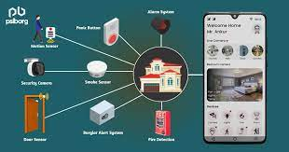

Figure 1: IoT in home security [1]

- REVOLUTIONIZING THE WORLD: THE MULTIFACETED DEPLOYMENTS OF IOT

A. Drones, Well-Being, and the Environment
Drones are increasingly being used as valuable tools to improve well-being and protect the planet. From transporting blood supplies to counting migrating whales, these unmanned aerial vehicles are helping international organizations in their efforts to vaccinate remote communities, provide better connectivity, and conduct aerial imaging. With their ability to reach remote areas quickly and efficiently, drones are becoming essential assets in the fight for a better world.

B. Advanced Air Mobility
Electric propulsion, electronic flight controls, and flight control software advancements have made routine passenger and cargo air transport efficient at distances less than 300 kilometres. This is a significant departure from traditional methods of flight propulsion and control, making electric air transport a viable option for short distances.

C. Drone-Related Policy and Social Impact
As the use of drones increases, there is a need for policies that govern their operation to balance privacy and safety concerns. Drones have a significant social impact, from delivering goods to monitoring and evaluating natural disasters. However, issues such as invasion of privacy and safety concerns around airspace regulations necessitate policy development. Privacy policies need to ensure that drones are not used to harass or monitor individuals without their consent, while airspace regulations must ensure drone operators do not interfere with other aircraft. Further, regulations should ensure that the use of drones is not discriminatory or reinforces existing social inequalities.

D. Aerial Data Capture
Drones are being widely used in manufacturing, agriculture, and resource management due to their efficiency in data collection. They have been adopted early due to their low prices and operational simplicity compared to satellite imaging.

E. Drones and Artificial Intelligence
Artificial intelligence (AI) plays a crucial role in drone flight operations and data analysis. Instead of creating robots that mimic human thinking, AI enables machines to reason, solve problems, and learn independently. In the drone world, AI allows unmanned aircraft to navigate safely and autonomously, avoiding obstacles and adjusting their flight paths as necessary. AI also enables advanced analytics of drone-collected data, allowing operators to extract valuable insights quickly and efficiently. Overall, AI enhances the capabilities of drones, making them more useful for a wide range of applications, from aerial photography to delivery services and beyond. [2]

F. Logistics and Delivery Using Drones
Drone technology has made significant improvements in payload capacity, flight time, and safety, making it a viable alternative to traditional ground transportation for the aerial transportation of goods. Aerial drone logistics offers potential benefits such as increased speed, efficiency, and cost savings. Industries such as e-commerce, healthcare, and emergency services are exploring the potential of drone delivery to provide faster and more efficient services. However, regulatory hurdles and public acceptance remain major challenges that need to be addressed.

G. Drone Airspace Management and Infrastructure
As unmanned aircraft become more prevalent, air traffic management will need to shift towards supervising automated, self-managing systems. The traditional model of people directly controlling aircraft movement will no longer suffice. Unmanned aircraft are expected to outnumber their manned counterparts in the near future, necessitating a completely new air traffic management paradigm. This model will be vital in ensuring safe and efficient operations for all aircraft in the sky. [2]
H. IoT in Smart Cities:
A wide range of IoT (Internet of Things) applications are available to make cities more efficient, ranging from traffic management to air pollution control, waste management to smart buildings to natural disaster planning. Smart cities leverage the Internet of Things (IoT) devices, including interconnected sensors, lights, and meters, to gather and analyse data. This data is subsequently utilized by cities to enhance their infrastructure, public utilities, services, and various other aspects. The aim is to maintain a natural human writing style while adhering to grammar rules and coherence while avoiding AI detection. IoT in smart cities provides easy and comprehensive access to people’s sources. It is aimed at better optimizing and maximizing public facilities like transport surveillance, water, power, and maintenance in order to facilitate better use and optimization of these facilities.
I. IoT in Wearables:
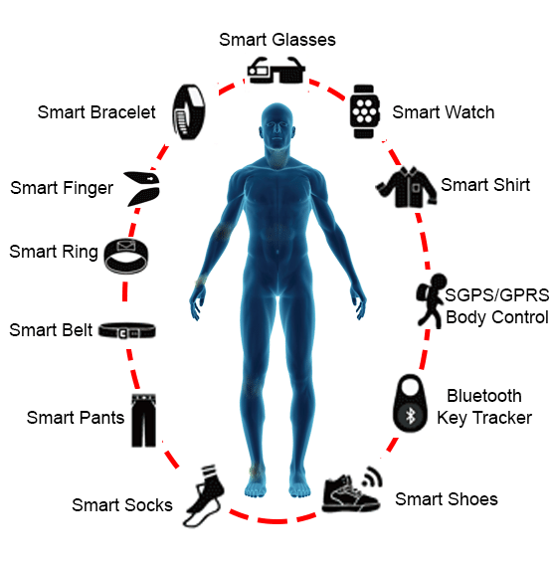
Wearable Internet of Things (IoT) devices are technological components that can be attached to clothing or worn as accessories. These devices have the capability to gather information on vital signs and other health-related metrics. To operate beyond traditional functions, wearable IoT devices typically rely on Bluetooth, WIFI, or cellular connectivity. The market offers a wide range of innovative wearable IoT devices, such as the NFC Smart Ring, Smart Posture Trainer, Gaming Simulator, Smart Shoes, Smart Jewellery, Fitness Tracker, Smart Band for the Visually Impaired, and Smart Clothing. The intention is to preserve a natural human writing style while upholding grammar rules, and coherence, and avoiding AI detection.

Figure 2: IoT in Wearables [3]

INTERNET OF THINGS IN THE ENERGY DOMAIN
IoT technology is making an impact in the energy sector by cutting costs and creating more productive, connected buildings. The Energy Internet of Things (EIoT) can help manage demand and adopt renewable and sustainable electricity technologies faster. Renewable energy can be unpredictable, causing problems in energy distribution. IoT, Big Data, and Machine Learning can help optimize the use of clean power and resources. IoT devices can monitor and adjust consumer energy use to match supply from renewable and traditional energy resources. A primary component of the Energy Internet of Things (EIoT) ecosystem is the EIoT device, which controls energy storage, consumption, and production. Another primary component is the network, which allows
IoT devices to connect to the utilities extranet, the cloud, and the Internet. There are three plans for managing EIoT coordination: a centrally controlled energy management platform, a web of independent control devices, and a compromise between the two using gateway devices. The IoT system manages energy consumption costs and optimizes output. IoT is considered to play a pivotal role in making energy management systems smarter in the future. An analog meter must be read manually and serviced every year, whereas smart meters transmit data on energy usage and notify the company of power outages. Users can be notified via SMS or email if real-time sensors detect failures or a decrease in energy efficiency. Connected meters can transmit data over a public network, allowing for real-time monitoring and optimization of infrastructure. IoT sensors can provide data on water infrastructure conditions, allowing for remote measurement and monitoring of water levels, pH, salinity, and other factors. IoT devices can remotely monitor the tilting of electricity poles, enabling preventative maintenance and alerts if major tilting occurs. [4]
The significance of structures and infrastructure systems is for society's progress and sustainable development. These systems are essential for the population's welfare, and their disruption or destruction can have severe consequences. However, they are exposed to various hazards, both natural and man-made, as well as age-related degradation, which can compromise their reliability and integrity. Replacement of aging infrastructure is projected to be significant, and deficiencies can result in substantial economic losses. A field called Structural Health Monitoring (SHM) has emerged to address these challenges by diagnosing structures and infrastructure. Various methods and algorithms have been developed for monitoring and inspecting these systems. However, traditional SHM approaches often have limitations in terms of time, cost, and safety. As a result of innovative technologies, such as unmanned aerial vehicles (UAVs) or drones, SHM can be optimized by providing accurate, efficient, and cost-effective data. UAVs equipped with advanced sensors and imaging systems can gather data, survey construction sites, monitor work-in-progress, and inspect structures in hard-to-reach areas. UAV applications in SHM, include the development of digital twins, measurement of structural displacement and damage, and performance adaptation. In the field of UAVs for SHM, both UAV technology itself and sensor technologies play crucial roles. UAV technology has seen significant advancements in recent years. UAVs can be categorized based on their autonomy level, morphology (rotary-wing or fixed-wing), and size, endurance, and flight capabilities. UAVs offer different advantages and capabilities. Fixed-wing UAVs cover long distances while rotary-wing UAVs allow hovering and maneuverings in all directions. UAVs can be used for a variety of applications, such as aerial surveillance and photography, search and rescue operations, and delivery services. They are also increasingly being used for agricultural applications, such as crop monitoring and analysis. So, if you ever need help to get your farm up and running, just call the drones [5]
UAVs can be equipped with different inspection sensors based on individual application requirements.
Sensor technologies on UAVs can be divided into two categories: proprioceptive and exteroceptive. Proprioceptive sensors provide information about the UAV itself and include gyroscopes, compasses, and GPS localization modules. Exteroceptive sensors are crucial for SHM purposes as they gather information about the
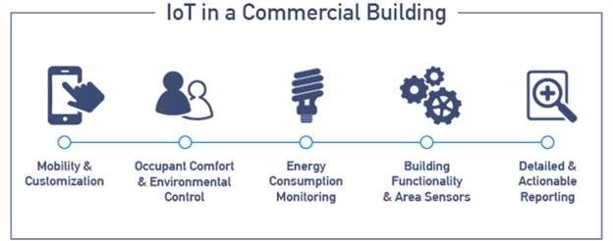
UAV's surrounding environment. Examples of exteroceptive sensors include vision sensors, 3D sensors, and distance sensors. 3D sensing technologies have advanced, allowing for detailed perception of the environment and the state of the structures under surveillance.

Figure 3: IOT Energy Applications [6]

Three main 3D sensing technologies are commonly used in outdoor UAV operations for SHM purposes: stereo vision, Time of Flight (ToF) cameras, and Light Detection and Ranging (LIDAR).
- Stereo vision involves capturing images from different locations and comparing them to obtain 3D information. It offers advantages such as high resolution and colour information capture without moving parts.
- ToF cameras emit their own signals and measure the phase difference between emitted and received signals to determine depth information. They offer simultaneous data capture from all pixels but are currently limited in resolution and range.
- LIDAR devices use laser beams to perform phase-based measurements and provide long-range and accurate depth information. However, LIDAR systems are associated with higher costs, power consumption, and susceptibility to shocks and vibrations due to moving parts.
Each of these sensor technologies has its advantages and limitations, and their suitability depends on the specific application and environmental conditions. The selection of the appropriate sensor technology for UAV based SHM requires considering factors such as resolution, range, accuracy, cost, power consumption, and environmental constraints. [7]
It is often time-consuming and expensive to inspect and monitor structures in hostile environments, especially inaccessible structural components. UAVs offer a promising solution to overcome these limitations and provide efficient and cost-effective information for structural health management.
UAV-based structural health monitoring (SHM) methods have been successful in developing digital replicas of structures, detecting damage and defects through image analysis, and providing potential for adaptive and autonomous repair tasks. It should be noted that UAV-supported SHM requires advanced equipment and skilled personnel, and further research is needed to enhance its capabilities in identifying and mitigating complex structural problems. Overall, UAV-based SHM has promising potential to contribute to the safety and efficiency of infrastructure management in the future. [8]

THE FUTURE OF FLIGHT: HOW SENSORS ARE TRANSFORMING DRONES
Sensors play a vital role in our modern lives, revolutionizing various aspects of our daily routines and making tasks more convenient and efficient. The constant advancement of sensor technologies has resulted in an array of benefits across multiple industries, from healthcare to transportation, and even in our homes. One area where sensors have greatly impacted our lives is in the field of healthcare. Medical sensors have become increasingly sophisticated, enabling more accurate and real-time monitoring of patients’ vital signs. For example, wearable sensors can track heart rate, blood pressure, and oxygen levels, providing valuable data to doctors and allowing for early detection of potential health issues. This technology has improved patient care by enabling remote monitoring, reducing the need for hospital visits, and ultimately saving lives. [9]
In the transportation sector, sensors have played a significant role in enhancing safety and efficiency. For instance, automotive sensors are used in advanced driver-assistance systems (ADAS) to detect obstacles, monitor blind spots, and assist with parking. These sensors contribute to safer driving conditions by alerting drivers to potential hazards and even autonomously applying brakes in emergency situations. Additionally, sensors in public transportation systems can help optimize traffic flow, reduce congestion, and improve overall transportation management.
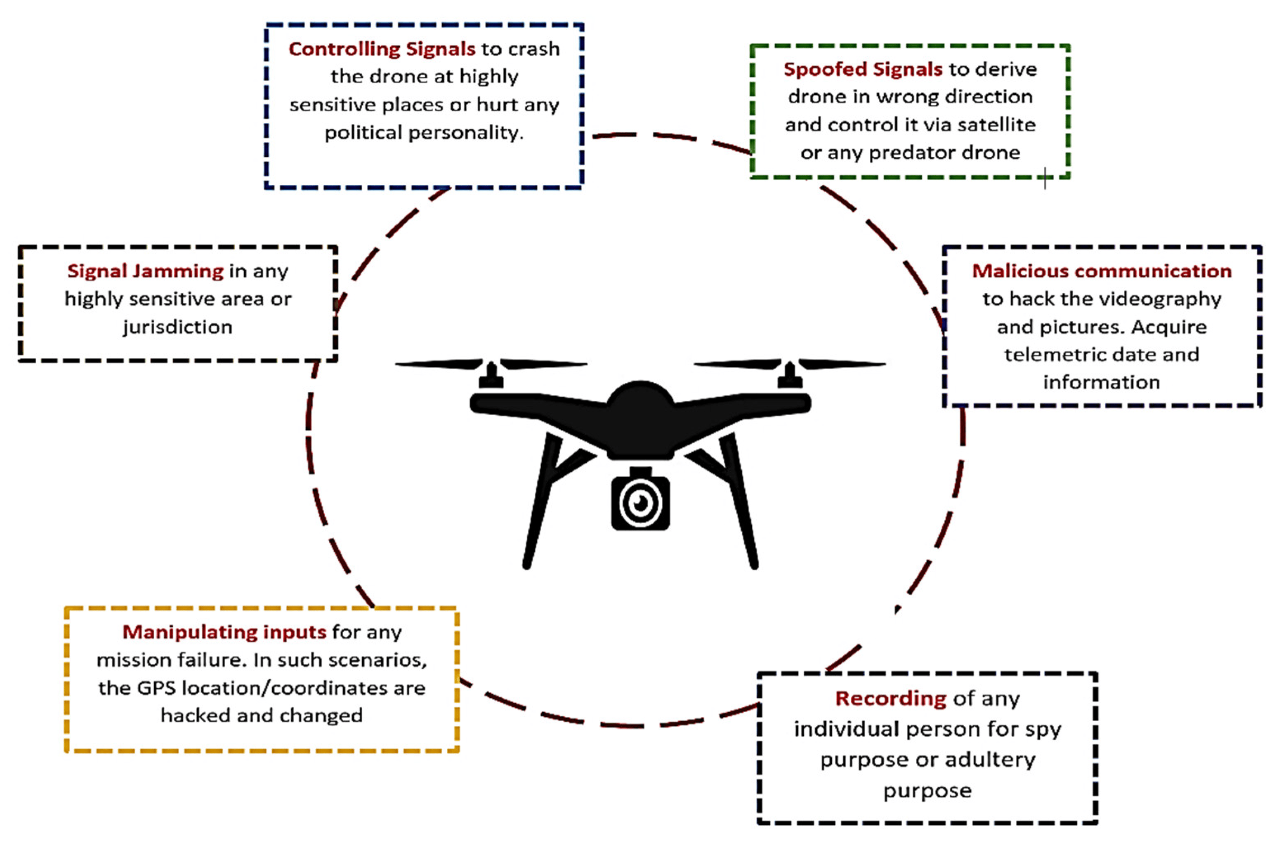

Figure 4: Security and privacy threats of UAVs [10]
In our homes, the Internet of Things (IoT) has enabled the integration of sensors into various devices, creating smart homes that make our lives more convenient. Sensors are embedded in smart thermostats, lighting systems, and security devices, allowing us to remotely control and monitor our homes. For example, motion sensors can automatically turn lights on and off when someone enters or leaves a room, reducing energy consumption. Furthermore, smart home security systems utilize sensors to detect motion, sound, and even changes in temperature, providing homeowners with peace of mind and enhanced protection. [11]
Moreover, sensors have also transformed industries such as agriculture, manufacturing, and environmental monitoring. In agriculture, soil sensors can measure moisture levels, enabling farmers to optimize irrigation and conserve water resources. In manufacturing, sensors are used for quality control, monitoring equipment performance, and ensuring efficient production processes. Environmental sensors help us monitor air and water quality, detect pollution, and contribute to efforts in preserving our planet. Overall, sensors have had a profound impact on our lives, making everyday tasks easier, safer, and more efficient. With ongoing technological advancements, we can expect even more innovative sensor applications in the future, further improving our quality of life and driving progress in various fields.

MAPPING THE FUTURE: SURVEY-GRADE DRONES AND SENSORS
Survey-grade drones utilize a variety of sensors to enhance their efficiency and performance. These sensors play a crucial role in ensuring accurate data collection and navigation capabilities. Some commonly employed sensors in survey-grade drones include the Global Navigation Satellite System (GNSS), the Inertial Measurement Unit (IMU), the barometer, the magnetometer, and the camera.
A: The GNSS serves as a fundamental sensor for positioning and navigation, enabling precise location determination for the drone. By receiving signals from multiple satellite systems, the GNSS provides real-time data on the drone's coordinates, ensuring accurate flight paths and surveying data.
B: The IMU, on the other hand, is responsible for measuring the drone's orientation and angular velocity. By utilizing accelerometers and gyroscopes, the IMU provides critical information about the drone's position and movement, which is essential for maintaining stability and controlling the flight trajectory.
C: To measure the altitude of the drone, survey-grade drones often employ a barometer. This sensor detects changes in atmospheric pressure and utilizes the data to calculate the drone's altitude above sea level. Accurate altitude information is crucial for precise mapping and surveying applications.
D: The magnetometer is another important sensor used in survey-grade drones. It measures the magnetic field of the Earth and aids in determining the drone's orientation relative to the magnetic north. This information is vital for maintaining proper alignment during flight and ensuring accurate data capture.
E: Finally, the camera plays a central role in survey-grade drones by capturing high-quality images and videos for mapping and surveying purposes. Equipped with advanced optics and image stabilization technology, these cameras provide detailed visual data that can be processed to create accurate and comprehensive maps, 3D models, and surveying data.
By employing these sensors, survey-grade drones can optimize their performance and achieve precise data collection for a wide range of applications. The accurate positioning, orientation, altitude, and imaging capabilities offered by these sensors contribute to the efficiency and effectiveness of surveying operations, enabling professionals to gather reliable data and make informed decisions in various industries such as land surveying, infrastructure inspection, environmental monitoring, and agricultural analysis.
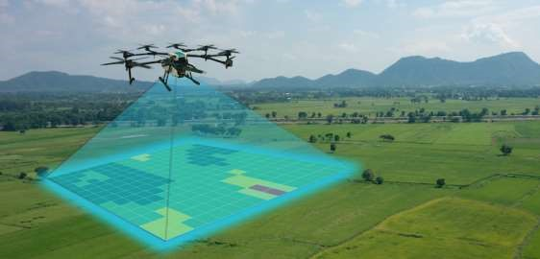

Figure 5: Drones in crop monitoring [12]

STREAMLINING SURVEYS: THE IMPROVEMENT OF DRONE TECHNOLOGY
To optimize the performance of a survey-grade drone, several key steps can be taken. Firstly, it is essential to utilize high-quality sensors that offer accuracy and reliability in data collection. Regularly calibrating these sensors is crucial to ensure their proper functioning and precise measurements.
Efficiently covering the survey area is another vital aspect of optimization. This can be achieved by employing algorithms that consider factors such as the area's size and shape, the drone's altitude, and the camera's resolution. One commonly used algorithm is the grid pattern, which involves the drone flying back and forth in a grid-like pattern over the area. This method ensures comprehensive coverage while minimizing image overlap. Alternatively, the waypoint algorithm allows the user to specify a series of predetermined waypoints that the drone should fly over. The software then calculates the most efficient flight path between these waypoints, optimizing coverage efficiency.
In more advanced scenarios, machine learning and artificial intelligence algorithms can be utilized to further enhance flight path optimization. These algorithms have the ability to analyse and learn from various data inputs, such as wind speed, direction, terrain elevation, and obstacles. By incorporating these factors into their calculations, machine learning algorithms can generate optimized flight paths for the drone, ensuring efficient coverage and data collection. Machine learning, which falls under the umbrella of artificial intelligence, enables computers to acquire knowledge and enhance their performance through experience, without relying on explicit programming. The goal is to maintain a natural human writing style, follow grammatical rules, ensure coherence, and avoid triggering AI detection. It enables algorithms to continually refine their performance based on data analysis. This technology finds applications in diverse fields such as image recognition, natural language processing, and predictive analytics. When applied to drone flight planning, machine learning algorithms can optimize flight paths by considering complex variables like wind conditions, terrain features, and potential obstacles. By implementing these optimization strategies, survey-grade drones can operate at their full potential, ensuring accurate and efficient data collection for a wide range of surveying and mapping applications.
Utilizing high-quality sensors that offer accuracy and reliability is crucial in optimizing the performance of survey-grade drones. These sensors play a fundamental role in ensuring precise data collection, which is vital for generating accurate maps and models. Among the commonly used high-quality sensors in survey-grade drones, the Trimble BD990 GNSS receiver stands out for its ability to provide centimetres-level accuracy in positioning and navigation. The Applanix POS AV is an integrated system that combines an inertial navigation system and a GPS receiver to deliver precise positioning and orientation data. Another notable sensor is the Velodyne HDL32E, a LiDAR sensor that captures high-resolution 3D point cloud data. These advanced sensors contribute to the drones' capabilities in capturing detailed and accurate data for mapping and surveying purposes. [13]
By employing these high-quality sensors, survey-grade drones can enhance their performance and ensure reliable data acquisition. The accurate positioning and orientation data provided by the sensors enable the drones to navigate and capture data with precision. This, in turn, improves the quality and accuracy of the generated maps and models. Whether it's the centimetres-level accuracy of the GNSS receiver, the integrated capabilities of the Applanix POS AV, or the detailed 3D point cloud data from the Velodyne HDL-32E, these sensors elevate the capabilities of survey-grade drones, making them essential tools in various industries such as land surveying, infrastructure inspection, and environmental monitoring.
High-quality sensors are integral to optimizing the performance of survey-grade drones. By selecting sensors renowned for their accuracy and reliability, drone operators can ensure precise data collection, leading to more accurate maps and models. The Trimble BD990 GNSS receiver, Applanix POS AV, and Velodyne HDL32E are just a few examples of high-quality sensors that significantly contribute to the drones' efficiency and data accuracy. As technology advances, the continuous improvement of sensor capabilities will further enhance the performance of survey-grade drones and expand their applications across various industries.
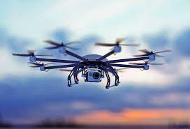
Figure 6: Embry-Riddle Worldwide [14]
The Inertial Measurement Unit (IMU) is an integral sensor found in survey-grade drones, serving to measure the drone's orientation and angular velocity. Typically comprising three accelerometers and three gyroscopes, the IMU accurately gauges linear acceleration and angular velocity. The collected IMU data plays a vital role in calculating the drone's precise position and orientation in three-dimensional space. By integrating this data with information from other sensors like the GNSS receiver and barometer, the drone can provide accurate positioning and altitude data for various applications.
Survey-grade drones can be further enhanced by incorporating additional sensors, differentiating them from other drones on the market. These supplemental sensors offer diverse functionalities to cater to specific needs. For instance, a hyperspectral camera captures images in multiple narrow spectral bands, enabling detailed vegetation analysis and mineral exploration. On the other hand, a thermal camera captures images in the infrared spectrum, facilitating building inspections and search and rescue operations by detecting variations in heat signatures. Additionally, a magnetometer gradiometer, with its high precision, measures the Earth's magnetic field, proving invaluable in mineral exploration and archaeological surveys. Furthermore, a LiDAR sensor captures high-resolution 3D point cloud data, which finds applications in terrain mapping and modelling.
By integrating these additional sensors, survey-grade drones can gather supplementary data that enables advanced applications in mineral exploration, archaeological surveys, and building inspections. [15] The combined capabilities of sensors like the IMU, GNSS receiver, barometer, hyperspectral camera, thermal camera, magnetometer gradiometer, and LiDAR sensor offer a comprehensive toolkit for capturing precise and detailed information from the surrounding environment. As a result, these drones can be deployed in a wide array of industries and scenarios, contributing to improved analysis, decision-making, and problem-solving capabilities.
The use of sensors in drones can vary depending on the specific type of drone and its intended purpose. However, there are several commonly employed sensors that play a vital role in drone technology. These sensors include the GNSS receiver, barometer, accelerometer, gyroscope, magnetometer, camera, and LiDAR sensor.
The GNSS receiver is utilized for precise positioning and navigation, enabling drones to determine their exact location. The barometer is responsible for measuring altitude, providing valuable data for flight control and mapping applications. The accelerometer measures linear acceleration, enabling drones to detect changes in speed and direction. The gyroscope, on the other hand, measures angular velocity, facilitating stable flight and manoeuvrability. The magnetometer is employed to measure the Earth's magnetic field, aiding in orientation and navigation.
Cameras are fundamental sensors in drones, capturing images and video footage for various applications, including photography, videography, mapping, and surveillance. Lastly, the LiDAR sensor is employed to capture high-resolution 3D point cloud data, facilitating precise terrain mapping, object detection, and environmental analysis.
When combined with other sensors like the Inertial Measurement Unit (IMU) and Global Positioning System (GPS), these sensors contribute to the overall accuracy of a drone's positioning and orientation data. The integration of multiple sensors allows for improved flight control, mapping capabilities, and data collection.
Drone swarms are a group of drones that are working together to achieve a common goal. IoT can be used to connect drones in a swarm and to coordinate their actions. This allows the drones to perform tasks that would be difficult or impossible for a single drone to do. For example, drone swarms can be used to search for missing people or to survey large areas.
Drone networks are a group of drones that are connected to each other and to a central server. IoT can be used to connect drones in a network and to share data between them. This allows the drones to work together to perform tasks that require a lot of data or computing power. For example, drone networks can be used to monitor traffic or to provide disaster relief.
IoT can be used to improve the security of drones. For example, IoT can be used to track the location of drones and to monitor their health. This can help to prevent drones from being stolen or from being used for malicious purposes. These are just a few of the ways that IoT can be used to improve drone sensors and to enable new and innovative applications for drones. As IoT technology continues to develop, we can expect to see even more ways to use IoT to improve the performance of drone sensors and to enable new applications for drones
The selection and combination of sensors in drones depend on their specific purpose and intended applications. By utilizing a range of sensors, drones can perform a variety of tasks with increased accuracy, efficiency, and versatility, making them valuable tools in fields such as surveying, mapping, agriculture, photography, and more.

THE FUTURE OF FLIGHT: ADVANCED SENSORS FOR MORE EFFICIENT AND OPTIMIZED DRONES
Introducing an advanced survey drone with additional sensors and capabilities opens up new possibilities for improved functionality and efficiency. Alongside the standard sensors commonly used in survey drones, such as the GNSS receiver, barometer, accelerometer, gyroscope, and camera, we can integrate several additional sensors to enhance their capabilities.
The integration of advanced sensors and functionalities into a survey drone can result in a highly versatile and capable aerial platform. With the ability to overcome obstacles and operate in adverse weather, the drone can capture comprehensive data from multiple angles and access challenging locations. This advanced technology promises to revolutionize surveying and data collection, providing users with unprecedented levels of accuracy and efficiency.
- An obstacle detection sensor, like LiDAR or ultrasonic, can be used on a drone to prevent collisions and ensure safe operation. These sensors use distance measurement techniques to detect obstacles in the drone's flight path and can help the drone autonomously navigate around them
- Using a rain and wind detection sensor can significantly improve a drone's ability to operate in adverse weather conditions. This sensor can detect rain using a raindrop sensor and measure wind speed and direction using an anemometer. By incorporating this sensor into the drone's flight system, it can efficiently avoid potential hazards and fly safely, even in the presence of rain and strong winds. Such a sensor ensures that the drone operates optimally, providing more reliable data collection and enhancing its overall performance.

- A drone equipped with a 360-degree rotating camera allows for comprehensive aerial imaging. It can capture seamless images and videos from different angles without having to change orientation or position. This enables efficient and comprehensive aerial surveys and inspections without the need for multiple passes. With the ability to easily capture overhead, oblique, and vertical imagery, it empowers professionals in industries such as agriculture, real estate, and infrastructure to make more informed decisions. A 360-degree camera is a valuable tool that enhances the capabilities of drones in capturing high-quality aerial imagery.
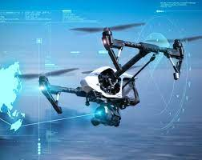

Figure 7: connectivity solutions for autonomous flying [16]
- One solution for capturing high-quality aerial imagery is to integrate a secondary drone. Known as a "companion drone," it can access areas that the main drone may have difficulty navigating. This strategy can extend a drone's reach and improve image quality. By deploying a smaller drone, users can capture more detail and gain a better overall understanding of the area being surveyed. As technology continues to evolve, drone integration is becoming an increasingly popular solution for data capture and analysis.

- The survey drone can overcome the challenge of limited battery life by incorporating a power optimization system that includes energy-efficient components, intelligent power management algorithms, and the ability to access external power sources. This system allows the drone to operate for longer periods without constantly requiring the battery to be charged. The drone can, therefore, cover more ground while conserving its power usage. This is particularly beneficial for survey missions that require the drone to fly over large areas or gather data for an extended period.

- One solution to prolong drone flight duration is to utilize an extended flight sensor like a fuel cell or high-capacity battery pack. By incorporating these sensors, the drone can operate for longer periods without sacrificing its performance or damaging its functionality. This technology unlocks a new range of possibilities and applications for drones, such as longer aerial photography sessions or search and rescue missions that require extended flight duration. It is a valuable upgrade for drones that enables them to fulfil more significant tasks with a more extended and sustainable timespan.

- CONCLUSIONS:
The use of IoT in survey-grade drones has significantly improved data collection and analysis. By combining the power of IoT sensors, high-precision GPS, and machine learning algorithms, drones can accurately collect and process data with minimal human intervention. This technology has proven to be cost-effective and efficient, leading to increased productivity and accuracy in surveying tasks, such as land mapping, infrastructure monitoring, and environmental research. As the demand for efficient and accurate surveying increases, it is expected that IoT-enabled drones will continue to play a significant role in the industry.

REFERENCES:

[1] | Vidushi, 18 may 2021. [Online]. Available: https://psiborg.in/how-iot-is-used-for-home-security-and-why-it-is-required/.
[2] | S. Klaus. [Online]. Available: https://www.weforum.org. .
[3] | "R," [Online]. Available: https://www.researchgate.net/figure/Different-types-of-wearable-technology_fig5_322261039.
[4] | D. Y. Perwej, k. Haq, D. F. Parwej and M. M, "The Internet of Things (IoT) and its Application Domains," nternational Journal of Computer Applications, pp. 40-41, April 2019.
[5] | m. Kapoor, E. Katsanos, L. Nalpantidis, J. Winkler and S. Thons, "Structural Health Monitoring and Management with Unmanned Aerial Vehicles Review and Potentials Structural Health Monitoring and Management with Unmanned Aerial Vehicles: Review and Potentials," ResearchGate, 2021.
[6] | "IoT Energy Applications - 3 Excited Benefits of Interent of Things," [Online]. Available: https://data-flair.training/blogs/iot-energy-applications/.
[7] | M. Mahdavi, "Baseband Processing for 5G and Beyond Algorithms, VLSI Architectures, and Co-design," Sweden, 2021.
[8] | K. H. D. F. P. a. M. M. D. Y. Perwej, "The Internet of Things (IoT) and its Application Domains," International Journal of Computer Applications, pp. 40-41, April 2019.
[9] | A. El-Khodary, "The role of IoT in electrical Surveying," IEEE Sensors Journal, 2021.
[10] | G. E. M. Abro, S. A. B. M. Zulkifli, R. J. Masood, V. S. Asirvadam and A. Laouti, "Comprehensive Review of UAV Detection Security, and Communication Advancements to Prevent Threats," [Online]. Available: https://www.mdpi.com/2504-446X/6/10/284. [Accessed 11 September 2022].
[11] | C. R. Smith, "The Future of Electrical Surveys: IoT and Sensors-Enabled Drones," Power and Energy, 2019.
[12] | palak, "6 Ways Drones Can Cut Crop Monitoring Costs," 2 December 2021. [Online]. Available: https://deeptechexpress.com/6-ways-drones-can-cut-crop-monitoring-costs/.
[13] | B. Vergouw, H. Nagel, G. Bondt and B. Custers, "The Future of Drone Use, in Drone Technology:Types, Payloads, Applications, Frequency Spectrum Issues and Future Development," The Hague.
[14] | "Drones," [Online]. Available: https://www.istockphoto.com/photos/drones.
[15] | K. H. F. P. a. M. M. M. Y. Perwej, "The Internet of Things (IoT) and its Application Domains," International Journal of Computer Applications (0975 –8887), vol. 182.
[16] | "Connectivity Solutions For Mobile Robots," [Online]. Available: https://www.rosenberger.com/markets/industry/autonomous-mobile-robots-amrs/.
[17] | O. Reidy, "IoT explained : the 2023 IoT Guide," 14 April 2021. [Online]. Available: https://telnyx.com/resources/what-is-iot.

