ENHANCEMENT OF SAFETY AND ENERGY EFFICIENCY IN BUILDINGS USING Lo Ra TECHNOLOGY

Dr. Akhil Pandey ¹, Dr. Vishal Shrivastava ², Dr. Vibhakar Pathak ³, Er. Sangeeta Sharma ⁴
Department of Computer Science ^{1,2,3}
Arya College of Engineering & IT
akhil@aryacollege.in¹, vishalshrivastava.cs@aryacollege.in ³, vibhakar@aryacollege.in ³, sangeetayuwansh1@gmail.com⁴

Abstract—Smart building management systems (SBMS) are becoming increasingly popular due to their ability to improve the energy efficiency and sustainability of buildings. This research uses Lora technology- the latest trend to deliver a secure wireless SBMS using very little power. LoRa devices involve incorporating wireless communication technology into building management systems to increase power efficiency, ensure safety by earlier earthquake and fire detection, providing safety instructions, escape routes to the occupants and alert to the local emergency response team, security to the end user, automation and monitoring capabilities.SBMS also provides advanced automation capabilities, such as automated lighting, heating, and cooling systems. These systems adjust in real-time based on the occupancy levels and other building parameters, providing optimal comfort to occupants while minimizing energy usage. The goal is to enhance comfort, safety, security and energy efficiency for the occupants.
LoRa offers long-range coverage and low power consumption, making it ideal for use in smart buildings.

Keywords— Internet of things (IOT), Smart buildings, Lora, Cloud computing.

Introduction
The integration of modern technologies with traditional building management systems has led to the emergence of smart building management systems. The problem with traditional building management systems is that they often

rely on wired communication systems, which can be expensive, inflexible, and difficult to upgrade. This can limit the efficiency and sustainability of the building and make it difficult to monitor and control the various systems in real-time. Traditional building management systems utilize more
power for their functioning and are only limited to low range communication and it requires a complex infrastructure. Smart building management systems using LoRa technology will be focused on improving efficiency, reduced costs, and enhanced sustainability, safety, and comfort of the occupant. LoRa allows the collection of data from many sensors and devices, enabling the automation of various building management functions, such as lighting, HVAC (Heating, Ventilation, and Air Conditioning), and security. Around 100 million devices throughout 100 countries are connected to the network of Lora. This research paper aims to investigate the use of LoRa technology in smart building management systems. The paper will discuss the benefits of using this technology, and the various applications of it. It will also present case studies of buildings that have successfully implemented LoRa technology for building management. IoT in smart building management systems has revolutionized the way buildings are managed and maintained. They are designed to optimize building performance, reduce energy consumption, and enhance occupant comfort and safety. One of the key features of IoT in smart building management systems is the ability to collect and analyze real-time data from a variety of sensors and devices. This data can be used to identify patterns, trends, and anomalies in building performance, allowing building managers to make informed decisions about energy usage, maintenance, and security.
The findings of this research will be beneficial to building owners, facility managers, and building automation system providers who are interested in implementing smart building management systems using LoRa technology and the data collected can be sold to third-party companies or organizations, such as energy providers or environmental agencies. The research will also contribute to the existing body of knowledge on smart building management systems and will bring more role of LoRa technology in this field.

RELATED WORK
This section gives a brief on the previous work done related to our proposed system. Over the past decade, significant advancements have been made in the field of IoT, specifically in the domain of smart buildings. The proliferation of smart devices and objects has enabled the development of an IoT ecosystem, with projections indicating that the number of interconnected objects will grow to over 50 billion by 2020. In R. Islam, Md. Wahidur Rahman, R. Rubaiat,(2020) worked on the architecture of home automation for both short-range and long-range utilizing multiple communication technologies, namely LoRaWAN, server-based Lora gateway, and Bluetooth connectivity.
ElShafee et al. (ElShafee and Hamed, 2012) proposed system is a smart home automation system that utilizes Wi-Fi technology to provide control and monitoring capabilities to users. The system consists of two main components, a web server, and several sensors. The web server is responsible for managing and controlling the smart home, while the sensors detect and monitor various environmental conditions within the home. The proposed methodology is claimed to be superior to existing commercial solutions, implying that it offers better performance, functionality, and features than traditional home automation systems. The use of Wi-Fi technology in the proposed system enables remote access and control of the smart home, making it more convenient and flexible for users.
The authors in ( Pavithra and Bala krishnan (2015)), have also proposed Wi-Fi-based home automation systems that utilize technologies like Raspberry Pi and smart phones for control and monitoring. The system in this study also includes a smoke detection mechanism that alerts users through their smartphones.
The paper by Rizwan Bashir, published in 2017, discusses the challenges associated with managing and analyzing massive amounts of data in IoT-enabled smart buildings. The authors conducted a comprehensive literature review, utilizing the SLR (Systematic Literature Review) method, to identify the major obstacles and potential solutions to this problem. Through the analysis of 22 relevant papers, the authors identify a range of challenges, including data quality issues, privacy and security concerns, interoperability issues, and data analysis complexities. The authors also identify potential solutions, such as the use of big data analytics, cloud computing, and standardized communication protocols. Overall, this paper highlights the importance of understanding the challenges associated with managing and analyzing data in IoT-enabled smart buildings. The authors provide insights into the major obstacles that must be overcome to successfully utilize the Internet of Things capabilities in smart buildings. This research serves as a valuable resource for scholars and practitioners looking to further develop and improve the management of smart buildings with IoT capabilities.
In our proposed solution we will design a SBMS using IOT that utilizes LoRa technology to provide real-time monitoring, control, and automation of various building systems. It will also provide better Safety by implementing Earthquake detection system, Fire detection system and an advanced emergency response system. During emergencies we will provide safety instructions, escape routes to the occupants and alert the local emergency response team.
It also includes comfort of occupant by adjusting the indoor lighting according to the outdoor lighting. Using LoRa Technology we will communicate with multiple devices and systems throughout the building, while using minimal power and achieving long-range connectivity. Even, several countries have developed long-term national strategies for the implementation of IoT, with smart homes and buildings being an important component. Smart buildings are characterized by interconnected electronic devices and appliances, generating large amounts of data (i.e., big data).

TECHNOLOGY USED

- IOT
The IoT network of physical devices that are connected to the internet, allowing them to collect and exchange data. These devices can series from simple sensors to complex machinery and can include anything from home appliances to industrial equipment. The IoT works by connecting these devices to the internet and enabling them to communicate with each other and with other systems. The data collected by these devices can be analyzed to provide valuable insights and enable more efficient and effective decision-making.
This data is then transmit over the internet to a central server or cloud-based platform, where it can be analyze and acted upon. It enables real-time monitoring and control of devices, leading to increased efficiency, cost savings, and improved safety and security. However, the IoT also raises concerns around data privacy and security, as the large amounts of data collected by IoT devices can be vulnerable to hacking and cyber-attacks. As such, it is important to ensure that proper security measures are in place to protect the data and devices in the IoT network. The IoT has had a significant impact on the growth and development of smart buildings. Smart buildings leverage IoT technology to collect and analyze data in real-time, allowing for more efficient and effective management of building systems and resources.
The growth of IoT in smart buildings can be attributed to several factors, including:
- Cost Reduction: IoT technology has become more affordable, making it more accessible for building owners and managers to implement smart building solutions. The cost reduction has been driven by advances in sensor technology, cloud computing, and the widespread availability of wireless connectivity.
- Automation: IoT technology allows building systems to be monitored and controlled in real-time, enabling more efficient use of energy and resources. This includes monitoring HVAC systems, lighting, and other building systems, to analyze their routine and reduce get-up-and-go utilization.
- Improved Occupant Comfort: Smart buildings can leverage IoT technology to create a more comfortable and productive environment for occupants. This includes adjusting lighting and temperature to match occupant preferences and using occupancy sensors to optimize space usage.
- Predictive Maintenance: IoT technology can be used to monitor the performance of building systems, identifying potential issues before they become major problems. This enables preventive maintenance, reducing downtime and costs associated with unexpected system failures.
As the benefits of IoT in smart buildings become more apparent, we can expect to see continued growth and adoption of IoT technology in this sector. This will lead to more efficient, comfortable, and sustainable buildings that meet the evolving needs of occupants and building owners.

- LoRa Technology
LoRa (Long Range) is a Low Power Wide Area Network (LPWAN) technology that is used to build wireless sensor networks. It is designed for long-range communications, low power consumption, and low cost. LoRa uses the unlicensed ISM (Industrial, Scientific, and Medical) frequency bands and operates in a star-of-stars topology, where gateways connect to the network and bridge the communications between the nodes (devices) and the central network. LoRaWAN, the networking protocol for LoRa, provides end-to-end encryption and is suitable for many IoT applications. LoRa is a low-power, long-range wireless communication technology that is designed for the Internet of Things (IoT). It enables long-range wireless communication between sensors, gateways, and other devices, making it ideal for IoT applications.
Advancements in LoRa technology have led to several improvements in its capabilities, including:
- Increased Range: LoRa technology can now achieve ranges of several kilometers, depending on the environment and the type of device used. This makes it ideal for applications that require long-range communication, such as smart agriculture, asset tracking, and smart cities.
- Improved Battery Life: LoRa devices typically operate on battery power, and advancements in LoRa technology have enabled longer battery life. Some LoRa devices can now operate for several years on a single battery, depending on the usage patterns.
- Enhanced Security: LoRa technology supports end-to-end encryption, ensuring that data is transmitted securely between devices. This is critical for IoT applications where data privacy and security are a concern.

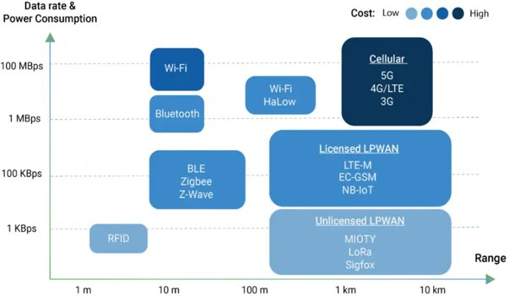

Fig 1. Comparison of various Wireless Technology

- Cloud Computing
Cloud computing is a that provides access to a shared pool of computing resources over the internet, including servers, storage, applications, and services. It allows individuals and organizations to use computing resources as a utility, like electricity, without the need for physical infrastructure, such as servers and data centers. It is based on the concept of virtualization, where physical resources are abstracted and presented as virtual resources. These virtual resources can be allocated and de-allocated as needed, providing a high degree of flexibility and scalability.
Overall, cloud computing provides a flexible and scalable way to manage computing resources, enabling individuals and organizations to focus on their core business activities without having to worry about the underlying infrastructure. It is becoming a key technology used in smart building management systems (SBMS). Cloud computing allows SBMS to scale up or down as needed, depending on the size and complexity of the building. It has the capability to store large amounts of data collected by sensors, smart devices, and other building automation systems. It enables real-time monitoring of building systems, allowing facility managers to quickly identify and address any issues that arise. This can lead to improved energy efficiency, reduced maintenance costs, and improved occupant comfort and safety.
The most and foremost benefit/advantage cloud computing provides is to enable building managers to access SBMS data and systems remotely, allowing them to monitor and control building performance anytime from anywhere which results them to reduce the costs by eliminating the need for on-site data storage, servers, and other hardware. The large amounts of data collected enables building managers to gain insights into building performance, such as energy usage, occupancy patterns, and equipment performance.

METHODOLOGY
The methodology section is classified into two major segments. First, we will discuss the technical details of the home automation system. The system will be designed to control various home appliances such as lights, fans, air conditioners, etc. using a Smartphone application. Secondly, we will discuss the hardware and software components required for the proposed solution. The paper will also discuss the programming requirements for each component.
The figure included in the paper illustrates that the range of Bluetooth is limited to up to 8-10 meters, while the range of the server based LoRa gateway can be up to 30 meters, and the range of LoRaWAN can cover larger area over several kilometers, with ranges of up to 10 kilometers (about 6.21 mi) or more possible under optimal conditions.

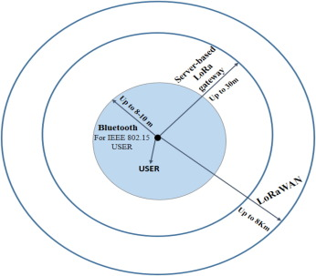

Fig 2. A block diagram of LoraWAN

Technical details of the Projects
• Embedded System: The Embedded system will be equipped with sensors, actuators and microcontrollers where the sensors are used to gather data from various building systems and Microcontrollers fetch the data from sensors and send control signals to Actuators.
• Central Gateway: The central gateway is responsible for collecting data from the private network (building system) and forwarding it to the public network (cloud). The gateway also communicates with the actuators to control the building systems.
• Cloud Storage: The cloud will store the data collected by end devices and process it to provide a user-friendly interface for monitoring and controlling the building systems.
• Mobile Application: A mobile application will be developed for building managers and occupants to control and monitor the building systems from their mobile devices. The mobile application will be connected to the cloud and will provide real-time data and control options for the building systems.
• Data Analysis and Automation: The cloud will use machine learning algorithms to analyze the data collected by the End devices and automated certain processes and procedures.
• Security: The system will be designed with security in mind to ensure the protection of sensitive data and prevent unauthorized access to the building systems. By using LoRa technology we provide better security than existing solutions.

- Requirements for the proposed solution
1) Hardware system requirements.
2) Software system requirements
3) Advance Web Development
4) Updated Android Development

Overall, the Hardware interface module is a system that uses an Arduino Uno memory chip, LoRa component, and relay to supervise and control various appliances.. The communication between microprocessor and application is handled by the server, which manages the users and the appliances.
The Android application serves as a frontend and provides an interface for the user to interact with the microprocessor. The application presents a list of devices that the user can manage and observe. The system offer switch functionalities for various appliances, such as lights, fans, air-conditioners, and other appliances connected to the system. The relays ensure that the system is safe and can handle high voltage loads without damaging the microprocessor. The Android application provides an intuitive interface that enables users to control their appliances easily.

PROPOSED SOLUTION
We are designing a Smart building management system using IOT that utilizes LoRa technology to provide real-time monitoring, control, and automation of various building systems. We are using LoRa technology that uses less power, provides long-range connectivity and better security. For security and Safety, we provide the implementation of earthquake detection system, Fire detection system and an advanced emergency response system. During emergencies we will provide safety instructions, escape routes to the occupants and alert the local emergency response team. It also includes comfort of a user by adjusting the indoor lighting according to the outdoor lighting. We are using LoRa (Long Range) devices as it uses low-power, wide-area network (LPWAN) technology to communicate with other devices in a building, allowing for the exchange of data over long distances and the main aim is the minimal power consumption. In a smart building management system, LoRa devices gather data from various building systems and send it to a central control system for analysis and decision making.
This system will use LoRa technology and have such features:
- Integration with Existing Systems: - The smart building management system should be designed to seamlessly integrate with existing building systems, such as HVAC, lighting, and security systems, to provide a unified platform for building management.
- Better Safety: - Implement the Earthquake detection system and Advance emergency response system.
- User Adoption: The smart building management system should be designed with a user-friendly interface and intuitive controls that make it easy for building occupant use.
- Cost-Effective Deployment: The implementation of the smart building management system using LoRa technology should be cost-effective, use low-power and provide long-range capabilities that minimize the need for additional infrastructure and reduce costs
- Data Management and Security: The smart building management system should be designed to securely manage and analyze the large amount of data generated by the system.

RESULTS AND DISCUSSION
Currently, we have made a dashboard which can have multiple rooms. All rooms are given a particular ID and, like when we enter Room 1, we can see the dashboard attached below fig (4). Here we can have multiple options such as Button for Light On/Off, Fan On/Off, AC and we can see the live temperature and humidity in room 1. Here in fig (3) we have made some connections which include an Esp8266 Wi-Fi module, temperature sensor, a Led and a buzzer.
If we click on the Light button, it will automatically switch On the Led on the breadboard and on clicking again it will turn off the Led. The buzzer will beep when the temperature is high as compared to normal it can be used in case of any emergency like fire.
For example, if the current temperature of a room is 28.1 degree Celsius and the temperature rise to 50 degrees then according to that the buzzer will give alarm.

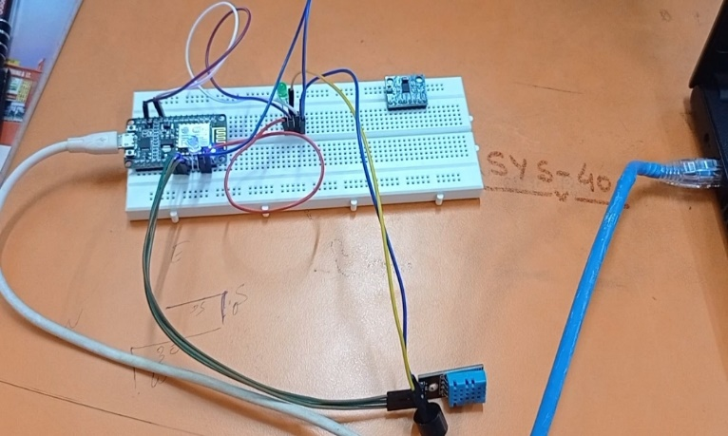
Fig 3. Led OFF
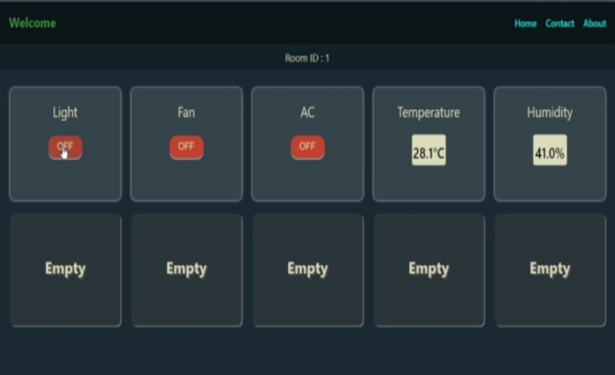
Fig 4. Dashboard

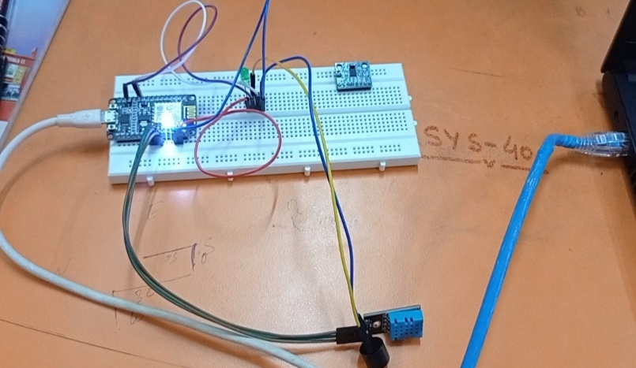
Fig 3. Led ON

SUMMARY AND CONCLUSION
The study papers introduce a resolution for accepted users to have a entire well-groomed building management system. The solution involves the development of an android application that allows users to control all the building equipment in their homes. The structure utilizes LoRa WAN technologies. If the user is outside of short and medium-range wireless communiqué, the system operates through LoRa technology.
There is a lot of potential for IoT to transform smart buildings services, but the practical applications are still in the early stages. The review highlights the importance of IoT in driving innovation in this area and its collaboration with other modern technologies. The paper also suggests that there is a lot of room for future research and improvements in this field of making buildings smart. As new ideas for IoT applications in smart buildings services emerge, it is likely that we will see even more transformative changes in our environment and daily lives. Some potential future works and improvements could include further exploration of IoT's collaboration with other technologies, improving IoT- enabled smart services to make them more efficient and effective, and developing new innovative ideas for IoT applications in this field. In summary, the paper systematically reviewed IoT-enabled services in smart buildings and found that the IoT is a key enabler and driver of smart buildings services.
The use of LoRa technology in smart buildings has shown significant improvements in both safety and energy efficiency. By monitoring key aspects of building operation in real-time, building managers can identify potential safety issues and take appropriate action before accidents occur. Additionally, by reducing energy waste, LoRa technology helps to lower energy costs and reduce the environmental impact of building operations.
In conclusion, the paper suggests that we are currently in the hype phase of IoT-enabled services in smart buildings. Future research in this field can focus on the development of more advanced technologies, such as edge computing and block chain, to enhance the efficiency and security of smart building management systems.

References
- Gambi et al., 2018 Gambi, E., et al., 2018. A home automation architecture based on LoRa technology and message queue telemetry transfer protocol. Int. J. Distrib. Sens. Netw. 14(10), p. 1550147718806837.
- R. Islam, Md. WahidurRahman,R.Rubaiat, Md Mahmudul Hasan, Mohammad Motiur Rahman," LoRa and server-based home automation using the internet of things (IoT)".
- ElShafee et al. (ElShafee and Hamed, 2012) proposed Wi-Fi-based home automation and security system.
- Risteska Stojkoska and Trivodaliev, 2017 B.L. Risteska Stojkoska, K.V. TrivodalievA review of Internet of Things for smart home: challenges and solutions. Cleaner Prod., 140 (2017), pp. 1454-1464, 10.1016/j.jclepro.2016.10.006
- Bababe et al., 2017 A. Bababe, A. Jha, R. Kumar Lora based intelligent home automation system Int. J. Eng. Adv Technol. (IJEAT), 6 (2017), pp. 88-92
- M. R. Bashir and A. Q. Gill, "IoT enabled smart buildings: A systematic review," 2017 Intelligent Systems Conference, 2017, pp. 151-159, http://doi.org/10.1109/IntelliSys.2017.8324283.
- (Pavithra and Balakrishnan (2015)) wi-fi-based home automation systems.

