IoT-based Gas Leakage detection and Rain detection system

Kunwar Rajveer
Computer Science Engineering
MS Ramaiah university of Applied Sciences
Bengaluru,India
19ETCS002061@msruas.ac.in
Mohammed Shuaib
Computer Science Engineering
MS Ramaiah university of Applied Sciences
Bengaluru,India
19ETCS002068@msruas.ac.in
Lokeshwari Siva
Computer Science Engineering
MS Ramaiah university of Applied Sciences
Bengaluru,India
19ETCS002063@msruas.ac.in
Raghav Dubey
Computer Science Engineering
MS Ramaiah university of Applied Sciences
Bengaluru,India
19ETCS002094@msruas.ac.in
Nemi Makadia
Computer Science Engineering
MS Ramaiah university of Applied Sciences
Bengaluru,India
19ETCS002065@msruas.ac.in
Divyansh
Computer Science Engineeringn
MS Ramaiah university of Applied Sciences
Bengaluru,India
19ETCS002036@msruas.ac.in

Abstract—The system proposed in this paper is an advanced solution for monitoring any gas leakage or rain at a particular place and make the information visible anywhere in the world. The technology behind this is Internet of Things (IoT), which is an advanced and efficient solution for connecting the things to the internet and to connect the entire world of things in a network .This project was developed to produce a prototype product of a web based system based on statistical behavior of multiple gas molecules. The reported gas sensor, consisting of a tiny gap, provides on/off switching behavior as it captures the target gas molecules. The key innovation lies in the fact that such an off/off switching becomes statistically-reliable when multiple gaps and molecules are utilized.
Keywords— Internet of Things (IoT) ,Gas leakage detection, Rain detection ,node mcu, Sensors to cloud System, Arduino IDE

Introduction
In this IoT project, I have explained how to make an “Mq2 Gas Sensor And Rain Detection System” using ESP8266 or ESP32 with Blynk Notification. If there is any gas leakage or rain, you get the Alert in your mobile notification and email in your inbox from anywhere in the world. The Main principle for making safety for human life and time balancing. Now days world getting more developed in all automation techniques. The large-scale implementation of IoT devices promises to transform many aspects of the way we live. For consumers, new IoT products like Internet-enabled appliances, home automation components, and energy management devices are moving us toward a vision of the “smart home’’, offering more security and energy efficiency.
Internet of Things (IOT) is a concept where each device is assign to an IP address and through that IP address anyone makes that device identifiable on internet. The mechanical and digital machines are provided with unique identifiers (UIDs) and the ability to transfer data over a network without requiring human-to-human or human-to-computer interaction. Basically, it started as the “Internet of Computers.” Research studies have forecast an explosive growth in the number of “things” or devices that will be connected to the Internet. Using a WIFI shield to act as a Micro web server for the Arduino which eliminates the need for wired connections between the Arduino board and computer which reduces cost and enables it to work as a standalone device. The Wi-Fi shield needs connection to the internet from a wireless router or wireless hotspot and this would act as the gateway for the Arduino to communicate with the internet. With this in mind, an internet based home automation system for remote control and observing the status of home appliances is designed.
Due to the advancement of wireless technology, there are several different type of connections are introduced such as GSM, WIFI, and BT. Each of the connection has their own unique specifications and applications. Among the four popular wireless connections that often implemented in HAS project, WIFI is being chosen with its suitable capability. The capabilities of WIFI are more than enough to be implemented in the design. Also, most of the current laptop/notebook or Smartphone come with built-in WI0FI adapter. It will indirectly reduce the cost of this system. template, modified in MS Word 2007 and saved as a “Word 97-2003 Document” for the PC, provides authors with most of the formatting specifications needed for preparing electronic versions of their papers. All standard paper components have been specified for three reasons: (1) ease of use when formatting individual papers, (2) automatic compliance to electronic requirements that facilitate the concurrent or later production of electronic products, and (3) conformity of style throughout a conference proceedings. Margins, column widths, line spacing, and type styles are built-in; examples of the type styles are provided throughout this document and are identified in italic type, within parentheses, following the example. Some components, such as multi-leveled equations, graphics, and tables are not prescribed, although the various table text styles are provided. The formatter will need to create these components, incorporating the applicable criteria that follow.

LITERATURE SURVEY
MQ2 gas sensor is an electronic sensor used for sensing the concentration of gases in the air such as LPG, propane, methane, hydrogen, alcohol, smoke and carbon monoxide.
MQ2 gas sensor is also known as chemiresistor. It contains a sensing material whose resistance changes when it comes in contact with the gas. This change in the value of resistance is used for the detection of gas. MQ2 is a metal oxide semiconductor type gas sensor. Concentrations of gas in the gas is measured using a voltage divider network present in the sensor. This sensor works on 5V DC voltage. It can detect gases in the concentration of range 200 to 10000ppm.
This rain detector will give you a heads-up the instant it starts to rain, hopefully giving you time to close windows and bring in possessions. The battery-powered circuit draws virtually no current when the sensor is dry and the current consumption is low when the buzzer is activated so a couple of AA cells will last a long time. Alternately, a molded power supply with a simple voltage regulator to drop the voltage to 3 volts could be used. The circuit is basically a handy flasher circuit that operates well on only 3 volts using ordinary silicon transistors. When the circuit is triggered, the buzzer is pulsed about once per second for a very short time, giving it a "dripping water" sound which seems appropriate. A slower, longer beep may be had by increasing the 1 uF capacitor. The 10 k resistor may be increased for a longer beep time without decreasing the beep rate but at some point the circuit will cease to function properly, depending on the gain of the transistors

METHODS AND MATERIAL

System: Input, Output , Success, Failure
Input: Sensor data signal which is not regular or Change in Signal
Output: End User get informed with alert buzzer and Display to LCD

REQUIREMENT ANALYSIS
SOFTWARE REQUIREMENTS
▪ Arudino Ide
▪ Blynk Iot

HARDWARE REQIREMENTS
▪ ESP32 or NodeMCU
▪ MQ2 Gas sensor
▪ Rain sensor module
▪ 1k 1/4 watt resistors (2no)
▪ LEDs (2no)

SOFTWARE INFORMATION

This section explains , in detail, usage of the ESP8266 or ESP32 with Blynk Notification to build a MQ2 gas sensor and a rain detection system.

Blynk is an IoT platform for iOS or Android smartphones that is used to control Arduino, Raspberry Pi and NodeMCU via the Internet. This application is used to create a graphical interface or human machine interface (HMI) by compiling and providing the appropriate address on the available widgets.
If there is a rain or gas leak, the system notifies the subscriber with an Alert in your mobile device and email inbox from anywhere in the world.
Features of Blynk IoT on Home Safety:
- ESP32 or NodeMCU will automatically connect to WiFi if it is available.
- For rain or gas leaks, one receives a mobile notification and email alert.
- If there is a gas leak or rain, the RED LED will light when the system is offline.

HARDWARE INFORMATION

- ESP32 BOARD
ESP32-WROOM-32 is a powerful, generic Wi-Fi+BT+BLE MCU module that targets a wide variety of applications, ranging from low-power sensor networks to the most demanding tasks, such as voice encoding, music streaming and MP3 decoding.
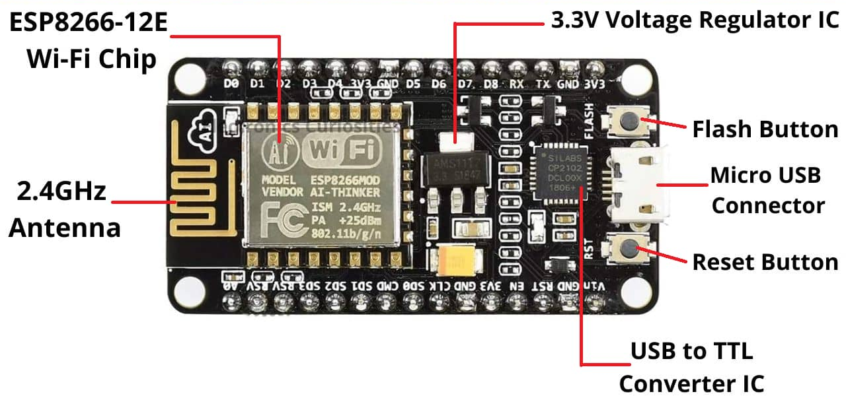

At the core of this module is the ESP32-D0WDQ6 chip*. The chip embedded is designed to be scalable and adaptive. There are two CPU cores that can be individually controlled, and the CPU clock frequency is adjustable from 80 MHz to 240 MHz. The user may also power off the CPU and make use of the low-power co-processor to constantly monitor the peripherals for changes or crossing of thresholds. ESP32 integrates a rich set of peripherals, ranging from capacitive touch sensors, Hall sensors, SD card interface, Ethernet, high-speed SPI, UART, I2S and I2C.

- MQ2 Gas Sensor
MQ2 gas sensor is an electronic sensor used for sensing the concentration of gases in the air such as LPG, propane, methane, hydrogen, alcohol, smoke and carbon monoxide.
MQ2 gas sensor is also known as chemiresistor. It contains a sensing material whose resistance changes when it comes in contact with the gas. This change in the value of resistance is used for the detection of gas.
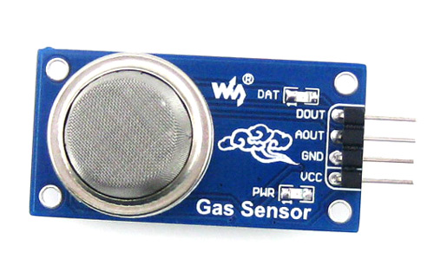
Working Principle :
This sensor contains a sensing element, mainly aluminium-oxide based ceramic, coated with Tin dioxide, enclosed in a stainless steel mesh. Sensing element has six connecting legs attached to it. Two leads are responsible for heating the sensing element, the other four are used for output signals.
Oxygen gets adsorbed on the surface of sensing material when it is heated in air at high temperature. Then donor electrons present in tin oxide are attracted towards this oxygen, thus preventing the current flow.
When reducing gases are present, these oxygen atoms react with the reducing gases thereby decreasing the surface density of the adsorbed oxygen. Now current can flow through the sensor, which generated analog voltage values.
These voltage values are measured to know the concentration of gas. Voltage values are higher when the concentration of gas is high.

- Rain sensor
A rain sensor is one kind of switching device which is used to detect the rainfall. It works like a switch and the working principle of this sensor is, whenever there is rain, the switch will be normally closed.
The rain sensor module/board is shown below. Basically, this board includes nickel coated lines and it works on the resistance principle. This sensor module permits to gauge moisture through analog output pins & it gives a digital output while moisture threshold surpasses.
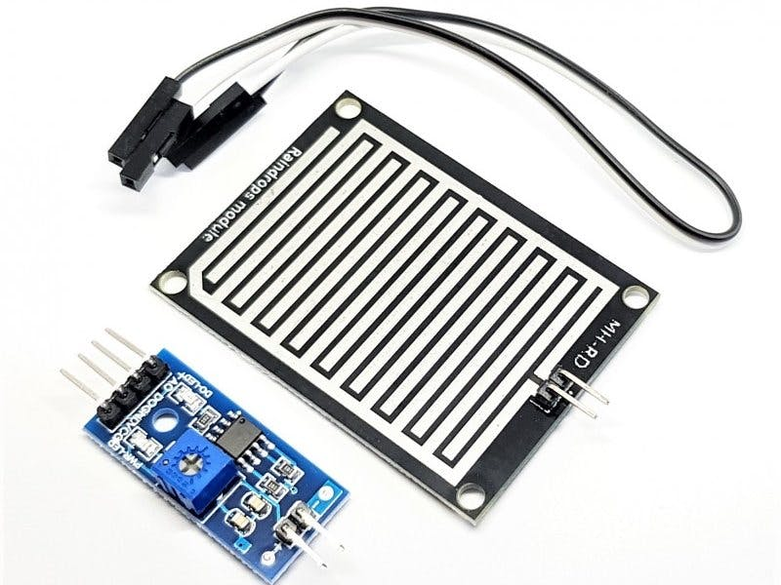 rain-sensor-module
This module is similar to the LM393 IC because it includes the electronic module as well as a PCB. Here PCB is used to collect the raindrops. When the rain falls on the board, then it creates a parallel resistance path to calculate through the operational amplifier.
This sensor is a resistive dipole, and based on the moisture only it shows the resistance. For example, it shows more resistance when it is dry and shows less resistance when it is wet.

Circuit Diagram :

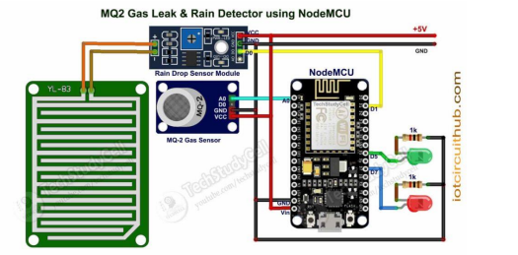

- In the circuit, ESP32 is used .
- The MQ-2 Gas sensor analog output is connected with the GPIO D35.
- Rain detector module’s digital output is connected with the GPIO D34.
- The Indicator LEDs are connected with GPIO D14 & D25.
- The ESP32 board LED connected with GPIO D2 is used as the Wi-Fi indicator.
- And the Rain detector module’s digital output is connected with the D1 (GPIO 5).

CONCLUSION

In this we developed IOT enable system to send security alert to user or a owner of the house and the registered member through app. BYLNK APPLICATION system consist of Mq2 gas sensor, rain dectector sensor, jumper wire for connection, Arduino ESP32.
It is basically used to detect the rain drops when the rain drop is fallen on the rain detection sensor it will detects the rain , it gives the signal that the rain drops is detected and the red light will turn on.
When the gas leakage occurred the gas detector i.e, MQ2 gas sensor will detect through smell of gas and sends the alert message through mail., it gives the signal which is red light turns on.

REFERENCES
- . Fundamentals of Database Systems, RamezElmasri and Shamkant B. Navathe, 7th Edition, 2017, Pearson
- Herbert Schildt, Java The Complete Reference, 7th Edition, Tata McGraw Hill, 2007.
- Programming Arduino: Getting Started With Sketches (second edition)
- https://iotcircuithub.com/mq2-gas-sensor-rain-detection-blynk-notification/
- https://dl.espressif.com/dl/package_esp32_index.json/
- https://github.com/espressif/arduino-esp32/
- https://github.com/blynkkk/blynk-library/
- https://www.arduino.cc/reference/en

M. Young, The Technical Writer’s Handbook. Mill Valley, CA: University Science, 1989

