Grammar- A Sentence making machine
Objectives: To strengthen the young learners develop accuracy, meaningfulness and appropriacy in the usage of Grammar
To enable the young learners, use appropriate grammar in sentence structuring/building in terms of spoken and written communication
To empower the confidence levels of young English learners with the backup of solid grammar execution
Discussion:
- Grammar is a Sentence making machine, an invisible force that drives the language user forward accurately, meaningfully and appropriately. (Larsen-Freeman 2003) Let us discuss these three areas of Grammar teaching and Learning from the perspective of research and developments of the young learners of this web worm generation. To begin with, the productive skills of Writing and Speaking depend on the receptive skills of Listening and Reading. Which means, the input is receptive skills and the output is productive skills. Recall the Context, Retain the Text and Reproduce it in the Test is the mantra. Contextually/Situationally the learners should be encouraged to recollect or remember the Form, Meaning and Use of the Structure of sentence construction. Graphophonic, Syntactic and Semantic elements have to be carefully considered. By the phrase Graphophonic it is the spelling, structure and the sound of the phrases and expressions, Syntactic is Subject Verb Agreement and Semantic is the meaning.
- Use it or lose it: The Language users should Use English on Social media platforms as much as they can. This is the platform where they spend half of their lifetime!!! They should be encouraged to use English language exclusively to develop the knowledge of sentence construction, spelling, phrases and expressions, confidence, command, authority, fluency and accuracy. The problem with the young English learners now-a-days is they use English script to communicate in their local language. We say Communication skills are extremely important but we never communicate in English. In the light of this situation, how can we develop confident written and spoken communication? Use English on Social Media platforms.
- Appropriateness: Using the relevant Grammar structures depending on the context and text has to be properly practised. Actually, subconsciously, the structuring of sentences can be executed while speaking and writing when the confidence levels of the user are properly enhanced. Let me use the term Strategy here in terms of Grammatical careful plan or method. Grammatical strategy is an attentive internally changeable intellectual technique aimed at refining the constructiveness or remedying for the breakdowns in the making of particular writing and reading or listening and speaking of the texts and contexts/situations.
- Oxford Advanced Learner’s Dictionary defines “Grammar” as the rules in a language for changing the form of words and joining them into sentences. Conventionally it is the syntax and morphology of sentences. A competent listener/reader/speaker/writer of the language applies these rules to listen/read/speak/write effectively and acceptably.
- The problems encountered by the young learners:
- Common mistakes in everyday English.
- Use of substandard phrases and expressions.
- Not meticulous about practicing simple but correct English which is logically, grammatically and meaningfully correct.
- Very poor reading habits whether it is screen reading or hard copy reading
- Less priority to acquire/learn English as a medium of communication
- Poor encouraging environment
- The feeling of mother tongue and other tongue bias
- Regular users who are so called professionals’ language which is substandard
- Shortage of suitable mentors to guide with resourceful tips and techniques
- Less Role models whom the young learners can emulate
- Did followed by v2: He did not came yesterday. (Correct: did not come yesterday)
- Last before year, the concerned author: (Correct: Year before last, the author concerned)
- Today college is there, no it is not there. No is there. (Correct one: Is it a working day today? Are we working today? For Business establishments: We are open today or we are closed today)
- We doesn’t, They doesn’t: (Correct ones: We don’t, They don’t)
- Cope up: (Correct: Cope meaning Manage, Cope with (Not cope up)
- Most unique: (Correct: unique)
- One another, each other: Each other for 2 persons and One another for more than 2 persons
- Between, among: The Trio kept the secret among them. (2 persons between, more than 2 persons among)
- Past perfect tense: A past in the past
- Present perfect tense: Just now, so far, not yet, already, recently, of late (Important Time phrases used)
- Future perfect tense: will have been
- Wrong usage of present continuous: I am having 4 brothers and 3 sisters. (Correct: I have 4 brothers and 3 sisters.)
- Wrong usage of passive. The worksheets have corrected. The data sheets have gathered. (Correct: The worksheets have been corrected. The data sheets have been gathered.)

Solutions to the research problems:
Common errors in everyday English:
The posterity has to practice using English in their day-to-day life. Several discussions have taken place and research has been done in this regard. However, the amount and volume of English that the young users use in day to day life is considerably negligible. They are tempted to use their local language especially in canteen, bus, campus and even Buddy Teaching. As proposed by Michael Lewis (1993) in his Lexical Approach the teachers will have to discuss the language patterns, phrases and expressions with the learners as a roughly tuned input during the informal conversations with them. This will be captivating their interest to develop language skills as the teacher himself stands as a role model. The chunks will be entrenched in their long-term memory. They can pluck the chunks out during the times of exams, interviews and viva voce examinations. They can also use them in their workplace in their future.
Buddy Teaching: Let the students explain the subject in English to his buddy who was absent the previous day. This has been proven in the case of one my colleagues who did this to his buddies explaining the core Engineering concepts to his peers in English which enabled him to develop his confidence levels of the subject in particular and language skills in general.
Use of Standard Phrases and Expressions: Substandard phrases and expressions have become part and parcel of this younger generation’s spoken and written English. Examples are: You only told me no, (Correct one: It was you who told me) Bunking the classes (Skipping the classes is better) The biometric is coming or not coming (The biometric is working or not working?) The current gone. The current came. (The power went off or the power resumed) This kind of simple phrases and expressions have to be properly understood, learnt, remembered, recalled and reproduced based on the context.
Very poor reading habits whether it is screen reading or hard copy reading: Students especially the first year Engineering students read unless it is unavoidable and mandatory in terms of writing exams or attending viva voce exams. This habit should be broken. In order to support themselves mentally, physically, emotionally, intellectually and in a team the young blood should keep reading, and a constant and consistent practise of reading will be converted into a habit and life style. Reading relaxes the body and cools the mind. Reading helps the young learners to think in a logical and clear manner. Readers are Leaders. Think before you speak and read before you think.
Form, Meaning and Use:

Practise the Form, Meaning and Use especially by using Referencing tools such as Dictionaries and Thesauruses. Cambridge Online Dictionary is one such excellent referencing tool that young students should make use of as it not only enables the learners to learn correct phonetic transcription, pronunciation, stress markers but also the correct meaning and usage. E-Thesaurus is another tempting take away tool that the students should download on their smartphones as a ready reckoner for their language needs. For instance, the word Mayhem: Turmoil, Commotion, Disturbance, Disorder, Unrest. A string of synonyms or antonyms. The more the merrier. This will empower the students to develop their knowledge of vocabulary and develop confidence in terms of spoken and written communication.
And one must practice the art of writing with patience and great care.
- Paraphrasing is an art. All the Scholars and researchers are bombarded by the knowledge explosion, and they are tempted to copy.
- The best way to make the ideas one’s own by writing them in one’s own language is a great challenge that challenges all the intellectuals.
- Most importantly in terms of passive structures, tenses, syntax, collocations, phrases and expressions.
- How do we best summarize the text in terms of paraphrasing without losing the actual meaning of it??? A million-dollar question???
- Syntax, Subject Verb Agreement or Concord (We doesn’t, They doesn’t (Correct ones: We don’t and They don’t) Even Professionals are still committing this mistake in their pep talks and conversations. Of course, in written communication too. This should be properly learnt.
- The sequence of 1st, 2nd and 3rd persons (For a positive idea: You, He and I will be rewarded for the exemplary work that we have done. For a negative idea: I, You and He will be penalized for the blunder that we have committed>)
- Which sentence? Simple, Complex or Compound
- Tricky Confusion with prepositions: Especially I came to college by walk (Correct one: On foot, My classroom is in the 2nd floor (Correct one: On the second floor)
- Conjunction connection
- The correct collocation: The co-occurrence of parts of speech (Big fat salary, Handsome salary, Hearty Congratulations and Deepest Condolences) should be appropriately remembered, retained and reproduced.
- Take care of these following Progression markers/Connecting/Link/Sign posts or in short Conjunctions:
- Hardly…followed by…….When (
- Scarcely………………….When
- Lest………………………Should
- Else………………………Would
- Although………………….Yet
- Both………………………And
- Between…………………..And
- Not only…………………..But also
- No sooner…………………Than
- Practice makes Perfect:
- Access to and practicing sufficient amount of “samples” result in successful Automatization. Repetition which is one of the oldest keys of teaching and learning will yield fruitful results by accessing and practicing different models, structures of Grammar. The research confirms that acquisition of learning doesn’t take place unless the learner revises and revisits the structures, phrases and expressions repeatedly. The research also showcases that when a learner learns a structure, phrase or expression for seven times it gets entrenched in his long-term memory. When the situation demands he can pluck out the structure, phrase or expression and use according to the situation.
- Eclectic Approach:
- A conscious blending of different methods. Need based. Integration of implicit/explicit prescriptive/descriptive teaching through reinforcement. Teachers should practice this approach. Teachers should think about this Eclectic Approach in terms of consciously and carefully using mother tongue in the process of teaching and learning without affecting the learning enthusiasm of the learner in the target language. When the situation demands the vernacular language alternatives may be provided to the young learners to enable their process of learning interesting, thought provoking, brain-storming and innovative/creative.
- Lexical Approach and the Eclectic Approach would enrich the understanding of the language system, its patterns and its use in a fruitful/productive and result-oriented manner.
- This approach of teaching empowers to produce correct language and transforms the learners into self-monitoring, self-directing and self-guiding individuals. (Independent language learners) Metacognition is appropriately learnt here.
- Builds the confidence levels as the learners self-correct and eliminate the wrong sentence structures and phrases
- Results in fine-tuning the performance outcome
- Implicit Grammar Teaching: focuses on meaning rather than form. It is contextualized and authentic language not rules or forms.
- Explicit Grammar Teaching: language forms and explains the grammar rules and practice through drilling. Best Activities: Spot errors/Gap filling
- Swift and effortless listening, speaking, reading and writing is Automatization
- Automatization demands practice and real mastery
- Internalizing structural knowledge will be on an unconscious level resulting in functional usage
One must study the best models and learn from them
Learner participation: Increase the Talking time of the Learners especially in the classrooms, Language laboratories so that the classroom becomes a learning hub. Let the students open up, think, react, respond elaborately.
Keen observation: Stephen Krashen (1989) mentions that language acquisition takes place subconsciously when the learners are exposed to language. However, conscious and keen observation during the process of language learning would result in confidence building in terms of spoken and written communication. Vocabulary, Grammar and Punctuation for Writing and Vocabulary, Grammar and Pronunciation for speaking. VGP is the Foundation on which the LSRW floors can be built.
The Learners should be exposed to quality inputs in terms of Man, Method and Materials or Teacher, Technique and Text so that the quality inputs are converted into quality intakes.
Negative Evidence: Eventually, before this discussion is brought to an end, let me quote an anecdote that over generalization of negative evidences/assumptions impact in real life situations. One of the Professors who is not from the English faculty was speaking in the Retirement meeting of another Professor. The Professor who was speaking was using the combination notorious as negative evidence. He was saying Prof. Verma was notorious in conducting several workshops and welfare programmes. He was notorious in bringing wi-fi facility to the scholars hostels. Likewise, the professor who was speaking used the word notorious several times in his talk.
One of the English Professors seated in the audience who could not contain his enthusiasm went ahead and asked the one who spoke by using the word notorious several times in his talk in terms of what is that he understands about notorious. The Professor said popular and famous. Then the English Professor explained him that it is truly popular and famous but famous for negative things such as a notorious killer/criminal/smuggler etc., This is a blazing example of over generalization/assumption of intangible combinations. The Teachers and Experts should ensure that this kind of negative evidence doesn’t occur in the language learning process of the young English language learners.
Multipurpose English Table:
Practice Multipurpose English Table:
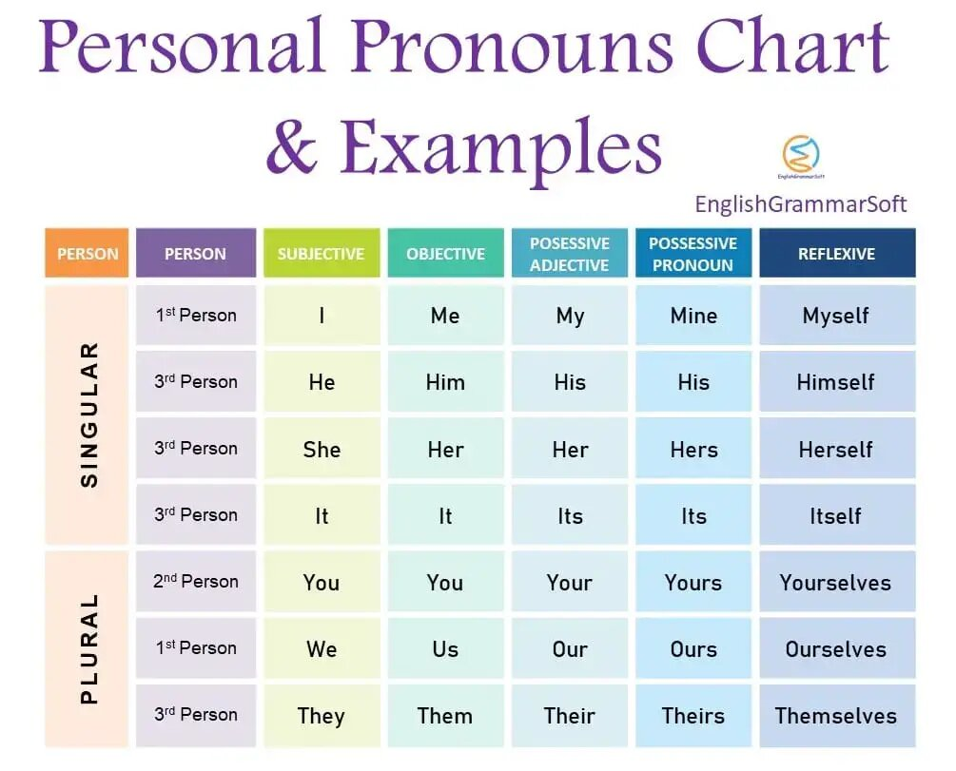

Practice: Rigorous writing generating drill such as using Active voice, Passive voice, all the tenses, positive, negative, positive interrogative and negative interrogative sentences need to be practiced. All the Personal pronouns can be used here. For example:
Sentences | Active voice/Simple present | Passive Voice/Simple present | Active Voice/Present Perfect | Passive Voice/Present perfect
Positive | Sachin plays cricket everyday | Cricket is played by Sachin everyday | Sachin has played Cricket so far. | Cricket has been played by Sachin so far.
Negative | Sachin doesn’t play cricket everyday | Cricket is not played by Sachin every day. | Sachin has not played Cricket so far. | Cricket has not been played by Sachin so far.
Positive Interrogative | Does Sachin play cricket every day? | Is Cricket played by Sachin every day? | Has Cricket been played by Sachin so far? | Has Cricket been played by Sachin so far?
Negative Interrogative | Doesn’t Sachin play cricket every day? | Isn’t Cricket played by Sachin every day? | Hasn’t Cricket been played by Sachin so far? | Hasn’t Cricket been played by Sachin so far?

Howard Gardner (1983) has suggested the Multiple Intelligences theory.
- Visual-spatial
- Linguistic-verbal
- Logical-mathematical
- Body-kinaesthetic
- Musical
- Interpersonal
- Intrapersonal
- Naturalistic
Teachers and Parents should identify which learning style does their child prefer and why. Students should recognise which learning style in the given styles they are comfortable with.
Individualised Learning Instruction: (Customised/Tailor made) should be provided to the young and enthusiastic learners of English to sustain their interest levels and to transform them into successful and confident language users.
Material developed by:
Dr. Sunil Solomon Philip
Assistant Professor of English,
Methodist College of Engineering and Technology
Abids, Hyderabad
Author and Resource Person, Oxford University Press
(M): 9849678017
Email id: sunil7solomon@gmail.com

References:

Karal Rajeevan (2019) English Grammar Just for you: Oxford University Press, Oxford

Verma Shivendra et al (2000) An Interactive Grammar of Modern English: Frank Brothers, New Delhi

Murphy Raymond (2013) English Grammar in Use: Cambridge University Press, Cambridge

Murphy Raymond (2000) Essential English Grammar: Cambridge University Press, Cambridge

Murphy Raymond (1999) Intermediate English Grammar: Cambridge University Press, Cambridge

Hewings Martin (1999) Advanced English Grammar: Cambridge University Press, Cambridge

