Futuristic Trends in Management
ISBN: 978-93-95632-62-1
IIP Proceedings, Volume 2, Book 8, Part 1, Chapter 10
FINTECH COMPANIES WITH RESPECT TO THE FUTURE OF BANKING SERVICES

FINTECH COMPANIES – A PIVOTAL ROLE IN SHAPING THE FUTURE OF BANKING SERVICES
Abstract -
As the economic growth went to a high peak, Indian banking changed its dynamics over the next two decades. Economic and digital transformation, financial innovation and development of internet are the new buzz in the financial banking. Due to increase in technologies, the need of customer demands increased. The technology which is hitting in the financial services is Digitalization, Mobile banking, Block chain technology, UPI, Wearables, Cloud computing, Biometrics, Augmented reality by this new transformation of technology helps Indian banks to diversify the services through various products and services. The summary chapter written on this topic is based on Futuristic Trends in Management Book 2, Volume 8, Part 1, and Chapter- 10 written by Amreen Sultana. M Assistant Professor Department of Commerce East West College of Management Bangalore, India.
Keywords: Indian Banking, Digital transformation, Fintech Banking.
INTRODUCTION-

The emergence of Fintech was stimulated by the global financial crisis of 2008 and was caused by the transition of financial market participants to low-capital-intensive business models, modernized in accordance with modern market realities. The market conditions contributed to the emergence of provoked participants in the financial services market - fintech companies. The current state of fintech is characterized by rapid digital transformations based on the robotization, automation, artificial intelligence, electronic communication and radio dynamics. Thus, fintech has evolved from the initial stage of introducing technologies into traditional sectors of the economy, by using unique mechanism to meet the customer demands. Fintech service providers are professionally managed companies with broad operational capabilities, a comprehensive product portfolio, and an international presence.

FINTECH

Fintech is a back pack for “financial technology.” It’s a technology used to augment, streamline, digitize or disrupt traditional financial services. Fintech refers to software, algorithms and applications for both desktop and mobile. In some cases, it includes hardware, too- like internet-connected piggy banks. Fintech platforms enable tasks like depositing cheques, moving money between accounts, paying bills or applying for financial aid. They also facilitate in lending and crypto exchanges.
Businesses rely upon fintech for payment processing, e-commerce transactions, accounting and, more recently, help with government-assistance efforts like the Payroll Protection Program (PPP). In the wake of the Covid-19 pandemic, more and more businesses are turning to fintech to accept contactless payments or adopt other tech-fuelled advancements and technologies to meet the customer demands in high transactions.

FINTECH BANKING

Banks use fintech for back-end processes- monitoring of account activity. For example- a consumer-facing solutions, like the app to check the account balance. Banks also use fintech to underwrite loans. Individuals use fintech to access many bank services, including paying for purchases with a smartphone and receiving investing advice on their home computers.

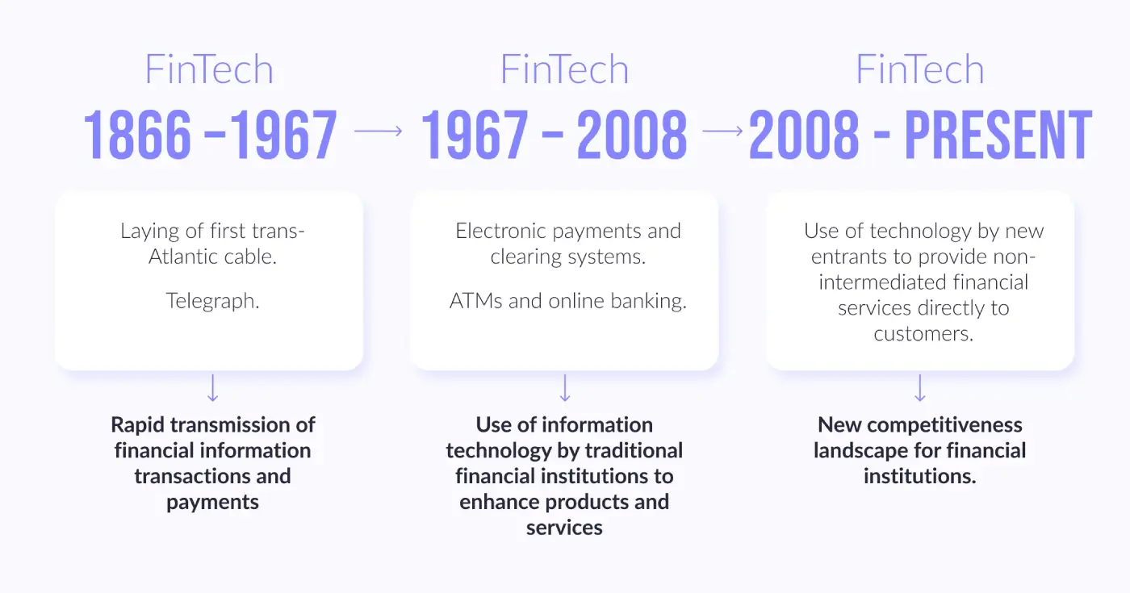

II. REVIEW OF LITERATURE
- Deepa Chauhan (2021), titled "Role of innovation on the performance of Indian banking sector" analysed the role of innovation on the performance of Indian banking sector of both private, and public sectors which adopted the technology in all their banking business achieved the objective of customers satisfaction but it is understood that private banks lead the role first when compare to public sector banks.

- Smt. V Vimala (2015), titled "The Impact of Information Technology Adoption on the Customers of Bank of India, Bangalore Urban – An Evaluative Study", in this study it speaks about the significance of information technology adoption and its impact on customers with the various variable which indicate a positive impact on both customers and also on bankers, but still it is suggested to look after the area like security system, implementation of new IT policies and regulations, to provide better services to customers with new technology.

III. THE RISE OF FINTECH COMPANIES IN THE BANKING INDUSTRY
The number of customers has increased with the increased new technologies and tech savvy, cashless transactions. New technologies are coming up from money deposits till withdrawals. This will improve the efficiency and lower the cost. It encourages the practice of digital technology which is a key for the new business to invent products and services of banking that can easily be read by customers and retail banking firms. Further Fintech can merge with the banking system to smoothen the process and achieve the targets.
IV. OBJECTIVES OF TH FINTECH COMPANIES-
1. It provides tech savvy in banking industry.
2. It aims for providing services less than one roof, even if the bank branches are different.
3. It aims at a cashless technology.
4. It aims for the privacy and secured technologies between the consumers and the banks.

V. TOP FINTECH COMPANIES -

These are the top 10 fintech companies in India as per 2023- More than 60,000 companies are in India.

- Perfios
- Paytm
- Lending kart
- Zerodha
- DMI Finance
- Satya Micro capital
- Phone pe
- Acko
- Unnati
- Upstox

Others are- MobiKwik, ETMoney Policy bazaar, Free charge Mswipe Ezetap.

VI. FUTURE OF THE BANKING SECTOR-

- E-wallets
E-wallet is one of the top fintech solutions in the financial industry. The immense growth of E-wallets is an indicator of the rise of FinTech services. While Samsung Pay, PayPal, and Apple Pay are some of the well-known e-wallet companies in the world, these wallets are used for payments, bills, top-ups, ticket booking, international remittances, and many more. There are also some standalone wallets, such as Starbucks and Walmart Pay. E-wallets have attracted users due to their tempting offerings like exciting offers, lucrative cashbacks, reward points, and many more. The users need to add their bank account details to the wallet for adding funds to it; make digital payments, ultimately benefiting the banks. The huge success of E-wallets has led many banks to realize their importance and recognize e-wallets as a collaborative measure to embrace technological advancements.

b. Smart Chip Technology
According to Thales Group, as of 2020, there were around 10.81 billion EMV cards. Smart chip technology, also known as EMV (Europay, MasterCard, and Visa) technology, is a type of chip-based payment system that uses microprocessor chips to secure payment transactions. These chips are embedded in credit and debit cards and are designed to make it more difficult for fraudulent transactions to occur. The advantage of smart chip technology on the banking industry is that it has increased the security of payment transactions. These chips create unique codes for each transaction, which makes it difficult for fraudsters to use stolen card data to make unauthorized purchases. Hence, there has been a significant reduction in card fraud and has increased consumer confidence in electronic payments. The smart chip technology has also made it easier for banks to comply with Payment Card Industry (PCI) security standards, which require banks to take steps to protect cardholder data. This has reduced the risk of data breaches and the associated costs for banks.
- Biometric Sensors
Biometric sensors, along with Iris scanners, are two technological advancements that ATMs are witnessing. According to ABI Research, the number of biometric sensor cards is estimated to reach up to 20.6 million by 2025. They eliminate the need to carry a plastic card and there's no need to remember the PINs which offers immense convenience and ease to the customers. Apart from providing convenience and ease, these advancements also make ATMs more secure than ever since the user can access their account without any password. The biometric ATMs use integrated mobile applications, fingerprint sensors, palm scans, and eye recognition to identify the account owner. For more accurate and secure identification, ATMs also use micro-veins which eliminate the errors made by ATMs in customer recognition. The biometric technology has brought a satisfaction to all the customers who get panic at the thought of losing their ATM card. With biometrics, they can access their funds even if their card gets lost. Thus, there is a significant impact of biometric technology in the banking sector.
- Mobile Banking
The increase in the use of smartphones has compelled banks to come up with mobile applications that offer convenient FinTech banking services. The use of these applications is called mobile banking. According to a study by Allied Market Research, the global mobile banking market is expected to reach around US Dollars 1824.7 million by 2026. Almost all banks have a mobile banking application that has a user-friendly interface and delivers every service available in traditional banks. The feature of fingerprint recognition for users has been introduced, which the application performs this function without any biometric app or hardware. A mobile banking app provides quick access to funds, and the user can perform several banking functions such as quick bill payments, cheque deposits, account balances, statements, and many more.

- Artificial intelligence

Over the years, AI has become essential in FinTech banking services. According to Business Wire, the global AI in the banking market is estimated to reach $ 64.03 billion by 2030, up from $ 3.88 billion in 2020, with a CAGR of 32.6% during the forecast period. And AI combined with machine learning is vital for fraud detection. Banks use this software for fraud detection that generates alerts whenever there is a possible fraudulent transaction. Later it is checked by the human investigation that determines if the attack was real or false. However, with time the detection of attacks is becoming difficult since, the attacks are becoming more prone. So, the old method was costly and time-consuming. The risk of customer data loss is always there. To solve this issue, the banks are now adopting AI technology. Moreover, with AI and machine learning algorithms, banks can grip historical data to predict and determine fraud attack patterns. This reduces half of the manual effort. The increasing use of AI and ML in financial services can also help banks in automating their processes and get detailed insights for making informed decisions.
- AI-powered service chatbots
FinTech providers have also come up with AI-based customer service chatbots that have become popular in the recent past. According to a study by Juniper Research, it was found that the service conversations by chatbots were expected to deliver around $8 billion worth of cost savings by the end of 2022. Chatbots are nothing but software that uses machine learning and natural language processing to impersonate human conversation, either by voice or text communication. These are used to deliver fast and efficient customer service, responding to frequently asked questions and helping with simple tasks such as account balance inquiries and bill payments. They can handle a high volume of customer inquiries simultaneously, thus the humans to focus on more complex tasks. It also provides personalized guidance and help, leading to a more positive customer experience. Hence, chatbots have become an integral asset for all banks as it reduces costs, enhance customer satisfaction, and allow their agents in the call centres to focus on value addition.
- Mobile banking
ICICI bank was the first bank in India to launch mobile banking in the year 2008. This is another type of banking technology which is taken place next after digitalization. The foremost trend in the banking sector i.e., mobile banking, provides the service of various banking activities like the inquiry of account balance, account transfer, and bill payments through smartphone by banking customers from its bankers. At present, it is coming up with innovations like voice-enabled services and internet technologies. These voice-enabled services can be found in every smart television, smart car, and smart home. Industrial leaders are merging to adopt the internet technologies which are connected to networks mobile banking technology that require user’s voice to operate based on the query received and it will transmit and take the process of completion to meet the customer interests, demands and queries.

- Block chain
In 1991 concept of block chain was first introduced to alienate the risk which is involved in recording the information of customers. It is an open distributed ledger that records the entire transaction of each customer in a secured manner which is shared among the bundle of technology that helps to create blocks, develop, authenticate and record transactions without any modification. As this technology evolved in the banking industry it made difficult for hackers to extract the confidential reports of the customers. Block chain technology works on the principles of computer science. The introduction of block chain technology in the Indian banks regulated the work with efficiency, cost, speed, and security prospect. The future of block chain is connected with cryptocurrency which is now in a trend called bitcoin; this widespread application is in use since the year 2009.
- Cloud computing
This technology started to break down the operational barriers which are their in-banking industry. Its flexibility, scalability, and efficiency made every bank adopt this application to fasten the service. Further, banks can easily invest in hardware and software and update the information on cloud models. Various types of clouds like public cloud, private cloud, hybrid cloud, and community cloud which is used for a different purpose by different users.
- Wearables
The new trend in the smart world is wearable technology which is connects smartwatches of users to encash the retail banking service. This technology has changed the way users perform their daily activity by tapping on their wearables they experience a user-friendly interface that provides the banking services of payment of bills.
VII. SOME OF THE CHALLENGES FINTECH COMPANIES FACE IN PROVIDING BANKING TECHNOLOGIES
- Information security:

Securing the confidential information of customers is a big task for each bank because of internet banking, mobile banking, and payment application system. Fintech has provided smooth banking services for its customers, which again deal with technology. This kind of technology creates a fear of confidential data hacks from which the customer hesitates to adopt the technology in advance.
- Government protocols:

Fintech companies have to meet the requirements of government regulation with the support of this they can distribute their technology-oriented services to its customer. The government approvals on certain technology take a long time which is very difficult for fintech companies to proceed in their business.

- Customer retention and experience

Another challenge the fintech companies face while providing advanced technology is customer retention with a high set of new experiences and fulfilling the meets and demands of the same. The fintech companies have to look at both the side of the customer that is the high-tech rich customers who is expecting to fasten the activities also the general customer which makes them easily access the services. Hence, they have to create the technology for the smooth functioning of banks.

VIII. Fintech and Banks Should Work Collaboratively

Increase in the use of smartphones

A study says that there were around 7.26 billion smartphone users as of 2022. This statistic is enough to interpret that there is a significant increase in the use of smartphones in the modern world. So, all these users are the perfect customers of both banks and fintech. As banks could not reach every location owing to operating costs for meeting the demands, fintech helps banks to reach and acquire more customers.

Every service is online

Today, people can buy anything and everything online, products like medicines and groceries or the services like cleaning and grooming, vegetables, clothes, accessories, even the gold everything can be found and brought online.
For banking services, fintech’s payment solutions are linked with the respective bank account of the user, and then the user can use the funds in the bank to make online payments for services available on the fintech app, such as ticket booking, bill payments, EMIs, and many more.

Security

Fintech companies are utilizing advanced technologies to protect customers' financial information. They use AI for fraud detection, block chain for secure data storage, RegTech for compliance, and multi-cloud and IoT for smarter security solutions.
Hence, the customers’ financial information is safe from threats like fraud and hacking is avoided. Fintech companies are taking a comprehensive and integrated approach to security by implementing a range of technologies and solutions to keep customers' data safe and secure.

Better Branding

Fintech companies are utilizing modern tools such as gamification or digital advertising to make financial tasks, such as budgeting, thus engaging and attracting more customers. This fresh approach leads to branding services is which the banks should take note of, as it can help them attract and retain customers. By incorporating these modern techniques, banks can improve their customer experience and stay competitive in the market.

Enhanced Customer Satisfaction

Fintech companies have disrupted the financial services industry with their innovative approach to customer experience thus enhancing and attracting the users to use cashless technology. They have a reputation for being faster, more efficient, and more secure than traditional banks, while also having lower costs. This has led to many fintech companies earning the trust of their customers through high tech driven service and referral-based client acquisition and mergers. This can lead to better service for customers, and ultimately, increased trust and loyalty to the bank. In short, Banks can improve their services by adopting the customer-centric approach of fintechs.

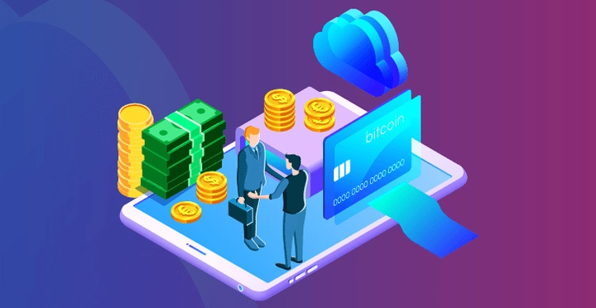

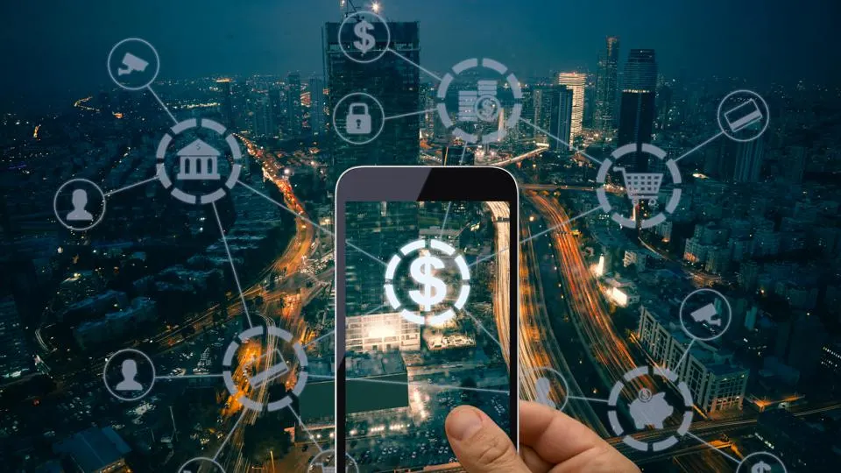

IX. Fintech Hold and the Future

Nobody knows for sure what fintech innovations are on the scope and skyline view and this uncertainty has been worsened by the chaos caused by the pandemic. Fintechs, like their customers, have suffered financial setbacks- some have had to downsize the staff, and others are struggling to secure investor funding. The demand for fintech has perhaps never been higher. Businesses and banking customers increasingly rely on technology to help navigate their financial services. Due to the economic uncertainty, larger and long-term trends for the future of fintech remain relatively intact. Consolidation, partnerships and continued collaborations between legacy banks and fintechs seems fast approaching and consumers can probably expect to see the continued emergence of companies glossy and hype, with worthy and efficient smooth services, including the likes of block chain, cryptocurrency, artificial intelligence and peer-to-peer transactions.

X. Conclusion
Consumers, businesses and all sorts of financial services firms are increasingly turning to imaginative combinations of software, hardware and data to create and deliver both new and traditional financial products and services. Fintech is firmly a frame of our financial society, and it appears its influence will only grow in the future.
With the help of Fintech and its services. Indian banking adopted advanced technologies, to meet the customer demands and requirements for security and user friendly smooth services banking experience.
Today FinTech is bigger and more successful than ever, in the coming years, it is all set to become ever bigger with its fintech solutions for businesses, retail banking software, financial core banking software, Human Resource software’s and many other components coming under it. The future holds the answer how big impact FinTech will have on the banking world.

REFERENCES
[1] Deepa Chauhan (2021), titled "Role of innovation on the performance of Indian banking sector", Pal Arch’s, journal of archaeology of Egypt, 18 (18) 2021
[2] Smt. V. Vimala (2015), "The Impact of Information Technology Adoption on the Customers of Bank of India, Bangalore Urban – An Evaluative Study", IOSR Journal of Business and Management (IOSR-JBM) e-ISSN: 2278-487X, p-ISSN: 2319-7668. Volume 17, Issue 3.Ver. I (Mar. 2015), PP 39-44
[3] www.forbes.com
[4] https://geniusee.com
[5] www.digipay.guru
[6] Futuristic Trends in Management
ISBN: 978-93-95632-62-1
IIP Proceedings, Volume 2, Book 8, Part 1, Chapter 10
FINTECH COMPANIES WITH RESPECT TO THE FUTURE OF BANKING SERVICES
Amreen Sultana. M Assistant Professor Department of Commerce East West College of Management Bangalore, India.

