Nanorobotics: A novel approach in the Drug Delivery System of Cancer Chemotherapy and its application.
Mr Kashyap Saurabh R., Miss. Panchwagh Mayuri P.
Department of pharmacy practice, ASPM’S K.T Patil College of Pharmacy, Osmanabad, Maharashtra 413 501.
*Corresponding author’s E-mail: Kashyapsaurabh241@gmail.com
Abstract:
One of the most awaited developments in the area of health care is the development of nanorobotics, which consists of complex submicron devices made of nanocomponents. It has a promising future in the field of medicine administration for cancer, the main cause of death for those under 85 years old. To kill cancer cells without damaging healthy cells, nanorobots might distribute and spread enormous volumes of antineoplastic drugs. This would lessen the negative effects of conventional therapies like chemotherapy. Due to close cooperation among professionals in medicine, nanorobotics and nanotechnology, the finished product of this invention will significantly affect disease detection, therapy, and prophylaxis. Modern technological advancements have made it possible to experiment with building nano-robotic devices and connecting them to the larger world for control. Such machines are abundant in nature, and it is possible to create more of them by emulating nature. These nanorobots are now extremely important in the biomedical feild. In particular, cancer, cerebral aneurysm, kidney stone removal, as well as the elimination of the flawed portion of our DNA structure, are some of the therapies that have the more potential to save the lives of people. This paper provides a study on several nanorobot-based cancer therapies. It also sheds light on the potential depth of this field of study.
Keyword:
Nanotechnology, nanorobots, cancer, treatment, nanomedicine, drug delivery system, antineoplastic drug
Introduction:
Cancer is the uncontrolled growth of abnormal cells in the human body. Uncontrolled cell proliferation that defies the normal cycle of cell division is a hallmark of cancer. These cells are referred to as cancer cells. The direct monitoring of proper cell development, proliferation, and cell division is done through signal transduction. However, cancer cells have their separate mechanisms for proliferation and development. A malignant condition results in carcinogenesis, a process that changes healthy cells into cancerous ones. Clinically speaking, cancer can take many various forms, but the disease's molecular cause—an issue with gene expression—remains the same. Normal cells can develop into cancer cells for several reasons. These compounds or components are known as carcinogenic.^{1,2}
The best way to define nanotechnology is as a description of atomic and molecular-level activities that have practical uses. One billionth of a metre, or around 1/80,000 of a human hair's diameter, or 10 times the size of an atom of hydrogen, is referred to as a nanometer. The capacity to measure, manipulate, and construct matter with features on the scale of 1-100 nm is a size-related issue.⁴ Automating molecular production will be crucial for nanotechnology to become cost-effective. The engineering of molecular goods requires the application of nanorobots, which are miniature robotic machines.
The remarkable technological movement known as nanotechnology, which is marked by the fastest growth of electronics used in communication, health care (also called nanomedicine), and environmental surveillance, has recently attracted the attention of researchers. Many research being conducted right now focuses on the technological limitations that affect lifespans, including humans. The majority of these blockages are brought on by illnesses for which there are little or no treatment alternatives.^{1,4}
Nanorobots are similar in size to biological organelles and cells. Imagine artificial cells (nanorobots) scouring the circulatory system for illnesses and removing even the smallest amounts of them. This opens up a several possible uses, such as environmental microorganism monitoring and health care. This might amount to a programmable system with important medical repercussions, changing the focus from therapy to prohibition. Alternative applications, such as healing of cell, might be viable if nanorobots were small enough to enter the cells.⁶ Additionally, tiny sensors and actuators are necessary if the idea of a physically connected elevated information infrastructure is to become a reality.
According to the Quintiles IMS Institute's Global Oncology Trend Report, the cost of cancer drugs was $100 billion worldwide in 2014. The development of nanorobotics was most likely driven by the cancer treatment. Chemotherapeutic drugs are used to treat cancer, however, they are disseminated generalised across the body, affecting both cancerous and healthy cells. This limits the dose that can be delivered to the tumour and also leads to substandard treatment because of excessive toxicity.^{8,11} The need for molecularly focused medical treatment has emerged to address the inadequate specificity in conventional cancer therapeutic drugs.
A nanorobot can support smart chemotherapy for administering drugs and give an effective early cancer eradication by specifically targeting the cancer-specific tissues and cells and protect the surrounding cells that are healthy from the toxin of the chemotherapy drugs being used. Chemotherapy and radiation therapy are frequently used to treat cancer.^{6,14} They frequently work well in eliminating cancer cells. They have long-term effects and seriously harm healthy tissue. Nanoparticles will increase the the level of medication concentration inside cancer cells while reducing toxicity in normal cells by utilising both active as well as passive targeting mechanisms. As a result, this paper concentrates on new technological developments in nanorobotics harvesting primarily for the utilisation of drug delivery systems in the cancer treatment.¹
Pathophysiology of cancer:
Despite the histological and physiological variations between various cancer types, the development of malignant tumours or cancerous cells in the body follows a common pathophysiological process.
The aetiology of cancer is generally accepted to be damage to the genetic machinery of cells (such as mutation, anomalies in gene expression, activation of tumour promoter genes, inactivation of tumour suppressor genes, etc.).⁵
Malignant tumours are believed to arise primarily as a result of damage to a cell's genetic machinery and the silencing of anti-tumor genes. However, the inactivation of tumour suppressor genes is a physiological response of the body and when this response turns into a pathological scenario, cancer might occur.^{7,9}

Normal cell
Loss of the regulating gene product and altered gene product expression
DNA damage
Malignant neoplasm
Mutations in the genome of somatic cells
Alteration of the apoptosis-controlling genes

Inherited mutation in:
Genes affecting DNA repair.
Genes affecting cell apoptosis.

suppression of cancer-suppressor genes

Activation of oncogenes that promote growth

Fig. No.1 Pathophysiology of cancer.
Step one: tumour development and mutation.
- A single genetically altered cell will mutate, leading to its aberrant proliferation and transformation into a tumour cell.
Step two: growth of tumours and cell division.
- As the tumour grows, new mutations continue to occur within the cells that make up the tumour population.
- Mutant cells have an advantage over normal cells due to their rapid growth and multiplication. The offspring of a cell with this additional mutation will therefore dominate the number of tumours.

Step three: selection of colnal and malignancy.
- New tumour cell clones with quicker growth rates or other characteristics (such as survival, invasion, or metastasis) that provide them with a selective advantage are then created by tumour cell division. It's referred to as clonal selection.
- Clonal selection takes place during a tumor's growth, causing it to multiply faster and become more aggressive.
Step four: Metastasis
- Through a challenging process termed metastasis, in which they detach from the primary tumour and migrate through the circulatory or lymphatic system, cancer cells can spread to other parts of the body.
- The propensity of tumours to metastasize plays a significant role in the lethality of diseases like cancer of pancreas and uveal (ciliary body, iris or choroid of the eye) cancers. The cells continue to divide at the new locations, where they eventually produce more tumours made up of cells that resemble the original tissue.
- The extent of ongoing parallel evolution in primary and metastatic sites, the evolutionary links between metastases, and the clonal architectures of metastatic tumours are all essential issues that remain unanswered, as how the tumor spreads, and the part the tumor micro-environment plays in determining the metastatic site.
Types of nanorobots:
Nanorobots are miniature machines that can perform tasks on par with those currently performed by larger machines. They are used in health care and other industries. One example is the creation of energy-saving nanomotors. By serving as an engine and improving when they are connected with sperm motility, nanorobots have also shown their value in lowering infertility problems. Inorganic and organic nanorobots are the two most often studied varieties.^{5,8} Organic nanorobots, or bio-nanorobots, and are developed by merging DNA cells from bacteria and viruses. This specific type of nanorobot puts the organism at less risk. Since inorganic nanobots are formed of materials like synthetic proteins, diamond structures, and other things, they are more harmful than biological nanobots.⁹
Scientists will be suitable to know how to energise micro- and nano-sized widgets using reactive processes by understanding the natural motors of living cells. The Chemistry Institute of the Federal Fluminense University developed a nano stopcock. It's made out of a tank with a shutter covering it, from which colour motes can escape when the lid is unevenly opened. This device will be used for remedial purposes and is made of beta- cyclodextrins, organometallic composites, and silica (SiO2).^{11,9} In some investigations, proteins are utilised to create nanorobots by using DNA hybridization and antibody proteins, as well as to power nanomotors that are used to move heavy items.
How Nanorobot Kills Tumor Cells:
Small ultrasonic powdered robots that can swim through blood and remove harmful bacteria as well as the poison they produce have been created by engineers at the University of California, San Diego. In the future nanorobots will be used to cleanse and detoxify biological fluids effectively after going on sale. These nanorobots were created specifically to treat cancer cells, and by using a blood clotting protein to locate their target within the cancer cell, they can kill the tumour.
A sheet of DNA origami measuring 90 nanometers by 60 nanometers is used to construct each nanorobot. The surface is coated with thrombin, a vital blood clotting enzyme.

By clotting the blood in the vessel that supplies the growth of the tumour, thrombin can cut off the blood supply to the tumour, mimicking a mini-heart attack in the tumour, and causing the tumour tissue to die.

Steps in killing cancer cells: ^{1,3,4}
Step -1:
First, a flat DNA scaffold was coated with an average of four thrombin molecules. The flat sheet was then folded over on itself, just like a piece of paper, to form a circle and a hollow tube. They were injected into a rat via an IV, and after moving through the bloodstream, they focused on the tumour.
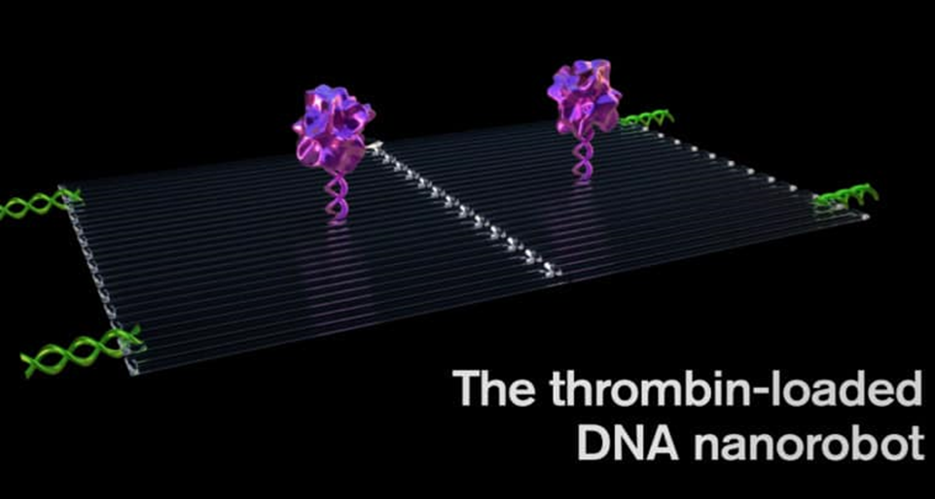
Fig. No.2 Thrombin-loaded DNA nanorobot
Step -2:
The protein nucleolin, which is only produced in significant quantities on the outside of cancer endothelium cells and is absent from healthy cells, could be the target of the DNA aptamer payload. This was a crucial component in designing a nanorobot that only kills cancer cells.
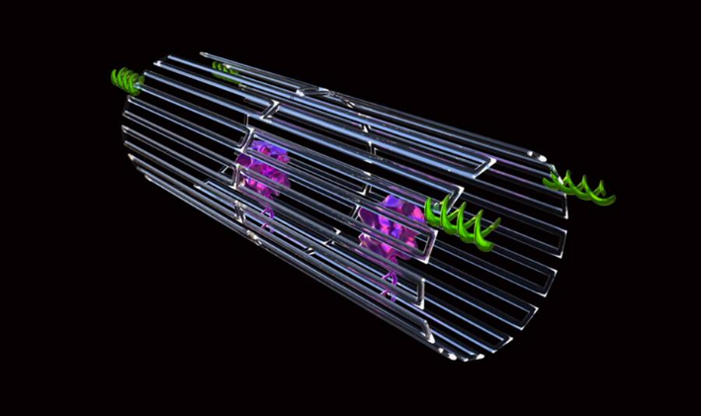
Fig. No.3 Nanorobot enclosed in DNA sheath with tumor-targeting DNA
Step -3:
The little robot has a programme, like the infamous Trojan horse, to transport its unwary drug cargo into the exact centre of the tumour, exposing the thrombin, once it had been bonded to the surface of the tumour blood vessels.
Fig. No.4 Illustrates Nanorobots killing the tumor cell.
Chemotherapy drug delivery in treatment if cancer by using nanorobots:
More effective targeted drug administration has been made possible by recent developments in medication delivery, which use nanosensors to identify specific cells and smart medications to control discharges.¹ Since rapidly replicating cells is a key characteristic of malignant cells, traditional chemotherapeutic medicines work by destroying them. Most anticancer drugs have a minimal therapeutic window and frequently cause cytotoxicity to healthy stem cells that divide rapidly, such as those found in the macrophages, bone marrow, hair follicles, and gastrointestinal tract (GIT). This has a variety of adverse effects, including organ malfunction, thrombocytopenia/anaemia, alopecia, mucositis (inflammation of the GUT lining), myelosuppression (reduced production of WBCs, which results in immunosuppression), and haematological side effects.^{9,10}
Doxorubicin in addition to other anticancer drugs to reduce its adverse effect & toxicity, it's employed to treat a variety of cancers, like Hodgkin's disease. Breast cancer is treated with the intravenous injection of the medication paclitaxel. Suppression of bone marrow and an increase in neurotoxicity are two main side or adverse effects. Binding filament for intra-DNA is produced by the alkylating drugs cisplatin.^{4,14,12}. It is nephrotoxic and has side effects including euphoria and violent vomiting. By blocking topoisomerases type 1, it is an enzyme necessary for the duplication of the cell of genetic material, camptothecin is the drug, which is employed to treat neoplasia.
Numerous projects have been started to use nanotechnology to create DDS that can lessen the adverse effects of conventional therapy. Doxorubicin was coated on the surface of single-walled carbon nanotubes (SWNTs). Metastatic cancer cells were treated with doxorubicin using a polymer prodrug hybrid. An innovative development in the field is the use of polymeric pro-drug nanotechnology in the treatment of aberrant cancerous cells that divide quickly.⁵
A nanorobot can help with advance chemotherapy for drug administration and provide efficient early destruction of cancer by specifically targeting the cancerous tissue and cells and protect the surrounding cells that are healthy from the toxin of the chemotherapy drugs being used.^{12,13} Chemical molecules can be retained in the bloodstream so much as necessary thanks to nanorobots acting as drug transporters, providing chemotherapy with the appropriate pharmacokinetic characteristics.
Injecting nanobots intravenously, it is important to use them in clinical settings for diagnosis, treatment, and surgery. The recipient's body may be infused with the nanorobots intravenously. The pharmacokinetics of chemotherapy includes absorption, metabolism, and excretion as well as a rest interval to give the body time to heal before the next chemotherapy session. For very small tumours, patients are frequently treated in two weeks.^{1,12} Using proteomic-based sensors, nanorobots can quickly examine and diagnose cancer as a first-time threshold for medicinal applications. The transport of protein medications to solid tumors can be predicted using the kinetics of the ingestion of a tiny molecular weight magnetic resonance contrast agent. The study of nanorobotics must include testing and diagnosis.
The drug's efficacy will rely on how long it stays inside the tumour after nanorobots penetrate cell membranes of the cell for targeted administration. Depending on the shape of the tumour, the drug transport channels from the plasma to the tissue affect the chemotherapy to provide very effective tumour chemotherapy. The most current research indicates that site-specific functionalization, DNA generation of molecular-scale devices with enhanced shape control, and nanotechnology ensure exciting benefits in the development of nanomedicine.^{6,8} In vivo, deployment is still hampered by biological milieu unpredictability and activation of the innate immune system. Therefore, the main advantage of using nanobots to administer cancer medications is that they lessen the adverse impacts of chemotherapy.
DNA & Carbon nanotubes, which are currently competitors for the newest categories of nanoelectronics, are included in the nanorobot design in the most efficient way. For compound biosensors using sole-chain antigen-binding proteins, circuits of typical sizes in the tens of nanometers are made by using a complementary metal oxide semiconductor (CMOS). This technique stimulates drug release by bioelectronics and proteomics signals. Consequently, nano actuators are activated to modify the delivery of drugs whenever the nanorobot notices certain changes in protein gradients. Relevant variables directly linked to major medical target identification include signal changes caused by heat and chemicals. B cell lymphoma-2 (Bcl-2) and E-cadherin are examples of varying protein aggregation in the body close to a therapeutic target under pathological circumstances.⁵⁻⁷. Additionally, temperature changes typically occur in tissues that are inflamed. The framework incorporates chemical and thermal properties together with the most important clinical advice for nanorobot template testing. Additionally, it combines chemical and thermal qualities as the essential standards for assessing nanorobot frameworks for diagnostic and therapeutic purposes.⁸
Limitation of nanorobotics used in cancer therapy:
Nanorobots do, however, have several drawbacks, such as well design, development costs and expensive, high complications, and interface issues. The drug-carrying nanorobots can hardly get through blood capillaries because of how thick blood is at the nanoscale. Due to molecular collisions brought on by Brownian motion in the molecules, the action of the nanorobot becomes unpredictable and uncontrollable. One significant obstacle and significant issue that academics are working to overcome is this instability. The development of applicable feedback sensors to enable independent control at a larger scale represents the other major problem.
In massive manufacturing, nanorobots must be fully operational with little supervision, extremely efficient, precisely controlled, and reasonably priced. To enter the body without physically destroying live tissues, they must be both large enough to process both endogenous and external input from numerous sensory systems and small enough to fit within. Due to a lack of efficient procedures in the realm of nanotechnology, the nanoscale structures needed for various applications have not been produced from a design perspective. Physicists embrace the bottom-up manufacturing method—the notion of developing gadgets atom by atom—but chemists do not favour it because of the high reactivity of the majority of atomic species.
Other difficulties for researchers include creating nanorobots with sizes below the range of nanometer, as well as controlling huge groups of nanorobots (called swarms). Additionally, there are many unique design challenges in the realm of nanorobotics, including, power communication, movement, and navigation, sensing and component manipulation. The ability to manipulate matter at the molecular level to change the behaviour (dynamics and characteristics) of nanorobots is another challenge related to their structural design. In general, the automation, power, and production of nanorobots is a difficult and extremely unique subject.
Future of nanotechnology in medicine:
To combine the essential cooperative skills to produce special technologies, numerous traditional scientific disciplines, including pharmacology, medicine, chemistry, physics, materials science, and biology, have gathered together to construct the growing field of nanotechnology. It has a wide range of possible applications, from improving present processes to creating new tools and selective skills. A cutting-edge subfield called nanomedicine has emerged results in the exponential growth in interest in nanotechnology research over the past few years, which has revealed novel applications for the technology in medicine. It covers the science and practises of treating pain, traumatic damage, and disease diagnosis, management, and prevention; preserving and improving human health through the use of nanoscale architectured materials, biotechnology, as well as genetic engineering; and eventually, complex mechanical systems and nanorobots, or "nanomedicine."
Technology for in vivo diagnostics, which operates inside the body of humans to identify illnesses faster & earlier and find and monitor dangerous substances and cancer cells, may be developed using nanomedicine. A surgical nanorobots are guided by a surgeon may operate autonomously when implanted through the intravenous route into the body. The device's operations might be controlled by an integrated computer while still staying in touch with the supervising surgeon through coded ultrasonic signals. This might include screening for disease and using nanomanipulation to identify and treat injury. Scientists have created a new generation of self-sustaining insert sensors, medical devices and portable gadgets by converting mechanical energy from human movement, muscle stretching, or water flow into electricity.
Nanogenerators typically, piezoelectric and semiconducting zinc oxide nanowires are bent, then released to generate electricity. One day, it might be possible for portable gadgets to be powered by the movements of their users thanks to the creation of nanowires on polymer-based films and the utilisation of flexible polymer substrates. A few examples of the applications include fluorescent biological labelling, drug and gene delivery, pathogen detection, protein sensing, DNA structure probing, tissue engineering, cancer diagnosis, separation and purification of biological molecules and cells, MRI contrast enhancement, and phagokinetic research are some examples of the technologies used in these fields.
Applications of nanorobots in medicine:
Nanorobots are anticipated to make it possible for people suffering from various ailments to receive new treatments, which will signal a significant advancement in medical history. Recently developed in the field of biomolecular computing are a promising first step towards enabling more complicated nanoprocessors in the future. Studies aimed at developing the biosensors and nano-kinetic tools needed to enable the operation and movement of medical nano-robotics have also advanced.³
Using nanorobots to do minimally invasive procedures could advance biomedical intervention, assist patients who require ongoing bodily function monitoring, or even increase treatment efficacy through the early detection of potentially fatal diseases.⁸
For example, the nanorobots could be employed to adhere to moving white blood cells or immunological cells, enabling them to reach injured regions more quickly and aid in their recovery. Nanorobots can be used in chemotherapy to treat tumor or cancer by administering exact dosages, and the same strategy might be used to make nanorobots capable of delivering anti-HIV medications.^{10,11} Nanorobots could be utilised as auxiliary equipment for damaged organs to process certain chemical reactions in the human body. Nanorobots could be used to monitor diabetes and control patient glucose levels.³
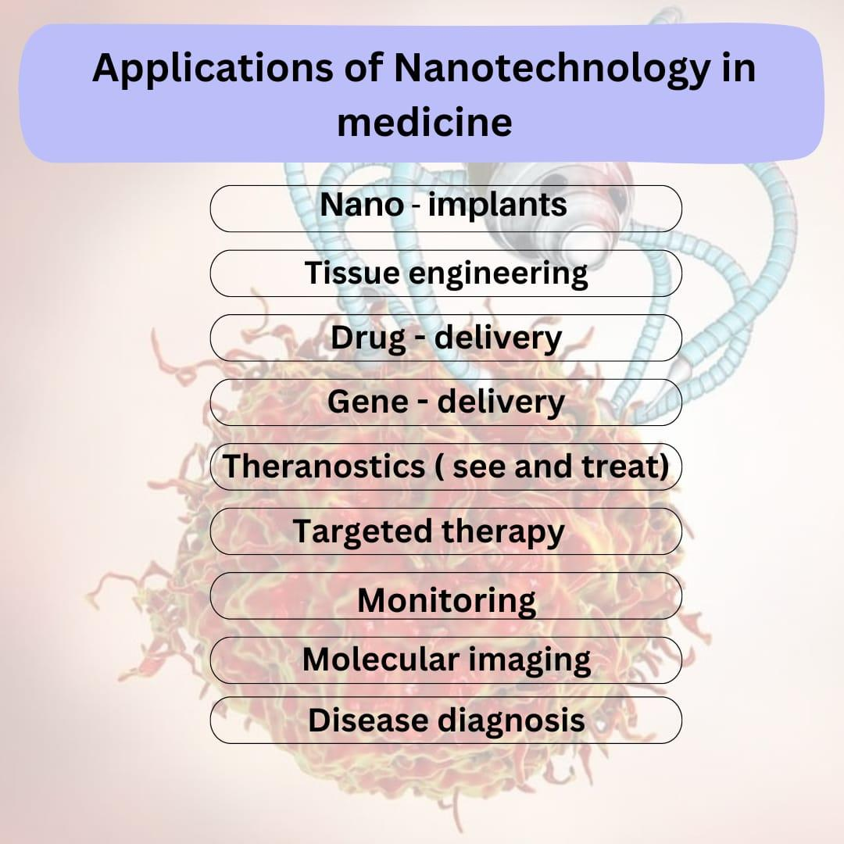
Fig. Illustrates applications of Nanotechnology in medicine
- Nanorobot used in gene therapy:
Medical nanorobots can quickly cure inherited problems by comparing the molecular structures of the DNA and proteins found in the cell to desired or known reference structures. Then, any errors can be fixed or the desired improvements can be introduced. Chromosome replacement therapy may occasionally be more effective than CY to repair a damaged chromosome. In a human cell's nucleus, a repair vessel built by an assembler carries out particular genetic upkeep. The nanomachine gently pulls an unwound strand of DNA through an aperture in its prow for analysis after stretching a super coil of DNA between its lower set of robot arms. While this is going on, the higher arms are removing the chain's regulating proteins and depositing them in an intake port. A larger nano computer located outside of the nucleus and linked to the cell-repair ship through a communications link compares the data to the molecular structures of DNA and proteins.⁶ The repair vessel would be able to execute treatments and cures that are inconceivable to modern medical practitioners despite being smaller than the majority of bacteria and viruses. If defects in either structure are rectified and the proteins are reattached to the DNA chain, which re-coils into its original form with a diameter of only 50 nanometers, the repair vessel would be smaller than most bacteria and viruses. Internal medicine would gain new significance when a patient's blood contained trillions of these devices.¹⁴ The molecular level of disease would be tackled, including viral infections, cancer, and arteriosclerosis might be eradicated.
- Nanorobot used for brain aneurysm:
A medical gadget prototyped using computational nanotechnology is the nanorobot for brain aneurysm prognosis. Prototyping of equipment, manufacturing methods, and inside-body transduction are the three key components of this. To produce nanorobots quickly and effectively, equipment prototyping is a critical component of computational nanotechnology. It aids in the exploration of essential issues related to medical instruments and device prototypes. The construction of race cars, aircraft, submarines, ICs, and medical equipment all used a similar strategy in the past. Now, the same can be used to further the investigation and creation of medical nanorobots.^{2,3} The biochip should be constructed using the same manufacturing techniques as the nanorobot. As a result, a description of the architecture of the nanorobot is offered together with new materials, photonics, and nanobioelectronics. Additionally, the parameters for the inside-body interactions and nanorobot morphology are based on cell morphology, microbiology, and proteomics. Medical prognosis is based on changes in chemical gradients and telemetric instruments, with the nanorobots activated depending on proteome overexpression.¹² These three ideas make up the essential components needed to enhance the creation and application of medical nanorobots, as they are described in the study. Nanorobots must monitor vessel endothelial damage before a subarachnoid haemorrhage happens to determine the prognosis of brain aneurysms.¹⁴
The early stages of a brain aneurysm are detected by nanorobots using these variations in chemical concentration. Because biomolecules are too small to be accurately recognised, the robot employs chemical nano biosensor contact to find them. The primary morphologic characteristics of brain aneurysms are used as models for the investigation of nanorobot interaction and sensing within the distorted blood artery. Intracranial NOS concentrations are low, and pNOS's positive interactions with N-oxide can even lead to occasional false positives.⁹
Along with the flow of fluid, cells and nanorobots are constantly entering one end of the workstation. For the nanorobots to detect protein over-expression, the configuration for sensing and control activation can be adjusted for various values, such as changing the detection thresholds. Any nanorobots that are silent while inside the workplace are treated as though they have not detected any signals, and as the fluid departs the workspace, they are lowered with it. The electrochemical sensor on the nanorobot produces a feeble signal of less than 50 nA when it detects NOS in small quantities or within a typical gradient [23–25]. Because the NOS concentration, in this case, is within the typical range of intracranial NOS, the nanorobot ignores it. A significant indication of an intracranial aneurysm is considered to have been obtained whenever the cell phone has received at least a total of 100 nanorobots higher proteomic signal transduction as a practical threshold for medical diagnosis, to prevent noise distortions and generate a greater resolution. When the sensors on the nanorobots are activated, additionally, they provide information on where they were standing when they discovered a significant amount of NOS protein, which is essential for determining the size and location of the vessel bulb.^{8,10}
- Nanorobots used in dentistry:
The rising interest in the potential dental applications of nanotechnology is fueling the development of a brand-new speciality called nano dentistry. Nanorobots realign and straighten crooked teeth while also enhancing dental durability by using oral anaesthesia, tooth desensitisation, and tissue manipulation. It is further detailed how preventive, restorative, and curative procedures are carried out by nanorobots.⁹ For extensive tooth repair, nano dental techniques use a variety of tissue engineering approaches. To replace the entire dentition, a biologically autologous full replacement tooth is made and implanted using both mineral and cellular components.^{13,14,10}
Sapphire, a substance created by nanotechnology in dentistry, improves the durability and aesthetics of teeth. Upper enamel layers are replaced with artificial material that has been covalently linked, such as sapphire. This substance is 100 to 200 times harder and more resilient to failure than ceramic.^{8,9} Sapphire is slightly resistant to corrosion of acid, much like enamel. Sapphire offers the greatest conventional whitening sealant and cosmetic substitute. Nanocomposites are a new type of restorative material that improves tooth durability. By equally distributing discrete nanoparticles in resins or coatings after nano-agglomerating them, nanocomposites are produced. The alumina silicate powder in the nanofiller has an alumina to silica content of 1:4 and an 80 nm particle size. The nanofiller has great hardness, elasticity modulus, translucency, aesthetic appeal, excellent colour density, high gloss, and a 50% half reduction in filling. It has a refractive index of 1.503. They blend much better with a tooth's natural structure and are preferred to conventional composites.¹²
Conclusion:
The primary goal of producing this paper is to give an overview of the advancement of nanotechnology in medical or medicine by creating a nanorobot and using it as a novel method of drug delivery in the cancer treatment. A growing number of people are diagnosed with cancer each year, which is a group of diseases typified by the body's malignant cells developing and spreading out of control. Treatment of cancer is most likely what inspired the development of nanorobotics; it will be successfully treated with current technology used in medical and therapeutic tools, with nanorobotics playing a vital role. The following considerations should be taken into account when determining a cancer patient's prognosis and survival prospects: If the disease's course is time-varying and a prompt diagnosis is established, better outcomes can be reached. Another crucial element is developing effective targeted drug delivery methods to lessen the side effects of drugs on patients.
Nanotechnology has shown how real advances in new manufacturing technologies are enabling creative activities that may help in producing and employing nanorobots most effectively for biomedical difficulties when utilised as a diagnostic and therapeutic tool for cancer and diabetes patients. The efficacy, comfort, and timeliness of upcoming medical treatments will once more increase significantly with the development of molecular nanotechnology, while also significantly lowering their risk, expense, and invasiveness. Nanorobotics has potential to completely transform healthcare sand the way diseases are treated in the future, even though his science currently sounds like science fiction. It creates new opportunities for extensive, prodigious research. More than other breakthroughs, nanotechnology will have a major impact on health care and human existence.
Acknowledgement:
The authors are thankful to the Principal, ASPM’s K. T. Patil College of Pharmacy for providing the necessary facilities for study.
Reference:
- da Silva Luz GV, Barros KV, de Araújo FV, da Silva GB, da Silva PA, Condori RC, Mattos L. Nanorobotics in drug delivery systems for treatment of cancer: a review. J Mat Sci Eng A. 2016;6:167-80.
- Jaffray DA, editor. World congress on medical physics and biomedical engineering, june 7-12, 2015, Toronto, Canada. Springer; 2015 Jul 13.
- Ross JS, Schenkein DP, Pietrusko R, Rolfe M, Linette GP, Stec J, Stagliano NE, Ginsburg GS, Symmans WF, Pusztai L, Hortobagyi GN. Targeted therapies for cancer 2004. American journal of clinical pathology. 2004 Oct 1;122(4):598-609.
- Maeda H. The enhanced permeability and retention (EPR) effect in tumor vasculature: the key role of tumor-selective macromolecular drug targeting. Advances in enzyme regulation. 2001 May 1;41(1):189-207.
- Bhat AS. Nanobots: the future of medicine. International Journal of Management and Engineering Sciences. 2014;5(1):44-9.
- Sharma NN, Mittal RK. Nanorobot movement: Challenges and biologically inspired solutions. International journal on smart sensing and intelligent systems. 2008 Mar 1;1(1):87-109.
- Artemov D, Solaiyappan M, Bhujwalla ZM. Magnetic resonance pharmacoangiography to detect and predict chemotherapy delivery to solid tumors. Cancer research. 2001 Apr 1;61(7):3039-44.
- Sivasankar M, Durairaj R. Brief review on nano robots in bio medical applications. Adv Robot Autom. 2012 Feb 27;1(101):2.
- Frcitas RA. Exploratory design in medical nanotechnology: a mechanical artificial red cell. Artificial Cells, Blood Substitutes, and Biotechnology. 1998 Jan 1;26(4):411-30.
- Patil M, Mehta DS, Guvva S. Future impact of nanotechnology on medicine and dentistry. Journal of Indian society of periodontology. 2008 May;12(2):34.
- Acebes-Fernández V, Landeira-Viñuela A, Juanes-Velasco P, Hernández AP, Otazo-Perez A, Manzano-Román R, Gongora R, Fuentes M. Nanomedicine and onco-immunotherapy: from the bench to bedside to biomarkers. Nanomaterials. 2020 Jun 29;10(7):1274.
- Moghimi SM, Hunter AC, Murray JC. Nanomedicine: current status and future prospects. The FASEB journal. 2005 Mar;19(3):311-30.
- Soto F, Wang J, Ahmed R, Demirci U. Medical Robotics: Medical Micro/Nanorobots in Precision Medicine (Adv. Sci. 21/2020). Advanced Science. 2020 Nov;7(21):2070117.
- Salata OV. Applications of nanoparticles in biology and medicine. Journal of nanobiotechnology. 2004 Dec;2(1):1-6.

