TRANSPARENT CONCRETE BLOCK

VIJAYAKUMAR HALAKATTI¹, MOHAMMED AZAM2, B SHASHANK3, SHWETHA M4 and PAVAN D C5
¹Professor, Department. of Civil Engineering, Vidya Vikas Institute of Engineering and Technology, Karnataka, India
2,3,4,5BE Students, Dept. of Civil Engineering, Vidya Vikas Institute of Engineering and Technology, Karnataka, India

Abstract - Transparent concrete is the new type of concrete introduced in modern era which carries special property of light transmitting due to presence of glass rods & is also known as translucent concrete or light transmitting concrete. It is lighter than conventional concrete having special features such as low density and thermal conductivity with main advantage of reduction in dead weight, faster building rate in construction, lower haulage & handling cost. Light is transmitted from one surface of the brick wall to the other due to glass rods along the overall width of the wall which allows light to pass through. An optical glass fiber (or optical fiber) is a flexible, transparent fiber made of glass (silica)or plastic, slightly thicker than a human hair & can function as waveguide, or “light pipe” to transmit light between the two ends. Main aim of the study is to design translucent concrete blocks with the use of glass rods with sand & cement then analyses their various physical & engineering properties with respect to conventional concrete blocks by adding glass rods of 1%, 2 %, 3 % 4 % 5% at 1.5 CMS spacing respectively. From the study, it can be concluded that there is 5% to 10% increase in initial compressive strength for 7 days & also10% to 15% increase in initial compressive strength for 28 days to a glass rod mix of up to 3% Whereas the initial &final characteristic compressive strength gradually decreases with an increase in glass rods in the concrete mix.

KEY WORDS: Transparent concrete, Workability, Compressive strength, Tensile strength, Flexural strength

- INTRODUCTION

Transparent concrete, also known as translucent concrete or light-transmitting concrete, is an innovative construction material that combines the properties of concrete and light transmission. Unlike traditional opaque concrete, transparent concrete allows light to pass through it, creating a unique and visually striking effect. It is achieved by embedding optical fibers within the concrete matrix, which transmit light from one end to the other.
The optical fibers used in transparent concrete are typically made of plastic or glass and are dispersed throughout the concrete mixture during the casting process. The fibers are aligned in such a way that they create a network or grid-like pattern within the concrete, enabling light to pass through while maintaining the material's structural integrity.
The benefits of transparent concrete are numerous. It allows natural light to permeate into interior spaces, reducing the need for artificial lighting during the day and enhancing the overall ambiance. It can be used in architectural designs to create visually stunning facades, partitions, or decorative
elements that provide a unique play of light and shadow. Additionally, transparent concrete retains the strength and durability of traditional concrete, making it suitable for various construction applications
Despite these challenges, transparent concrete represents an innovative approach to construction and design. Its ability to combine transparency and strength opens up new possibilities for architects, interior designers, and artists to create captivating structures and spaces. As technology advances and research continues, transparent concrete holds the potential for further development and application in the construction industry.

BENEFIT OF OPTICAL GLASS FIBER.
Glass is a non-crystalline strong solid that is often transparent and as a widespread particle technology under decorative usage in any things.
- It is transparent. One can only pass light through it.
- It is impermeable, it does not allow water or other any liquid to pass through, and it does not get soggy and stained.
- User friendly. This is durable, UV protected and there is nothing to break or burn.

MATERIALS

  - Ordinary Portland cement (53 grade).
  - Manufactured sand off penetrating sieve size(<4.75mm).
  - Glass rod fiber 0.75mm in dia are used for casting transparent concrete block.

Cement
Fine. Made with calcinate limit and dirt, it is blended with water and sand to frame water and blended with sand, rock and water to make concrete. In assembling of concrete shape and balance OPC-43 was utilized

Fine aggregates
aggregates are the major and important constituents of concrete They. From the whole body of the concrete as it occupies 70 to 80% of the volume of concrete. Fine aggregate sand which is usually obtained from rivers or lakes, sometimes reach and also used. In this project we use River sand.

Optical Glass Fiber

Optical glass fiber is flexible. Flexible and transparent fibers made-up of pure glass(silica). It functions as a view light wipe

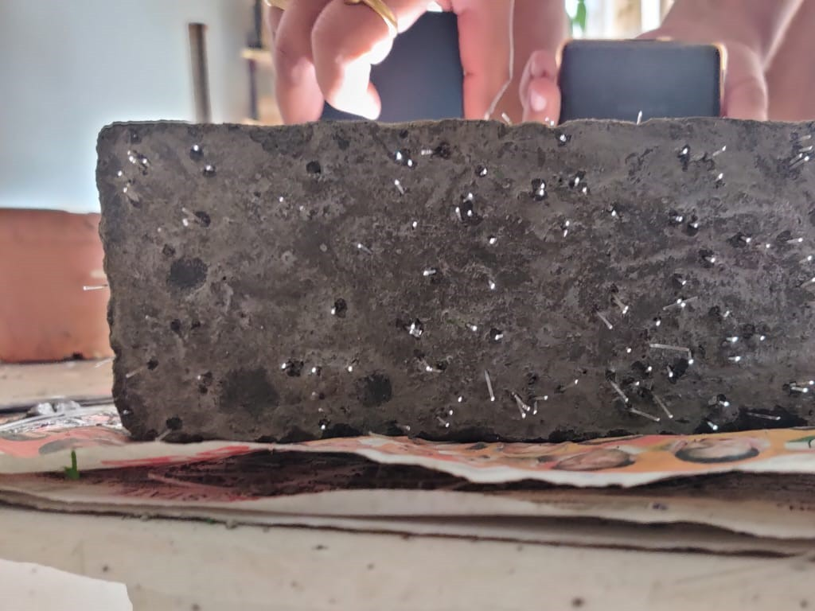
to transmit light between two ends of the optic fiber. Generally, 1mm diameter sands is used for construction of transparent concrete block

METHODLOGY

- The methodology for producing transparent concrete involves several key steps, including the selection of materials, mixing, casting, curing, and finishing. Here is a general outline of the methodology:
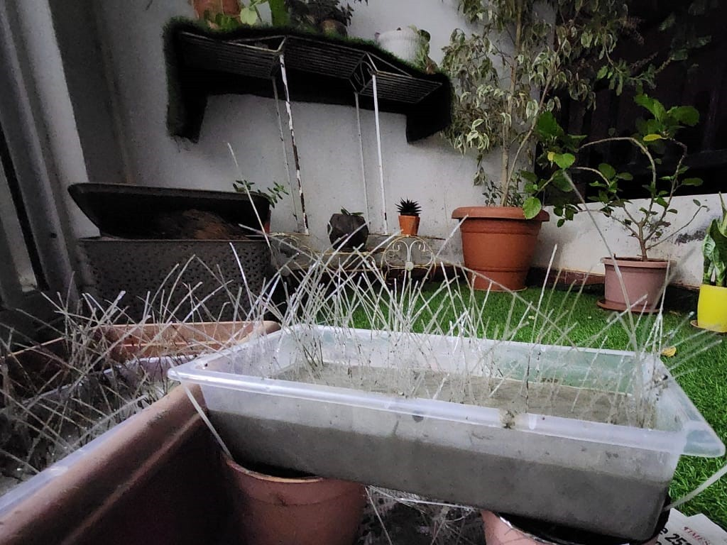
- Material Selection: The primary components of transparent concrete are cement, fine aggregates (such as sand), water, and optical fibers. The optical fibers can be made of glass or plastic and are available in different diameters and lengths. The selection of these materials should be based on their compatibility, strength, and transparency properties.
- Fiber Preparation: Optical fibers are prepared by cutting them into desired lengths. The lengths can vary depending on the intended application and design requirements. The fibers may also be treated with a coating to enhance their adhesion to the cement matrix.
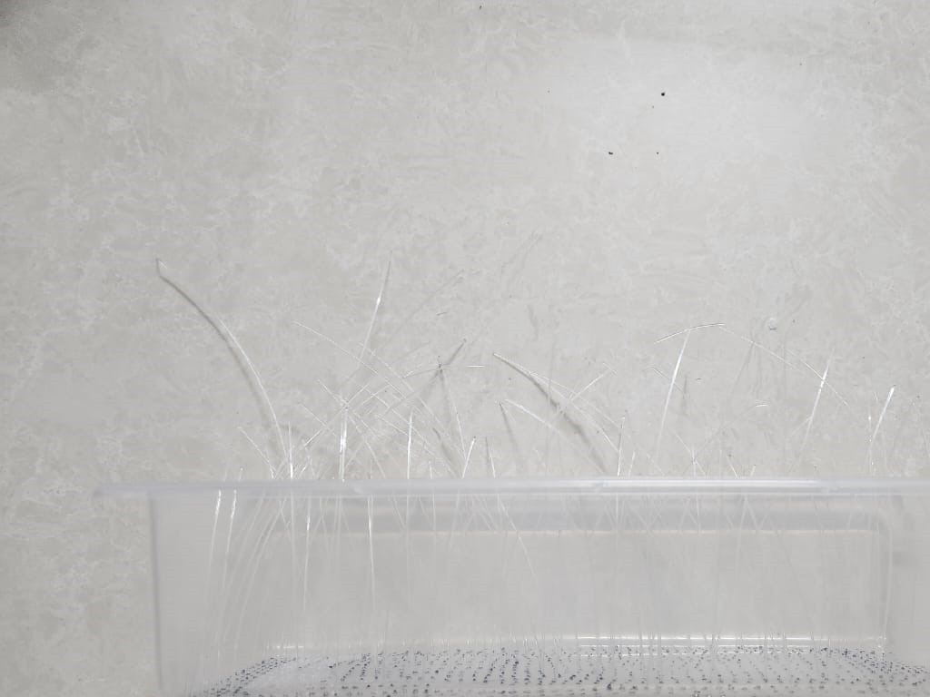
- Mixing: The concrete mixture is prepared by combining cement, fine aggregates, water, and any necessary additives or admixtures. The specific proportions and mix design should be determined based on the desired strength, workability, and transparency of the final product. The optical fibers are then added to the mixture and evenly dispersed to form a network throughout the concrete matrix.
- Casting: The mixed transparent concrete is cast into molds or formwork, depending on the intended shape and size. Care should be taken to ensure proper alignment and distribution of the optical fibers within the mold. The casting process should be performed efficiently to prevent segregation of the fibers and to achieve uniformity in the finished product.
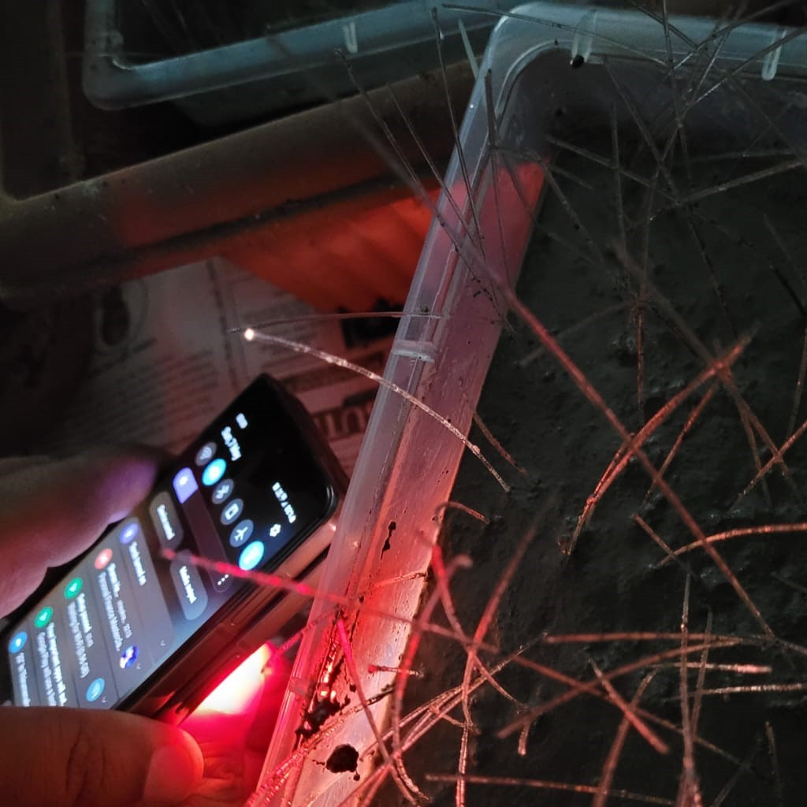
- Curing: After casting, the transparent concrete needs to be cured to develop its strength and durability. Curing methods may include traditional moist curing or steam curing, depending on the specific requirements of the concrete mix. Proper curing is essential to achieve optimal mechanical properties and to prevent cracking or shrinkage.
- Finishing: Once the transparent concrete has achieved sufficient strength, it can be finished according to the desired architectural or design specifications. Finishing techniques may include polishing, sanding, or coating to enhance the transparency and appearance of the surface. Surface treatments can also be applied to improve resistance to staining or weathering.

RESULT AND DISCUSSION:
Relation between characteristics strength for the Plain Concrete Mix for 7 & 14 days
The characteristic strength of plain concrete mix refers to the specified strength that the concrete is expected to achieve. The relationship between the characteristic strength at 7 days and 14 days can vary depending on several factors, including the mix proportions, curing conditions, and the specific cementitious materials used. However, there are some general trends observed in the development of concrete strength over time.
  - Early Strength Gain: Generally, concrete exhibits significant strength gain during the initial curing period of 7 days. This is attributed to the early hydration reactions of cement, which result in the formation of hydration products and the development of strength.
  - Continued Strength Development: Beyond 7 days, the concrete continues to gain strength, albeit at a slower rate compared to the early age. The hydration process and the gradual filling of voids in the cement matrix contribute to the ongoing strength development.
  - Maturity Concept: The strength development of concrete can also be expressed using the concept of maturity, which takes into account both time and temperature history. The maturity of concrete is influenced by factors such as curing temperature and time, which can accelerate or retard the strength development.
  - Variation in Strength Gain: The rate of strength gain and the relationship between the characteristic strength at 7 days and 14 days can vary depending on several factors. These include the type and composition of cement, water-cement ratio, curing conditions (temperature, moisture), and presence of admixtures or supplementary cementitious materials.
In practice, it is common to estimate the characteristic strength at 14 days based on the strength achieved at 7 days using empirical relationships or established statistical methods. However, it is important to note that the specific relationship between the 7-day and 14-day strengths can vary and should be determined based on the mix design and testing data specific to the project or concrete mixture being used. Testing concrete samples at both 7 days and 14 days provides more accurate information for assessing the concrete's strength and can be helpful in evaluating its performance.

Sl no | Average strength at 7  days N/mm2 | Average strength at 14 days N/mm2
1 | 17.6 | 21.7
2 | 17.5 | 21
3 | 17.55 | 21

Table 1: Compressive Strength of Concrete specimen for 7&14 days

4. CONCLUSIONS

- In conclusion, transparent concrete is a cutting-edge material that combines the strength and durability of traditional concrete with the unique property of light transmission. It offers several advantages that make it an attractive option for architectural and design applications.
- The transparency of this material allows natural light to penetrate into interior spaces, reducing the need for artificial lighting and enhancing the visual appeal of the surroundings. It opens up new possibilities for creative and innovative design concepts, enabling architects and designers to create visually striking facades, partitions, or decorative elements.
- Transparent concrete also contributes to energy efficiency by harnessing natural light during daylight hours, thereby reducing energy consumption for lighting purposes. Its structural integrity remains intact, ensuring that it can be used in various construction applications without compromising on strength or durability.
- Additionally, transparent concrete provides effective sound insulation, enhancing acoustic privacy between spaces. This makes it suitable for applications where noise reduction is important.
- While there are challenges associated with transparent concrete, such as the complexity of its production process and higher cost compared to traditional concrete, ongoing research and advancements in the field hold promise for further improvements and cost-effective production techniques.
- Overall, transparent concrete represents a remarkable advancement in the construction industry, offering a unique combination of aesthetics, functionality, and sustainability. As it continues to evolve, transparent concrete is expected to find increasing applications in architectural design, contributing to the creation of visually stunning and environmentally friendly structures

TEAM WITH TRANSPARENT CONCRETE BLOCK

REFERENCES

- Prof. Sonali and Kakatiya “translucent concrete by using optical fiber and glass rod” international journal of scientific and research publication, volume 6, issue 10, oct 2016, ISSN 250-3153

- Abhishek Tiwary and Pramod Saharan “study of behavior of translucent concrete using rice husk and steel fiber SSRG, international journal of civil engineering (SSRG -IJC) – volume 3 issue 7-july 2016

- IS:7320-1974 Code of practice for “WORKABILITY OF CONCRETE BY SLUMP TEST”

- IS:516-1959 Code of practice for “COMPRESSIVE STRENGTH TEST”

- IS:5816-1976 Code of practice for “SPLIT TENSILE STRSNGT TEST”

- IS:516-1959 Code of practice for “FLEXURAL STRENGTH TEST”

